We have data on the number of students at universities. create a dataframe univer. csv file: Universities.csv

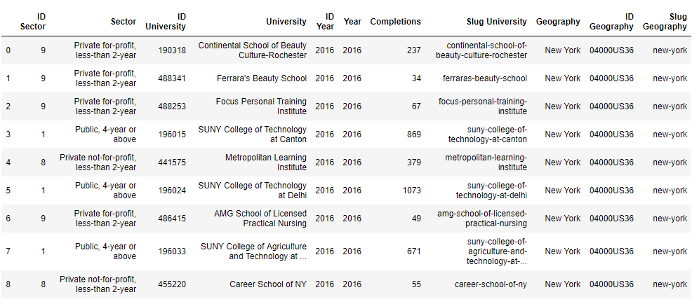

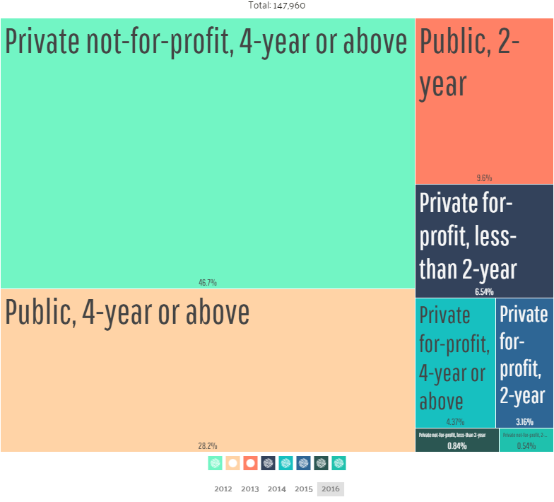

We also have data on the most popular destinations. We will write the data in the dataframe conc. Csv file: Concentrations.csv

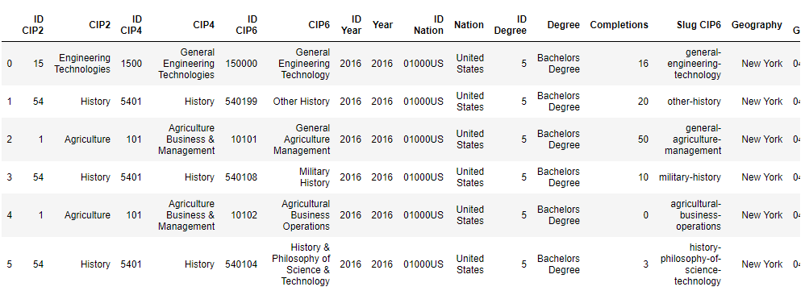

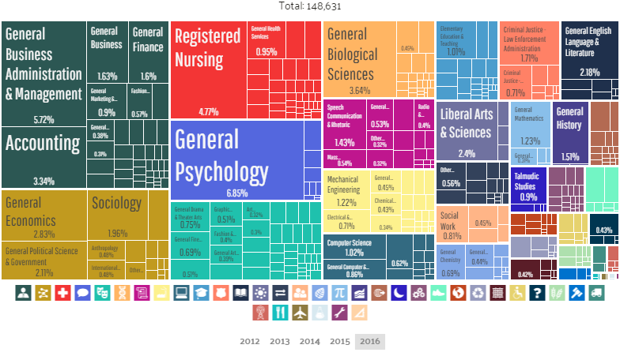

And data on the nationality of students. Write the data in the dataframe rase. csv file: Student Race and Ethnicity.csv

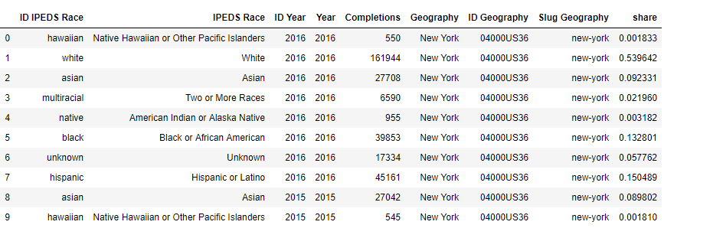

Data taken from the site https://datausa.io in the form of csv files.

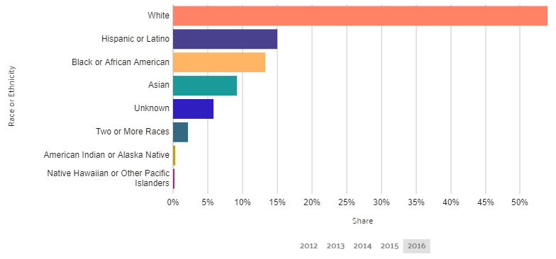

And we use <https://ru.foursquare.com> to determine the best location.