**Sorting (Part 1)**

EX1 :

Code :

Merge sort

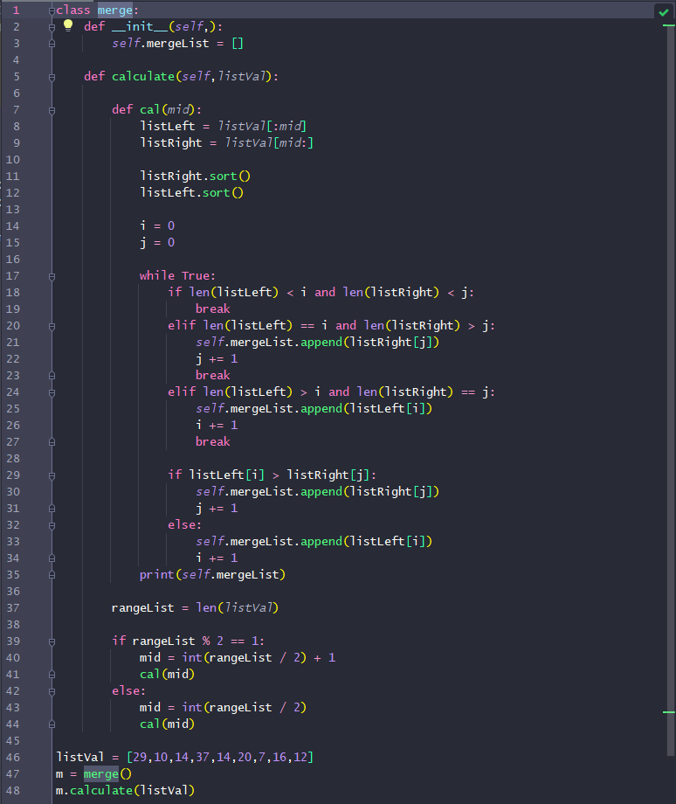

Result :



EX2 :

Code :

Quick sort lomuto

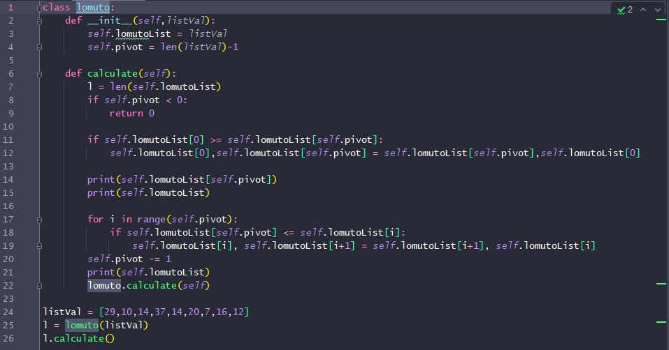

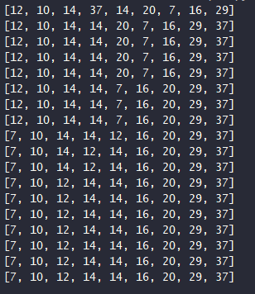Result :

EX3 :

Code:

Quick sort hoare

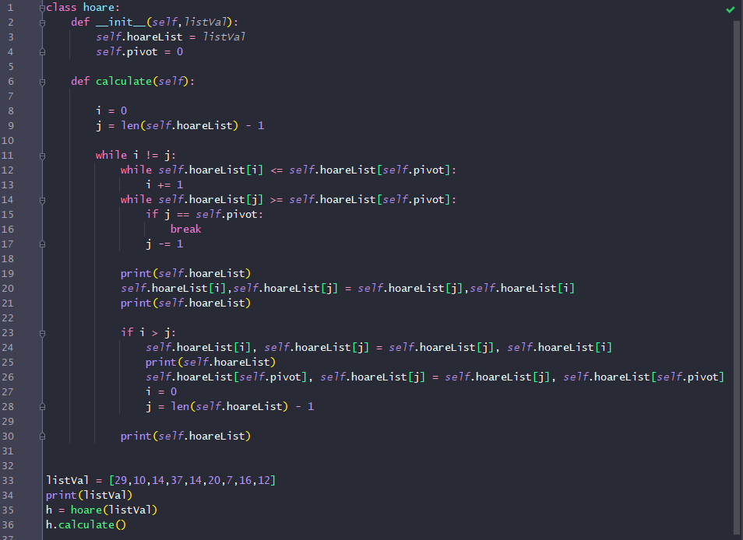

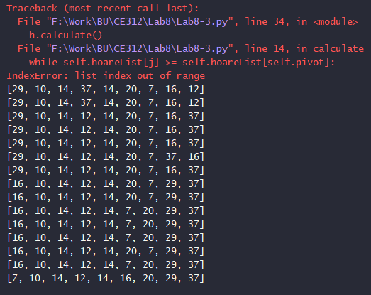Result:

Explanation

Merge sort Draw the sorting