**Basic graph structure**

Code:

Create, Connect and display Adjacency matrix function

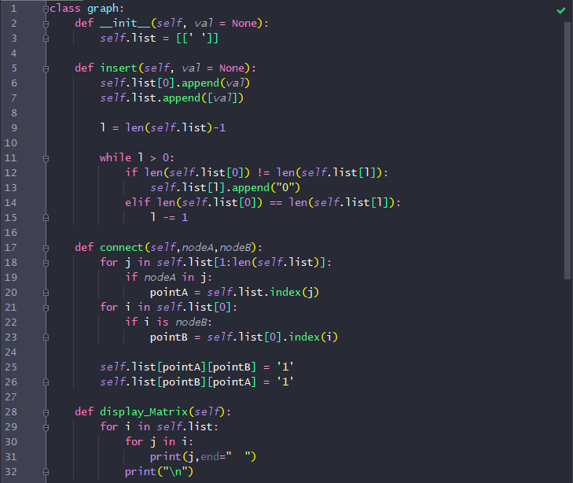

Disconnect function 

display Adjacency list function

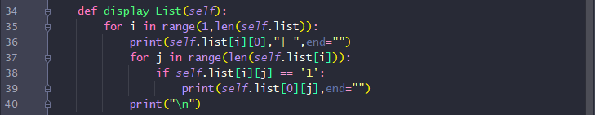

display Edge list function 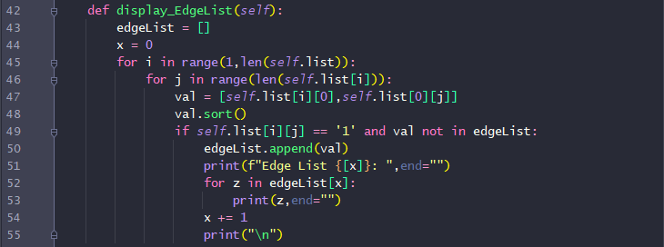

EX 1

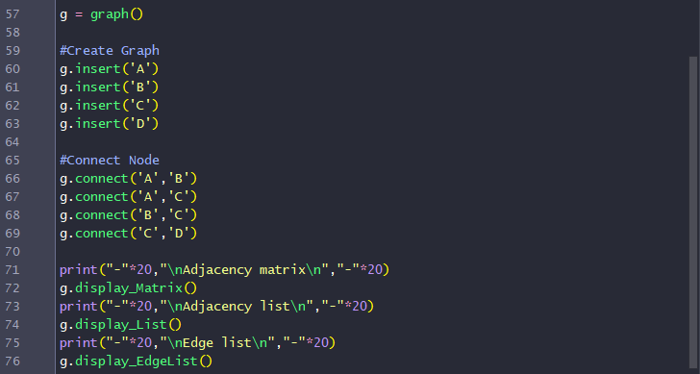

EX2 and EX3

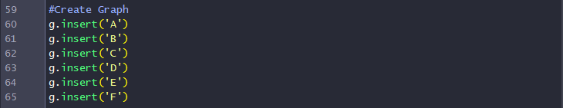

EX2

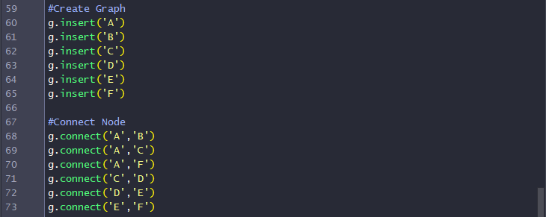

EX3-1



EX3-2



EX3-3



Result :

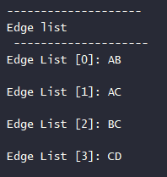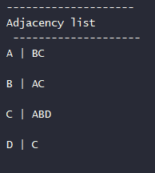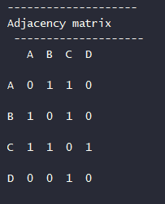EX 1 : Adjacency matrix | EX 1 : Adjacency List | EX 1 : Edge list

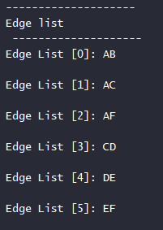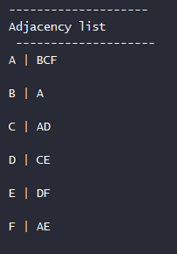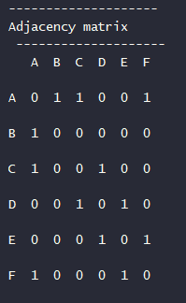EX 2 : Adjacency matrix | EX 2 : Adjacency List | EX 2 : Edge list

Connect AB,AC,CD,CF,EF

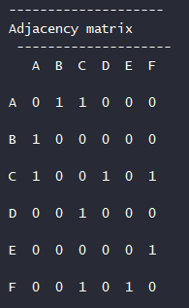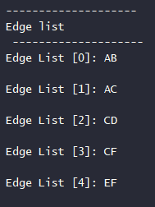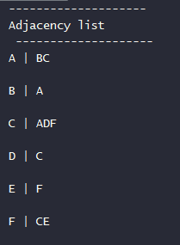EX 3: Adjacency matrix | EX 3 : Adjacency List | EX 3 : Edge list

draw graph diagram

Disconnect CF,AB,CD

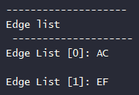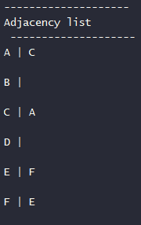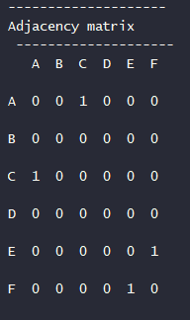EX 3: Adjacency matrix | EX 3 : Adjacency List | EX 3 : Edge list

draw graph diagram

Connect AE, BC, DF

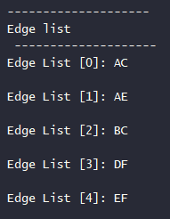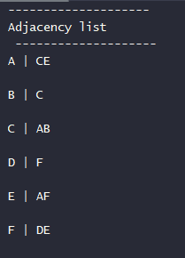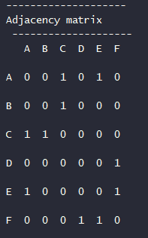EX 3: Adjacency matrix | EX 3 : Adjacency List | EX 3 : Edge lis t

draw graph diagram