**Sorting (Part 1)**

EX1 :

Code :

Bubble sort

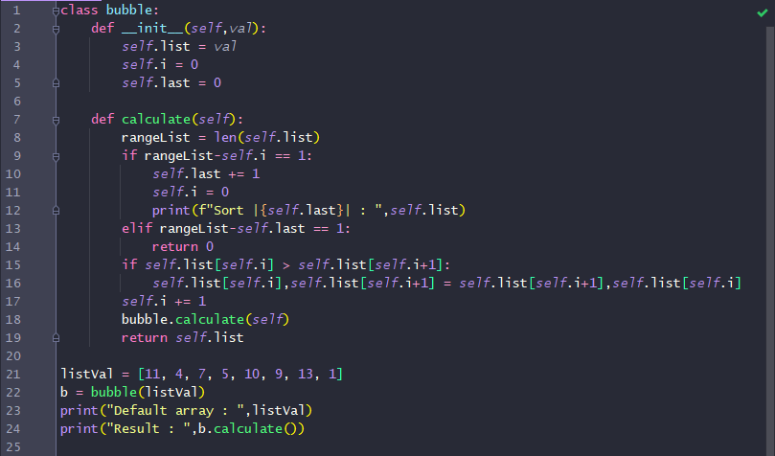

Result :

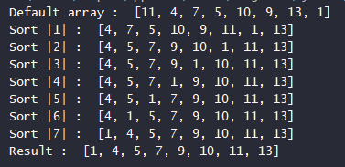

EX2 :

Code :

Selection sort

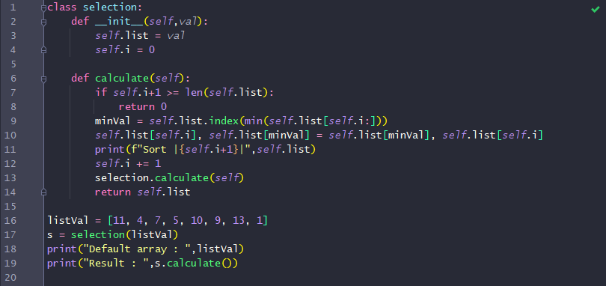

Result :

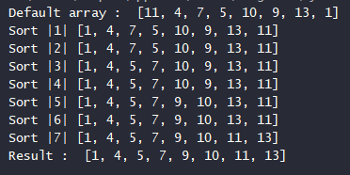

EX3 :

Code:

Insertion sort 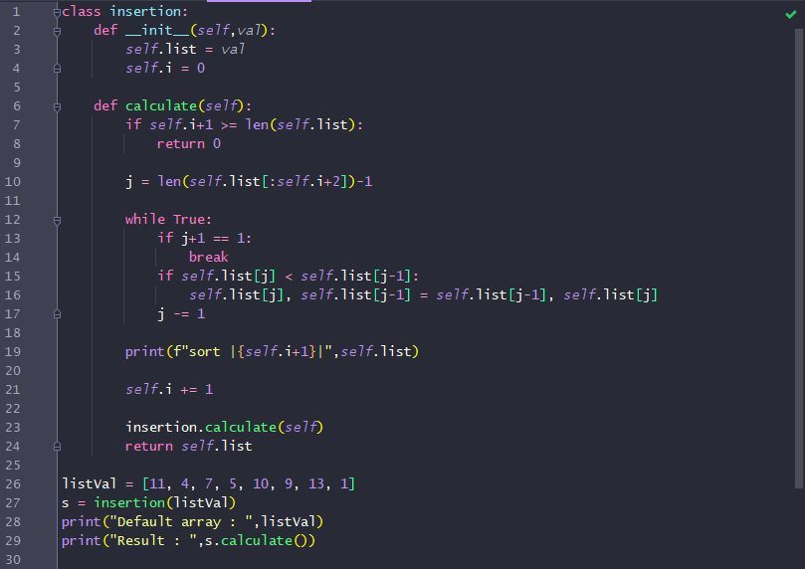

Result:

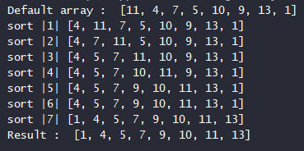

Explanation

From all above method which one is the best in term of performance?

- Bubble sort

From all above method which one is the best in term of resource management?

* Insertion sort

From all above method which one is the best in your opinion?

* Selection sort