World.java

Building the 2D ArrayList from CSV files

Rather than adding every single tile to the world, we can build a world in Excel or Open Office Calc and use Java's file IO to map that to a 2D ArrayList. Using this tutorial from Oracle, we set up a Scanner that reads the csv file http://docs.oracle.com/javase/tutorial/essential/io/scanfor.html

- Using a scanner (we must use a try statement here to throw an exception if the file is not found, and a finally statement to close the reader stream) we can loop through each line in the spreadsheet and split the entries using a comma (I will get into the spreadsheet and delimiters below).
- We then must make an ArrayList of each string using a for loop. Each of these ArrayLists forms a row in our 2D ArrayList, map.
- Note that 2D ArrayLists have different syntax than 2D arrays. To access a field in a 2D ArrayList, we use map.get(index).get(index). So while a 2D array entry might look like this: map[1][4], a 2D ArrayList looks like this map.get(1).get(4). I have written a getTile(int,int) method that will make this much less annoying, see below.

Scanner s = null; //makes a scanner
try {
s = new Scanner(new BufferedReader(new FileReader(filename)));

int row = 0; //keeps track of row #
int col = 0; //keeps track of col #
while (s.hasNextLine()) {
//System.out.println(s.next());
String line = s.nextLine(); //makes a string from each row
String[] array = line.split(","); //splits the rows into string arrays
ArrayList<Tile> currentLine = new ArrayList<Tile>(); //makes a row array list for the map
map.add(currentLine); //adds the row

for (col=0; col<array.length; col++) //for each space in the row
{
tile = new Tile();
//based on the string type, we place the appropriate tile
if (array[col].equals("water"))
{
//water tile
tile.setObstacle("water");
} else if (array[col].equals("enemy_tiger")) {
//enemy tile
tile.setEnemy("enemy_tiger");
} else{
//anything else is gonna be empty
tile.setType("Emtpy Tile");
}
currentLine.add(tile); //now add the tile
}
row++; //increments row
}

- Couple things to note for now:
  - I haven't figured out all the types yet for the if statement.
  - I am going to change the filename to a variable so that we can select from different maps in the constructor, or use the default constructor to get a random map
- Adding new tile types will be easy, just a matter of adding to the if statement. If you accidentally name the tile something that doesn't exist, it will just register as an empty tile.

Editing a CSV File

- CSV files are text-based files that Java can read without a fancy API
- Name each cell based on a type of Tile
- You can edit them right in a spreadsheet editor, but I would recommend making them as an xls file first and then saving them out. If you open a csv file, make sure that only comma separators are selected or you'll end up with a bunch of unwanted punctuation breaking stuff. If you open one in a text editor, you'll just see the words separated by their delimiter. In this case, a comma.
- To make a CSV file that works in this project, make your spreadsheet and select Save As, then select to save it as a CSV file. You will get a prompt like the one below. Make sure that the Field Delimiter is a comma and the Text delimiter is blank.
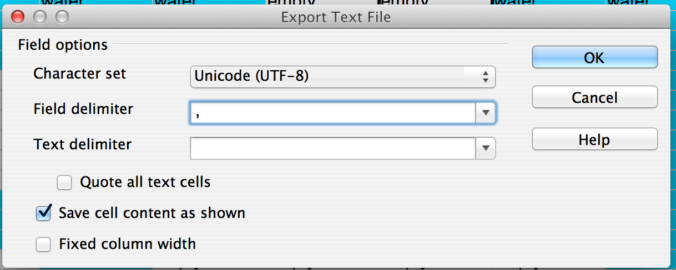

- And that's it.

Tile Types

- “water” - water obstacle that can't be walked on
- “empty” - empty, can be walked on
- “enemy_TYPE” - what enemy types are there?
- “item_TYPE” - what item types are there?
- “wild” - picks empty or enemy based on random number

Instantiating the World.java

- You will need to make an instance of world in the Game.java or whatever file you are making the world in. You can pass in the map file path, otherwise it will default to map01.
- You will also need to run the buildMap() method if you want the map to exist (this may or may not require including a “throws IOException” at the end of your method signature)

World w = new World();
w.buildMap();

- Use getMap(); to get the map 2D ArrayList
- I have added methods to find the start and finish tiles on the map. We may wish to move these later to a Game.java file or something, depending on how movement is set up.

int startRow = w.getStartRow();
int startCol = w.getStartCol();
System.out.println(startRow + ", " + startCol );
int finishRow = w.getFinishRow();
int finishCol = w.getFinishCol();
System.out.println(finishRow + ", " + finishCol );

- If you want to get a tile's type in spot i,j in a 2D array, you would use this:

w.getTile(i, j)

- This will be significantly less annoying typing. I'm kind of wondering if we really even need the getMap() method, or if that's just kind of repetitive. I'd like someone to take a look at this and try and make a thing move and tell me if there's more I can add.

