PlanLibre – a basic tutorial – make a Tatin’s pie project

What You Will Learn
- defining project settings
- defining ressources for a project
- defining tasks of a project
- add images to ressources and tasks
- modify project boundaries, ressources, tasks
- move tasks and understand timeine

Here, we want to teach you with a basic project, basic, but using various features. Suppose that you want to cook a delicious Tatin’s pie (a pie with apples and so on), and the various tasks involve YOU, your son and your daughter.
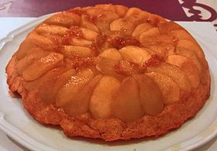Figure 1: Tatin's pie, credits : Wikipedia France

Then we have 3 « human forces » among our resources ; but in order to make this pie, we must get cooking tools, ingredients, and so on. Here is the list of resources :

Resources |  | Cost
Human work force | Me, Son, Daughter | 0
Raw materials | Apples (2 kilos or 4 pounds), | 6
 | Sugar : 0.250 kilo or 1/2 pound | 2
 | Ready made puff pastry | 1
 | Butter : 0.125 kilo or 1/4 pound | 2
Tools | Soup spoon | 0
 | Rolling pin | 0
 | pastry mold | 0
 | Oven | 0.5

When a manager sets up a project, he or she must break down the project in various tasks, like us !

Task | Duration | When ? | Who ?
Go to the library in order to get a recipe book | 2 hours | 3 days before | Me, son, daughter
Choose a recipe | 2 hours | 2 days before | Son, daughter
Go to the grocery to buy apples | 2 hours | 1 day before | Son
Collect tools (apart owen!) | 1 hour | Target day | daughter
Prepare ingredients | 1 hour | Target day | Me, son, daughter
Mix ingredients | 1 hour | Target day | Son
Cook pie | 1 hour | Target day | Me
Cool pie | 1 hour | Target day | Me
Eat pie | 1 hour | Target day | Me, son, daughter
Comment result | 3 days (yes, 3!) | Target day | Me, son, daughter

In order to have more fun with PlanLibre, go to Internet, and try to get some free pictures for :
- Tatin Pie
- apples
- cooking book
- cooking tools
- owen
Please, use only small pictures, it’s better for your computer.

store them on your computer, we will reuse them.

Let’s go !
For all steps, we suppose that you have launched PlanLibre with an empty project.

1. Define global properties.
For all steps, we suppose that you have launched PlanLibre with an empty project.

Choose menu Project>properties
A dialog appears.
Fill fields like this screenshot :
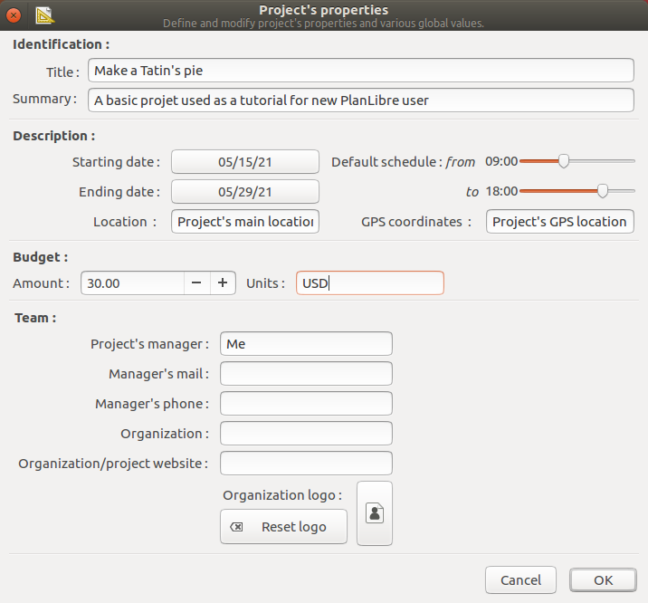

You are free to change dates : by default, PlanLibre uses current date.

Once done, click on [Ok] button ; if you are on « home screen », you can see that the display has changed, with the project’s name :

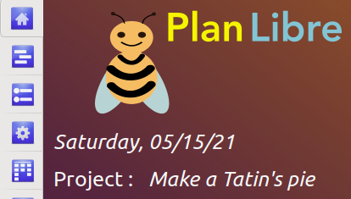
That’s all for properties !

Now, it’s time to add tasks, it’s the second step for you.

2. Add tasks to project
We can add tasks in every order, but since it’s a basic tutorial, please follow steps of the previous table. For convenience, I copy this table here :

Task | Duration | When ? | Who ?
Go to the library in order to get a recipe book | 2 hours | 3 days before | Me, son, daughter
Choose a recipe | 2 hours | 2 days before | Son, daughter
Go to the grocery to buy apples | 2 hours | 1 day before | Son
Collect tools (apart owen!) | 1 hour | Target day | daughter
Prepare ingredients | 1 hour | Target day | Me, son, daughter
Mix ingredients | 1 hour | Target day | Son
Cook pie | 1 hour | Target day | Me
Cool pie | 1 hour | Target day | Me
Eat pie | 1 hour | Target day | Me, son, daughter
Comment result | 3 days (yes, 3!) | Target day | Me, son, daughter

We proceed step-by-step, and will add only tasks themselves ;, for now.
For example, suppose we want to add the 1st task, « go to the library ... ».
- switch display to task view by clicking the « task » icon on the left side.
- click on the [+] button on upper bar

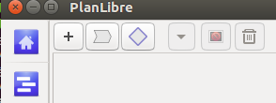
- a dialog appears, please fill it like me :

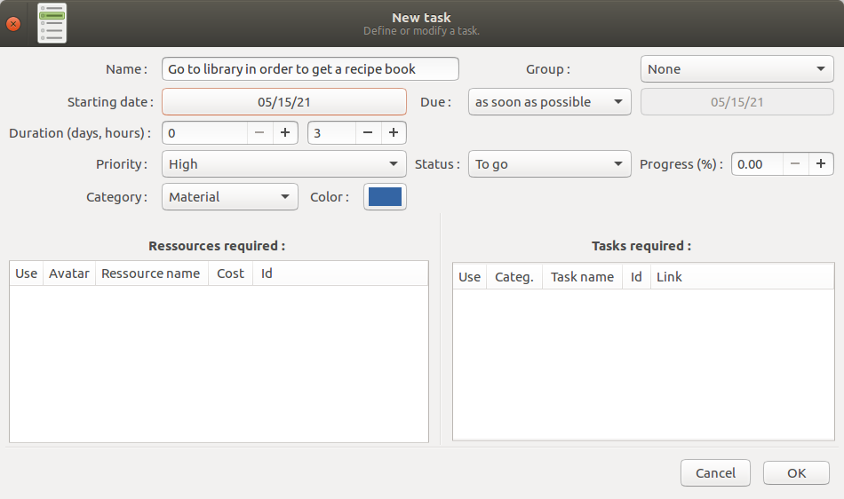
I’ve choosen a « blue » color ; fill free to choose yours, and, as usual, don’t matter the date.
Click the [Ok] button, and notice the change on « task display » :
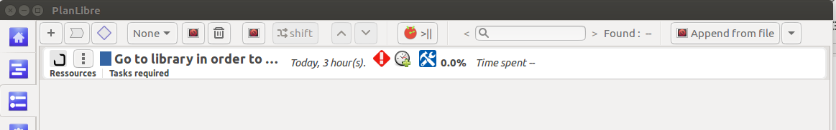
You’ve just started your task list, congratulations !
Since you’ve understood, please proceed on the same way for all other tasks. You should obtain something like that :
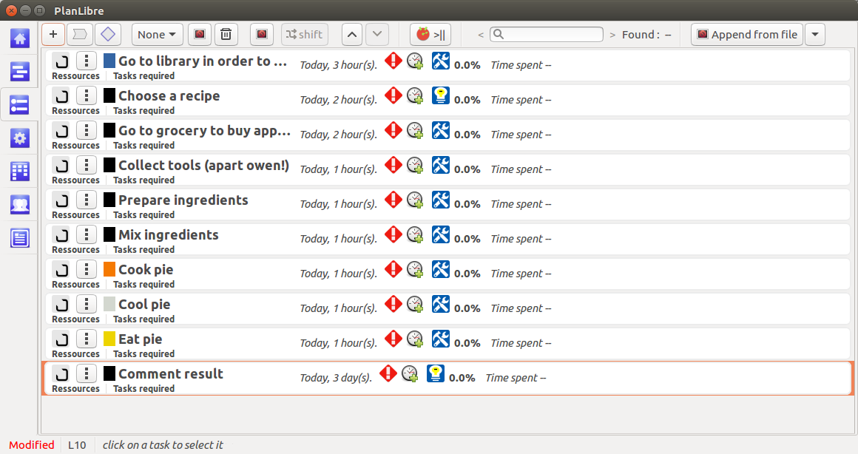

Don’t forget to save your project !
And notice the nice « lamp » icon for « choose a recipe » and « comment recipe » : they are intellectual tasks, against other « material » tasks (tool like icon).

3. Now, it’s time to add ressources !
In real world, tasks use many resources ; for example, suppose our task is to build a wall, we have to use human workforce, concrete, various tools …
Same thing for our pie ! Her, we reuse the « resources » table.
Launch PlanLibre, reload previous file, and, now, switch to ressource view.
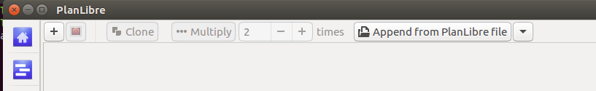
like for tasks, please click on [+] button to add a resource. You can add a resource in any order. A new dialog box appears : as a trial, fill fileds with datas for ressource «apples» :

Ressources |  | Cost
Human work force | Me, Son, Daughter | 0
Raw materials | Apples (2 kilos or 4 pounds), | 6
 | Sugar : 0.250 kilo or 1/2 pound | 2
 | Ready made puff pastry | 1
 | Butter : 0.125 kilo or 1/4 pound | 2
Tools | Soup spoon | 0
 | Rolling pin | 0
 | pastry mold | 0
 | Oven | 0.5

As an exercice, try,, like me, to change color, and to add a picture.

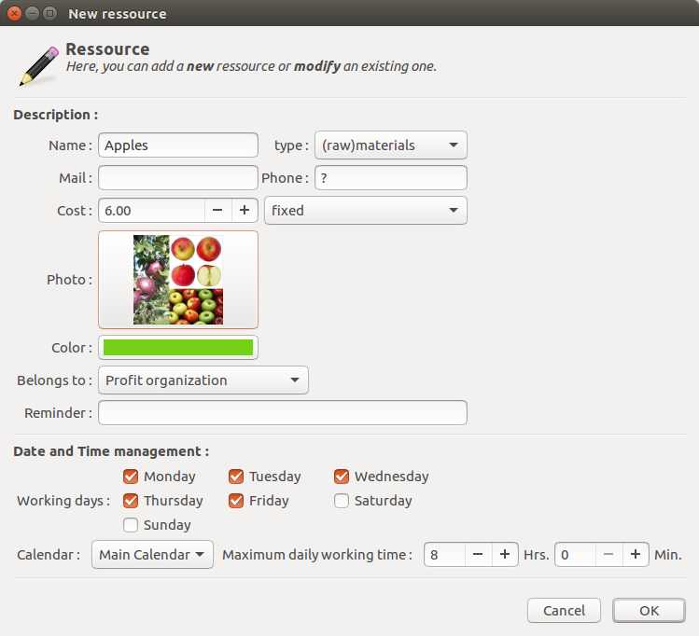
Once done, click on [Ok] button. The new resource is on top on resources’ list :
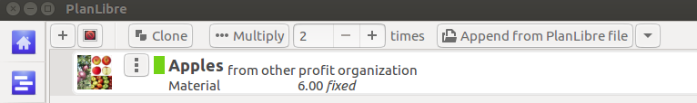
As you can see, it’s possible to set an icon for each resource : the source picture is automatically resized (the original file remains unchanged)
Do the same for all resources, you should obtain something like that :

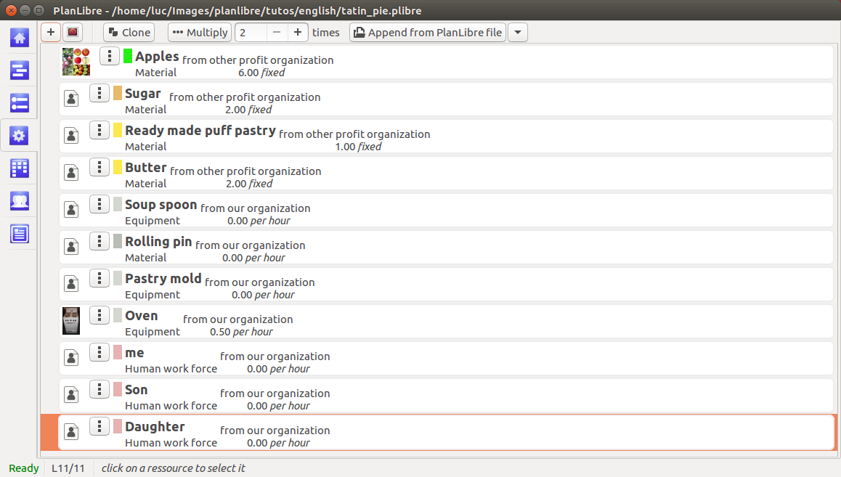
We don’t looking for truth or accuracy, it’s only a training ! Fill free to add pictures, change colors, and so on.
Save your job, the next step is more complex …

4. like in true life : associate tasks and ressources
No task without resources ! So, we will learn to associate (assign) one or more ressource to various tasks.
In order to achieve that, please switch to task view, and get in mind this table :

Task | Duration | When ? | Who ? | With ?
Go to the library in order to get a recipe book | 2 hours | 3 days before | Me, son, daughter
Choose a recipe | 2 hours | 2 days before | Son, daughter
Go to the grocery to buy apples | 2 hours | 1 day before | Son
Collect tools (apart owen!) | 1 hour | Target day | daughter
Prepare ingredients | 1 hour | Target day | Me, son, daughter | Apples, sugar, ready made pastry, butter, tools
Mix ingredients | 1 hour | Target day | Son | Apples, sugar, ready made pastry, butter, tools
Cook pie | 1 hour | Target day | Me | owen
Cool pie | 1 hour | Target day | Me
Eat pie | 1 hour | Target day | Me, son, daughter
Comment result | 3 days (yes, 3!) | Target day | Me, son, daughter
How to do that ?

In task view, for each task, click on button :

then we reopen the task dialog. For example, let’s open the « Go to the library » task ; you should see something new :
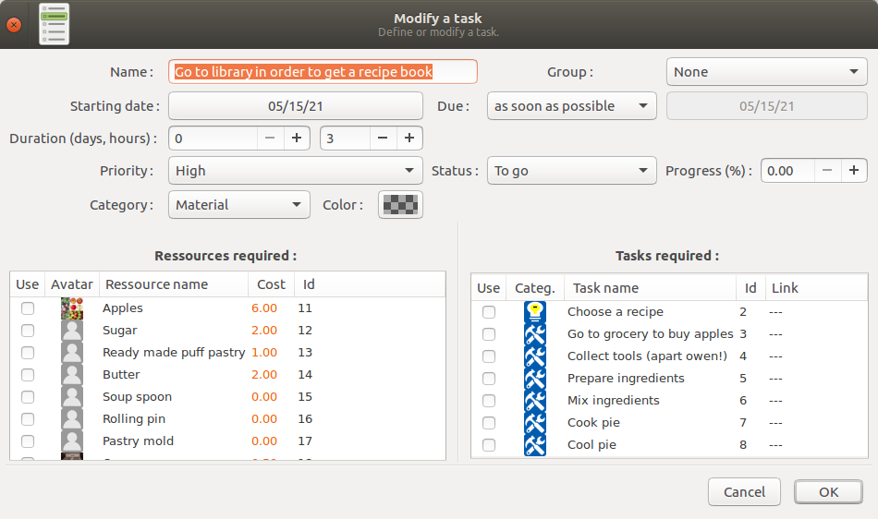

Please have a look on lower left side : we can see the list of available resources : click on Me, Son and Daughter resources, then click [ok] button.
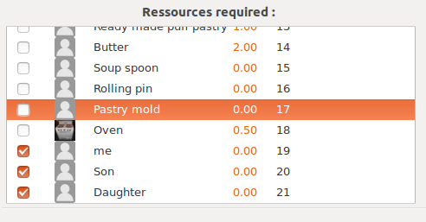
Notice the change on task View :

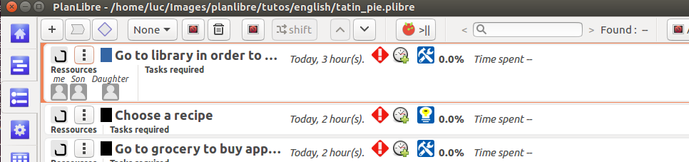
Now, for the « Go to the library » task, used resources are displayed.
Since you attempt to reuse ressources Son & Daughter on this task, at the same period than they are already used on task « Go to the library … « , PlanLibre displays a warning dialog, like this :

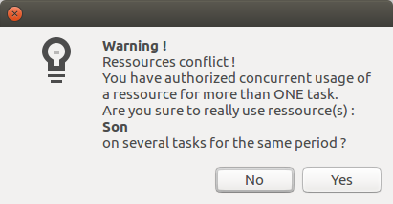
It isn’t an error, only a warning, take it easy !

Do the same for all tasks, according to previous table. Don’t forget to save your job. You should obtain something like that (I used various pictures for my resources) :
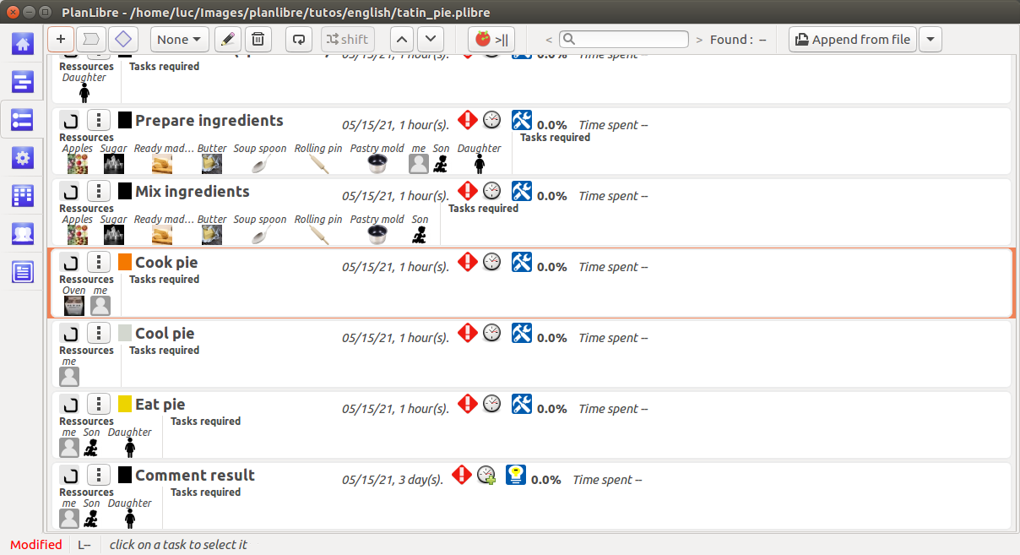

5. Hey doc, there’is something wrong on the timeline !
Please, switch to timeline view. You should see something like that :
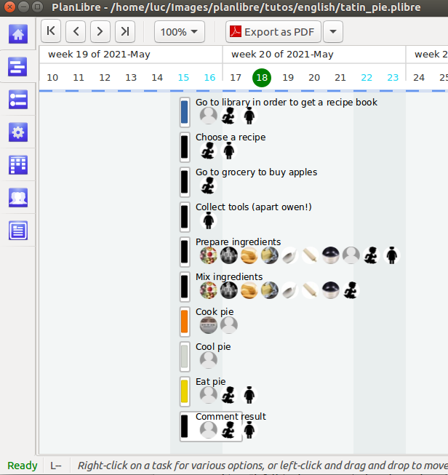
Gasp ! All tasks seems to be aligned on the same day ! We have to work better. As you can remind, «the « Go to the library » task is defined 3 days before other tasks. Then, we have to change project starting date, and, after, move this task along the timeline.
Let’s go !
- first, go to menu project>poperties. Then, change the starting date in order your project starts 3-4 days before. This step will change project’s boundaries, and it’s a very useful skill for many projects !
Click on starting date button, a calendar dialog appears :
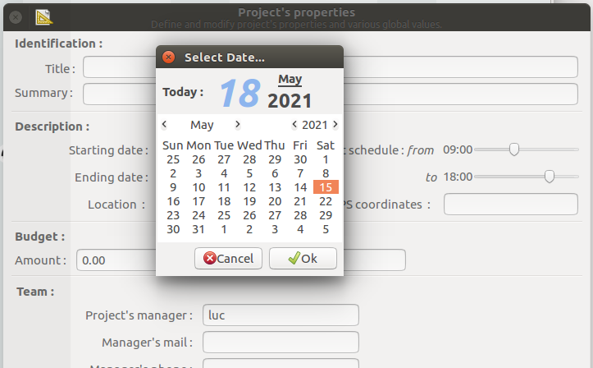

choose a new date, click [Ok] → the calendars disappears ; then click [ok] button for properties dialog.

- Now, we will change the starting date of the « Go to the Library … « task. I will teach you the two ways ; first way, by modifying task, second way by moving directly on timeline. Choose as you want !
- if you want to use the dialog way (#1), switch to task view, and click on modification button for the task « Go to the library ... ». On the dialog, change the starting date, and click [Ok] button.
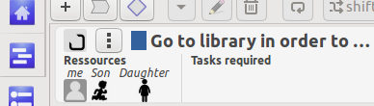
- if you want to use only the mouse, switch to « timeline view ». Move mouse pointer to the task « Go to library ». Left click, and withour releasing left button, move the pointer to the left : you can see a colored rectangle, as a shadow of the task. Once you’ve reached the true starting day, release left button. It’s done !
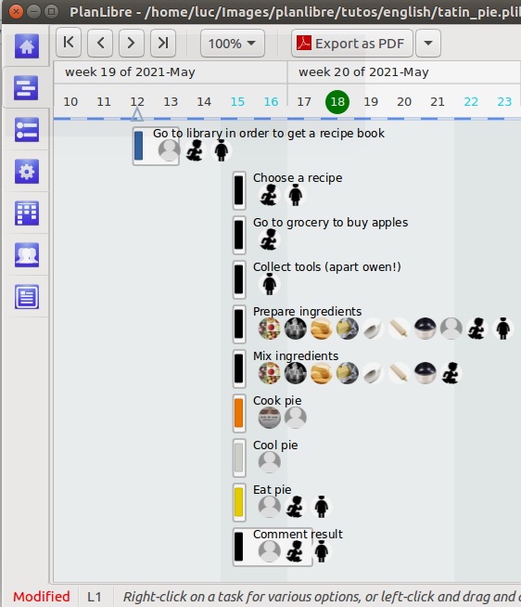
And, of course, if you switch to « task view » and click on « modify » button of this task, you can check that the starting date is automatically updated.

