Project : the break-in of the century

Here, a bit of history : in year 1976, in Nice city, France, audacious burglars perpetrated one of the most famous break-in ever made, they drilled a tunnel, and used the sewers. So, this break-in is nicknamed : “paradise’s sewers” ( more than 24 millions of euros in current money).
I propose you to see this break-in as an example of planned project.

With this tutorial, you will learn to :
- define complex tasks with predecessors and successors (linked tasks)
- set-up a “true” historical project in the past
- define milestones
- define deadline and due dates
- group tasks
- add pictures for resources, project and tasks.
- clone a resource
- produce a report


The team

Albert Spaggiari, commando’s leader. Spaggiari, retired soldier and right-wing activist, recruited two “sub teams” ; the first team with only gangsters, the second team with only friends of him. The first team was nicknamed by its origin, “les marseillais” (they are gangsters from Marseille city).
SubTeam #1 : 6 members, Pierre, Joseph “the elder”, Jean “Gold mouth”, Mathieu, Saint-Jacques “the weasel”, Thomas “the ladykiller”.
 |  | 
 |  | 
Images are under Creative commons licence

SubTeam #2 ; “68”, Gégé, Carlos, Rico, Nick, Biki, Mireille (the only woman).

   | 
 |  | 

Images are under Creative commons licence

The two teams merged rapidly, because they became rapidly all confident for themselves.

The tools :
Radio scanners, tools for drilling, and so on.

The goal :
break-in the Société Générale Bank at Nice City.

The dates :
early month of 1974 to summer 1976

Let’s go !

1. Prepare PlanLibre project
Collect various free (libre) pictures on the Internet for the teams, the tools, jewelry and so on. Store them on your hard-disk.
Choose menu project>properties.
Fill fields with those values :
starting date : 1st january 1974
ending date : 31 december 1976
Project manager : YOU or Albert Spaggiari
Project summary : break-in the Société Général Bank at Nice city.
Add a picture for organization logo.
The “properties” dialog should look like this :
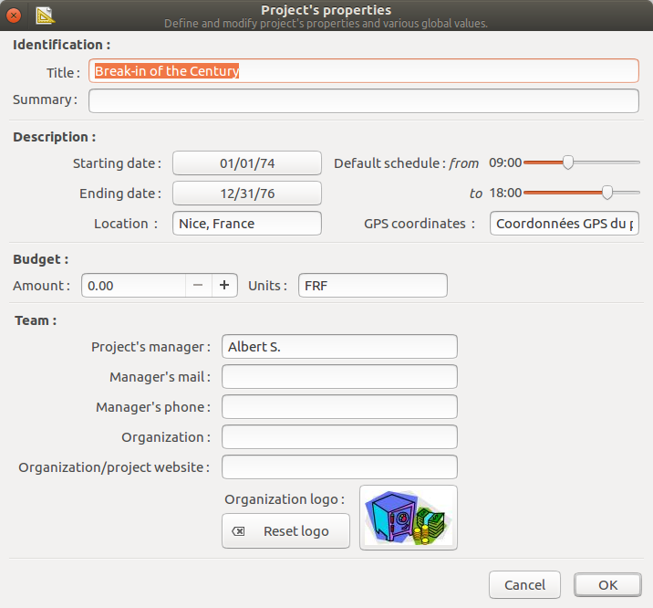
There isn’t any calendar constraint, gangsters are supposed to work every days !
Save your project. Quit PlanLibre, and reload the project file : PlanLibre move automatically the timeline view to the year 1974.
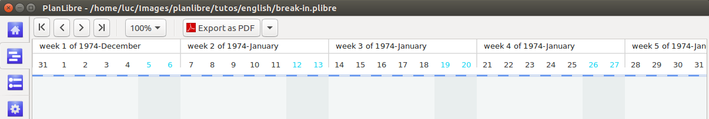
Now, we add teams #1, #2 and Albert Spagiarri as resources for our project. I remind you how to proceed : switch to “resources” view, and click the [+] button in order to add a new resource. You can modify an existing resource by clicking on the editing button [ | ]for each resource.

Add resource button | Modify resource button
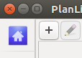 | 

here is how I fill the dialog fields for the team leader :
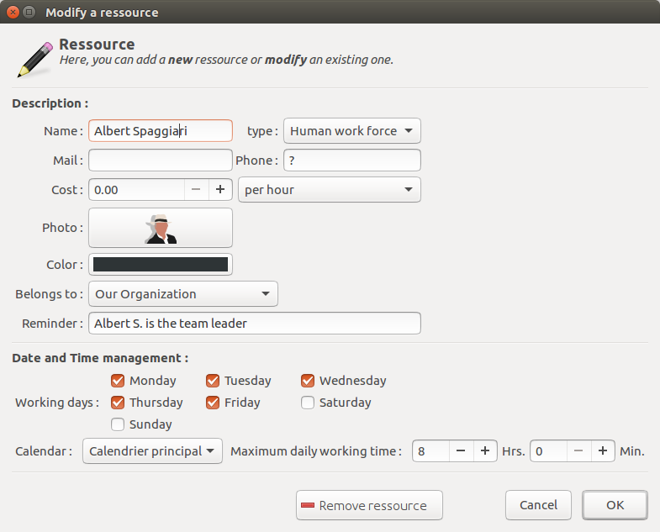
Proceed for all other men an woman.

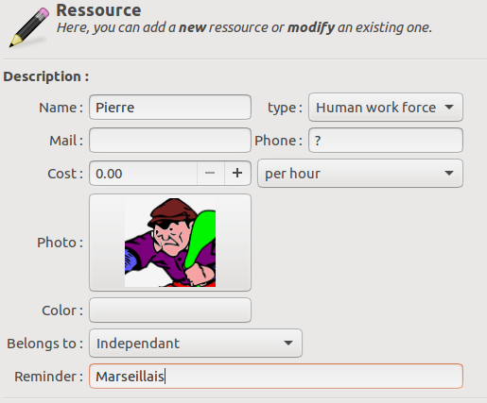
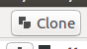
I used a color code : yellow for team #1, blue for team #2.
Tip : you can gain some time by using “clone” button : select a resource, click on {clone] button, then edit/modify the clone, only for few elements.

Once done, the resource view should look like this :
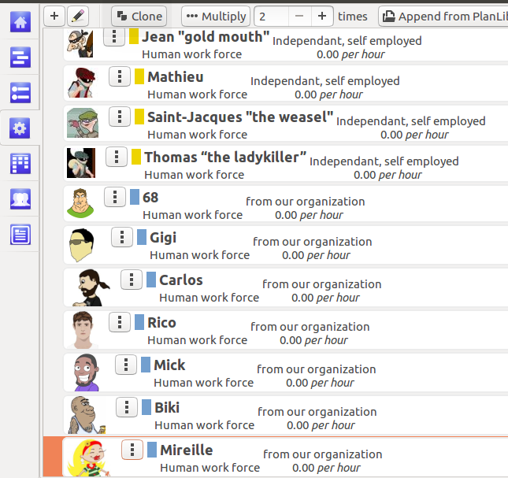
Now, it’s time to add material resources : here is a simplified list of resources, I let you to add them to project’s resources list. We don’t care about costs, since this tutorial isn’t aimed to learn you to compute monetary costs with PlanLibre.
Name
Radio scanner, Drilling machine, Mace , Hammer, Blowtorch , Shovel , Pick , Ropes , Bags

Now, it’s time to learn task placement and group definitions. Let’s go !

2. Plan tasks and define groups of tasks
Here we have to think a bit : a break-in supposes many tasks, but, really, those tasks are gathered by main categories :
- preparation tasks
- deployment tasks
- digging tasks
- execution tasks
- terminating tasks.

Thus, we have defined 5 “groups” for this step. Please, switch to “tasks” view. Like for resources, click on [+] button to add a new task, and once done, you can modify an existing task by clicking on its edit button. Please have a look on this 3 buttons, from left to right :
- add a new task
- add a group
- add a milestone

Please, look at this table :
Groups of tasks | tasks | Duration  (* means supposed) | When ? | Who, how ?
Preparation tasks
 | Get informations from a banker | 1 day* | 1 January 1974 | Albert Spaggiari
 | Rent a strong box in the bank | 1 day* | February 1974 | Albert Spaggiari
 | hang out with employees of the bank in order to get more informations | 12 month* | Feb 1974, june 1976 | Albert Spaggiari
 | Assess walls’ thickness | 1 week* | March 1974 | Albert Spaggiari
 | Draw an approximate plan of the bank | 1 week* | March 1974 | Albert Spaggiari
Recruiting
 | Talks with Marseille’s gang Zampa | 1 week* | March 1974 | Albert Spaggiari
 | Recruiting team #1 | 1 month* | March 1974 | Albert Spaggiari
 | Recruiting team #2 | 1 week* | March 1974 | Albert Spaggiari
 | Agreement on booty sharing with Zampas | 1 day | 7 april 1974 | Albert Spaggiari, Pierre
 | Milestone #1
Deployment
 | Steal material and tools due to lack of money | 4 months* | April 1974-october 1974 | Albert Spaggiari,, members of team #1 and team #2
 | Rent an appartment as a base camp | 24 months | April 1974-july 1976 | Albert Spaggiari,
 | Spotting sewers | 1 day | 8 april 1974 | Albert Spaggiari,, Pierre, 68, Joseph
 | Gathering materials | 3 months* | 9 april 1974>10 july 1974 | Members of team #1
 | Drawing a map of sewers and loojking for an access to the bank | 1 month* | 9 april 1974>10 may 1974 | Albert Spaggiari,
 | Milestone #2
Digging
 | First descent in sewers | 1 night | 7 may 1976 | Whole team
 | dig a 8 meters tunnel to the bank | 2 months | 8 may 1976>*8 july 1976 | Whole team
Execution tasks
 | Open strongboxes, get jewelry | 3 nights | 16 july 1976>19 july 1976 | Whole team
 | Milestone #3
Terminating tasks
 | Booty sharing | 1 day | 20 july 1976* | Albert Spaggiari and team #1
 | Escape from France to USA | 3 days | 28 july 1976* | Albert Spaggiari,
 | Arrestation in USA | 1 day | 27 october 1976 | Albert Spaggiari,
 | Milestone #4 : end of game

Now, we have enter datas : switch to “tasks view”, and let’s go !
- first we create an empty group : click on “new group” button ; a dialog appears. Type all datas like me :
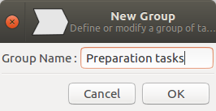

An here is the result :
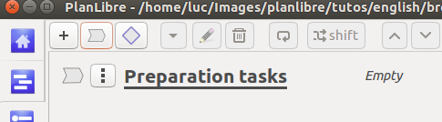
Please notice the “arrow” icon on the left side, and the fact that the group’s name is in bold and underlined.
Switch to “timeline view”, and notice how the group is displayed (the length of the arrow will adapt automatically) :
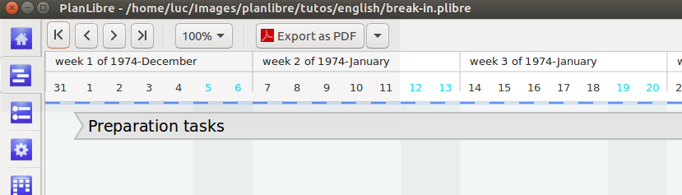
Switch again to “tasks view”, and now please add a new task, and enter datas like me :
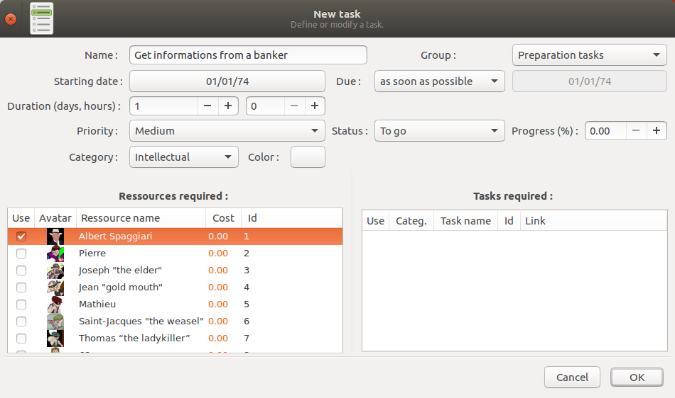
Don’t forget t select the group “preaparation” on the drop down menu, and, mostly, checj Albert Spaggiari as ressource. Click Ok, and see the result :
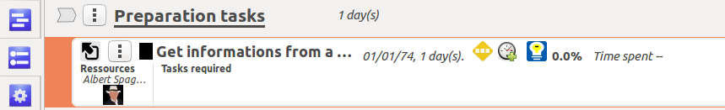
You can see something interesting :
- a small icon on the top left for this task, indicating that the task belongs to the group “Preparation tasks”.
- the task is shifted to the right, because it belongs to this group.
Please switch to “timeline view”, and see !
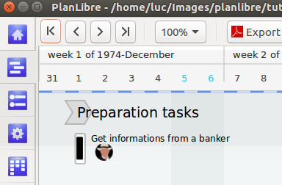
- the size of the arrow as reduced, because its length depends of the longest task linked to it.
- when we will add more tasks, the length of arrow will increase.
- the task starts 1st january and lasts 1 day, please see the length of the task’s rectangle.
- the task use the resource “Albert Spaggiari” as show the rounded icon

Switch again to “tasks view”.
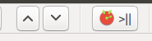
At this step, I’m confident, you can add all the remaining tasks belonging to “preparation group”. I wait you, but don’t try to add a milestone for now, please !
Tip : you can use up and down buttons to move up or down a task

You’re supposed to get something like that ;
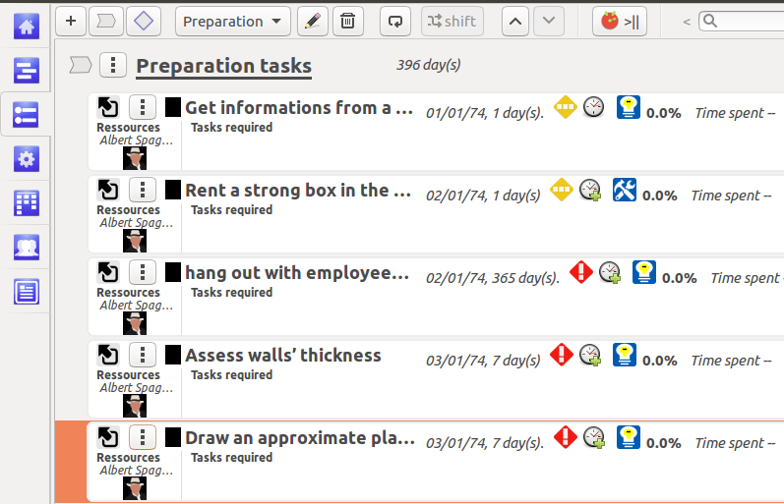
Now, it’s time to put a milestone. Click on milestone button. A dialog appears :
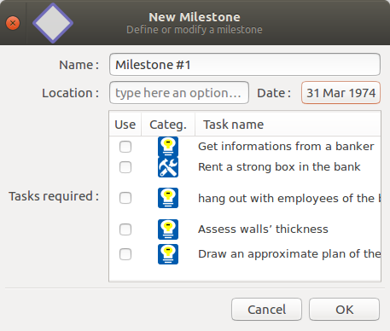
Enter datas like in this picture :
Please, dont’t check anything, I will explain you that later.
Then click Ok button, and the the changes, firstly in “tasks view” and secondly, in “timeline view”.

Tasks view :
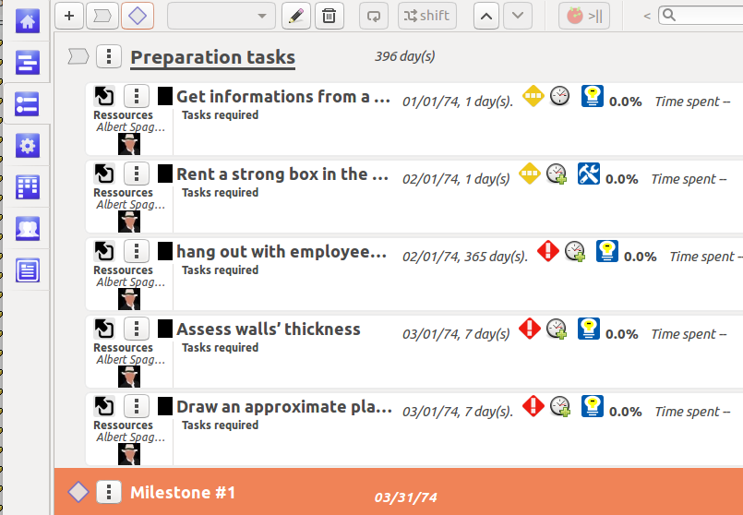
Timeline View :
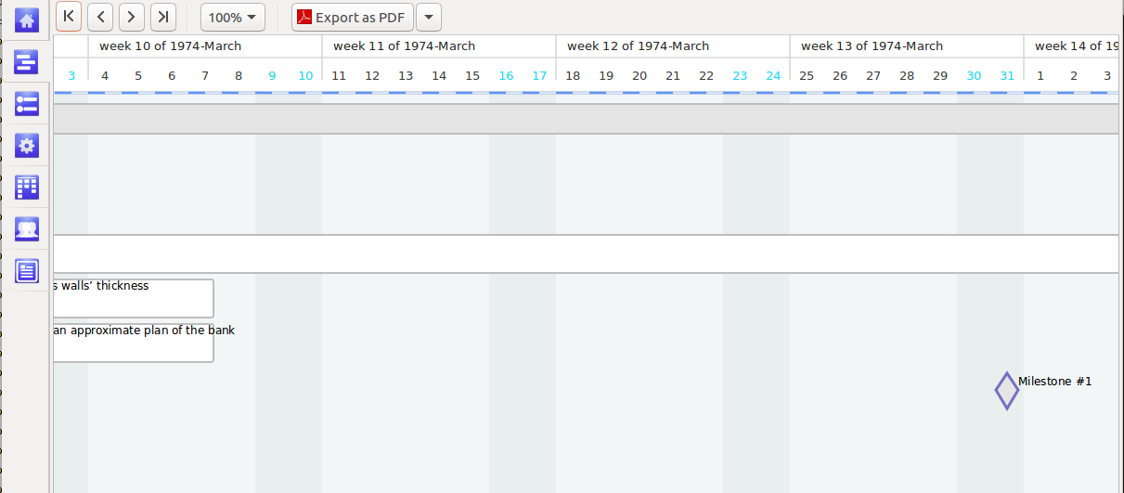
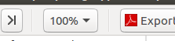
(please, use sliders to advance timeline to March 1974 ; you can also use “zooming” drop-down menu button on the top bar :

Now, it’s time to understand predecessors and sucessors of task ; for Albert Spaggiari, the task “draw an approximate plan of the bank” is a go/no-go case ; so, the milestone #1 requires that this task is finished. Thus, this task is an predecessor of the milestone #1. We will tell that to PlanLibre.
Switch to the “task view”, and click ont edit button for Milestone #1. In the dialog, check the task “draw an approximate plan”. Switch to “timeline view”, and see the change.
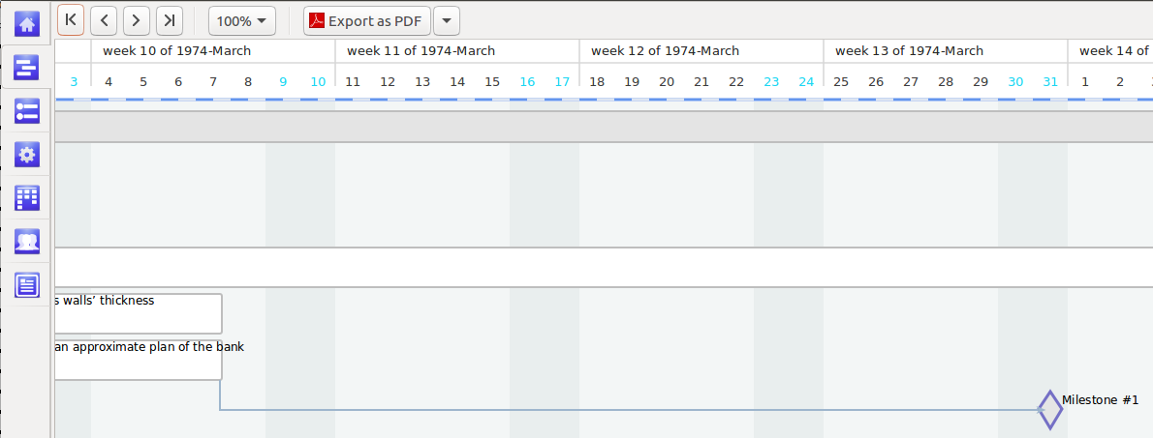
Useless for now, but this function (define predecessors or successors) is a key function in a planning application ; keep in mind how to set a link. In this tutorial, we wil not explore more, we will see the power of this function in another tutorial.
Tip : you can get edit directly from Timeline by right-click on a task, a group or a milestone.
Tip : when you link a milestone to a predecessor, you haven’t to compute a date ; PlanLibre adjusts milestone’s date.

Now, please, add all other tasks, groups and milestones ; don’t forget to “link” each milestone with its immediate ancestor.
Here is an example, a screenshot from the timeline :
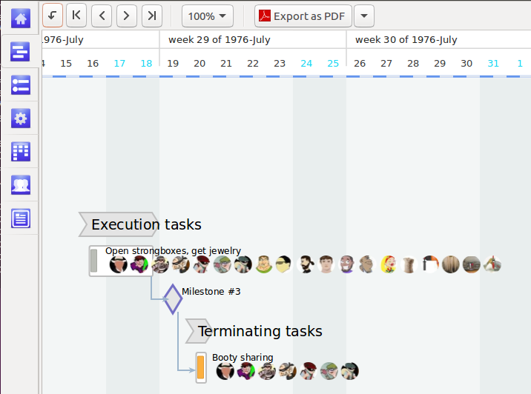
- we have 2 groups
- every task as its resources displayed
- we have a link between milestone #3 and two task : obviously, it’s impossible to share booty if we haven’t opened strongboxes !

3. Reporting functions
In this section, we will see to set-up a report and export the report to a word processor. Dont’ forget to achieve placement of all tasks (with their resources), groups and milestones.
Switch to the “report view”.

As a basic example, we want to know who, among team members, was more involved in project.
Please, switch to “report” view.
Choose menu Reports>Global activity analysis
We get a diagram : here is a screenshot :

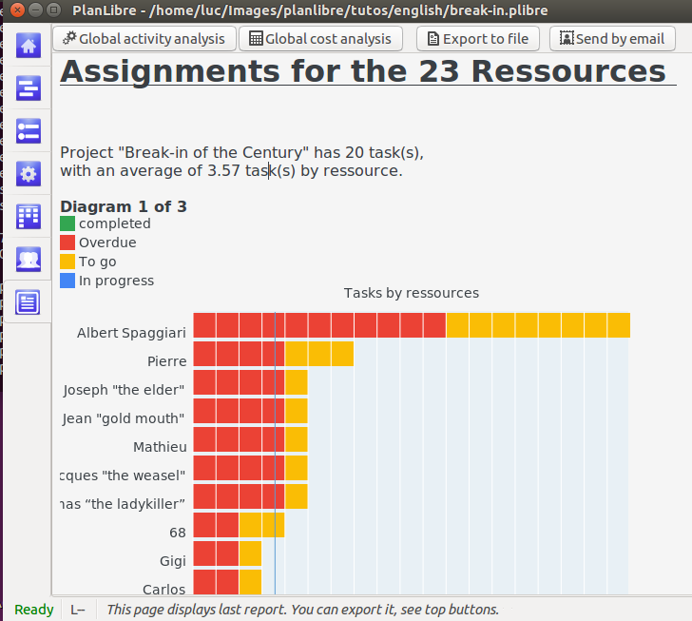
Nobody will be surprised that Albert Spaggiari was very involved in project !
PlanLibre has produced several diagrams, use sliders to discover the others.
Tip : you can type any text on this view, but, be careful ! You can’t undo any wrong operation in the report view !

Since we are happy with this report, we can export it or send it by email. For example, I’ve choosen a local file exportation (in RTF format, in order to be easily imported by a word processor).

Here is the report, once imported in LibreOffice :

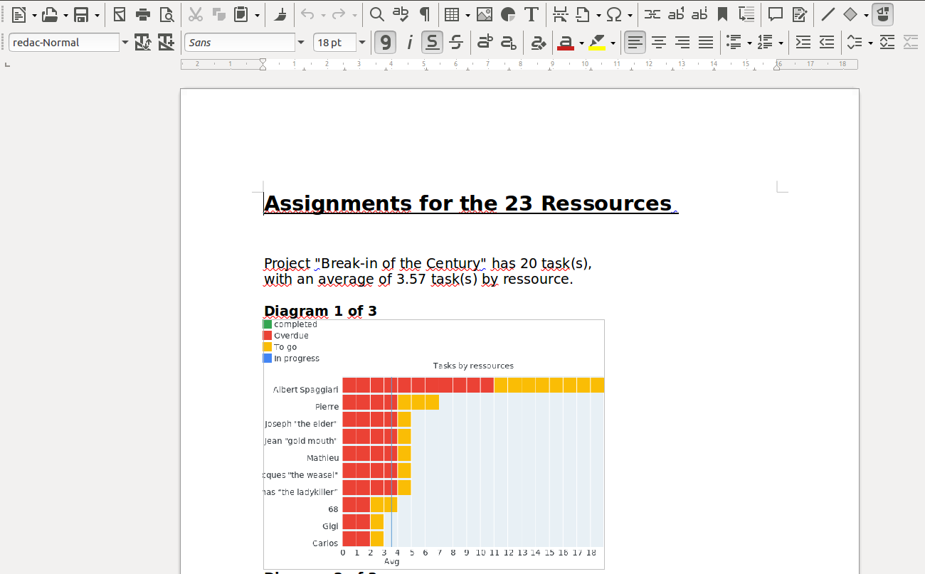

End of this tutorial

