Project : house construction

Now, the very classical project for every project’s software : the Work Breaking Structure based construction project.
This project is a very complete demonstration of PlanLibre capabilities.

Summary
In this tutorial, we will learn how to …
- define tasks with due dates
- learn to link tasks
- learn to manage type of due dates constraints.
- define resources
- define milestones with due dates
- manage groups of tasks like in a hierarchical tasks breakdown (aka as summarizing tasks)
- manage calendars

1. Project’s properties
For this project, we suppose that the project starts 26 june 2021. Feel free to choose another date. For now, the estimated duration is 9 months, so the ending date should be 24 december 2021.
tip : you can change later dates and time shift whole project if necessary.
have a look on other tutorials in order to fill project’s properties. Choose a title and fill all fields as you like. Here is a screenshot for me :
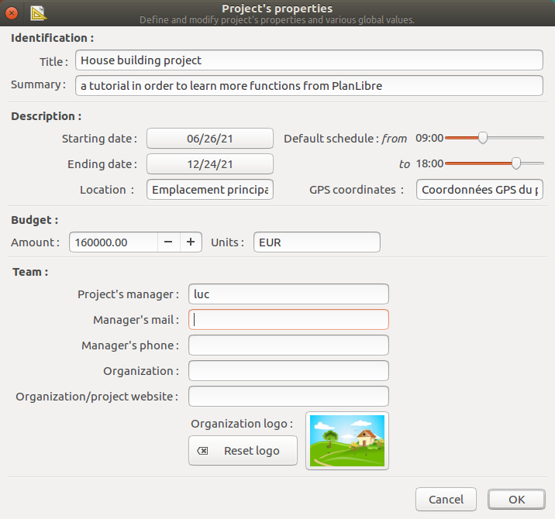

2. Define tasks
There is many tasks required to build a house. Let’s go to enter datas (I remind you : you have to switch to “tasks view “).
Don’t worry about dates, I will, very soon, show you how PlanLibre is able to compute dates automatically.

Number | Tasks | Duration
 | planning | 10 days
 | implantation by surveyor | 4 days
 | site preparation and brush clearing | 4 days
 | Excavation | 5 days
 | debris evacuation | 5 days
 | Earthworks | 10 days
 | Concrete | 15 days
 | Walls | 7 days
 | Floors | 5 days
 | Windows and exterior doors | 10 days
 | Roofing | 12 days
 | Heating system | 2 days
 | Electrical (meters …) | 3 days
 | Electrical wiring | 7 days
 | Exterior plaster | 6 days
 | Interior doors | 2 days
 | Plumbing | 20 days
 | Floors, carpet | 8 days
 | Access paths | 7 days
 | Grass and trees | 9 days
 | Site cleaning | 2 days
 | Works receipt by customers | 1 day

Reminder
Mouse
Click button | Action
 | new task
 | new group
 | new milestone
 | for selected task : edit/modify task
 | Move up or down current task/group/milestone
Keyboard | Action
Hit key or press simultaneously keys
[ f3 ] | New task
[CTRL]+[G] | New group
[CTRL]+[/] | New milestone
[ f2 ] | Edit/modify selected task
[CTRL]+[Z] | Undo

Here is a screenshot for the first task, planning ; as you can see, PlanLibre get project’s starting date as default starting date for the task.
Obviously, you can change it later !

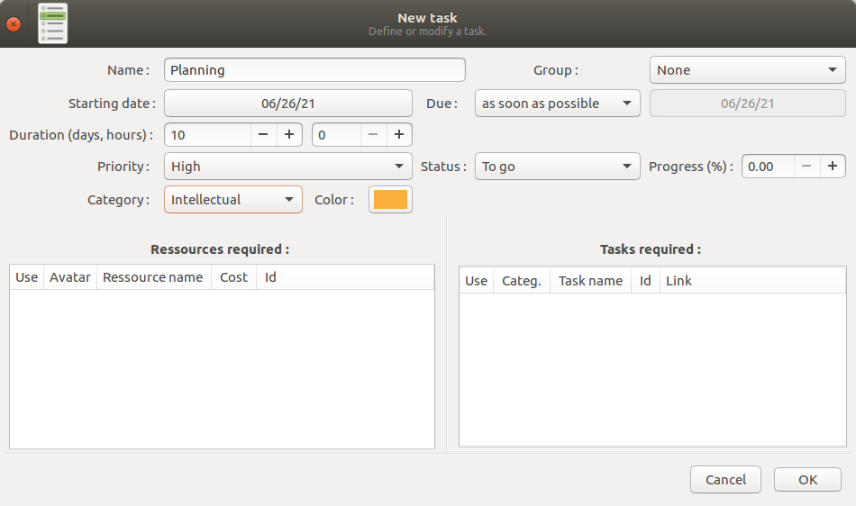
And, as usual, here is the timeline with this first task :

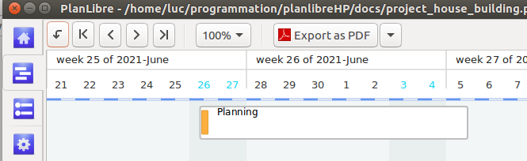
Do the same for all tasks listed in above table.
I hope that you’ve noticed that the starting date is a … saturday ! I will learn you to change it later, as an exercise.
At the end of this step, the timeline looks like that :
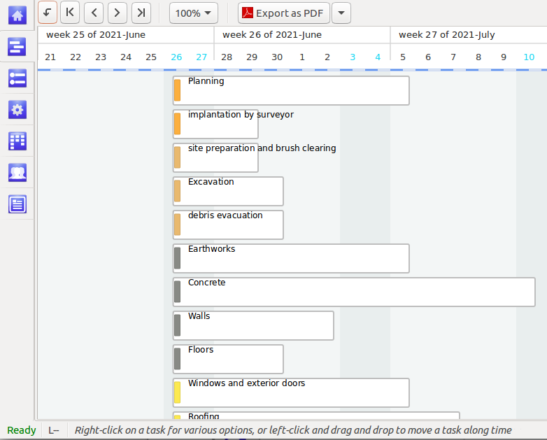

3. Define resources
It’s a very classic step, please see other tutorials in order to fill datas. Here is the resources table. Please, enter those datas in PlanLibre (switch to “ressources view ‘”).
And don’t forget to change the currency unit (see menu project>properties).
Tip : resources can have a rated cost or a fixed cost ; it’s smart to distinguish resources by a color code.

Use the drop down button menu on the right to choose between variable and fixed cost
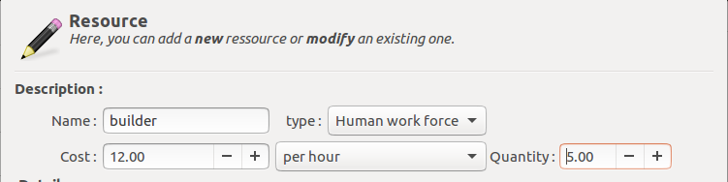
Tip : in PlanLibre, we see resources as families. For example, if we use builders, we haven’t to distinguish them by lastname (but we can do it, of course) ; we simply create a resource named ‘’builder’’ and type the number of builders in the field ‘’quantity’’. In above screenshot, our company uses 5 builders. So, we can use them on concurrent tasks at the same time.
Of course, you can conversely create 5 different builders in order to assign them accuratly on tasks.

Tip : PlanLibre allow by default resource assigning on concurrent tasks (e.g. same resource on two or more tasks at the same time)

Resources table (simplified)
Resource name | Belongs to | Units | variable | fixed | cost
Architect | Independant | 1 |  | x | 2000
Foreman | Our organization | 1 | x |  | 20 By hour
Heating engineer | Profit org. | 2 | x |  | 200 By day
Rooffer | Profit org. | 3 | x |  | 150 By day
Electrician | Profit org. | 3 | x |  | 175 By day
Surveyor | Independantt | 1 |  | x | 1200
Builder | Our org. | 6 | x |  | 15 By hour
Digger | Our. Org. | 5 | x |  | 13 by hour
Carpenter | Profit org. | 4 | x |  | 150 By day
Painter | Profit org. | 2 | x |  | 150 By day
Gardener | Profit org. | 2 | x |  | 150 By day
Plumber | Profit org. | 2 | x |  | 180 By day
Machine operator | Our Org. | 1 | x |  | 17 By hour
Concrete mixer | Profit org. (rent) | 1 |  | x | 400 By day
Crane | Profit org. (rent) | 1 |  | x | 700 By day
Backhoe | Profit org. (rent) | 1 |  | x | 700 By day
Concrete | Profit org. | 100 |  | x | 15 By unit → total fixed = 1500
Breeze blocks | Profit org. | 2000 |  | x | 5 By unit → total fixed = 10000
Tiles | Profit org. | 1000 |  | x | 7 By unit → total fixed = 7000
Windows | Profit org. | 10 |  | x | 150 By unit → total fixed = 1500
Doors | Profit org. | 10 |  | x | By unit → 200 total fixed = 2000
Boiler | Profit org. | 1 |  | x | By unit → 1500 total fixed = 1500

Reminder
Mouse
Click button | Action
 | new resource
 | Modify selected resource
Keyboard | Action
Hit key or press simultaneously keys
[ f3 ] | New resource
[ f2 ] | Edit/modify selected resource
[CTRL]+[Z] | Undo

For now, the user should compute himelf or herself the total cost for raw materials ; in other words, we consider that raw materials are fixed costs (once computed, of course), and please consider that there is only 1 (ONE) whole unit.

Tip : how to compute fixed total cost for raw material ;
formula :
unit cost * units used
example : doors → 200*10 = 2000
Here is an example for the ressource ‘’architect’’ :
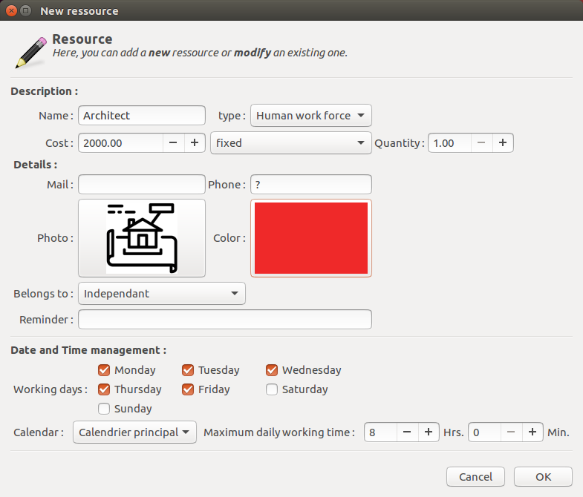
The result in ‘’resource view’’ :
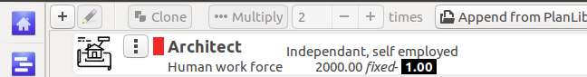
And when we’ve finsihed enter datas in ‘’ressource view’’ :

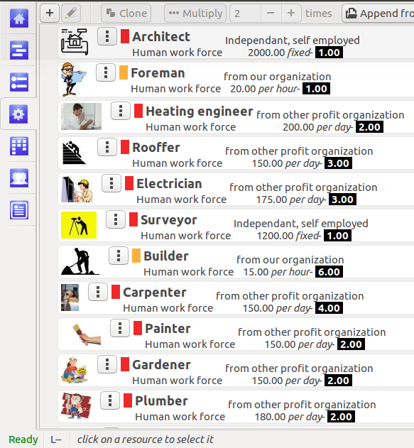

tip : don’t forhet to use different colors for yours resources : it’s better for report’s diagrams !

4. Understand groups of tasks : the other way to summarize tasks.
A famous application like MS Project® uses « summary tasks » as a way to gather tasks. PlanLibre uses a different approach : we use ‘’groups’’. A group has two faces :
- you can use it to visually seperate tasks, like a kind of bookmark.
- or you can link tasks to a group in order to manage more than one task at the same time. This second way if closer to summary tasks, but not identical.

Let’s go ! We will now explain how to set-up « groups ». Please, consider this table :

Number | Tasks | Group
 | planning | Preparation tasks
 | implantation by surveyor | Preparation tasks
 | site preparation and brush clearing | Preparation tasks
 | Excavation | Preparation tasks
 | debris evacuation | Preparation tasks
 | Earthworks | Preparation tasks
 | Concrete | Building tasks
 | Walls | Building tasks
 | Floors | Building tasks
 | Windows and exterior doors | Building tasks
 | Roofing | Building tasks
 | Heating system | Equipment tasks
 | Electrical (meters …) | Equipment tasks
 | Electrical wiring | Equipment tasks
 | Exterior plaster | Exterior decoration task
 | Interior doors | Interior tasks
 | Plumbing | Interior tasks
 | Floors, carpet | Interior tasks
 | Access paths | Finishing tasks
 | Grass and trees | Finishing tasks
 | Site cleaning | Finishing tasks
 | Works receipt by customers | Finishing tasks

Here is a step-by-step explanation : we will set-up the first group ‘’preparation tasks’’ :
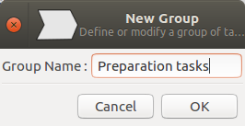
- move cursor to first task of this group : ‘’planning’’.

- click on [new group] button.

A new dialog appears ; simply type the group name, and click [Ok] button.

- notice the change on task view :

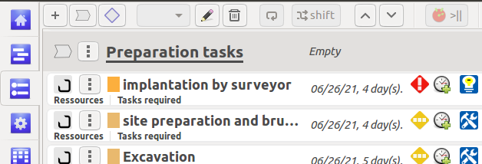
A group has been created. But, none of the preparation tasks are really linked to the group (please, have a look to the opn O icon on left side of each tasks)

tip : if the group is misplaced, select it by clicking, then use up and down buttons near [shift] button.

- now, for each task belonging to « preparation » group, click on edit button, and see on the right side of the dialog window :
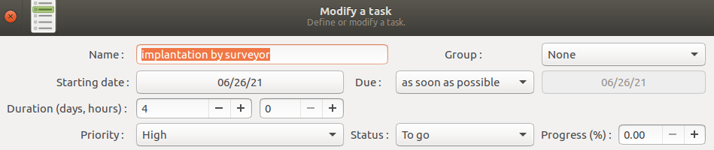
Click on drop-down button near « group » and choose « preparation tasks », then click on [Ok] button.
Notice the change on tasks view display :

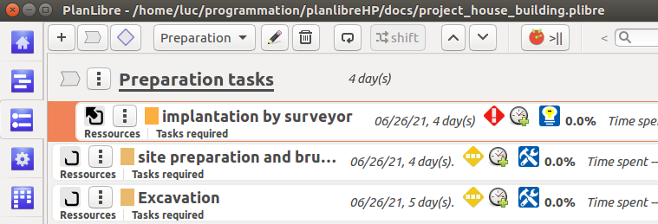
Now, the icon on the left side has changed ! The tasks « implantation by surveyor » is linked to group « preparation tasks » ; do the same for all tasks and groupe, according to the above table.
Here is an example with two groups
- on tasks view :
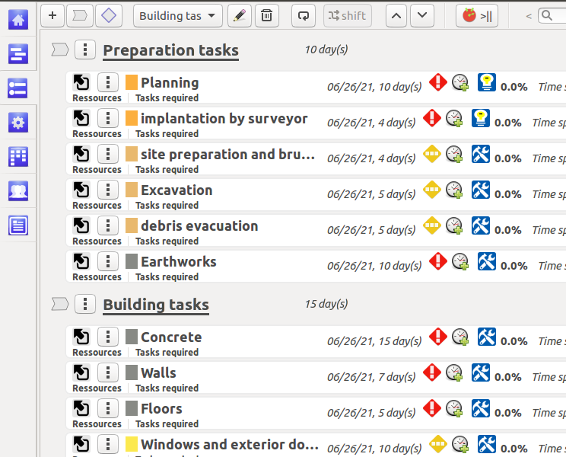
- on timeline view :
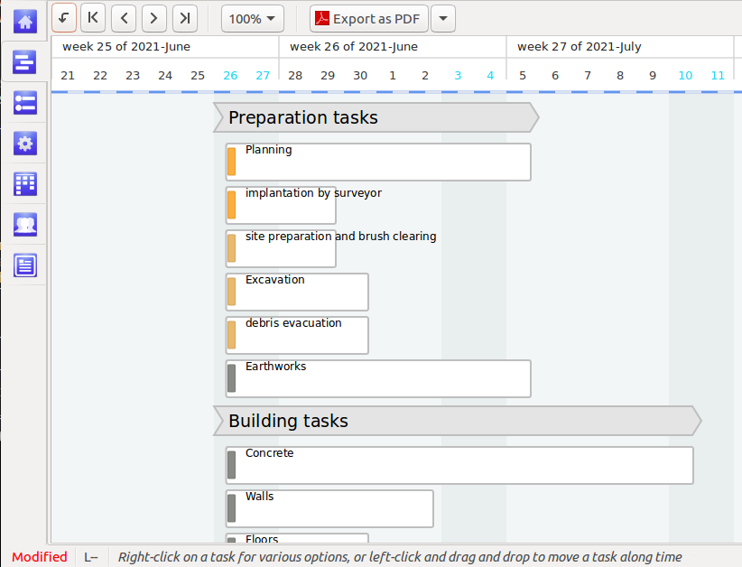
tip : every time PlanLibre adds a task to a group, the total duration for whole group is computed and updated.
Don’t forget to save your work once finished tasks

5. Define Project’s calendars
Now, it’s time to learn more complex skills ! As other planning softwares, PlanLibre is able to manage various schedulings and links between tasks.
As you remind, I hope, I’ve warned you that our projetc’s started a saturday. So, we have various issues :
a- changing whole project‘s dates
b- define calendars for whole project and some resources.

Let’s go.
First, we will change dates for whole project ; this operation is named ‘’date shift’’. It’s very easy :
Choose menu project>global dates shift
A new dialog appears ; change staritng date to Mon june 28, 2021 :
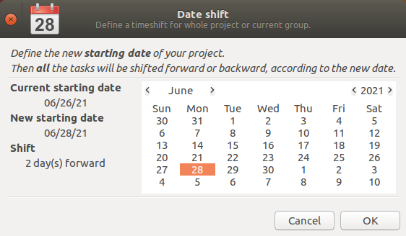
And then click [Ok] button ; you can switch to ‘’timeline view’’ to see the change.

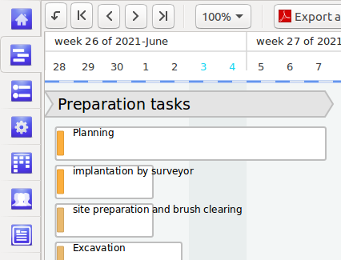
Now, we will learn to manage a less easy part, the calendars : with PlanLibre, calendar’s management is made at resource level. Indeed, it seems more natural, because it’s the resource availability which really define tasks accomplishments !
By default, there is a default calendar for whole project. This default calendar has a priority on any resource’s calendar. For example, if you defined in default calendar that the project is paused the 1st of may, even if a worker can work the 1st may, PlanLibre will consider 1st may « non worked » for everyone. Conversely, if you defined 2nd of May as a working day, but a worker’s calendar defined a non-working day, then the 2nd of may is treaten as a non-working day for this resource (worker), and a working day for other resources. And, obviously, reports, cost computing and so on will be corrected according to all calendars !
As a first step, we will define non-working days for default calendar. Choose menu project>manage calendars and working hours. A dialog is displayed (a complex one!) :

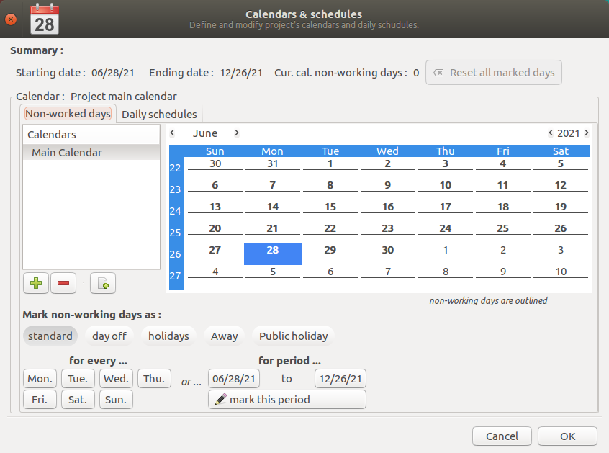
→ please notice that the notebook has two pages : first for calendars (non-worked days), second for daily schedules.
→ on calendars, you can essentialy define non-working days, but, in some cases, you can force a day as a worked day. For your convenience, it’s possible to distinguish between types of non-working days.
→ the main calendar («main calendar» in this screenshot) is the default for all tasks. But you can define other calndars, and, once defined, assign them to resources. In summary : default calendarr for tasks and resources, other calendars for one or more specific resources.
→ the daily schedules are part of each calendar : so, there is a default daily schedule associated with main calandard, and a specific daily schedule for all other calendars defined by user.

Let’s go to define several non-working days :
- all saturdays and sundays
- and for the fun, we assume that in a certain country, july 5 is non worked.
- click on button [standard]
- click on buttons [sat.] and [sun.].
here is the result :
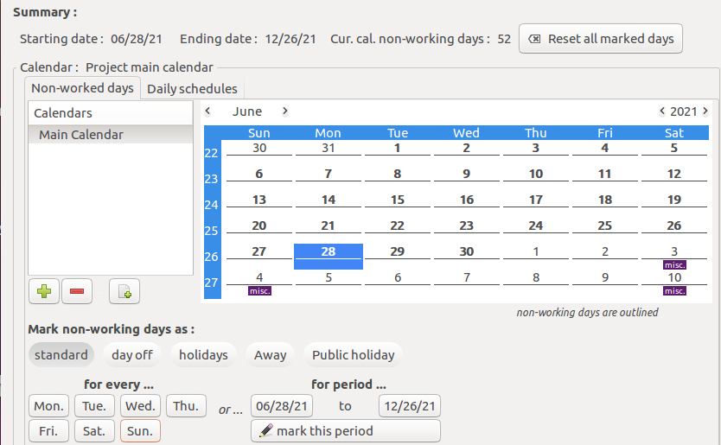
all saturdays and sundays belonging to project’s peeriod are now marked.
Change the month to July to check my assertion :
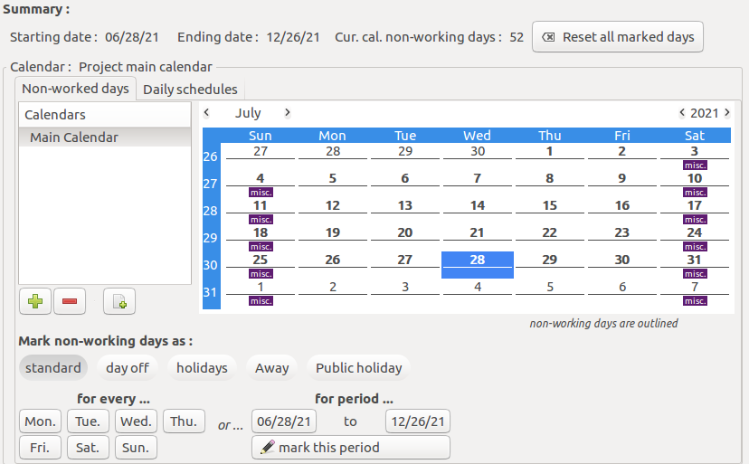
Now, stay on July, click on ‘’public holiday’ button, then double-click with your mouse on the 5th of july ; here is the result :
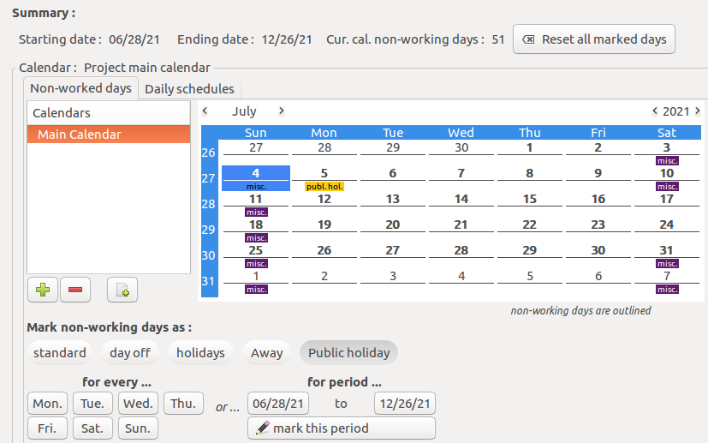
tip : in order to mark only ONE day, please select a button between ‘’types’’ on non-working days, then double-click on the day itself.
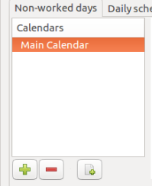
Now, for the fun, we will define a new calendar dedicated to builders only.
- click on third [] button on calendars area in order to add a new calendar based on default calendar.
- click on the arrow (triangle) in order to see the new calendar.
- double-click on the new calendar to define a new name for it.
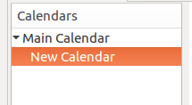
- I suggest to name it ‘builders calendar’.
- we suppose that our team of builders are on another building projects every mondays, so they aren’t available for our project. Thus, we ckick on [away] button, then on [Mon.] button. Here is the final result for this calendar :
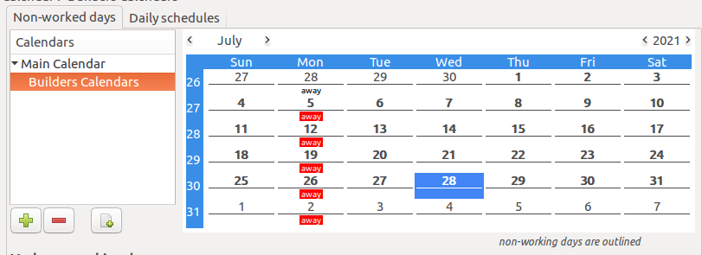

Now, switch to ‘’resources view’, and click to edit/modify builder resources. On the dialog box, choose « builders calendars » on the drop-down menu :

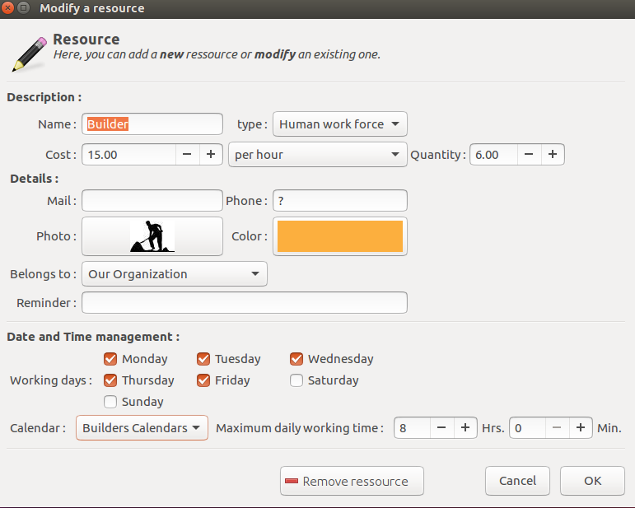
Tip : you can also define daily schedules. Buy, this tutorial is already complex, so we will learn daily schedules later.
You can also defin directly (non) working days for a resources without defining a new calendar, see above screenshot.
Don’t forget to save your work.

6. Schedule the project

6.1 Due dates in a project
Now, we will improve our skills : as you know, in real life, there is something to do with ‘’due dates’’. PlanLibre allows you tu use 4 ways to define ‘’due dates’’. Here is a table to summarize this idea :

Mode | Status | Remarks
As soon as possible | By default | No constraints, you are free to move the task along the timeline
Don’t end after | You choose this mode on drop-down button menu, and, then define the ending date | You can’t move the task after the deadline ; this deadline is computed by adding starting date+duration for the task.
Start no earlier than | Same, apart that you will define starting date | You can’t move the task before the starting date
Must start on | The task must start at the date choosen as starting date, exactly at this date | You can’t move the task, or you must change the starting date.  If this task has a predecessor, the predecessor can’t end after the starting date of this task.

tip : if you use a global date shift, of course all dates are updated.
Let’s go to learn more with an explanation for our building project

6.2 Links between tasks
Here, we will introduce two words : predecessor and successor. Suppose this task : ‘’building a wall’’ ; in order to achieve it, one task is required : dig foudations ; so, ‘’dig foundations’ is the ‘’predecessor’’. A very important point : ‘’dig foundations’ is mandatory ; so, if ‘’dig foundations’ is delayed, « build wall’’ will also be delayed, because ‘’buld wall’ is the sucessor.
PlanLibre has a mechnism to automatically adjuste tasks each other, and compute due dates when a task is a successor. Those computations are dependant of due date types you have defined, see previous paragraph. For example, if you’ve fixed a ‘don’ end after’ deadline, the task risks not be able to be delayed.

PlanLibre, for now, can only manage one type of link between tasks, known as « end to start ». In this case, a task with one or more predecessor can’t start before all its predecessor are completed.

Nb. : undo with linked tasks
You can, of course, undo links between tasks ; but notice that the undo menu shows « undo modify tasks » and not « unlink tasks ». Same thing when you linka a milestone.

Nb. : automatic removing of links in case of an error
PlanLibre automatically check that a link if compliant with tasks using a due mode different from « as soon as possible ». In the case of a predecessor ends too late for a task, the link is automatically removed. You are supposed to modify yourself the dus dates if necessary in order to set-up a valid link.

Now, you can set-up links for various tasks in our bulding project. Please, consider this new table :

Number | Tasks | Depends of task #
 | planning | -
 | implantation by surveyor | 1
 | site preparation and brush clearing | 2
 | Excavation | 3
 | debris evacuation | 4
 | Earthworks | 5
 | Concrete | 6
 | Walls | 7
 | Floors | 8
 | Windows and exterior doors | 8
 | Roofing | 8
 | Heating system | 9
 | Electrical (meters …) | 8
 | Electrical wiring | 8
 | Exterior plaster | 8
 | Interior doors | 8
 | Plumbing | 12
 | Floors, carpet | 16
 | Access paths | 8
 | Grass and trees | 15, 19
 | Site cleaning | 20
 | Works receipt by customers | 21

Please, select task #2, an click modify button, or hit [f2] key. On the dialog, see the right side, and like me, check on the « tasks required field », « planning ».
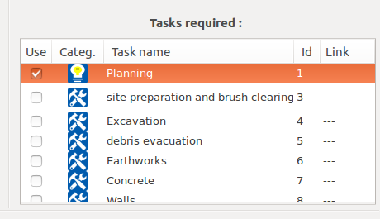
Then click OK. Notice the change on ‘’tasks view’’ :
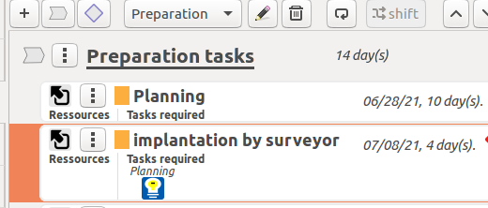

And now switch to ‘’timeline view’’ and notice also the change :
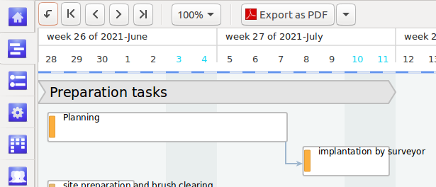
Now, a small line terminated by an arrow show the link between the two tasks.

tip : PlanLibre has automatically updated starting date for the taks ‘’implantation by surveillor’’, because this task is successor of ‘’planning’’.
You can stay on ‘’timeline view’’ : right-click on task ‘’site preparation …’’ and choose ‘’modify’’. Now, link this task with its predecessor ‘’implantation by surveyor’’. Here is the result in timeline, you can again notice the date updating (for tasks and group of tasks)
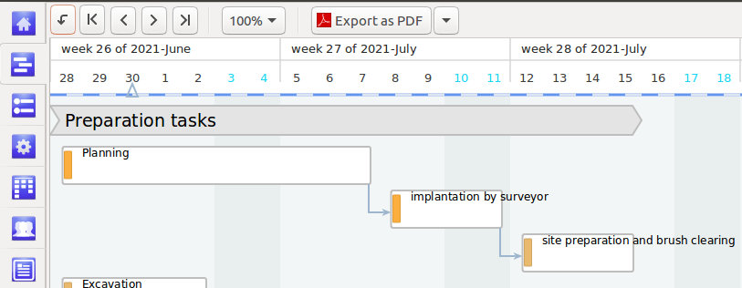
tip : the width of tasks on timeline view depends of dialy scheduling

Proceed for all other links. Please notice the display when two tasks have the predecessor or when a task has two or more predecessors.
Exemple : same predecessor for 3 tasks :
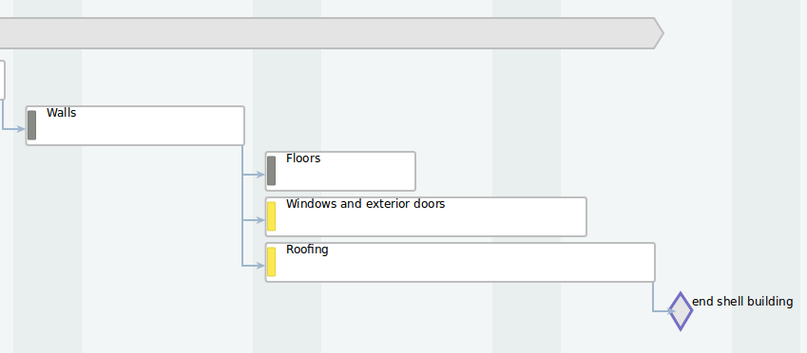
And now complte project (ending part) ; see multiple links, auto-updating for dates, groups of tasks, milestone.
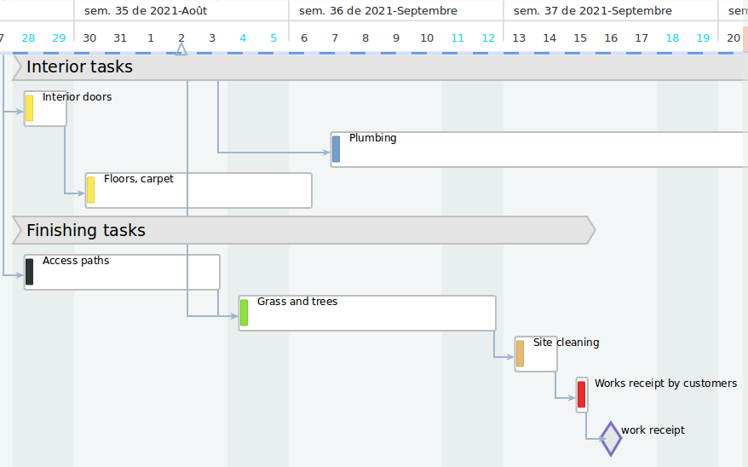

6.3 Milestones
Now, we will improve our project by adding milestones. With PlanLibre, Milestone is a ‘’key moment’’ in your project. Contray Ms Project ®, Milestone aren’t tasks with a zero day duration. They are a ‘’diffrent specie’’.
We have to add those miletones :
contract signature ; before task #1, task #1 should b linked to this milestone

‘’end shell building’’ after task #11 ‘’roofing’’, miletone linked to task #11.

work receipt : after the last task, this milestone should be linked to the last task.

How to :
- switch to ‘’tasks view’’.
- for the first miletone, select the first task (‘’plannin’’). Click on ‘’new milestone button’.
- a new dialog appears, fill it like me :
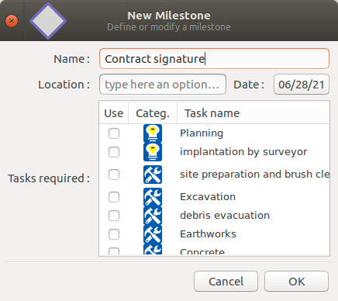
- the milestone is misplaced, please use button ‘up’ to place the milestone before task ‘’planning’’.
- here is the result in ‘’tasks view’’ :
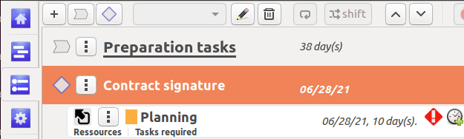
- now edit/modify the task « pllaning », and add a link with the milestone. Switch to ‘’timeline view’’, and notice the change :
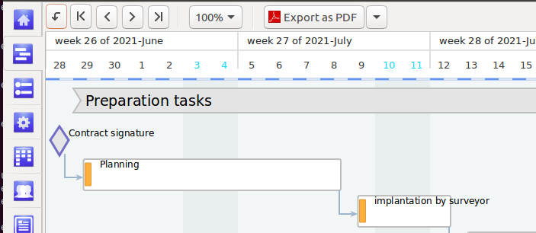
tip : you are free to change the date for this milestone, because you’ve probably noticed that the milestone consumes one day and then other tasks dates are updated.
Proceed for all other miletones.

7. Resources assignments

7.1 enter datas
Now, our tasks are defined : it’s time to assign resources to them. We have defined our resources at step 3.
How to assign resources ? It’s very easy. Simply, edit/modify a task. You will see the usual dialog. You have only to choose resources used by the task on the left side list.
Let’s go !
Here is a table below with tasks and necessary resources : your job is to assign resources to tasks.

Tip : PlanLibre allow you, by default, to concurrent usage of resources ; but, when you assign same resource on at least 2 tasks on the same time, you will be warned by PlanLibre.

Here is an example for task ‘’windows and interior doors’’ :
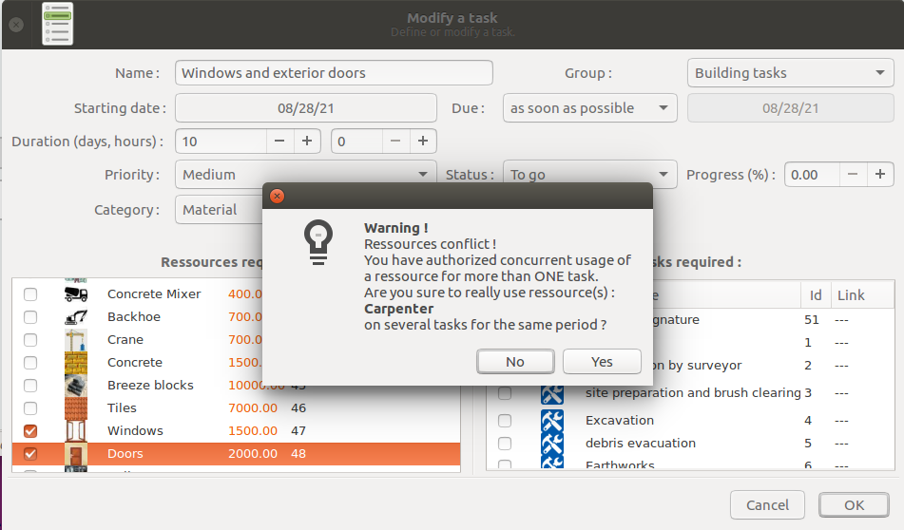

Tip : see below how to check which resources are overloaded

Number | Tasks | Ressources (human work force) | Resources (non human)
 | planning | Architect
 | implantation by surveyor | Surveyor, foreman
 | site preparation and brush clearing | Foreman, diggers, machine operator | Backhoe
 | Excavation | Foreman, diggers, machine operator | Backhoe
 | debris evacuation | Machine operator | Backhoe
 | Earthworks | Foreman, diggers, machine operator | Backhoe
 | Concrete | Foreman, diggers | Concrete mixer, concrete
 | Walls | Foreman, builders | Concrete, crane, breeze blocks
 | Floors | Carpenters
 | Windows and exterior doors | Carpenters | Doors, windows
 | Roofing | Foreman, roofers | Crane, tiles
 | Heating system | Heating engineer | Boiler
 | Electrical (meters …) | Electricians
 | Electrical wiring | Electricians
 | Exterior plaster | Painters, foreman
 | Interior doors | Carpenters
 | Plumbing | Plumber
 | Floors, carpet | Carpenters
 | Access paths | Diggers
 | Grass and trees | Gardener
 | Site cleaning | Diggers, foreman, gardener
 | Works receipt by customers | Foreman

Swicth to ‘’timeline view’’ (but you can prefer to stay on ‘’tasks view’’). Choose a task, then right-click with your mouse, and choose modify in the pop-up menu.
Then, choose the required resources. Here is an example for the task ‘’site preparation’’ :
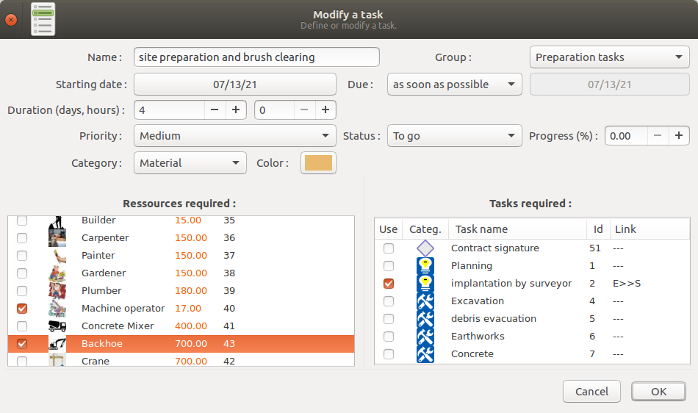
Once done, click [Ok] button, and, then notice the change on timeline view :
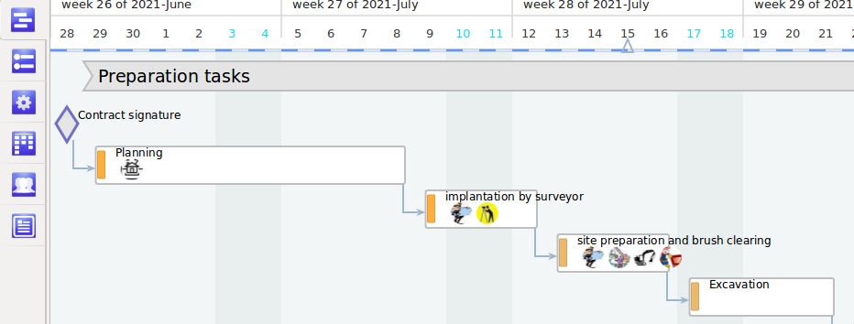
Proceed on the same way for other tasks.

7.2 check-up resources assignments and overloads
Now, it’s time to discover ‘’assignments view’’ and ‘’report view’’.
Please, slide view in order to see ‘’foreman’, and ‘september in calendar’’ :

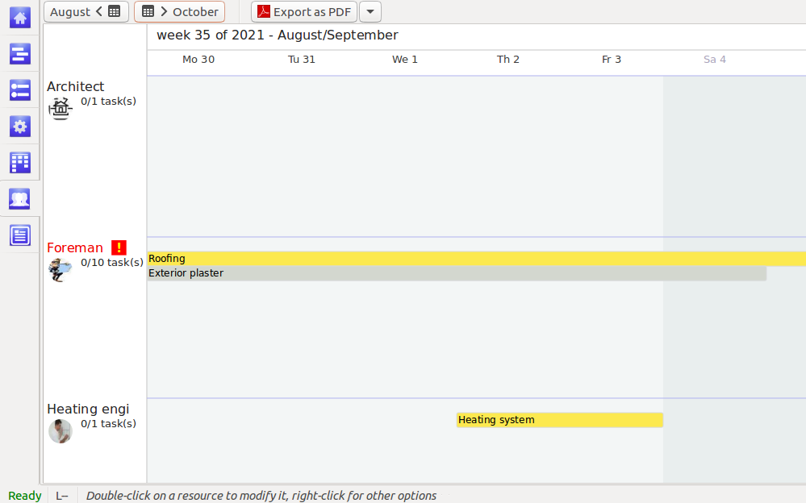
On my screenshot, you can see 3 resources ;
- architect, foreman and heating enginer.
Observe something : the sole resource written in red is foreman, because this resource is in overload in week 35 : we have assigned ‘foreman’ in same time to ‘roofing’ (yellow) and ‘external palster’ (grey).

Move your mouse pointer on ‘foreman’ (icon preferably), and right-click : a local menu appears.
Click on overload details ….
PlanLibre switches to ‘’report view’’, and we have a detailed explanation about overload :
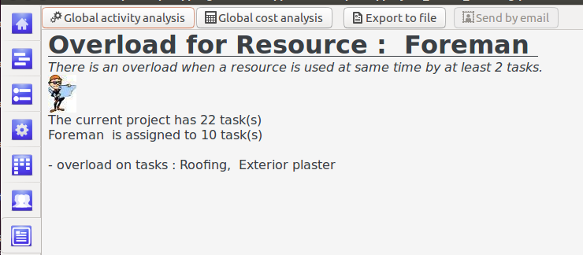
Now, you are free to modify ‘foreman’ assignments in order to remove overloads, or keep it as it, because in true life, management have to work on concurrent tasks, no ?

8. Project reporting
In this final step, we will learn to obtain reports. In both cases, report can be done for all project or only one resource.

8.1 Resources’ charge
In a first step, we want to analyse charge for resource ‘’foreman’’ ; please, switch view to ‘’assignments’’, like in screenshot below :

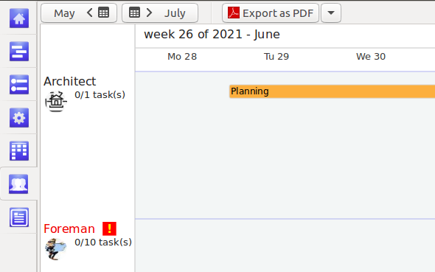
As we have already explained, resource ‘’forman’’ if overloaded, as the red writing color and the < !> symbol confirm. So, right-click on ‘’foreman’’ text or icon. On the dop-down menu, select resource charge. The view automatically switches to ‘’report’, and we get a new display :

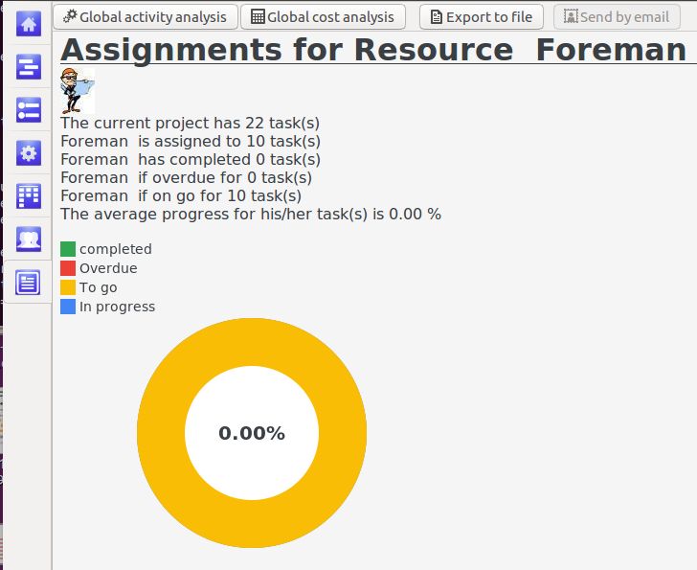
We get a detailed summary of this resource charge. The main percent 0.0 % value means that foreman hasn’t completed any task for now.
As usual you can export this report as RTF file in order to import it in your word processor.
For some novelty, here is the imported file in textmaker 2021 from Softmaker :
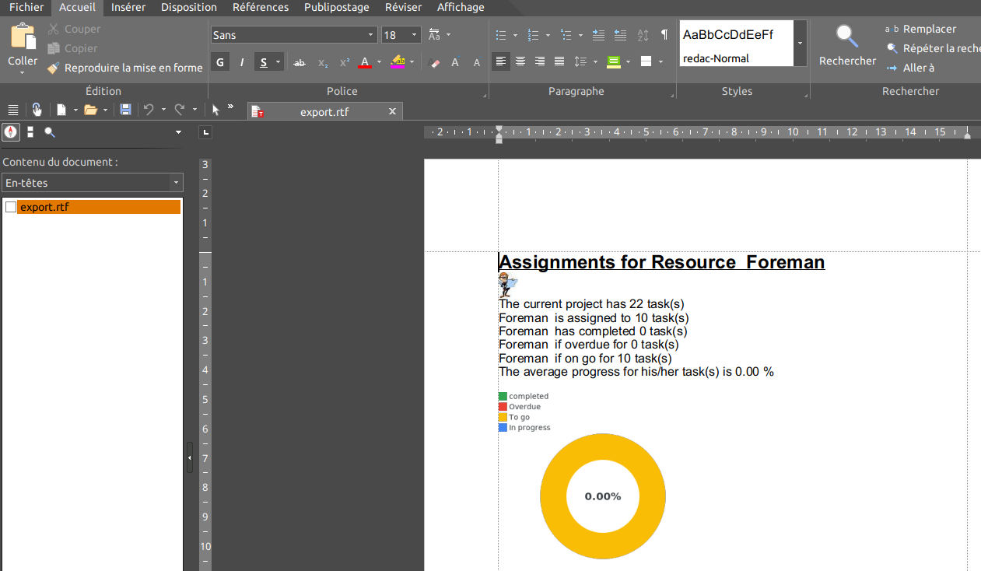
Now, you can easily to the same thing for all project’s resources ; in order to do that, you can stay on ‘’report view’’ and click [global activity analysis] button, or, simply, choose menu Reports>global activity analysis.
You get a new report with complete analysis :
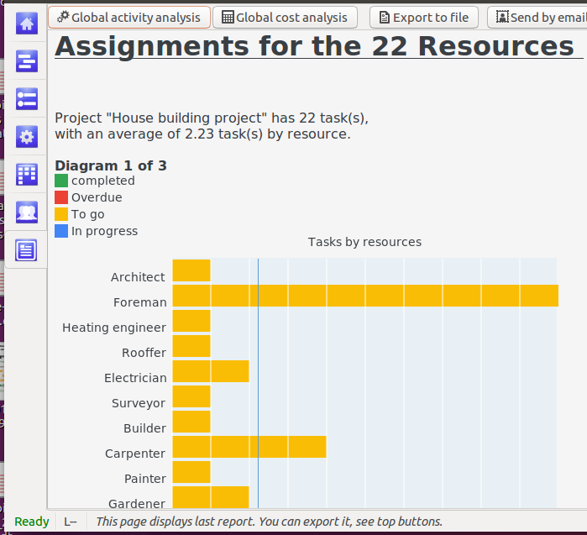
In case there is more than 10 resources, the report is divided in several diagrams.

8.2 Costs
As for resources, you can choose analysis for one resource (yes, resource) or for the whole project. The cost is computed in hours of work (corrected by calendars and their non-working days) an converted in money, known rate for each resource.
For one resource anlysis, switch on ‘’asignment’’ view, and right-click on the resource on the left side ; in the pop-up menu, choose resource costs. Here is the output for our foreman and his involvment in various tasks :

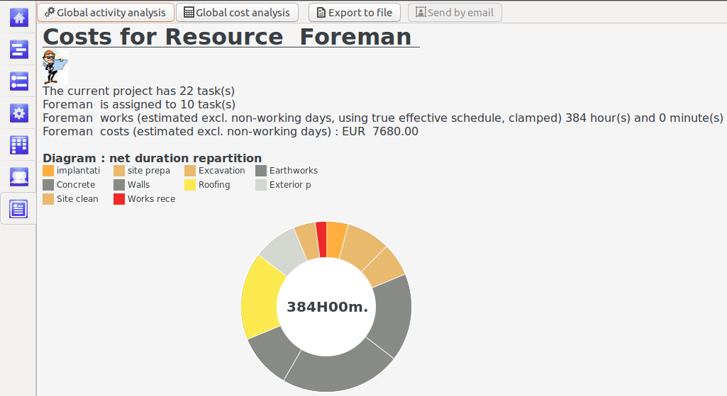
And, you can get a global cost analysis : I’ve choosen to use classical pie charts and an ‘’old school’’ diagram to explain the part of each resource on total cost (in hours) :
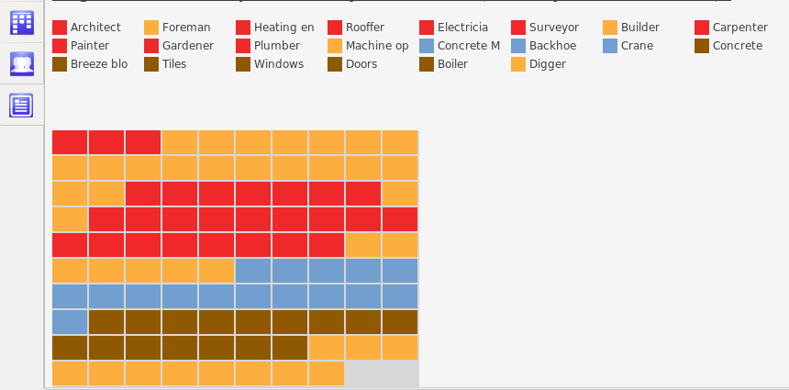
As usual you can export reports as RTF file to your word processor.

9. Reminder : mouse and keyboard

Don’t forget to read the base manual for PlanLibre. In this ‘’how to ‘’ we will remind you about main mouse and keyboard usage.

9.1 Keyboard
Choose menu help>keyboard shortcuts to get a dialog with all keyboards shortcuts.

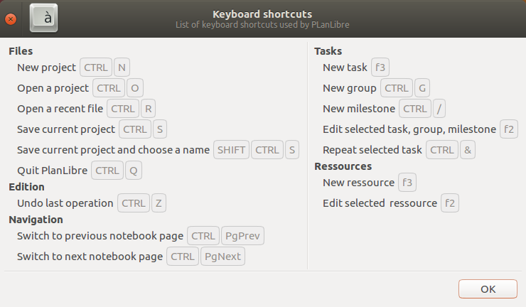
9.2 Mouse
Almost all elements are clickable.
Move your mouse pointer above an element (button for example) : in many case, an help window appears.

To select a line (Tasks View, resource View) : left-click ont it
To get a local menu (timeline view, assignment view) : right-click
To move an element between columns (Table view) : left-click and drag’n’drop it.
To move a task along the timeline (timeline view) : left-click and drag’n’drop (only horizontally, you CAN’T move up/down a task with the mouse).

