

PlanLibre
A simple planning application
v. 0.2.2

2021

© 2021 by Luc A.
Licence : CC-BY-SA

Table of contents
Introduction 7
1. About this manual 7
2. Linguistic and typographic conventions 8
3. PlanLibre presentation 9
4. PlanLibre user interface 10
5. Workflow with PlanLibre 11
Chapter 1 : about project management 13
1. Project management philosophy and its implementation under PlanLibre 13
2. Definitions 14
Chapter 2 : how to start easily with PlanLibre 19
1. Project properties 19
2. Calendars 21
3. Tasks 23
3.1 Introduction to tasks 23
3.2 Modifying of an existing task 25
3.3 Time constraints for tasks 25
3.4 Insert a task among existing tasks 27
3.5 Automatically repeat a task 27
4. Resources 29
4.1 Introduction 29
4.2 Set-up resources 30
4.3 Resource assignments 34
5 The timeline 38
5.1 Introduction 38
5.2 Modifying tasks from timeline view 40
6. Assignments view 41
6.1 Introduction 41
7. The table (Scrum® method) 43
Chapter 3 : go further with PlanLibre 45
1 More complex tasks 45
1.1 Linked tasks 45
1.2 Advanced use of milestones 49
2 Group of tasks 52
2.1 Presentation 52
2.2 Set-up a group and attach a task 54
2.3 Move groups 56
2.4 Change tasks attachments 56
3 Discover calendars 57
3.1 Presentation 57
3.2 Differences with other planning applications 58
3.3 The logic of calendars and daily schedules 58
3.4 The logic for daily schedules 60
4 Produce a report 60
4.1 Standard reports 60
4.2 Overload reports 62
Chapter 4 : communicate 65
1 Settings 65
2 Emails 66
2.1 Email service provider settings 66
2.2 The two ways to send emails 68
3 Agendas 72
Chapter 5 : some little extras 75
1 Import datas 75
1.1 Principles 75
1.2 Import resources 75
1.3 Import tasks from a spreadsheet 78
2 Export datas 78
2.1 Export task list to a spreadsheet 78
2.2 As a diagram/picture 80
3 Productivity timer 81
3.1 Tomato timer 81
3.2 How work the tomato timer ? 82
4 Retrieve a previous version of the project 83
5. Synchronization with Trello® 84
5.1 Principes 84
5.2 Settings 87
5.3 Export project to Trello® 88

Introduction

1. About this manual
This document is written as an help on PlanLibre usage. It isn’t a project management manual. By the way, PlanLibre is aimed to be used by small organizations. PlanLibre uses a mixed approach, project AND to do list.
This manual is written under Creative Commons CC-BY-SA : you are free (libre) to redistribute, translate and improve this document.
PlanLibre is built on various free libraries : I want to express my thanks to developpers, translators and any person involved in libre software development.
Screenshots are taken from an Ubuntu desktop. So, don’t be afraid if icons, colors and so on are different on your computer. I apologize in case of mixed english/french words in screenshot.
This manual, written in 2021, is up to date for PlanLibre 0.2.

2. Linguistic and typographic conventions
All along this manual, we us “menus” ; menus are typed with a fixed width font, and sub-menus folow an arrow : ->
Example :
File>Save means drop menu “file” and choose sub-menu “save”.
The user interface (GUI) uses various “buttons” ; you are supposed to click them. In this manual, “buttons” are presented on a yellow background, like this :
[ OK ]
Some buttons are fllowed by an arrow down-oriented ; this arrow have to be clicked to show a local menu. In this case, the manual is written like this :
Press button [Test] to show local menu Trials.
The « tips » are typed with a sans-serif font, on a light blue background.
Example :
This is a tip
Very important points are typed in italics, wuth a sans-serif font, using a withe color on a red background. Example :
Be careful, this point is very important !
PlanLibre uses keyboard shortcuts, i.e. one or two keys combinaisons By convention, keys are typed on a grey background. Example :
CTRL + S
Means : press simultaneously on CTRL and S keys.
There is special keys on PC keyboards ; for example, f1 means the first key of the superior row of a standard PC keyboard.

3. PlanLibre presentation
PlanLibre is a free (libre) project management software. It isn’t in any way a ‘’clone” of a well known proprietary software like Microsoft Planner ®. PlanLibre has been built after seeing that a complete professional software isn’t aimed for a small team requirements. For a small team, emphazis is on flexibility adn communication, all along the project. Those ideas have guided PlanLibre development
Even if we don’t want to copy a “model”, we have to exchange with another platforms : so, we choosen to use very useful simple text file formats, very easy to use when an user want to import/export his/her work. For those reasons, the native PlanLibre format is an XML text file. PlanLibre can exchange its datas by using of CSV format (Comma Separated Values, known by almots all spreadsheets in the world) and RTF format (Rich text Format, known also by almost all word processors).
PlanLibre uses several tools used in project management : Gantt diagram, Scrum ®/Kanban table. None of this tools is “prefered” in PlanLibre : the user is totally free to choose between different views.

4. PlanLibre user interface
Here we depict the user interface (GUI) for 0.2 release.
When PlanLibre starts, you are directly in “home” view :

Since I use unity with global menus, the screenshot shows only main window. Of course, menus are present !

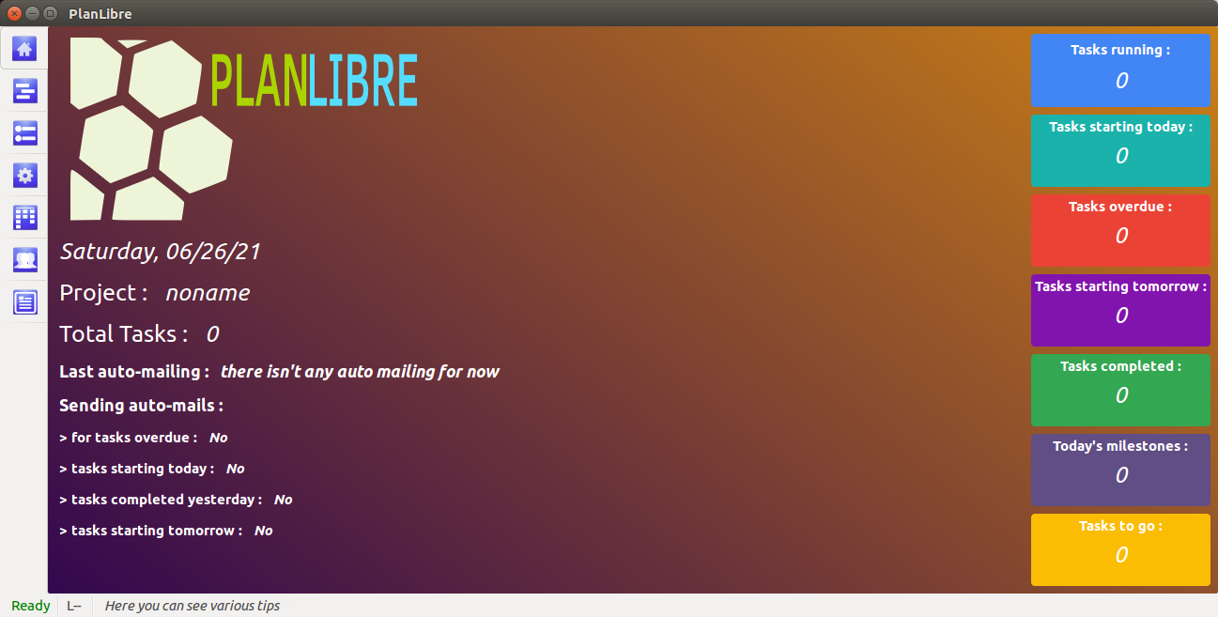
PlanLibre is built on a classic user interface for a classical user experience : classic menus, dialog boxes. In order to offer a better user experience (I hope), the main window is divided in notebook’s pages.
We heavily use the mouse pointer, but, of course, PlanLibre offers various keyboard shortcuts.
Each notebook’s pages are a “view” ; for example, in order to jump to “tasks view”, the user should click on the notebook’s page named “tasks” ; it’s possible to jump between notebook’s pages by using those keyboard shortcuts :
CTRL + PageUp et CTRL + PageDown

You can find the complete keyboard shortcuts :
- by the menu Help>Keyboard shorcuts
- or by pressing simultaneously CTRL + f1 keys

At PlanLibre startup, you are at the “home” page screen. It’s a good idea, everytime you load a file, to go to this “home” view, since it shows you a summary of critical events for current day (mails to send, tasks overdue, and so on)

Coloured rectangles on the left of “home” view are clickable, move your mouse pointer hover, and we will see a change on pointer icon (we use the hand metaphor, in order to show the user that he/she can follow a link).

5. Workflow with PlanLibre
Each user is free to set-up a workflow ; but, we are certain that it’s a good idea to offer and adapted workflow to PlanLibre. Indeed, our advices depnd of PlanLibre specififties. So, we think that a project should be built following 4 steps :

step 1 : project preparation
- define project’s duration and enter datas in PlanLibre.
- list all tasks, and enter their datas in PlanLibre.
- list resources used by our project, and enter datas in PlanLibre.
- define tasks duration, and enter datas in PlanLibre.
- define cost of resources.
- very important : define one or more calendars for our project (with week-end, days-off ... )

step 2 : communicate
- export our project as a standard agenda to your prefered appplication and or to your Trello® account.
- activate automatic emails when tasks start, in order to inform your team.

step 3 : drive
- follow task completion, for example with the “table view”.
- follow cost evolution, and produce reports.
- communicate (automatic or manual emails)

step 4 : close project
- produce reports
- export reports
- send an email when a task is completed

Chapter 1 : about project management

1. Project management philosophy and its implementation under PlanLibre
What is a project ? A method to achieve hierarchical aims. In that direction, it’s necessary to do various intermediate tasks, by using resources. A system of driving and following it’s, obviously, mandatory. All those features are present in PlanLibre.
- the project driving uses “home” and “table” views.
- the “timeline” view is used to manage hierarchical tasks and objectives.
- intermediate tasks are defined in “tasks” view.
- resources are defined in “resource” view and managed in “assignment” view.
And finally, a good project management supposes internal communication (menu communicate) and external communication (“report” view).

2. Definitions
- task : it’s an activity that we have to complete in a certain duration, by using one or several resources. Some tasks are dependant (linked), when, for example, a task “B” can’t start before a task “A” is completed.

- resource : contributes to task’s realization. In PlanLibre, are considered as resources : himan work force, animal work force, equipments, areas (for example, grain filed), raw materials (concrete bags ... ). Resources are supposed to have a monetary cost. And more, they can have various constraints (days offs, for example)
- timeline: it’s a graphical representation of the project. In PlanLibre, “timeline” is a kind of Gantt’s diagram. The timeline allow to quickly visualise the time structure of our project and the hiercharchy between tasks.
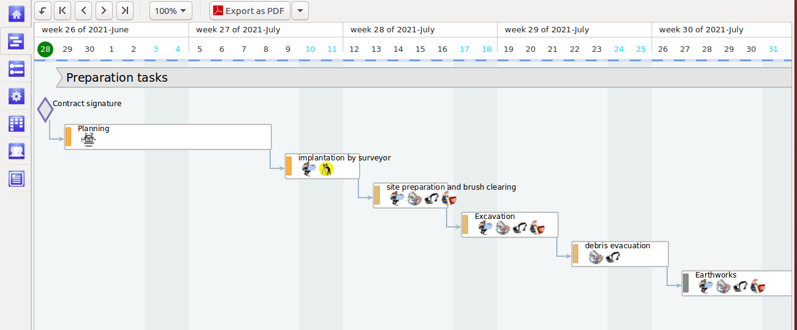
- table: it’s a reprensation aimed to ease the daily driving of our project. At each session, the tasks are placed in a kind of kanban/Scrum © table in order to check their status, for example to see if one or more task is delayed.

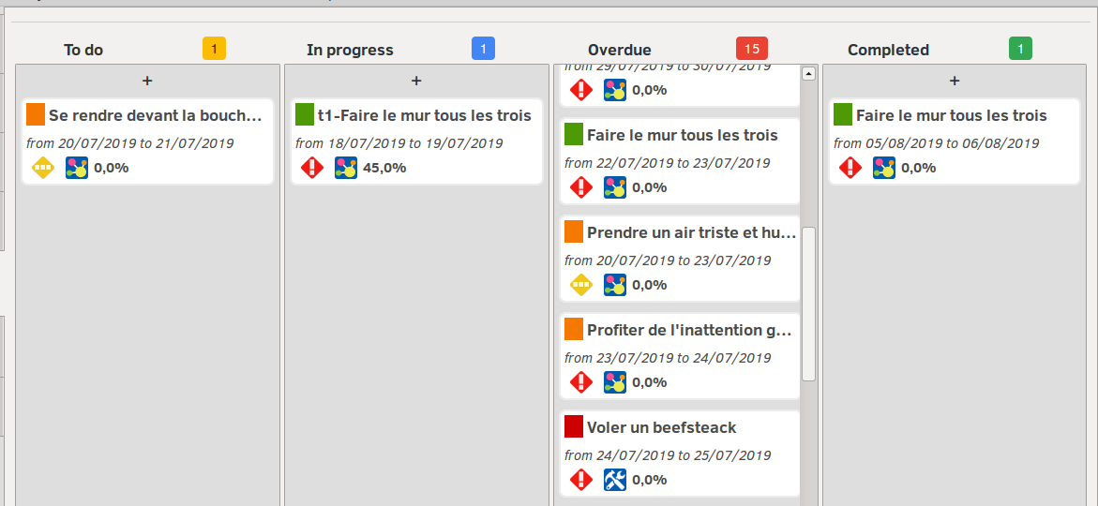
- assignments: a high level project checking supposes to manage resources’ assignments in order to detect their und/over loading, and, of course, verify if a resource is assigned to one or more task(s).

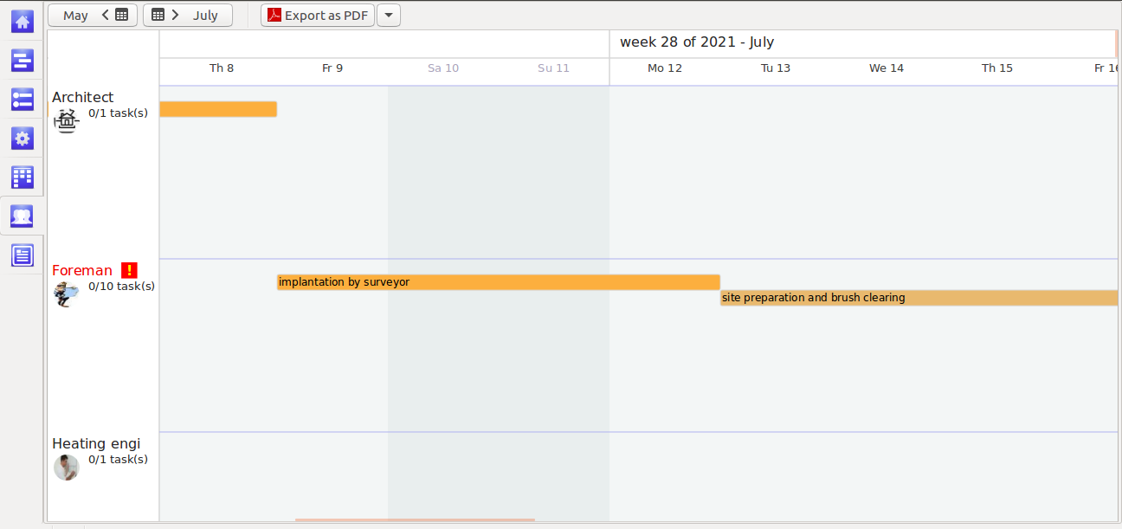
- milestone: it’s a time “mark”, a date treaten as important or critical, in order to check project status. In PlanLibre, we have “flottain” (free) milestones or “linked” milestone (linked to one or more tasks).
- group : here, PlanLibre is different from standard project applications. Groups have two meanings : they can be used, as a simple visual separation (intercalary), or or a powerfull way to tie tasks by “families”. See the screenshot below :
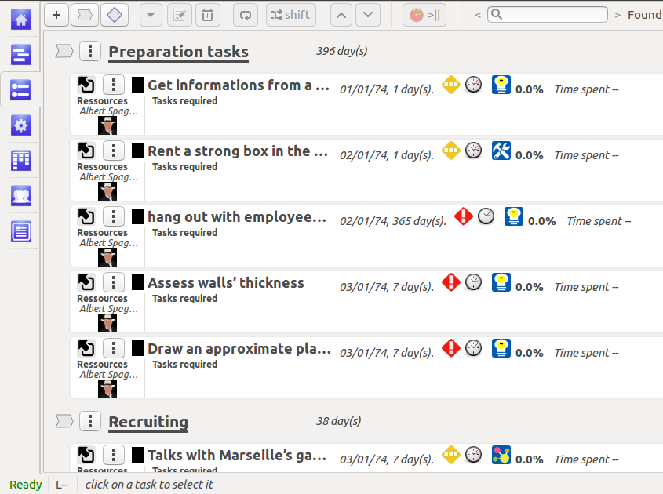
In the “tasks” view, we have two “groups” of tasks (preparation tasks and recruiting). See how the group “preparation” is displayed in “timeline” view :
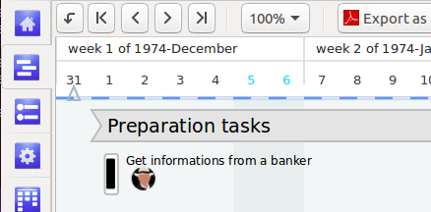

Chapter 2 : how to start easily with PlanLibre

1. Project properties
This step is very formative in order to discover PlanLibre : we will define starting and ending dates for our project, choose a logo, name our chief for project, and so on.
Take it easy, all our operations will cancelable in case of mistake or inconsistency. For example, if you define an ending date before the starting date, PlanLibre will display an error dialog and an advice to fix your error.
We get an access to properties with menu project>properties
Then, a dialog appears with very comprehensive fileds. You can keep as it the default values if you want. But, please, be carreful and checj dates and currency unit.
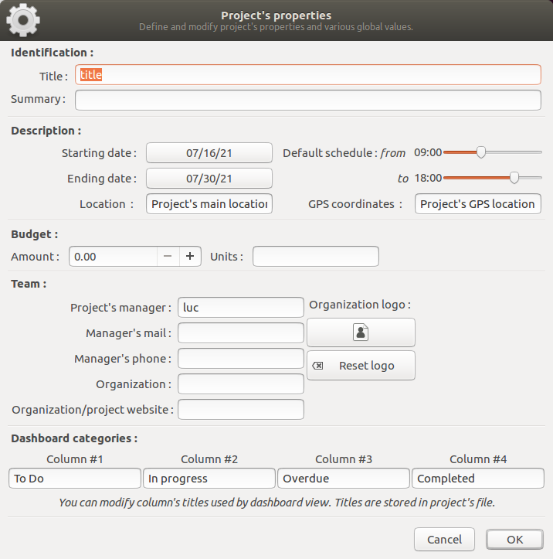
Please notice : contrary to MS Project, PlanLibre allows you to set up projects “in the past” or “in the future”. PlanLibre will never force you to use current date as starting date for your project, unless you really want it. You can change starting date by calling menu project>properties
And more : you can “shift” all your project with menu project>global dates shift when you want.

2. Calendars
PlanLibre is developped in western european context ; but, however, it never imposes european days-offs. The user has to define non-worked days, so, PlanLibre is usable in others cultural contexts.
As default, users should define non-worked days on default calendar, because this calendar is used to manage tasks.
Please, choose menu Project>Manage calendars and working hours
A new dialog appears, please have a look on lower part of this dialog :

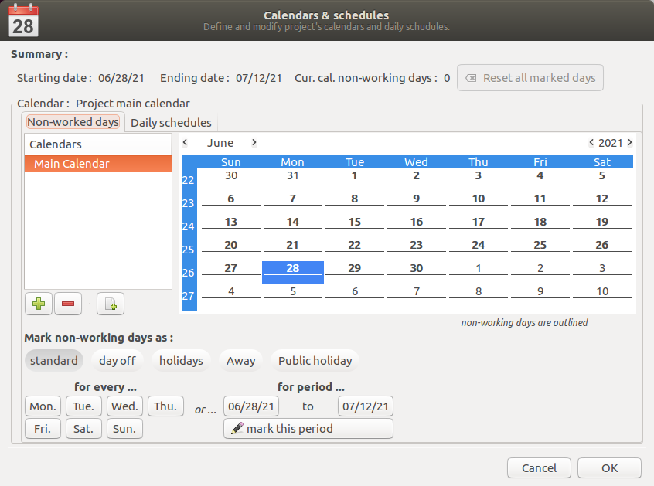
Starting and ending dates are indicated : on this screenshot, the project starts : 28 june 2021,
Ending date is : 12 july 2021.
Have you noticed the name of default calendar (top left of the dialog ; you can’t modify its name, but, of course, you are free for all others calendars).
We will “mark” saturdays and sundays as standard non-worked days for all project’s period. Here is how to :
- please check that the button “ standard “ is activated (if necessary, click this button)
- click on button “[sat]”, on lower left side of the dialog, see the change on clandar, do the same with the button [wed]. See the changes on calendar.
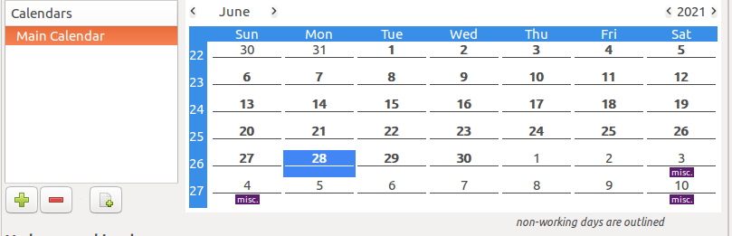
It’s wuick and easy, no ? Now, when PlanLibre compute reports, all saturdays and sundays are excluded as non-worked days.
Now, we will mark july 5 as a “public holiday” : go to july 2021, click on button [public holidays], and finally double-click on the date of july 5 on the calendar ; here is the result :

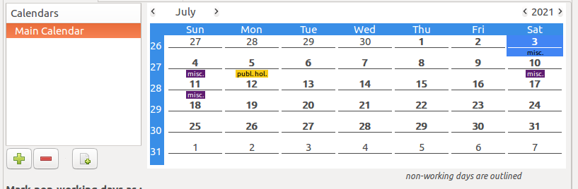
We will see later how to play with more complex calendars, with different schedules along the day, how to “mark” quickly holidays, and so on.

3. Tasks

3.1 Introduction to tasks
A task is an operation to do, known its starting date and for a certain duration (or an operation to complete for a certain date).
Example : build a wall, by starting april 4 with a duration of 10 days. Or deliver a report for june 12.
With PlanLibre, you can set up a new task whenever, even if no resource is already defined.
In order to set-up a new task, please switch to “tasks” view, then click button [ + ] or use the keyboard shortcut f3
A new dialog appears, with very comprehensive fields.
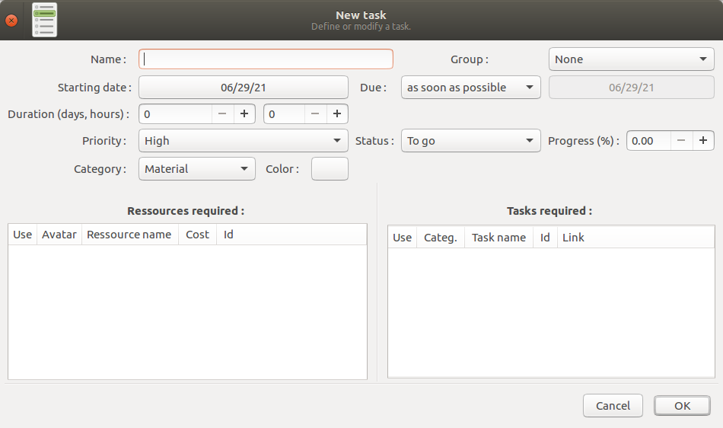
As a training, define task’s name (“build a wall”), duration (10 days), and choose a “material” task. Keep default date as it, because you can modify the starting date later.
Then click on [ Ok ] button.
You can now see the new task on the list of task.
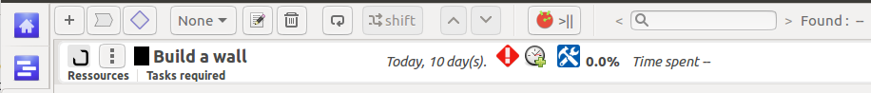
And more, see the changes on “timeline” and “table” views.
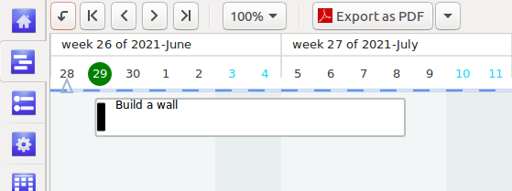
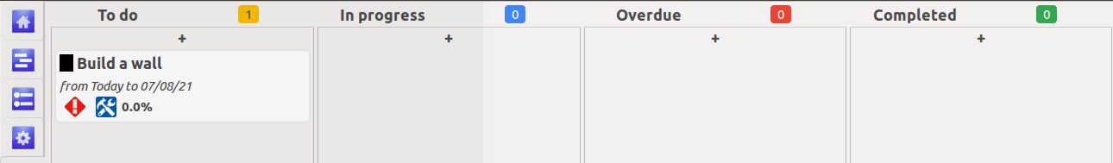

3.2 Modifying of an existing task

We suppose that we are on “tasks” view ; you can also modify a task from the “timeline” view, see below. In order to modify a task, first, select the task by clicking on its line or by moving the selected task with up and down arrows (notice on screenshot below the orange selection border).
Then click on the small button with 3 points [ | ] on the task line, or, second possibility, click on the button modify on the top bar, and third possibility, hit the key f2 .
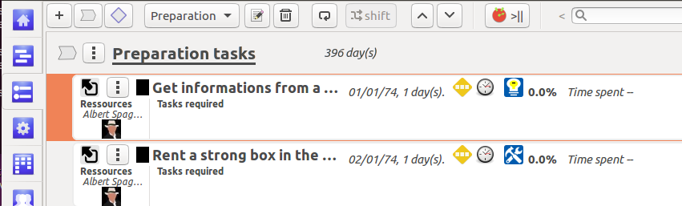

3.3 Time constraints for tasks
Determination of delivery date :
We have 4 modes of management for time constraints : by default, a task is started “as soon as possible” (see below why it’s important by reading the section about linked tasks) ; second mode, “don’t end after”, its meanings it’s that the task shoud not has en ending date after a certain limit ; third mode, “don’t start earlier than”, when a task should not start before one or more other tasks are completed ; fourth mode, “must start on”, the task can only start at a certain date and can be moved along the timeline, until the user changes this date.

Mode | Status | Remarks
As soon as possible | By default when user set up a new task | There isn’t any constraint, the task, even linked, can be moved along the timeline
Don’t end after | The user choose this option when he/she set-up a new task or modify an existing one ; after, the user have to choose an ending date | The task can’t be moved after this ending date ; the ending date is computed like this : ending date = starting date+duration
Don’t start earlier than | id. | The task can’t be moved before the limit date
Must start on | User chooses on drop-down list, but, here, the critical date is the starting date | We can’t move the task along the timeline, unless the user modify the task and change the starting date.  PlanLibre checks, in case of this task has a predecessor (see below) that the predecessor ending date if before the task starting date when the user moves the predecessor.
Please note : if you asj for a global time shift, PlanLibre will automatically update all dates. Thus, all constraints are also updated automatically.

3.4 Insert a task among existing tasks

Please notice : if you’ve forgotten a task, you can insert a new task where you want among task list. Example : suppose your task #35 is “pluck stumps” and your task #37 is “plant trees”, and, suddenly (yeah) you relize that the task #36 “prepare the terrain”, is absent !
Damned ! What to do ?
- switch to “tasks view”
- select task #35
- hit the key f3 or click the button [ + ] on the top toolbar
- fill datas for the task #36
and that’s all !
Another, longer, way :
- set-up a new task anywhere
- select this new task
- use buttons (top toolbar) [ Up] or [down] (see screenshot above) in order to move the task at the right position (after #35 and before #37)

3.5 Automatically repeat a task
Task repetition :
It’s quite frequent that a tasj repeats itself along the whole project. For example : weekly meetings. So, in order to save our force, we can ask PlanLibre to repeat a task. PlanLibre will keep all characteristics, and will only update dates.
In order to repeat a task, please click the button [repeat] on the top tool bar. A new dialog appears :

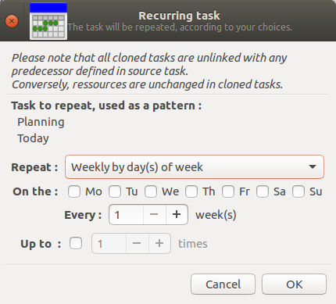
Important : when a task belongs to a group, the repeating process is, I hope, a “smart” process : PlanLibre computes repeatitions in order that task remains in its group.

4. Resources

4.1 Introduction
Resources are used to help realization of certain task. For example, the task “build a wall” uses human resources (builders) and equipments (various tools), and raw materials (concrete ... ). Each resource has a monetary cost (for builders : hour cost, tools : rental from another company).
Please notice : it’s better to manage raw materials as a fixed cost ; for that, simply multiply individual costs by used quantities.
For example, if a cement bag costs 5 dollars, we shall use this formula :

total cost = 5 * quantity of bags

Of course, at the end of the project, we can redjust this cost, known true consumtion of cement ...
Thanks to version 0.2 of PlanLibre, it’s however possible now to consider raw material like other resources, and define quantity used and individual cost, like other resources

Please, switch to “resources” view

How to declare resources ? Since PlanLibre 0.2, we have two ways. Let’s suppose that our project uses 4 builders ; thus, we have 2 ways :
- either decide to set-up 4 different resources named builder1, builder2 ... with a quantity of 1 ...
here is the screenshot for builder1 :
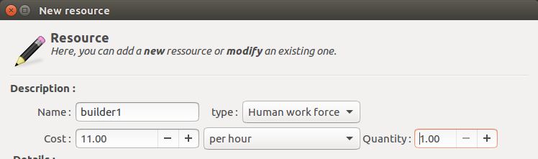
- or decide to set-up an unique resource named “builder” with a quantity of 4. Here is the screenshot, compare with previous situation, please.
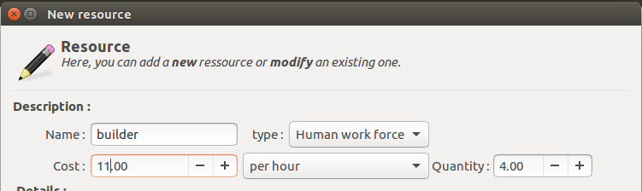

4.2 Set-up resources
Don’t forget to switch to “resources” view
It’s very easy to set-up a new resource ; simply, click on the add resource button (the small button [ + ] ). Then, a dialog box appears, feel free to fill as you want the various fields.
You can assign an image to each resource : the image is integrated to your current file, you haven’t to keep a copy of the image

In order to set-up a new resource, switch to “ressources” view, and, then click on the “new resource” small button [ + ] or hit the key f3 . A dialog appears.
Please, have a look on this dialog : you can notice various default values. If you are not comfortable with “calendars” please keep as-it values for “Date and time management section”.

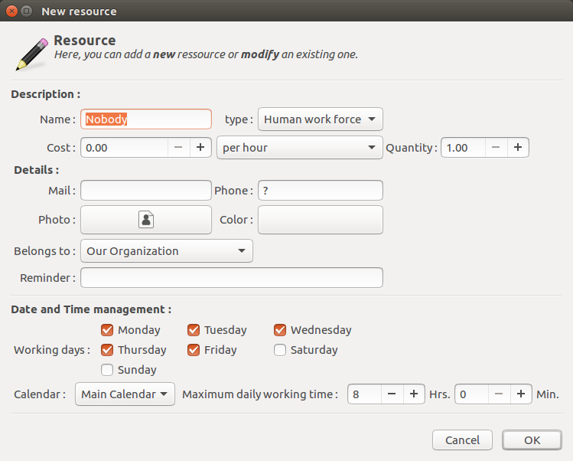
Once you have defined one or more resources, they are listed on the “resources” view ; as a traing, please create two resources “builder1” and “builder2” (human work force) and a resource “tool” (equipment resource) .You can play with “photo” button to add a picture.

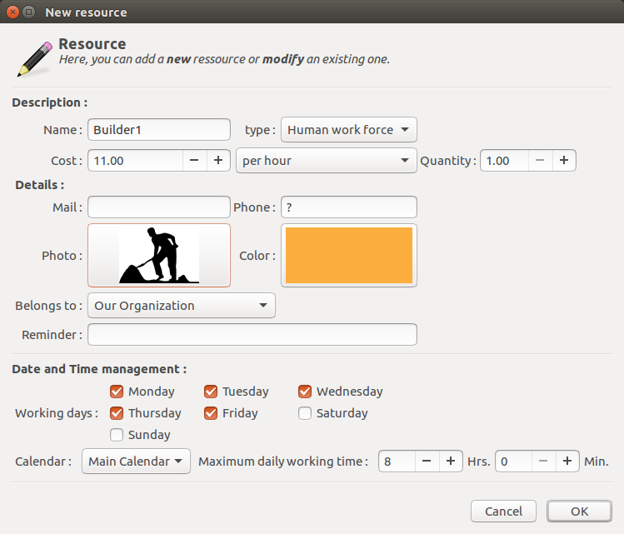

After some work you should obtain something like that on the “resources” view :
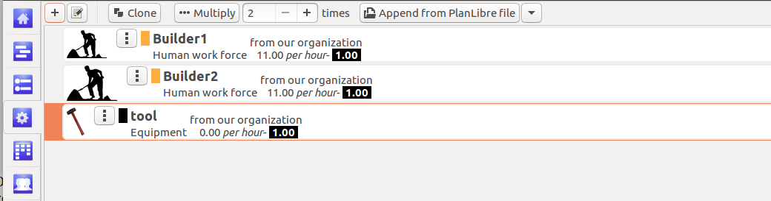
→ in order to modify a resource, select-it by clicking and then click on “modify” button on the top tool bar or hit the key f2 ,
You can also click directly the button [ | ] on the resource line.

Please notice : you can/should use [clone] or [multiply] button if you’re using several resources from the same category, for example “builders”. It’s useful in the real life when the builders, for example, are diffrencied wages. You have just to clone or multply the “basic” builder resource and then, edit it to adjust monetary cost, for example.
During cloning or multiplying, the “photo” field isn’t copied, it isn’t a bug

4.3 Resource assignments
Suppose that you have defined the task “build wall”. We are going now to assign to it two builders and one tool.
Please switch to “tasks” view. Click on task “build wall” : ckick on button “modify” ‘op tool bar) or directly on mini button modify on task line.
A dialog appears : you can notice that now, the list of resources isn’t empty.
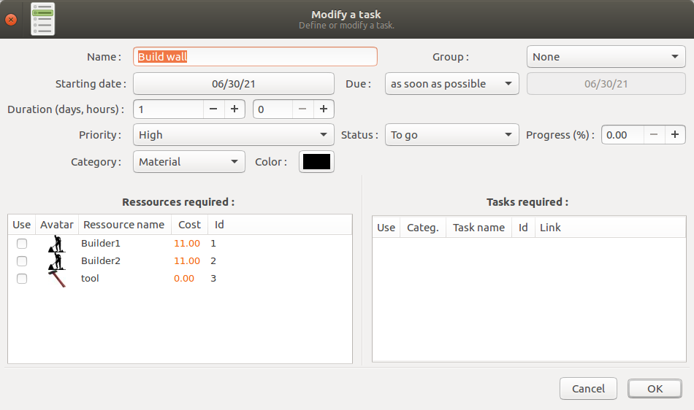
Now, to assign the two builders and the tool, you have just to check (with the mouse, double-click on the small square) the resources.
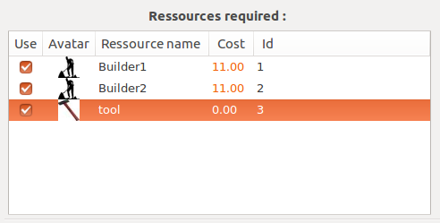
Click [ Ok ] button, and see the changes :
- on “tasks view” :
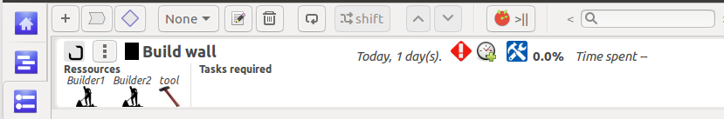
- on “timeline view” ;
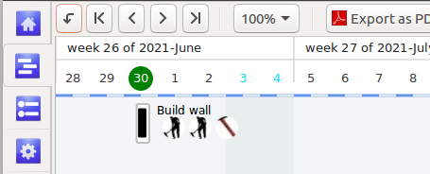
- on “assignment” view :
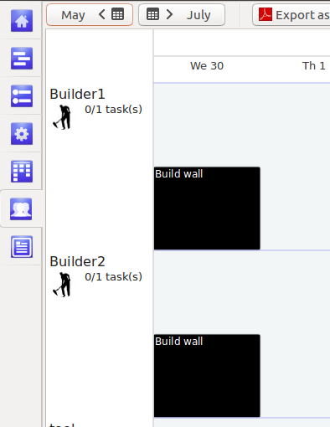
- on “table” view :
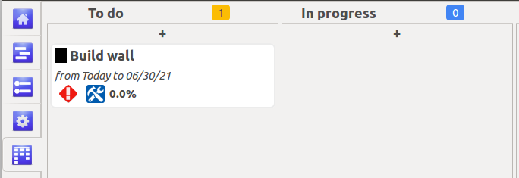

Don’t forgot de save your project (menu file>save or keyboard shorcut CTRL+ S ).

5 The timeline

5.1 Introduction
The timeline is a graphical representation of our project. It’s not axactly a Gantt diagram. Each task is displayed by a bar ; the le,gth of this bar depends of the task duration. The top “ribbon” is a calendar. You can see a trangular cursor which represents your current position on the timeline. The current day is displayed in a green circle. Since PlanLibre is developped in western Europa, we assume that saturdays and sundays are non-worked days, so they are displayed on a grey background., and the days are in midlle-blue on the “ribbon”.

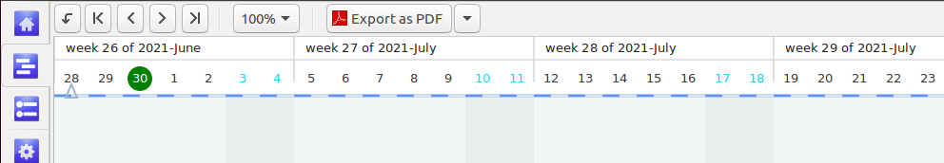
On the above screenshot, we are june 30 of 2021.
since you have created your tasks, they are placed on the timeline. Of course, the timeline is partially displayed ; so, if the tasks are outside the current view, please use 5 “navigation buttons” on the top toolbar above the “ribbon” :

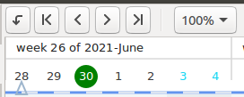
from left to right :
- jump to date
- jump 1 year backward
- jump 1 page backward
- jump 1 page forward
- jump 1 year forward
- zoom button (with a drop-down menu)

Don’t forger to use sliders and zooming button

Here is an example of timeline with several tasks :
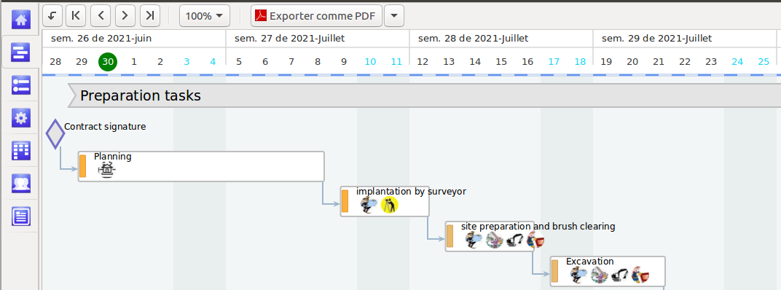

→ the bar length depends of task duration
→ the bars contain icons (or default icon) for all resources used by the task
→ each bar has a colored rectangle according to your choices
→ please notice that bars are linked by blue lines : we will see that later, but, for now, please notice that is “linked” tasks (with predecessors/successors)
→ there is a milestone (blue diamond) in top left

5.2 Modifying tasks from timeline view

5.2.1 Contextual Menu
Each “bar” representing a task is “sensitive” ; move the mouse pointer inside a bar, the mouse pointer picture changes, then do a right-click, and a contextual menu will appear.

5.2.2 Changing starting/ending dates with the mouse
Move your pointer inside a task bar, left-click, and without releasing the left button, move your cursor along the timeline (only horizontaly !).
The task rectangle (indeed a ghost) will follow your mouse, and the starting/ending dates will be updated when you release the left button.

There is various checkings during this operation : don’t be surprised if an error dialog appears, for example if you attempted to move a tlinked ask before its predecessor !

5.2.3 Changing task duration with the mouse
Move the mouse pointer near the right border of the task bar, but remain inside the bar. Left-click your mouse, and, without relasing the left button, move the pointer to right in order to increase duration, to left if you want to reduce duration.
During the operation, a ghost rectangle appears to help you.
Example :
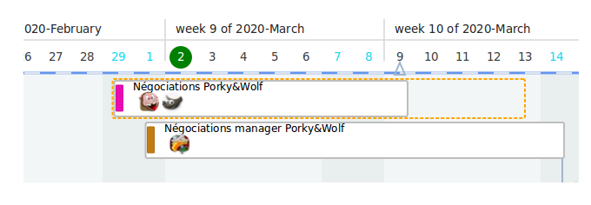
The change is effective when you relase the left button.

There is various checkings during this operation : don’t be surprised if an error dialog appears, for example if you attempted to increase duration of a linked task after its succesor !

6. Assignments view

6.1 Introduction
Assignments are a graphical representation of the various tasks where are involved the different resources. The idea is to visually check the level of “charge” for each resource, and, sometimes, detect an “overload”. The graphical represantation seems close to this of the timeline, but, indeed, its interpretation is very different.
Like for the timeline, le top part displays a calendar, but the calendar is different. You have several buttons to navigate, but, they are different from the timeline view.
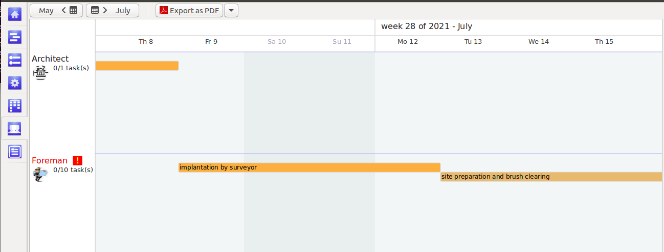
The left colomun list all resources defined and used in the project. You can use vertical sliders to see all resources and horizontal sliders to see their assignments along the time.
When you reach the end of the display, use top toolbar buttons to navigate.

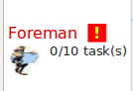
To the right, you can see all tasks using the current resource.
You can also notice, sometime, near the resource name, an exclamation mark : it means that the resource is overloaded. Thus, right-click on resource name, a contextual menu appears, and you can obtain a report in order to understand why this resource is overloaded.

7. The table (Scrum® method)
A project requires driving tools ; this is the “job” for the “table” view. The table allows, days by day, to visually check tasks status. In Planlibre, the “table” view is close to Kanban or Scrum® methods.
Until version 0.2 you can’t change columns titles ; so, we decided to use more “natural” titles : todo, in progress, overdue, completed.
Since 0.2.1 release, it’s now possible to change columns titles. You have simply to define new titles by using menu Project>properties

The table is automatically updated at PlanLibre start, in order to check, for a certain day, the effective status for the tasks. On top of each column, you can read the number of tasks, for example the number of task to go.

The color used on top of each column if the same than the rectangular large buttons on the “home” view

When we write “automaticcaly”, it’s mean that PlanLibre will place each task in the relevant column ; for example, if a task appears to be “overdue” today, PlanLibre will move the task from “in progress” to “overdue” column.
Definition : a task is overdue, if, the day when we launch PlanLibre, task progress if <100% and ending date is before current day

The “table” view is dymanic :
- the table interacts with the “tasks” view ; every modifying of the task status (for example : changing progress value) will change its status on “table” view ; conversely, if you change status of a task on “table” view, values in “task” view will be updated.
- indeed, the “table” view allow you drag’n’drop : you can move a task from one column to other with the mouse. Example : left-click on a task inside the “overdue” column ; without releasing the left button, move the task on the [ + ] symbol on top of the column “completed”. Then release the left-button. If the operation is successufl (the drag’n’drop is sometime capricious), switch to “task” view, edit the task, and see the change : the progress value is now automatically ajusted to 100%.

Chapter 3 : go further with PlanLibre

1 More complex tasks

1.1 Linked tasks
→ definition : a linked task has one or more predecessors, one or more sucessors. Predecessors and sucessors are also tasks. PlanLibre uses an “automatic placement” function when tasks are linked, known the time constraint of linked tasks (see : chapter 1 section 3.3). For example, PlanLibre will compute correct starting date of current task, according to its predecessor ending date.
Let’s take an example : the task to do is “mow the lawn with the mower”. But, alas, the mower hasn’tsufficient gazoline ; so, before mowing, we must buy gazoline. And more, we must service the mower after winter months.
Let’s analyse the situation :

Buy gazoline
Mow the lawn
Service mower

The task “mow the lawn” can’t be achieved until the 2 others tasks has been completed ; in project management terms, this task is linked to 2 predecessors. Let’s go to enter datas in PlanLibre !
- first step : switch to “tasks” view and, please, create the 3 taks. Then switch to “timeline” view, you should see something like that :
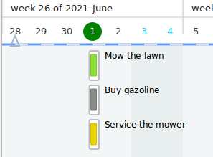

- second step : switch to “tasks” view ; edit/modify the task “Mown the lawn”. Here is the dialog box, please have a look on right side, and check the 2 other tasks like me.
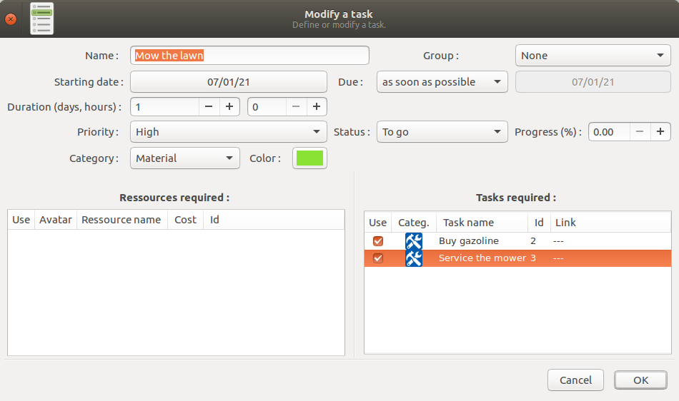
Click [ Ok ] button, and switch again to “timeline” view. Here is the result :
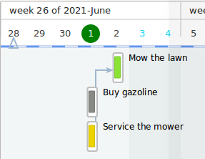
PlanLibre as automatically updated starting date for task “mow the law” (supposed 1 day after other tasks).
Swutch again to “tasks” view, and have a look on line “Mow the law”, compare icons with other tasks :
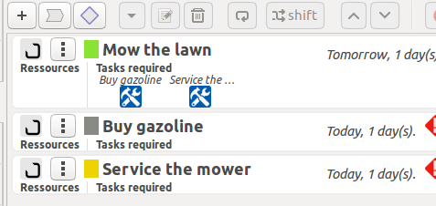
Now, tasks required contains two icons an some text.

PlanLibre can, for now, only manage one type of link, “end to start”. In this case, a task with one or more predecessors can only start AFTER the end of all the predecessors tasks
Please note that current PlanLibre files are reday to future improvments, for example when we will set-up “start to start” or “end to end” linking modes.

Nb. : undo with linked tasks
When you call undo menu, all linked tasks will return in their initial state. For example, if the task “A’ impacts tasks “B”, “C”, “D”, then all those 4 tasks will retuen to their initial state.
Please note : the undo menu don’t show “undo all linked task” but “undo modify task” or “undi modify milestone”.

Nb. : automatic removing of links in case of error.
We have written that tasks with time constraint “as soon is possible” can be moved freely on the timeline. Conversely, PlanLibre checks tasks with other time constraints. In case that you request an incoherent link, a warning dialog appears and all the links are removed, it isn’t a bug. You can change parameters (dates, constraints) if you really want to link those tasks.

1.2 Advanced use of milestones
Let’s imagine this scenario : we have to organize a little music event. for that we will have to look for the artists of the group “Pokey and wolf” ; lthe “deal” with the group is que the event manager must bear the hotel costs, but the deal will become possible only when the group manager will agree about the group’s cachet.
Thus, we have to set-up a milestone for this agreement, and, only after, confirm hotel reservation.
Let’s examine the tasks :

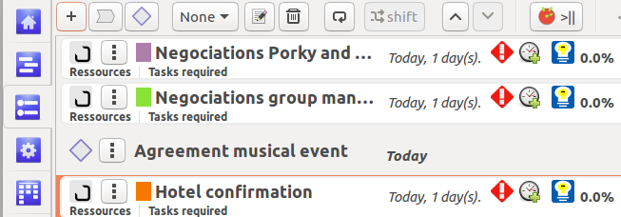
And the initial state for the timeline :
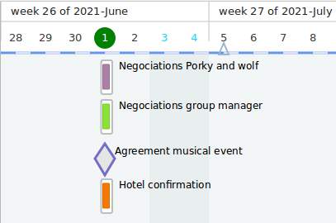
Now, we will use automatic placement and linking functions of PlanLibre. For that, please, switch to “tasks” view.
- select the milestone, and choose edit/modify it.
- a new dialog appears ; on the right part, check like me the two “predecessors” tasks.

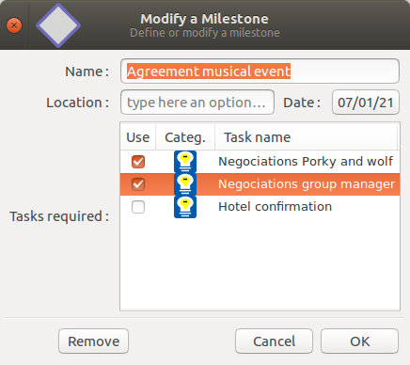
Then, click [ Ok ] button, and switch to timeline view :

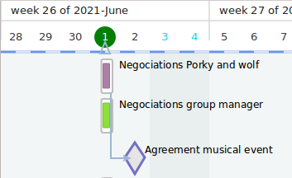
Now, please, edit “hotel confirmation” task and link it to the milestone. You should obtain someting like this :
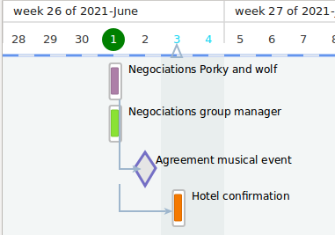

Nb : for milestones, links are only of type “end to start”

I remind you that PlanLibre monitors miletones, at every start of PlanLibre, and the display on “home” view is updated in order to show if there is one or more milestones for current day

2 Group of tasks

2.1 Presentation
In PlanLibre, we can use “groups” of tasks ; it’s something like, but not identical to “summarizing tasks” of very famous (proprietary) planing utility !
In PlanLibre, “groups” of tasks allow user, either to “visually” gather several tasks, in case of various coordinated operations ; or to simply separate visually tasks, without any coordination in mind.
For example, dig, evacuate waste, pour concrete, can be gathered under the category “bulding foundations”.
Another strengh of “groups” : they are automatically updated when you add or remove a task ; so a “group” display the total duration, known all tasks are belonging to the group. This information is displayed under “tasks” view :
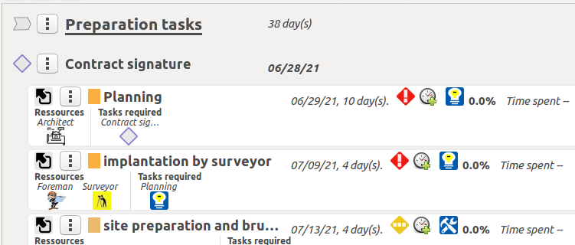
On the above example, all the tasks inside “Preparation tasks” lasts 38 days.
If you switch to “timeline” view, you can see that the length of groups auto-adjust to their tasks.
You can’t move a group with mouse on timeline view
In order to move up/down a group you must switch to “tasks” view, select it, and move it like any task (buttons with arrows ‘up’ ‘down’).
When you move up/down a “group” of task, all tasks follow the group
Please notice that “groups” and tasks belonging to a group are auto-placed. So, when you ask to set-up a new group, please pay attention to current line where you are positionned in “tasks” view.

In case of the cursor is on a line (a task) belonging to a previous group, the new group will be moved outside the current group ; actually, the new group will be placed after the last task belonging to current group.

2.2 Set-up a group and attach a task
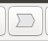
It’s very easy ! The first step is to set-up a new group. Switch to “task” view. Then move the cursor to the line where you want to place the new group, for example above the first “task” planned to be attached to the new group.
Then click on button new group [ => ] ; a new dialog appears :
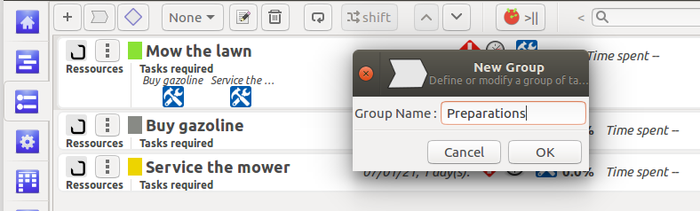
Type a name for your group, and then click [ Ok ] button.
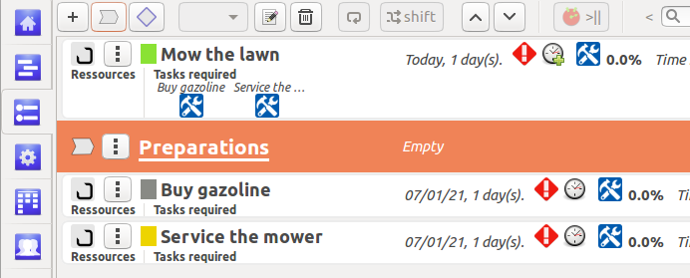
Don’t care about group placing !
Now we will attach tasks “buy gazoline” and “Service the mower”. For that, edit those tasks ; here his an example for the second one :
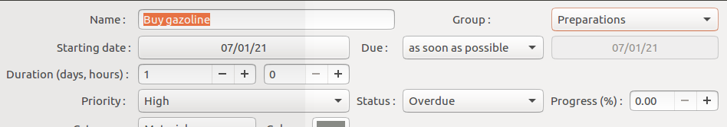
Now, the drop-down menu to the to right isn’t empry : you can choose the group “Preparations”. Here is the result once you have choosen this group and clicked the [ Ok ] button :
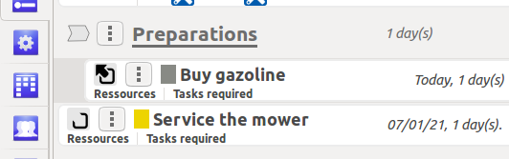
“Buy gazoline” is attached to the group “Prepration”, no, for now the task “Service the mower” ; in fact, have a look on left side icons. For “buy gazoline”, we have an icon with an arrow, for “Service the mower” an “open” icon.

The group to whicj belongs a task is displayed on top tool bar :
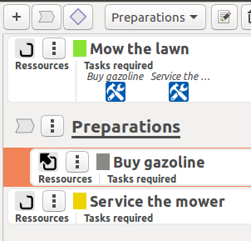

2.3 Move groups
In order to move a group (and all its tasks) : click on line where is the group, and click the up/down buttons on the top toolbar of the “tasks view”.
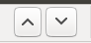

2.4 Change tasks attachments
You can change the group to which belongs a task, or “release” the task attachment.
Switch to “tasks” view, ckick on a task to edit it. On the dialog box, see the top right section, after the word group ; here, you can change the group or choose none to detach a task from its group.
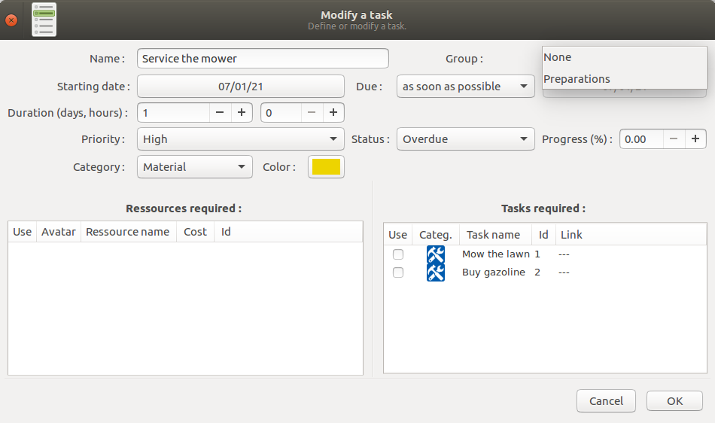
After those operations, the task will be auto-placed, i.e. moved on the task list

3 Discover calendars

3.1 Presentation
PlanLibre, like other planning applications, can manage calendars. There is not limitation to number of calendars defined by user. A calendar allow you to :
- define non-worked days, and to classify those days by “families” (day-offs, week-ends ...).
- define with accuracy daily schedules for every day of week.

There is, of course, a default calendar ; this calendar is very important : it drives tasks. User can, of course, modify settings for default calendar.
You can also whole define daily schedules : please see Project>properties menu.
Or, conversely, define precisely calendars and daily schedules for each resources if necessary.

3.2 Differences with other planning applications
Since PlanLibre is a junior application, you can’t, for now, use only one calendar for tasks (the default calendar). On the other hand, each resource can either use the default calendar, or use a user-defined calendar. In summary, resources can have their own calendar ; it seems not stupid ... because if a resource isn’t available, the task can’t run !

If necessary, without chaning file format, it’s possible in a later release to allow tasks to have their own calandars.

Very important : PlanLibre starts new projects with an empty calendar where ALL days are worked ! Don’t forget to define non-worked days

3.3 The logic of calendars and daily schedules
Reminder : there is a default calendar for tasks.
Each resource can have, if necessary, its own calendar. It’s also possible, for a resource, to only define its daily schedules without defining a specific calendar.
As you can see, PlanLibre offers various ways ; let’s explain them !

Example :
- the task “service engine” requires 2 weeks of work, from monday to sunday ; but, in default calendar, suppose you’ve indicated that sundays are always non-worked days.
- but, in order to service the engine, we have two mechanics, Paula and Paul. Paula never works the monday, but she’s OK to work saturday. Paul don’t work wednesday, nor saturdays.

Here is the summarized situation :

calendars | MO | TU | WE | TH | FR | SA | SU
tasks (by default) | OK | OK | OK | OK | OK | OK | NO
Calendar Paula | NO | OK | OK | OK | OK | OK | OK
Calendar Paul | OK | OK | NO | OK | OK | NO | OK
Computed | Paul | Paula+Paul | Paula | Paula+Paul | Paula+Paul | Paula | -

During cost and activity computing (for reports), nobody will accounted as working sundays, because task calendar takes priority on other calendars.
On mondays, only work made by Paul is accounted.
On tuesdays, Paul AND Paula are accounted, and so on.
So PlanLibre can offer you an interesting estimation of activity and costs for your project.
Advice : at task level, use a larger daily schedule, a more accurate for resources

3.4 The logic for daily schedules
When PlanLibre computes costs or charge, an estimation is made ; the application uses daily schedules (default or for resource specific).
Suppose that for ou friend Paula, no daily schedule is defined. Contray, for Paul, a daily schedule is defined : the friday, Paul can only work from 2 PM to 16 PM. Let’s examine together how PlanLibre will compute Paul’s working day for a friday. We suppose that daily maximum duration is 7h30.
For friday ...
Paula : PlanLibre computes 7h30.
Paul : PlanLibre considers that Paul works 2h.
So, when PlanLibre produces a report, each friday represents 9h30 (7h30+2h). Thus, the estimated cost will be :

(hour cost Paula * 7.5) + (hour cost Paul * 2)

4 Produce a report

4.1 Standard reports
You’ve certainly noticed that PlanLibre offers a “report” view. It’s a kind of “space” which can contain editable text and non-editable graphics.
Be careful : on “report” view, there isn’t any undo if you modify text or graphics ; in case of mistake, simply ask PlanLibre to do the same report
PlanLibre offers 4 ways to obtain reports :
- global reports for the whole report : either a report about “work charge” for all resources, i.e. a global analysis of the activity, or an estimated global cost analysis, task by task.
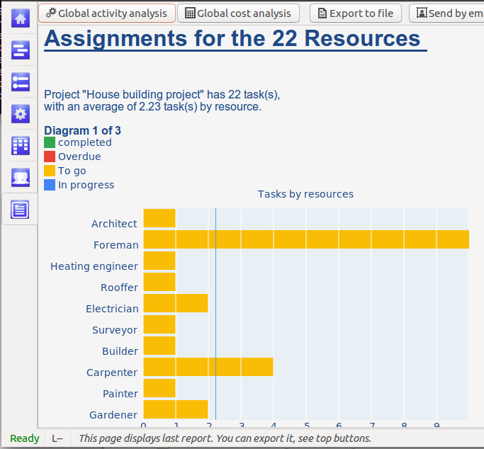
- specific reports about a certain resource : either a report about work charge, or a report about resource’s cost. For that purpose, the way is a few different :
- switch on “assignment” view
- with your mouse, go on the left side, on the resource line, and then, right-click
- choose on menu either “resource charge” or “resource cost”, and, in certain cases “Overload details”
- PlanLibre compute values and switch to “report” view.

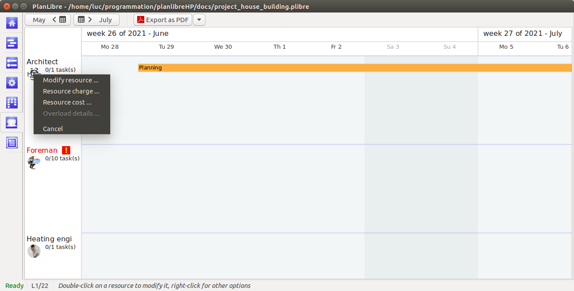
Those reports can be exported to word processors ; once report displayed, simply click on button [Export to file] in order to get a file in RTF format (Rich Text Format) with all text an graphics. The button [Send by email ] will send the same RTF file to a list of recipients choosen among project’s resources.

For reports, you can define font an color of text withthe menu Edit>settings

4.2 Overload reports
Definition : a resource is overloaded when it’s used on the same time period on at least 2 tasks.
Overload is in some case a very important problem, so the project manager has to know quickly if sometime like that appears.
In order to detect overloads, switch to “assignment” view, and check if some resources (on left side) are displayed in red with an exclamation mark :
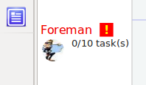
In this case, the resource “foreman” is in overload : right-click on the resource name or icon, and choose “overload details”. PlanLibre switches to “report” view, an you get a new report :
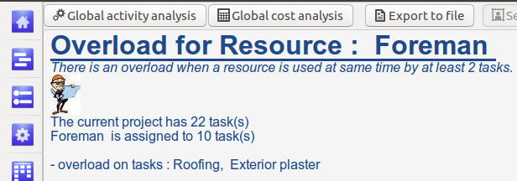

Chapter 4 : communicate

1 Settings
In this section we will see and define various settings with a global effect on PlanLibre functions and/or modifying default settings.
Some settings require a restart – the user must restart PlanLibre, there isn’t automatic restart
In order to access those options, please choose menu Edit>settings
Then a dialog appears :
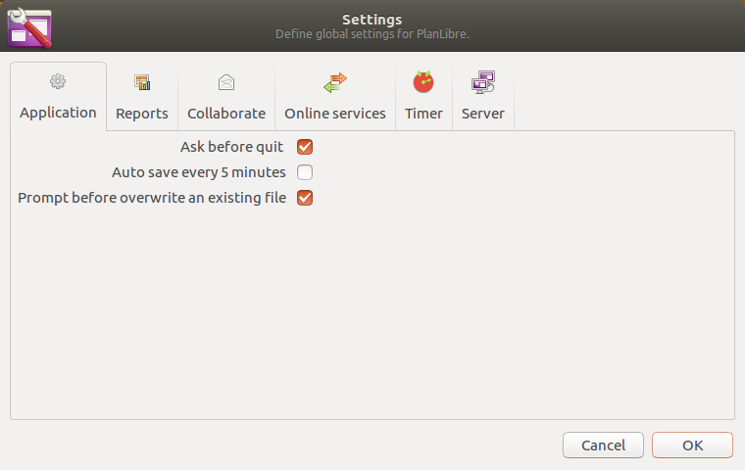
Don’t forget to fill datas in server section if you want to send emails with PlanLibre, or online services if you attempt to export PlanLibre project to your Trello ® account.
Other settings aren’t critical.

2 Emails

2.1 Email service provider settings
PlanLibre is able to send “massive” emails. But, it’s only possible if you’ve entered datas for a valid email account. You must use datas from an existing email account, PlanLibre don’t offer such a service by itself !
compte existant.
For that, open your prefered emailing application (where you store yours email accounts) et collect those datas : your identifier, your email password, the “type” of outcoming email service (normaly, “smtp”) and the “port” used by yoyr email server provider.
Once you’ve collected those datas, with PlanLibre, go to menu Édit>settings. A dialog appears, click on page Server .
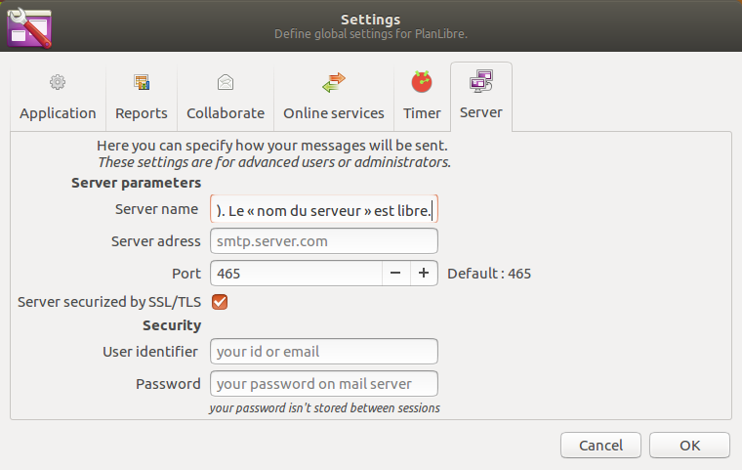

Then, fill all fields with previous datas, or keep “as it” when uou’ve a doubt (for example, for the “port” field). You are totally free for the “server name ” field, it isn’t critical, just a convenient field.

When you quit PlanLibre, all datas will be saved for a later session, except password for security ; your password will never be saved and thus, will be requested during other sessions.

2.2 The two ways to send emails

2.2.1 Introduction
PlanLibre offers you two modes : a “manual” mode where you are free to choose time of sending, and a double “automatic” mode where PlanLibre manages itself sending. The two ways use the same user interface :
- Please note that the password used by your email account is requested the first time, during the session, when you ask PlanLibre to send emails, or at very start of session when PlanLibre sends automatic emails.
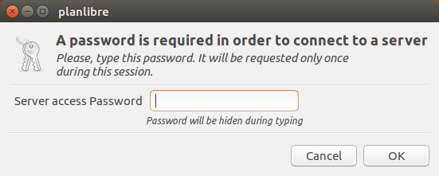

The password isn’t stored when you quit PlanLibre
- PlanLibre can’t send emails if you haven’t defined a valid email adress for the project manager. Please, see Project>properties
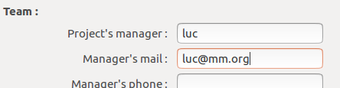

This email adress is stored in the projectt’s file ; so, each project can have a different manager, but : the email adress must be compatible with your mail server provider.

Once you’ve defined project manger adress, password and email account, you can send emails !

- you can be asked to choose recipient’s list with a dialog window.
- the text of email, is, either automatically written by PlanLibre (preformated messages), or, freely typed by the user ; in the second case, PlanLibre displays a dialog to type the message. In both cases, the message is sent in “strict text” mode, without images nor formattings.
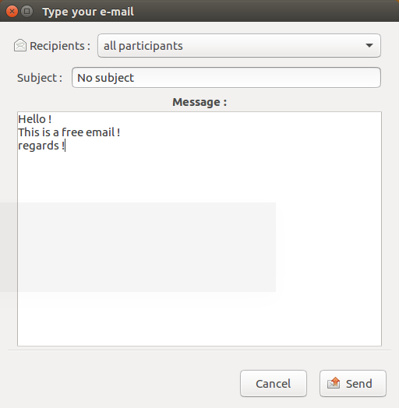

2.2.2 Manual emails
You can access them with menu Collaborate>send free email to participants
A dialog appears (see above). You’re supposed to define a title, and to type the text. By default, the message will be sent to all resources with a valid email adress. You can refine/filter list of recipients by clicking on button [ all participants ]

iIt isn’t possible to choose individually recipients

2.2.3 Preformated emails
They depend of tasks progress, or, in other words, the position of those tasks in “table” view. Here, you can’t choose the message. For example, il you choose the menu Collaborate>send mail for overdue tasks here is what PlanLibre will do : PlanLibre will check how many tasks are in “overdue” column of the “table” view, and, then, filter resources involved on those overdue tasks ; Then, the automatic email will be sent only to those resources.

2.2.4 Preformated emails in automatic mode
It’s the same principle that other preformated emails, but, with a main difference ! The mails will be automatically sent by PlanLibre at the very start of your session, once you’ve reloaded the project file.
Automatic emails work only if you’ve activated those options (menu Eition>settings, then see page Collaborate)
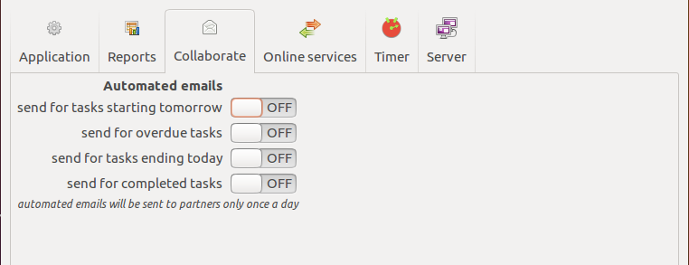

3 Agendas
It’s possible to “export” tasks defined with PlanLibre, either as a file, or by email. PlanLibre use a “standar” ICS format ; for example, the resulting agenda is easly imported by Thunderbird.
During this process, PlanLibre reviews all tasks, thier starting and ending dates, and also daily schedules. During export, PlanLibre datas are converted as an ICS compliant file.

PlanLibre offers 2 ways in order to export tasks’ agenda : as a file or by email
- if you choose to export agenda by email : please, see menu Collaborate>send calendar/agenda … A dialog appears, you’ve asked to add a message and/or to filter recipients (since it can be very long, PlanLibre offers you a default list where you have just to uncheck the non-wanted recipients). An ICS compliant file is added to your email.
- if you choose to export directly to a file : choose menu Project>Export as calendar/agenda … You get a file with an .ics extension, which you are free to copy, save, send, and so on.

Chapter 5 : some little extras

1 Import datas

1.1 Principles
The file format used for import/export by PlanLibre is the very classical CSV (Comma Separated Values). This format is managed probably by all spreadsheets. The CSV format is also used by email applications (Thunderbird … ) in order to exchange adress books.

1.2 Import resources

1.2.1 From a spreadsheet
Place notice that a successful import requires that you use semicolon as a separator.
So, don’t forget, during export from your speadsheet, to check that the separator is the semicolon.
It’s also necessary that the sheet used be structured in a
way compliant with PlanLibre import filter :
- the first line of the sheet must contains exactly the same titles and in the same order like on the screenshot below ; the columuns titles are in english.
- the real datas must start at the second line.

NAME | MAIL | PHONE | REMINDER | MAX DAILY WORKING TIME | HOUR COST | MONDAY | TUESDAY | WEDNESDAY | THURSDAY | FRIDAY | SATURDAY | SUNDAY
toto | toto@aol.us | ‘06335277 | remind to call | 8 | 12 | 1 | 1 | 1 | 1 | 1 | 0 | 0

tips :
- the phone number, is used must start with a non digit value
- for days of the week, the value 0 (zero) means non-worked, the value one (1) means worked day.
You can find an empty LibreOffice Calc file used as a template in the source of PlanLibre, in /docs directory ; the file is named : ressources_export_model.ods
very important : no cell can contain the semicolon character. In case a cell contains this char, it will be removed during import by PlanLibre

The different columns must contain :
1st column : mandatory the resource name, never an empty cell !
2nd column : only its email or nothing
3rd column : telephone number, with a non-digit first char, for example ‘ , or nothing
4th column : a note about resource or nothing
5th column : maximum duration for a working day, in hours
6th : cost of each hour of work
all other columns for days of week : the value 0 (zero) means non-worked, the value one (1) means worked day

1.2.2 From an email application
The procedure has been tested with Thunderbird. We are constrained by Theunderbird. For example, this application don’t use any working days duration.
We will learn how to import from the “adress book” (tested with Thunderbird).
Please notice that your are responsbile, after import of Thunderbird’s adress book, to check value of fields and have any relevant information s(costs, durations ...)

- first, lauch Thunderbird. Look for the menu to manage “adress book” or “contacts”, and export datas as CSV file. Note somewhere the file name, and close Thunderbird.
- launch PlanLibre, switch to “resources” view. Click on the traingle near the button [Append from PlanLibre file] and on drop-down menu choose append from Thunderbird contacts

this procedure should work with other email applications
Use the file selector to load the file exported by Thunderbird. If all it’s OK, the Thunderbird contacts are now in your resources list. Don’t forget to add to them informations like costs ...

1.3 Import tasks from a spreadsheet
In order to complete sucessfully an import, PlanLibre requires that the CSV file uses semicolon (;) as separator. D’ont forget to verify the export filter used by your speadsheet.
Second, the sheet must be organized in a certain way, like this screenshot :

The file has 8 columns, the first line contains only headers. The file must store datas in this way :
- column 1 : name of task
- column 2 : starting date day (1 to 31)
- column 3 : starting date month (1 to 12)
- column 4 : starting date year(positive value)
- column 5 : duration in days
- column 6 : duration in hours
- column 7 : priority code (1, 2, 3 are the only values allowed = 3 means high, 2 medium, 1 low)
- column 8 : progress, in % from 0 to 100
You can find a template file for alla spreadsheets (in CSV format) in sources of PlanLibre, in the directory /docs, the file is : tasks_export_model.csv

2 Export datas

2.1 Export task list to a spreadsheet
Thanks to the CSV file format, it’s very easy to export datas from “tasks list” to a wide range of spreadsheets.
The idea is the following : for computations, statitistics, spreadsheets are better tools than PlanLibre.
How to proceed ?
- switch to “tasks” view
- click on triangle near button [Append from file…] in order to show the dop-down menu u Export to spreadsheet

Here is the fields exported in the CSV file :

task | starting date | duration (days) | duration (hours) | due | due date | done | priority | status

Please notice. :
- PlanLibre uses the CSV file format, but, during import by your spreadsheet, please check that the cell separator is semi-colon
- if you use LibreOffice, activate the detection of special numbers for detecting dates
Here is the setting for LibreOffice (this dialog appears when you ask to open a CSV file) :

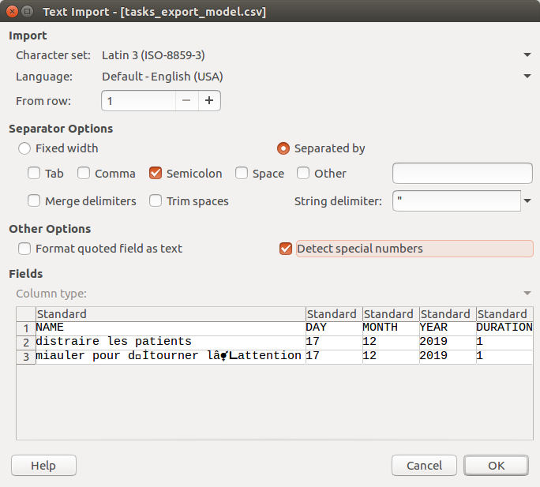
2.2 As a diagram/picture
Thanks to GooCanvas library, we have 3 file formats : PDF, SVG (vector graphic, for example for Inkscape), and PNG (bitmap picture, for example for The Gimp, Krita, Photoshop ®... )
There is three “views” allowing graphical export :
- timeline
- assignments

please notice that saving of report is a kind of mixed exportation : RTF format supports formated text and graphics (bitmap)

2.3 Export from PlanLibre to MS project®
It’s possible, since PlanLibre 0.2.2, to export whole project to MS famous software. For that, we export the PlanLibre project as an XML file compliant with MS project 2007 and later.
Of course, the export isn’t perfect, because PlanLibre has its own interbal logic ; however, Tasks, Resources, Assignments and Milestones are exported to Ms Project®. Of course, pictures and so on arent”t exported !
How to expport to MS Project® ?
- open PlanLibre, load your project, go to Import/export>Export to mS Project® XML menu.
- choose a file name, the file will get an .xml extension. For example, if the file name is something, the file will be saved as something.xml
- now, you can switch to another OS, and lauch a well known planning software (joke, sorry) ; this launch MS Project, and then choose to open XML file. Choose the file exported from PlanLibre.

Example :
original project :
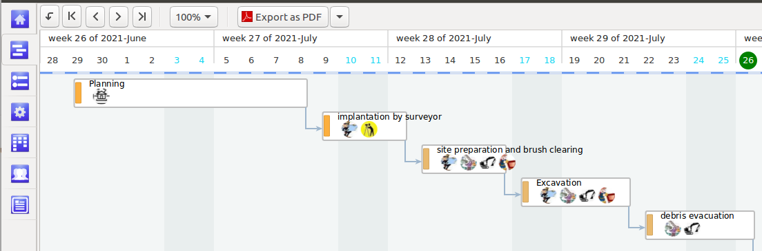

file imported with MOOS® Project viever :
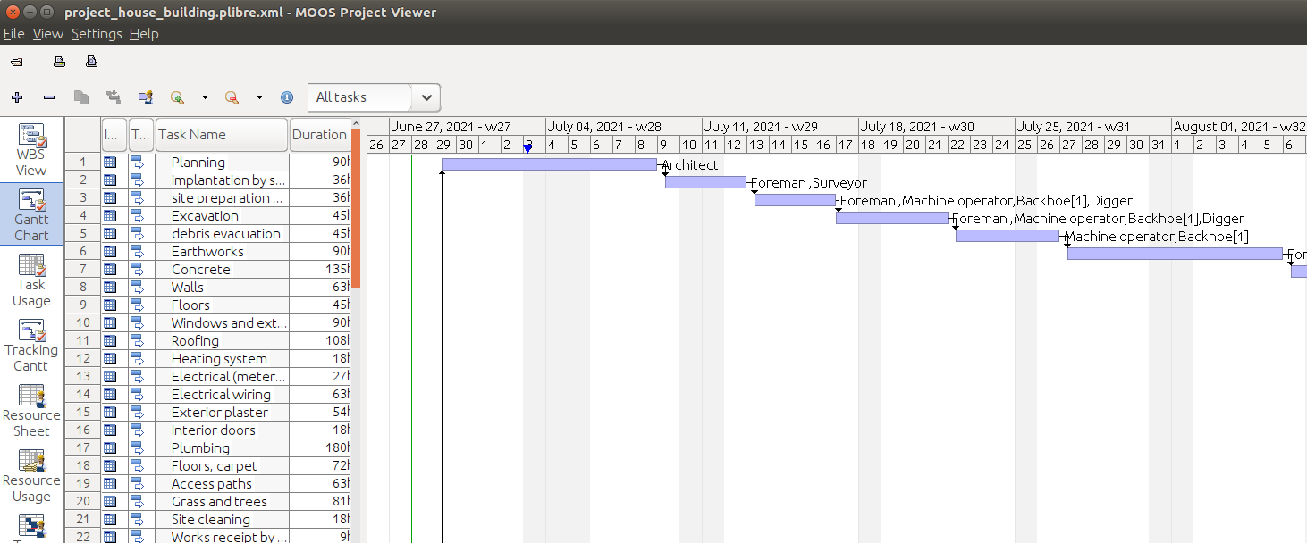

- your PlanLibre project is now imported, with minor glitches.

Limits
- Groups arent’t exported
- Milestone are, sometime, misplaced along the lines of the Gantt table (but the links remains OK).
- pictures (project logo, resources icons) aren’t exported.
- completed percents, productivity timer values aren’t exported

3 Productivity timer

3.1 Tomato timer
Everybody know this method : Tomato timer aka “pomodoro” timer. The principle is to alternate short working periods followed by short pauses. For example, 25 minutes of work, followed by a 5 minutes pause, then 25 minutes of work, and so on ...
This method is present in PlanLibre. Have a look on the top toolbar on “tasks” view :
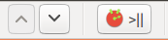
In order to unlock this timer, simply select a line with a task.
In order to use the timer, don’t forget to set-up the working and pause durations (by default 25 minutes and 5 minutes).
For that purpose, choose menu Edit>settings and go to “timer” page :

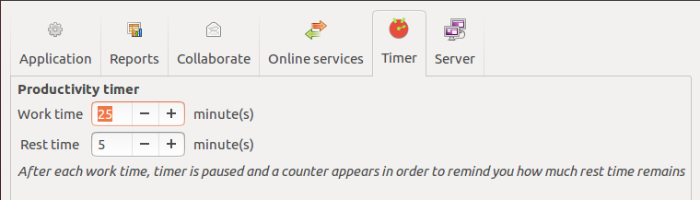
3.2 How work the tomato timer ?
First, switch to the “tasks” view. Then, click on the line displaying the task on which you want to work. Now, the “timer” button is unlocked.
Click on this button : the timer starts, and the time value is displayed and updated on statusbar of the main window. The time is displayed in the form minutes:seconds and a progress bar.

BE CAREFUL : if you click on the timer button, this stop the timer
Why ? Because the timer mechanism used by PlanLibre, according to “pomodoro” principles, is totally automatic. The timer mange itslef working period and pause periods.
For example, when a work run is completed, the status bar displays “pause”, and the counter displays the duration of the pause and not of the work.
Of course, since the pause is finished, the counter switches to “work” mode, and so on.
So, click on the timer button (top tool bar) only when you have finished to work.
In automatic mode, enjoy the pause ! Because since the pause duration is over, the timer switches automatically in “work” mode.
Internally, PlanLibre records the total time spent on each task (in case of use of the timer). For example, if you’ve spent two periods of 25 minutes on the task “weep”, PlanLibre records a total duration of 50 minutes on the task “sweep”
Those datas are stored with the project file, and displayed in “tasks” view. Don’t worry if the value displayed on “tasks” view isn’t updated in real time ; the “true” value is stored, and the correct value will be displayed if you modify the task or reload the file.

A gift : 10 free seconds
When the timer switches from work to pause, the switch isn’t on “cut” mode ; a 10 seconds period is interspersed

4 Retrieve a previous version of the project
In certain ways, this version is useful : for example, let’s imagine that you’ve made mistakes on the current project. And even worse, you’ve used quick saving function with the mistakes on the file ! What to do ? Go to menu Edit > Restart backup of the current project
Furthermore, PlanLibre will offer you to save the current version with your mistakes before reloading last backup version of your project.
Please note that after the reloading, the project will be named with an arbitrary name (please, see the title bar of the main window after reloading) and will be asked to save it with a new name.

This tool can produce miracles : it only reloads the last backup. Indeed, the backup is created when you load a project file. So, PlanLibre go back to the state of project at start of your session. Example : I open file « my_project ». PlanLibre backup it before any modification. Then I work on the file, and I see that I’ve made mistakes. I ask to reload the previous backup. Then it’s the copy of the file at session start which will be reloaded.
Be careful: when you use quick save, there isn’t a new backup
Conversely, a call to menu Save as … creates a new backup, a kind of snapshot of your project at the time when you use the saving function.

5. Synchronization with Trello®

5.1 Principes
It’s possible to do do partial export/synchronization from a PlanLibre project to a Trello “dashboard”. Let’s us explain the vocabulary.
PlanLibre vocabulary | Trello® vocabulary | Différences de fonctionnement | Constraints/limits for export
dashboard | board | PlanLibre can’t modify the name of the board ; the name exported is defined by project proprties | You must define a name for your projet (see menu project>properties) because this name becomes the name of the board in Trello®
Dashboard columns; it isn’t a true equivalent to Trello® | Lists | PlanLibre can’t modify lists names | During export, PlanLibre set-up 4 lists in Trello® ; they use the same title as the columns in PlanLibre. If you modify the Trellov® board, be careful to not change order of lists to avoid errors during later exports
tasks | Cards | PlanLibre isn’t centered of the dashboard view, contrary to Trello®.  Of course, you are free to drag’n’drop tasks between columns and modify tasks before export them to Trello® | None of extended datas from Trello® (example : atatched files) will be synchronized from PlanLibre. However they are protected during export, and remain presents in board.  PlanLibre exports tasks names and their due date (tou should notice a watch icon under Trello®). A simplified color code (red = thigh priority, orange = medium priority, green = low priority) is added as a label.
Milestones | Cards | Inside PlanLibre, milestones are hidden in dashboard view ; however, they are exported to Trello®, but as a “cards” | Milestones use a blue label
Groups | They aren’t exported to Trello® | - | -

Graphical comparison :
first, we show the dashboard under PlanLibre, below the resulting board under Trello® :

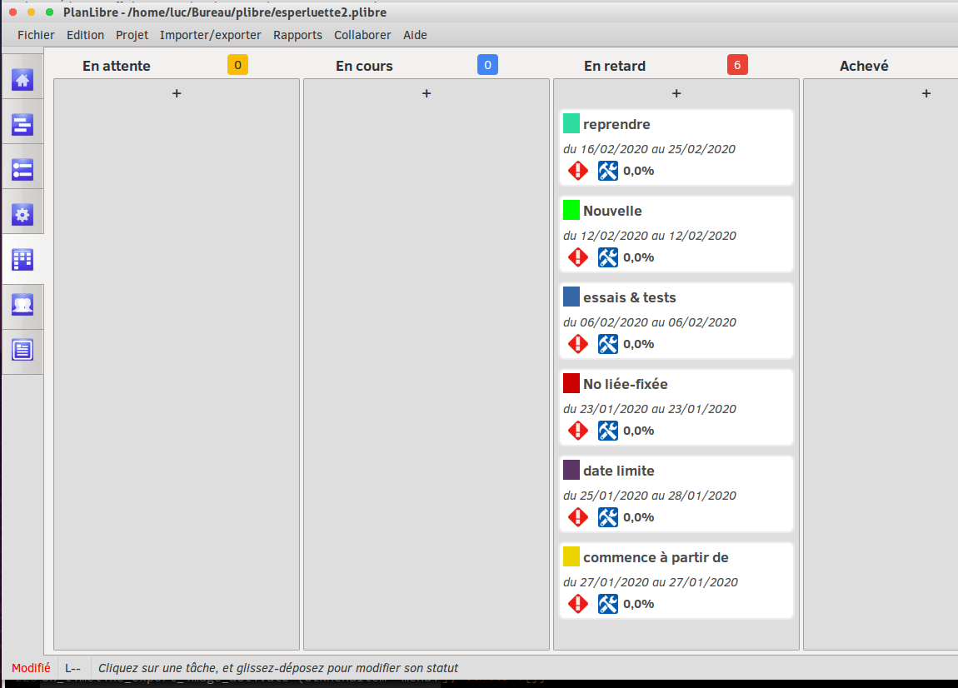

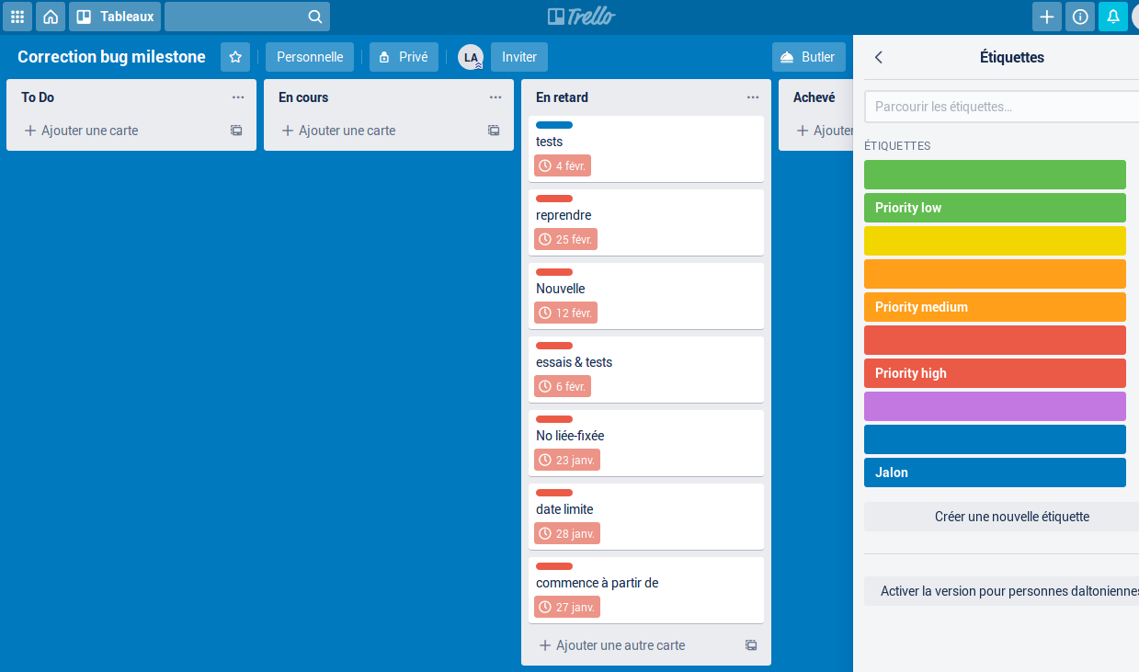

5.2 Settings
Here, we explain how to configure PlanLibre. First, we must allow PlanLibre the access to your Trello® account. This operation is done only once, after you’ve get your personnal user token from Trello®. It’s a kind of password, be careful !
Once done, you must fill datas in PlanLibre : see menu Edit>settings and choose the page Online Services.
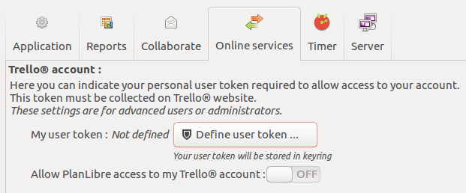

5.3 Export project to Trello®
Before any attempt to export, please (menu project>properties) check that the PlanLibre project has a name and that your are connected to Internet.

Export is straightforward : choose menu Import/Export > Export tasks to Trello® ...
If all it’s OK, a message box is displayed, or an error message if something wrong happened.
You can export various states of your project, but it’s not a true synchronization ! Datas go from PlanLibre to Trello®, never from Trello®.
Please notice that Planlibre set-up a new Trello® board for every export, the previous version remains on servers.
The tasks (or cards in Trello® vocabulary) uses and alarm, and your members on board should receive alerts from Trello® on their email adress, one day (d-1) the due date.

