**Developer Guide**

**jWebSocket**

**MapSensors**

**1.0**

# Introducción

The manual describes how to modify the developer and use the application code MapSensors developed on jWebSocket framework. This document has been created for software developers to create, assemble and deploy applications using the framework jWebSocket.

MapSensors location is an application that allows users to view a map in real time via the mobile Web, in addition to reference the current position of the mobile device. It differs from other applications of location because it works in real time through the new WebSocket protocol that makes it possible. It was developed using the framework jWebSocket, allowing the user to view the potential for locating jWebSocket in real time.

# Infrastructure of solution

img\diagrama.jpg

* The application MapSensors consumes features libraries JavaScript PhoneGap and OpenLayers.
* The application MapSensors receives and sends data through the client jWebSocket
* The server contains the plugin jWebSocket the application that is responsible for managing the maps with the map server.
* **2. Requirements and prerequisites**
* Resource requirements
  + Smartphone with OS Android 2.3.3 or higher.
  + WIFI Wireless Access Point.
* Equipping
  + SDK android 2.3.3
  + Plugin ADT-12
  + GeoServer map server
  + Eclipse Helios

# Modularization of the application

* 1. **The client side**

|  |  |
| --- | --- |
| Nombredelproyecto: | MapSensors |
| LocalizacióndelasfuentesenelservidorSVN: | http://repo.hab.uci.cu/svn/tesis/Tercer_Corte_de_Tesis/JWS/Carlos_Karen/Codigo/ |
| SVNbranch: | jWebSocket-1.0 |
| Módulo: | MapSensors.apk |
| Estructura de los paquetes | img\Developer\cliente_js.png |
| Phonegap-1.1.0.js  Libreri JavaScript of PhonGap | |
| Main.js:  Contains the definition and implementation of the application of maps and sensors. | |
| Base64:  Contains the libraries responsible for converting a String to an image in base64. | |
| OpenLayers:  Contains the definition and implementation of the library Openlayers | |
| Websocket:  Contains the implementation of the classes responsible for performing communication with the server. | |
| Master.css , index.html:  Containing the definition of the application for the control of the interface. | |

* 1. **The Server Side**

The server has a plugin jWebSocket receiving requests from users and performs MapSensors request to Geoserver server to respond to users. This server is structured as follows.

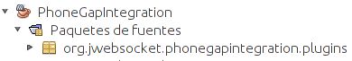

# Source code structure

# Client:

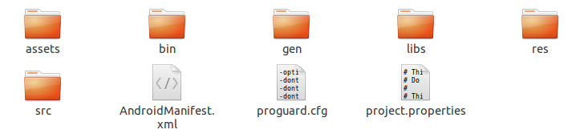

# Description of the elements:

assets: This directory stores files that are part of the solution of the source code for the web, html files, js and css.

bin: In this directory the file is generated. Apk which is the application executable.

libs: Directory where you copied. Jar to be loaded by the application.

src: This directory stores files with source code (. Java) that are part of the solution

AndroidManifest.xml: Configuration file the application.

gen, res, proguard.cfg, proyect.properties: Folders and files are automatically created when you build a NetBeans project.

# Libraries and tools used

**On the client side:**

The libraries and classes for the extension MapSensors clients are available in Java and JavaScript files. The requirements of external libraries in the client side are:

|  |  |
| --- | --- |
| **Library** | **Description** |
| OpenLayers | Version 2.1.1 |
| Phonegap | Version 1.1.0 |

# Standard code

View Template Code Standard:

[http://repo.hab.uci.cu/svn/tesis/JWS/Carlos_Karen_Cespedes/artefactos_arreglados/Plantilla Estandar de codigo.doc](http://repo.hab.uci.cu/svn/tesis/JWS/Carlos_Karen_Cespedes/artefactos_arreglados/Plantilla%20Estandar%20de%20codigo.doc)

# Libraries and Tools used

* Framework PhoneGap, MIT License.
* Framework OpenLayers, the BSD license
* SDK Android 2.3.3
* Plugin ADT-12

# Hardware requirements

To use the application for location management in mobile web, developed with the framework jWebSocket must have the following features in the work environment:

* Smartphone with operating system Android 2.3.3

# Network protocol used

The application of location through the mobile web with the framework developed jWebSocket, used to establish the protocol comunicaciónel WebSocket technology that provides a bidirectional communication channel and full-duplex over a single TCP socket.

# Detailed description of the application code

**11.1 Server:**

The basic methods in the plugin on the server are:

ProcessToken: Receive incoming requests from any client WebSocket

img\Developer\processToken.png

getURLData: Get the url of an image, performs the request and returns it converted to a String.

img\Developer\getURLData.bmp

**Client:**

The methods on the client side that describe the most important features are:

openWebSocket: Set the connection to the server.

img\Developer\openWebsocket.png

map: Allows load map for proper display.

img\Developer\map.png

moveFeature: Moves the given feature in the given map.

img\Developer\moveFeature.png

rotateFeature: Rotates a given feature

img\Developer\rotateFeature.png

toggleAcceleration: Capture the event of acceleration sensor

img\Developer\toggleAcceleration.png

getLocation: Subscribes to the events of gps.

img\Developer\getLocation.png