# User Guide

**jWebsocket.**

**MapSensors**

**1.0**

1. **Characteristics of the solution**

MapSensors permite a los usuarios conectados visualizar en un mapa su ubicación en tiempo real mediante la web móvil. Se diferencia de otras aplicaciones de localización porque esta trabaja en tiempo real a través del nuevo protocolo WebSocket que lo hace posible. La aplicación se desarrolló sobre el marco de trabajo jWebSocket, permitiendo que el usuario pruebe el potencial de jWebSocket para la localización en tiempo real.

El nivel de escalabilidad de las conexiones soportadas por los servidores jWebSocket permite alta concurrencia de usuarios. Pruebas de estrés realizadas a un servidor jWebSocket arrojan como resultado 10 000 conexiones concurrentes sin afectar el tiempo de respuesta de la aplicación. Este elemento garantiza no solo realizar procesos en tiempo real sino poder garantizar un alto número de usuarios utilizando un mismo servicio en el mismo instante de tiempo.

Allows users MapSensors connected on a map displaying Their location in real time via the mobile web. It differs from other location-based Applications Because it works in real time-through the new WebSocket protocol That Makes it possible. The application framework on the WAS Developed jWebSocket, Allowing the user to test the Potential for real time locating in jWebSocket.

The scalability of the servers connections supported by high user concurrency Allows jWebSocket. Stress Tests Performed to a server as a result jWebSocket shed 10 000 concurrent connections without Affecting the response time of the application. This element not only Perform Ensures real-time process to Ensure But to high number of users using the Same service at the Same instant of time.

**2. Main funcionalities**

**Demo MapSensors functionality:**

**1. Management satellite tracking**

**2. Share real-time location**

**3. Calculation of travel speed**

**4. Display orientation.**

This solution can be used in dissimilar areas of society, as at present trend is the use of tracking systems, due to ease of use and how useful.

**3. Problems to be solved**

|  |  |
| --- | --- |
| **Problem** | **Contributions of the solution** |
| Later in the process of disseminating coordinates on the mobile web | MapSensors allows coordinates spread through the mobile Web in real time through WebSocket protocol. |
| Translation speed calculation is not performed by the accelerometer device. | MapSensors gives the possibility of calculating the speed at which the device is moved by the accelerometer. |

**4. Glossary**

Real-Time on the Web: The real time on the Web is defined as a set of technologies and practices that allow users to receive information as soon as published by their authors, rather than checking a source of regular updates. Replacing request/response mechanisms by permanent connections with less latency and protocol overhead.

Mobile Web: Web access from devices whose main characteristic is the mobility.

WebSocket: is a technology that provides a bidirectional communication channel and full-duplex over a single socket TCP (Transmission Control Protocol), addresses the limitations of the HTTP protocol by establishing a full-duplex communication (TCP) between the client and server, replacing the half-duplex communication (HTTP).

Full-Duplex: A full-duplex allows communication in both directions, and, unlike half-duplex, allows this to happen simultaneously.

Socket: A method for communication between a client program and a server program on a network.

jWebSocket framework: is a new technology aiming to develop WebSockets based applications that provide high levels of speed, scalability, security and real-time work.

Half-Duplex: It means that the method or protocol for transmission of information is bidirectional but not simultaneously, and in http the server can only send data after the client request them.

**5. Model of the solution**

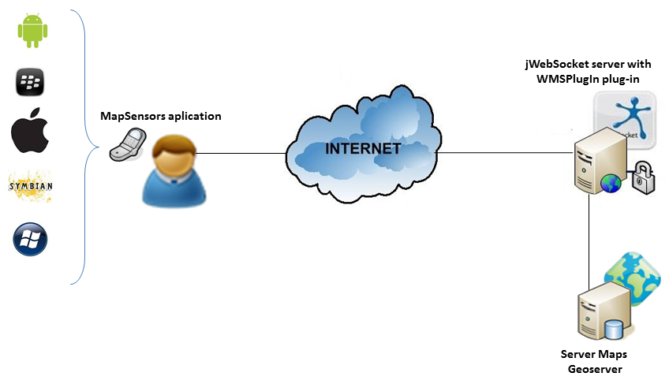

Para acceder a MapSensors el cliente debe utilizar dispositivo móvil con un navegador que soporte el protocolo WebSocket. Luego debe autenticarse en la aplicación para comenzar a interactuar en MapSensors. El cliente envía al servidor jWebSocket las peticiones de imagen y este se encarga de gestionarlas con el servidor de mapas.

To access the MapSensors the client should use mobile device with a browser that supports WebSocket protocol. The client sends requests to the server jWebSocket image and this is responsible for managing them with the map server

**7. Requirements for Use**

To use MapSensors must have a mobile device with Internet connection, you must also have the android OS 2.3.3 or higher and have the physical devices accelerometer and GPS. It must also be running the application server.

**8. Roles of the solution**

User: You can log in and see how is the localization process.

**9. System Operation**

**Main application view**

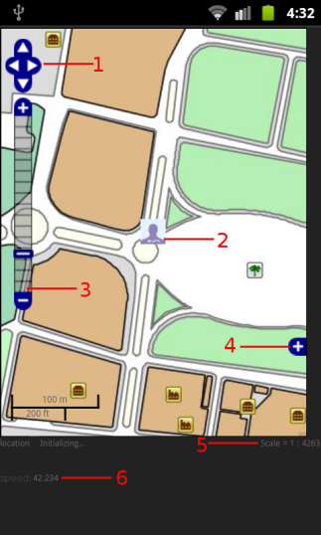

1 --------- Buttons in the display to scroll the map

2 ------- Image representing the location

3--------- Zoom bar

4 ------- Reference map in the lower right corner of the map

5 ------- Scale at which the map is being displayed

6 ------- The speed at which you move the device.

**9. Configurations of the solution**

It does not require specific configurations.

**10. Rules of the solution**

R1: If the user does not have GPS connection enabled the system issues an error message and does not continue with the normal flow. Solution: The user must activate the device's GPS connection to achieve the full flow of the Location functionality.

R2: If the user does not have WIFI enabled the system issues an error message and does not continue with the normal flow. Solution: The user must activate the device's WiFi connection to get the full flow of the Location functionality.