Skip to main content

Global Knowledge

M55341A | Lab 3

Top of Form

Bottom of Form

M55341A | Lab 3

* [Home](https://gk.labsonline.it/Labs/DelegateLab/81655965-cb7d-ef11-9561-00155d800002)
* [Lab Guide](https://gk.labsonline.it/Labs/DelegateLab/81655965-cb7d-ef11-9561-00155d800002)

 Lab Guide

Lab 3: Implementing enterprise storage solutions

Lab A: Planning and configuring storage technologies and components

**Scenario**

You are a Storage Administrator in Adatum Corporation, and part of your job is to ensure that your data storage systems meet both short-term and long-term business needs that evolve regularly.

Exercise 1: Planning storage requirements

**Scenario**

The Adatum Corporation wants to design new storage solutions to support several recent changes. These changes include:

* External customers are using web applications more, and these customers need more and new business services.
* Internal users need more support and internal infrastructure services.
* Requirements for managing block-level storage and shared file access have expanded.
* A recently acquired company uses a different IT infrastructure than Adatum. The IT department now needs to manage a mixed environment that includes remote geographical areas in London, New York, and Japan.
* The cost of storage has decreased significantly over recent years.
* The amount of data produced by Adatum business groups has increased even faster.

Task 1: Read the supporting documentation

* Read the supporting documentation in the lab exercise scenario.

Task 2: Record your planned course of action

1. **You plan to evaluate iSCSI, Fibre Channel, and InfiniBand solutions to meet the requirements. Which solution do you expect to select?**

You would not use InfiniBand because the requirements call for reasonable performance and low cost. InfiniBand is for high‑performance solutions, and it is expensive. Meanwhile, of the two remaining choices, iSCSI most closely matches the low cost and reasonable performance requirements that you expect. You should deploy an iSCSI solution to each of the geographic locations that has an IT infrastructure and that requires storage.

1. **Which storage type do you plan to implement for the SQL databases, block-level storage or file-level storage?**

Based on the requirements alone, you could use either type, because each has advantages and disadvantages. SQL databases can run SMB file shares since the release of SMB 3.0/3.1, and the overall performance is similar to that of block-level storage. The answer might depend on whether you have an existing highly available SMB file server infrastructure and whether the server team or the storage team will manage the storage.

1. **How will your solution minimize administrative overhead for the storage administrators?**

By selecting iSCSI, you avoid the complexities of Fibre Channel and InfiniBand solutions. In addition, an iSCSI solution requires less hardware and less software. All of these choices reduce the administrative overhead for the storage administrators.

1. **Which server role(s) do you plan to use for the provisioning of VMWare ESX/ESXi virtual machines?**

You can use the Server for NFS role to create NFS file shares that VMWare ESX/ESXi virtual machines support.

1. **Will you run the Hyper‑V in Windows Server 2012 virtual machines on NFS or SMB?**

The Hyper‑V virtual machines can run on SMB, but NFS does not support them. As a result, you will need to run the virtual machines on SMB.

1. **Which file sharing protocol will you use for UNIX clients that require access?**

Historically, NFS was the protocol of choice for UNIX clients to access file shares. However, today most UNIX clients equally support NFS and SMB natively. Therefore, you can use either of the technologies. If you have an existing NFS file sharing deployment, you would likely choose NFS. If you have an existing SMB file sharing deployment, you would likely choose SMB.

1. **How do you plan to disable legacy SMB access for existing SMB file shares?**

First, you need to locate all the existing file servers that have legacy SMB shares. You can check for legacy shares on the current host by using the following command at a Windows PowerShell prompt:

Get-SmbServerConfiguration | Select EnableSMB1Protocol

You also can create a Windows PowerShell script to check for legacy shares on all the file servers.

1. After you have located all of the existing file servers that have legacy SMB shares, you need to disable the SMB access. You can disable the SMB 1 protocol on each server by using the following command:
2. Set-SmbServerConfiguration ‑EnableSMB1Protocol $false

You also can create a Windows PowerShell script to disable legacy SMB access across all of your servers.

**Results**: After completing this exercise, you should have successfully planned a storage solution that will meet your organization's requirements.

Exercise 2: Configuring iSCSI storage

**Scenario**

You need to implement highly available iSCSI storage by using MPIO. There are two independent network paths between the file server and the iSCSI target. You will configure MPIO to use both paths to provide redundancy at the network level.

The main tasks for this exercise are as follows:

1. Install the iSCSI target feature.
2. Create and configure an iSCSI target.
3. Configure MPIO.
4. Connect to the iSCSI target.
5. Initialize the iSCSI disks.

Task 1: Install the iSCSI target feature

1. Switch to [**LON-STOR1**](urn:gd:lg:a:select-vm)
2. Send the [**CTRL+ALT+DEL**](urn:gd:lg:a:send-vm-key-combo) command and login on as **[Adatum\AdatumAdmin](urn:gd:lg:a:send-vm-keys" \o "Paste text into VM)** with the password [**Pa55w.rd**](urn:gd:lg:a:send-vm-keys).
3. Click the **Start** menu and open **Server Manager**, select **Manage**, and then click **Add Roles and Features**.

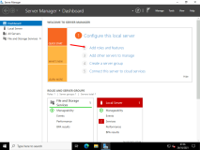

1. In the **Add Roles and Features Wizard**, on the **Before you begin** page, click **Next**.

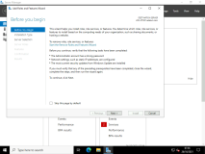

1. On the **Select installation type** page, click **Next**.

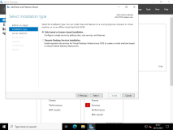

1. On the **Select destination server** page, ensure that **Select a server from the server pool** is selected, and then click **Next**.

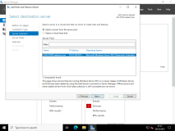

1. On the **Select server roles** page, expand **File and Storage Services (1 of 12 Installed)**, expand **File and iSCSI Services**, select the **iSCSI Target Server** check box, click Add features and then click **Next**.

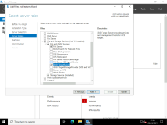

1. On the **Select features** page, click **Next**.

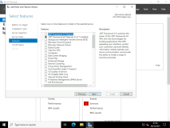

1. On the **Confirm installation selections** page, click **Install**.

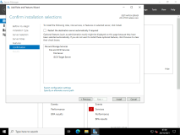

1. When the installation completes, click **Close**.

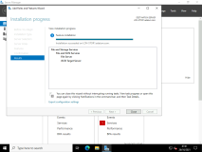

Task 2: Create and configure an iSCSI target

1. On [**LON-STOR1**](urn:gd:lg:a:select-vm), in Server Manager, in the navigation pane, click **File and Storage Services**.

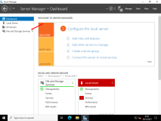

1. In the **File and Storage Services** pane, click **iSCSI**.

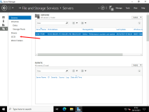

1. In the **iSCSI VIRTUAL DISKS** pane, click **TASKS**, and then click **New iSCSI Virtual Disk**.

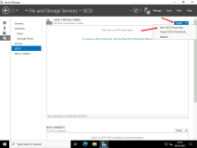

1. In the **New iSCSI Virtual Disk Wizard**, on the **Select iSCSI virtual disk location** page, under **Storage location**, click volume **C:**, and then click **Next**.

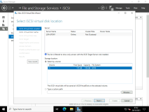

1. On the **Specify iSCSI virtual disk name** page, in the **Name** text box, type [**iSCSIDisk1**](urn:gd:lg:a:send-vm-keys), and then click **Next**.

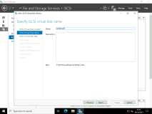

1. On the **Specify iSCSI virtual disk size** page, in the **Size** text box, type [**5**](urn:gd:lg:a:send-vm-keys), ensure that **GB** is selected, and then click **Next**.

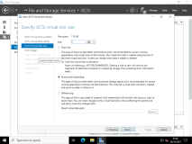

1. On the **Assign iSCSI target** page, ensure that the **New iSCSI target** option is selected, and then click **Next**.

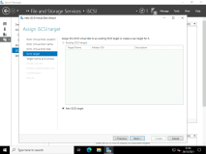

1. On the **Specify target name** page, in the **Name** box, type [**LON‑STOR1**](urn:gd:lg:a:send-vm-keys), and then click **Next**.

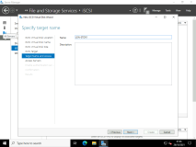

1. On the **Specify access servers** page, click **Add**.

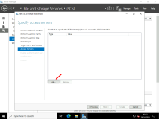

1. In the **Select a method to identify the initiator** dialog box, click **Enter a value for the selected type**, in the **Type** list, click **IP Address**, in the **Value** text box, type [**10.10.100.21**](urn:gd:lg:a:send-vm-keys), and then click **OK**.

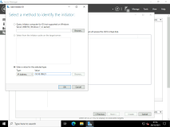

1. On the **Specify access servers** page, click **Add**.

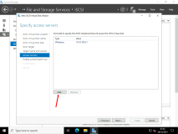

1. In the **Select a method to identify the initiator** dialog box, click **Enter a value for the selected type**, in the **Type** list, click **IP Address**, in the **Value** text box, type [**10.10.100.22**](urn:gd:lg:a:send-vm-keys), and then click **OK**.

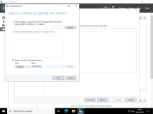

1. On the **Specify access servers** page, click **Next**.

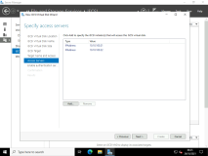

1. On the **Enable Authentication** page, click **Next**.

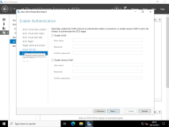

1. On the **Confirm selections** page, click **Create**.

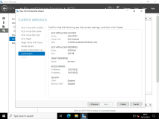

1. On the **View results** page, wait until the virtual disk is created, and then click **Close**.

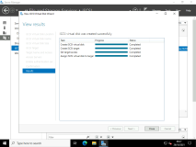

1. In the **iSCSI VIRTUAL DISKS** pane, click **TASKS**, and then click **New iSCSI Virtual Disk**.

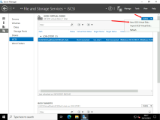

1. In the **New iSCSI Virtual Disk Wizard**, on the **Select iSCSI virtual disk location** page, under **Storage location**, click volume **C:**, and then click **Next**.

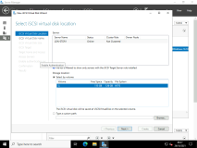

1. On the **Specify iSCSI virtual disk name** page, in the **Name** box, type [**iSCSIDisk2**](urn:gd:lg:a:send-vm-keys), and then click **Next**.

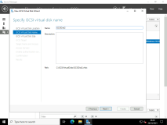

1. On the **Specify iSCSI virtual disk size** page, in the **Size** box, type [**5**](urn:gd:lg:a:send-vm-keys), ensure that **GB** is selected, and then click **Next**.

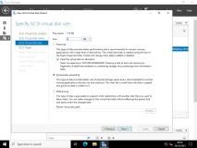

1. On the **Assign iSCSI target** page, click **lon‑stor1**, and then click **Next**.

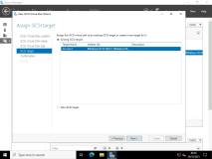

1. On the **Confirm selections** page, click **Create**.

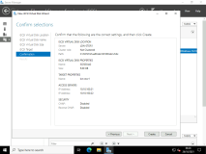

1. On the **View results** page, wait until the virtual disk is created, and then click **Close**.

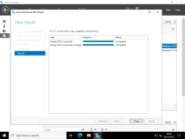

Task 3: Configure MPIO

1. Switch to [**LON-SVR1**](urn:gd:lg:a:select-vm)
2. Send the [**CTRL+ALT+DEL**](urn:gd:lg:a:send-vm-key-combo) command and login on as **[Adatum\AdatumAdmin](urn:gd:lg:a:send-vm-keys" \o "Paste text into VM)** with the password [**Pa55w.rd**](urn:gd:lg:a:send-vm-keys)

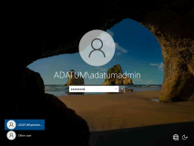

1. Click **Start** and select **Server Manager**

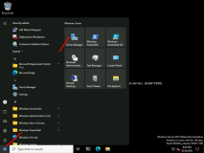

1. In Server Manager, click the **Manage** menu, and then click **Add Roles and Features**.

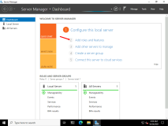

1. In the **Add Roles and Features Wizard**, on the **Before you begin** page, click **Next**.

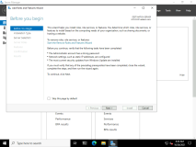

1. On the **Select installation type** page, click **Next**.

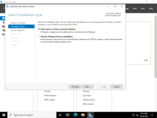

1. On the **Select destination server** page, ensure that **Select a server from the server pool** is selected, and then click **Next**.

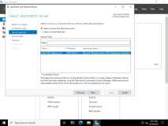

1. On the **Select server roles** page, click **Next**.

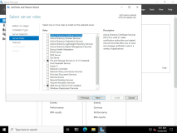

1. On the **Select features** page, click **Multipath I/O**, and then click **Next**.

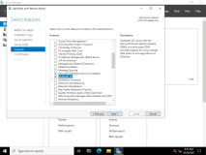

1. On the **Confirm installation selections** page, click **Install**.

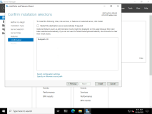

1. When installation is complete, click **Close**.

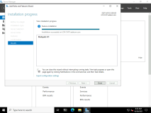

1. Restart **LON-SVR1**, and then send the [**CTRL+ALT+DEL**](urn:gd:lg:a:send-vm-key-combo) command and login on as **[Adatum\AdatumAdmin](urn:gd:lg:a:send-vm-keys" \o "Paste text into VM)** with the password [**Pa55w.rd**](urn:gd:lg:a:send-vm-keys)
2. Click **Start**, and then click **Server Manager**.

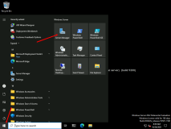

1. In **Server Manager**, on the menu bar, click **Tools**, and then click **iSCSI Initiator**.

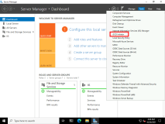

1. In the **Microsoft iSCSI** dialog box, click **Yes**.

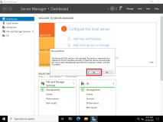

1. In the **iSCSI Initiator Properties** dialog box, on the **Targets** tab, in the **Target** box, type [**10.10.100.201**](urn:gd:lg:a:send-vm-keys), and then click **Quick Connect**.

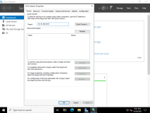

1. In the **Quick Connect** box, click **Done**.

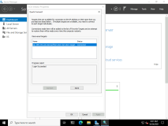

1. In the **iSCSI Initiator Properties** dialog box, to close the dialog box, click **OK**.

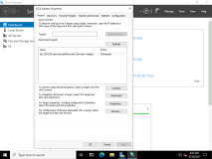

1. In Server Manager, on the menu bar, click **Tools**, and then click **MPIO**.

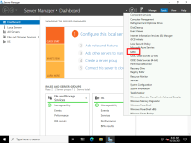

1. In the **MPIO Properties** dialog box, on the **Discover Multi-Paths** tab, select **Add support for iSCSI devices**, and then click **Add**.

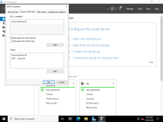

1. When prompted click **OK** twice.

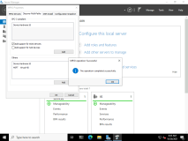

1. Restart **LON-SVR1**, and then send the [**CTRL+ALT+DEL**](urn:gd:lg:a:send-vm-key-combo) command and login on as **[Adatum\AdatumAdmin](urn:gd:lg:a:send-vm-keys" \o "Paste text into VM)** with the password [**Pa55w.rd**](urn:gd:lg:a:send-vm-keys)
2. Click **Start**, and then click **Server Manager**.

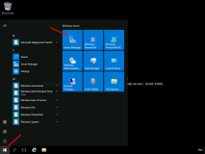

1. In Server Manager, on the menu bar, click **Tools**, and then click **MPIO**.

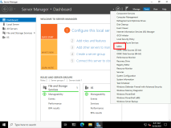

1. In the **MPIO Properties** dialog box, on the **MPIO Devices** tab, notice that **Device Hardware Id MSFT2005iSCSIBusType_0x9** has been added to the list.

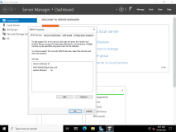

1. In the **MPIO Properties** dialog box, to close the dialog box, click **OK**.

Task 4: Connect to the iSCSI target

1. On [**LON-SVR1**](urn:gd:lg:a:select-vm), in Server Manager, on the menu bar, click **Tools**, and then click **iSCSI Initiator**.

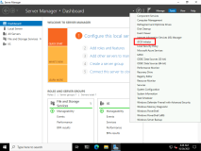

1. In the **iSCSI Initiator Properties** dialog box, on the **Targets** tab, click **Disconnect**.

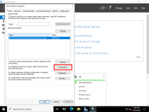

1. In the **Disconnect From All Sessions** dialog box, click **Yes**.

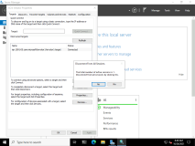

1. In the **iSCSI Initiator Properties** dialog box, on the **Targets** tab, click **Connect**.

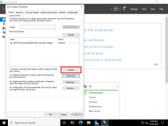

1. In the **Connect To Target** dialog box, select the **Enable multi-path** check box, verify that the **Add this connection to the list of Favorite Targets** check box is selected, and then click **Advanced**.

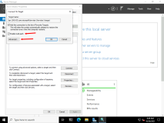

1. In the **Advanced Settings** dialog box, on the **General** tab, change the **Local adapter** from **Default** to **Microsoft iSCSI Initiator**.

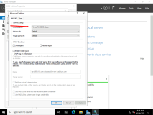

1. In the **Initiator IP** list, select **10.10.100.21**.

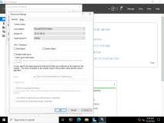

1. In the **Target portal IP** list, click **10.10.100.201 / 3260**.

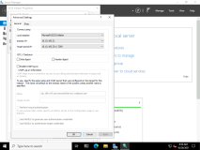

1. In the **Advanced Settings** dialog box, click **OK**.
2. In the **Connect To Target** dialog box, click **OK**.
3. In the **iSCSI Initiator Properties** dialog box, on the **Volumes and Devices** tab, click **Auto Configure**.

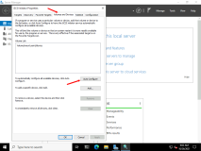

1. In the **iSCSI Initiator Properties** dialog box, on the **Targets** tab, in the **Targets** list, select **iqn.1991-05.com.microsoft:lon‑stor1-lon‑stor1-target**, and then click **Devices**.

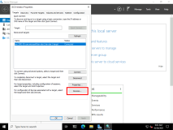

1. In the **Devices** dialog box, click **MPIO**.

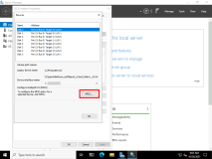

1. Verify that in **Load balance policy**, **Round Robin** is selected.

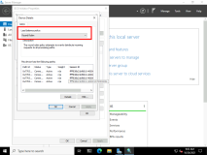

1. Under **This device has the following paths**, notice that two paths are listed. Select the first path, and then click **Details**.
2. Note the IP address of the source and target portals, and then click **OK**.
3. Select the second path, and then click **Details**.
4. Verify that this path is using another network, and then click **OK**.

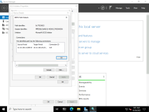

1. In the **Device Details** dialog box, click **OK**.
2. In the **Devices** dialog box, click **OK**.
3. In the **iSCSI Initiator Properties** dialog box, click **OK**.

Task 5: Initialize the iSCSI disks

1. On [**LON-SVR1**](urn:gd:lg:a:select-vm), in Server Manager, click **File and Storage Services**, and then in the left pane, click **Disks**.
2. In the right pane, right-click an offline disk with a bus type of **iSCSI**, and then click **Bring Online**.

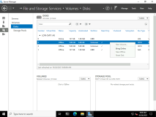

1. In the **Bring Disk Online** dialog box, click **Yes** to bring the disk online.

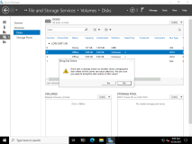

1. Right-click the iSCSI disk that you brought online, and then click **New Volume**.

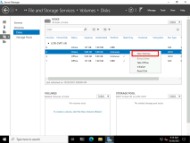

1. In the **New Volume Wizard**, on the **Before you begin** page, click **Next**.

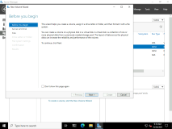

1. On the **Select the server and disk** page, ensure that your iSCSI disk is selected, and then click **Next**.

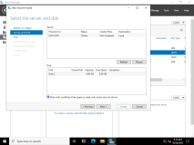

1. In the **Offline or Uninitialized Disk** dialog box, to initialize the disk as a GPT disk, click **OK**.

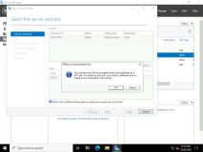

1. On the **Specify the size of the volume** page, to accept the default of using the entire disk size for the volume, click **Next**.

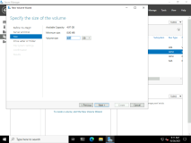

1. On the **Assign to a drive letter or folder** page, in the **Drive letter** list, select **J**, and then click **Next**.

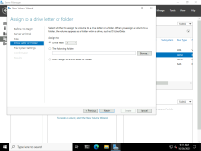

1. On the **Select file system settings** page, in the **Volume label** text box, type **[SMBShares](urn:gd:lg:a:send-vm-keys" \o "Paste text into VM)**, and then click **Next**.

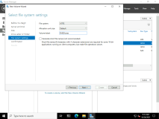

1. On the **Confirm selections** page, to finish creating the volume, click **Create**.

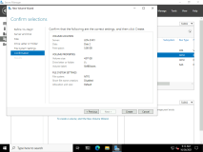

1. After the volume is created, on the **Completion** page, click **Close**.

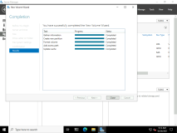

1. In Server Manager, in the right pane, right-click the remaining offline disk with a bus type of iSCSI, and then click **Bring Online**.

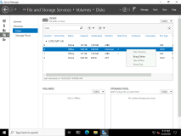

1. In the **Bring Disk Online** dialog box, to bring the disk online, click **Yes**.

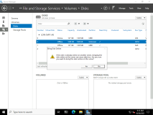

1. Right-click the iSCSI disk that you brought online, and then click **New Volume**.

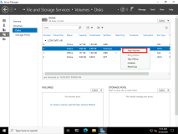

1. In the **New Volume Wizard**, on the **Before you begin** page, click **Next**.

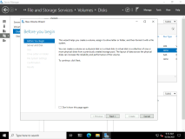

1. On the **Select the server and disk** page, ensure that your iSCSI disk is selected, and then click **Next**.

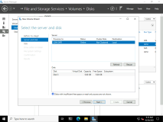

1. In the **Offline or Uninitialized Disk** dialog box, to initialize the disk as a GPT disk, click **OK**.

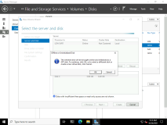

1. On the **Specify the size of the volume** page, click **Next** to accept the default of using the entire disk size for the volume.

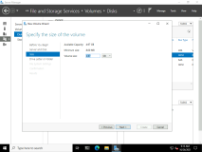

1. On the **Assign to a drive letter or folder** page, in the **Drive letter** list, select **K**, and then click **Next**.

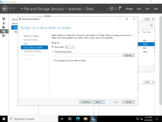

1. On the **Select file system settings** page, in the **File system** box, select **NTFS**.
2. In the **Volume label** text box, type **[NFSShares](urn:gd:lg:a:send-vm-keys" \o "Paste text into VM)**, and then click **Next**.

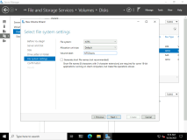

1. On the **Confirm selections** page, to finish creating the volume, click **Create**.

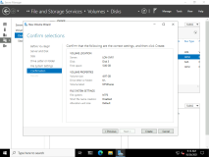

1. After the volume is created, on the **Completion** page, click **Close**.

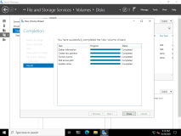

1. On the taskbar, click **File Explorer**, browse to **This PC**, and then verify that the **SMBShares** and **NFSShares** volumes are displayed.

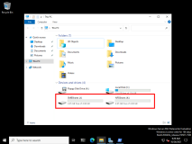

**Results** : After completing this exercise, you should have successfully configured an iSCSI target that uses MPIO for redundancy.

Exercise 3: Configuring and managing the share infrastructure

**Scenario**

After configuring iSCSI storage for LON-SVR1, you need to create shares to support clients that are running both Windows and Linux operating systems.

The main tasks for this exercise are as follows:

1. Install the File Server role
2. Create an SMB share on iSCSI storage.
3. Create an NFS share on iSCSI storage.
4. Use Windows PowerShell to view share information.
5. Disable the legacy SMB1 protocol.

Task 1: Install the File Server role

1. Right click the Start menu and open **Windows PowerShell (Admin)**.
2. Run the the following command to install the File Server and NFS Server role.
3. Install-WindowsFeature FS-Fileserver,FS-NFS-Service
4. Return to **Server Manager** and select the refresh button.

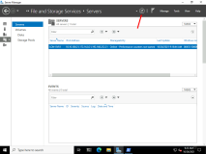

Task 2: Create an SMB share on iSCSI storage

1. On [**LON-SVR1**](urn:gd:lg:a:select-vm), in Server Manager, in the navigation pane, click **File and Storage Services**, and then click **Shares**.

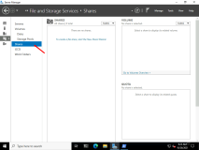

1. In the **SHARES** area, click **TASKS**, and then click **New Share**.

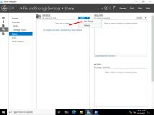

1. In the **New Share Wizard**, on the **Select the profile for this share** page, in the **File share profile** box, click **SMB Share - Quick**, and then click **Next**.

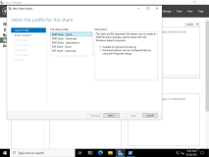

1. On the **Select the server and path for this share** page, select **LON-SVR1**, click **Select by volume**, click **J:**, and then click **Next**.

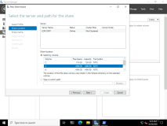

1. On the **Specify share name** page, in the **Share name** box, type [**Data**](urn:gd:lg:a:send-vm-keys), and then click **Next**.

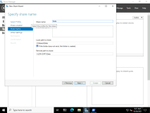

1. On the **Configure share settings** page, select the **Enable access-based enumeration** check box, and then click **Next**.

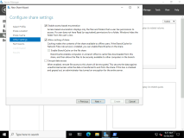

1. On the **Specify permissions to control access** page, click **Customize permissions**.

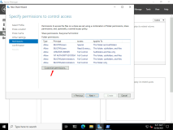

1. In the **Advanced Security Settings for Data** window, on the **Permissions** tab, click **Add**.

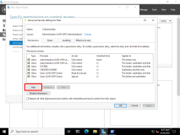

1. In the **Permission Entry for Data** window, click **Select a principal**, type [**Domain Users**](urn:gd:lg:a:send-vm-keys), and then click **OK**.

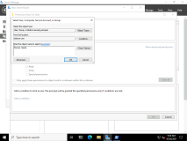

1. In the **Basic permissions** area, select the **Modify** check box, and then click **OK**.

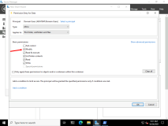

1. In the **Advanced Security Settings for Data** window, click **OK**.

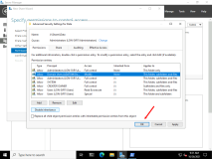

1. On the **Specify permissions to control access** page, click **Next**.

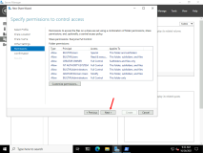

1. On the **Confirm selections** page, click **Create**.

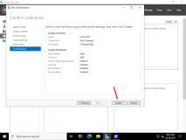

1. When the creation of the share is complete, click **Close**.

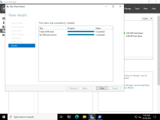

Task 3: Create an NFS share on iSCSI storage

1. On [**LON-SVR1**](urn:gd:lg:a:select-vm), in the **SHARES** area, click **TASKS**, and then click **New Share**.

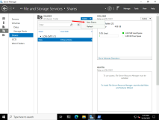

1. In the **New Share Wizard**, on the **Select the profile for this share** page, in the **File share profile** box, click **NFS Share - Quick**,and then click **Next**.

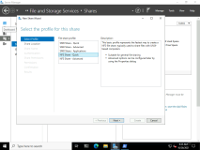

1. On the **Select the server and path for this share** page, click **LON-SVR1**, click **Select by volume**, click **K:**, and then click **Next**.

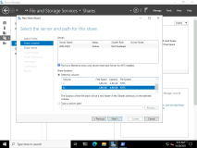

1. On the **Specify share name** page, in the **Share name** box, type **[LinuxData](urn:gd:lg:a:send-vm-keys" \o "Paste text into VM)**, and then click **Next**.

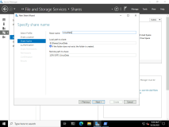

1. On the **Specify authentication methods** page, select **Kerberos v5 authentication(Krb5)**, and then click **Next**.

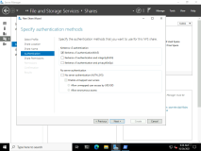

1. On the **Specify the share permissions** page, click **Add**.

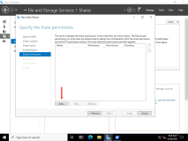

1. In the **Add Permissions** window, click **All Machines**.

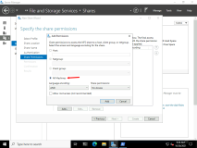

1. In the **Share permissions** box, select **Read / Write**, and then click **Add**.

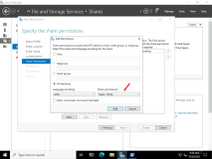

1. On the **Specify the share permissions** page, click **Next**.

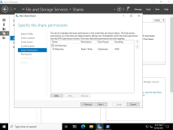

1. On the **Specify permissions to control access** page, click **Next**.

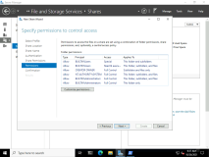

1. On the **Confirm selections** page, click **Create**.

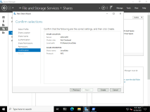

1. On the **View results** page, click **Close**.

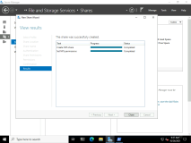

Task 4: Use Windows PowerShell to view share information

1. Switch to [**LON-STOR1**](urn:gd:lg:a:select-vm), then on the taskbar, click **File Explorer**.

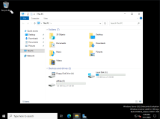

1. In **File Explorer**, in the address bar, type [**\\LON-SVR1\Data**](urn:gd:lg:a:send-vm-keys), and then press Enter.

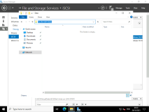

1. Click the **Home** tab, click **New item**, and then click **Text Document**.

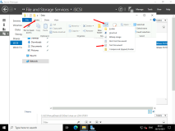

1. Type **[NewFile](urn:gd:lg:a:send-vm-keys" \o "Paste text into VM)**, and then press Enter to rename the document.

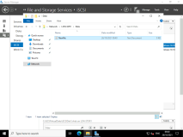

1. Double-click **NewFile.txt** to open it in Notepad.

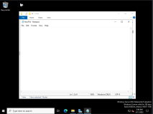

1. Leave Notepad open for later in the task.
2. Return to [**LON-SVR1**](urn:gd:lg:a:select-vm), right-click **Start**, and then click **Windows PowerShell (Admin)**.

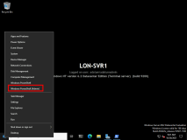

1. At the Windows PowerShell prompt, type the following command, and then press Enter:
2. Get-NfsShare | FL

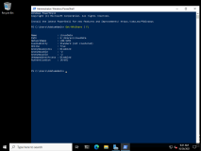

1. Type the following command, and then press Enter:
2. Get-NfsShare LinuxData | FL

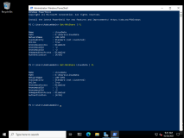

1. Type the following command, and then press Enter:
2. Get-SmbShare

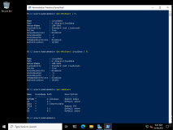

1. Type the following command, and then press Enter:
2. Get-SmbShare **Data** | FL

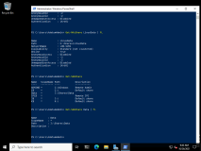

1. Type the following command, and then press Enter:
2. Get-SmbSession

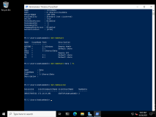

1. Type the following command, and then press Enter:
2. Get-SMBSession -ClientUserName Adatum\AdatumAdmin | FL

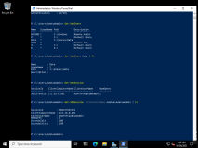

1. Type the following command, and then press Enter:
2. Get-SmbOpenFile

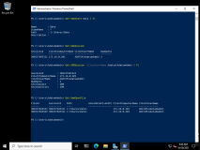

**Note:** There are two entries for **Adatum\AdatumAdmin**. File Explorer creates one, and Notepad creates the other. If **NewFile.txt** is not included, it is because the file connection is maintained only for brief periods when you open the file initially or save it. If you do not see two entries, switch to **LON-STOR1**, close Notepad, and then double-click **NewFile.txt**. Then, on **LON-SVR1**, repeat step 14.

1. Leave the Windows PowerShell prompt open for the next task.

Task 6: Disable the legacy SMB1 protocol

1. On [**LON-SVR1**](urn:gd:lg:a:select-vm), at the **Windows PowerShell** prompt, type the following command, and then press Enter:
2. Set-SmbServerConfiguration -AuditSmb1Access $true
3. Type [**Y**](urn:gd:lg:a:send-vm-keys) to confirm, and then press Enter.

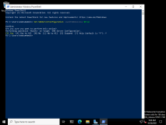

1. Type the following command, and then press Enter:
2. Get-SmbServerConfiguration | FL

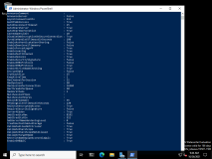

1. Type the following command, and then press Enter:
2. Set-SmbServerConfiguration -EnableSMB1Protocol $false
3. Type [**Y**](urn:gd:lg:a:send-vm-keys) to confirm, and then press Enter.

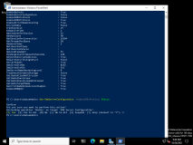

1. Type the following command, and then press Enter:
2. Get-WindowsFeature *SMB*

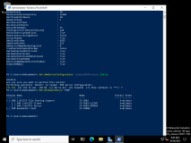

1. Notice, Windows Server 2022 does not have SMB enabled by default. The above commands and task are important for legacy versions of Windows Server.
2. Close the Windows PowerShell prompt.

**Results**: After completing this exercise, you should have successfully created SMB and NFS shares.

Lab B: Implementing File Services

**Scenario**

Your manager has recently asked you to configure file and print services for the branch office. This requires you to configure a new shared folder that will have subfolders for multiple departments, configure shadow copies on the file servers.

Exercise 1: Creating and Configuring a File Share

**Scenario**

Your manager has asked you to create a new shared folder, which all departments will use. There will be a single file share, with separate folders, for each department. To ensure that users see only the folders and files to which they have access, you need to set the file permissions on the departmental folders and enable access based enumeration on the share.

There have been problems in other branch offices with multiple versions of files when offline files were used for shared data structures.

The main tasks for this exercise are as follows:

1. Create the folder structure for the new share.
2. Configure file permissions on the folder structure.
3. Create the shared folder.
4. Test access to the shared folder.
5. Enable access-based enumeration.
6. Test access to the share.

Task 1: Create the folder structure for the new share

1. On [**LON-SVR1**](urn:gd:lg:a:select-vm), on the taskbar, click the **File Explorer** icon.

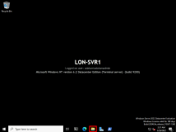

1. In File Explorer, in the navigation pane, expand **This PC**, and then click **Allfiles (D:)**.

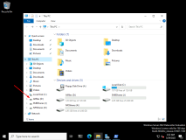

1. On the menu toolbar, click **Home**, click **New folder**, type [**Data**](urn:gd:lg:a:send-vm-keys), and then press Enter.

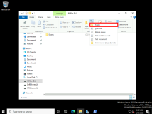

1. Double‑click the **Data** folder.

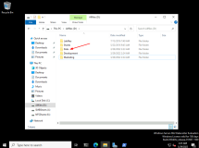

1. On the menu toolbar, click **Home**, click **New folder**, type [**Development**](urn:gd:lg:a:send-vm-keys), and then press Enter.

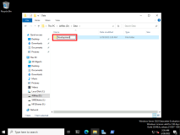

1. Repeat step 5 to create a new folder named [**Marketing**](urn:gd:lg:a:send-vm-keys).

Task 2: Configure file permissions on the folder structure

To restrict access to the departmental folders, you must prevent inherited file permissions from the Data folder from being applied to each department folder. To do this, perform the following steps.

1. In File Explorer, double-click the **D:\Data** folder.



1. Right‑click the **Development** folder, and then click **Properties**.

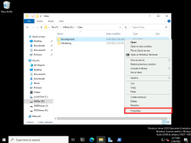

1. In the **Development Properties** dialog box, click **Security**, and then click **Advanced**.

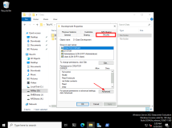

1. In the **Advanced Security Settings for Development** dialog box, click **Disable Inheritance**.

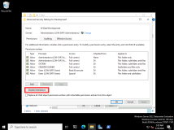

1. In the **Block Inheritance** dialog box, click **Convert inherited permissions into explicit permissions on this object**.

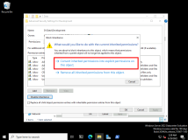

1. Remove the two permissions entries for Users (LON‑SVR1\Users), and then click **OK**.
2. On the **Security** tab, click **Edit**.

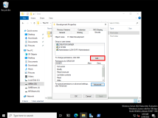

1. In the **Permissions for Development** dialog box, click **Add**.

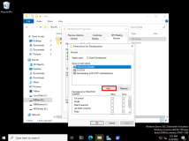

1. Type [**Development**](urn:gd:lg:a:send-vm-keys), click **Check names**, and then click **OK**.

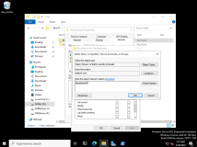

1. In the **Permissions for Development** dialog box, under **Allow**, select **Modify** permission.

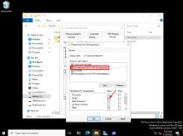

1. Click **OK** to close the **Permissions for Development** dialog box.
2. Click **OK** to close the **Development Properties** dialog box.
3. Repeat steps 2 through 12 for the **Marketing** folder, assigning Modify permissions to the **Marketing** group for their folder. In Step 9, replace **Development** with [**Marketing**](urn:gd:lg:a:send-vm-keys).

Task 3: Create the shared folder

1. In File Explorer, navigate to drive D, right‑click the **Data** folder, and then click **Properties**.

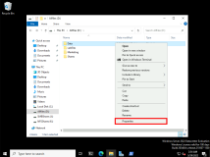

1. In the **Data Properties** dialog box, click the **Sharing** tab, and then click **Advanced Sharing**.

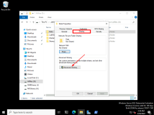

1. In the **Advanced Sharing** dialog box, select **Share this folder**, and then click **Permissions**.

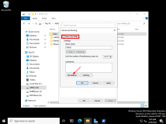

1. In the **Permissions for Data** dialog box, click **Add**.

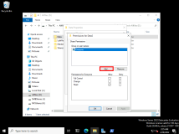

1. Type [**Authenticated Users**](urn:gd:lg:a:send-vm-keys), click **Check names**, and then click **OK**.

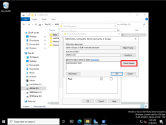

1. In the **Permissions for Data** dialog box, click **Authenticated Users**, and then under **Allow**, select **Change** permission.

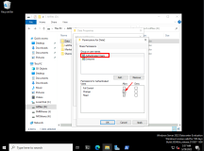

1. Click **OK** to close the **Permissions for Data** dialog box.
2. Click **OK** to close the **Advanced Sharing** dialog box.
3. Click **Close** to close the **Data Properties** dialog box.
4. Sign out of [**LON-SVR1**](urn:gd:lg:a:select-vm)

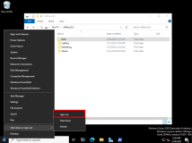

Task 4: Test access to the shared folder

1. Press [**CTRL+ALT+DEL**](urn:gd:lg:a:send-vm-key-combo) and Sign in to [**LON-CL1**](urn:gd:lg:a:select-vm) as **[Adatum\Bernardo](urn:gd:lg:a:send-vm-keys" \o "Paste text into VM)** with the password [**Pa55w.rd**](urn:gd:lg:a:send-vm-keys).

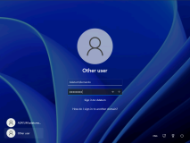

1. On the taskbar, click the **File Explorer** icon.

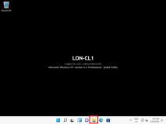

1. In File Explorer, in the address bar, type [**\\LON‑SVR1\Data**](urn:gd:lg:a:send-vm-keys), and then press Enter.

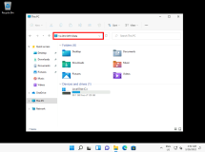

If the correct folders do not appear, please input this into the address bar instead [**\\LON‑SVR1\Data2**](urn:gd:lg:a:send-vm-keys)

1. Double‑click the **Development** folder.

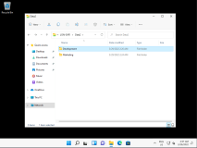

Bernard should have access to the Development folder as he is a member of the Development group.

1. Attempt to access the **Marketing** folder.

File permissions on this folder prevents you from doing this. Bernard can still see the Marketing folder, even though he does not have access to its contents.

1. Sign out of **LON‑CL1**.

Task 5: Enable access-based enumeration

1. Sign back in to [**LON-SVR1**](urn:gd:lg:a:select-vm) as **[Adatum\AdatumAdmin](urn:gd:lg:a:send-vm-keys" \o "Paste text into VM)** with the password [**Pa55w.rd**](urn:gd:lg:a:send-vm-keys).
2. On the taskbar, click the **Server Manager** icon.

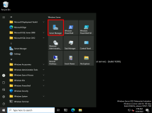

1. In Server Manager, in the navigation pane, click **File and Storage Services**.

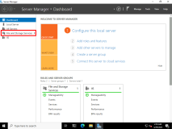

1. In the File and Storage Services window, in the navigation pane, click **Shares**.

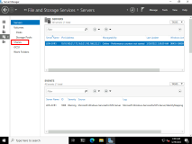

1. In the **Shares** pane, right‑click **Data**, and then click **Properties**.

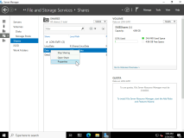

1. In the **Data Properties** dialog box, click **Settings**, and then select **Enable access‑based enumeration**.
2. Click **OK** to close the **Data Properties** dialog box.
3. Close Server Manager.

Task 6: Test access to the share

1. Sign in to [**LON-CL1**](urn:gd:lg:a:select-vm) as **[Adatum\Bernardo](urn:gd:lg:a:send-vm-keys" \o "Paste text into VM)** with the password [**Pa55w.rd**](urn:gd:lg:a:send-vm-keys).
2. On the taskbar, click the **File Explorer** icon.
3. In File Explorer, in the address bar, type [**\\LON‑SVR1\Data**](urn:gd:lg:a:send-vm-keys), and then press Enter.

If the correct folders do not appear, please input this into the address bar instead [**\\LON‑SVR1\Data2**](urn:gd:lg:a:send-vm-keys)

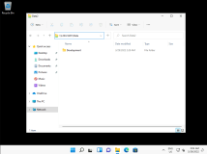

Bernard can now view only the Development folder, the folder for which he has permissions.

1. Double‑click the **Development** folder.

Bernard should have access to the Development folder.

1. Sign out of **LON‑CL1**.

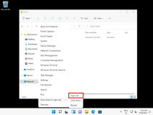

**Results**: After completing this exercise, you will have created a new shared folder for use by multiple departments.

Exercise 2: Configuring Shadow Copies

**Scenario**

A. Datum Corporation stores daily backups offsite for disaster recovery. Every morning, the backup from the previous night is taken offsite. To recover a file from backup, the backup tapes need to be shipped back onsite so the overall time to recover a file from backup can be a day or more.

Your manager has asked you to enable shadow copies on the file server so you can restore recently modified or deleted files without using a backup tape. Because the data in this branch office changes frequently, you are going to create a shadow copy once per hour.

The main tasks for this exercise are as follows:

1. Configure shadow copies for the file share.
2. Create multiple shadow copies of a file.
3. Recover a deleted file from a shadow copy.

Task 1: Configure shadow copies for the file share

1. On [**LON-SVR1**](urn:gd:lg:a:select-vm), open File Explorer.

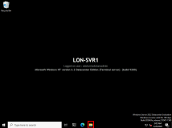

1. Navigate to File Explorer and select **This PC**. Right‑click **Allfiles (D:)**, and then click **Configure Shadow Copies**.

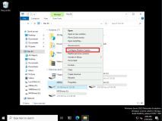

1. In the **Shadow Copies** dialog box, click drive **D**, and then click **Enable**.

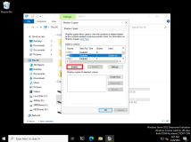

1. In the **Enable Shadow Copies** dialog box, click **Yes**.

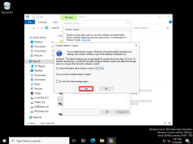

1. In the drive **Shadow Copies** dialog box, click **Settings**.

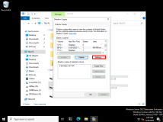

1. In the **Settings** dialog box, click **Schedule**.

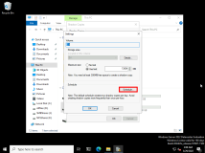

This opens the drive **D:** dialog box.

1. In drive **D:** dialog box, change **Schedule Task** to **Daily**, change **Start time** to **12:00** **AM**, and then click **Advanced**.

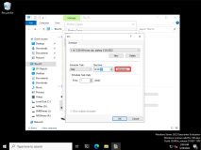

1. In the **Advanced Schedule Options** dialog box, select **Repeat task**, and then set the frequency to **every 1 hours**.
2. Select **Time**, and then change the time value to **11:59** **PM**.

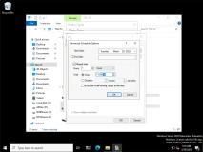

1. Click **OK** twice, and then click **OK** to close the **Settings** dialog box.
2. Leave the drive **Shadow Copies** dialog box open.

Task 2: Create multiple shadow copies of a file

1. On [**LON-SVR1**](urn:gd:lg:a:select-vm), open File Explorer.
2. Navigate to **D:\Data\Development**.

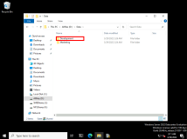

1. On the menu toolbar, click **Home**, click **New item**, and then click **Text Document**.

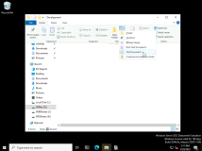

1. Type [**Report**](urn:gd:lg:a:send-vm-keys), and then press Enter.

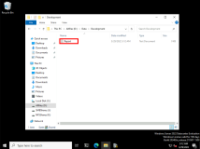

1. Switch back to the **Shadow Copies** dialog box. It should be opened on the **Shadow Copies** tab.
2. Click **Create Now**.

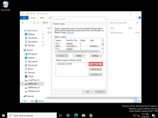

Task 3: Recover a deleted file from a shadow copy

1. On [**LON-SVR1**](urn:gd:lg:a:select-vm), switch back to File Explorer.
2. Right‑click **Report.txt**, and then click **Delete**.

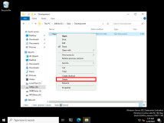

1. In File Explorer, right‑click the **Development** folder, and then click **Properties**.

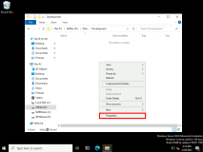

1. In the **Development Properties** dialog box, click the **Previous Versions** tab.
2. Click the most recent folder version for **Development**, and then click **Open**.

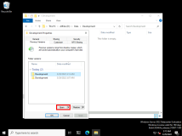

1. Confirm that Report.txt is in the folder, right‑click **Report.txt**, and then click **Copy**.

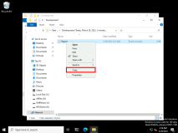

1. Close the File Explorer window that just opened.
2. In the other File Explorer window, right‑click the **Development** folder, and then click **Paste**.

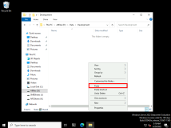

1. Close File Explorer.
2. Click **OK**, and then close all open windows.

**Results**: After completing this exercise, you will have enabled shadow copies on the file server.

**Congratulations!** You have now completed this lab. To continue to the next lab click End Lab in the Tools Menu . If you wish to contiue with this lab at a later date ensure you save the lab environment rather than ending it.

**00:18:030 hours and 18 minutes remaining on your lab session**

**Keyboard released from VM**