55341 / Global Knowledge

Top of Form

Bottom of Form

Module 6: Deploying and managing Windows and Hyper-V containers

Lab: Installing and configuring containers

**Scenario**

The DevOps team at Adatum Corporation wants to explore containers to see if the technology can help reduce deployment times for new applications and to simplify moving applications to the cloud. The team has decided to evaluate Windows Server containers and to look at IIS in a container.

You have also been tasked to evaluate how the Windows Admin Center can manage containers.

Exercise 1: Installing Docker Enterprise Edition for Windows Server 2022

**Scenario**

The first step when deploying containers is to install Docker. You need Docker to manage containers in Windows Server 2022. In this exercise, you will install Docker as part of your task of container deployment.

The main tasks for this exercise are as follows:

1. Install Docker Enterprise Edition for Windows Server 2022.
2. Deploy a new container

Task 1: Install Docker Enterprise Edition for Windows Server 2022

1. Switch to [**LON-SVR3**](urn:gd:lg:a:select-vm).
2. Send the [**CTRL+ALT+DEL**](urn:gd:lg:a:send-vm-key-combo) command and login on as **[Adatum\AdatumAdmin](urn:gd:lg:a:send-vm-keys" \o "Paste text into VM)** with the password [**Pa55w.rd**](urn:gd:lg:a:send-vm-keys)

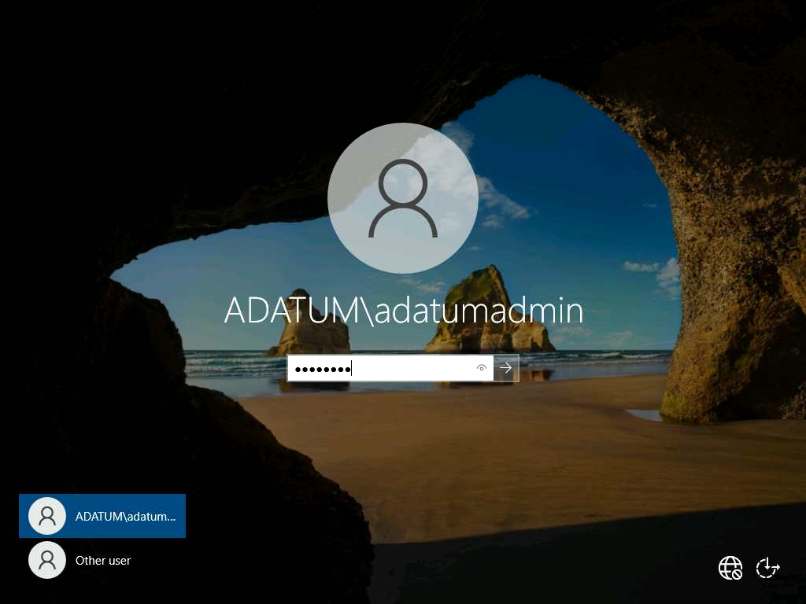

1. On **LON-SVR3**, right click **Start**, and then click **Windows PowerShell (Admin)**.

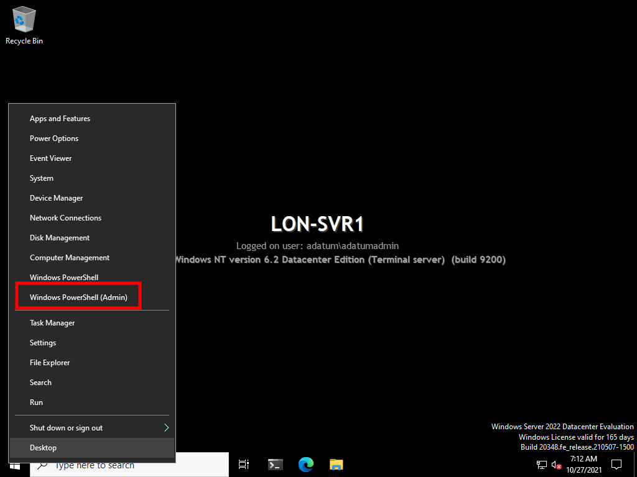

1. At the **Windows PowerShell** command prompt, type the following commands to install Docker and if prompted type [**A**](urn:gd:lg:a:send-vm-keys), and then press Enter:
2. Start-Process 'Docker' -Wait Install
3. Install-Module -Name DockerMsftProvider -Repository PSGallery -Force

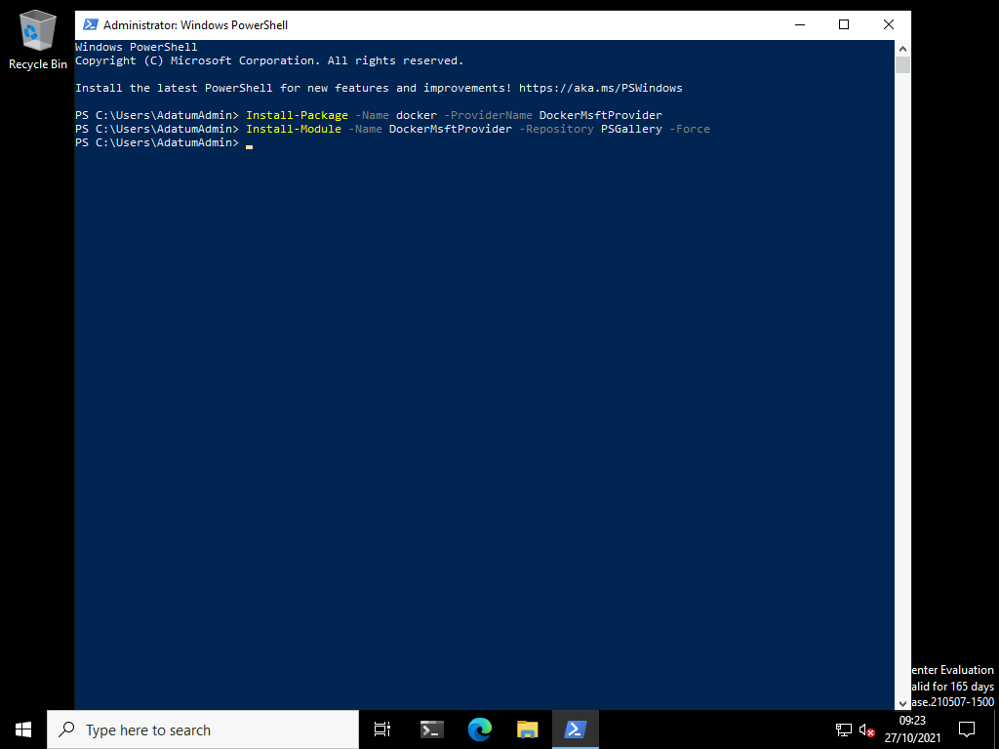

1. Type the following command to restart the computer, and then press Enter:
2. Restart-Computer -Force

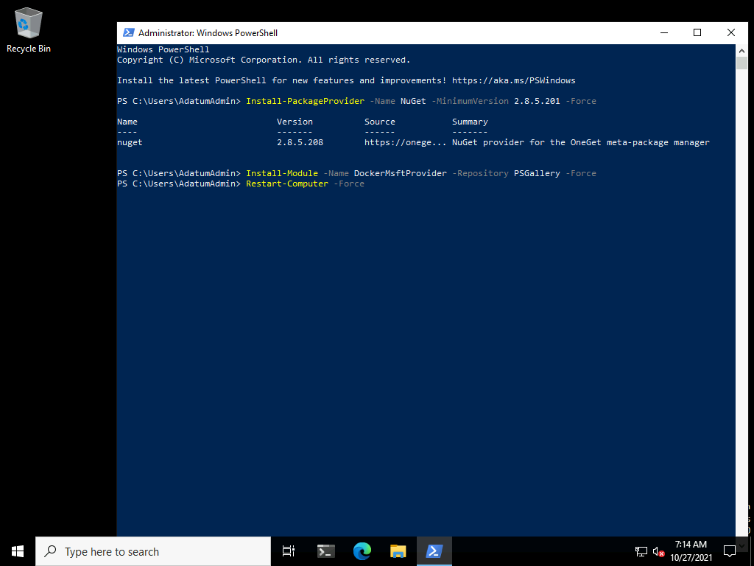

Personal Email Account Setup

If you don't have a Personal Microsoft Outlook email account, you can follow the steps below to configure one:

1. Once rebooted, enter [**CTRL+ALT+DEL**](urn:gd:lg:a:send-vm-key-combo) command and login on as **[Adatum\AdatumAdmin](urn:gd:lg:a:send-vm-keys" \o "Paste text into VM)** with the password [**Pa55w.rd**](urn:gd:lg:a:send-vm-keys)
2. To create a new account, navigate to the following URL: [**https://signup.live.com**](urn:gd:lg:a:send-vm-keys).
3. On the **Create account** account window, type in a unique name followed by either [**@Outlook.com**](urn:gd:lg:a:send-vm-keys) or [**@Hotmail.com**](urn:gd:lg:a:send-vm-keys) ( For example, **User1@Outlook.com**) and then select **Next**.
4. Once a unique email address has been accepted, you'll be prompted to **Create a password**. Enter a unique password that has at least 8 characters and contains at least two of the following: uppercase letters, lowercase letters, numbers, and symbols, and then select **Next**.

**Important**: Before selecting **Next**, please be sure to review both the [**Microsoft Services Agreement**](https://www.microsoft.com/servicesagreement/default.aspx?azure-portal=true) and [**Privacy and cookies statement**](https://go.microsoft.com/fwlink/?LinkID=521839). By selecting **Next**, you choose to agree to Microsoft's service agreement.

1. On the **What's your name?** window, enter your full name (or if you'd prefer, fictitious information), and then select **Next**.
2. On the **What's your birthdate?** window, choose your **Country/region** and enter a **Birthdate**, then select **Next**.
3. On the **Create account** window, select **Next** and solve the generated puzzle.
4. On the **Stay signed in?** page, select **Yes**.
5. In a new **Microsoft Edge** tab, navigate to the URL: [**https://outlook.live.com/mail/**](urn:gd:lg:a:send-vm-keys).
6. Confirm you're able to sign-in to your new email account. Make note of your sign-in details for future lab tasks.

Task 2: Deploy a new container

1. On [**LON-SVR3**](urn:gd:lg:a:select-vm), right-click the **Microsoft Edge** icon from your taskbar and select **New InPrivate Window**.
2. To create a docker account, navigate to [**https://hub.docker.com/signup/**](urn:gd:lg:a:send-vm-keys).
3. On **Create a Docker Account** fill out the necessary information using the email address you previously created, agree to the **Subscription Service Agreement, Privacy Policy, and Data Processing Terms** then click **Sign Up**.
4. On **LON-SVR3**, right click **Start**, and then click **Windows PowerShell (Admin)**.
5. At the **Windows PowerShell** command prompt, type the following command to login to docker, then press Enter:
6. docker login

Enter the username and password you previously created.

1. On **LON-SVR3**, right click **Start**, and then click **Windows PowerShell (Admin)**.



1. At the **Windows PowerShell** command prompt, type the following command to search the Docker Hub for all types of images, and then press Enter:
2. docker search microsoft

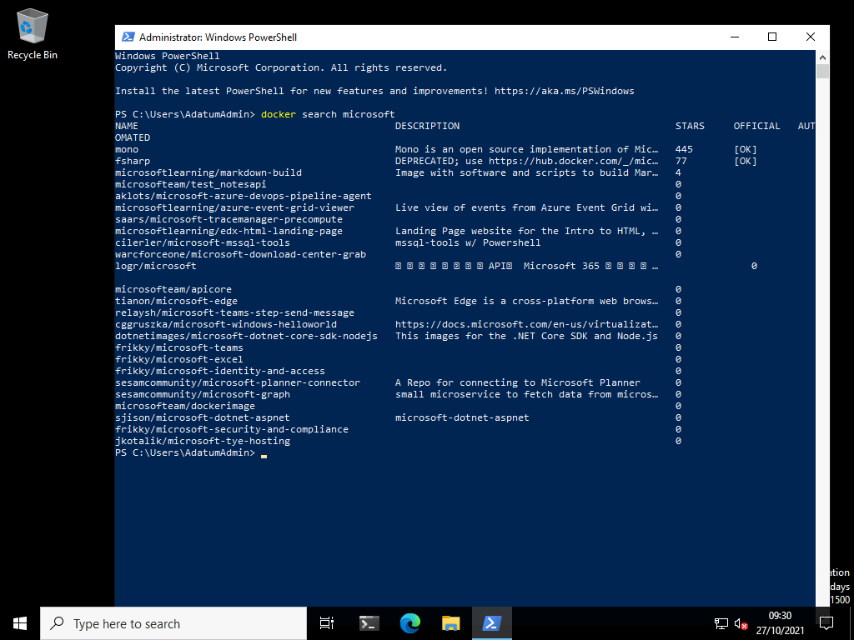

1. To download the IIS image, type the following command, and then press Enter:

**Note**: It may take some time for the image to download, extract and create.

docker pull mcr.microsoft.com/windows/nanoserver:ltsc2022

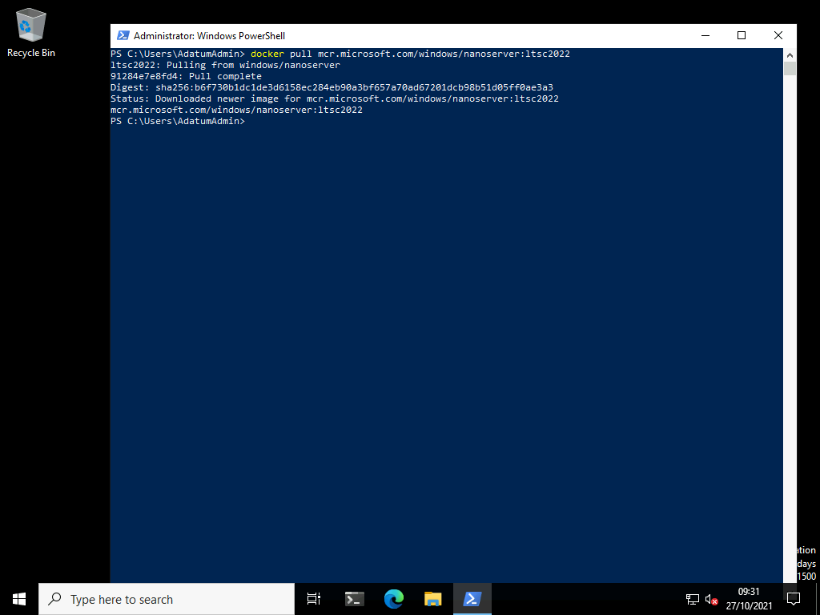

**Results**: After completing this exercise, you should have installed Docker.

Exercise 2: Installing and configuring an IIS container

**Scenario**

Now that you have prepared the container host machine and downloaded the image, the next step is to deploy a container image. You will then be able to validate that the container deployed and is functional and ready to be managed.

The main tasks for this exercise are as follows:

1. Identify the new container.
2. Manage the container.
3. Prepare for the next module.

Task 1: Identify the new container

1. At the **Windows PowerShell** command prompt, type the following command to display the downloaded container image, and then press Enter:
2. docker images

**Note:** Note the image **REPOSITORY** of **microsoft/nanoserver** with a **TAG** of **latest**. You will use this to run the container.

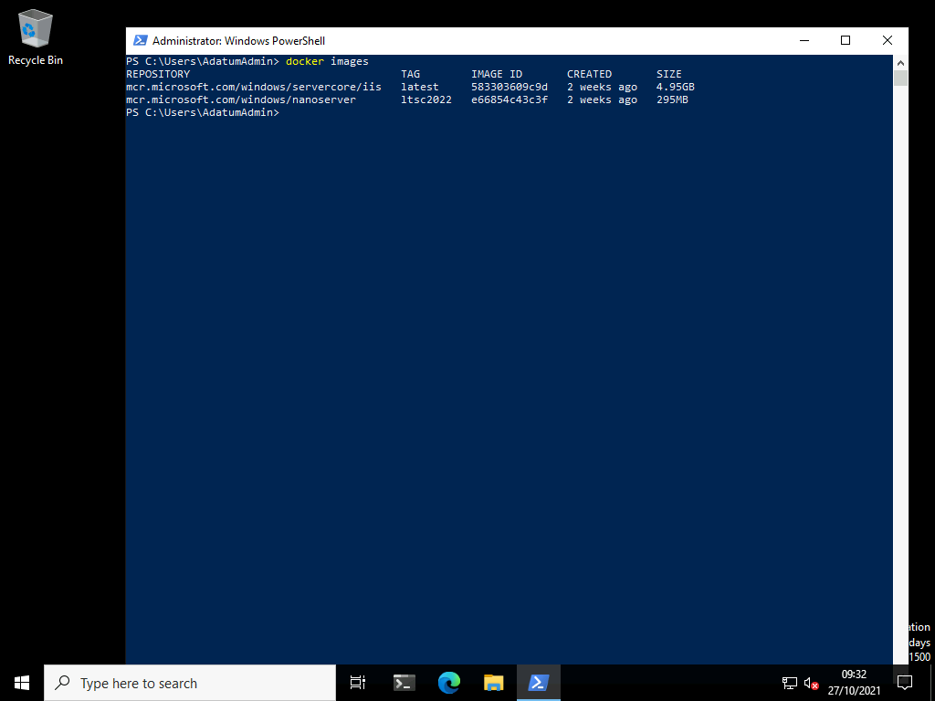

1. At the **Windows PowerShell** command prompt, type the following command to deploy the IIS container, and then press Enter:
2. docker run -it mcr.microsoft.com/windows/nanoserver:ltsc2022 cmd.exe
3. After the container is started, the command prompt window changes context to the container. Exit the container by entering the following commands:
4. exit

Task 2: Manage the container

1. On [**LON-SVR3**](urn:gd:lg:a:select-vm), in the **Windows PowerShell** command prompt window, type the following command to view the running containers, and then press Enter:
2. docker ps -a

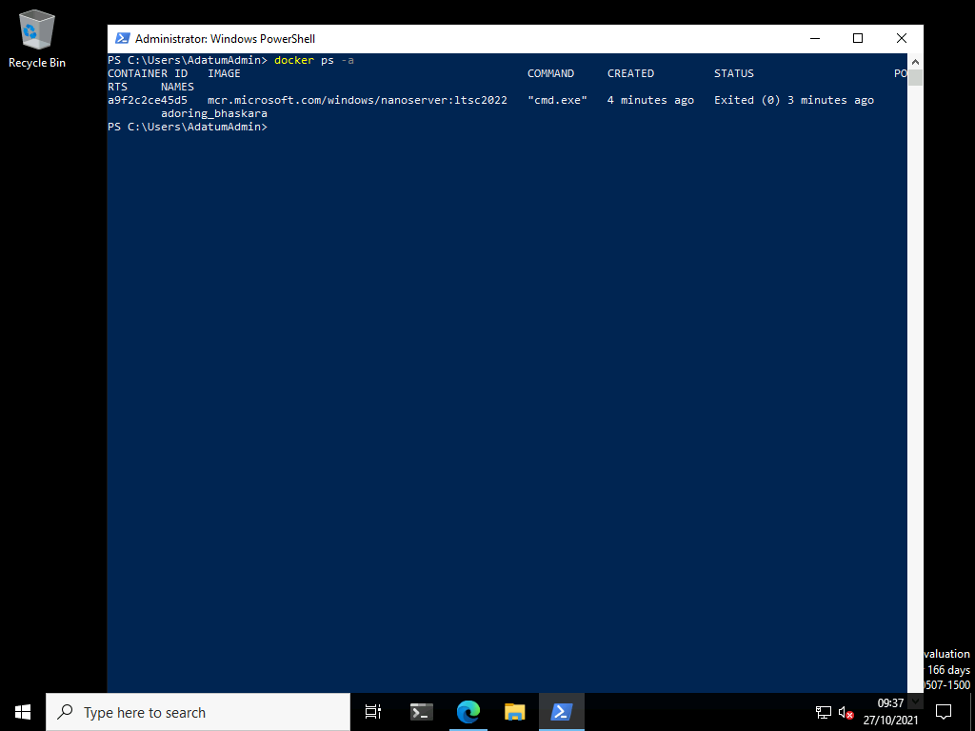

1. Make a note of the container ID.

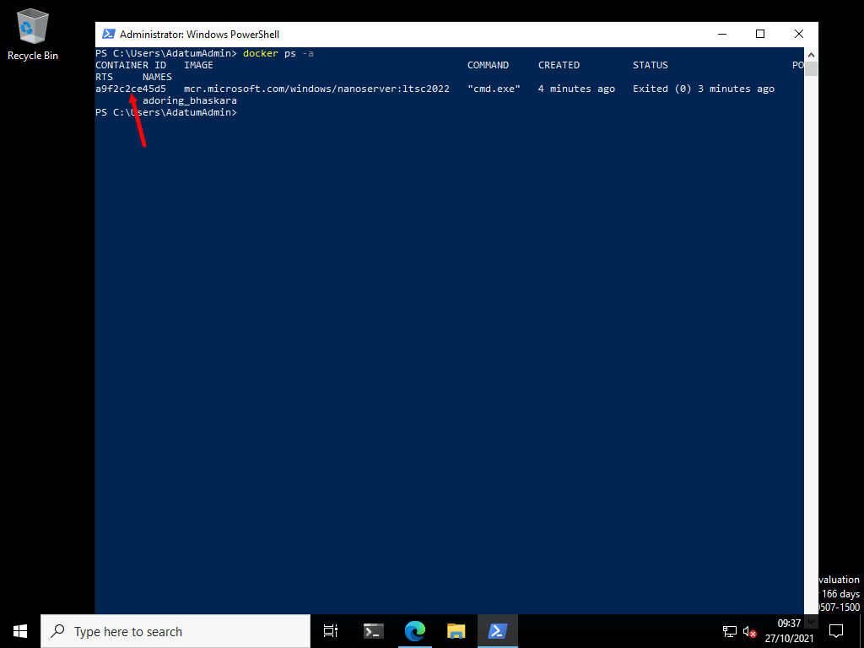

1. Type the following command to stop the container, and then press Enter:
2. docker stop <ContainerID>

**Note:** Replace < ContainerID > with the container ID.

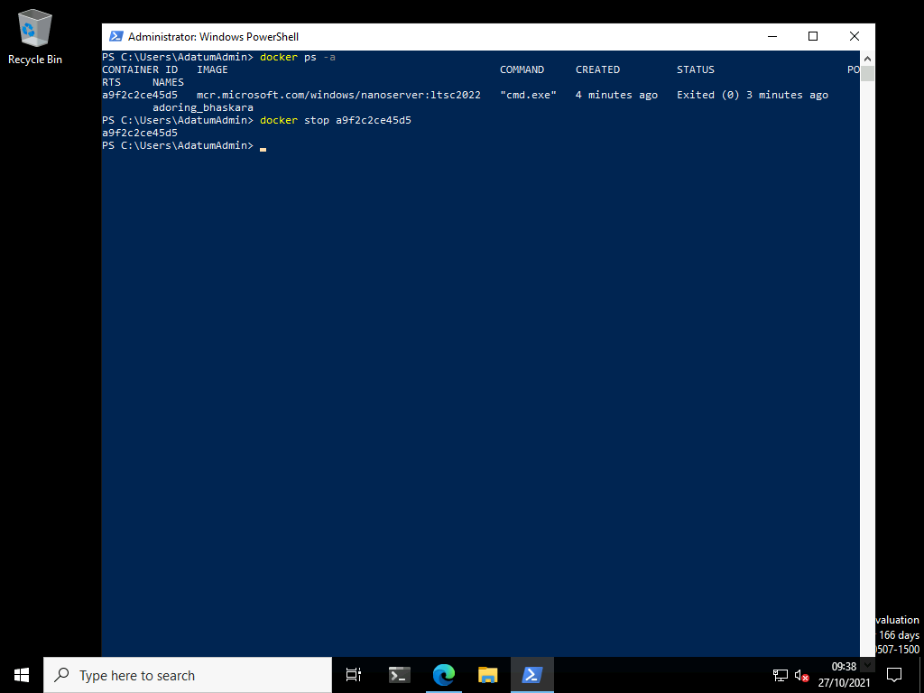

1. On **LON-SVR3**, in the **Windows PowerShell** command prompt window, type the following command to delete the container, and then press Enter:
2. docker rm <ContainerID>

**Note:** Replace < ContainerID > with the container ID.

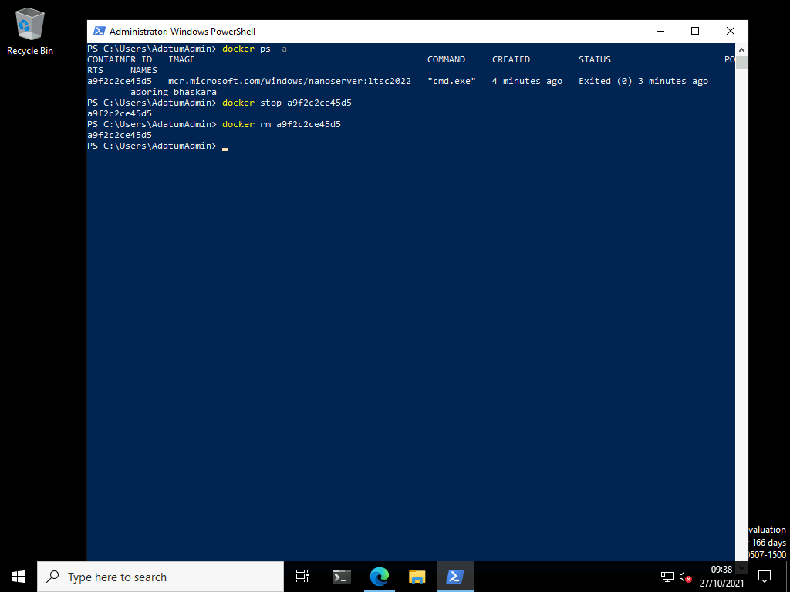

**Results**: After completing this exercise, you should have deployed and managed a container.

Exercise 3: Run a Windows container using Windows Admin Center

**Scenario**

You can use Windows Admin Center to run your containers locally. Specifically, you use the the Containers extension of your Windows Admin Center instance to run the containers.

Task 1: Manage Containers using Windows Admin Center

1. Switch to [**LON-MGT1**](urn:gd:lg:a:select-vm).
2. Send the [**CTRL+ALT+DEL**](urn:gd:lg:a:send-vm-key-combo) command and login on as **[Adatum\AdatumAdmin](urn:gd:lg:a:send-vm-keys" \o "Paste text into VM)** with the password [**Pa55w.rd**](urn:gd:lg:a:send-vm-keys)
3. Open **Microsoft Edge** and select the **Windows Admin Center** favourite button.

**Note**: The Windows Admin Center (WAC) has been preinstalled in the lab environment. Installing the WAC is a very simple installation process.

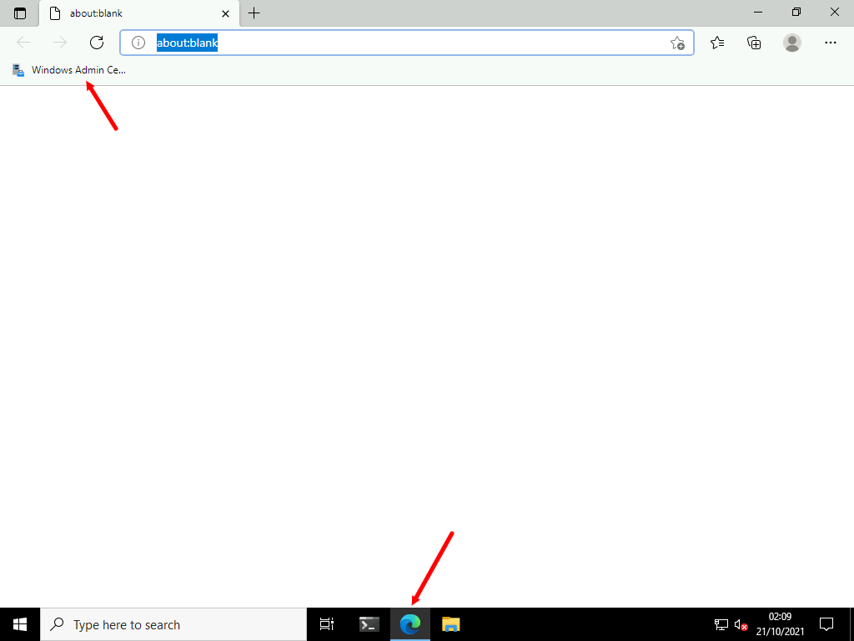

1. On the WAC **All connections** screen select **lon-svr3.adatum.com**.

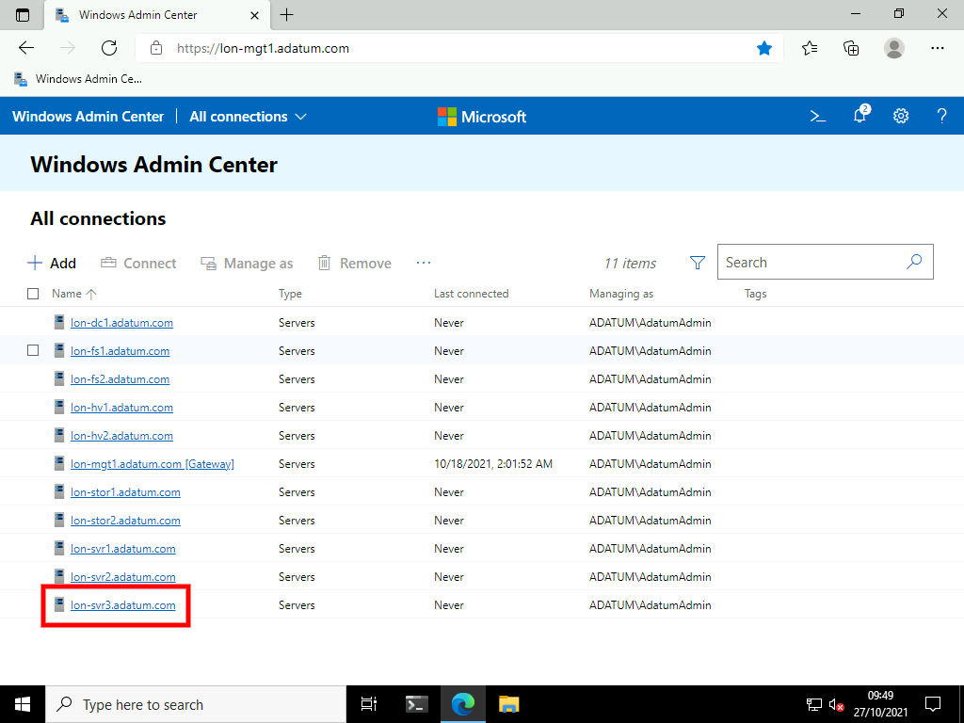

1. On the Tools menu select **Containers**.

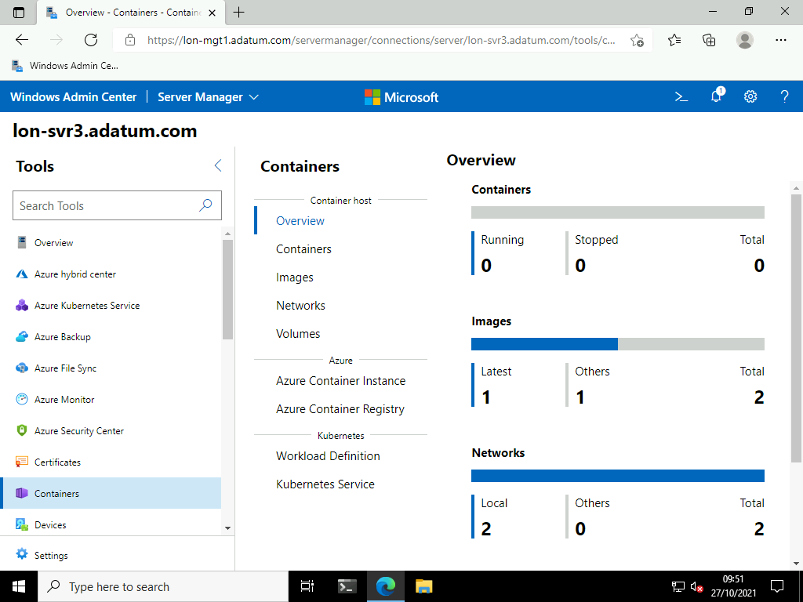

1. Select **Images** then select the image you downloaded in the previous exercise then select **Run**.

**Note**: Notice you can also pull container images from the docker repository using the Windows Admin Center

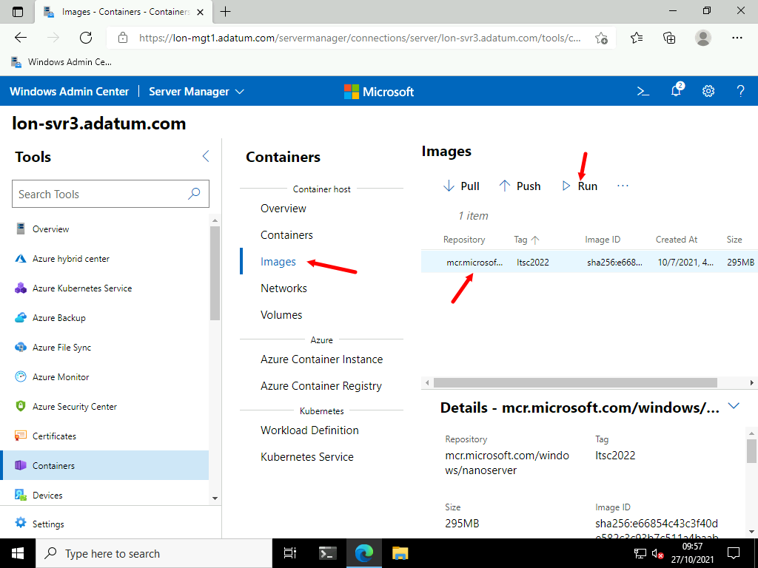

1. On the **Run image** blade enter the following settings then click **Run** (leaving all other values as default).
   * Container Name: [**Test**](urn:gd:lg:a:send-vm-keys)
   * Publish Port(s): [**80:80**](urn:gd:lg:a:send-vm-keys)
   * Memory allocation: [**1024**](urn:gd:lg:a:send-vm-keys)
   * CPU count: [**1**](urn:gd:lg:a:send-vm-keys)

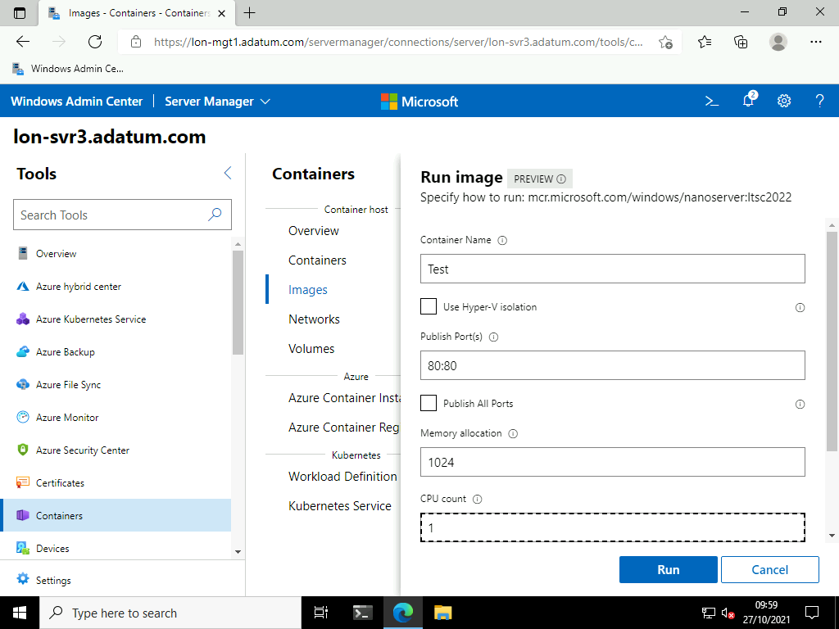

1. Select **Containers** and notice your running container.

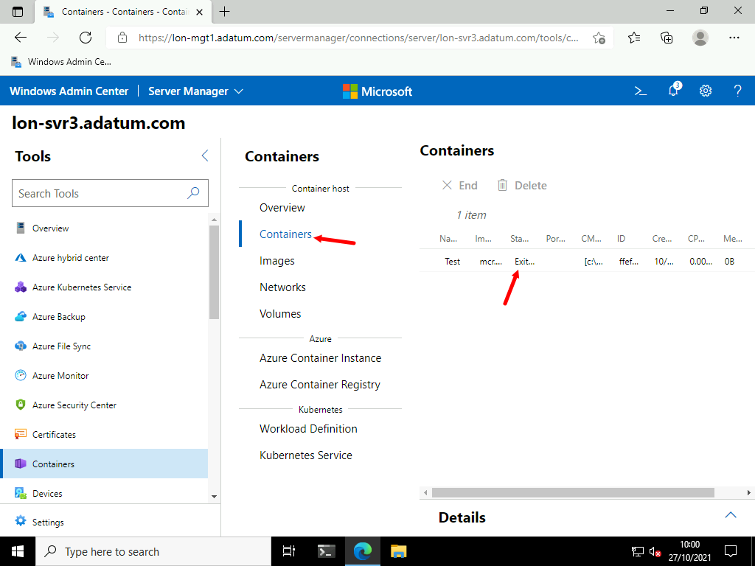

1. Select **Delete** the on the Delete container dialogue box select **Delete**.

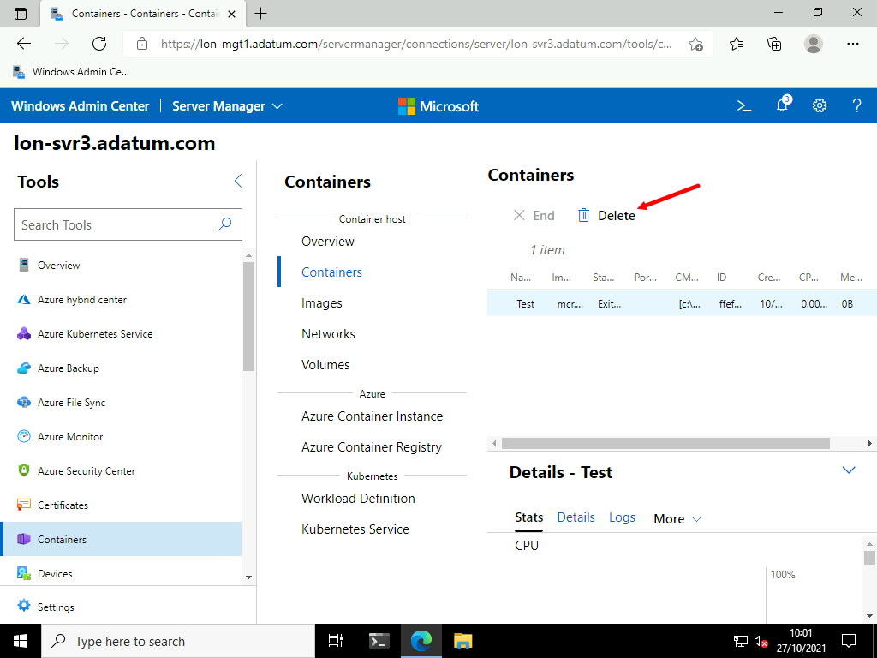

**Results**: After completing this exercise, you should have deployed and managed a container using the Windows Admin Center.

**Congratulations!** You have now completed this lab. To continue to the next lab click End Lab in the Tools Menu . If you wish to contiue with this lab at a later date ensure you save the lab environment rather than ending it.