Module 8: Implementing failover clustering

Lab A: Implementing failover clustering

**Scenario**

Adatum Corporation is looking to ensure that its critical services, such as file services, have better uptime and availability. You decide to implement a failover cluster with file services to provide better uptime and availability.

Exercise 1: Creating a failover cluster

**Scenario**

Adatum has important applications and services that they want to make highly available. Therefore, you decide to implement failover clustering by using iSCSI storage. You will configure iSCSI storage to support your failover cluster, and then configure a failover cluster.

To configure a failover cluster, you plan to implement the core components for failover clustering, validate the cluster, and then create the failover cluster. After you create a cluster infrastructure, you plan to configure a highly available file server, and then implement settings for failover and failback. Additionally, you also will perform failover and failback tests.   The main tasks for this exercise are as follows:

1. Connect cluster nodes to iSCSI shared storage.
2. Install the Failover Cluster feature.
3. Validate the servers for failover clustering.
4. Create the failover cluster.
5. Add the file-server application to the failover cluster.
6. Add a shared folder to a highly-available file server.
7. Configure failover and failback settings.
8. Validate the highly available file-server deployment.
9. Validate the failover and quorum configuration for the File Server role.

Task 1: Connect cluster nodes to iSCSI shared storage

Configure the iSCSI targets

1. Switch to [**LON-STOR1**](urn:gd:lg:a:select-vm) and send the [**CTRL+ALT+DEL**](urn:gd:lg:a:send-vm-key-combo) command and login as **[Adatum\AdatumAdmin](urn:gd:lg:a:send-vm-keys" \o "Paste text into VM)** with the password [**Pa55w.rd**](urn:gd:lg:a:send-vm-keys)
2. Right click **Start** and select **Windows PowerShell (Admin)**.

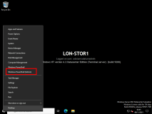

1. Run the following command to install the File Services and iSCSI Target Server roles.
2. Install-WindowsFeature File-Services,FS-iSCSITarget-Server -IncludeManagementTools

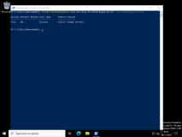

1. Click **Start** and select **Server Manager**.

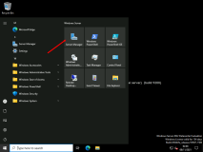

1. In Server Manager, in the **Navigation** pane, click **File and Storage Services**.

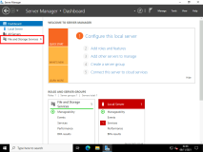

1. In the **File and Storage Services** pane, click **iSCSI**.

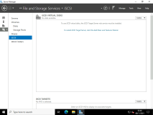

1. In the **iSCSI VIRTUAL DISKS** pane, click **TASKS**, and then, in the **TASKS** drop-down list, select **New iSCSI Virtual Disk**.

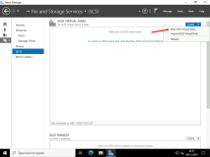

1. In the **New iSCSI Virtual Disk Wizard**, on the **Select iSCSI virtual disk location** page, under **Storage location**, click **E:**, and then click **Next**.

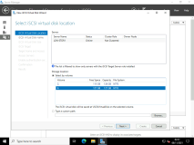

1. On the **Specify iSCSI virtual disk name** page, in the **Name** text box, type [**iSCSIDisk1**](urn:gd:lg:a:send-vm-keys) and then click **Next**.

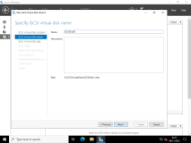

1. On the **Specify iSCSI virtual disk size** page, in the **Size** text box, type [**5**](urn:gd:lg:a:send-vm-keys), ensure that **GB** is selected in the drop-down list, and then click **Next**.

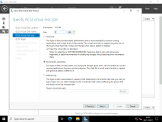

1. On the **Assign iSCSI target** page, click **New iSCSI target**, and then click **Next**.

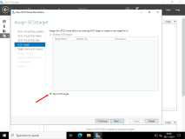

1. On the **Specify target name** page, in the **Name** text box, type **[lon-svr-vms](urn:gd:lg:a:send-vm-keys" \o "Paste text into VM)** and then click **Next**.

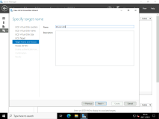

1. On the **Specify access servers** page, click **Add**.

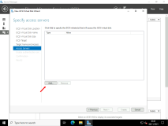

1. In the **Select a method to identify the initiator** dialog box, click **Enter a value for the selected type**, and in the **Type** drop-down list, select **IP Address**. In the **Value** text box, type [**172.16.0.21**](urn:gd:lg:a:send-vm-keys) and then click **OK**.

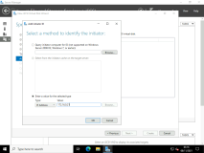

1. On the **Specify access servers** page, click **Add**.

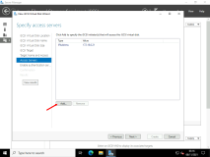

1. In the **Select a method to identify the initiator** dialog box, click **Enter a value for the selected type**, and then, in the **Type** drop-down list, select **IP Address**. In the **Value** box, type [**172.16.0.22**](urn:gd:lg:a:send-vm-keys) and then click **OK**.

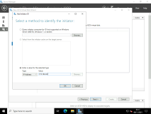

1. On the **Specify access servers** page, click **Next**.

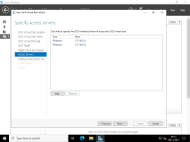

1. On the **Enable Authentication** page, click **Next**.

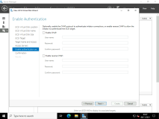

1. On the **Confirm selections page**, click **Create**.

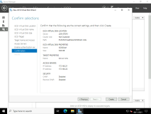

1. On the **View results** page, wait until creation is complete, and then click **Close**.

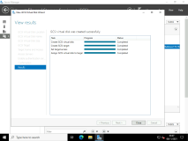

1. In the **iSCSI VIRTUAL DISKS** pane, click **TASKS**, and then, in the **TASKS** drop-down list, select **New iSCSI Virtual Disk**.

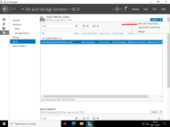

1. In the **New iSCSI Virtual Disk Wizard**, on the **Select iSCSI virtual disk location** page, under **Storage location**, click **E:**, and then click **Next**.

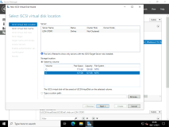

1. On the **Specify iSCSI virtual disk name** page, in the **Name** text box, type [**iSCSIDisk2**](urn:gd:lg:a:send-vm-keys) and then click **Next**.

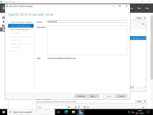

1. On the **Specify iSCSI virtual disk size** page, in the **Size** text box, type [**5**](urn:gd:lg:a:send-vm-keys), ensure that **GB** is selected in the drop-down list, and then click **Next**.

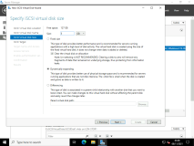

1. On the **Assign iSCSI target** page, click **lon-svr-vms**, and then click **Next**.

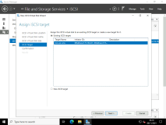

1. On the **Confirm selections** page, click **Create**.

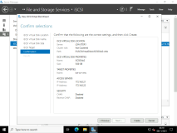

1. On the **View results** page, wait until the creation is completed, and then click **Close**.

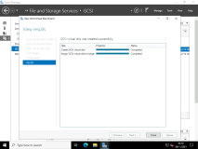

1. In the **iSCSI VIRTUAL DISKS** pane, click **TASKS**, and then, in the **TASKS** drop-down list, select **New iSCSI Virtual Disk**.

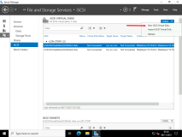

1. In the **New iSCSI Virtual Disk Wizard**, on the **Select iSCSI virtual disk location** page, under **Storage location**, click **E:**, and then click **Next**.

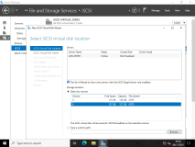

1. On the **Specify iSCSI virtual disk name** page, in the **Name** text box, type [**iSCSIDisk3**](urn:gd:lg:a:send-vm-keys) and then click **Next**.

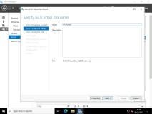

1. On the **Specify iSCSI virtual disk size** page, in the **Size** text box, type [**5**](urn:gd:lg:a:send-vm-keys), ensure that **GB** is selected in the drop-down list, and then click **Next**.

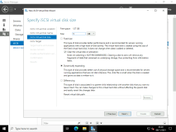

1. On the **Assign iSCSI target** page, click **lon-svr-vms**, and then click **Next**.

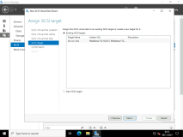

1. On the **Confirm selections** page, click **Create**.

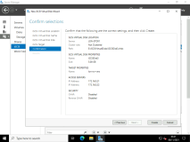

1. On the **View results** page, wait until the creation is complete, and then click **Close**.

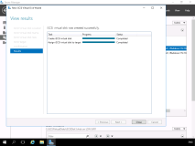

Connect nodes to the iSCSI targets

1. Switch to [**LON-SVR1**](urn:gd:lg:a:select-vm) and send the [**CTRL+ALT+DEL**](urn:gd:lg:a:send-vm-key-combo) command and login as **[Adatum\AdatumAdmin](urn:gd:lg:a:send-vm-keys" \o "Paste text into VM)** with the password [**Pa55w.rd**](urn:gd:lg:a:send-vm-keys)
2. Click **Start** and select **Server Manager**.

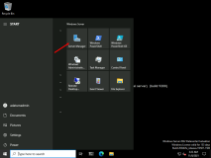

1. Click **Tools**, and then click **iSCSI Initiator**.

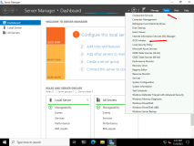

1. In the **Microsoft iSCSI** dialog box, click **Yes**.

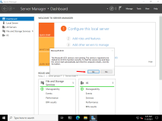

1. In the **iSCSI Initiator Properties** window, click the **Discovery** tab, and then click **Discover Portal**.

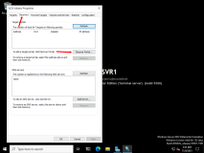

1. In the **IP address or DNS name** text box, type [**172.16.0.201**](urn:gd:lg:a:send-vm-keys) and then click **OK**.

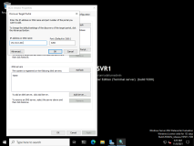

1. Click the **Targets** tab, and then click **Refresh**.

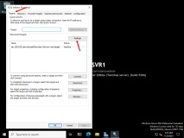

1. In the **Targets** list, click **iqn.1991-05.com.microsoft:lon-stor1-lon-svr-vms-target**, and then click **Connect**.

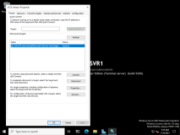

1. Ensure that **Add this connection to the list of Favorite Targets** is selected, and then click **OK** two times.

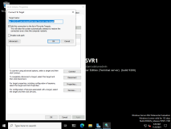

1. Switch to [**LON-SVR2**](urn:gd:lg:a:select-vm) and send the [**CTRL+ALT+DEL**](urn:gd:lg:a:send-vm-key-combo) command and login as **[Adatum\AdatumAdmin](urn:gd:lg:a:send-vm-keys" \o "Paste text into VM)** with the password [**Pa55w.rd**](urn:gd:lg:a:send-vm-keys)
2. Click **Start** and select **Server Manager**

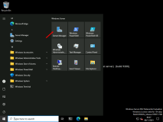

1. Click **Tools**, and then click **iSCSI Initiator**.

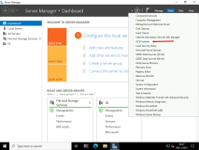

1. In the **Microsoft iSCSI** dialog box, click **Yes**.

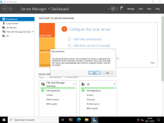

1. In the **iSCSI Initiator Properties** window, click the **Discovery** tab, and then click **Discover Portal**.

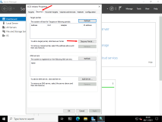

1. In the **IP address or DNS name** text box, type [**172.16.0.201**](urn:gd:lg:a:send-vm-keys) and then click **OK**.

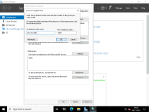

1. Click the **Targets** tab, and then click **Refresh**.

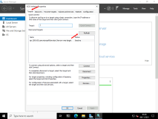

1. In the **Targets** list, click **iqn.1991-05.com.microsoft:lon-stor1-lon-svr-vms-target**, and then click **Connect**.

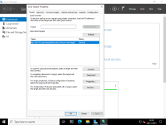

1. Ensure that the **Add this connection to the list of Favorite Targets** check box is selected, and then click **OK** two times.

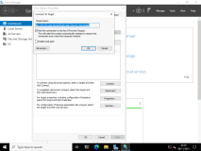

1. Switch to [**LON-SVR1**](urn:gd:lg:a:select-vm) in **Server Manager**, click **Tools**, and then click **Computer Management**.

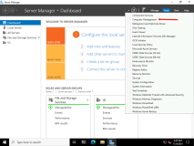

1. Expand **Storage**, and then click **Disk Management**.

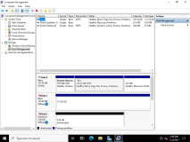

1. Right-click **Disk 2**, and then click **Online**.

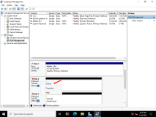

1. Right-click **Disk 2**, and then click **Initialize Disk**.

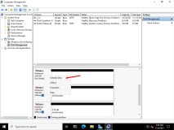

1. In the **Initialize Disk** dialog box, click **OK**.

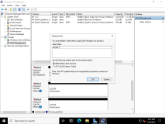

1. Right-click the unallocated space next to **Disk 2**, and then click **New Simple Volume**.

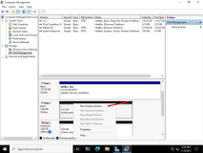

1. On the **Welcome** page, click **Next**.

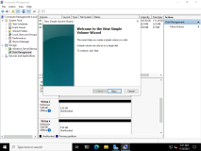

1. On the **Specify Volume Size** page, click **Next**.

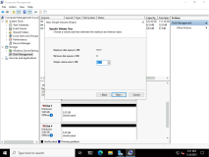

1. On the **Assign Drive Letter or Path** page, click **Next**.

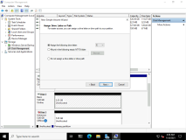

1. On the **Format Partition** page, in the **Volume Label** text box, type [**Data1**](urn:gd:lg:a:send-vm-keys). Select the **Perform a quick format** check box, and then click **Next**.

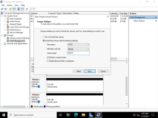

1. Click **Finish**.

**Note:** If a dialog box appears with a prompt to format the disk, click **Cancel**.

1. Repeat steps 21 through 29 for **Disk 3** and **Disk 4**, using [**Data2**](urn:gd:lg:a:send-vm-keys) and [**Data3**](urn:gd:lg:a:send-vm-keys), respectively, for volume labels.
2. Close the **Computer Management**

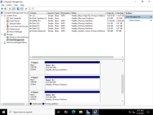

1. Switch to [**LON-SVR2**](urn:gd:lg:a:select-vm), in Server Manager, click **Tools**, and then click **Computer Management**.

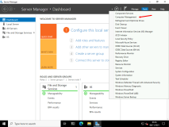

1. Expand **Storage**, and click **Disk Management**.

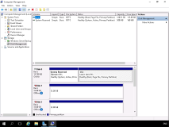

1. Right-click **Disk 1**, and then click **Online**.
2. Right-click **Disk 2**, and then click **Online**.
3. Right-click **Disk 3**, and then click **Online**.

If you experience an error when trying to bring these online, you may need to close and re-open computer management.

1. Close the **Computer Management**

Task 2: Install the Failover Cluster feature

1. Switch to [**LON-SVR1**](urn:gd:lg:a:select-vm), if Server Manager is not open, click the **Server Manager** icon.
2. Click **Add roles and features**.

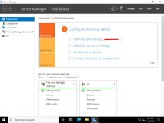

1. In the **Add roles and features Wizard**, on the **Before You Begin** page, click **Next**.

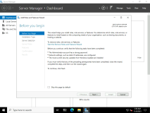

1. On the **Select installation type** page, click **Next**.

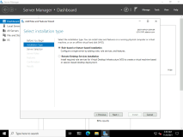

1. On the **Select destination server** page, ensure that **Select a server from the server pool** is selected, and then click **Next**.

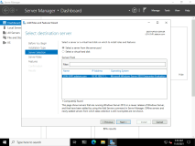

1. On the **Select server roles** page, click **Next**.

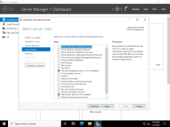

1. On the **Select features** page, in the **Features** list, select **Failover Clustering**.

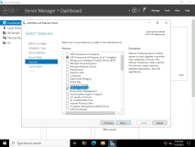

1. In the **Add features that are required for Failover Clustering** window, click **Add Features**, and then click **Next**.
2. On the **Confirm installation selections** page, click **Install**.

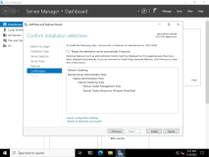

1. When installation completes and you receive the **Installation succeeded on LON-SVR1.Adatum.com** message, click **Close**.

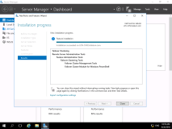

1. On [**LON-SVR2**](urn:gd:lg:a:select-vm), repeat steps 2 through 10.
2. Switch to [**LON-SVR3**](urn:gd:lg:a:select-vm) and send the [**CTRL+ALT+DEL**](urn:gd:lg:a:send-vm-key-combo) command and login as **[Adatum\AdatumAdmin](urn:gd:lg:a:send-vm-keys" \o "Paste text into VM)** with the password [**Pa55w.rd**](urn:gd:lg:a:send-vm-keys) then repeat steps 2 through 10.
3. When installation completes and you receive the **Installation succeeded on LON-SVRX.Adatum.com** message, click **Close**.

Task 3: Validate the servers for failover clustering

1. On [**LON-SVR1**](urn:gd:lg:a:select-vm), in Server Manager, click **Tools**, and then click **Failover Cluster Manager**.

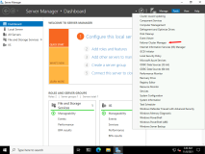

1. Close the Failover Cluster Manager Windows Admin center pop up.

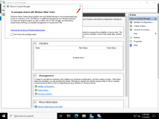

1. In **Failover Cluster Manager**, in the **Actions** pane, click **Validate Configuration**.

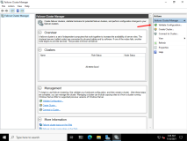

1. In the **Validate a Configuration Wizard**, click **Next**.

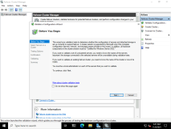

1. In the **Enter Name** text box, type [**LON-SVR1**](urn:gd:lg:a:send-vm-keys) and then click **Add**.

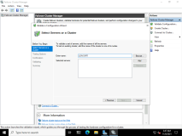

1. In the **Enter Name** text box, type [**LON-SVR2**](urn:gd:lg:a:send-vm-keys).

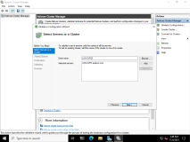

1. Click **Add**, and then click **Next**.

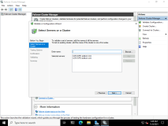

1. Verify that **Run all tests (recommended)** is selected, and click **Next**.

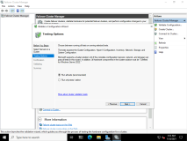

1. On the **Confirmation** page, click **Next**.

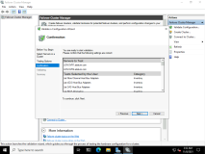

1. Wait for the validation tests to finish, which might take between 5 and 7 minutes, and then on the **Summary** page, scroll through the report. Verify that all tests completed without errors.

**Note:** Some WARNINGS are expected due to the configuration of the virtual environment. These are NOT errors.

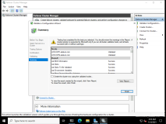

1. On the **Summary** page, click **Finish**.

Task 4: Create the failover cluster

1. On [**LON-SVR1**](urn:gd:lg:a:select-vm), in the Failover Cluster Manager, in the **Actions** pane, click **Create Cluster**.

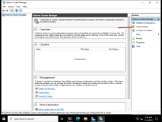

1. On the **Before you begin** page, click **Next**.

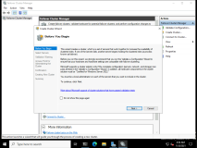

1. On the **Select Servers** page, in the **Enter server name** box, type [**LON-SVR1**](urn:gd:lg:a:send-vm-keys) and then click **Add**.
2. In the **Enter server name** box, type [**LON-SVR2**](urn:gd:lg:a:send-vm-keys) click **Add**, and then click **Next**.

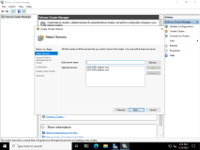

1. On the **Access Point for Administering the Cluster** page, in the **Cluster Name** text box, type [**Cluster1**](urn:gd:lg:a:send-vm-keys)

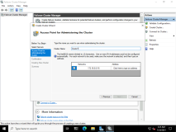

1. In the **Address** text box, type [**172.16.0.125**](urn:gd:lg:a:send-vm-keys), and then click **Next**.

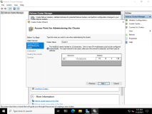

1. On the **Confirmation** page, click **Next**.

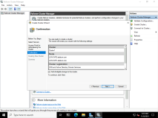

1. On the **Summary** page, click **Finish**.

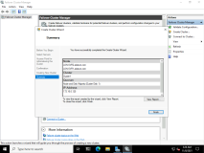

Task 5: Add the file-server application to the failover cluster

1. Right click the **Start** menu and select **Windows PowerShell (Admin)** and run the following command to install the File Server service.
2. Install-WindowsFeature File-Services
3. Switch to [**LON-SVR2**](urn:gd:lg:a:select-vm) and run the same command.
4. Switch back to [**LON-SVR1**](urn:gd:lg:a:select-vm), in the **Failover Cluster Manager** console, expand **Cluster1.Adatum.com**, expand **Storage**, and then click **Disks**.

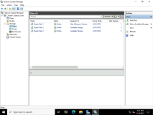

1. Ensure that three disks named **Cluster Disk 1**, **Cluster Disk 2**, and **Cluster Disk 3** are present and online.

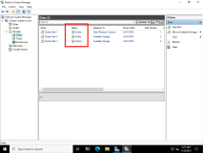

1. Right-click **Roles**, and then click **Configure Role**.

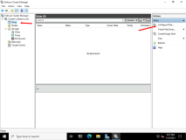

1. On the **Before You Begin** page, click **Next**.

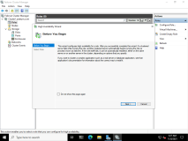

1. On the **Select Role** page, click **File Server**, and then click **Next**.

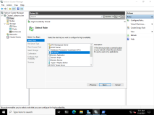

1. On the **File Server Type** page, click **File Server for general use**, and then click **Next**.

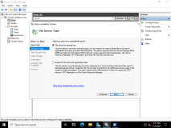

1. On the **Client Access Point** page, in the **Name** text box, type **[AdatumFS](urn:gd:lg:a:send-vm-keys" \o "Paste text into VM)**. In the **Address** text box, type [**172.16.0.130**](urn:gd:lg:a:send-vm-keys), and then click **Next**.

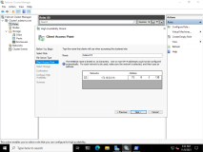

1. On the **Select Storage** page, select the **Cluster Disk 2** check box, and then click **Next**.

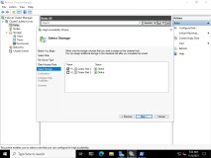

1. On the **Confirmation** page, click **Next**.

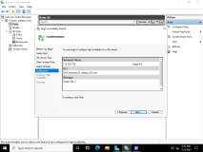

1. On the **Summary** page, click **Finish**.

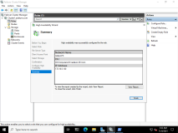

Task 6: Add a shared folder to a highly available file server

1. Switch to [**LON-SVR2**](urn:gd:lg:a:select-vm), in the **Server Manager** console, click **Tools**, and then click **Failover Cluster Manager**.

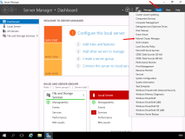

1. Expand **Cluster1.Adatum.com**, click **Roles**, right-click **AdatumFS**, and then click **Add File Share**.

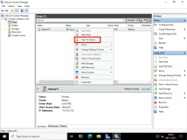

1. In the **New Share Wizard**, on the **Select the profile for this share** page, click **SMB Share - Quick**, and then click **Next**.

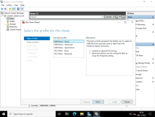

1. On the **Select the server and the path for this share** page, click **Next**.

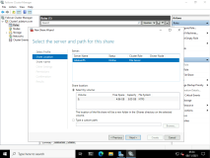

1. On the **Specify share name** page, in the **Share name** text box, type [**Docs**](urn:gd:lg:a:send-vm-keys), and then click **Next**.

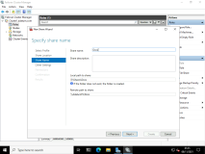

1. On the **Configure share settings** page, review the available options but do not make any changes, and then click **Next**.

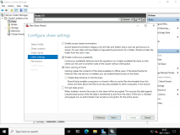

1. On the **Specify permissions to control access** page, click **Next**.

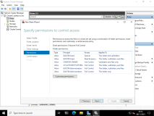

1. On the **Confirm selections** page, click **Create**.

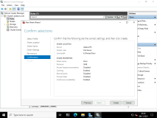

1. On the **View results** page, click **Close**.

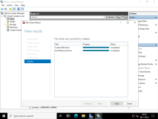

Task 7: Configure failover and failback settings

1. On [**LON-SVR2**](urn:gd:lg:a:select-vm), in the **Failover Cluster Manager** console, click **Roles**, right-click **AdatumFS**, and then click **Properties**.

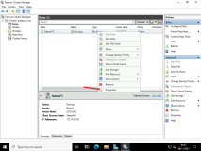

1. In the **AdatumFS Properties** dialog box, click the **Failover** tab, and then click **Allow failback**.

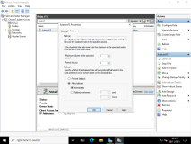

1. Click **Failback between**, and set the values to [**4**](urn:gd:lg:a:send-vm-keys) and [**5**](urn:gd:lg:a:send-vm-keys) hours.

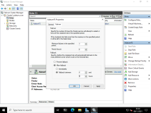

1. Click the **General** tab.
2. Select both **LON-SVR1** and **LON-SVR2** as preferred owners.

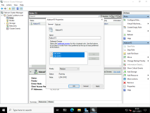

1. Select **LON-SVR2**, and click **Up** so that it is first in the preferred owners list.

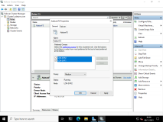

1. To close the **AdatumFS Properties** dialog box, click **OK**.

Task 8: Validate the highly available file-server deployment

1. Switch to [**LON-MGT1**](urn:gd:lg:a:select-vm) and send the [**CTRL+ALT+DEL**](urn:gd:lg:a:send-vm-key-combo) command and login as **[Adatum\AdatumAdmin](urn:gd:lg:a:send-vm-keys" \o "Paste text into VM)** with the password [**Pa55w.rd**](urn:gd:lg:a:send-vm-keys)
2. Open **File Explorer**. In the address bar, type [**\\AdatumFS\**](urn:gd:lg:a:send-vm-keys), and then press Enter.

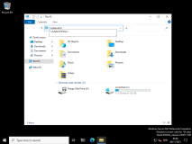

1. Verify that you can access the location and that you can open the **Docs** folder.

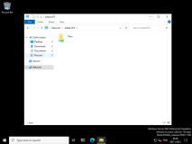

1. Right-click in the empty space in **Docs**, point to **New**, then select **Text Document**. Name this file called [**Test**](urn:gd:lg:a:send-vm-keys).

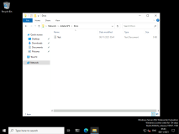

1. Switch to [**LON-SVR1**](urn:gd:lg:a:select-vm), switch to **Failover Cluster Manager**.
2. In the **Failover Cluster Manager** console, expand **Cluster1.Adatum.com**, and then click **Roles**.

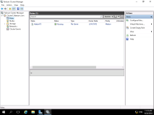

1. In the **Owner Node** column, note the current owner of **AdatumFS**.

**Note:** The owner will be **LON-SVR1** or **LON-SVR2**.

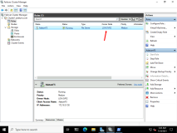

1. Right-click **AdatumFS**, click **Move**, and then click **Select Node**.

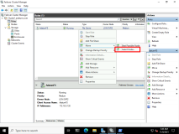

1. In the **Move Clustered Role** dialog box, select the cluster node (it will be either **LON-SVR1** or **LON-SVR2**), and then click **OK**.

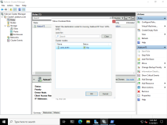

1. Verify that **AdatumFS** has moved to a new owner.

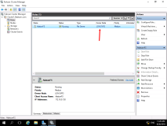

1. Switch to [**LON-MGT1**](urn:gd:lg:a:select-vm)
2. To verify that you can still access the **\\AdatumFS\** location, open **File Explorer**, and in the address bar, type [**\\AdatumFS\**](urn:gd:lg:a:send-vm-keys) and then press Enter.

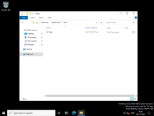

Task 9: Validate the failover and quorum configuration for the File Server role

1. Switch to [**LON-SVR1**](urn:gd:lg:a:select-vm), in the **Failover Cluster Manager** console, click **Roles**.
2. In the **Owner Node** column, verify the current owner for the **AdatumFS** role.

**Note:** The owner will be **LON-SVR1** or **LON-SVR2**.

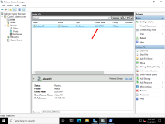

1. Click **Nodes**, and then select the node that is the current owner of the **AdatumFS** role.

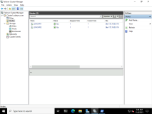

1. Right-click the node, click **More Actions**, and then click **Stop Cluster Service**.

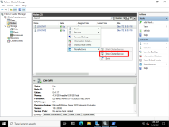

1. In the **Failover Cluster Manager** console, click **Roles**, and verify that **AdatumFS** is running.

**Note:** This confirms that **AdatumFS** has moved to another node.

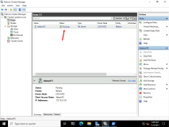

1. Switch to [**LON-MGT1**](urn:gd:lg:a:select-vm)
2. On [**LON-MGT1**](urn:gd:lg:a:select-vm), to verify that you can still access the **\AdatumFS\** location, open **File Explorer**. In the address bar, type [**\\AdatumFS\**](urn:gd:lg:a:send-vm-keys), and then press Enter.

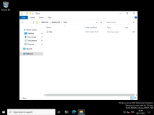

1. Switch to [**LON-SVR1**](urn:gd:lg:a:select-vm).
2. In the **Failover Cluster Manager** console, click **Nodes**, right-click the stopped node, click **More Actions**, and then click **Start Cluster Service**.

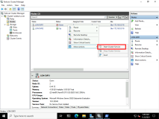

1. Expand **Storage**, and then click **Disks**.

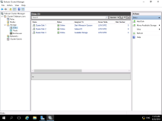

1. In the center pane, find the disk that is assigned to **Disk Witness in Quorum**.

**Note:** You can view this in the **Assigned To** column.

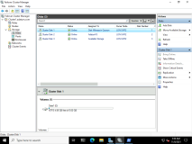

1. Right-click the disk, click **Take Offline**, and then click **Yes**.

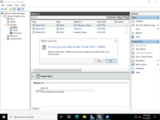

1. Switch to [**LON-DC1**](urn:gd:lg:a:select-vm).
2. On [**LON-DC1**](urn:gd:lg:a:select-vm), login as [**Adatum\AdatumAdmin**](urn:gd:lg:a:send-vm-keys) with the password [**Pa55w.rd**](urn:gd:lg:a:send-vm-keys). Verify that you can still access the **\\AdatumFS\** location, open **File Explorer**, and in the address bar, type [**\\AdatumFS\**](urn:gd:lg:a:send-vm-keys), and then press Enter.

**Note:** This verifies that the cluster is running even if the witness disk is offline.

1. Switch to [**LON-SVR1**](urn:gd:lg:a:select-vm).
2. In the **Failover Cluster Manager** console, expand **Storage**, click **Disks**, right-click the disk that is in **Offline** status, and then click **Bring Online**.

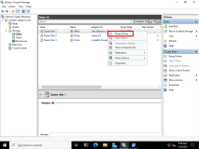

1. Right-click **Cluster1.Adatum.com**, click **More Actions**, and then click **Configure Cluster Quorum Settings**.

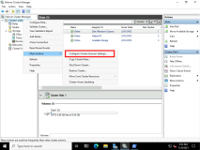

1. On the **Before You Begin** page, click **Next**.

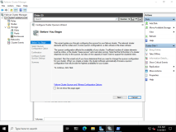

1. On the **Select Quorum Configuration Option** page, click **Advanced quorum configuration**, and then click **Next**.

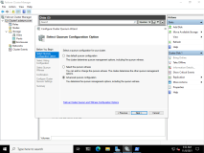

1. On the **Select Voting Configuration** page, review the available settings.

**Note:** Notice that you can select a node or nodes that will, or will not, have a vote in the cluster.

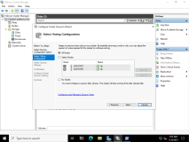

1. Do not make any changes, and then click **Next**.
2. On the **Select Quorum Witness** page, ensure that **Configure a disk witness** is selected, and then click **Next**.

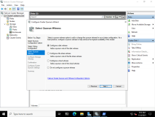

1. On the **Configure Storage Witness** page, click **Cluster Disk 3**, and then click **Next**.

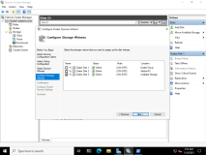

1. On the **Confirmation** page, click **Next**.

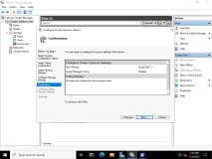

1. On the **Summary** page, click **Finish**.

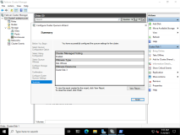

**Results** : After completing this exercise, you should have created a failover cluster successfully, configured a highly available file server, and tested the failover scenarios.

Exercise 2: Verifying quorum settings and adding a node

**Scenario**

As Adatum's business grows, it is becoming increasingly important that many of the applications and services on the network have increased scalability and remain high available at all times. Your responsibility is to increase the number of cluster nodes in the current cluster, and to evaluate and suggest a new quorum model.   The main tasks for this exercise are as follows:

1. Remotely connect to a cluster.
2. Check the assigned votes in the Nodes section.
3. Verify the status of the disk witness.
4. Add a node in the cluster.
5. Verify the assigned votes.
6. Prepare for the next lab.

Task 1: Remotely connect to a cluster

1. Switch to [**LON-MGT1**](urn:gd:lg:a:select-vm) and send the [**CTRL+ALT+DEL**](urn:gd:lg:a:send-vm-key-combo) command and login as **[Adatum\AdatumAdmin](urn:gd:lg:a:send-vm-keys" \o "Paste text into VM)** with the password [**Pa55w.rd**](urn:gd:lg:a:send-vm-keys)
2. Right click the **Start** Menu and select **Windows PowerShell (Admin)**.

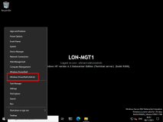

1. Run the following command to install the Failover Management tools.
2. Install-WindowsFeature RSAT-Clustering-Mgmt
3. Click **Start**, click **Windows Administrative Tools**, and then click **Failover Cluster Manager**.

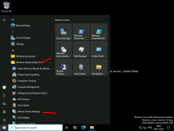

1. In **Failover Cluster Manager**, right-click **Failover Cluster Manager**, and then click **Connect to Cluster**.

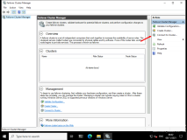

1. In the **Select Cluster** dialog box, in the **Cluster name** box, type [**Cluster1.Adatum.com**](urn:gd:lg:a:send-vm-keys), and click **OK**.

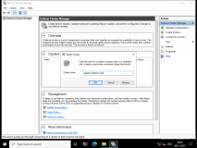

1. Expand **Cluster1.Adatum.com**, and then click **Roles**.

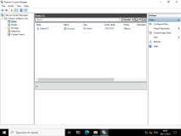

Task 2: Check the assigned votes in the Nodes section

1. On [**LON-SVR1**](urn:gd:lg:a:select-vm), right-click **Start**, and then click **Windows PowerShell (Admin)**.

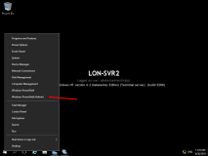

1. In the **Windows PowerShell** console, run following cmdlet to check the assigned votes:
2. Get-ClusterNode | select name, nodeweight, ID, state

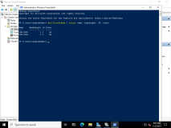

1. Verify that the **NodeWeight** property of a cluster node has value **1**, which means that the quorum vote of the node is assigned and that the cluster is managing it.

Task 3: Verify the status of the disk witness

1. On [**LON-SVR1**](urn:gd:lg:a:select-vm), in the **Windows PowerShell** console, type the following command, and then press Enter:
2. Get-ClusterQuorum | Select Cluster, QuorumResource, QuorumType

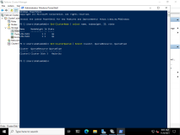

Task 4: Add a node in the cluster

1. Switch to [**LON-SVR3**](urn:gd:lg:a:select-vm) and right-click the **Start** menu and select Windows PowerShell (Admin).
2. Run the following command to install the File Services feature.
3. Install-WindowsFeature File-Services

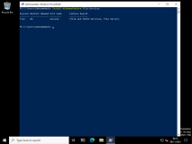

1. Switch to [**LON-SVR1**](urn:gd:lg:a:select-vm).
2. On [**LON-SVR1**](urn:gd:lg:a:select-vm), in the Failover Cluster Manager, click **Nodes**.

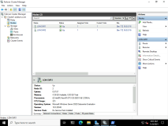

1. In the **Actions** pane, click **Add Node**.

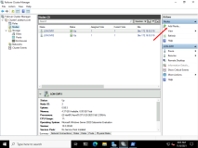

1. On the **Before You Begin** page, click **Next**.

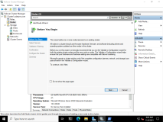

1. On the **Select Servers** page, in the **Enter server name** box, type [**LON-SVR3**](urn:gd:lg:a:send-vm-keys), click **Add**, and then click **Next**.

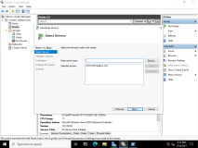

1. On the **Validation Warning** page, click **Next**.

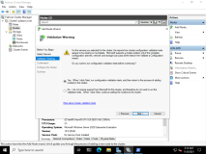

1. Complete the validation by using the defaults.
2. On the **Summary** page of the **Validate a Configuration Wizard**, click **Finish**.

**Note**: You can safely ignore any errors on the validation wizard.

1. In the **Add Node Wizard**, on the **Confirmation** page, click **Next**.

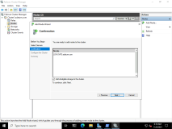

1. On the **Summary** page, click **Finish**.

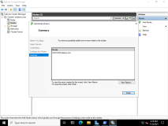

Task 5: Verify the assigned votes

1. On [**LON-SVR1**](urn:gd:lg:a:select-vm), in the **Windows PowerShell** console, type following cmdlet, and then press Enter:
2. Get-ClusterNode | select name, nodeweight, ID, state

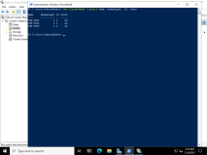

1. Verify that the **NodeWeight** property of a cluster node has value **1**, which means that the quorum vote of the node is assigned and that the cluster is managing it.

Lab B: Managing a failover cluster

**Scenario**

Adatum Corporation recently implemented failover clustering for better uptime and availability. The implementation is new and your boss has asked you to go through some failover-cluster management tasks so that you are prepared to manage it moving forward which also inclues managing the failover-cluster using the Windows Admin Centerf.

Objectives

After completing this lab, you will be able to:

* Evict a node and verify quorum settings.
* Change the quorum from a disk witness to a file-share witness and define node voting.
* Add and remove disks from the cluster.
* Identify how to manage a failover-cluster using the Windows Admin Center

Exercise 1: Evicting a node and verifying quorum settings

**Scenario**

You have added a node to the cluster to test your organization's application scalability. Some of your organization employees have moved to another department, and they will not use the clustered application any more. According to your test, you will not need the current number of nodes in the cluster, so you will evict one node from the cluster.

The main tasks for this exercise are as follows

1. Evict node LON-SVR3.
2. Verify changes in quorum settings and the witness disk.

Task 1: Evict node LON-SVR2

1. On [**LON-SVR2**](urn:gd:lg:a:select-vm), if necessary, open **Failover Cluster Manager**.
2. Expand the **Cluster1.Adatum.com** cluster, and then click **Nodes**.

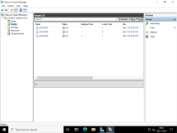

1. Right-click the **LON-SVR3** node, click **More Actions**, and then click **Evict**.

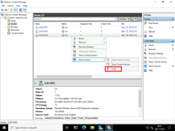

1. In the **Evict node LON-SVR3** dialog box, click **Yes** to evict the node.

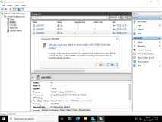

Task 2: Verify changes in quorum settings and the witness disk

1. On [**LON-SVR2**](urn:gd:lg:a:select-vm), in the **Windows PowerShell** console, type following cmdlet, and then press Enter:
2. Get-ClusterNode | select name, nodeweight, ID, state

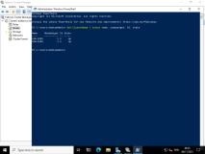

1. Verify that the **NodeWeight** property of a cluster node has value **1**, which means that the quorum vote of the node is assigned and is managed by the cluster.

**Results** : After completing this exercise, you should have evicted a node from the cluster, and verified the changes in quorum settings and witness disk.

Exercise 2: Changing the quorum from disk witness to file-share witness and defining node voting

**Scenario**

You have introduced a new application in your organization that works better by using scenarios with the File Share Witness quorum model. Additionally, the new application requires that you configure node voting.

The main tasks for this exercise are as follows:

* Get the current quorum model.
* Create a file share on LON-SVR1.
* Change the current quorum model to a file-share witness.
* Verify that the current quorum model is a file share witness.

Task 1: Get the current quorum model

1. On [**LON-SVR2**](urn:gd:lg:a:select-vm), in the **Windows PowerShell** console, type the following command, and then press Enter:
2. Get-ClusterQuorum | Select Cluster, QuorumResource, QuorumType

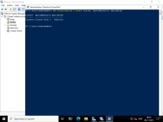

Task 2: Create a file share on LON-SVR1

1. On [**LON-MGT1**](urn:gd:lg:a:select-vm), on the taskbar, click **File Explorer**, double-click **Local Disk (C:)**, right-click in some white space and choose **New**, and then click **Folder**.

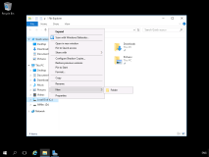

1. Type [**FSW**](urn:gd:lg:a:send-vm-keys), and press Enter.

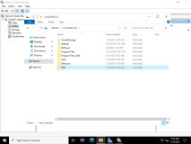

1. Right-click **FSW**, click **Give access to**, and then click **Specific people**.

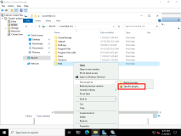

1. In the dialog box, type [**Everyone**](urn:gd:lg:a:send-vm-keys), and then click **Add**.

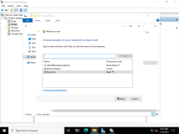

1. In the **Read** list, click **Read/Write**.

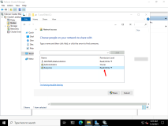

1. Click **Share**, and then click **Done**.

Task 3: Change the current quorum model to a file-share witness

1. On [**LON-SVR1**](urn:gd:lg:a:select-vm), in the **Windows PowerShell** console, type the following command, and then press Enter:
2. Set-ClusterQuorum -NodeAndFileShareMajority "\\LON-MGT1\FSW"

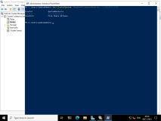

Task 4: Verify that the current quorum model is a file share witness

1. On **LON-SVR2**, in the **Windows PowerShell** console, type the following command, and then press Enter:
2. Get-ClusterQuorum | Select Cluster, QuorumResource, QuorumType

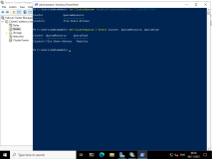

**Results**: After completing this exercise, you should have changed the quorum from disk witness to file share witness and defined node voting

Exercise 3: Verifying high availability

**Scenario**

You want to test your high-availability solution by taking one of your servers offline, and then verify that your application, services, and data are still available to clients. After you verify that high availability works, you will bring the server back online.

The main tasks for this exercise are as follows:

1. Simulate server failure.
2. Verify functionality in Cluster1 and verify file availability.
3. Validate whether the file is still available.

Task 1: Simulate server failure

1. On [**LON-SVR2**](urn:gd:lg:a:select-vm), in the **Failover Cluster Manager** console, expand **Cluster1.Adatum.com**, and then click **Roles**.

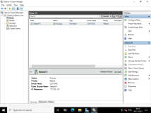

1. In the **Owner Node** column, notice the current owner of **AdatumFS**.

**Note:** The owner will be **LON-SVR1** or **LON-SVR2**.

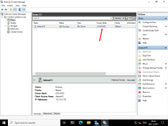

1. If **LON-SVR2** is not the owner, right click **AdatumFS**, click **Move**, click **Select Node**, click **LON-SVR2**, and then click **OK**.
2. Shut down **LON-SVR2**.

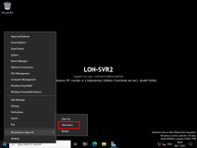

Task 2: Verify functionality in Cluster1 and verify file availability

1. On [**LON-MGT1**](urn:gd:lg:a:select-vm), open **File Explorer**. In the address bar, type [**\\AdatumFS\**](urn:gd:lg:a:send-vm-keys), and then press Enter.

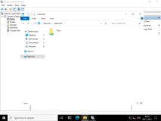

1. Verify that you can access the location and that you can open the **Docs** folder.

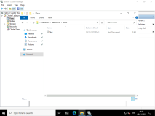

1. Right-click in the empty space in **Docs**, point to **New**, then select **Text Document**. Name this file called [**Test2**](urn:gd:lg:a:send-vm-keys).

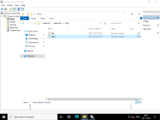

Task 3: Validate whether the file is still available

1. Start the [**LON-SVR2**](urn:gd:lg:a:select-vm) virtual machine by selecting the LON-SVR2 Virtual machine and then clicking the Power On and in Home Tab of the LMS.

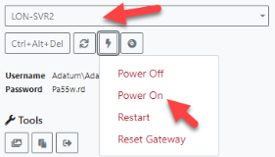

1. On [**LON-SVR1**](urn:gd:lg:a:select-vm), in the **Failover Cluster Manager** console, expand **Cluster1.Adatum.com**, and then click **Roles**.
2. Right click **AdatumFS**, click **Move**, click **Select Node**, click **LON-SVR2**, and then click **OK**.

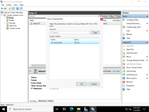

1. On [**LON-MGT1**](urn:gd:lg:a:select-vm), open **File Explorer**. In the address bar, type [**\\AdatumFS\**](urn:gd:lg:a:send-vm-keys), and then press Enter.

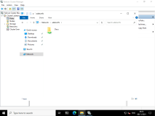

1. Verify that you can access the location and that you can open the **Docs** folder.

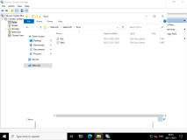

1. Right-click in the empty space in **Docs**, point to **New**, then select **Text Document**. Name this file called [**Test3**](urn:gd:lg:a:send-vm-keys).

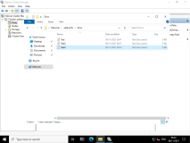

**Results**: After completing this exercise, you should have tested failover cluster high availability successfully by taking a server offline and then bringing it back online.

Exercise 4: Identify how to manage a failover-cluster using the Windows Admin Center

Your manager has requested to look into how you can manage failover-clusters using the Widnows Admin Center.

The main tasks for this exercise are as follows:

1. Connect the failover cluster to the Windows Admin Center
2. Identify how you administrater failover clusters using the Windows Admin center.

Task 1: Connect the failover cluster to the Windows Admin Center

1. Switch to [**LON-MGT1**](urn:gd:lg:a:select-vm).
2. Open **Microsoft Edge** and select the Widnows Admin Center favourite.

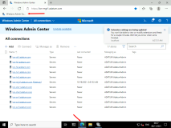

1. Select **+ Add** and in the Add or create resources blade select **Add** in the **Servers clusters** section.

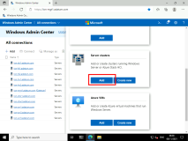

1. In the Cluster name section, enter [**cluster1.adatum.com**](urn:gd:lg:a:send-vm-keys), then click **Add**.

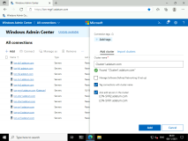

1. Select the **cluster1.adatum.com** from the All connections screen.

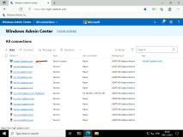

1. Once connected, select the option and note the **AdatumFS** file server role.

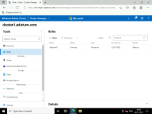

1. Select Nodes and note both servers are Up.

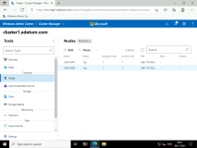

1. Select **LON-SVR2** then select **Stop service**.

**Note**: You may have to select the elipsis (...) button to see the Stop service option.

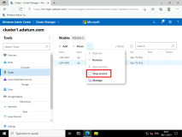

1. On the stop cluster service dialogue box select **Yes**.

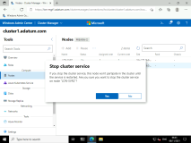

1. On [**LON-MGT1**](urn:gd:lg:a:select-vm), open **File Explorer**. In the address bar, type [**\\AdatumFS\**](urn:gd:lg:a:send-vm-keys), and then press Enter.

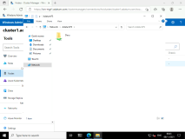

1. Verify that you can access the location and that you can open the **Docs** folder.

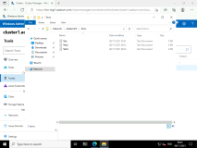

1. Right-click in the empty space in **Docs**, point to **New**, then select **Text Document**. Name this file called [**Test4**](urn:gd:lg:a:send-vm-keys).



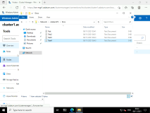

1. Switch back to the Windows Admin center and select **LON-SVR2** then select **Start service**.

**Note**: You may have to select the elipsis (...) button to see the Start service option.

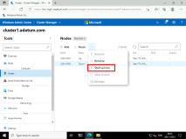

**Result**

You have now managed a Windows File Server Cluster using the Windows Admin Center.