key_128 = {128'd0, 128'h2b7e151628aed2a6abf7158809cf4f3c};

key_192 = {64'd0, 192'h8e73b0f7da0e6452c810f32b809079e562f8ead2522c6b7b};

key_256 = 256'h603deb1015ca71be2b73aef0857d77811f352c073b6108d72d9810a30914dff4;

test_iv = 128'h000102030405060708090a0b0c0d0e0f;

test_pt1 = 128'h6bc1bee22e409f96e93d7e117393172a;

test_pt2 = 128'hae2d8a571e03ac9c9eb76fac45af8e51;

# BLOCK_MODE: 000 | KEY_LEN: 00

# ENCRYPT BLK1 PT: 6bc1bee22e409f96e93d7e117393172a -> CT: 3ad77bb40d7a3660a89ecaf32466ef97

# ENCRYPT BLK2 PT: ae2d8a571e03ac9c9eb76fac45af8e51 -> CT: f5d3d58503b9699de785895a96fdbaaf

# DECRYPT BLK1 CT: 3ad77bb40d7a3660a89ecaf32466ef97 -> DT: 6bc1bee22e409f96e93d7e117393172a

# DECRYPT BLK2 CT: f5d3d58503b9699de785895a96fdbaaf -> DT: ae2d8a571e03ac9c9eb76fac45af8e51

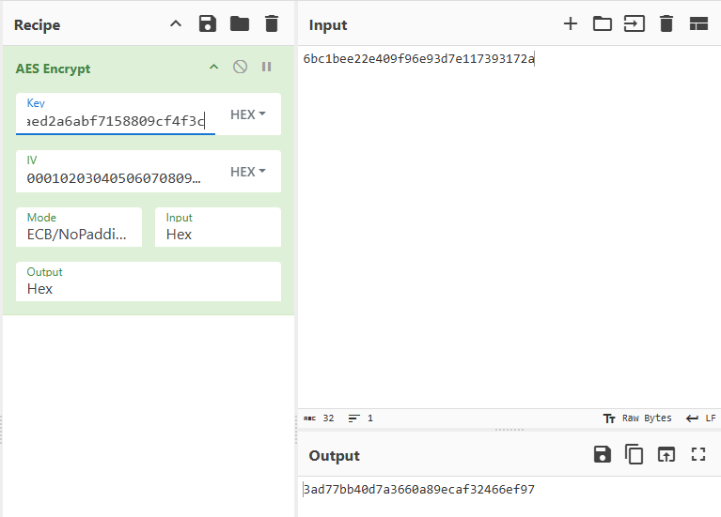

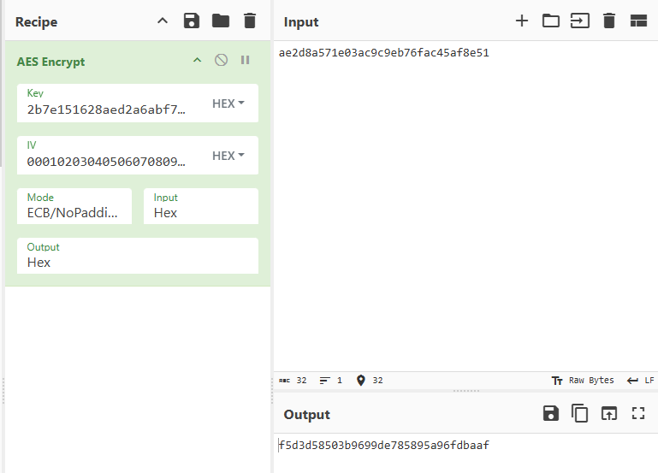

# ----------------------------------------------------------------

# BLOCK_MODE: 000 | KEY_LEN: 01

# ENCRYPT BLK1 PT: 6bc1bee22e409f96e93d7e117393172a -> CT: bd334f1d6e45f25ff712a214571fa5cc

# ENCRYPT BLK2 PT: ae2d8a571e03ac9c9eb76fac45af8e51 -> CT: 974104846d0ad3ad7734ecb3ecee4eef

# DECRYPT BLK1 CT: bd334f1d6e45f25ff712a214571fa5cc -> DT: 6bc1bee22e409f96e93d7e117393172a

# DECRYPT BLK2 CT: 974104846d0ad3ad7734ecb3ecee4eef -> DT: ae2d8a571e03ac9c9eb76fac45af8e51

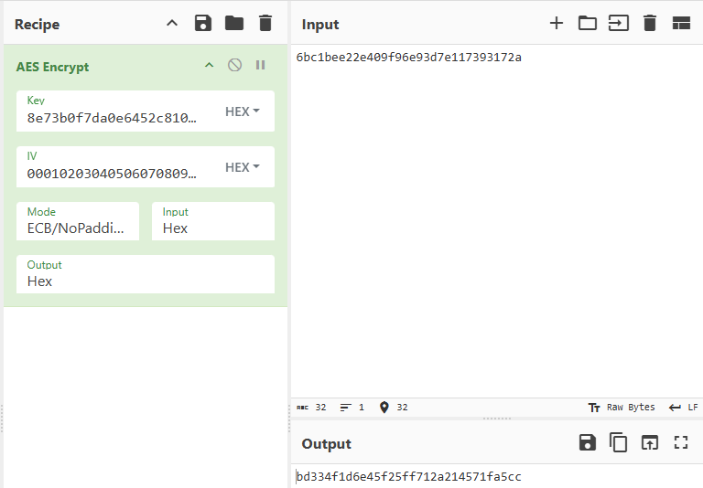

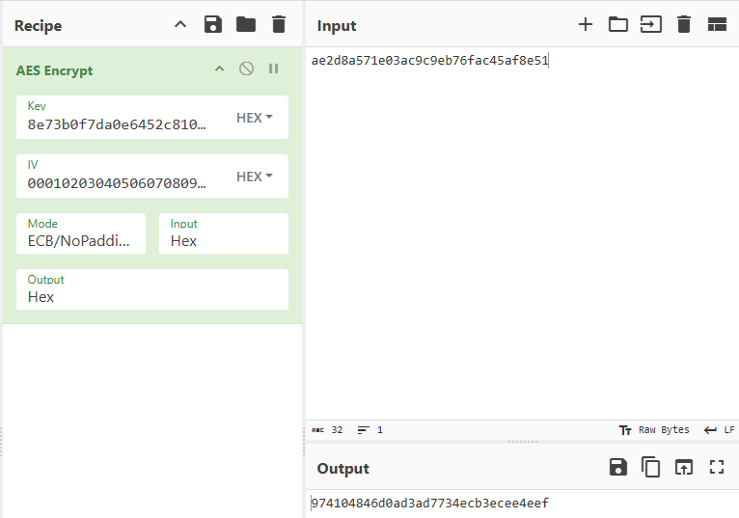

# ----------------------------------------------------------------

# BLOCK_MODE: 000 | KEY_LEN: 10

# ENCRYPT BLK1 PT: 6bc1bee22e409f96e93d7e117393172a -> CT: f3eed1bdb5d2a03c064b5a7e3db181f8

# ENCRYPT BLK2 PT: ae2d8a571e03ac9c9eb76fac45af8e51 -> CT: 591ccb10d410ed26dc5ba74a31362870

# DECRYPT BLK1 CT: f3eed1bdb5d2a03c064b5a7e3db181f8 -> DT: 6bc1bee22e409f96e93d7e117393172a

# DECRYPT BLK2 CT: 591ccb10d410ed26dc5ba74a31362870 -> DT: ae2d8a571e03ac9c9eb76fac45af8e51

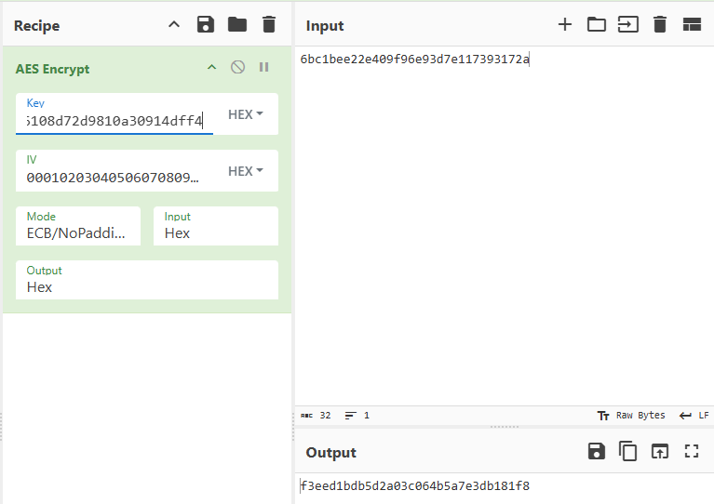

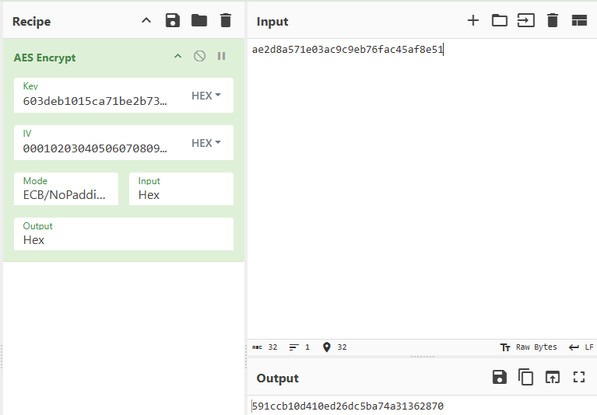

# ----------------------------------------------------------------

# BLOCK_MODE: 001 | KEY_LEN: 00

# ENCRYPT BLK1 PT: 6bc1bee22e409f96e93d7e117393172a -> CT: 7649abac8119b246cee98e9b12e9197d

# ENCRYPT BLK2 PT: ae2d8a571e03ac9c9eb76fac45af8e51 -> CT: 5086cb9b507219ee95db113a917678b2

# DECRYPT BLK1 CT: 7649abac8119b246cee98e9b12e9197d -> DT: 6bc1bee22e409f96e93d7e117393172a

# DECRYPT BLK2 CT: 5086cb9b507219ee95db113a917678b2 -> DT: ae2d8a571e03ac9c9eb76fac45af8e51

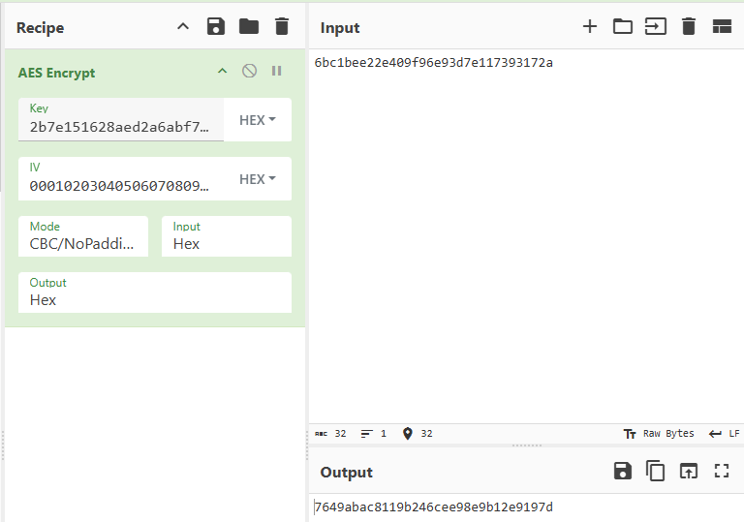

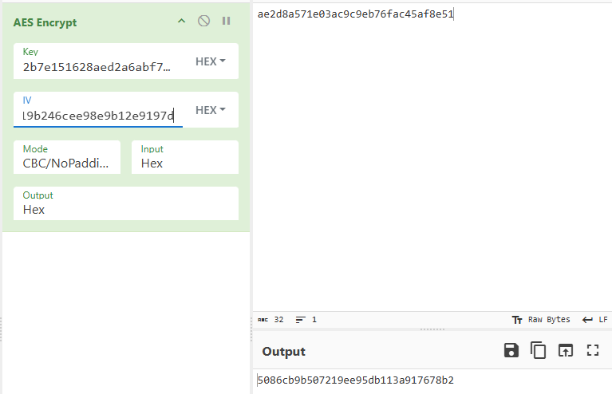

# ----------------------------------------------------------------

# BLOCK_MODE: 001 | KEY_LEN: 01

# ENCRYPT BLK1 PT: 6bc1bee22e409f96e93d7e117393172a -> CT: 4f021db243bc633d7178183a9fa071e8

# ENCRYPT BLK2 PT: ae2d8a571e03ac9c9eb76fac45af8e51 -> CT: b4d9ada9ad7dedf4e5e738763f69145a

# DECRYPT BLK1 CT: 4f021db243bc633d7178183a9fa071e8 -> DT: 6bc1bee22e409f96e93d7e117393172a

# DECRYPT BLK2 CT: b4d9ada9ad7dedf4e5e738763f69145a -> DT: ae2d8a571e03ac9c9eb76fac45af8e51

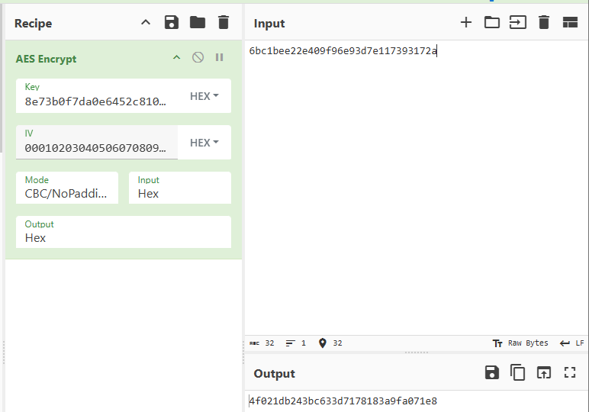

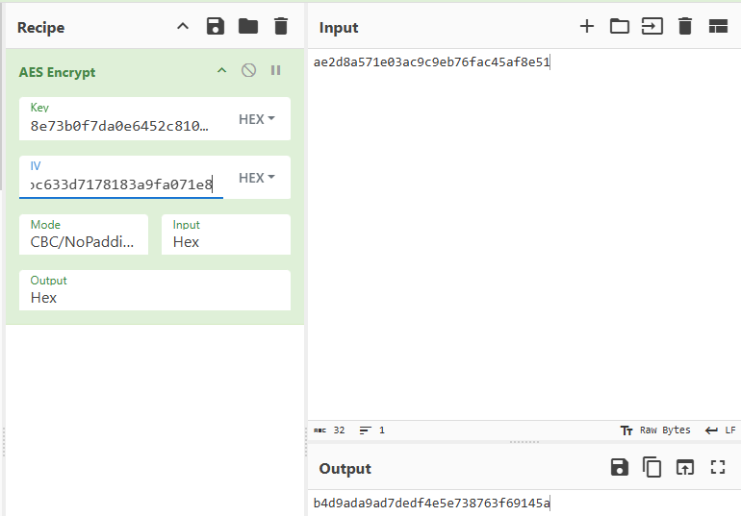

# ----------------------------------------------------------------

# BLOCK_MODE: 001 | KEY_LEN: 10

# ENCRYPT BLK1 PT: 6bc1bee22e409f96e93d7e117393172a -> CT: f58c4c04d6e5f1ba779eabfb5f7bfbd6

# ENCRYPT BLK2 PT: ae2d8a571e03ac9c9eb76fac45af8e51 -> CT: 9cfc4e967edb808d679f777bc6702c7d

# DECRYPT BLK1 CT: f58c4c04d6e5f1ba779eabfb5f7bfbd6 -> DT: 6bc1bee22e409f96e93d7e117393172a

# DECRYPT BLK2 CT: 9cfc4e967edb808d679f777bc6702c7d -> DT: ae2d8a571e03ac9c9eb76fac45af8e51

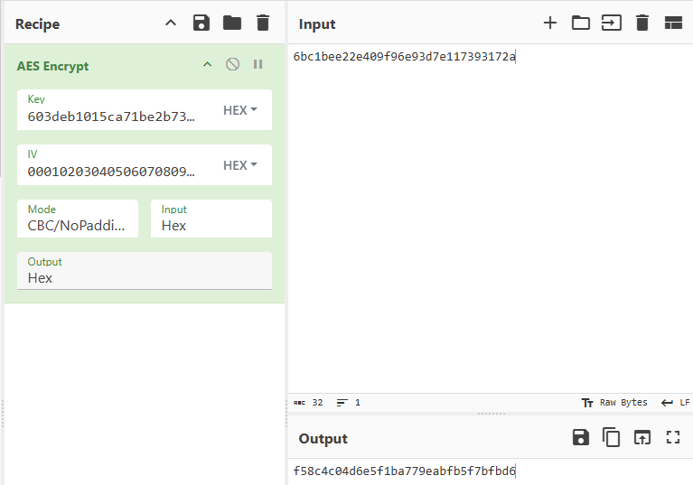

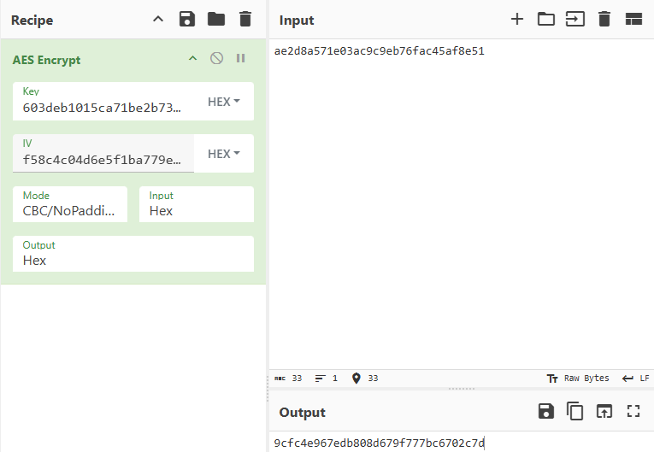

# ----------------------------------------------------------------

# BLOCK_MODE: 010 | KEY_LEN: 00

# ENCRYPT BLK1 PT: 6bc1bee22e409f96e93d7e117393172a -> CT: 3b3fd92eb72dad20333449f8e83cfb4a

# ENCRYPT BLK2 PT: ae2d8a571e03ac9c9eb76fac45af8e51 -> CT: c8a64537a0b3a93fcde3cdad9f1ce58b

# DECRYPT BLK1 CT: 3b3fd92eb72dad20333449f8e83cfb4a -> DT: 6bc1bee22e409f96e93d7e117393172a

# DECRYPT BLK2 CT: c8a64537a0b3a93fcde3cdad9f1ce58b -> DT: ae2d8a571e03ac9c9eb76fac45af8e51

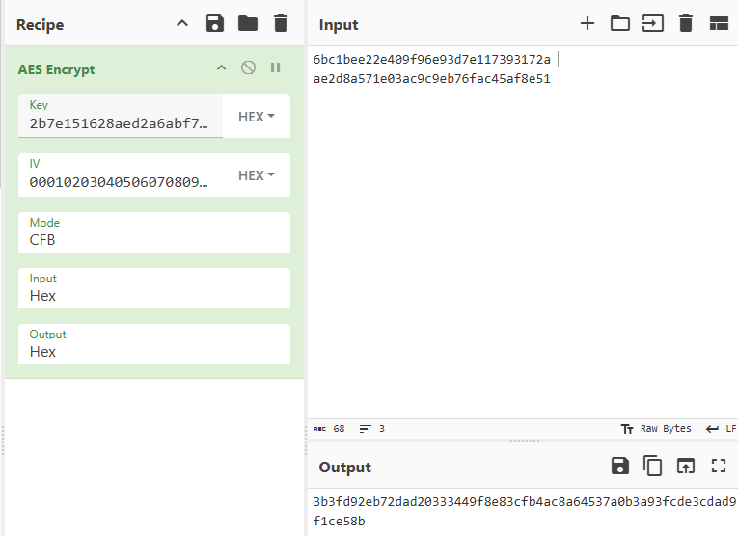

# ----------------------------------------------------------------

# BLOCK_MODE: 010 | KEY_LEN: 01

# ENCRYPT BLK1 PT: 6bc1bee22e409f96e93d7e117393172a -> CT: cdc80d6fddf18cab34c25909c99a4174

# ENCRYPT BLK2 PT: ae2d8a571e03ac9c9eb76fac45af8e51 -> CT: 67ce7f7f81173621961a2b70171d3d7a

# DECRYPT BLK1 CT: cdc80d6fddf18cab34c25909c99a4174 -> DT: 6bc1bee22e409f96e93d7e117393172a

# DECRYPT BLK2 CT: 67ce7f7f81173621961a2b70171d3d7a -> DT: ae2d8a571e03ac9c9eb76fac45af8e51

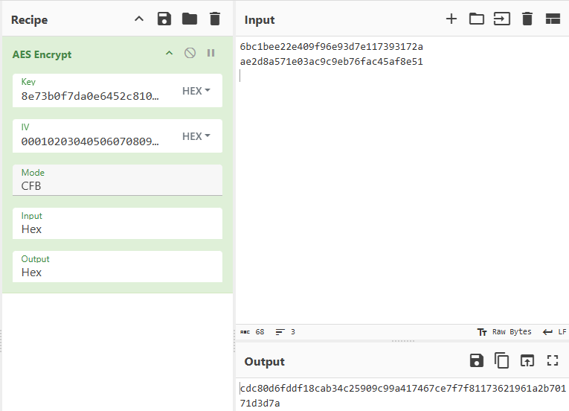

# ----------------------------------------------------------------

# BLOCK_MODE: 010 | KEY_LEN: 10

# ENCRYPT BLK1 PT: 6bc1bee22e409f96e93d7e117393172a -> CT: dc7e84bfda79164b7ecd8486985d3860

# ENCRYPT BLK2 PT: ae2d8a571e03ac9c9eb76fac45af8e51 -> CT: 39ffed143b28b1c832113c6331e5407b

# DECRYPT BLK1 CT: dc7e84bfda79164b7ecd8486985d3860 -> DT: 6bc1bee22e409f96e93d7e117393172a

# DECRYPT BLK2 CT: 39ffed143b28b1c832113c6331e5407b -> DT: ae2d8a571e03ac9c9eb76fac45af8e51

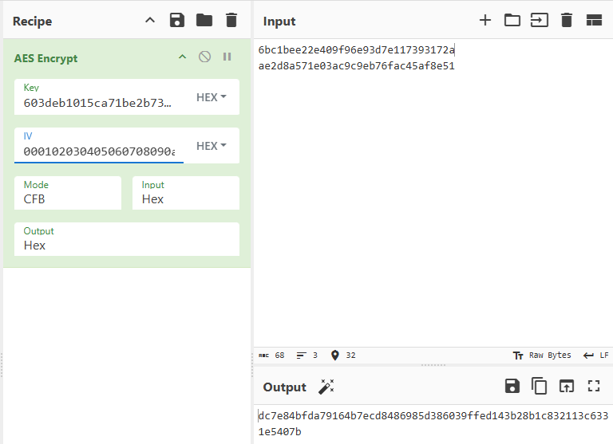

# ----------------------------------------------------------------

# BLOCK_MODE: 011 | KEY_LEN: 00

# ENCRYPT BLK1 PT: 6bc1bee22e409f96e93d7e117393172a -> CT: 3b3fd92eb72dad20333449f8e83cfb4a

# ENCRYPT BLK2 PT: ae2d8a571e03ac9c9eb76fac45af8e51 -> CT: 7789508d16918f03f53c52dac54ed825

# DECRYPT BLK1 CT: 3b3fd92eb72dad20333449f8e83cfb4a -> DT: 6bc1bee22e409f96e93d7e117393172a

# DECRYPT BLK2 CT: 7789508d16918f03f53c52dac54ed825 -> DT: ae2d8a571e03ac9c9eb76fac45af8e51

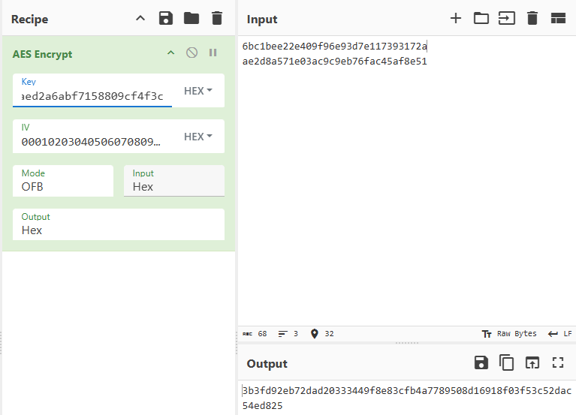

# ----------------------------------------------------------------

# BLOCK_MODE: 011 | KEY_LEN: 01

# ENCRYPT BLK1 PT: 6bc1bee22e409f96e93d7e117393172a -> CT: cdc80d6fddf18cab34c25909c99a4174

# ENCRYPT BLK2 PT: ae2d8a571e03ac9c9eb76fac45af8e51 -> CT: fcc28b8d4c63837c09e81700c1100401

# DECRYPT BLK1 CT: cdc80d6fddf18cab34c25909c99a4174 -> DT: 6bc1bee22e409f96e93d7e117393172a

# DECRYPT BLK2 CT: fcc28b8d4c63837c09e81700c1100401 -> DT: ae2d8a571e03ac9c9eb76fac45af8e51

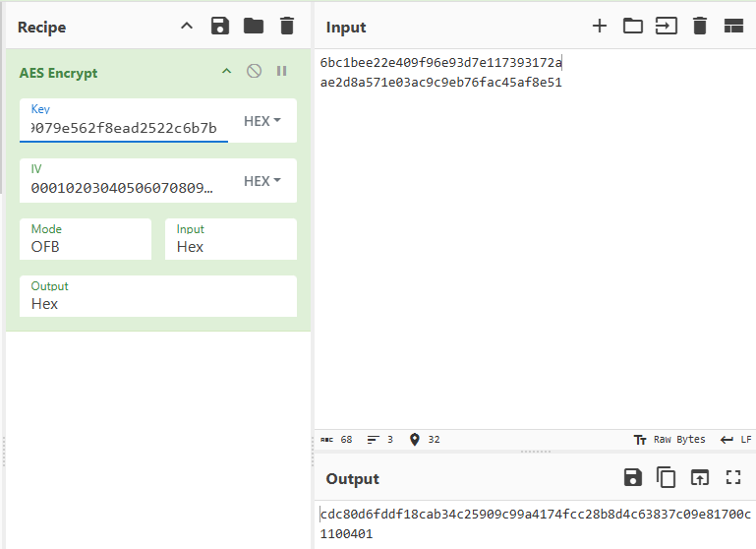

# ----------------------------------------------------------------

# BLOCK_MODE: 011 | KEY_LEN: 10

# ENCRYPT BLK1 PT: 6bc1bee22e409f96e93d7e117393172a -> CT: dc7e84bfda79164b7ecd8486985d3860

# ENCRYPT BLK2 PT: ae2d8a571e03ac9c9eb76fac45af8e51 -> CT: 4febdc6740d20b3ac88f6ad82a4fb08d

# DECRYPT BLK1 CT: dc7e84bfda79164b7ecd8486985d3860 -> DT: 6bc1bee22e409f96e93d7e117393172a

# DECRYPT BLK2 CT: 4febdc6740d20b3ac88f6ad82a4fb08d -> DT: ae2d8a571e03ac9c9eb76fac45af8e51

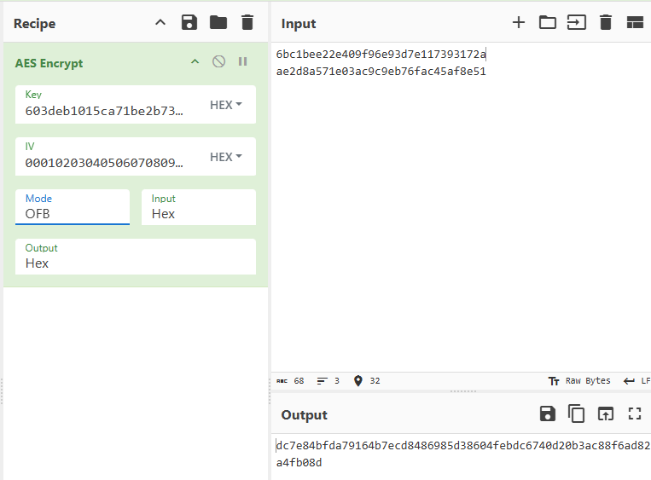

# ----------------------------------------------------------------

# BLOCK_MODE: 100 | KEY_LEN: 00

# ENCRYPT BLK1 PT: 6bc1bee22e409f96e93d7e117393172a -> CT: 3b3fd92eb72dad20333449f8e83cfb4a

# ENCRYPT BLK2 PT: ae2d8a571e03ac9c9eb76fac45af8e51 -> CT: 010c041999e03f36448624483e582d0e

# DECRYPT BLK1 CT: 3b3fd92eb72dad20333449f8e83cfb4a -> DT: 6bc1bee22e409f96e93d7e117393172a

# DECRYPT BLK2 CT: 010c041999e03f36448624483e582d0e -> DT: ae2d8a571e03ac9c9eb76fac45af8e51

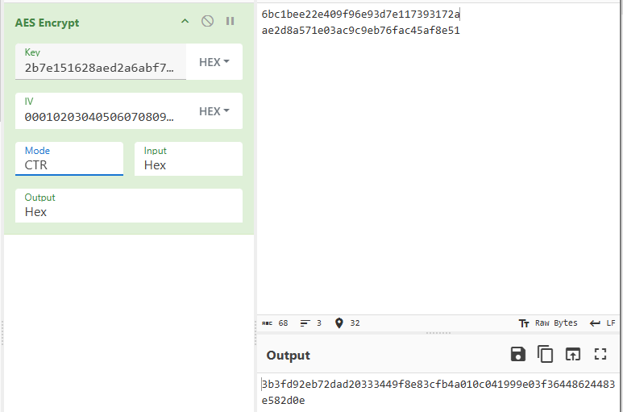

# ----------------------------------------------------------------

# BLOCK_MODE: 100 | KEY_LEN: 01

# ENCRYPT BLK1 PT: 6bc1bee22e409f96e93d7e117393172a -> CT: cdc80d6fddf18cab34c25909c99a4174

# ENCRYPT BLK2 PT: ae2d8a571e03ac9c9eb76fac45af8e51 -> CT: 37d8a639171fdcca63ebd17ce2d7321a

# DECRYPT BLK1 CT: cdc80d6fddf18cab34c25909c99a4174 -> DT: 6bc1bee22e409f96e93d7e117393172a

# DECRYPT BLK2 CT: 37d8a639171fdcca63ebd17ce2d7321a -> DT: ae2d8a571e03ac9c9eb76fac45af8e51

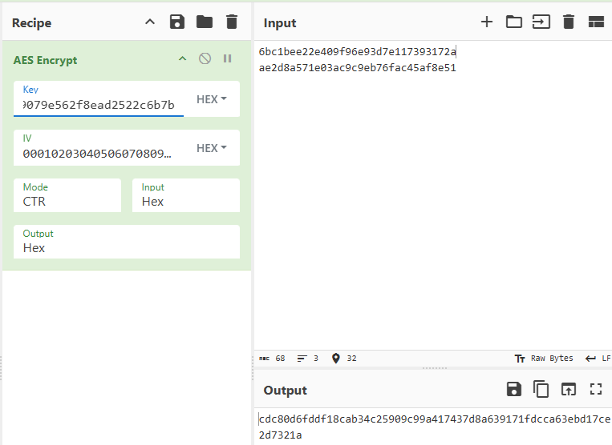

# ----------------------------------------------------------------

# BLOCK_MODE: 100 | KEY_LEN: 10

# ENCRYPT BLK1 PT: 6bc1bee22e409f96e93d7e117393172a -> CT: dc7e84bfda79164b7ecd8486985d3860

# ENCRYPT BLK2 PT: ae2d8a571e03ac9c9eb76fac45af8e51 -> CT: d577788b8d8a85745513a5d50f821f30

# DECRYPT BLK1 CT: dc7e84bfda79164b7ecd8486985d3860 -> DT: 6bc1bee22e409f96e93d7e117393172a

# DECRYPT BLK2 CT: d577788b8d8a85745513a5d50f821f30 -> DT: ae2d8a571e03ac9c9eb76fac45af8e51

