# Week 2 Assignments

# Reusable Barrier (I)

Implement the Reusable Barrier of paragraph 3.7 (LBOS), but only with the use of semaphores (so no counters). The number of threads is known at compile time, e.g. 4.

# Reusable Barrier (II)

Re-implement the solution of the Reusable Barrier of paragraph 3.7 (LBOS), but don't use turnstile.wait() for locking (aka closing) a turnstile (see the rectangles in the following picture).

Tip: do not start with the code as given in LBoS and move some statements around until it more or less seems to work, but start with an empty sheet and write a clean implementation.

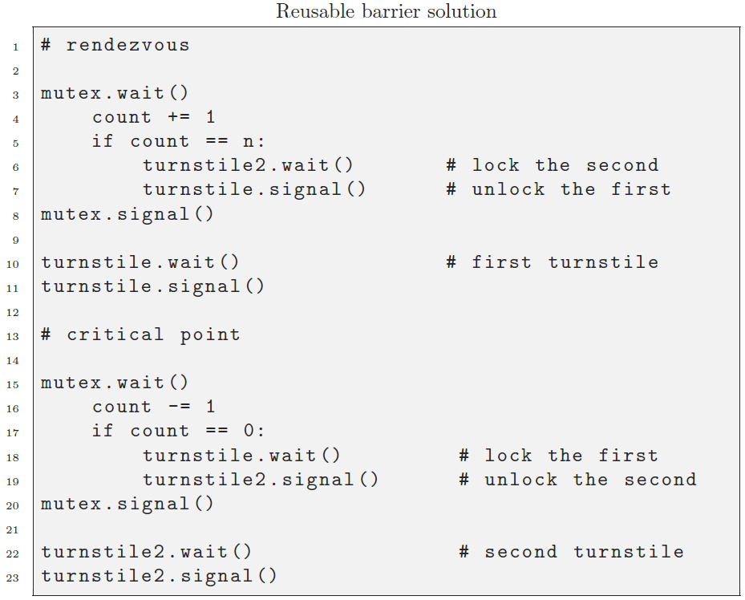

# Queue: followers & leaders

Make a symmetric implementation of the 3.8 problem (LBOS) with a pipet; without counters.

Ensure that an arbitrary number of follower and leader threads can be started (e.g. N=5)