PRACTICAL EXAMINATION
Subject code: PRN212 - FA25
Duration: 85 minutes
Notes:
- Only allowed to access the Internet during the first 5 minutes to install packages via NuGet.
- The tables must be related as shown in the requirements above, and these relationships are automatically generated through Code First or Database First.
- The DataConnectionString must be declared in appsettings.json.
- You may use local resources, but internet access is restricted to downloading the exam, submitting your work, and installing packages via NuGet.
- Fully implemented according to software architecture and design principles, transition from tight coupling to loose coupling such as BusinessLogic, DataAccess.
- If the code does not run, the students’ work will receive a score of zero.
Question 1 (3.5 marks)
- Create a Console Project named StudyPlannerUtilityApp
- Create a generic class DataVault<T> to store any type of data (0.5 mark)
The class should have:
- Items: List<T> property
- Add(T item) method
- FindAll(Func<T, bool> predicate): IEnumerable<T> method
- Remove(T item) method
- Count(): int method
- Create a StudyTask class (1.0 mark)
Properties (0.5 mark):
- TaskId (int)
- Subject (string)
- Description (string)
- Priority (int) – 1 = High, 2 = Medium, 3 = Low
- DayOfWeek (string) – e.g. “Monday”, “Tuesday”, …
Methods (0.5 mark):
- Override ToString() → "[TaskId] Subject - Priority: Priority (Day: DayOfWeek)"
- Use the Generic Class + LINQ (2 marks)
In Main() method:
- Create a DataVault<StudyTask> and add at least 6 tasks with different priorities and days (0.25 mark)
- Display all tasks before sorting (0.25 mark).
- Sort the tasks by Priority (ascending) using LINQ and display the sorted list (0.5 mark).
- Use LINQ to filter and display tasks with Priority == 1 (High) (0.5 mark).
- Use LINQ to group tasks by Priority and display each group with its task count (0.5 mark).

Example output:

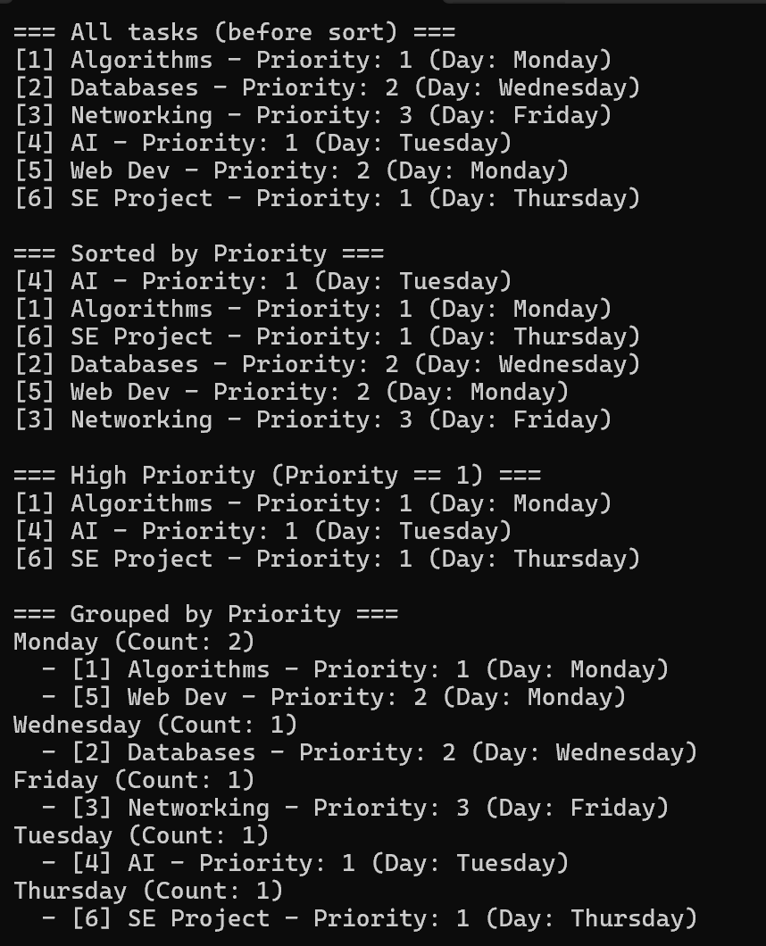
Question 2 (6.5 marks)

A team wants to develop a simple Study Planner Management System to help students manage their study schedules and weekly tasks.
- Create a Library Project StudyPlannerDataAccess inside a solution named StudyPlannerSystem with BussinessLayer, DataAccessLayer, RepositoryLayer and ServicesLayer (0.5 mark)
- Create database DBMStudyPlanner and generate related tables (0.25 mark)

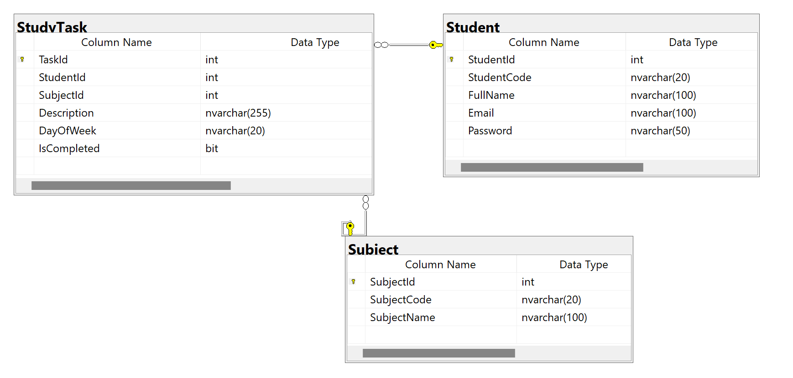
- Use Entity Framework Core (Code First or Database First) with the following classes and relationships (1 mark)
- Student: StudentId, StudentCode, FullName, Email, Password
- Subject: SubjectId, SubjectCode, SubjectName
- StudyTask: TaskId, StudentId, SubjectId, Description, DayOfWeek, IsCompleted

Relationships:
- One Student can have many StudyTasks (1–n)
- One Subject can have many StudyTasks (1–n)
- StudyPlannerDataAccess contains EF, DbContext, entity, DAO classes.
- StudyPlannerBusiness contains all business logic.
- Create a WPF Application namely StudyPlannerApp (5 marks)
Student Login (1 mark)
- A login form where students enter StudentCode and Password (0.25 mark).
- Validate credentials from the database (0.5 mark).
- If valid → navigate to MainWindow; otherwise → show 'Invalid StudentCode or Password' (0.25 mark)

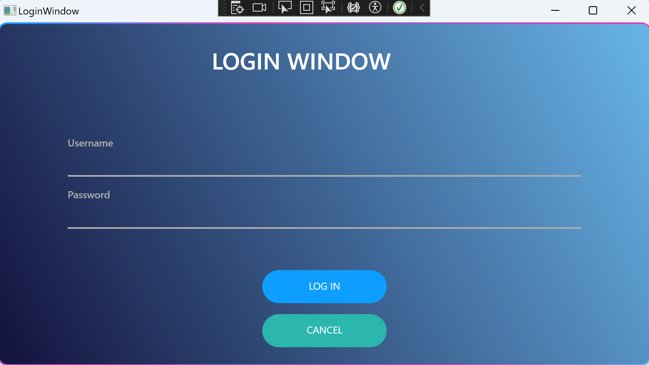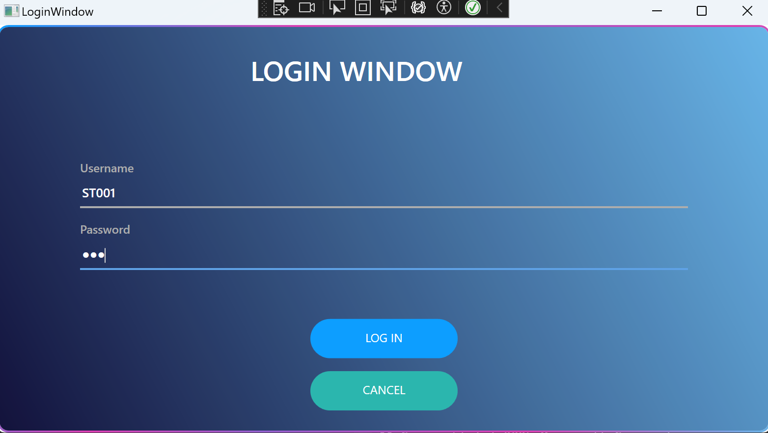
MainWindow with Menu: Study Tasks and Subjects (0.5 mark)

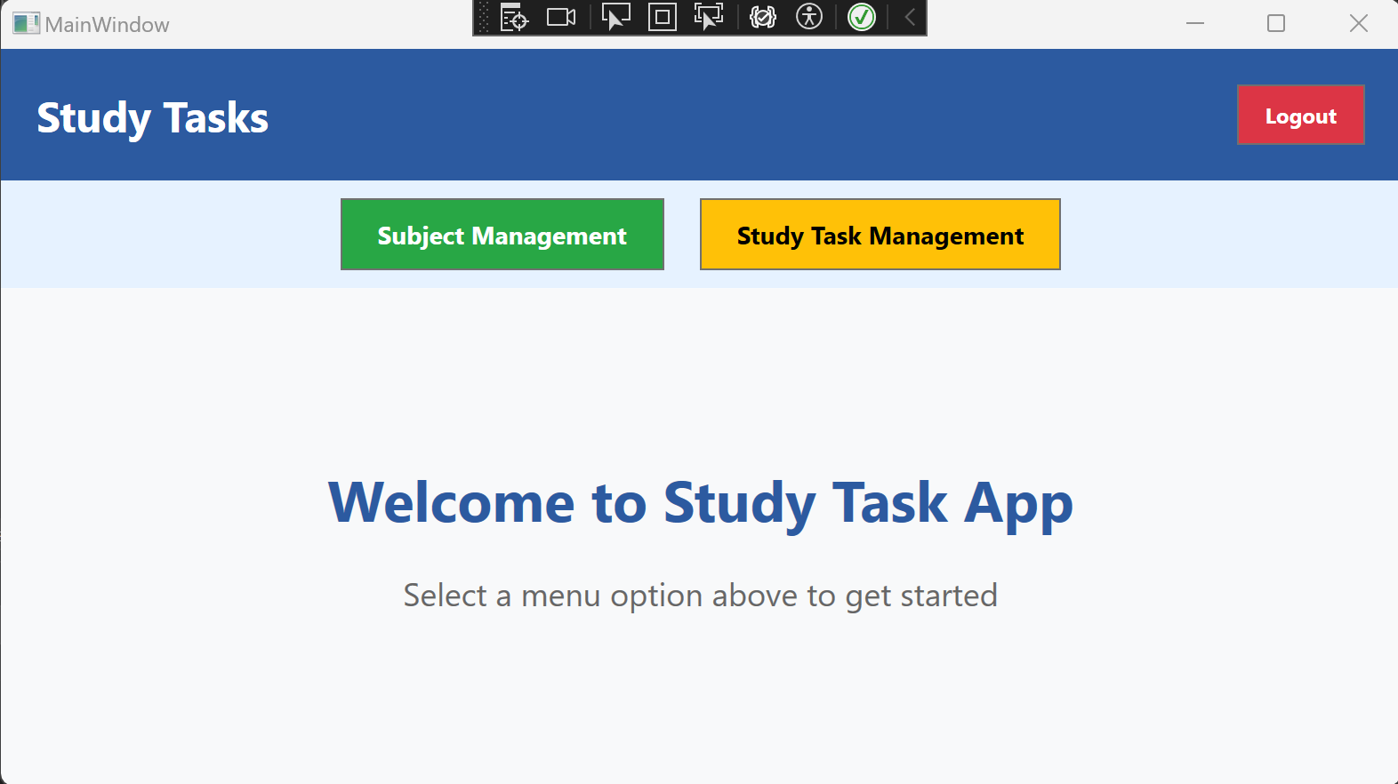
Study Tasks Management (1.5 mark)
- Display all tasks with: Subject Code and Subject Name. (0.5)
- Add a new subject. (0.5)
- Edit existing subject. (0.25)
- Delete subject (0.25)

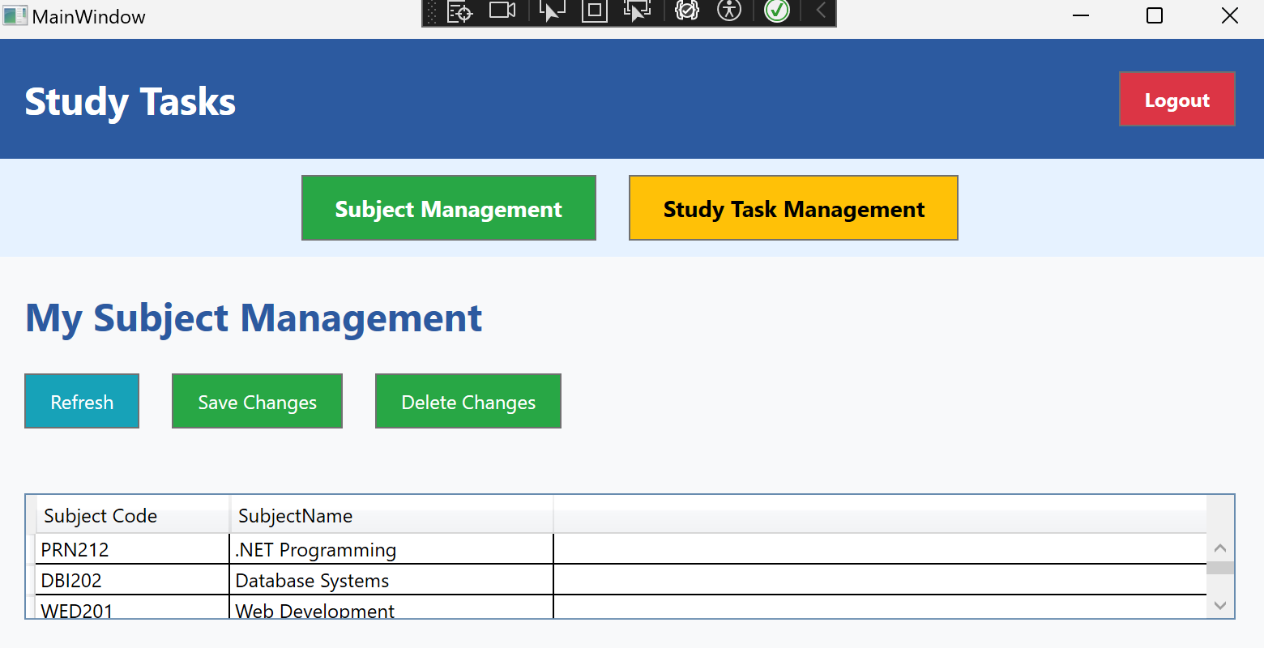
My study tasks (0.5 mark)
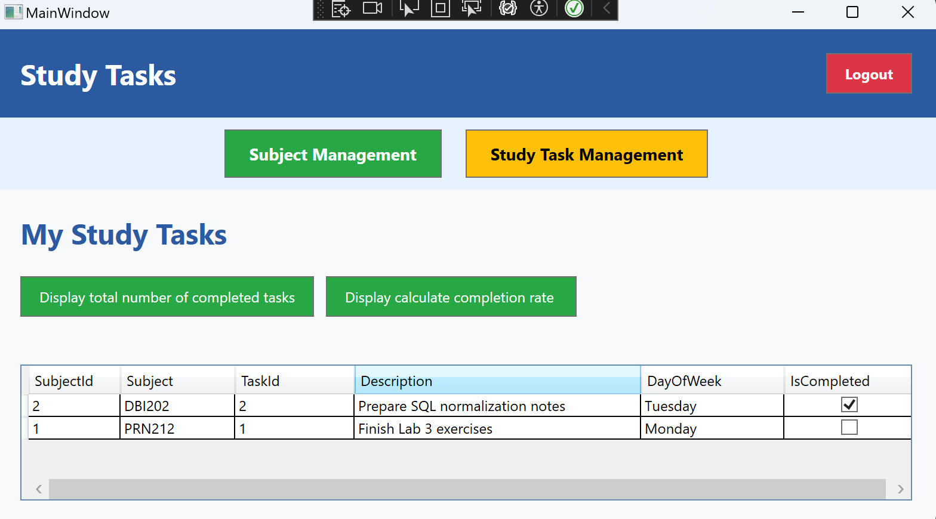
My Progress (1 mark)
- Display total number of completed tasks for the logged-in student. (0.5 mark)

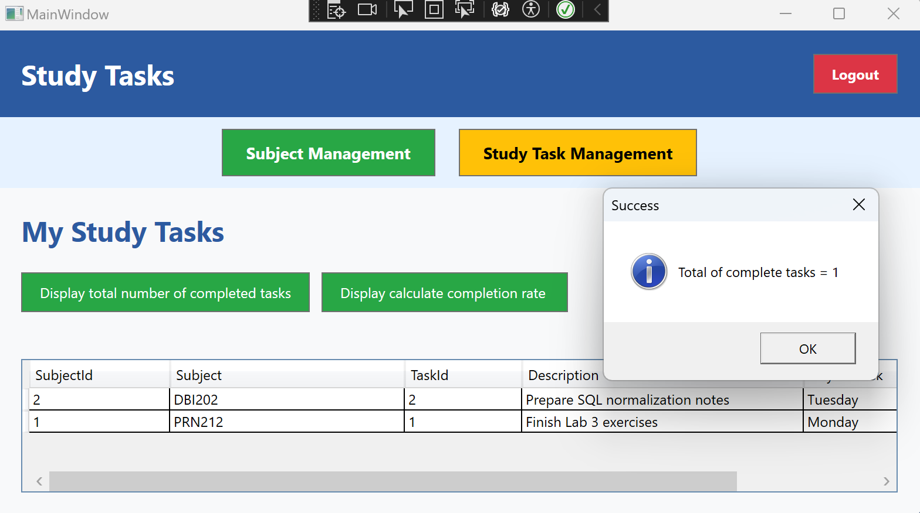
- Calculate completion rate percentage (0.5 mark)

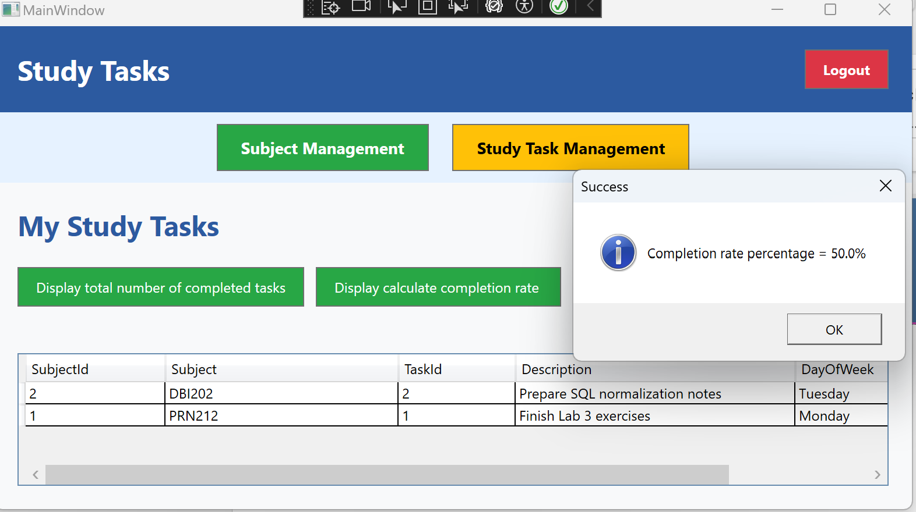
Logout Functionality (0.25 mark)
- Logout button that returns user to login screen.

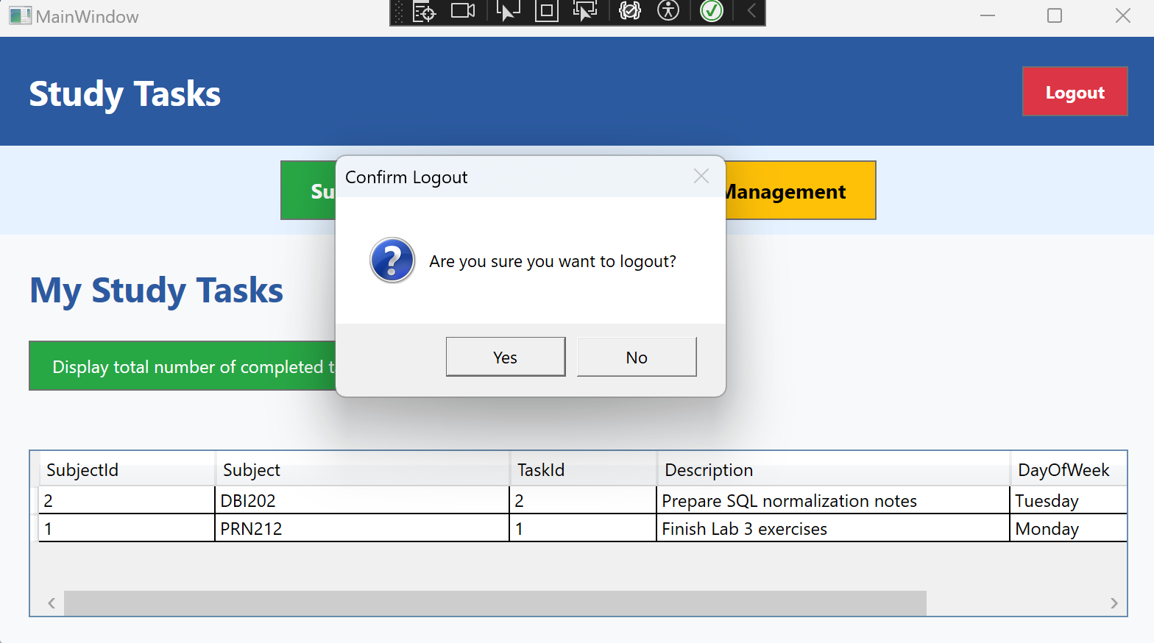
- When clicking Yes button, Login Window will display.

Submission Requirements:
- Submit all project files
- Ensure that no personal identifiers (name or student ID) are included in the submission.
--END--

