

**TASK**

**Exploratory Data Analysis on the 2019 Clean Technology Fund Data Set (World Bank**

[](http://www.hyperiondev.com/portal/)

**Introduction**

The 2019 Clean Technology Fund (CTF) Data Set comprises the data from various clean technology projects which were carried out over the course of 2019 in developing nations. The data analysis centered around the costs of such projects and the results they achieved. This was done by looking at the number of projects in each country, the type of technology being focused on and the resultant effect it had in reducing both greenhouse gasses (GHG) and energy use. The clean technology fund is one of two multi donor Trust Funds within the Climate Investment Funds (CIF) and focuses on implementing clean technologies which will have a lasting effect GHG emissions in developing nations.

**DATA CLEANING**

There were no missing values in the data set to be dealt with, so the data cleaning focused mainly around inconsistencies with data entries. These included stripping the extra whitespaces in some of the column names as well as fixing spelling errors for some of the row entries. Fortunately, due to the completeness of the data the majority of data could be held onto with only irrelevant data needing to be dropped. Visualizations carried out during the cleaning process focused on grouping the data mainly by country and then later by specific technology. When grouped by country the number of project, amount of funding, and effectiveness of the projects were looked at in order to gain a clearer picture of what the story the data was telling. Similarly, the effectiveness and funding were looked at in terms of specific technology (project type) thus helping us see the most/least effective technologies and their respective costs.

MISSING DATA

There was no data missing from this dataset.

DATA STORIES AND VISUALIZATIONS

Below are two visualizations comparing the total annual expected and actual energy savings of each specific technology with the average cost of them on the y-axis. As the graphs show you the expectation versus reality is somewhat underwhelming especially in terms of energy saving. The results are significantly lower than what was hoped for. Similarly, but to a lesser extent with GHG emissions. The best projects in terms of performance and cost will fall on the bottom right of the grid. This top left is most un desirable.

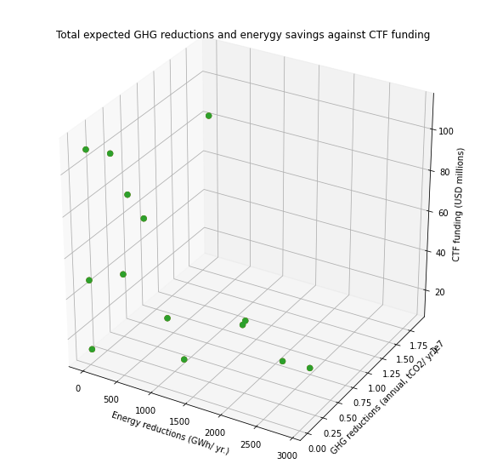

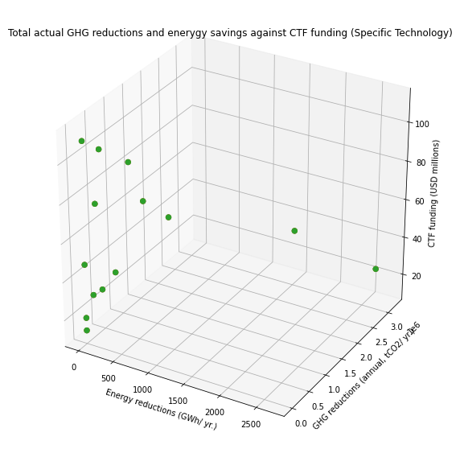

Expectation vs Performance:

Now if we look at the following two visualizations they focus on energy savings followed by GHG again by specific technology. As the first shows, the energy savings that categories such as, EE-Other, EE-Multiple, EE-District Heating, and EE-Smart Grid all had very little actual energy savings (below 150 GWh/year) when compared to their much higher expected savings.

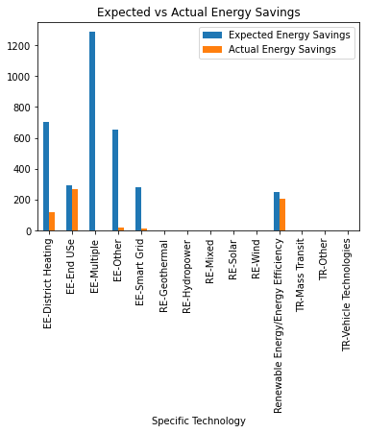

While EE-End Use, and Renewable Energy/Energy Efficiency technologies performed the best and the closest (although still below) to their expectation. This was again only in the region of 2-300 GWh/year.

Next the GHG emission reductions were slightly more effective although they still fell way below expectations. The most significant underperformers were solar, wind, and geothermal technologies. EE-End Use surpassed its expectations however, they were relatively low in comparison to the rest of the categories. That being said, it was the second-best performer in terms of GHG reductions. Renewable Energy/Energy Efficiency were again the most effective in terms of reducing GHG emissions.

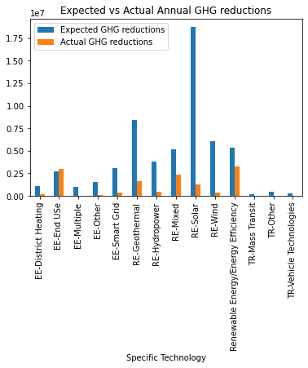

Funding:

The following visualizations is focused on the amount of funding received by each country and the expected GHG emission reductions that come along with it. In the scatter plot, the majority of projects aim at below a 0.25 tCO2/year reduction. With these projects ranging from inexpensive ($20 million) to the most expensive (over $140 million). Thus, for a project with a goal of around 0.25 tCO2/year reduction the cost should not exceed $60 million. As soon as the cost of the project goes above $60 million, the target for GHG reductions should be 0.5 tCO2 or more. The best performing technology cost around $100 million and reduced GHG emissions by just over 2.0 tCO2/year.

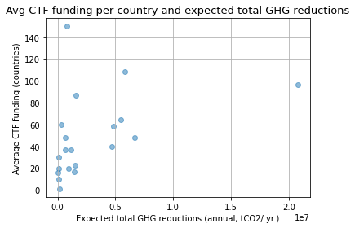

Next the average GHG reductions and energy savings achieved in each country for the last year will be looked at in order to get a clear idea of their performances.

Country Performance:

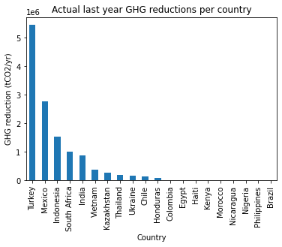The GHG reductions per country have been shown below. Turkey has the greatest GHG reduction of over 5.0 tCO2 over 2019 while Colombia, Egypt, Haiti, Kenya, Morocco, Nicaragua, Nigeria, Philippines, and Brazil all failed to reduce their CO2 emissions.

The energy savings achieved by each country follows. Turkey again came out as clearly the best preforming country with over 400 GWh saved in 2019. Followed by Kazakhstan and then Mexico, which is the last country of note as the rest of the countries failed to register any significant energy savings.

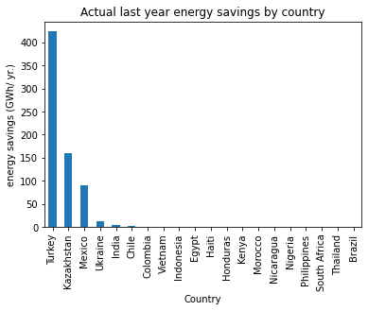

Conclusions:

Now that we have looked at the expectations and performance of the technologies and countries, the next point of focus is on the funding each country received and how many projects it was allocated for. The number of projects has been multiplied by a factor of 10 to make for easier reading and the funding figures are in the hundreds (eg. if no. of projects is 100 then 100/10 = actual number is 10 projects). As we can see, the top performers Turkey only received around $50 million in funding for eight projects in 2019. Thus, their projects were highly effective and inexpensive. Egypt on the other hand received around $150 million for one project which recorded no reduction in GHG and zero energy saving. Thus, the project is highly ineffective and highly expensive. Colombia, Philippines, Turkey and Ukraine all have relatively low funding for a high number of projects. Nigeria, Nicaragua, Haiti, Honduras, and Brazil all have very low levels of CTF funding

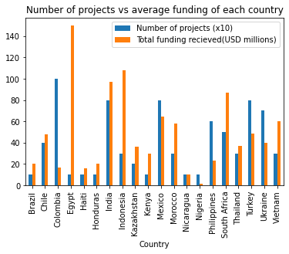

Lastly the cost of each technology will be looked. The best overall performers were Renewable Energy/Energy Efficiency technologies and EE-End Use technologies. This coupled with the low average cost of around $30 million makes them by far the best technology to focus on implementing in future projects, both from an economic and ecological standpoint. Solar, wind and geothermal technologies have high costs and expectations in terms of GHG reductions and energy savings but fall short in delivery of those targets.

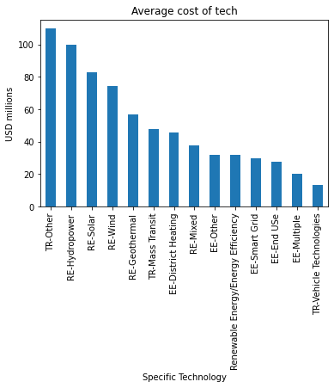

**THIS REPORT WAS WRITTEN BY : LUC MAINGARD**

