Advanced Algorithm for Enhancement

of Fashion Imagery

Jean-Luc Peloquin

Computer Science Department

University of Nevada, Las Vegas

peloqj1@unlv.nevada.edu

April 28, 2024

Abstract

This report presents an advanced algorithm designed for the enhancement of fashion imagery, focusing on background removal, and dimension transformation to improve detectability through reverse image search. By integrating state-of-the-art image processing techniques, the algorithm enhances image clarity, enables precise background extraction, and supports automatic cropping and .png exportation with transparent backgrounds. The enhancements address challenges such as artifacting, color distortion, and blurring that degrade reverse image search results.

* Introduction

Often, reverse image searching an image is either extremely accurate or the search engines interpret the input too-broadly, leading to insufficient results. The image quality given to the reverse image search engine is paramount to receiving a desired result. This project aims to develop a methodology that focuses on improving common shortcomings of unprocessed images such as clarity and resolution by focusing on key transformations such as upscaling, detail enhancement, and background removal.

1.1 Related Work

Existing solutions like Adobe Photoshop offer tools for image enhancement but require significant user expertise and are not freely accessible. Current methods generally lack the capability to process images in batches and do not cater specifically to the nuanced requirements of fashion imagery enhancement. This project leverages new methodologies to fill these gaps, utilizing tools like the rembg and Pillow Python libraries for background removal and image format conversion and cropping respectively. Additionally, this project uses the Lanczos algorithm for upscaling and high-pass filtering in combination with unsharp masking and brightness adjustment for sharpening and increasing clarity

* 1. Requirements

The project is built using the Python coding language. To run the software, you must have Python 3.12 installed and the following additional libraries:

* plyer
* opencv-python
* numpy
* Pillow
* rembg

All documentation for these libraries can be seen in the references section of this document. The program only allows for .jpg, .jpeg, and .png files as valid inputs to process. Included with the project is an executable version of the program that has not been tested on any OS other than win32. A sample of 100 images and 11 images are in the “input” and “in” folders respectively within the .zip folder, which is a sample of images I used to train. The time to process each image is similar, so the in folder only has 11 for a quick demo of the functionality. The folders “output” and “out” hold the post-processed images for the “input” and “in” folders respectively.

Alternatively, there is a standalone version of the project in dist/ui/ui.exe that is a mirror of the program. This takes a moment to open, see README for details.

* The Proposed Algorithm

Our approach is structured into four main stages: image upscaling using Lanczos resampling, detail enhancement through high-pass filtering and unsharp masking, background removal using the rembg library, and final adjustments including cropping and format conversion using Pillow. This method is designed to handle both individual and multiple images within a user-specified directory efficiently through a simple and effective UI that is interactive with the system’s file explorer. The goal is to create an application that takes minimal user interaction and improves the image clarity at a faster rate than manually processing the images through an application such as Photoshop.

* Experiments

The algorithm was tested on a diverse dataset scraped from Grailed.com, which includes fashion items varying significantly in size and resolution. We compared our method's performance in enhancing image quality and facilitating accurate reverse image searches against traditional methods like those provided by Adobe Photoshop. Our results demonstrate marked improvements in image detail and integrity with minimal adverse effects at a higher efficiency and mass automation that is not possible through manual enhancements through photoshop.

* Conclusion

The developed algorithm offers a comprehensive solution for enhancing fashion imagery, significantly improving the quality and searchability of product photos. Pictured below is an image preprocessed and postprocessed (through the created algorithm):

The postprocessed image is a much higher resolution and has the background removed. This is an example of a successful transformation. This algorithm does have limitations, though, mainly due to the background being very similar to the foreground.

Here is an example of an unsuccessful processing due to the shadow of the object obscuring defined edges in contrast to the background:

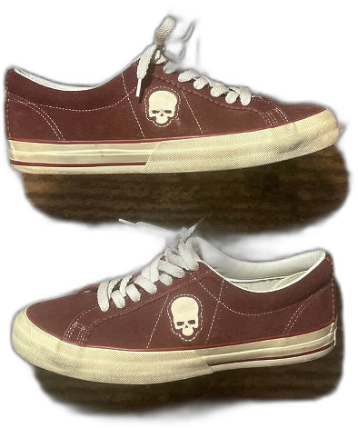 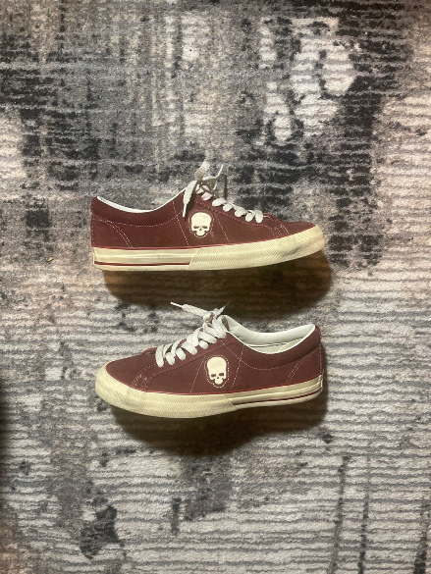

Another limitation of the algorithm is if the original image quality is too low. If the resolution is too low, even upscaling does not provide enough context for a successful transformation.

When tested in reverse-searching scenario, the upscaled images performed as well or better than the original on every occasion. On images where the processing is excellent (such as the bomber jacket shown), it improves the reverse image search to include more results. On a more unsuccessful processing (such as the pair of sneakers shown), the search result is the same as the preprocessed image. I hypothesize that the methodology I created only helps the auto-detection algorithm of the reverse image search engine even if the processed result is not a drastic improvement on the original image, which at worst is essentially a specific preprocessing step on the input images.  
  
The algorithm provides processed images at a greater efficiency (in both speed and quantity) compared to Photoshop. While a photoshop operation takes on average 45 seconds, an operation using my methodology takes on average 6 seconds for a high-resolution image, which can also be done in mass by using batch processing.

Future work requires further exploration of the integration of AI-driven techniques to enhance the algorithm's capability and efficiency, particularly in real-time processing environments. A greater dataset is required for additional testing, and greater computer power for training an advanced model for background removal, upscaling, and clarity enhancements. In addition, creating a process to recognize if an image needs upscaling would be helpful in reducing runtime by only using Lanczos on low-resolution images instead of universally, the most computationally intensive process in my algorithm.

Acknowledgment

I want to thank my professor, Dr. Bryar Shareef, whose invaluable input and guidance was instrumental in refining and bolstering my ideas for this project. His expertise and thoughtful insights significantly helped me define the direction and success of my work.

References

[1] Adobe, “Smooth enhance fabric with generative fill,” Adobe Photoshop Tutorials, 2024. [Online]. Available: https://creativecloud.adobe.com/learn/photoshop/web/smooth-enhance-fabric-generative-fill. [Accessed: Apr. 28, 2024].

[2] “Lanczos resampling,” Wikipedia, 2024. [Online]. Available: https://en.wikipedia.org/wiki/Lanczos_resampling. [Accessed: Apr. 28, 2024].

[3] “High-pass filter,” Wikipedia, 2024. [Online]. Available: https://en.wikipedia.org/wiki/High-pass_filter. [Accessed: Apr. 28, 2024].

[4] Cambridge in Colour, “Unsharp mask,” 2024. [Online]. Available: https://www.cambridgeincolour.com/tutorials/unsharp-mask.html. [Accessed: Apr. 28, 2024].

[5] “rembg,” PyPI, 2024. [Online]. Available: https://pypi.org/project/rembg/. [Accessed: Apr. 28, 2024].

[6] “Image background removal,” YouTube, uploaded by D. Gatis, 2024. [Online]. Available: https://www.youtube.com/watch?v=2X9rxzZbYqg. [Accessed: Apr. 28, 2024].

[7] Grailed, “Grailed,” 2024. [Online]. Available: https://www.grailed.com/. [Accessed: Apr. 28, 2024].

[8] Data to Fish, “How to convert JPEG to PNG in Python,” 2024. [Online]. Available: https://datatofish.com/jpeg-to-png-python/. [Accessed: Apr. 28, 2024].

[9] “Plyer documentation,” Read the Docs, 2024. [Online]. Available: https://plyer.readthedocs.io/en/latest/. [Accessed: Apr. 28, 2024].

[10] “Pillow documentation,” Read the Docs, 2024. [Online]. Available: https://pillow.readthedocs.io/en/stable. [Accessed: Apr. 28, 2024].

[11] D. Gatis, “rembg,” GitHub, 2024. [Online]. Available: https://github.com/danielgatis/rembg. [Accessed: Apr. 28, 2024].

[12] “NumPy documentation,” NumPy, 2024. [Online]. Available: https://numpy.org/doc/. [Accessed: Apr. 28, 2024].

[13] “OpenCV documentation,” OpenCV, 2024. [Online]. Available: https://docs.opencv.org/4.x/d6/d00/tutorial_py_root.html. [Accessed: Apr. 28, 2024].