INTRODUCTION

Problem Description
From project assignment:
Consider a punch’em videogame where your avatar meets two type of enemies: minions and bosses.
Fighting either of them until defeat takes some time (see later on) and they arrive with some
interarrival times. The rule of the game is such that you can fight only one opponent at a time. When
you are fighting a minion and a boss arrives, you stop fighting the minion and fight the boss instead.

A fight lasts until the opponent is defeated. However, when you fight a boss, the minion that you were
fighting earlier recovers some health, at a rate which is x% of the rate at which you deplete it when
fighting it.

A defeated opponent leaves the game. Opponents of the same class queue up one after the other and
are fought in a FIFO order.

Objectives
The objective for the project is to study the number of minion and bosses fought in the unit of time as a function of the arrival rates of both types of opponents. Moreover study the queueing time of both types of opponents.

More in detail, at least the following scenarios must be evaluated:
- Exponential distribution of the interarrival times for the opponents and fighting times.

Performance Indexes
In order to define a metric of performance of the objective, the following Performance Indexes are define:

- Throughput T_{m}, T_{b} : Number of opponents defeated per unit of time [defeated/s] (two different Throughput for each kind of opponent: T_{m} and T_{b}).
This will be studied as a function of the interarrival time, in particular will be studied different throughput for different values of the mean arrival time and putted on a plot.
The Formula for the throughput can be written as follows:

where N is the number of opponents defeated in a game.

- The mean waiting time E[W]: is defined as mean time between the arrival of an opponent (minion or boss) and its turn to fight.

- The mean response time E[R]: is defined as mean time between the arrival of an opponent (minion or boss) and its defeat.
This KPI is added in order to perform a better verification of the system

MODELING

Introduction
In this chapter a general description of the system is given

The system is modeled as a single player punch’em videogame, where there are Boss and Minion bases that sends opponents (new type of messages) to the Player. The latter fights against them trying to defeat as much opponents as possible during the game (the duration of one game is expressed in seconds).
Moreover there is a priority system that:
- detect if a Boss is coming,
- if the Player is fighting against a Minion:
  - recover a percentage of a minion life and queues up him again.
- Starts to fight against the Boss newly arrived before all
Of course if there are other bosses in queue it will be queued up.

The game finish when the time runs out or the system is stopped.

General Assumptions
General Assumption to better understand how the system works.
The following general assumtions have been made:

- Opponents serivce time is considered as their life
Is the service time of an opponent (minion or boss) is defined as his life (is expressed in seconds).
The service time could be exponential ditributed or constant.
From later on the service time is a synonimous of life (also in the code implementation it is used the term “service time”).

- Interarrival time
Is the time between the arrival of a new opponent (interarrival time) could be exponentially distributed or constant.

- Description of a “fight”:
The Player start to fight against an opponent when it leaves his queue, and it is defeated when the service time ends. The time between the start of the service and the defeat of an opponent is the duration of a fight.

- Recovering rate x:
The standard recovering rate is computed with the following steps:
  - 1. Compute the standard recovering rate from the original life (%)
  - 2. Compute the life to recover by applying the standard recovering rate to the actual life (minion life remaining in that moment).
  - 3. Sum up the life to recover to the actual life
  - 4. Queue to the bottom the minion recovered
It is possible to choose a % of the computed recovering rate, in order to increase/decrease the difficulty of the game (in the range of [0,100]).
The recovering rate compute the life to sum up with the actual life (see later on to better understand how),
A minion recovered is enqueued to the bottom of the queue.

- Queues for minions and bosses:
Are used 2 different queues for the two types of exisiting opponents, one for minions and one for bosses.
The queues type is FIFO order of unlimited capacity.

- To allow games with only with one opponent type (only minions or only bosses) in the model it must be set the arrival time constant and greather than the simulation time. This “trick” is used in order to manage the degeneracy cases (if we put service time 0 the simulation will be stuck, so it must be stopped in this case) and, at the same time, to ensure the game mode with only one type of opponent.
- *OLD*without minion or bosses the game cannot start (at least is possible to set that a minion/boss arrives after the end of the game, in order to simulate game with only one opponent type)

Preliminar Validation
Analyze the assumptions to validate the correctness of the system

Before the implementation a preliminar validation is necessary to ensure that the model is correct. In particular the assumption made in the previous section are analyzed:

- The unlimited capacity of the opponent queues is a reasonable assumption, because the game is designed to fight against as many opponents as possible in the time limit determined, which could potentially be very long.

- The computation of the recovering rate is made ensuring that the new life (actual life + life to recover) will never exceed the original life. Doing is ensured to do not have a minion that never dies (infinite life).

Factors
Factors that may affect the systems
- Minion inter-arrival time (1/lambda)
- Minion service time (Life) (1/mu)
- Boss inter-arrival Time
- Boss service time (Life)
- Recovering Rate x% (useful to set the game mode difficulty)
  - example: choose between: no-minion-recover (0%), total recover (100%), partial recvoer: (x% of the recover rate)
- The ratio between service/arrival time of minions and bosses (higher ratio , more opponents waiting in the queues)

IMPLEMENTATION

Modules
The following modules have been defined:
- Boss:
simple module which randomly generates opponents of type “Boss” with inter-arrival time and service time according to the specific distribution (with constant time or an exponential distribution).
- Minion:
simple module which randomly generates opponents of type “Minion” with inter-arrival time and service time according to the specific distribution (with constant time or an exponential distribution).

For the sake of simplicity and to make clearer the use of parameters Boss and Minion are defined in two different modules, even if they have almost the same code.

- Player:
The module that simulates the behavior of the player. It choose with which opponent to fight, manage the priorities (fight always when a boss is present) and the recovering of the minions.

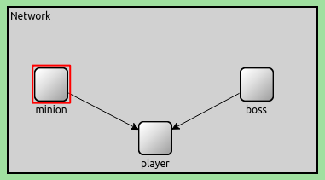

Messages
A new format of message has been defined, named “Opponent Message”. It contains the service time for each opponent, that represent the life time (simtime_t type).
This new type of message is used to represent an opponent, saving for each one its life. It is used to compute the response time.

Modules Behaviour

Boss and Minion:
This two modules behave similarly but one is used to generate opponents of type “boss” and the other is to generate opponets of type “minion”, the functionalities are the following for both modules:
- Generate a random number from the selected interarrival distribution (exponential or constant) and set a timer accordingly.
- When the timer goes off, generate a random number from the selected service time distribution (exponential or constant).
- Send a message to Player module with the generated service time.

The functions defined are:
- wait_new_arrival
- generate_new_opponent

Player:
The functionalities for the Player module are the following:
- When it receives a message from Minion or Boss modules, it pushes it in the proper FIFO queue (std::queue):
  - If receives a Minion Message it checks if the minion and boss queues are empty, if so it start to process the minion message (start the fight against the minion).
  - If receives a Boss Message it checks if is serving a minion process, if so it stop the process of the minion, recover the minion (described below) and start to process the boss message (start the fight against the boss) .

- When a minion has to be recovered it computes the life to recover (by calling a specific function, that makes the computation described in the “modeling” section), sum up the actual life and the life to recover and push again the minion in the queue.

- In order to process a message (fight againts an opponent), the Player reads its service time (life) and set a timer (are used 2 different timers for boss and minion messages). When the timer goes off the Player extract the message/opponent from its queue and delete it (opponent defeated).

- It also records statistics every time a message/opponent is deleted/defeated, (number of jobs and response time for both opponents), a minion is recovered (number of minions recovered) and when a message/opponent becomes the head and start to be processed by the Player, i.e. the fight start (number of jobs in the queue and waiting time for both opponents). It also record statistics about the total number of minions and bosses defeated.

The functions defined are:
- handleMinion/ handleBoss
- recoverMinion (that uses compute_life_recovered)
- defeatOpponent
- get_number_of_minions/bosses (to delete). Used only for windows version

VERIFICATION
Tests made to verify if the implementation reflects correctly the model

Deterministic and Simple Cases (Constant Arrival/Service Time)
Test made by deterministic and simple cases (predicted values with constant inter-arrival and service time) in order to test is the system act as the reality. In partucular this part is focused to ensure the correctness of the minion and boss enqueued, the correctness of fights (if they start and end when it is required) and if the minion recover system is implemented in a good manner (compute correctly the minion recovered life).
All tests are made by using graphical environments (Qtenv) and debugging prints.

- Easy Game Mode: no minion recover, low minion and boss service/arrival ratio:
as expected the player defeats in time all minions before a boss arrives, so the minion recover never happen.
Since the player defeats easily Minion and Bosses is congruent with the assumption that the game mode is Easy (at most 1 boss and 1 minion in the queues).

- Medium Game Mode: partial recover (50% of the rate), medium minion/boss service/arrival ratio
as expected the large amount of minion arriving does not allow the player to defeat them before boss or other minions arrives, the bosses are all defeated for the priority that the player has but minions accumulate in the queue (in our example 1000 minions and 0 boss in the queues).

- Hard Game Mode: total recover (100% of the rate), high minion boss service/arrival ratio
large amount of minions and bosses arriving. The player is not able do defeat them before the end of the game
(100 bosses and 2000 minions in the queues)

Degeneracy Test
The degeneracy tests verifies the behavior of the simulation with parameters set to 0 values.

- Minion/Boss service(life) rate = 0
The program end the simulation because with life=0 there are no minions or bosses to fight and without minions or bosses the videogame cannot start
- Minion/Boss arrival rate = 0
If the minions and bosses arrives at time 0 every time the simulation would be infinite, so this case is handled in order to do not allow games with this parameter.

Consistency Test
The consistency test verifies if the system react consistently with the output (2 test differenti con arrival time e service time uno il doppio dell’altro).
The test is made by separately the boss and the minion varying parameters, in order to compare easily against real working system.

Boss Varying Parameters (Throughput, Mean Waiting Time, Mean Response Time)
Different kind of tests are made in order to test if the consistency is preserved. They are made by studying the number of bosses defeated (to ensure the correctness of the throughput), the mean waiting time (by having the inter-arrival time less then the service time) and the mean response time (by having the inter-arrival time greather than the service time).

Different kind of tests are made, when the arrival time is less then the service time (in order to study when the opponents are enqueued, we can call it hard game mode), when the arrival time is greather than the serivce time (in order to study when the waiting time is 0, we can call it easy game mode).

Test 1: Number of bosses defeated (Throughput)
Performing this test we expect that the Player defeats more bosses if their life decreases and vice-versa.

Configuring a scenario with the arrival mean less than the service, and performing several repetitions by decreasing the service mean, the number of bosses defeated increases (as expected).
The test was made with constant and exponential interarrival time.

- Test 1.1
Bosses: Arrival mean = 1, Service mean = 3

- Test 1.2
Bosses: Arrival mean = 1, Service mean = 2

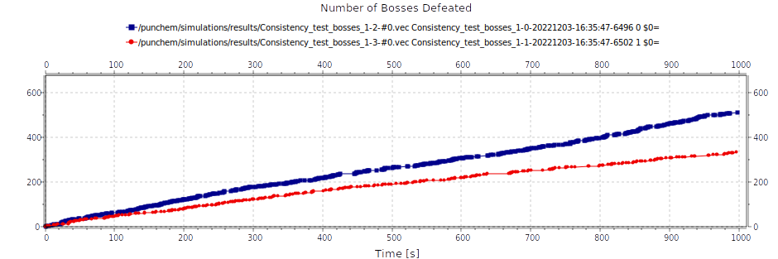

As expected in the first test (blue dots) the number of bosses defeated is larger, due to the fact that their life is decreased.
By doing this is possible to conclude that the results for the throughput (number of bosses defeated per unit of time [defeated / s] is consistent.

(VALUTA SE METTERE UN ISTOGRAMMA).

**FARE PIU’ REPETITIONS E GESTIRLO CON EXCEL

**SI POTREBBE FARE NELLA STESSA SEZIONE PER BOSS E MINION**

**FARLO ANCHE PER MINIONS**

Test 2: Bosses Mean Response Time (*DA SPOSTARE NEL CONSISTENCY E MONOTONICITY)
The aim of this test is to study if the mean response time is consistent, i.e. check for the conditions when no queue is created if the response time and the mean service time selected are almost equal.

By setting the arrival mean greater than the service mean, and then increasing/decreasing the service mean is possible to see that the response time is consistent, almost equal to the service mean.

- Test 2.1
Bosses: Arrival mean = 10, Service mean = 1

- Test 2.2
Bosses: Arrival mean = 10, Service mean = 2

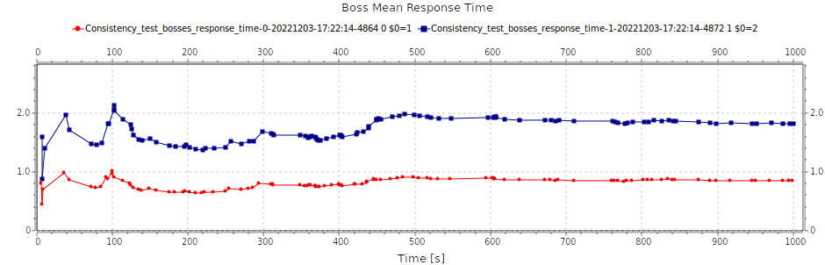

As is show in the figure #, the mean response time is almost euqal to the chosen mean service time for both tests, so the consistency is guaranteed.

**MEGLIO tramite ISTOGRAMMA e con calcolo dei CONFIDENCE INTERVALS**

Tets 3: Bosses Waiting Time
For this test the expected behavior is: if the service time is less than the arrival time the waiting time is close to zero, because the player has enough time to fight and defeat them before a new opponent arrives. On the contrary if the service time is bigger than the arrival time, the waiting time has to increase.
With this tests it is shown that the results are consistent.

*Note: the minion arrival/service time is set in order to don’t interfere too much (example arrival time = 20, service time = 1).

- Test 3.1
Bosses: Arrival mean = 10, Service mean = 0.1 (waiting time = 0)

- Test 3.2
Bosses: Arrival mean = 10, Service mean = 2 (waiting time: from 0.16 to 0.85)

- Test 3.3
Bosses: Arrival mean = 10, Service mean = 12 (waiting time: from 60 to 120)

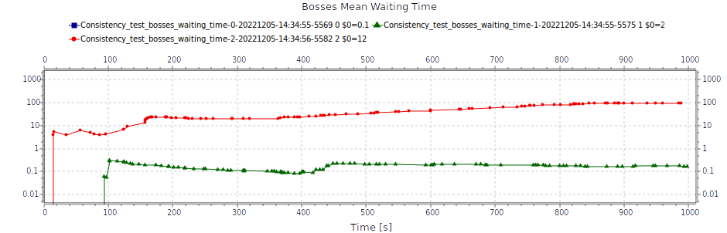
**la linea blu non si vede ma è a 0**
**FARLO CON EXCEL**

**CONCLUSIONE** I test della consistency per i minions sono identici a quelli dei boss, sia nei parametri che nei risultati. Omettere una sezione completa per loro.

Minion Varying Parameters *TO DELETE*
To allow the consistency study on minions it was decided to act as the bosses never arrives, i.e. without the minion recovering phase, in order to check minions behavior comparing with real case study.

The test made are as for the boss:

Test 1: Number of Minions Defeated
As for bosses, the number of minions defeated increases if their service time decreases (more minions defeated per unit of time)
- Test 1.1
Minions: Arrival mean = 1, Service mean = 3 (results: from 150 to 170 minions defeated, 5 repetitions)

- Test 1.2
Minions: Arrival mean = 1, Service mean = 2 (results: from 230 to 260 minions defeated, 5 repetitions)

**STESSO GRAFICO CHE PER BOSS**
Test 2: Minions mean response time
As for bosses, the mean response time is consistent with the service time
- Test 2.1
Minions: Arrival mean = 10, Service mean = 1 (results: from 0.99 to 1.17)

- Test 2.2
Minions: Arrival mean = 10, Service mean = 2 (results: from 2.30 to 2.75)

**STESSO GRAFICO CHE PER BOSS**
Test 3: Minions waiting time
As for bosses, the waiting time is consistent
**STESSO TEST E GRAFICO CHE PER BOSS**

Player Varying parameters (X% of the recover rate)
This test is made to study the recovering rate and its inference on the Player, in order to see if the response time and waiting time is consistent when the recovering rate is varying.

This test is made by changing the recovering rate (0%, 50% and 100%).

In order to perform this test the boss inter-arrival time is set a little bit greather than the minion inter-arrival time, in order to have a scenario where a lot of minions are recvoered and queued up.

As expected, in a situation where a lot of minions are recovered and the % of the recover rate is increased it happens that:
- the response time and waiting time increases with the increasing of the recover rate.
- The number of minions defeated decreases with the increasing of the % of the recover rate.

Tests:
- minions: arrival mean=2, service mean=1.5
- bosses: arrival mean=2.5, service mean = 0.5
- recover rate x:
  - test1=0%
  - test2=50%
  - test3=100%
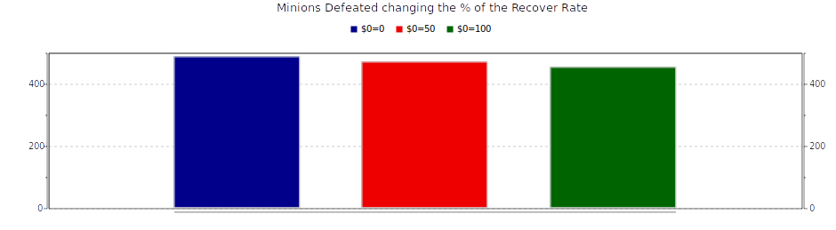

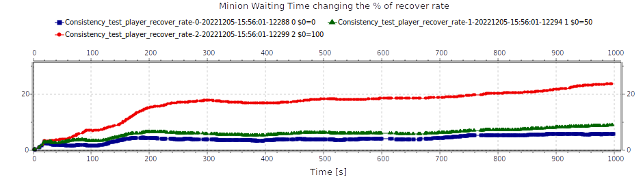

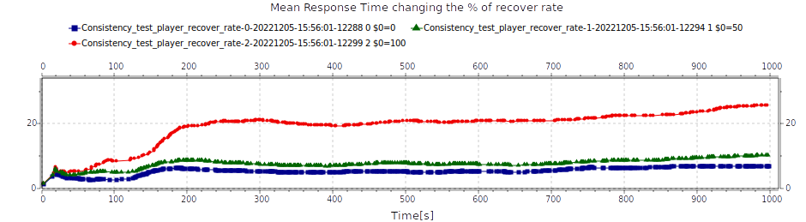

Continuity Test
The continuity test consists of check the correctness of the system in order to verify if changing slightly the input affect slightly the output.

It is possible to see by changing the boss parameters, increasing the slightly the service time (from 5 to 5.1) also the mean response time increases (possible to reproduce also for minions, but remember that the number of bosses infer on the minions response time).

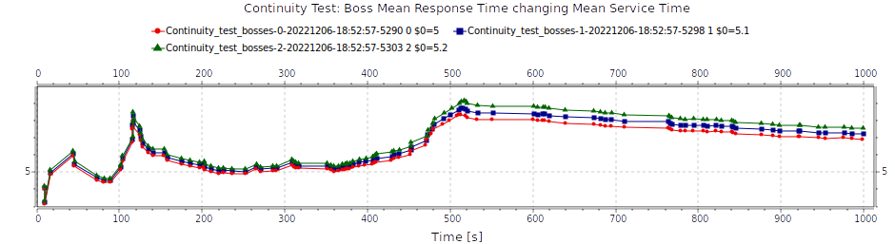

As shown in figure #, by slightly increasing the boss mean service time (life) it slightly increases also the mean response time, thus ensuring the continuity.

**FARE LO STESSO PER MINONS SETTANDO A 0 I BOSS (COME PER CONSISTENCY)**

Monotonicity Test
???Controllare se farlo o meno???
**farlo con response e waiting time**
This test consists in assessing the monotonocity of some KPIs by changing some factors.
In particular mean waiting time and mean response time were studied.

By changing the recover rate for the minions and fixing the other parameters the increase of the response time is expected.

**POSSIBILE IDEA*** tenere il mean inter-arrival e service time fissati, modificare qualche altro parametro e vedere cosa cambia e se la monotonicità è rispettata**

Verification Against Theoretical Model
The goal of this kind of verification is to compare the output of a simplified version of our system against a theoretical model.

In order to create a queueing model of the system were made the following assumptions:
- There is only one opponent type (bosses) and no recovering system;
- Exponential interarrival and service time.

The decision to have only bosses as opponent types lead us to discard the use of one of the two queues and then reproduce a M/M/1 system (queue + server), where the player is the “server” and the bosses are the “jobs”.

**figura queue + server teorica**

TEST: exponenetial arrival/service time

**calcolare il T (throughput) e il E[W] (waiting time)
**mostrare i risultati sia teorici che sperimentali

FACTORS CALIBRATION
Scenario Calibration
The aim of this part is to fix the intervals of the factors to correctly reproduce the behavior of the real system.

Ad esempio si potrebbero eseguire simulazioni per le GAME MODE: EASY,MEDIUM E HARD.

**trovare dei valori per i parametri interessanti, in modo che ci forniscano dei risultati soddisfacenti**

*OBJECTIVE*
the goal is to have a GOOD GAME EXPERIENCE.

*IDEAS*
- Boss have more life than minions and arrives more rarely than minions
- Try different game experiences (such as easy game mode or hard game mode)
- Study that the games has to be interesting, the player must have fun (not too boring, either too easy or too hard) (graphs with threshold, come progetto riccardo)

*TESTS*
- mean response time E[R] as a function of mean service time E[ts]
vedi risultati excel
  - boss: arrival time = 10. Avvicinandosi al valore del arrival time incrementa di molto, il massimo valore accettato è service time = 7
  - minions: arrival time = 5. Avvicinandosi al valore dell’arrival time anche questo incrementa esponenzialmente. Il massimo valore accettato è service time = 3 (test fatto mantenendo il boss service abbastanza basso), altrimenti i minions incrementerebbero esponenzialmente).
  - Recvoer rate mininos: solo tra 0% e 100% c’è un differenza non trascurabile, la quale potrebbe impattare sul response time dei minons e su tutte le altre metriche di studio

*CONCLUSIONI*

- interarrival time greather than the service time (altrimenti sale troppo il response e waiting time). I match devono essere testati cambiando il service time e fissando l’arrival alto.
- the bosses service time influences a lot on the minions. Deve esserci parecchio distacco in modo da avere anche delle recovers.
- IMPORTANTE: in questo modo si può studiare e concludere che si sono scoperte delle diverse modalità di gioco

*ESEMPIO*
- arrival rate minions = 5 e arrival rate boss = 20
- service rate minions ${0.5,1,2,3}
- service rate bosses ${3, 5, 7, 10, 12}

Calibration of Warm-Up Period (Steady-State Analysis)
In order to calibrate the warm-up time the following technique is used:
avg operator technique (method 2): is plotted the mean value of the samples and is studied when that value converges.
**vedi esempio pratico slides prof. Virdis**

Calibration of Simulation Time Period (Steady-State Analysis)
To choose the correct simulation time some experiments were made and a particular techinique was used, and it is the following:
- Measure of activity: consists of measure the thorughput itself, compute the mean value on it and take the end point of the simulation where the variance is small enough.
**vedi esempio pratico slides prof virdis**

2kr Analysis

SIMULATION EXPERIMENTS

Throughput Experiments - T

Mean Waiting Time Experiments - E[W]

CONCLUSIONS

