

MSc in Computer Engineering

Electronics and Communications Systems

________________________________

Matrix Multiplier Project Report

Luca Tartaglia

Kamran Mehravar

________________________________

Academic year 2021/22

Table of Contents

1. Introduction 3

1.1 Problem Description 3

1.2 State-of-Art of Digital Multipliers 4

1.3 Matrix Multiplication 7

1.4 Finite Arithmetic sizing 8

2. Matrix Multiplier Implementation 9

2.1 Algorithm 9

2.2 Model Architecture 10

3. VHDL Implementation 10

3.1 Bit Matrix type definition 11

3.2 Matrix Register 11

3.3 Matrix Multiplier 12

3.4 Matrix Multiplier Architecture 13

4 Test Plan 15

4.1 Python Testbench generator 15

4.2 Testbench implementation 17

5. Synthesis and Implementation Logic 20

5.1 Register Transfer Level design (RTL) 20

5.2 Synthesis 22

5.2.1 Timing Report and critical path 22

5.2.2 Power consumption 24

5.2.3 Device Utilization 25

5.3 Implementation 25

5.3.1 Timing Report and Critical Path 27

5.3.2 Device Utilization 28

5.3.3 Power Consumption 28

5.4 Warnings 29

5.4.1 Warnings Analysis 29

5.4.2 Timing Warnings 29

6. Conclusions 30

# 1. Introduction

## **1.1 Problem Description**

Design the VHDL description of a matrix multiplier with the following characteristics:

* input matrices of size (NxM) and (MxP) with elements represented in 2’s complement on 4 bits
* Output matrix of size (NxP) with elements represented in 2’s complement on Q bits. The value of Q has to be determined in order to avoid any finite arithmetic’s error.

For the test-bench simulation, please consider the following values of the parameters: N=2, M=3 and P=4.

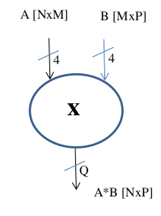

## **1.2 State-of-Art of Digital Multipliers**

A binary multiplier is an electronic circuit used in digital electronics with the purpose to multiply binary numbers. To implement a digital multiplier can be used a variety of techniques and most of them involve computing the set of partial products, which are then summed together using binary adders.

**Binary multiplication** is the process of multiplying binary numbers and is performed doing exactly the same multiplication as with decimal numbers.

As for the decimal multiplication one of the most used algorithm is the **shift and add**, i.e. doing the partial products (which is 0 or the first number), shifting one position left and then adding them together (using a binary addition).

Figure 1.1 binary multiplication

Using **binary numbers** it must be pay particular attention on which representation is been used, because, modern computers uses the **two’s complement** representation, so the sign is embedded in the number itself. That force the multiplication process to be adapted to handle two’s complement numbers, and that complicates the process of the multiplication.

For this reason, were be designed specific algorithms to handle the multiplication with 2’s complement numbers. One of the most important is the Booth algorithm, that is an algorithm designed to multiply two signed binary numbers in 2’s complement notation.

The **hardware implementation** of a digital multiplier can be realized by using 2 different approaches:

The first approach is called **ROM-based implementation** and it consist of use a ROM where are saved all the results of the multiplication of 2 words (for example A and B).

So, this architecture takes in input A and B words, and return as output the multiplication values stored in the ROM.

This approach has two big problems:

1. It would take a large amount of memory (e.g. for 2 words of 16 bit it would need 232 words of 32 bits = 16 Gigabytes of memory)
2. The speed of memory access would be too slow.

For this reason, this approach is not acceptable in digital signal processes.

The second approach is to implement a **parallel multiplier**, that is doing each single operation bit by bit. All can be split into 3 general steps:

1. generating the **partial product** on k bits, using the representations of the operands (e.g. X and Y) on n and m bits respectively.

the partial product can be calculated using a Full Adder and where there is not the carry-in it can be used a Half Adder.

1. reducing the partial product sizing it on k bits, that can be in the range [0 : n+m-1]
2. computing the final product, summing all the partial products.

To realize the blocks concerning the operations required are needed five different block types:

1. **Product:** is an AND that takes in input two values x, y and gives p as the product in output.
2. **Half Adder:** it is a Full Adder where the carry in is 0
3. **Full Adder:** here the carry is present and it will be summed (ci is the carry-in)
4. **Product+ Half Adder**:it makes both the sum and the product between x and y
5. **Product + Full Adder**:same as the block 4 but takes into account the carry-in

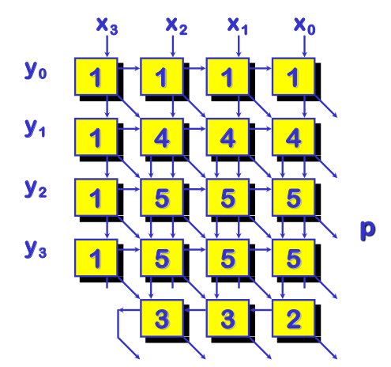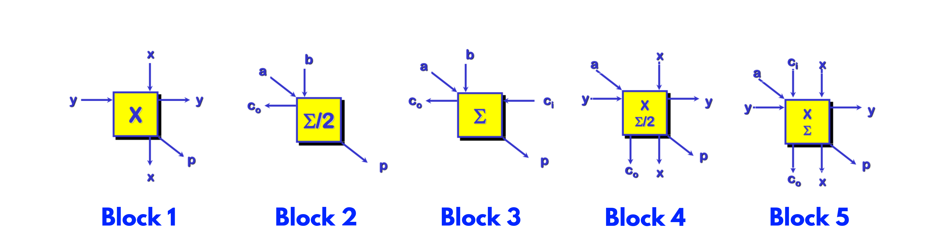

Figure 1.2 Block types required for the multiplication

The overall scheme of a parallel multiplier is represented in the figure below:

Figure 1.3 Parallel Multiplier Architecture

As is possible to note in the figure, the type 1 block provides all the partial products, the type 4 and 5 blocks are the Half Adders and Full Adders and the final blocks, of 2 and 3 type, represent a sort of ripple carry adder that makes the final sum.

The latter scheme is based on a 4x4 multiplier, but in general the are needed:

* N2 AND port
* N(N-2) Full Adder
* N Half Adder

## **1.3 Matrix Multiplication**

Matrix multiplication is a binary operation that produces a matrix from two matrices. For matrix multiplication, the number of columns in the first matrix must be equal to the number of rows in the second matrix.

The resulting matrix, known as the matrix product, has the number of rows of the first and the number of columns of the second matrix. The product of matrices A and B is denoted as AB.

Formally it can be defined that, given two matrices A ∈ ℤn*m , B ∈ ℤm*p

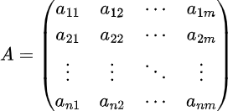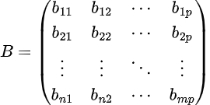

The product matrix P = AB ∈ ℤn*p is defined as:

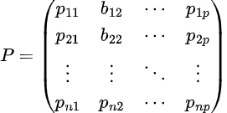

Where each element can be calculated as follow:



for *i* =1 to *m* and *j* =1 to *p*.

From this a simple algorithm can be constructed to compute the matrix multiplication, which loops over the indices *i* from 1 to *n* and *j* from 1 to *p*.

## **1.4 Finite Arithmetic sizing**

In order to avoid any finite arithmetic’s error on *q* (number of bits of matrix P elements) are assumed the followed assumption:

First, by definition, the interval of all possible representable numbers in 2’s complement with N bits is:



so in the case study the range of the representable number with 4 bits is [ -8 : 7 ].

Knowing the latter, the maximum number (real part) having 4 bits is 64.

The sum of 2 binary numbers on n bits can always be displayed on *n+1* bits, instead the product of two numbers in 2’s complement on *n* bits can always be displayed on *n+n = 2n* bits.

Moreover, doing the matrix multiplication operation it is possible to have the sum of the maximum number *m* times (where *m* is the number of rows of matrix A and columns of matrix B), so it is possible to define the maximum computable number for each cell in this way:



In this case, having matrices 2x3 and 3x4 *m* = 3, so the maximum representable number is 64*3 = 192.

By definition it is possible to calculate the number of bits needed to represent a number in 2’s complement as follow:



At this point, knowing that the maximum representable number and how to compute the number of bits given a number, is possible to conclude that in general the number of *q* bits needed is:



And in this specific case the number of *q bits* to represent an element of matrix P without finite arithmetic’s errors is:



# 2. Matrix Multiplier Implementation

## **2.1 Algorithm**

The algorithm used to compute the matrix multiplication is the following:

1 for i from 1 to n

2 for j from 1 to p

3 for k from 1 to m

4 Pij = Pij + (Aik * Bkj)

5 end for

6 end for

7 end for

This is a simple algorithm constructed with loops over the indices *i* from 1 through *n* and *j* from 1 through *p*, computing each element of the resulting matrix as follows:



this algorithm takes Θ(*nmp*). To simplify it can be assumed that all the matrices are square of size *n*n*, so the computation time is Θ(*n*3).

## **2.2 Model Architecture**

The block diagram for the implemented architecture is the following:

Figure 2.1 Matrix Multiplier blocks diagram

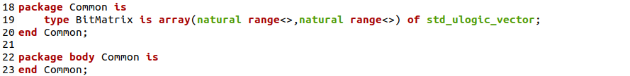Where the green blocks are the input/output registers, the blue block is the logic core (combinatorial circuit) of the matrix multiplier and the matrices (A, B and P) are matrices of bits (type defined).

In the following chapter all the components are explained in detail.

# 3. VHDL Implementation

In the following chapter is presented the VHDL code for all components of the Matrix Multiplier. It is used the VHDL 2008 syntax (that allow to use unconstrained *std_ulogic_vector* and *std_logic_vector* ).

In Modelsim, to use this language syntax it must be set the option in the “Project Compiler Settings” section.

## **3.1 Bit Matrix type definition**

It is declared a custom type of array called BitMatrix. It is the matrix type used in all modules of the matrix multiplier.

It is chosen to delegate the constraining to the single component in order to increase the dynamism of the whole structure.

Figure 3.1 BitMatrix type definition

## **3.2 Matrix Register**

The matrix register is a D-FlipFlop extended to hold a matrix of bytes (BitMatrix type). Its VHDL entity is defined as follows:

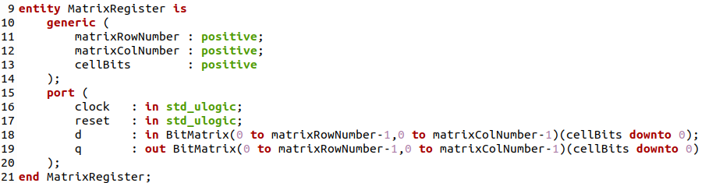Figure 3.2 Matrix Register VHDL entity

## **3.3 Matrix Multiplier**

This part is the logic core of the entire module. The matrix multiplier is a combinatorial circuit, below is show the entity definition:

Figure 3.3 Matrix Multiplier VHDL entity

taking into account the *finite arithmetic sizing problem* (chapter 1.4) some considerations are done.

The problem is focused on sizing the matrix P elements (line 21 Figure 3.3) and the considerations on what implement were two:

* assign 9 bits to matrix P elements (as the computation in this specific case return)
* assign “dynamically” to matrix P elements by using the VHDL transcription of the *q* bits computation formula (chapter 1.4) as it is shown below:



After the study, assumed that the second method does not add any advantage, it was decided to follow the first consideration in order to maintain the reliability of the code.

Finally, the combinatorial logic function that implement the matrix multiplication is the following:

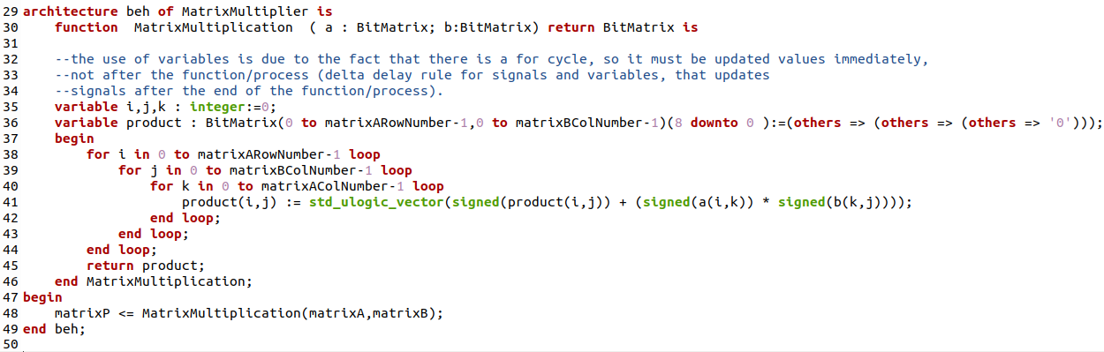Figure 3.5 Matrix Multiplication VHDL combinatorial logic

The implementation of the algorithm described in the chapter 2.1 force the uses of variables.

As commented in the VHDL file, the use of **variables** (only inside the process) is due to the fact that having a *for* cycle and knowing that the variables, with respect to signals, instantaneously resolve the assignment and not after the process termination (delta delay rule).

## **3.4 Matrix Multiplier Architecture**

The matrix multiplier architecture is the entire architecture composed by all components described above; 2 input registers for the matrices A and B, an output register for the product matrix P and a matrix multiplier.

In the figure below is possible to see the components:

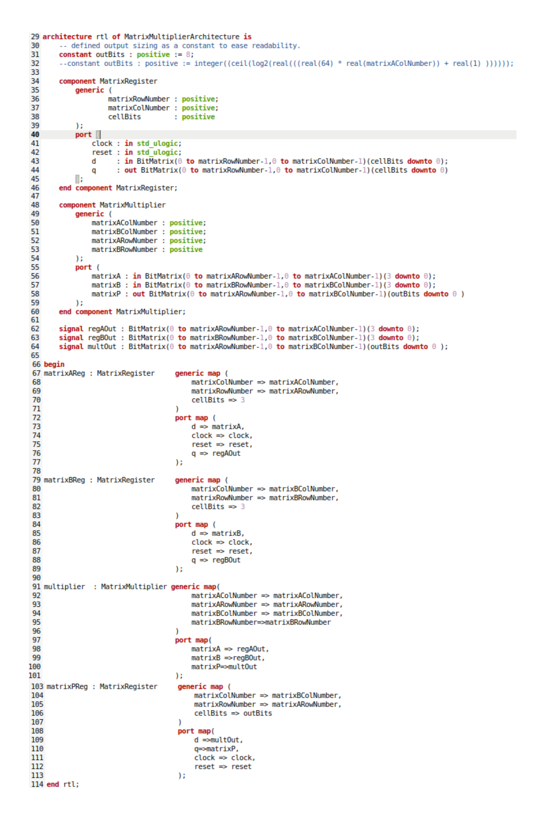

Figure 3.6 Matrix Multiplier Architecture

# 4 Test Plan

The test plan for matrix multiplier was designed to test some different case. So, for this purpose, it was written a python program, called *TB_generator.py.*

This program dynamically generates the *MatrixMultiplier_tb.vhd* files depending on which case it is decided to simulate.

One of the main goal of the test plan is to test the **finite arithmetic sizing resolution**. This test is focused on extreme values, i.e. among all the configurations that a matrix can assume it can be considered the worst case when limit values are all placed in a row of the first matrix and in a column of the second matrix.

Doing so it is possible to reproduce the largest positive values (192) and the largest negative values (-168) and see if the sizing of *q* (number of bits for matrix P elements) is congruent with the study.

Moreover, the test plan involves the simulation of a case with **random values** for the matrices A and B and another simulation with **values chosen by the user**.

## **4.1 Python Testbench generator**

As just mentioned, this python program generates the testbench files in order to make different types of simulation.

The program let the user choose between 4 different modes:

1. Assign values to matrices A and B to produce the largest positive number
2. Assign values to matrices A and B to produce the largest negative number
3. Generate randomly the values for matrices A and B
4. Let the user choose the values for Matrices A and B

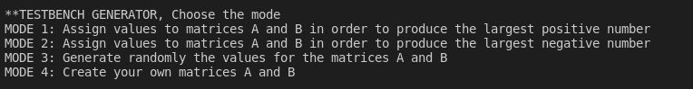

One time the mode is chosen the program creates the *MatrixMultiplier_tb.vhd* files and shows the binary matrices written inside the *stimulus process.*

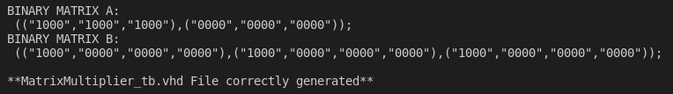

Moreover, the program computes the real matrix multiplication operation and returns the values into *Result.txt* file, so it is possible to compare the real values with the values returned by the simulation.

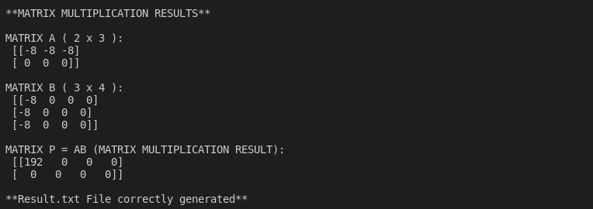

It is also important to point out that the program dynamically read the matrices A and B sizes, so it is possible to use the program to generate testbench files for matrices of any size.

## **4.2 Testbench implementation**

One time the *MatrixMultiplier_tb.vhd* file is created it is used to run the simulation in Modelsim.

Below are shown all 4 cases just explained:

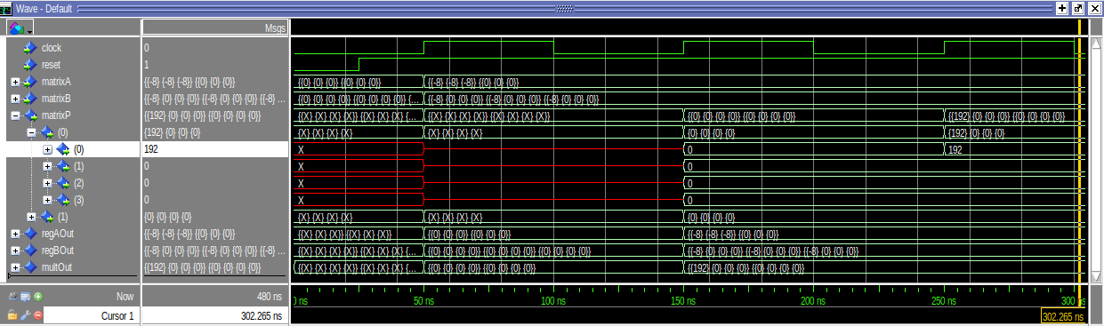**First test:** All elements in the first row of A and in the first column of B are equal to (−8)10⇔(1000)2 . The result must be (192)10 in the Matrix P cell*p0,0* :

Figure 4.1 First test Simulation with Modelsim

**Second test:** All elements in the first row of A are equal to (−8)10 ⇔ (1000)2 . All elements in the first column of B are equal to (7)10 ⇔ (0111)2. The result must be (-168)10 in the Matrix P cell*p0,0*:

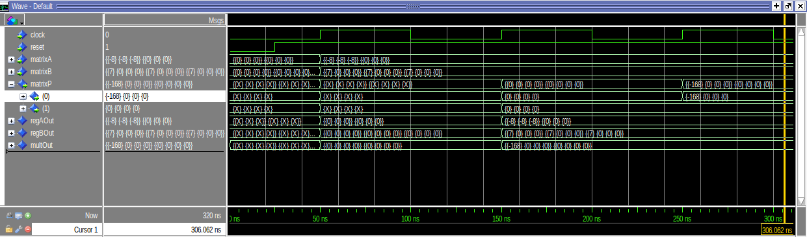Figure 4.2 Second test Simulation with Modelsim

**Third Test:** In this case the python program generates 2 random matrices (using an RNG for the values of each position) as input.

Matrix multiplication results generated by python are used to compar against the simulation results. Is possible to observe that the results match.

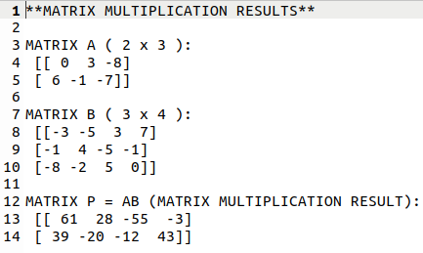

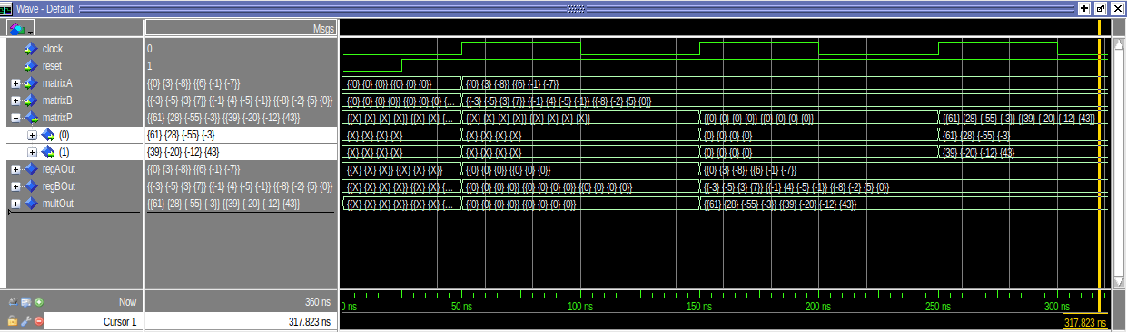

Figure 4.3 Third test Simulation with Modelsim

**Fourth Test:** Similar to the third test but this time is the user that choose the input matrices values.

The results return the same values for matrix P both in the python program and in the simulation.

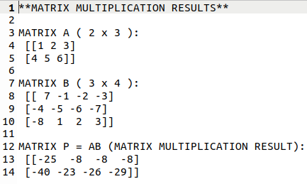

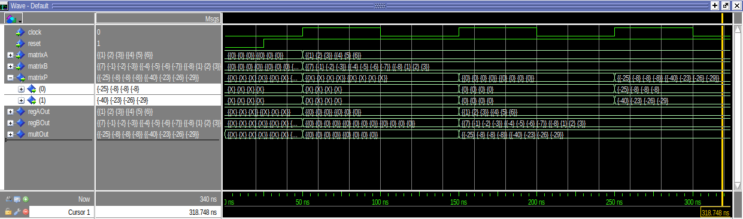

Figure 4.4 Fourth test Simulation with Modelsim

# 5. Synthesis and Implementation Logic

Like 2-D rotation matrices, we instantiate matrix dimensions in Vivado to *N* = *M* = *P* = 2. (In order for Vivado to recognize some VHDL-2008 syntactic constructs, there are several ways to run VHDL-2008 files with Vivado. We can go to the Source File Properties window and set Type: VHDL 2008 from the drop-down of available file types. The Vivado tool then sets that the file type to VHDL-2008. we can also set files to VHDL-2008 with the *set_property* command in the *Tcl* Console.  
The syntax is as follows:

*set_property FILE_TYPE {VHDL 2008} [get_files <file>.vhd]*

Finally, in the Non-Project or *Tcl* flow, the command for reading in VHDL has VHDL-2008 is as follows: *read_vhdl -vhdl2008 <file>.vhd.*  
If we want to read in more than one file, we can either use multiple read_vhdl commands or multiple files with one command, as follows: *read_vhdl -vhdl2008 {a.vhd b.vhd c.vhd}*

## **5.1 Register Transfer Level design (RTL)**

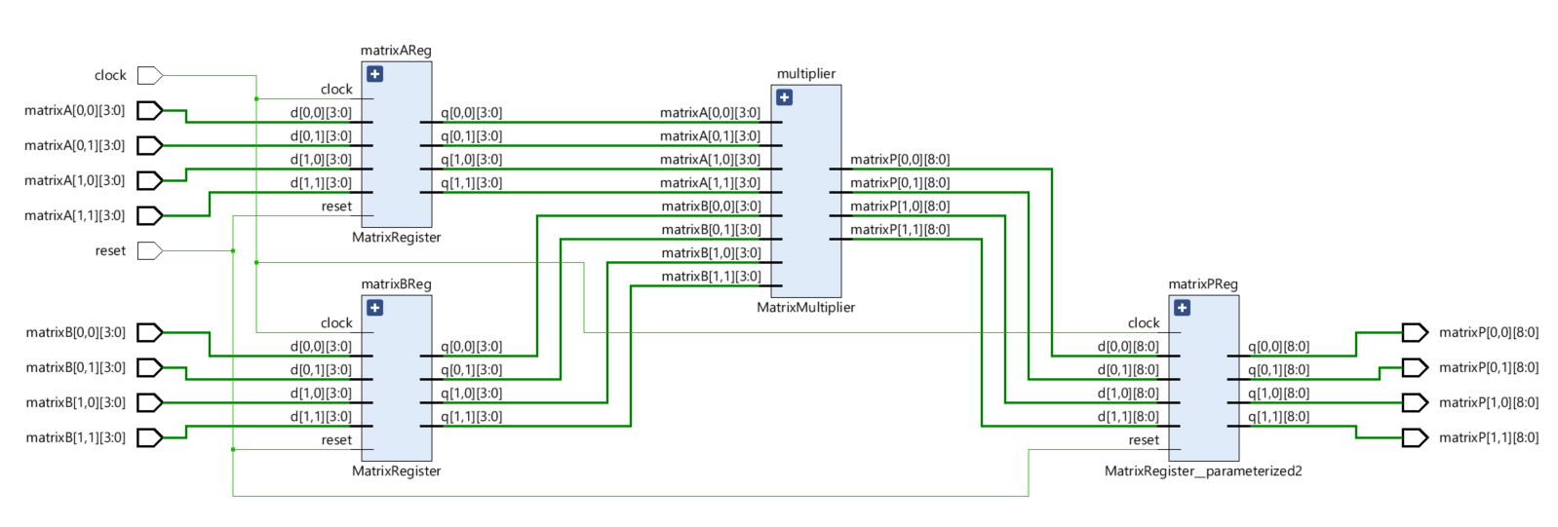This phase results in the following design:

Figure 5.1 RTL Design from Vivado

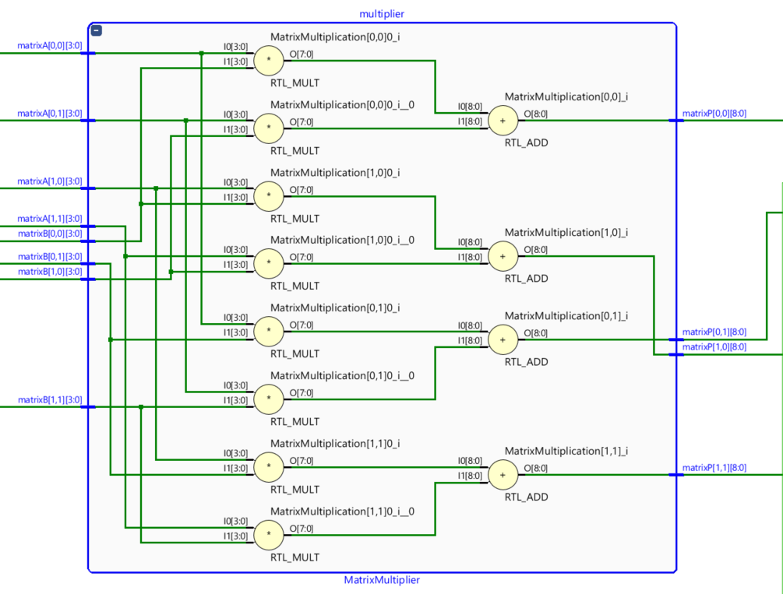It's also worth noting how the multiplier's loop-unrolled architecture appears:

Figure 5.2 Inside the MatrixMultiplier

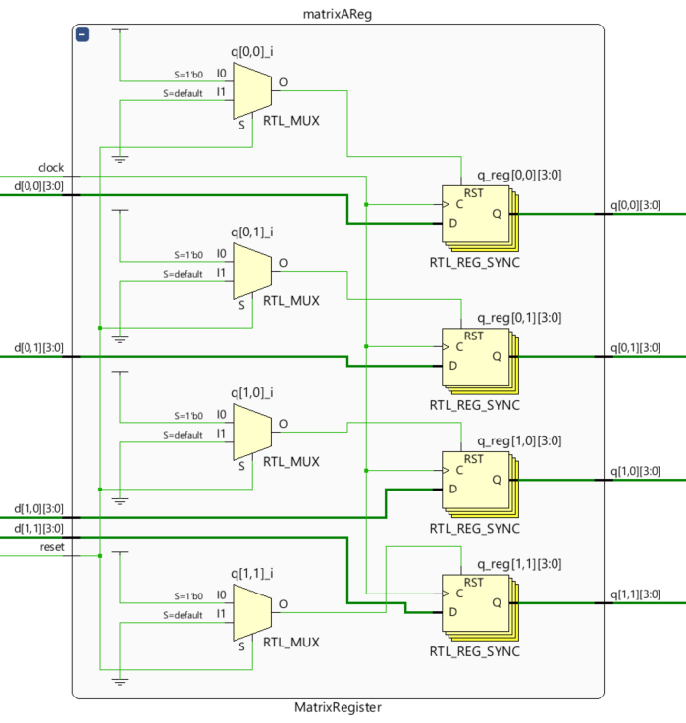

Figure 5.3 Inside the MatrixRegister

**5.2 Synthesis**

### **5.2.1 Timing Report and critical path**

We can examine the report timing in the following table after adding the constraint clock with a period of tclk = 125Mhz:

There are no negative slacks, therefore an 8ns clock is definitely sufficient for the resulting design. Furthermore, the worst negative slack is 2.278 ns, indicating that the clock can be quicker than this amount.

Figure 5.4. Timing report from VIVADO

The SLACK is the temporal margin between the stabilization of signal and is

TSLACK = TCLK + TSUP.

We can observe the worst path thanks to Vivado:

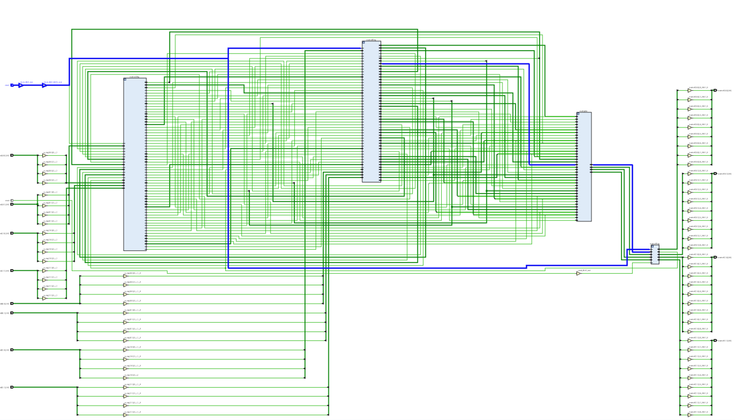Figure 5.5 Worst path from VIVADO

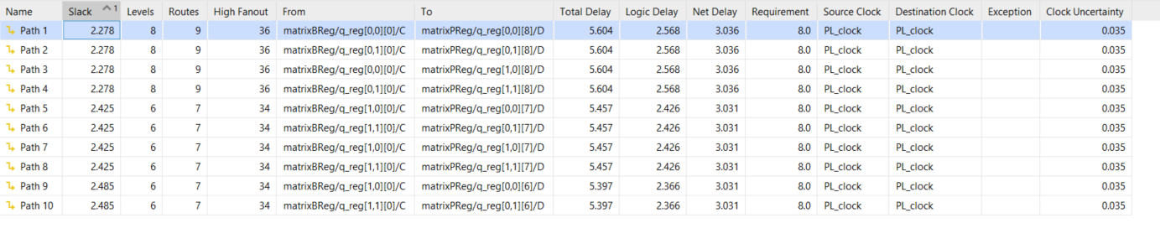

Figure 5.6Worst path from VIVADO

We can calculate how much quicker we can drive our clock given the slack:



The minimal clock may be found using the same formula. Only slack can be changed since other times are set:



Because we are in the limit scenario, the value of slack is zero. If we take the second form out of the first equation, we get:



So, in the end, we get:



When we look at the timing report after applying this value, we see that the worst negative slack is equal to zero, which is exactly what we want.

Figure 5.7 Timing report with tclk = 5.722ns

### **5.2.2 Power consumption**

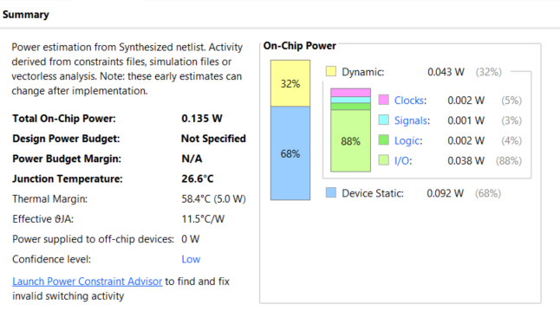The most recent report is on ***Power consumption***. This is a very preliminary estimate, but it gives you a good understanding of the circuit's power needs.

Figure 5.8Power consumption report

The average power usage is more than 100mW. Furthermore, the percentage of static power is clearly higher than the percentage of dynamic power. As a result, the switching activity in this circuit might be considered minimal.

### **5.2.3 Device Utilization**

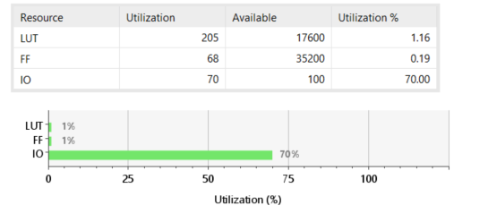The ***utilization report*** obtained are as follows:

Figure 5.9Utilization report

## **5.3 Implementation**

Vivado will perform the location and route in this step, with some beneficial improvements. In typically, this step is preceded by I/O Planning, in which the FPGA's I/O Physical Ports are linked to the Elaborated Design's I/O Ports. However, the FPGA does not have enough ports to accomplish a 16-bit input and output. As a result, the implementation will be done in Out of Context Mode, which eliminates the need for I/O planning.

Figure 5.10 Implementation Result

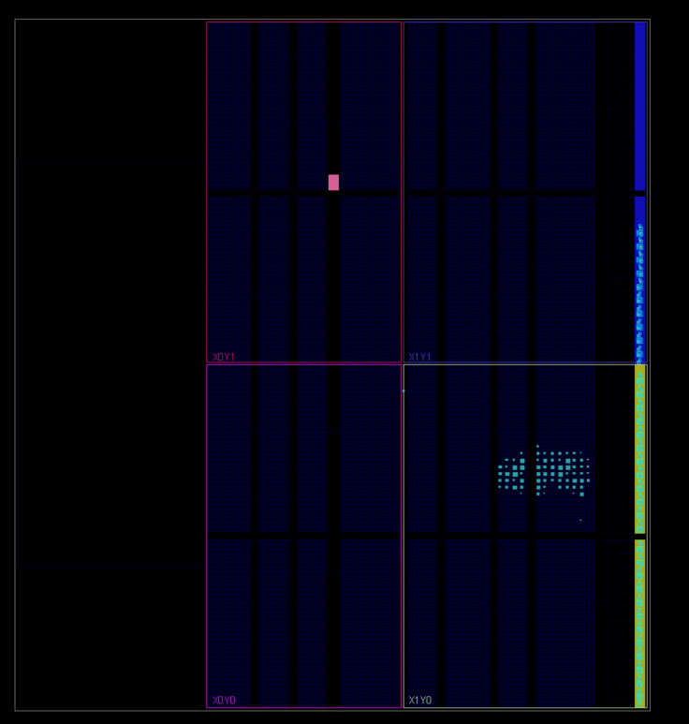Although there are no Errors, there are some cautions. They'll be studied afterwards.

I/O Ports

Combinatorial logic + in/out registers

Figure 5.11 Implemented design from VIVADO

### **5.3.1 Timing Report and Critical Path**

The following are the times obtained:

Figure 5.12 Timing Report

There are no negative slacks in this example, thus an *8ns* clock time is sufficient. However, the worst negative slack in this instance is far greater than previously. This is because the implementation enables us to acquire a more precise estimate.

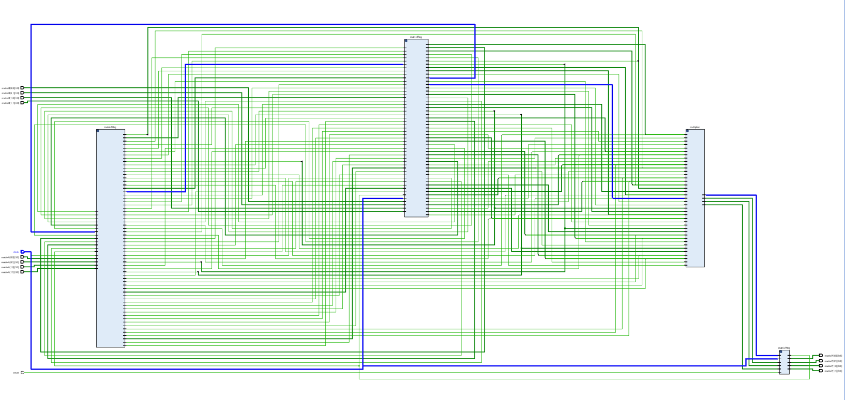The **critical path** that causes this slack is the following:

Figure 5.13 Critical Path for Setup time

### **5.3.2 Device Utilization**

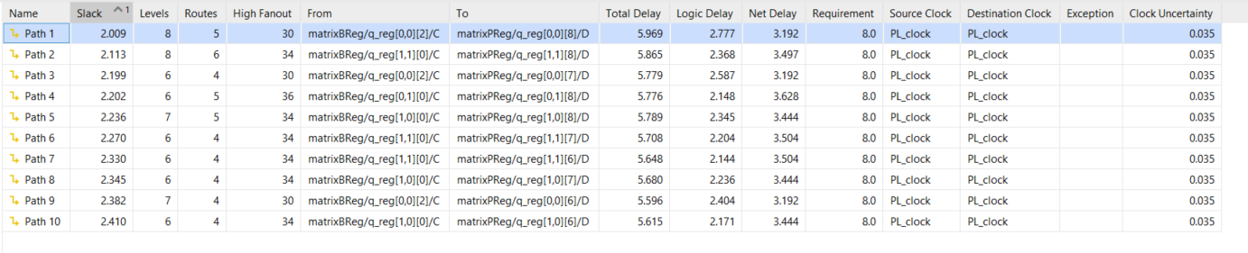The following is the utilization report:

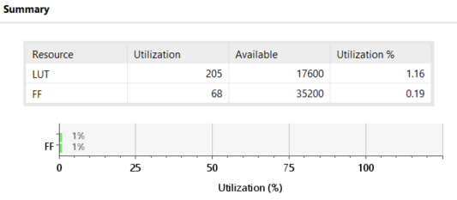Figure 5.14Utilization Report

The number of Look Up Tables and Flip Flops from the synthesis, have remained same.

### **5.3.3 Power Consumption**

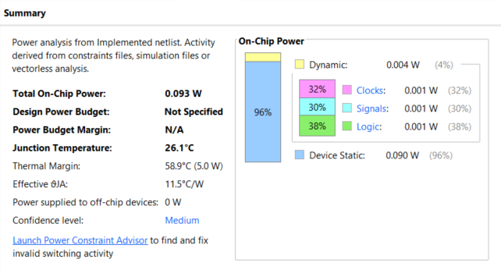The following are the findings in terms of Power Consumption**:**

Figure 5.15Power Report

## **5.4 Warnings**

### **5.4.1** Warnings Analysis

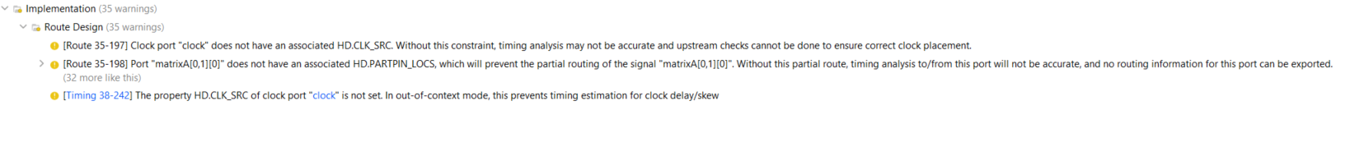The Implementation’s Warnings are the following:

Figure 5.16 Implementation Warnings

They're all internal Vivado warnings that may be disregarded.

### **5.4.2 Timing Warnings**

There is a warning concerning the lack of a delay limitation. This will determine whether or not our ASIC can fulfil the timing requirements of the external devices to which it is linked. If these timings are not reached, our ASIC will be unable to communicate with the external devices to which it is designed.

Figure 5.17 Timing warning from VIVADO

# 6. Conclusions

We will have a functional matrix multiplier at the conclusion of this project. It might be implemented using more space-efficient methods, such as Strassen's, to reduce the area occupied by combinatorial logic for multiplication and to parallelize combinatorial circuits, shortening the path between in-out registers. This might result in less restrictive clock frequency constraints, enhancing the module's total speed. This is crucial when discussing matrix multiplication since it is commonly used in graphics processors to perform 2-D and 3-D transformations on pictures and models.