Technical Report: Monte Carlo Simulation for P_W(E)
Analysis of the Initial Curve Region, Empirical Estimation, and Theoretical Model Validation
1. Explanation of the Region Choice (p ∈ [0.06, 0.10])
Focusing on the interval p ∈ [0.06, 0.10] is a strategic decision driven by both computational feasibility and the mathematical properties of transmission over a noisy channel (BSC):
• Computational Feasibility & Simulation Speed: In this region, the channel is highly noisy, making the word error probability P_W(E) relatively high (~10^-1). This allows the Monte Carlo simulation to accumulate the target number of errors (10 and 100) in very short computation times. At very low values of p (e.g., p = 10^-4), observing 100 errors would require simulating hundreds of millions of packets, creating a severe computational bottleneck.
• Dominance of the Binomial Term & Coding Threshold: For high values of p, the probability of experiencing exactly t+1 errors dominates significantly over t+2, t+3, etc. The curve lies in the transition/breakdown region, which is ideal for empirically verifying the limiting behavior and validity of the decoding model.
Key Takeaway: The selected range provides an optimal balance between low computation times and high accuracy in measuring the code's response.
2. Plotting the Analytical and Simulated Curves
The log-log plot displays both the theoretical analytical curve and the empirical estimates obtained using two different target error thresholds:
• Analytical Curve (Solid Cyan Line): Represents the exact theoretical solution calculated via the binomial tail summation for an error count w > t.
• Monte Carlo Curve – Target = 10 (Dashed Red Line with Circles): Represents the empirical simulation stopped upon reaching 10 word errors.
• Monte Carlo Curve – Target = 100 (Dashed Yellow Line with Squares): Represents the empirical simulation stopped upon reaching 100 word errors.
All curves share the same axes (p on the x-axis and P_W(E) on the y-axis) to allow direct comparison.
3. Comments on Results and Statistical Convergence
Analyzing the experimental results and comparing them with the mathematical model yields three fundamental conclusions:
• Convergence and the Law of Large Numbers: The yellow curve (target = 100) follows the solid cyan analytical curve much more closely and smoothly than the red curve (target = 10). This empirically demonstrates the Law of Large Numbers: as the sample size (number of accumulated errors) increases, statistical uncertainty decreases significantly.
• Variance and Empirical Fluctuations: The relative error of a Monte Carlo estimate scales as 1 / sqrt(N_err). With N_err = 10, the relative error is approximately 31.6%, which explains the noticeable ripples and fluctuations of the red curve around the theoretical trend. With N_err = 100, the relative error drops to 10%, making the curve stable and closely aligned with theory.
• Simulator Validation: The close alignment of the 100-error estimate with the theoretical curve serves as formal proof of the correctness of the simulation algorithm, confirming the absence of bugs in the BSC noise generation or the decoding logic.
Summary: The proximity of the simulated curves to the theoretical model confirms the code's correctness, while the gap between target 10 and target 100 clearly illustrates the importance of adequate statistical sampling.

4. Comparison between results obtained by the two codes
By analyzing the graphs obtained by the two codes the most noticeable feature is the difference between the 100 target curves of the MC (Monte Carlo) simulation on the C(7, 4) code and the C(8, 4) code.
Although the first code is a perfect code, that allows us to correct all error patterns of weight at most t (error correction capability) and to not overlap spaces, so we have a maximum efficiency in terms of geometrical space, we note that the 100-target curve in the other code that is NOT perfect is closer to the analytical curve Figure 2 rather than the same curve with the analytical for the perfect code Figure 1.
This tells us that a perfect code doesn’t mean a better code for transmission and error correction, in fact, we use less resources but we have a worse codeword error probability instead of a constant one for the NOT perfect code.

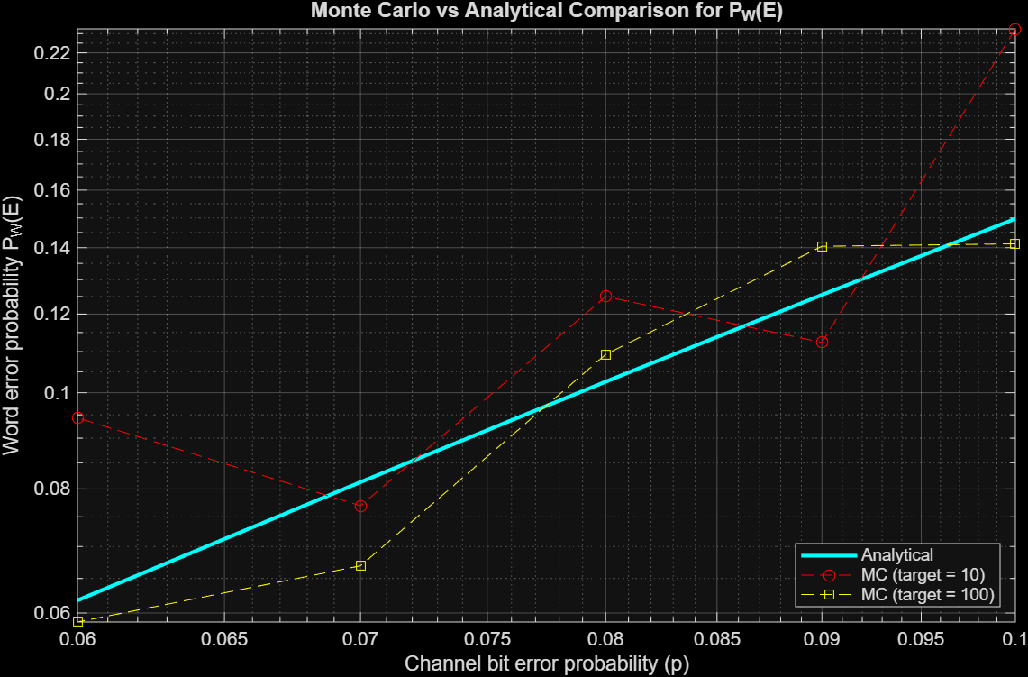
Figure 1: Monte Carlo simulation for a C(7, 4) perfect code
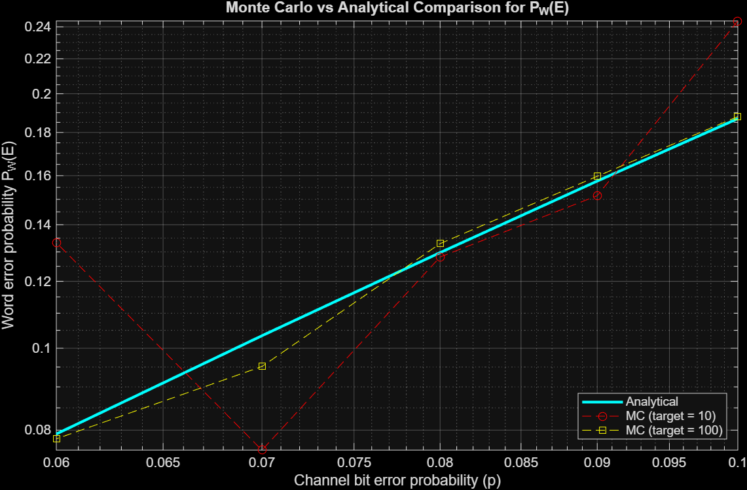
Figure 2: Monte Carlo simulation for a C(8, 4) code

