The Last Knight
Project Software Design

Design and Domain Model
The software can be mainly divided into two main parts: the game engine, responsible for the game logic, update of state, input handling, sound handling, etc.; and the artistic, creative part, namely how actors interact with each other.
One of the most important part of the software is the GameObject class. A GameObject is an object that can be updated and rendered inside of a GameCanvas context and interact with a GameData object.
With this simple architecture we could create complex interactions by allowing each GameObject to modify in standardized ways the GameData.
For example, instantiating and adding to the scene a GameDialog will set the state of the game to DIALOG, therefore easily controlling the flow of the game.
The graphical part of the project has been developed inside of a standard Java Swing application, allowing for an easy management of the UI part.

Domain Model
The domain model can be found in the docs in “compiled” .png form and as PlantUML code.
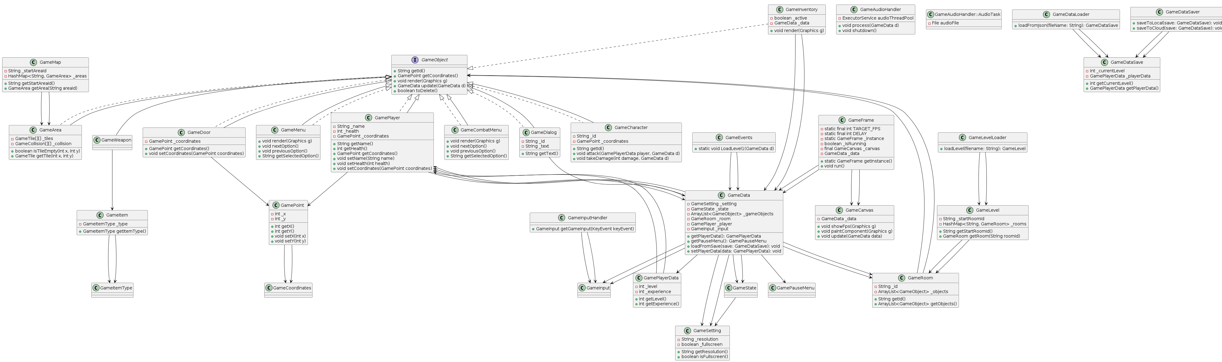

System Sequence Diagram (SSD)
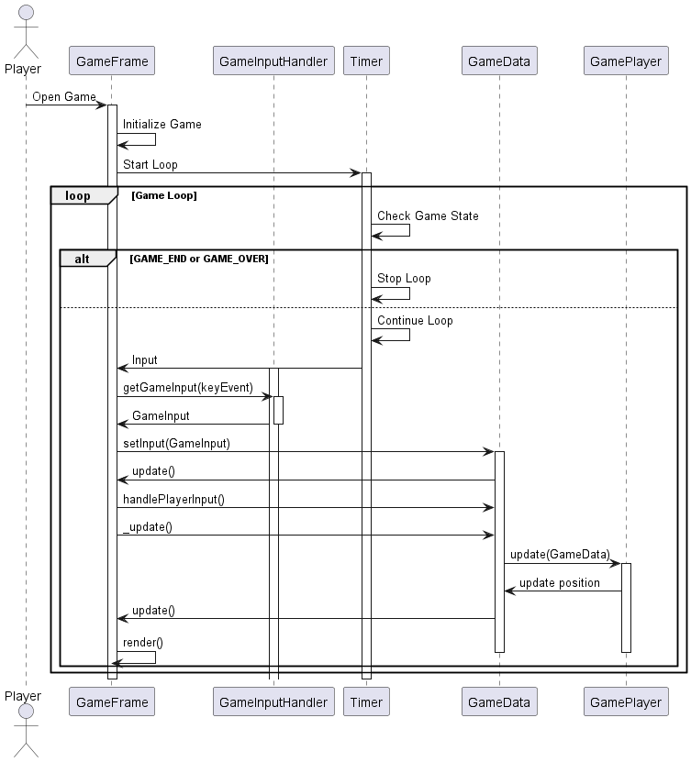

Design Class Model Diagrams
can be found in the docs in “compiled” .png form and as PlantUML code.

Internal Sequence Diagrams

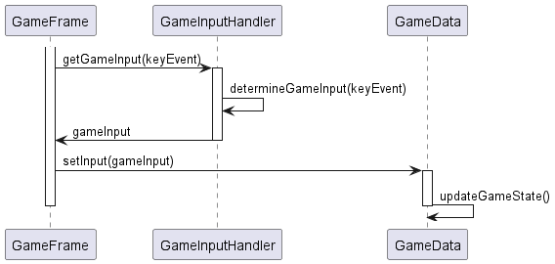
- Game Input Loop

- Game Dialog (e.g. of GameObject)
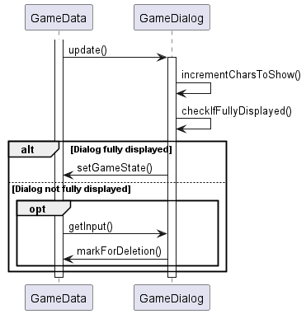

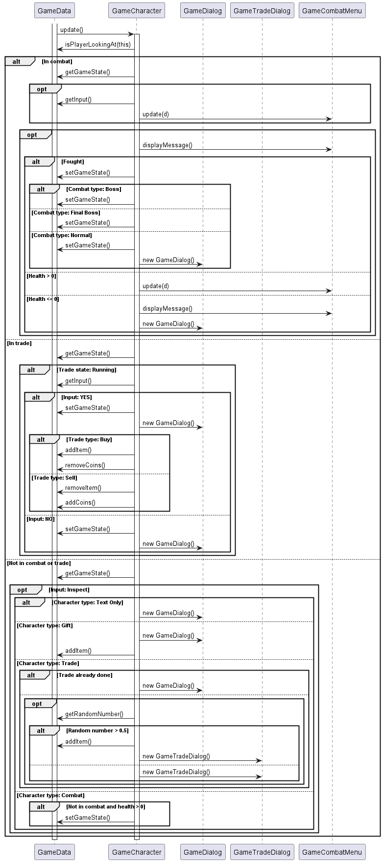
- GameCharacter (e.g. of GameObject)

