**Sales Forecasting for LS Clothing Inc. Using the Holt-Winters Method of Multiplicative Seasonality**

**Stephen Bickel and Luca Bulfon**

[**Stephen.bickel1@marist.edu**](mailto:Stephen.bickel1@marist.edu)**,** [**luca.bulfon1@marist.edu**](mailto:luca.bulfon1@marist.edu)

**Abstract**

The project's objective was to use the Holt-Winters method of multiplicative seasonality to illustrate how this model can be a useful tool for companies who want to accurately predict future sales in scenarios where seasonality is involved. The model we created was able to accurately predict sales for our fictional company, LS Clothing Inc, which experiences a cyclical seasonality trend with elevated sales every 4 months because of merch drops. This project should serve as a useful tool for businesses who want to accurately predict trends that involve multiplicative seasonality.

**Introduction**

The Holt-Winters method is a triple exponential smoothing technique that considers the trend of seasonality of time series data. The Holt-Winters method is a valuable tool for many scenarios, particularly when it comes to predicting sales, demand, or other time dependent phenomena. It is a valuable tool for analysts and data scientists. It was named after Charles Holt and Peter Winters who created the method. It is useful for forecasting data with clear seasonality patterns (Palvel, 2023). There are three components in the Holt-Winters method: level, trend, and seasonality. The level component represents the average value of the time series, the trend represents the direction and rate of change, and the seasonality represents the repeating pattern over fixed intervals (Palvel, 2023). There are many advantages to using the Holt-Winters method. It is simple to understand and implement, and it has good forecasting accuracy that outperforms simpler forecasting techniques (“Understanding Holt-Winters’ Method: A Powerful Forecasting Technique”, 2024).

The application of the model in this project will use data from a fictional clothing company called LS Clothing Inc, a clothing company that experiences spikes in popularity every 4 months, following the release of new merch. In this scenario we created a situation where LS Clothing experienced a popularity spike due to going viral on social media. This resulted in a large spike in sales while also continuing to follow trends of seasonality. The model we created forecasted the next year of sales for LS Clothing.

**Procedure**

In this study, we investigated the application of time series forecasting techniques to sales data from a small clothing company. Artificial intelligence (AI) was employed to generate monthly sales data for the past three years. The simulated data reflected the company's business model, characterized by new merchandise releases every four months, leading to intermittent sales spikes. Additionally, the data incorporated a gradual upward trend in sales over the three-year period. To simulate a viral marketing event, the AI also generated a surge in sales corresponding to a social media influencer promoting the company's apparel (LS Clothing).

The generated sales data was then imported into an Excel spreadsheet for analysis. We grouped the data by quarter and calculated a baseline level, a trend component, and a seasonality factor for each month's sales. Following the Holt-Winters method, we used the following formulas to compute the three parameters:

***Level***

Formula = ALPHA * (F6/I3) + (1 - ALPHA) * (G5+H5)

This equation estimates the underlying average value (level) at a given time period. It incorporates a weighted average of the previous period's smoothed level (G5+H5) and the current period's actual value (F6) divided by the seasonality factor (I3).

ALPHA: Cell containing the smoothing parameter (0 < α <= 1). A higher value in this cell places more weight on recent data.

***Trend***

Formula = BETA * (G6 - G5) + (1 - BETA) * (H5)

This equation estimates the trend component at a given time period. It considers the change between the current period's smoothed level (G6) and the previous period's smoothed level (G5).

BETA is the cell containing the smoothing parameter for the trend (0 < β <= 1). Similar to α, a higher value in this cell places more weight on recent changes in the level.

H5 is the cell containing the trend estimate at the current period.

***Seasonality***

Formula = GAMMA * (F6/G6) + (1 - GAMMA) * I3

This equation estimates the seasonal component for a specific period within the seasonal cycle. The multiplicative model treats seasonality as a percentage that affects the baseline level (G6) and trend. The formula calculates a seasonal index (I3) that represents this influence for each season in each period. This index is then used in the forecasting process to adjust the baseline level and trend based on the expected seasonal effect.

GAMMA: Cell containing the smoothing parameter for the seasonality (0 < γ <= 1). Similar to α and β, a higher value in this cell places more weight on recent seasonal effects.

The model's performance was evaluated using the Mean Absolute Percentage Error (MAPE), resulting in a value of 11.60%. Considering the inherent variability within the data, this MAPE can be considered a positive indicator of the model's accuracy.

**Results**

**Figure 1: Real vs Forecasted Sales for LS Clothing Company** 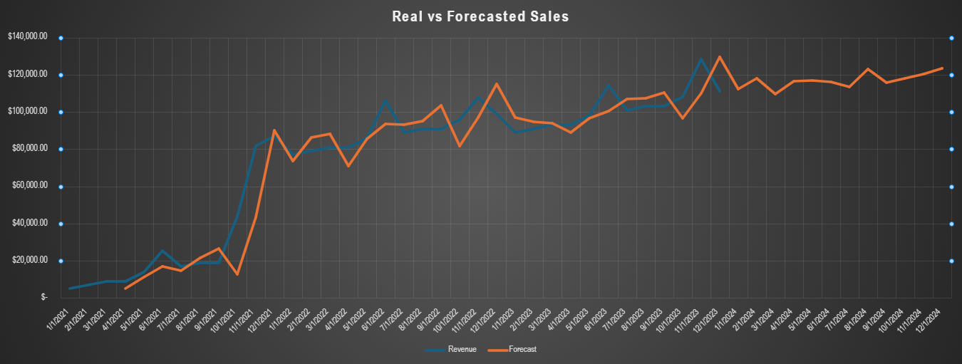

**Figure 2: Average Seasonal Forecast**

**Figure 3: Average Monthly Forecast**

**Figure 4: Mean Standard Error and Mean Absolute Percentage Error**



**Discussion and Conclusion**

The results show that we were about to accurately forecast the next year's sales with confidence using the Holt-Winters method. The forecasted sales followed the same trend as the actual sales for the first three years of data. Figure 1 shows the actual sales vs the model's prediction of sales for the first three years and the forecast for the next year. Based on the graph in figure 1, it is apparent that the model was able to follow the same trend as the actual data. Figure 2 shows the sales predictions for each quarter of the next year and the percentage of the expected average sales. The table on the right shows the expected sales based on the percentage of average sales for that quarter. Figure 3 is another table that shows the average sales for each month and the percentage of average sales as well as the smoothed percentage for each month. The table on the right is like the table from table 2 in that it shows the expected sales based on the percentage of average sales from each month. Figure 4 shows the mean squared error and mean absolute percentage error. Mean squared error quantifies the average squared difference between predicted values and actual values and mean absolute percentage error helps assess the accuracy of the model by considering the relative error between predictions and actual values.

**References**

Palvel, Subash. “Time Series Forecasting with Holt-Winters Method.” *Medium*, Medium, 16 Sept. 2023, subashpalvel.medium.com/time-series-forecasting-with-holt-winters-method-c773b0b07cca#:~:text=The%20Holt-Winters%20method%20is%20a%20triple%20exponential%20smoothing,after%20its%20creators%2C%20Charles%20Holt%20and%20Peter%20Winters.

“Understanding Holt-Winters’ Method: A Powerful Forecasting Technique.” *Medium*, Medium, 28 Apr. 2024, medium.com/@data-overload/understanding-holt-winters-method-a-powerful-forecasting-technique-b72f2edec994.

Gemini [Large Language Model]. Google AI.