This document will contain my personal finance project:
Architecture:
This section will have all the information regarding my personal finance project architecture. The project is divided into different layers in order to maintain an efficient and clear structure. This particular project is built using an n-tier architecture and the following are the layers I am implementing:
- API Layer – Presentation Layer:
Location in the project: app/api/v1/endpoints/
This layer is responsible for defining the HTTP routes. As an example, I have implemented /register or /login.
It is also responsible for handling the incoming requests. What does this mean?
It means that when a client sends an HTTP request like the following:
POST /api/v1/users/register
- The layer will match the URL path to the correct route function
- Extract the body (JSON)
- Validate it using the schema
- Inject the dependencies

The layer is also responsible for returning HTTP responses. This means that after applying logic such as CRUD, the API layer also decides what to send back to the client. It wraps the response in a specific schema and sets the proper HTTP status code (404 not found)
To summarize, the API layer is responsible for defining the HTTP routes, handling the request and returning the HTTP response. Ultimately this layer connects the outside world with internal logic.
- Schema Layer – Validation and Serialization layer
Location in the project: app/schemas/
The key responsibility for this layer is to act as a point of communication between the database and the API endpoint. This is being done to make sure that the database wont receives bad data, and the return value is properly validated and structured.
The key functions of this layer are the following:
Validating request data:
- All the incoming requests are checked against the Pydantic schema
Example: UserCreate schema ensures:
  - email is a valid email (EmailStr)
  - password meets minimum length requirements (min_length=8)
  - Optional flags like is active have default values
This prevents invalid data from reaching the database.
Defines the response model:
- Response schemas define what the client will receive by hiding specific information that is not necessary to send with the request
Example of how API and Schema layer works together:
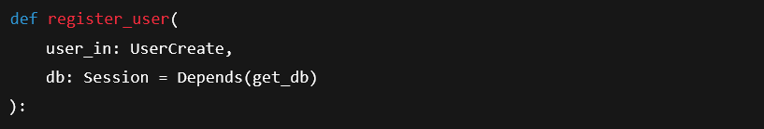
- user_in: UserCreate
This tells that the request body should match the UserCreate model
  - FastAPI automatically reads the JSON body of the request.
  - Pydantic parses it into a UserCreate object.
  - During parsing, Pydantic validates the data.

- db: Session = Depends(get_db)
This uses FastAPI dependency injection:
  - get_db provides a SQLAlchemy database session.
  - Every request gets its own session that you can use in the endpoint.

- Business Layer
Location: app/crud/
This layer contains business logic; this means it contains the core application logic which groups all the functions that interact with the database. In this case it is used to handle various actions, such as creating a user or also checking if an email is user and so on.
This layer defines where and how the system thinks
- Data layer:

Location: app/db/models/
This layer defines the database structure. In particular, how the tables and relationships are defined. It is also used to map python objects with database rows.

