**Communication Network Design Lab – Task Submission (Task #1)**

|  |  |
| --- | --- |
| **Full name** | **Person code** |
| Luca Ferraro | 10748116 |
| Bernardo Camajori Tedeschini | 10584438 |
|  |  |

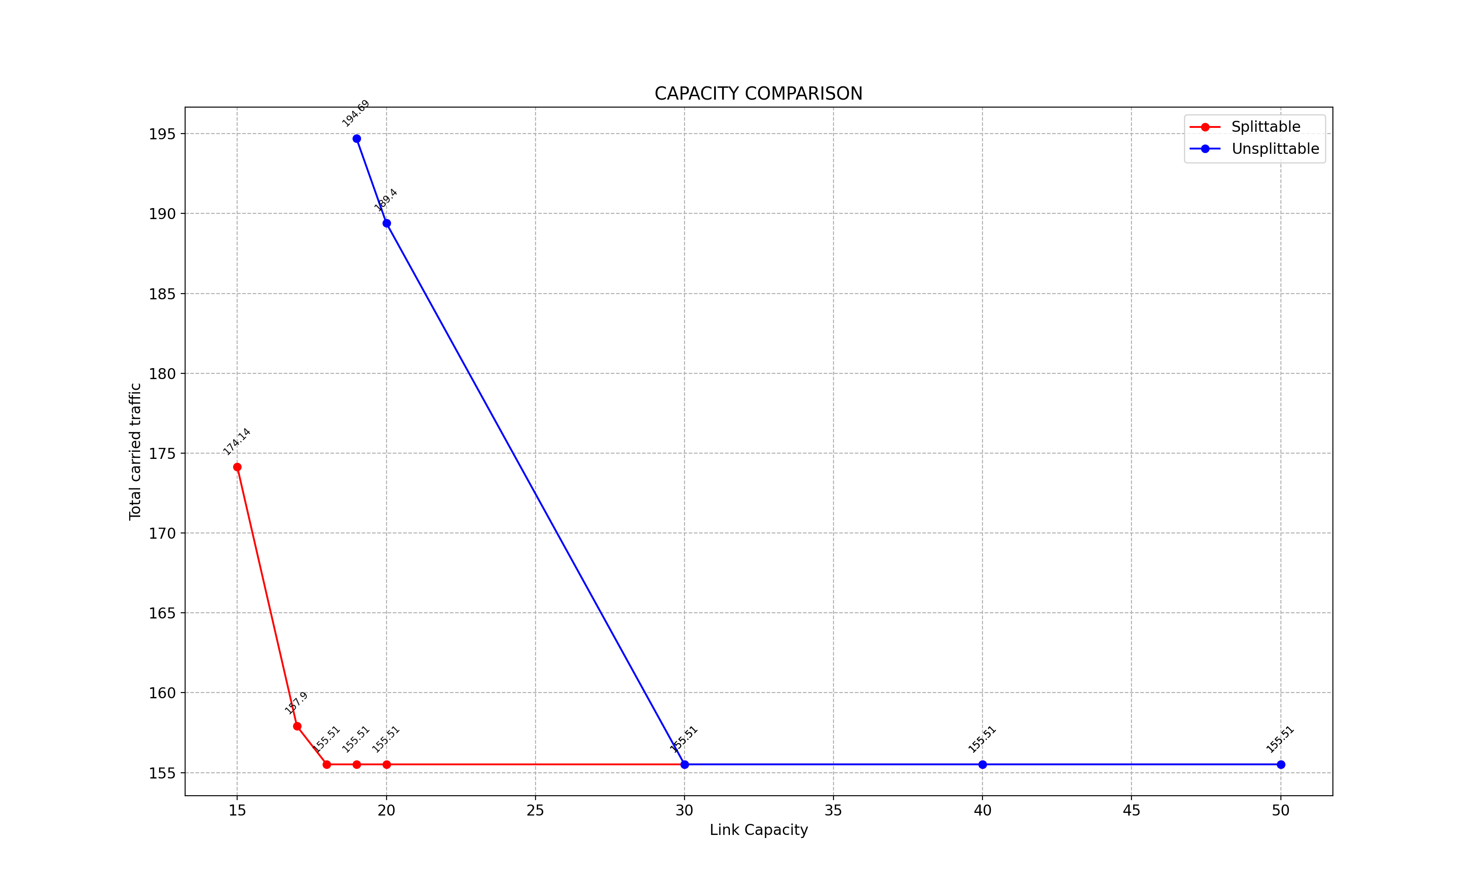In this graph we report the capacity requested by the two cases of splittable and unsplittable flow formulations:

As we can see from the graph, the capacity requested from the two formulations is the same for link capacities ≥ 30.

When we decrease the capacity, the total carried traffic (so the total bandwidth) required by the unsplittable flow formulation is higher than the one required by the splittable case. This is due to the fact that in the splittable formulation there’s more freedom in the way the flows can be routed.

Furthermore, in the unsplittable case the problem cannot be solved when the capacity of the links is ≤ 18. This is due to the fact that the request requiring the highest capacity needs to route more than 18 units of flow; since this flow cannot be splitted among the outgoing links of the source, the request cannot be satisfied and therefore a solution cannot be found.

Finally, for the splittable flow formulation, we cannot find an optimal solution only when the link capacity is ≤ 10. The feasible solution that the algorithm can find is 0 total carried traffic, meaning that actually no one of the requested could be satisfied.

All the codes and results can be found in this Github repository:

https://github.com/LucaFerraro/Communication_network_design_lab