Communication Network Design Lab

**Task #3: *IP over WDM Network Design***

In this task you will explore how to use the graphical user interface of Net2plan to design a network and its WDM and IP layers.

|  |  |
| --- | --- |
| **Full name** | **Person code** |
| **Luca Ferraro** | **10748116** |
| **Bernardo Camajori Tedeschini** | **10584438** |
|  |  |

# **Creating WDM topology**

1. Open Net2Plan, go to ***Offline network design & Online network simulation*** under ***Tools*** and Activate the **NIW framework** in Net2Plan by clicking the **NIW** button found at the top right corner.
2. Go back to main Net2Plan window and click on **Reset** button, this will create an **empty design** with an **empty IP and WDM layer**.
3. In the **View/edit network state** tab in *Design tables and control window*, under **Network** subtab, you will find a table just under ‘*Layer information*’ with one row per layer, i.e., one row for IP layer and one row for WDM layer. Since we are only interested in the WDM layer, remove the IP layer in the table by right clicking on it and clicking on the appropriate menu option.
4. Go back to the main Net2Plan window and in the geographical view, add four nodes to the design, placing them approximately in the following cities of Italy: **Milano, Genova, Roma, Venezia**. Then, create a WDM ring topology, with bidirectional WDM links as shown in **Figure 1**. For adding a new bidirectional WDM link, click the origin node, with **SHIFT** key pressed, and drag the mouse to the other node. *Report below the total number of kms of fiber and length of the longest link?*

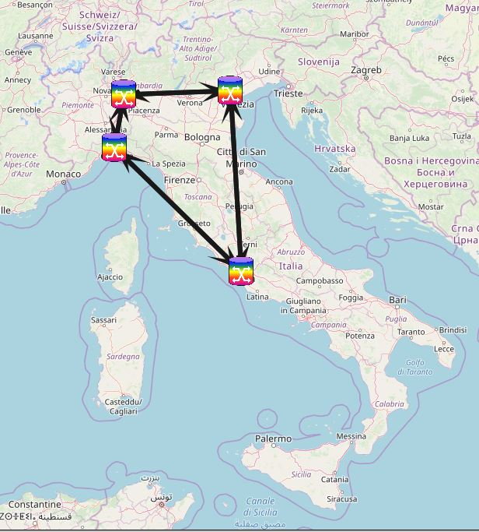

Total length = 2320.38 Km

Longest link: Genova – Roma → 401.68 Km

Figure 1 WDM topology

1. What is the default usable spectrum in each fiber (minimum and maximum frequency)? To which ITU band it corresponds to?

193.11 – 197.11 THz (1522nm →1533nm)

That corresponds to S-band (1460 - 1530 nm; 193.11THz) and C-Band (1530 – 1565 nm).

1. In the OADMs tab under WDM tab in View/edit network state tab, set the name of the nodes to correspond to each city, and set the populations of each node as follows: Milano 1352, Genova 583, Roma 2873, Venezia 269 (all numbers are measured in thousands of inhabitants) and then save the topology with the name “**topWdm.n2p**”.

# **Adding lightpaths**

1. Add a bidirectional lightpath request from Genova to Venezia requesting a line rate of 100 Gbps that should be 1+1 protected. Use the right-click option ***Add lightpath request*** in the ***Lightpath requests*** table (in WDM tab). *Is the lighpath request carried?*

No (look at the “Up?” column of the lightpath requests tables)

1. Add a bidirectional lightpath request from Venezia to Roma requesting a line rate of 100 Gbps (not 1+1 protected). *Is the lighptath request carried?*

No (same as previous point)

1. Select the *lightpath requests* created. Use the right-click option ***Add lightpath*** to selected requests to add the lightpaths that realize these requests. All lightpaths should occupy 50 GHz (4 slots of 12.5 GHz), and their route should be computed to minimize the optical latency*. How many lightpaths are assigned to 1+1 protected requests? Are they fiber* *disjoint? Which are the two paths? In the 1+1 requests, what is the value assigned to the worst end-to-end length and latency?*

We have 2 lightpaths both from Genova to Venezia and from Venezia to Genova.

They are Link disjoint by definition of 1+1 protection.

The primary paths are Genova-Milano-Venezia; the backup ones are Genova-Roma-Venezia.

Worst end-to-end length = 739.79 Km; Worst latency = 3.97ms

1. In the **Fibers table (in WDM tab)**, set as **down (not up)** the fiber between Milano and Venezia in both directions. *How many lightpaths are down? Is the lightpath request from Genova to Venezia down? why? and the one from Venezia to Roma?*

The only paths down are the ones for the connections Venezia-Genova and Genova-Venezia are down (so 2 lightpaths).

Venezia-Roma is up.

1. **Activate the Spectrum occupation view in the Lightpaths table**. *Which are the optical slots occupied by the lightpaths? Why some lightpaths occupy different slots?*

The connections between Genova and Venezia occupy the slots 1-2-3-4; the connections between Venezia and Roma occupy the slots 5-6-7-8.

The reason why the connections Venezia-Roma occupy different slots is that the first 4 slots are reserved for the backup paths of the connections Genova-Venezia

1. Use the option **Set optical slots occupied** to selected lightpaths and make the lightpath from Genova to Venezia (unidirectional) to occupy the slots 3, 4, 5 and 6. *Is this change affecting other lightpaths? How and why?*

Yes, this affects the results since the slots 5 and 6 weere already occupied by the connection Roma-Venezia.

The consequence is a clash, meaning that the two connections propagates using lightpaths with overlapping spectrum.

# **Creating an IP topology**

1. Remove all the lightpath requests (if you did not follow adding lightpaths section you simply need to load the topology “topWdm.n2p” file).
2. Add an IP layer to the model. Go to the **Network** tab, under **Layer information**, use the right-click option ***Add IP layer***. See that one more layer is now shown in the topology panel.  
   See the controls at the first part of the topology panel that permit: (i) making a layer visible or not (single-click its name), (ii) making a layer the main layer in the design (double-click its name), (iii) showing each layer in an upper or lower position (clicking the triangle arrows). Use these controls to place the IP layer at the top and make the IP layer the active layer.
3. Create **one unicast IP demand** between each node pair using the appropriate right-click option in the IP demands table (under IP tab). The demands should be all routed using **OSPF (hop-by-hop routing)**. *How many demands are created? what is the total offered traffic?*

The demands are 12 (ok since we consider all node pairs, so 4*3 = 12).

The total offered traffic is 0

1. Select all IP demands and set their offered traffic so that the traffic of each IP demand is proportional to the sum of end node populations, and the total traffic sums 1 Tbps (1000 Gbps). *Is the IP traffic carried? why?*

The traffic is not carried. This is because there are no links at IP layer.

1. In the **topology panel**, create a star IP topology with one IP link (bidirectional) between Milano and each of the other nodes (so a total of 6 unidirectional IP links are created). *What is the default capacity assigned to all links? Is all the IP traffic of the demands carried? Are there oversubscribed IP links (links with QoS violation, in this case, with more carried traffic than capacity)*?

The default nominal capacity is 100Gbps.

The IP demands are all carried (0% of lost traffic)

There are oversubscriptions for all the demands but for the one Venezia-Milano (look at the column WC oversubscription)

1. We want each IP link to achieve a maximum not more than 90% of its capacity, while its capacity is a multiple of 100 Gbps and it is the same in both directions.Use the right-click option **Set selected links capacity** -> to match given utilization for this purpose. *What is the total amount of capacity to be installed in the IP links? Is all the traffic carried now, without oversubscription? what is the maximum utilization among all the IP links? which is the average number of IP hops in the network? (see the Network tab, Routing table performances).*

We need at least 700Gbps for having a maximum utilization of 81% (<90%).

Yes, now all IP traffic is carried without oversubscriptions.

Average number of hops: (sum Trav IP links)/(Number of IP Demands) = 18/12 = 1.5

1. We now want each IP link to be a Link Aggregation Group (LAG) with the same capacity where each LAG aggregates enough IP links of 100 Gbps to match the required capacity. In the **IP links table**, use the ***Link Aggregation Group (LAG) options -> Convert selected links into LAGs...*** for realizing this. *How many LAG members are newly created?*

There are 42 LAG members

1. Change the IGP weight in the Genova to Venezia link making it equal to 10. *Is there any change in the IP routing? why?*

# **Creating the IP over WDM design**

1. First, we want to associate each IP link member to a newly created lightpath request that will be later realized through a lightpath. To do so, use the ***IP links table right-click*** option ***Create & couple lightpath requests*** for uncoupled selected links, after selecting all the IP links. *How many lightpath requests are created? Are the lightpath request associated to the IP bundles? Why is the capacity of all the IP links and members equal to zero now?*
2. Assert that all lightpath requests do not require being 1+1 protected then provision all the lightpath requests with lightpaths, using the shortest path in optical latency, and using 4 optical slots (50 GHz) of occupation for each lightpath. *Are all IP links up and with its occupied capacity equal to its nominal capacity? Is all the IP traffic being carried without oversubscription?*
3. Analyze the IP path and the WDM path of the traffic of the IP demand from Genova to Roma. *Which are the IP links traversed? Which is the WDM path of each IP link? Is the total WDM path with cycles? What is the end-to-end latency and total WDM length in km of the IP demand?*
4. *Which IP demand has the highest end-to-end latency? Are their nodes directly connected by a fiber? where all this latency comes from?*