1. **Set environment**

**>npm install jimp**

**>npm install tesseract.js**

1. **section 1**

* **modify line 5 of test.js file**



**>node test.js**

1. **section 2**

* **modify line 5 of test.js file**



**>node test.js**

1. **section 3**

* **modify line 5 of test.js file**



**>node test.js**

1. **Result**

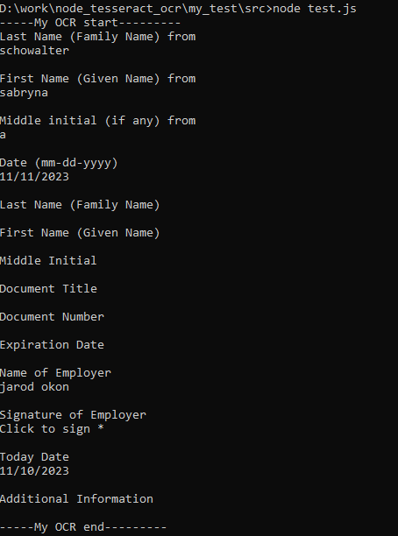

**Function :**

**ocr_main(img_path, img_w, img_h, section_option)**

**Section 1 OCR item**

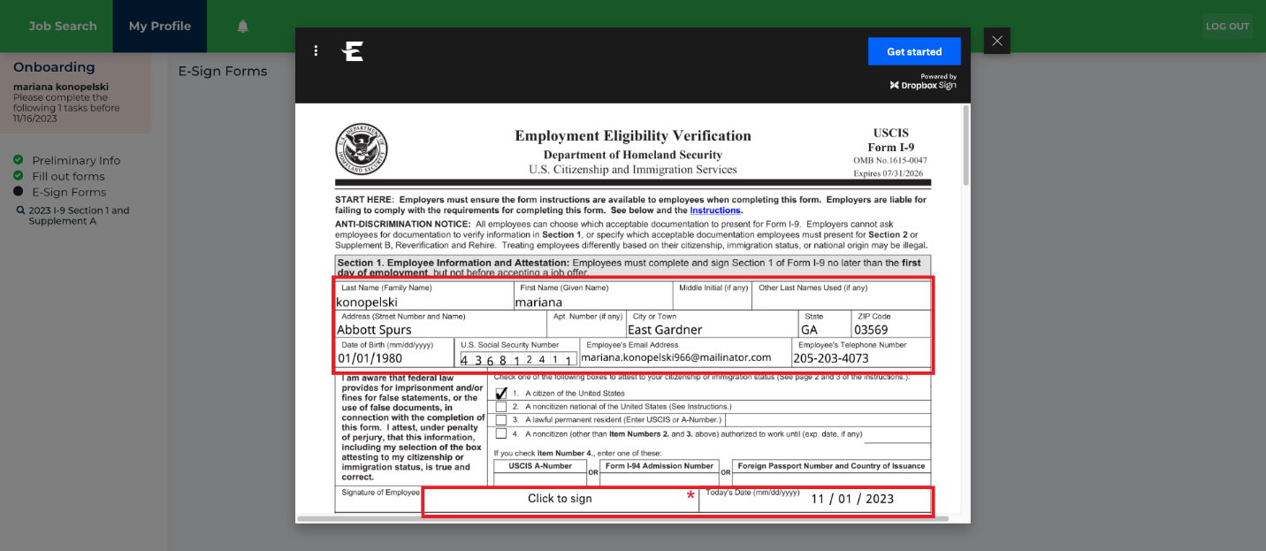

**Section 2 OCR item**

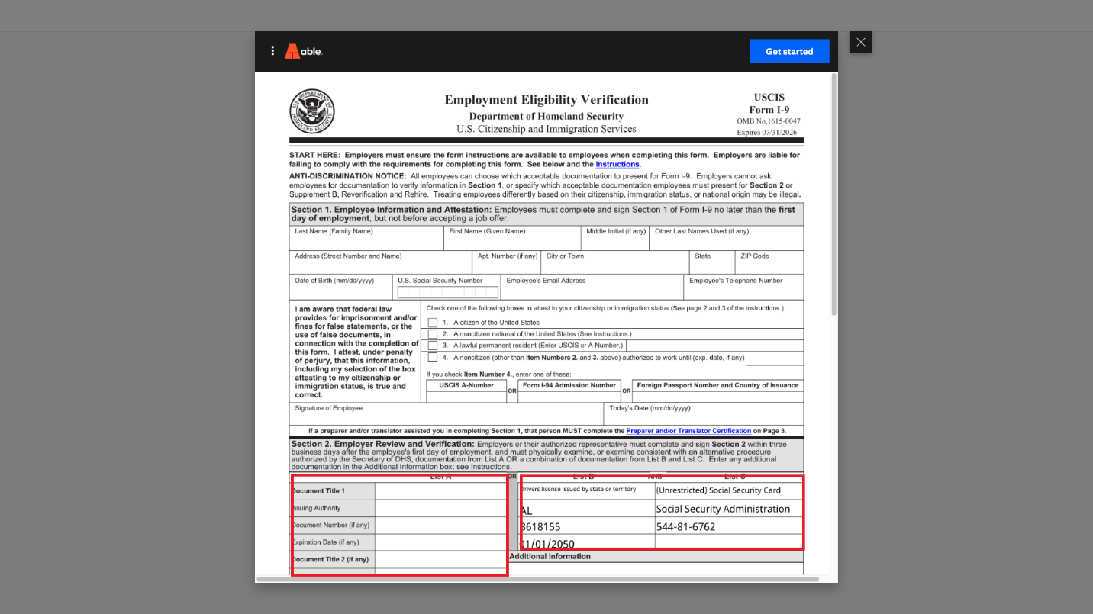

**Section 3 OCR item**

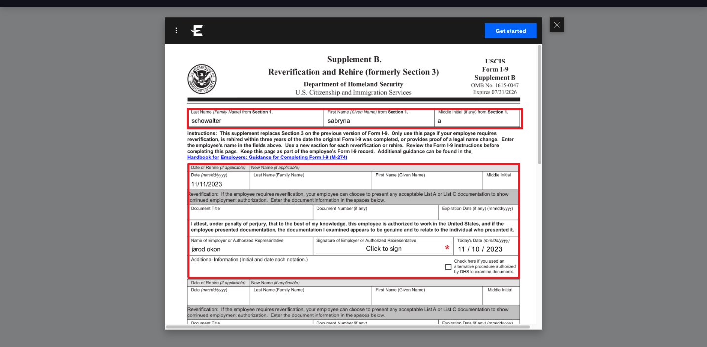

**ISSUE :**

**In section 1, the recognition rate for the value of "U.S. Social Security Number" is around 90%.**

