1. Testing environment

python 3.10

MSSQL 2022

MySQl 8.0

>pip install –r requirements.txt

1. Modify source code.(db_sync.py)

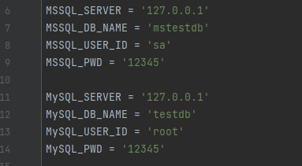

1. Run

>python db_sync.py

1. Function

- The database to be synchronized must be created in MySQL.

- A table in MSSQL must have at least one primary key (uniqueidentifier).

- Creation of tables in database in MySQL

- Synchronization of table information to MySQL

- Synchronization of changes in table structure in MSSQL

- Synchronization of addition, update, and deletion processing for record information