1. Install “tesseract-ocr-w64-setup-5.3.1.20230401.exe”
2. Modify 12 line of pdf_qrcode.py file

*Specifies the path installed in the system.*



1. Python environment

>conda create –n pdfqrcode python=3.11 –y

>conda activate pdfqrcode

>pip install –r requirements.txt

1. Run

>python pdf_qrcode.py –i [input_pdf_file]

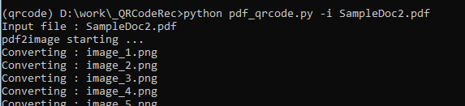

1. Result

./result/input_pdf_filename/*