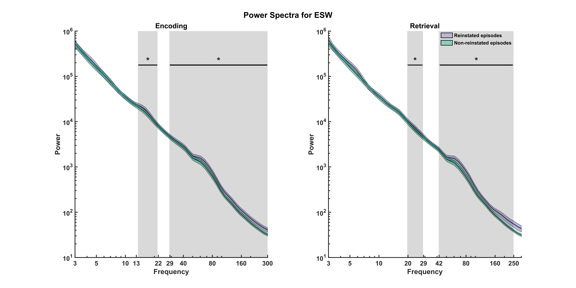

Materials and Methods

Procedure of memory experiment 1 and experiment 2

See above.

Participants

See above.

Ethical approval

See above.

Behavioural analysis

See Above.

Co-Registering

See Above.

Recording System and Electrodes

See above.

Statistical analysis

All statistical analyses were conducted using MATLAB R2020a on a computer running Windows 10 Enterprise. The significance threshold for all statistical tests was set at 0.05. Unless specified otherwise, all permutation tests were implemented with *N* = 1,000 random draws.

Identification of Episode Specific Neurons (ESNs)

See above.

LFP Preprocessing

We downsampled the LFP data from microwires that contained neurons in the hippocampus to 1,000 Hz and applied a fourth-order Butterworth bandstop filter with a centre frequency of 50 Hz (+-1 Hz) and its harmonics up to 300 Hz, to remove line noise.

LFP Artefact Rejection

For each microwire, we computed the bandpass-filtered signal between 70 Hz and 150 Hz using a first-order Butterworth filter. We identified any data points exceeding five standard deviations from the mean of this signal as artefacts and excluded the one-second intervals preceding and following them.

Identification of Episode Specific Microwires (ESWs)

We considered neural activity from the onset of the associated image to the patient's response in encoding trials, and from the cue onset to the response onset in retrieval trials. To account for edge artefacts, we extended these trial definitions by 100ms on each side. We then performed a wavelet analysis using wavelets from 70 Hz to 150 Hz in steps of 5 Hz and a width of 7 cycles, on the linenoise-removed broadband signal. After removing all artefacts (see #Artefact Rejection), we computed the mean power over all frequencies.

Trials that consisted of 50% or more artefacts during encoding or retrieval were excluded, and if fewer than nine trials remained, the microwire was not considered for further analysis.

We z-scored the remaining HFA power values independently for encoding and retrieval, and excluded trials not of interest (i.e., later forgotten or later remembered trials).

Finally, we defined the element-wise product of the encoding and retrieval standardized HFA power as a proxy for episode-specific reinstatement.

In order to calculate a threshold for this episode-specific firing reinstatement we permuted the order of the encoding and retrieval episodes and recomputed the reinstatement value. We repeated this step 1,000 times and took the 99th percentile as a threshold against which we compared the empirical reinstatement value. If the empirical reinstatement exceeded the threshold and its standardized power at encoding and retrieval was at least 1.645 (≙ pright-tailed < 0.05), we considered this microwire an Episodic Specific Microwire (ESW). This procedure allows for thresholding but does not correct for multiple comparisons on the level of a microwire.

To determine whether there was a significant number of microwires that showed this episode-specific power reinstatement, we randomly drew one of the previously calculated permutations for each microwire and determined whether it would be classified as a ESW under the same criteria as before. In each of the 1,000 permutations, we summed up the number of shuffled ESW which we then used to create a null distribution against which we compared the empirically determined number of ESW.

In order to generate Figure XX, we repeated the time-frequency analysis in the range of 3 Hz and 300 Hz for all microwires that exhibited a HFB power reinstatement in at least one episode. For each ESW we calculated the mean power in the HFB during reinstated and non-reinstated episodes and then averaged the respective power spectra across all ESW. To determine the statistical significance of the results, we used a cluster-based permutation test (Oostendorf/feld xx).

Identification of putative Concept Microwires (CWs)

We have adapted the method created by Mormann et al. (2011; 2008 xx) for detecting Concept Neurons to identify microwires whose power in the HFB (xx) was reliably increased following the presentation of a specific image. For each microwire we divided the local field potential of the 1000ms interval post-stimulus into 19 100ms overlapping bins, with the 500ms preceding stimulus onset as the baseline period. To prevent edge artefacts, we extended the testing and baseline intervals by 100ms on either side.

We performed a time-frequency analysis using wavelets in the range of 70 Hz to 150 Hz (stepsize: 5 Hz) and a width of 7 cycles, allowing us to estimate the time-resolved power. We then averaged the power over all frequencies and within each time bin. If more than one of any of the six repetitions of an image contained over 50% artefacts that time bin was discarded for all repetitions.

We then compared the mean HFA power in the remaining 19 bins across all six presentations of an image with the mean HFA power of all baseline periods in the session using a Mann-Whitney U test. We corrected for multiple comparisons using the Simes’ procedure (Rødland, 2006xx).

%% THETA & POS

We downsampled the signal to 100 Hz. Because we do not know the relative position of the recorded neurons to the microwires within a bundle of electrodes by extension we do not know if the microwire on which the neuron was recorded best represents the neural input into the neuron. For this reason, we took into consideration all eight microwires and generated two theta components using generalized eigendecomposition (xx).

We are using the generalization of the eigendecomposition that extends it to two square matrices. For the eigenvaluedecomposition, the eigenvector with the highest eigenvalue accounts for the maximal variance in the underlying square matrix and is pairwise orthogonal to the other eigenvectors.

On the other hand, the eigenvector with the highest eigenvalue in a generalized eigendecomposition can be understood as the filter that maximizes the difference between the two input matrices. The eigenvectors in a GED are independent, but not orthogonal. In practice when applied to two covariance matrices that represent the broadband activity and a narrowband signal the first eigenvector yields a spatial weighting that maximizes the narrowband activity and minimizes the broadband activity.  https://doi.org/10.7554/eLife.21792 xx

Based on previous literature (xx) we generated a slower theta component in the frequency range of 2 Hz to 5 Hz and a second faster component in the range of 5 Hz and 9 Hz. To generate these components, we first applied a first order Butterworth filter to bandpass the broadband signal in all eight microwire channels between 2 Hz and 5 Hz (slow theta component) or 5 Hz and 9 Hz (fast theta component). We then demeaned the signal and computed a covariance matrix using this narrowband signal, which we then divided by the number of samples. Next, we computed a second covariance matrix using the entire broadband signal. We computed the generalized eigendecomposition of these two covariance matrices and used the eigenvector with the highest eigenvalue as a spatial filter for the narrowband filtered signal to generate a narrowband component. We applied the Hilbert transform to get the analytic signal.

We considered the spikes of neurons up to two seconds preceding the patient's response during the encoding and retrieval of later remembered episodes. We confined all spike-field analyses to spikes and LFPs that were recorded on the same Behnke-Fried electrode.

We can plug in the spikes that we previously segmented into this complex signal

POS is a measure of phase opposition between to conditions. That means even if there is a high Inter Spike Consistency (ISC) within each condition (e.g., encoding and retrieval) if the phase preference is the same between conditions the phase opposition will be low. In order to compute the POS, we require at least 11 spikes in each condition. We computed the POS on the level of the neuron to account of inter-neuron difference in phase preference. The formular for POS is given by:

$POS= {ISC}_{enc}+ {ISC}_{ret}- {2*ISC}_{all}$ (1)

ISC is defined as (xx Tallon-Baudry et al., 1996; Lachaux et al., 1999 10.3389/fnins.2016.00426 xx?):

${ISC}_{all}=\left|\sum_{[i=1:n]}{\frac{ω_{i}}{\left|ω_{i}\right|} }\right|/n_{all}$ (2)

${ISC}_{enc}=\left|\sum_{[i∈{group}_{enc}]}{\frac{ω_{i}}{\left|ω_{i}\right|} }\right|/n_{enc}$ (3)

${ISC}_{ret}=\left|\sum_{[i∈{group}_{ret}]}{\frac{ω_{i}}{\left|ω_{i}\right|} }\right|/n_{ret}$ (4)

$ω_{i}$ is a complex number that represents the theta component at the times when the spikes occur (| is the magnitude of the signal and ($angle(ω_{i})$) is the phase at that time point). nenc and nret correspond to the numbers of spikes in the encoding and retrieval episodes, respectively, and nall  = nenc + nret.

To test the statistical significance of the empirical POS we shuffled the group identity for each trial 1,000 times and recomputed the POS. This allowed us to generate a baseline against which we compared the empirical POS. We have analysed the POS between encoding and encoding separately for ESN for reinstated trials contrasting the phase preference during encoding and retrieval, for later non-reinstated trials and for all other single neurons. We also calculated the POS for ESNs between reinstated and non-reinstated trials where we pooled the encoding and retrieval trials because there was no significant POS between encoding and retrieval trials for later reinstated and non-reinstated ESN trials.

I also show figures for SFC for encoding and retrieval for rESNs and SUs (?) and tested it using the Rayleigh test (cite toolbox)

-> calculate the difference and visualize

-> how do I shuffle for POS??

-> POS shuffling for rESN does not work because you just shuffle the one trial