Title: No theta spike-field coupling in the human hippocampus during episodic memory

Abstract

*Previous work has identified single neurons in the human hippocampus that significantly increase their firing rate during the encoding and retrieval of specific episodic memories (Episode Specific Neurons; ESNs). We here studied the reinstatement of HFP in the hippocampus of patients while they completed a memory association task.*

Theta oscillations play a central role in memory processing. According to an influential theory memory encoding and retrieval occurs in opposite theta phases so newly encoded memories do not cause catastrophic interference with older memories. Recent findings have demonstrated that there is not one dominant theta frequency in the human hippocampus, but rather two: a slow theta (2-5 Hz) and a fast theta (5-9 Hz) oscillation. Contrary to previously reported findings, our research did not reveal consistent evidence of individual neurons or ESNs firing at a distinct theta phase during encoding and retrieval, nor of a phase difference between firing at encoding and retrieval.

*These findings extend the discoveries of the previous chapters from the single neuron level to the population activity reflected in the local field potential.*

Introduction

*In the previous chapter we investigated the formation and retrieval of episodic memories on the level of single neurons in the human hippocampus. We provided compelling evidence in the second chapter that this episode specific code - expressed through individual assemblies of neurons (ESNs) - is separate from Concept Neurons. In this chapter we will delve into the neurophysiological substrates of memory processing that is one level above individual neurons: the local field potential (LFP). In contrast to local neural firing LFPs are a combination of thousands of local and distant transmembrane currents. (xx). We will probe the role of two prominent frequencies in the hippocampus LFP: the theta frequency (2-9 Hz) and activity in the high frequency band (40-200 Hz).*

Research in the role of theta oscillations on learning on memory go back to the late 70s (Winson, 1978, Berry and Thompson, 1978 xx). Winson (1978 xx) showed that lesioning the medium septum caused a reduced hippocampal theta rhythm along with an impaired spatial memory. In line with this, higher theta power in rabbits was associated with augmented learning (Berry and Thompson, 1978).

Since then, evidence regarding the role of theta oscillations in episodic memories has been contradictory. While most studies employing surface EEG report increases in theta power, most iEEG studies report a memory induced theta power decrease (Herweg et al., 2020). Herweg et al. (2020 xx) suggested that this might be because studies frequently contrast later remembered with later forgotten memories and therefore conflate domain-general cognitive processes, such as attention and perception, with memory-specific processes. Because domain-general cognitive processes are assumed to lead to a spectral tilt (i.e., less low frequency power and more high frequency power), a narrow band theta power increase induced by memory processing might be obscured. [simons synch/desync].

Another reason how surface EEG might show a theta power increase, although the LFP shows a decrease is if theta over larger areas synchronizes but decreases in amplitude. The decrease is truthfully reflected in the LFP, but activity on the scalp is integrated over larger areas and thus more synchronous theta could lead to higher scalp theta power. Taken together these considerations imply theta activity as an integral part of memory processing and suggest that conflicting evidence arises due to different recording methods (EEG/iEEG), memory contrasts (success vs success or vs failure) and frequency ranges (broadband vs narrowband).

An open question remains if all theta is created equal. Compared to rodents human theta activity is slower (xx) (hippocampal?) and hippocampal theta is split into slow (2-5 Hz) and fast (5-9 Hz) components (xx). Contrary to what has been believed for a long time there are separate theta generators in the hippocampus (septum, xx) and the cortex (xx).

More recent findings in humans demonstrated that behavioural response times in memory tasks are modulated by theta oscillations (ter Wal et al., 2021 nat coms xx) and that theta binds together the multiple elements within an episode (Griffiths 2021 xx) likely/arguably through long-term potentiation of synaptic connections (clouter xx, roux xx).

A central requirement of the hippocampus is the ability to encode new information without interfering with related previous experiences. Hasselmo and collegues developed a computational model that solves this conundrum by moving encoding and retrieval processes to opposing phases in the theta rhythm (xx, also shapiro turk browne botvinick norman 2017?). Empirical support for this 180° shift between memory encoding and retrieval has been recently found by Kerrén and collegues (Kerrén et al., 2018, current biology, xx; Kerrén et al., biorxiv xx).

Neurons code information not only through their firing rate, but also during the theta phase at which they fire (Josh 2007 paper, o'keefe phase precession paper, huxter et al, 2003 <-xx). For example, stronger spike-field coupling (rutishauser nature 2010) as well as locking to faster theta oscillations (Roux) predicts successful memory.

Importantly, recent findings suggest that there are two distinct theta rhythms governing the human hippocampus: a slow (2-5 Hz) and a fast (5-9 Hz) oscillation (xx).

We therefore hypothesized that (i) later remembered episodes show a shift in the aperiodic power spectrum and an accompanying increase in oscillatory fast and slow theta power in comparison to later forgotten episodes. (ii) We also expected this change in aperiodic and periodic activity to manifest when comparing episodes in which ESNs reinstate their firing rate (as described in Chapter 1) and episodes which are not reinstated. (iii) We hypothesized that neurons, particularly ESNs, fire at distinct slow and fast theta phases during the encoding and retrieval of episodic memories, and that there is a substantial phase offset between encoding and retrieval.

Materials and Methods

Procedure of memory experiment 1 and experiment 2

See above.

Participants

See above.

Ethical approval

See above.

Behavioural analysis

See Above.

Co-Registering

See Above.

Recording System and Electrodes

See above.

Statistical analysis

All statistical analyses were conducted using MATLAB R2020a on a computer running Windows 10 Enterprise. The significance threshold for all statistical tests was set at 0.05. Unless specified otherwise, all permutation tests were implemented with *N* = 1,000 random draws.

Identification of Episode Specific Neurons (ESNs)

See above.

Periodic and aperiodic theta analysis

To investigate periodic (i.e., oscillatory) and aperiodic activity (i.e., 1/f activity), we first downsampled the LFP in every microwire to 1000 Hz and bandpassed the signal using a fourth order Butterworth filter at 50 Hz ±1 Hz and harmonics up to 300 Hz. An episode was labelled as reinstated if any neuron on the respective microwire contained a single neuron that showed a significant firing increase during encoding and retrieval (i.e., an ESN; see Chapter 1). We defined the time of interest as the period two seconds prior to the response at memory encoding and retrieval. In experiment 1, an episode was considered correctly remembered if the patient correctly chose two out of two associate images and labelled as forgotten if the patient indicated they do not remember any associates or if they chose no correct associate.

For each episode, we extracted the periodic and aperiodic part of the signal using the FOOOF implementation (Donogue xx) in Fieldtrip (xx) in a frequency range from 1 Hz to 200 Hz. We analysed two contrasts of the periodic and aperidic activity: (i) reinstated episodes against non-reinstated episodes in microwires with ESNs, and (ii) correctly remembered episodes against forgotten episodes (excluding reinstated episodes).

For the periodic analysis, we averaged activity within the slow (2-5 Hz) and fast (5-9 Hz) theta bands and then conducted paired-sample t-tests to compare oscillatory activity between contrasts and one-sample t-tests to test for significant oscillatory activity. For the aperiodic analysis we performed paired-sample t-tests between contrasts, with the offset and tilt as dependent variables.

Theta components and pre-processing

As a first step, we downsampled the microwire signal to 100 Hz. Because we do not know the relative position of the recorded neurons to the microwires within a bundle of electrodes by extension we do not know if the microwire on which the neuron was recorded best represents the neural input into the neuron. For this reason, we took into consideration all eight microwires and generated two theta components using generalized eigendecomposition (xx).

The generalization of the eigendecomposition extends the eigendecomposition to a case with two square matrices. For an eigenvalue decomposition with a singular square matrix, the eigenvector with the highest eigenvalue accounts for the maximal variance in the underlying square matrix and is pairwise orthogonal to the other eigenvectors.

In contrast, the eigenvector with the highest eigenvalue in a generalized eigendecomposition can be understood as the filter that maximizes the difference between the two input matrices. The eigenvectors in a GED are independent, but not orthogonal. In practice when applied to two covariance matrices where one matrix represents the broadband activity and the other matrix is generated using a narrowband signal the first eigenvector yields a spatial weighting that maximizes the narrowband activity and minimizes the broadband activity. This eigenvector can be applied to the narrowband filtered multichannel data to generate a narrowband component (10.7554/eLife.21792 xx).

Based on previous literature (xx) we computed a slower theta component in the frequency range of 2 Hz to 5 Hz and a second, faster component in the range of 5 Hz and 9 Hz. To generate these components, we first applied a first order Butterworth filter to bandpass the broadband signal in all eight microwire channels between 2 Hz and 5 Hz (slow theta component) or 5 Hz and 9 Hz (fast theta component). We then demeaned the signal and computed a covariance matrix using this narrowband signal, which we divided by the number of samples. Next, we computed a second covariance matrix using the entire broadband signal. We computed the generalized eigendecomposition of these two covariance matrices and used the eigenvector with the highest eigenvalue as a spatial filter for the narrowband filtered signal to generate a narrowband component. We then applied the Hilbert transform to the narrowband component to get the analytic signal.

Spike-field coupling to slow and fast theta

We considered the spikes of neurons up to two seconds preceding the patient's response during the encoding and retrieval of later remembered episodes. Each neuron had to contain at least 11 spikes within the time of interest to be included for further analysis. We confined all spike-field analyses to spikes and LFPs that were recorded on the same Behnke-Fried electrode.

We first wanted to estimate phase preference during encoding and retrieval independently. To do this we identified the complex value at the time of each spike. We next normalized each complex value and averaged across spikes. For each neuron with spikes within the time of interest we computed the preferred phase by computing the angle of this average complex number. To estimate phase preference across neurons we performed a Rayleigh test.

For each neuron we determined the complex value of the narrowband component at the time of the relevant spikes during encoding and retrieval. We next investigated whether there was a significant difference in the phase of the narrowband signal between spikes during encoding and retrieval for (i) Episode Specific Neurons in trials that were later reinstated (rESN), (ii) for Episode Specific neurons in trials that were later not reinstated (nESN) and (iii) all other neurons (SU). To this end, we computed the cosine similarity between the complex value ANGLE?? of each spike at encoding with the complex value of each spike at retrieval. We then averaged these similarity values across spikes for each eligible neuron. We determined the statistical significance of these difference scores using a one sample test for a mean angle of 0°, which we implemented using the function *circ_mtest* from the Circular Statistics Toolbox v1.21.0.0).

However, if only few neurons are sensitive to the ongoing theta phase an encoding-retrieval phase offset in this small number might be overshadowed by other neurons whose activity is not theta modulated. To address this, we repeated the above phase difference analysis using only neurons whose spikes showed a significant coupling to the theta phase at encoding and retrieval, as evidenced by a Rayleigh test.

Results

We studied recordings from two different experiments (experiment 1: 585 neurons and 1011 microwires in the hippocampus, 16 participants, 7 female; average age = 36.125 years, from 26-53 years; experiment 2: 216 neurons and 339 microwires in the hippocampus, 14 participants, 7 female; average age = 33.857 years, from 19-58 years). Patients were implanted with stereotactic Behnke-Fried depth electrodes while completing a memory association task (see xx). During the encoding phase of experiment 1 patients were instructed to mentally create a vivid story consisting of an animal cue and two associate images (two faces, two places, or a face and a place). There was only one associate image in experiment 2 and cue and associate could be either a face, a place, or an animal. Following a short distractor task where patients had to indicate whether a series of 15 numbers were odd or even the retrieval phase begun. During the retrieval phase the cue image was presented and the patient had to recall the associate image(s). Each episode was learned and retrieved only once, and the experiment was self-paced.

Periodic and aperiodic theta activity during correctly remembered and forgotten episodes

The power spectrum can be separated into periodic and aperiodic components. The periodic components reflect true oscillations, while the aperiodic component is also referred to as 1/f reflect general excitability. We separated periodic and aperiodic components in the microwire LFP using the FOOOF (xx) implementation available in FieldTrip (xx) over a range of 1 Hz to 200 Hz and contrasted activity of later remembered with later forgotten episodes during encoding and retrieval.

Periodic and aperiodic theta activity during reinstated and non-reinstated episodes

and contrasted activity of reinstated against non-reinstated episodes on microwires that contained ESNs. We found no significant difference in the offset or steepness of the aperiodic component during encoding or retrieval (all *p* > 0.3).

We next tried to determine if there generally is significant oscillatory (i.e., periodic) activity in the (2-5 Hz) and fast (5-9 Hz) theta ranges. Using one-sample t-tests we found no significant slow theta oscillatory activity (all *p* > 0.18). However, there was a significant fast theta oscillation during encoding for reinstated episodes and non-reinstated episodes (reinstated episodes: *trein*(122) = 3.4233, *meanrein* = 6.9518, *serein* = 2.0307, *prein* = 0.00084282; non-reinstated episodes: *tnon-rein*(122) = 3.8151, *meanno-rein* = 10.4919, *seno-rein* = 2.7501, *pnon-rein* = 0.00021506) and during retrieval (reinstated episodes: *trein*(122) = 4.6513, *meanrei*n = 6.7263, *serein* = 1.4461, *prein* = 0.0000084372; non-reinstated episodes*: tnon-rein*(122) = 4.5176, *meanno-rein* = 10.4407, *seno-rein* = 2.3111, *pnon-rein* = 0.000014556). Finally, we contrasted oscillatory activity in the slow and fast theta range between reinstated and non-reinstated episodes but found no significant differences during either encoding or retrieval (all *p* > 0.16).

Single neuron firing to specific theta phases during memory encoding and retrieval

We next investigated whether single neuron firing would preferably occur within a specific theta phase during encoding and retrieval of episodic memories and whether there was a neuron specific phase offset between firing during the encoding and retrieval phases.

Based on previous literature no single theta frequency dominates the human hippocampus. Instead, there is a lower theta oscillation (2-5 Hz) and a faster theta oscillation (5-9 Hz) (10.1038/s41467-020-15670-6; 10.1523/JNEUROSCI.0767-20.2020).

We do not know which microwire best represents the dendritic input into a single neuron, so we computed theta components using a weighted average of all microwires within a microwire bundle. This was based on the generalized eigendecomposition of the narrowband theta covariance matrix and the broadband covariance matrix (see Methods). We distinguished three different categories of activity: spikes of ESN that occurred during reinstated trials (rESN), spikes of ESN during non-reinstated trials (nESN), and spikes of single units (SU). After excluding neurons with an insufficient number of spikes these analyses were based on nrESN = 36, nnESN = 116, and nSU = 380 neurons in experiment 1 and nrESN = 13, nnESN = 34, and nSU = 136 neurons in experiment 2. We first computed the preferred mean phase during encoding and retrieval for each neuron. In order to determine a general phase preference, we pooled this preferred phase value over all neurons within a category of neurons (rESN, nESN, SU) and used a Rayleigh test to determine statistical significant deviations from a uniform phase distribution. In experiment 1, only the SU category showed a phase preference for the slow theta component during encoding (θ = 197.5°, *p* = 0.048) and retrieval (θ = 181.9°, *p* = 0.004). After adjusting for multiple comparisons for two tests (slow and fast theta) SU only showed a slow theta phase preference during retrieval (*pencoding adj.* = 0.096; *pretrieval adj.* = 0.008; Bonferroni corrected). Neither rESN nor nESN showed any slow or fast theta phase preference during encoding or retrieval (all *p* > 0.28).

In experiment 2 the SU category showed a phase preference in the slow theta component during encoding (θ = 287.2°, *p* = 0.002; retrieval *p* = 0.633; all other *p* > 0.10). There was a statistically significant phase preference of rESN for the slow theta component during retrieval (θ = 201.3°, *p* = 0.048), however, after controlling for multiple comparisons (slow and fast theta), the effect was no longer significant (*padj.* = 0.096).

It is possible that despite an absence of phase preference during encoding or retrieval, neurons show a reliable offset between encoding and retrieval (a representative example of a 10° offset with four neurons: encoding: 0°, 90°, 180°, 270°; retrieval: 10°, 100°, 190°, 280°). To determine if there was a significant theta phase difference between neurons firing at encoding and at retrieval, we computed the mean cosine similarity of the complex value for each neuron for all spikes during encoding with all spikes during retrieval. We determined the statistical significance of the encoding-retrieval phase offset separately for each neuron type (rESN, nESN, SU) using a one-sample test with a mean angle of 0° (i.e., no phase difference between encoding and retrieval). This one-sample test is the circular equivalent of a one-sample t-test with continuous data (we used the function *circ_mtest* from the Circular Statistics Toolbox v1.21.0.0). In experiment 1 this approach yielded no significant encoding-retrieval phase differences for any category of neurons (rESN, nESN, SU) or theta components (slow, fast) (all *p* > 0.26). Likewise, no encoding-retrieval phase differences were found in experiment 2 (all *p* > 0.4).

It is conceivable that theta activity modulates only some neurons. In this case a small proportion of theta-sensitive neurons might show a consistent phase difference between their firing rate at encoding and retrieval, but due to their small number this effect might be obscured. To circumvent this, we repeated the above phase difference analysis for neurons whose firing rate showed a phase coupling at encoding and retrieval using a Rayleigh test.

To conclude, we found a slow theta phase preference for SU during encoding in experiment 2 and retrieval in experiment 1. However, no neuron type (rESN, nESN, SU) showed a significant encoding-retrieval theta phase offset. We replicated that finding when limiting the theta phase offset analysis to neurons that showed a significant phase coupling at encoding and retrieval 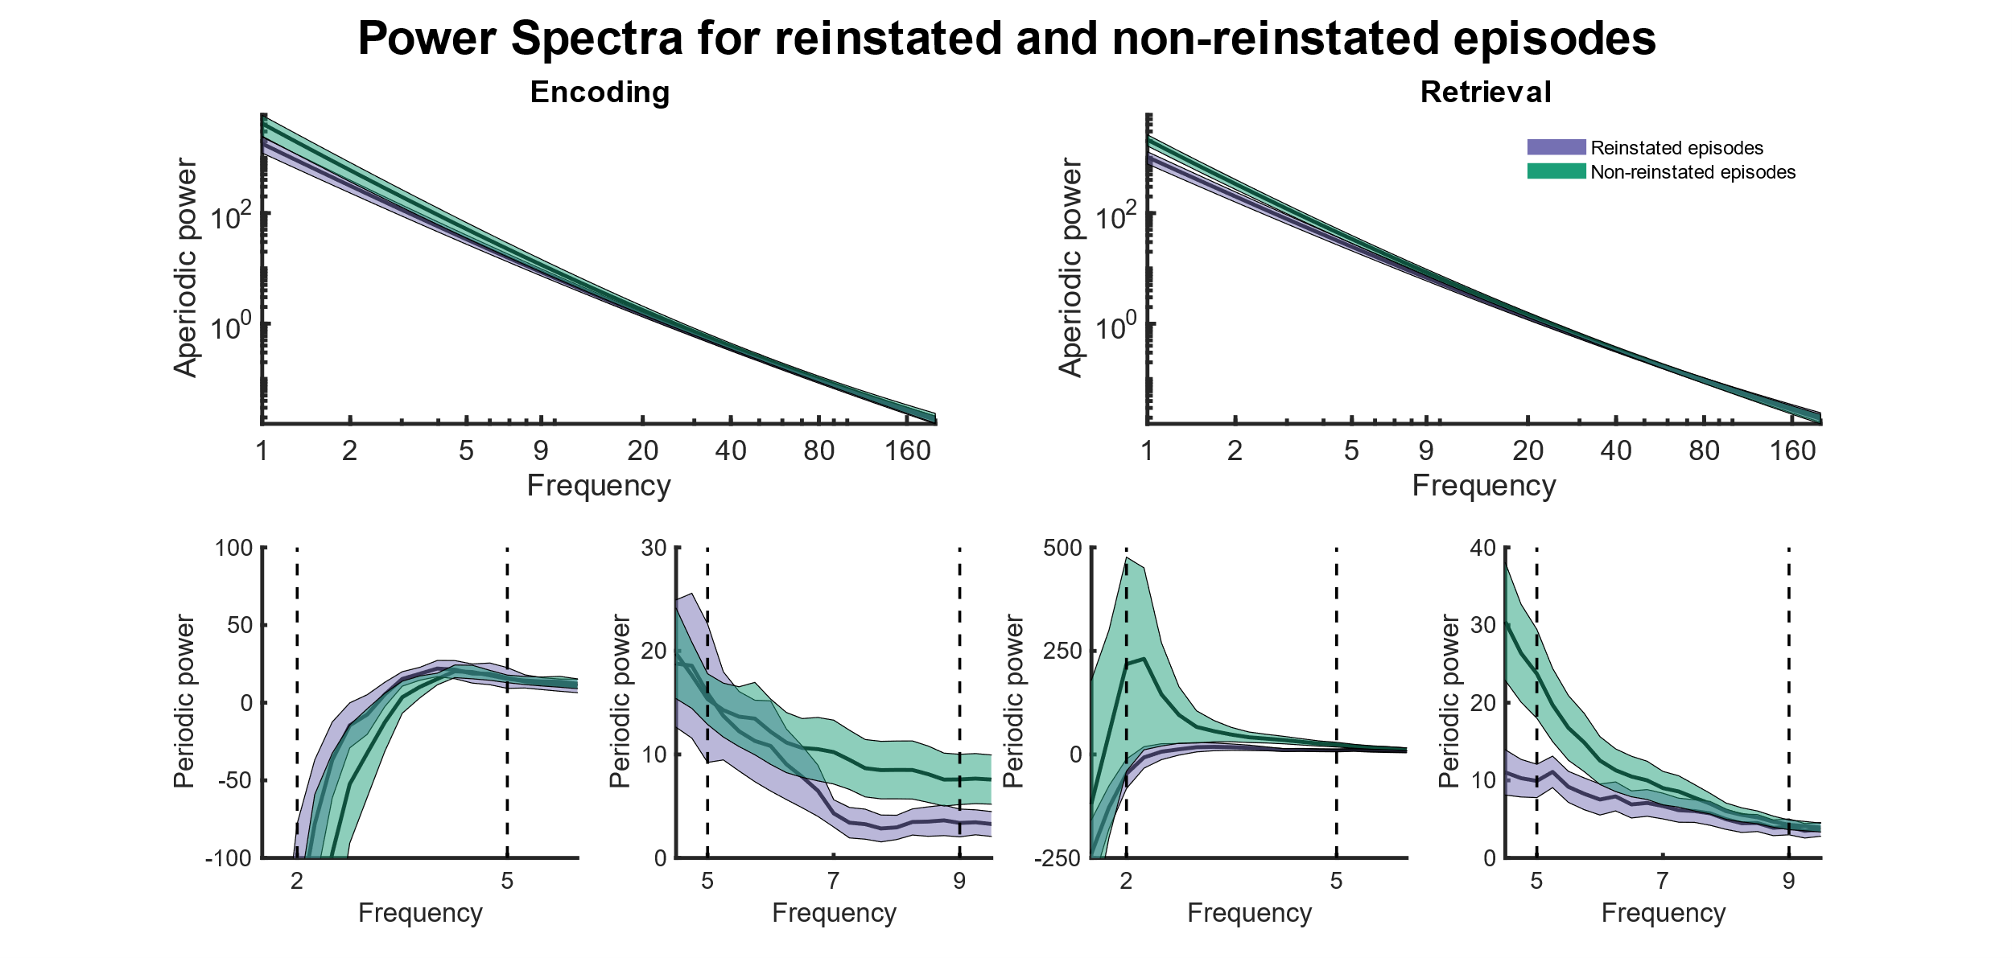

**Figure XX. title lorem ipsum (need to letterize subplots).** lorem ipsum some more descriptions. Need to shift lower figures to match encoding and retrieval above, so that its clear they belong together. Maybe add slow/fast theta as labels. Add that stuff is n.s.. Probably have to increase fontsize!! Add lines from oscillatory spectrum to 1/f spectrum? But that might be confusing because they only have the frequency range in common and the data is different. Add real 1/f in future? Function: powspctra_theta2 (you can load in the data and start with visualisation right away).

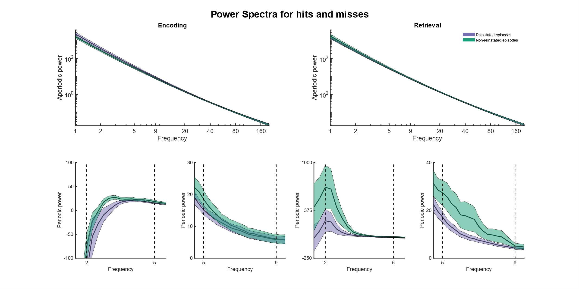

**Figure XX. Five second data snippet showing activity in the slow (2-5 Hz; A) and fast (5-9 Hz; B) components.** Components were generated by taking a weighted average of the narrowband signal of all microwires within a bundle. The weighted average was calculated using a generalized eigendecomposition of the broadband and narrowband covariance matrices.

Discussion

Episodic memories refer to distinctive events that occurred at a specific time and space. These memories are composed of multiple components. In Chapter 1 we identified the neural basis of how the hippocampus processes these episodic memories. These neurons (called Episode Specific Neurons; ESNs) increase their firing rate during encoding and retrieval of specific episodic memories. In the present chapter we extend these findings from single neurons to the population level by investigating the local field potential (LFP) as a proxy of multi unit activity.

We analysed two independent datasets that were collected using microelectrodes located in the human hippocampus while patients performed a memory association task.

A considerable body of literature exists that emphasizes the importance of theta oscillations for memory processing (xx). One influential theoretical model proposed that encoding and retrieval of memories occur in opposite phases of the theta oscillation thereby avoiding that encoding new information causes catastrophic interference of older memories (hasselmo, xx).

Recent studies have revealed that there is not one dominant theta frequency in the human hippocampus, but rather two distinct oscillations - a slow (2-5 Hz) and a fast (5-9 Hz) theta oscillation (xx). We investigated how the firing activity of different previously identified neuron types relates to the phase of the ongoing theta oscillations during memory encoding and retrieval. We distinguished between spikes from ESNs during reinstated (rESN), non-reinstated episodes (nESN) and spikes from other single neurons (SU). Although we found some rudimentary evidence that SU show a slow theta (2-5 Hz) phase preference during encoding and retrieval, this finding is not consistent across the two experiments. These unexpected results could be due to various reasons. Many of our recorded neurons may not have been involved in active memory processing and thus did not show any modulation induced by memory encoding and retrieval. However, this does not explain our null findings for rESN, which are, by definition, coding for that specific episode. In this case, our results may be attributed to an insufficient number of eligible neurons or the two seconds preceding the patient's response may be a suboptimal time window for investigating spike-field coupling. Moreover, we did not differentiate between interneurons and pyramidal neurons, which are known to fire at different theta phases thus introducing more variance (doi.org/10.1523/JNEUROSCI.19-01-00274.1999).

Most neurons seem to maintain a preferred theta phase between encoding and retrieval. It is tempting to suggest that there is no theta phase preference during encoding and retrieval and that across the population of physiologically differently excitable neurons the entire theta cycle is covered leading to a uniform phase histogram at encoding and retrieval.

However, we employed a frequentist approach when analyzing our data; thus, while we did not find compelling evidence to reject the null hypothesis (i.e., no theta phase difference between spikes at encoding and retrieval), this should not be interpreted as evidence for the null hypothesis (xx). To further investigate this, future studies should use a Bayesian framework and use a larger sample size.

To conclude the present chapter, contrary to our hypothesis, we did not find evidence of neural firing in specific phases during encoding and retrieval, or a phase difference between encoding and retrieval in two independent datasets.