Title: Absence of memory success induced theta oscillation increase and theta spike-field coupling in the human hippocampus during episodic memory processing

Abstract

Theta oscillations play a central role in memory processing. Recent findings point towards there being not one dominant theta frequency in the human hippocampus, but rather two: a slow theta (2-5 Hz) and a fast theta (5-9 Hz) oscillation.

Recent work has suggested that successful memory processing is reflected in a narrowband theta increase as well as a ‘tilt’ in the aperiodic power spectrum, where lower frequencies are diminished and higher frequencies increased. Furthermore, according to an influential theory memory encoding and retrieval occurs in opposite theta phases so newly encoded memories do not cause catastrophic interference with older memories.

We investigated these hypotheses in two independent samples of intracranial microwire recordings. Contrary to previously reported findings, our results provide inconclusive evidence regarding narrowband slow and fast theta power and an aperiodic tilt. Our research did not reveal consistent evidence of individual neurons or ESNs firing at a distinct theta phase during encoding and retrieval, nor was there a significant theta phase difference between neurons firing at encoding and retrieval.

Introduction

In the preceding chapters, we found evidence of an episode specific neurophysiological marker at both the single-neuron level and in the high frequency power of the microwire local field potential (LFP). Next we will explore another prominent frequency in the hippocampus: the theta frequency, and how it relates to single-neuron spiking.

Research in the role of theta oscillations on learning on memory go back to the late 70s (Winson, 1978, Berry and Thompson, 1978 xx). Winson (1978 xx) showed that lesioning the medium septum caused a reduced hippocampal theta rhythm along with an impaired spatial memory. In line with this, higher theta power in rabbits was associated with augmented learning (Berry and Thompson, 1978).

Since then, evidence regarding the role of theta oscillations in episodic memories has been contradictory. While most studies employing surface EEG report increases in theta power, most iEEG studies report a memory induced theta power decrease (Herweg et al., 2020). Herweg et al. (2020 xx) suggested that this might be because studies frequently contrast later remembered with later forgotten memories and therefore conflate domain-general cognitive processes, such as attention and perception, with memory-specific processes. Because domain-general cognitive processes are assumed to lead to a spectral tilt (i.e., less low frequency power and more high frequency power), a narrow band theta power increase induced by memory processing might be obscured. To ameliorate this shortcoming researcher should not contrast successful memory with unsuccessful memory but instead should compare strength of memory (e.g., retrieval confidence, amount of detail in contextual retrieval, retrieved spatial distance to encoded location in a navigational task).

Another reason how surface EEG might show a theta power increase, although the LFP shows a decrease is if theta over larger areas synchronizes but decreases in amplitude. The decrease is truthfully reflected in the LFP, but activity on the scalp is integrated over larger areas and thus more synchronous theta could lead to higher scalp theta power. Taken together these considerations imply theta activity as an integral part of memory processing and suggest that conflicting evidence arises due to different recording methods (EEG/iEEG), memory contrasts (success vs success or vs failure) and frequency ranges (broadband vs narrowband).

An increased narrowband theta activity is in line with the prediction from a computational model and theoretical considerations that theta synchronization in the hippocampus is necessary for memory processing (Parish et al., 2018, doi.org/10.1523/JNEUROSCI.2561-17.2018; Hanslmayr et al., 2016). More recent findings in humans demonstrated that behavioural response times in memory tasks are modulated by theta oscillations (ter Wal et al., 2021 nat coms xx) and that theta binds together the multiple elements within an episode (Griffiths 2021 xx) likely/arguably through long-term potentiation of synaptic connections (clouter xx, roux xx).

A central requirement of the hippocampus is the ability to encode new information without interfering with related previous experiences. Hasselmo and collegues developed a computational model that solves this conundrum by moving encoding and retrieval processes to opposing phases in the theta rhythm (xx, also hapiro turk browne botvinick norman 2017?). Empirical support for this 180° shift between memory encoding and retrieval has been recently found by Kerrén and collegues (Kerrén et al., 2018, current biology, xx; Kerrén et al., biorxiv xx).

The relation between single neuron firing and ongoing theta oscillation contains more information than the neural firing alone. Place cells in the hippocampus are neurons that code for specific spatial locations. As rodents move towards a location, a place cell fires at increasingly earlier phases of the ongoing theta oscillation. One can therefore decode the position of of the rodent in relation to a place by combining the theta phase and the neural firing (Josh 2007 paper??, o’keefe phase precession paper, huxter et al, 2003 <-xx). In humans a stronger spike-theta coupling (Rutishauser nature 2010 xx) as well as neurons locking to faster theta oscillations (Roux xx) predicts successful memory.

Importantly, recent findings suggest that there are two distinct theta rhythms governing the human hippocampus: a slow (2-5 Hz) and a fast (5-9 Hz) oscillation (xx).

We therefore hypothesized that (i) later remembered episodes show a shift in the aperiodic power spectrum and an accompanying increase in oscillatory fast and slow theta power in comparison to later forgotten episodes. (ii) We also expected this change in aperiodic and periodic activity to manifest when comparing episodes in which ESNs reinstate their firing rate (as described in Chapter 1) and episodes which are not reinstated. (iii) We hypothesized that neurons, particularly ESNs, fire at distinct slow and fast theta phases during the encoding and retrieval of episodic memories, and that there is a substantial phase offset between encoding and retrieval.

Materials and Methods

Procedure of memory experiment 1 and experiment 2

See above.

Participants

See above.

Ethical approval

See above.

Behavioural analysis

See Above.

Co-Registering

See Above.

Recording System and Electrodes

See above.

Statistical analysis

All statistical analyses were conducted using MATLAB R2020a on a computer running Windows 10 Enterprise. The significance threshold for all statistical tests was set at 0.05. Unless specified otherwise, all permutation tests were implemented with *N* = 1,000 random draws.

Identification of Episode Specific Neurons (ESNs)

See above.

Periodic and aperiodic theta analysis

To investigate periodic (i.e., oscillatory) and aperiodic activity (i.e., 1/f activity), we first downsampled the LFP in every microwire to 1000 Hz and bandpassed the signal using a fourth order Butterworth filter at 50 Hz ±1 Hz and harmonics up to 300 Hz. An episode was labelled as reinstated if any neuron on the respective microwire contained a single neuron that showed a significant firing increase during encoding and retrieval (i.e., an ESN; see Chapter 1). We defined the time of interest as the period two seconds prior to the response at memory encoding and retrieval. In experiment 1, an episode was considered correctly remembered if the patient correctly chose two out of two associate images and labelled as forgotten if the patient indicated they do not remember any associates or if they chose no correct associate.

For each episode, we extracted the periodic and aperiodic part of the signal using the FOOOF implementation (Donogue xx) in Fieldtrip (xx) in a frequency range from 1 Hz to 200 Hz. We analysed two contrasts of the periodic and aperidic activity: (i) reinstated episodes against non-reinstated episodes in microwires with ESNs, and (ii) correctly remembered episodes against forgotten episodes (excluding reinstated episodes).

For the periodic analysis, we averaged activity within the slow (2-5 Hz) and fast (5-9 Hz) theta bands and then conducted paired-sample t-tests to compare oscillatory activity between contrasts and one-sample t-tests to test for significant oscillatory activity. For the aperiodic analysis we performed paired-sample t-tests between contrasts, with the offset and tilt as dependent variables.

Theta components and pre-processing

As a first step, we downsampled the microwire signal to 100 Hz. Because we do not know the relative position of the recorded neurons to the microwires within a bundle of electrodes by extension we do not know if the microwire on which the neuron was recorded best represents the neural input into the neuron. For this reason, we took into consideration all eight microwires and generated two theta components using generalized eigendecomposition (xx).

The generalization of the eigendecomposition extends the eigendecomposition to a case with two square matrices. For an eigenvalue decomposition with a singular square matrix, the eigenvector with the highest eigenvalue accounts for the maximal variance in the underlying square matrix and is pairwise orthogonal to the other eigenvectors.

In contrast, the eigenvector with the highest eigenvalue in a generalized eigendecomposition can be understood as the filter that maximizes the difference between the two input matrices. The eigenvectors in a GED are independent, but not orthogonal. In practice when applied to two covariance matrices where one matrix represents the broadband activity and the other matrix is generated using a narrowband signal the first eigenvector yields a spatial weighting that maximizes the narrowband activity and minimizes the broadband activity. This eigenvector can be applied to the narrowband filtered multichannel data to generate a narrowband component (10.7554/eLife.21792 xx).

Based on previous literature (xx) we computed a slower theta component in the frequency range of 2 Hz to 5 Hz and a second, faster component in the range of 5 Hz and 9 Hz. To generate these components, we first applied a first order Butterworth filter to bandpass the broadband signal in all eight microwire channels between 2 Hz and 5 Hz (slow theta component) or 5 Hz and 9 Hz (fast theta component). We then demeaned the signal and computed a covariance matrix using this narrowband signal, which we divided by the number of samples. Next, we computed a second covariance matrix using the entire broadband signal. We computed the generalized eigendecomposition of these two covariance matrices and used the eigenvector with the highest eigenvalue as a spatial filter for the narrowband filtered signal to generate a narrowband component. We then applied the Hilbert transform to the narrowband component to get the analytic signal.

Spike-field coupling to slow and fast theta

We considered the spikes of neurons up to two seconds preceding the patient’s response during the encoding and retrieval of later remembered episodes. Each neuron had to contain at least 11 spikes within the time of interest to be included for further analysis. We confined all spike-field analyses to spikes and LFPs that were recorded on the same Behnke-Fried electrode.

We first wanted to estimate phase preference during encoding and retrieval independently. To do this we identified the complex value at the time of each spike. We subsequently normalized each complex value and averaged across spikes. For each neuron with spikes within the time of interest we computed the preferred phase by computing the angle of this average complex number. To estimate phase preference across neurons we performed a Rayleigh test.

We next investigated whether there was a significant difference in the phase of the narrowband signal between spikes during encoding and retrieval for (i) Episode Specific Neurons in trials that were later reinstated (rESN), (ii) for Episode Specific neurons in trials that were later not reinstated (nESN) and (iii) all other neurons (SU). To this end, we computed the cosine similarity between the complex value of each spike at encoding with the complex value of each spike at retrieval. We then averaged these similarity values across spikes for each eligible neuron. We determined the statistical significance of these difference scores using a one sample test for a mean angle of 0°, which we implemented using the function *circ_mtest* from the Circular Statistics Toolbox v1.21.0.0).

However, if only few neurons are sensitive to the ongoing theta phase an encoding-retrieval phase offset in this small number might be overshadowed by other neurons whose activity is not theta modulated. To address this, we repeated the above phase difference analysis using only neurons whose spikes showed a significant coupling to the theta phase at encoding and retrieval, as evidenced by a Rayleigh test. We proceeded with this analysis only if we there were at least 11 eligible neurons.

Results

We studied recordings from two different experiments (experiment 1: 585 neurons and 1011 microwires in the hippocampus, 16 participants, 7 female; average age = 36.13 years, from 26-53 years; experiment 2: 216 neurons and 339 microwires in the hippocampus, 14 participants, 7 female; average age = 33.86 years, from 19-58 years). Patients were implanted with stereotactic Behnke-Fried depth electrodes while completing a memory association task (see xx). During the encoding phase of experiment 1 patients were instructed to mentally create a vivid story consisting of an animal cue and two associate images (two faces, two places, or a face and a place). There was only one associate image in experiment 2 and cue and associate could be either a face, a place, or an animal. Following a short distractor task where patients had to indicate whether a series of 15 numbers were odd or even the retrieval phase begun. During the retrieval phase the cue image was presented and the patient had to recall the associate image(s). Each episode was learned and retrieved only once, and the experiment was self-paced.

Periodic and aperiodic theta activity during correctly remembered and forgotten episodes

The power spectrum can be separated into periodic and aperiodic components. The periodic components reflect true oscillations, while the aperiodic component is also referred to as 1/f and is assumed to reflect general excitability (xx). We separated periodic and aperiodic components in the microwire LFP using the FOOOF (xx) implementation available in FieldTrip (xx) over a range of 1 Hz to 200 Hz and contrasted activity of later remembered with later forgotten episodes during encoding and retrieval. We found no significant differences in the aperiodic offset during encoding in experiment 1 (all *p* > 0.54) or experiment 2 (all *p* > 0.55). However, during retrieval there was a significantly larger offset and steepness in the aperiodic signal for later forgotten episodes in both experiment 1 (offset: *toffset* (341) = 3.13, *meanremembered* = 2.23 (*s.e.* = 0.047), *meanforgotten* = 2.25 (*s.e.* = 0.050), *poffset* = 0.002; steepness: *ttilt*(341) = 3.36, *meanremembered* = 1.83 (*s.e.* = 0.020), *meanforgotten* = 1.84 (*s.e.* = 0.021), *ptilt* < 0.001) and experiment 2 (offset. *Toffset* (114) = 3.00, *meanremembered* = 2.04 (*s.e.* = 0.084), *meanforgotten* = 2.08 (*s.e.* = 0.088), *poffset* = 0.0034; steepness: *ttilt*(114) = 3.37, *meanremembered* = 1.59 (0.038), *meanforgotten* = 1.61 (*s.e.* = 0.039), *ptilt*= 0.001). We next compared the periodic theta activity between remembered and forgotten episodes. In experiment 1, there was no difference in oscillatory slow or fast theta activity between the types of episodes during either encoding or retrieval (all p > 0.059). However, in experiment 2 a difference in periodic fast theta activity during encoding emerged (*t*(114) = 2.6813, *p* = 0.0084; all other *p* > 0.065) where later forgotten episodes showed an increase in periodic power (*meanremembered* = 14.7522 (*s.e.* = 2.082); *meanforgotten* = 18.4177 (*s.e.* = 2.9803).

We found consistent evidence across experiments and experiment phase (i.e., encoding/retrieval) for periodic fast theta activity in remembered and forgotten episodes (all *p* < 0.001; see Table xx). In both experiments, forgotten trials contained significant slow theta activity during retrieval (*p* < 0.009) but not encoding (*p* > 0.07).

Remembered episodes showed slow theta activity inconsistently across experiments. There was significant periodic activity during encoding and retrieval in experiment 2 (*p* < 0.001), but not experiment 1 (*pencoding* = 0.6 and *pretrieval* = 0.025).

To conclude, we observed an increased aperiodic offset and steepness during retrieval, but not encoding, for later forgotten episodes compared to later remembered episodes. There was no coherent difference in periodic slow or fast theta power between forgotten and remembered episodes across experiments. We found reliable evidence for fast theta oscillations, whereas slow theta oscillations showed less clear results.

Periodic and aperiodic theta activity during reinstated and non-reinstated episodes

We next contrasted periodic and aperiodic activity of reinstated against non-reinstated episodes on microwires that contained ESNs. We found no significant difference in the offset or steepness of the aperiodic component during encoding or retrieval in Experiment 1 (all *p* > 0.3) or experiment 2 (all p > 0.5).

Next, we contrasted oscillatory activity in the slow and fast theta range between reinstated and non-reinstated episodes but found no significant differences during either encoding or retrieval in experiment 1 (all *p* > 0.16) or experiment 2 (all *p* > 0.09). We found evidence for fast theta oscillations in reinstated and non-reinstated episodes during encoding and retrieval across both experiments (p < 0.001; see Table xx). There was no reliable pattern of slow theta oscillations across experiments when contrasting reinstated and non-reinstated episodes (see Table xx).

To conclude, despite finding evidence for the existence of theta oscillations, we did not find evidence for a difference in oscillatory power between reinstated and non-reinstated trials during encoding or retrieval. Likewise, there was no difference in aperiodic offset or steepness between later reinstated trials and non-reinstated trials during encoding or retrieval.

Single neuron firing to specific theta phases during memory encoding and retrieval

We next investigated whether single neuron firing would preferably occur within a specific theta phase during encoding and retrieval of episodic memories and whether there was a neuron specific phase offset between firing during the encoding and retrieval phases.

Based on previous literature no single theta frequency dominates the human hippocampus. Instead, there is a lower theta oscillation (2-5 Hz) and a faster theta oscillation (5-9 Hz) (10.1038/s41467-020-15670-6; 10.1523/JNEUROSCI.0767-20.2020).

We do not know which microwire best represents the dendritic input into a single neuron, so we computed theta components using a weighted average of all microwires within a microwire bundle. This was based on the generalized eigendecomposition of the narrowband theta covariance matrix and the broadband covariance matrix (see Methods). We distinguished three different categories of activity: spikes of ESN that occurred during reinstated trials (rESN), spikes of ESN during non-reinstated trials (nESN), and spikes of single units (SU). After excluding neurons with an insufficient number of spikes these analyses were based on nrESN = 36, nnESN = 116, and nSU = 380 neurons in experiment 1 and nrESN = 13, nnESN = 34, and nSU = 136 neurons in experiment 2. We first computed the preferred mean phase during encoding and retrieval for each neuron. In order to determine a general phase preference, we pooled this preferred phase value over all neurons within a category of neurons (rESN, nESN, SU) and used a Rayleigh test to determine statistical significant deviations from a uniform phase distribution. In experiment 1, only the SU category showed a phase preference for the slow theta component during encoding (θ = 197.5°, *p* = 0.048) and retrieval (θ = 181.9°, *p* = 0.004). After adjusting for multiple comparisons for two tests (slow and fast theta) SU only showed a slow theta phase preference during retrieval (*pencoding adj.* = 0.096; *pretrieval adj.* = 0.008; Bonferroni corrected). Neither rESN nor nESN showed any slow or fast theta phase preference during encoding or retrieval (all *p* > 0.28).

In experiment 2 the SU category showed a phase preference in the slow theta component during encoding (θ = 287.2°, *p* = 0.002; retrieval *p* = 0.633; all other *p* > 0.10). There was a statistically significant phase preference of rESN for the slow theta component during retrieval (θ = 201.3°, *p* = 0.048), however, after controlling for multiple comparisons (slow and fast theta), the effect was no longer significant (*padj.* = 0.096).

It is possible that despite an absence of phase preference during encoding or retrieval, neurons show a reliable offset between encoding and retrieval (a representative example of a 10° offset with four neurons: encoding: 0°, 90°, 180°, 270°; retrieval: 10°, 100°, 190°, 280°). To determine if there was a significant theta phase difference between neurons firing at encoding and at retrieval, we computed the mean cosine similarity of the complex value for each neuron for all spikes during encoding with all spikes during retrieval. We determined the statistical significance of the encoding-retrieval phase offset separately for each neuron type (rESN, nESN, SU) using a one-sample test with a mean angle of 0° (i.e., no phase difference between encoding and retrieval). This one-sample test is the circular equivalent of a one-sample t-test with continuous data (we used the function *circ_mtest* from the Circular Statistics Toolbox v1.21.0.0). In experiment 1 this approach yielded no significant encoding-retrieval phase differences for any category of neurons (rESN, nESN, SU) or theta components (slow, fast) (all *p* > 0.26). Likewise, no encoding-retrieval phase differences were found in experiment 2 (all *p* > 0.4).

It is conceivable that theta activity modulates only some neurons. In this case a small proportion of theta-sensitive neurons might show a consistent phase difference between their firing at encoding and retrieval, but due to their small number this effect might be obscured. To circumvent this, we repeated the above phase difference analysis for neurons whose firing rate showed a phase coupling at encoding and retrieval using a Rayleigh test. Using this approach, we identified a significant phase offset between SU firing at encoding and retrieval in experiment 1 (θ = 14°, *puncorrected* = 0.048) that was no longer significant after correcting for multiple comparisons (*pcorrected* = 0.096; experiment 1 all other *p* > 0.39; experiment 2 all *p* > 0.435).

To conclude, we found a slow theta phase preference for SU during encoding in experiment 2 and retrieval in experiment 1. However, no neuron type (rESN, nESN, SU) showed a significant encoding-retrieval theta phase offset, which was also the case when limiting the theta phase offset analysis to neurons that showed a significant phase coupling at encoding and retrieval.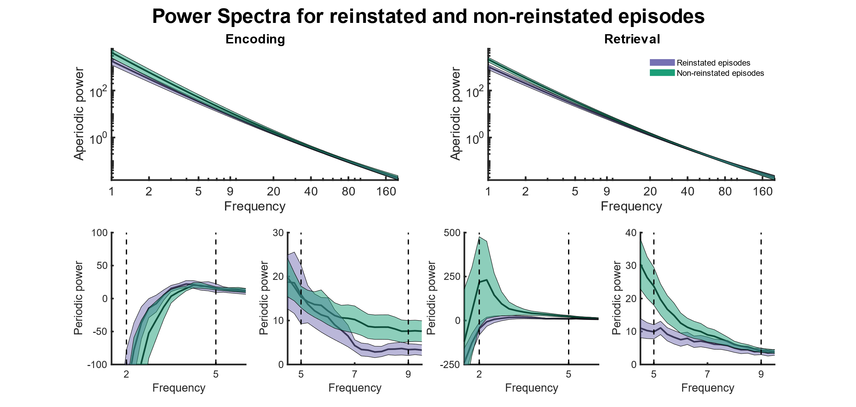

**Figure XX. Aperiodic and oscillatory fast and slow theta activity during encoding and retrieval of reinstated (purple) and non-reinstated (green) episodes. Shaded areas represented the SEM.**

(A) Aperiodic power during encoding. Both axes are log-scaled. The x-axis shows frequencies from 1 to 200 Hz. The y-axis depicts the power at the respective frequency.

(B) Same as (A) but for retrieval

(C) Oscillatory activity in the slow theta range (2 Hz and 5 Hz) at encoding

(D) Oscillatory activity in the fast theta range (5 Hz and 9 Hz) at encoding

(E-F) Same as (C-D) but for retrieval.

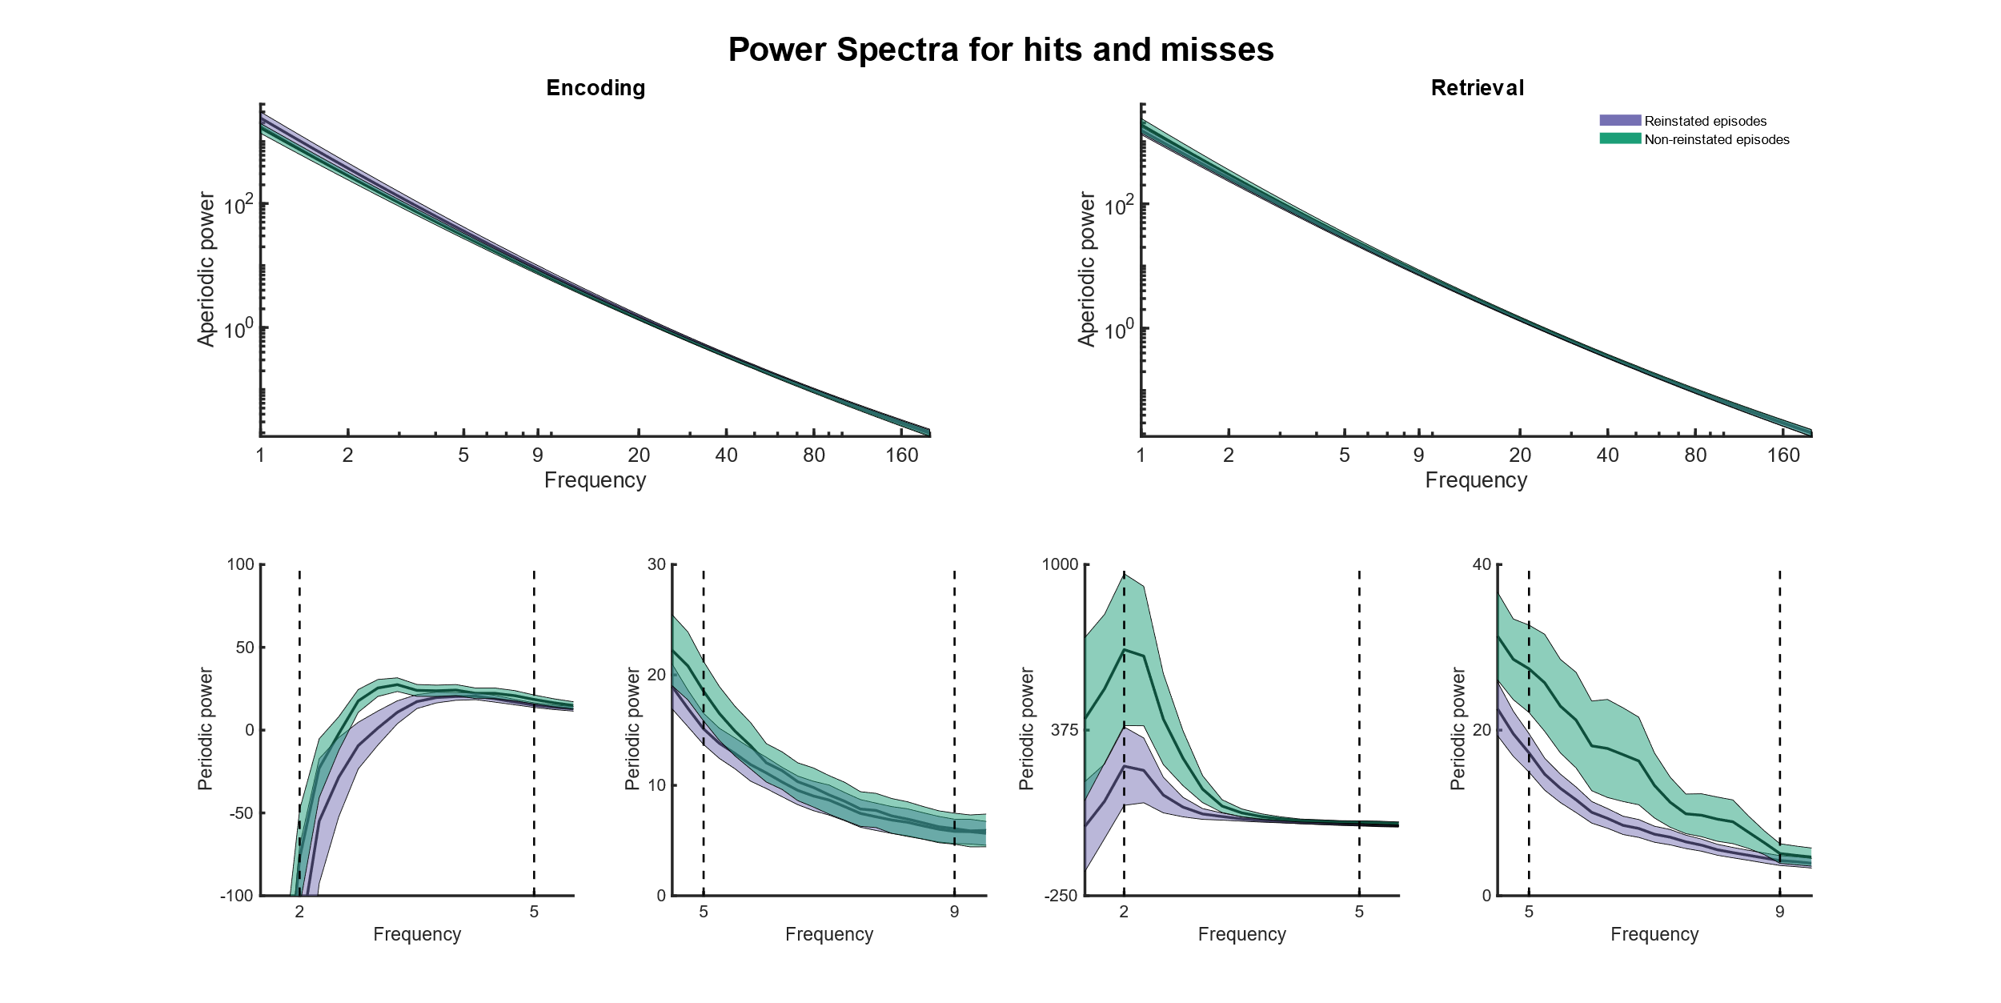

**Figure XX. Aperiodic and oscillatory fast and slow theta activity during encoding and retrieval of remembered (purple) and forgotten (green) episodes. Shaded areas represented the SEM.**

(A) Aperiodic power during encoding. Both axes are log-scaled. The x-axis shows frequencies from 1 to 200 Hz. The y-axis depicts the power at the respective frequency.

(B) Same as (A) but for retrieval

(C) Oscillatory activity in the slow theta range (2 Hz and 5 Hz) at encoding

(D) Oscillatory activity in the fast theta range (5 Hz and 9 Hz) at encoding

(E-F) Same as (C-D) but for retrieval.

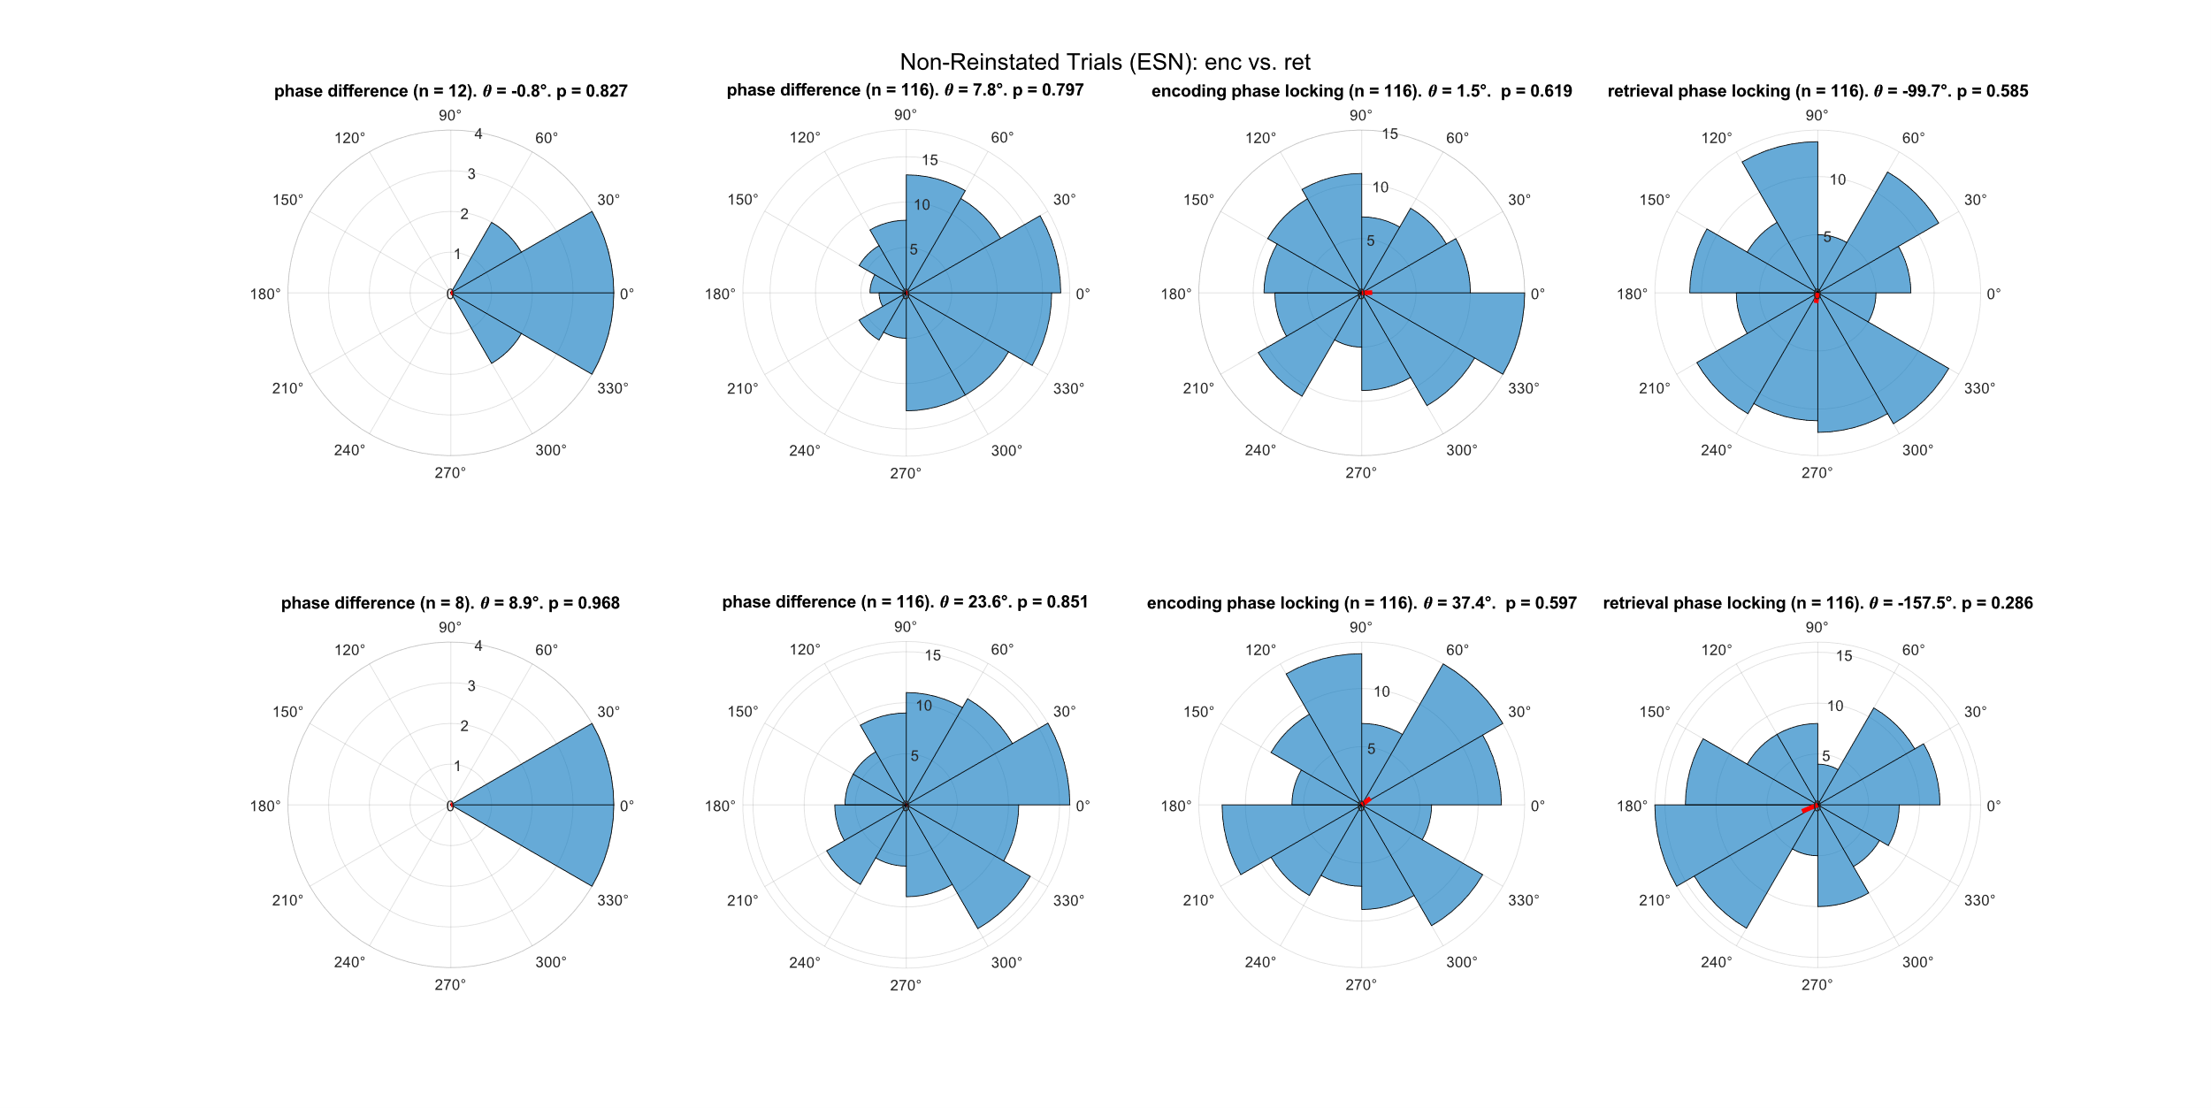**Figure XX. Polar histogram showing the phase offset between encoding and retrieval and the phase distribution during encoding and retrieval in ESNs during non-reinstated episodes.**

(A) Phase offset between encoding and retrieval in neurons that showed a significant theta coupling at encoding and at retrieval for slow theta (2 Hz – 5 Hz)

(B) Phase offset between encoding and retrieval across all neurons for slow theta (2 Hz – 5 Hz)

(C) Preferred phase during encoding across all neurons for slow theta (2 Hz – 5 Hz)

(D) Preferred phase during retrieval across all neurons for slow theta (2 Hz – 5 Hz)

(E-H) Same as (A-D) but for fast theta (5 Hz – 9 Hz)

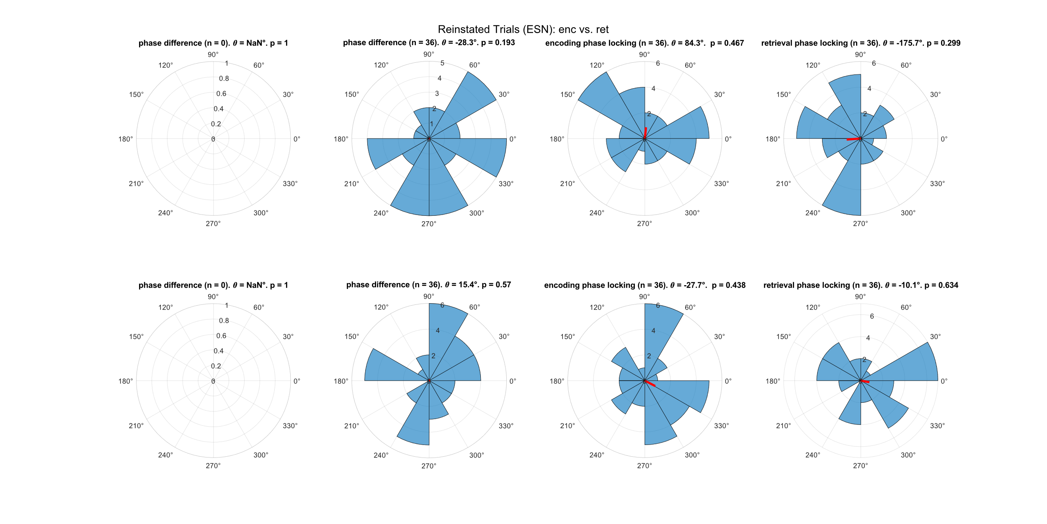 **Figure XX. Polar histogram showing the phase offset between encoding and retrieval and the phase distribution during encoding and retrieval in ESNs during reinstated episodes.**

(A) Phase offset between encoding and retrieval in neurons that showed a significant theta coupling at encoding and at retrieval for slow theta (2 Hz – 5 Hz)

(B) Phase offset between encoding and retrieval across all neurons for slow theta (2 Hz – 5 Hz)

(C) Preferred phase during encoding across all neurons for slow theta (2 Hz – 5 Hz)

(D) Preferred phase during retrieval across all neurons for slow theta (2 Hz – 5 Hz)

(E-H) Same as (A-D) but for fast theta (5 Hz – 9 Hz)

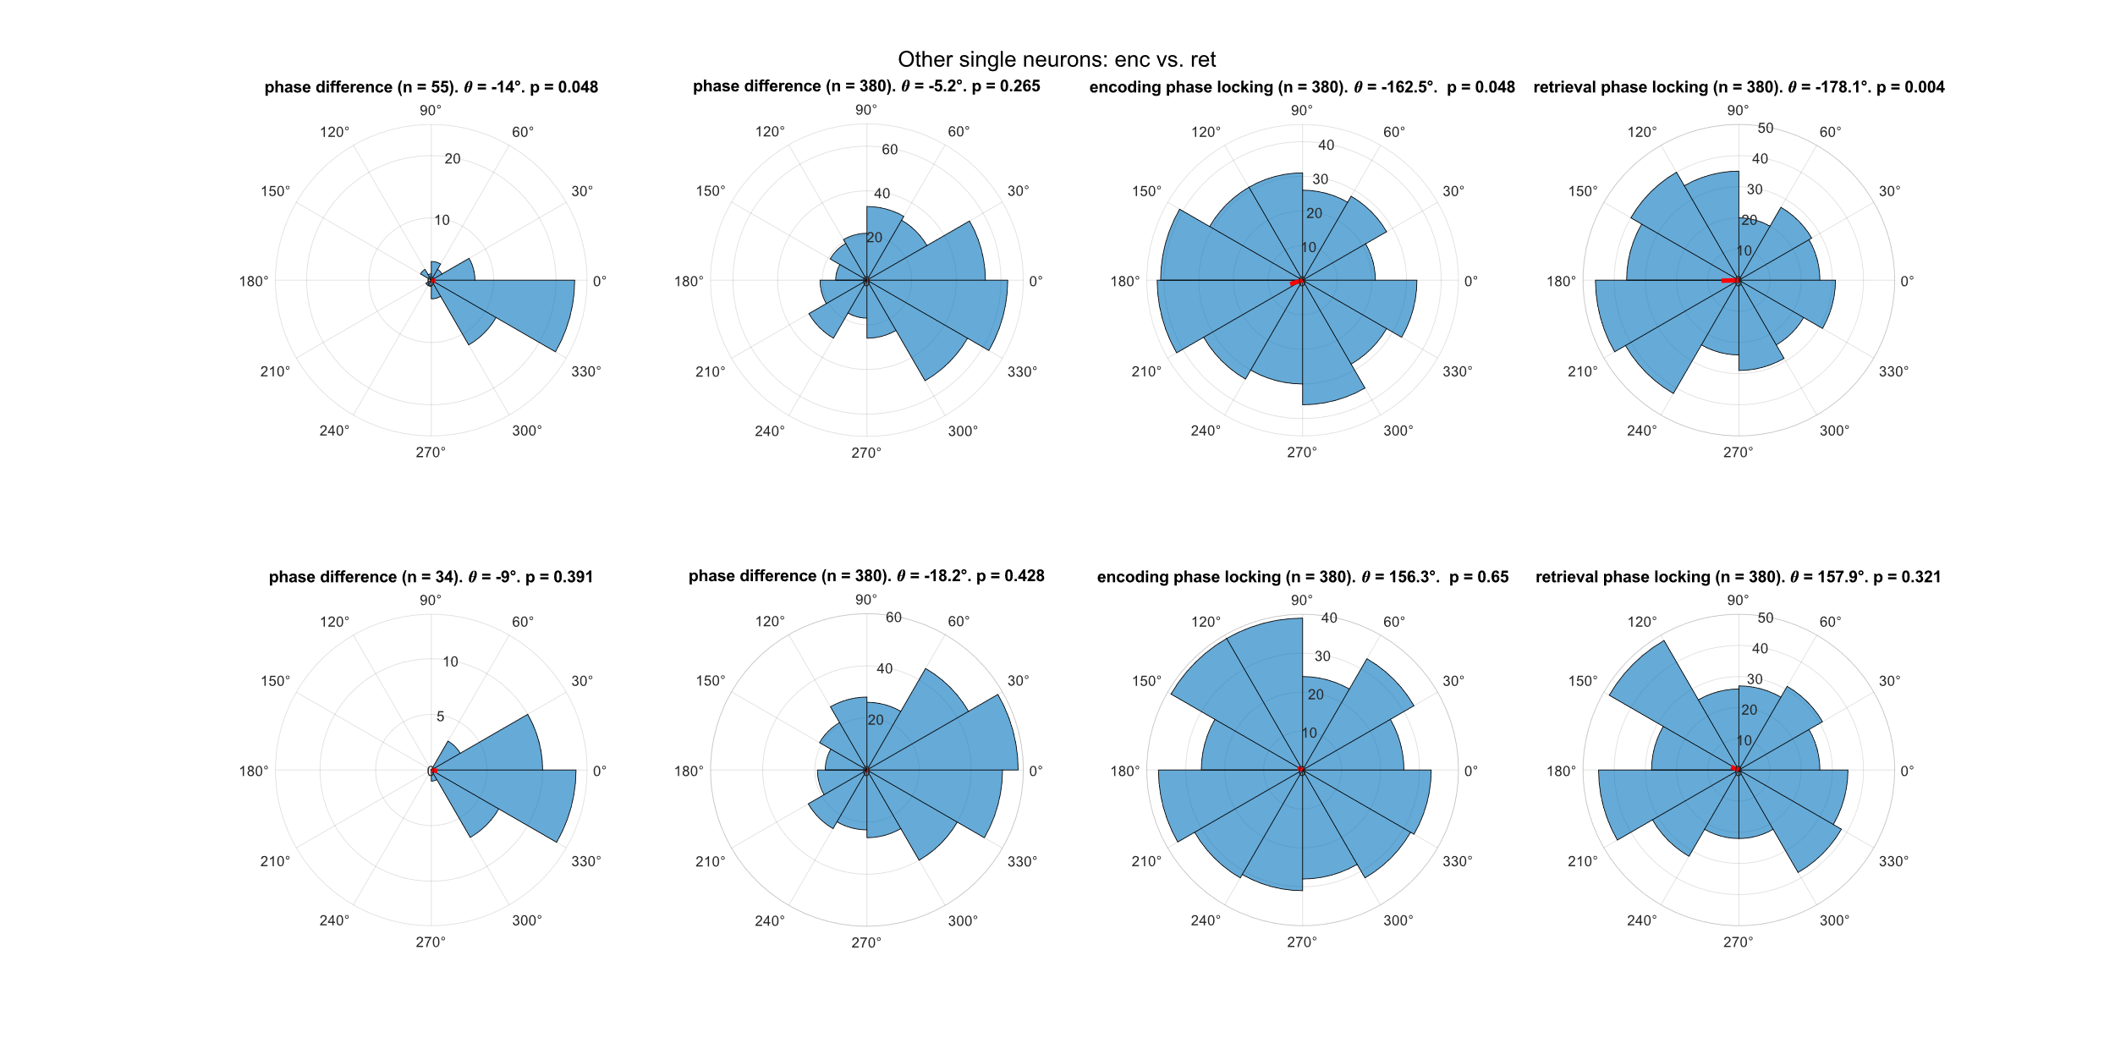

**Figure XX. Polar histogram showing the phase offset between encoding and retrieval and the phase distribution during encoding and retrieval in SU.**

(A) Phase offset between encoding and retrieval in neurons that showed a significant theta coupling at encoding and at retrieval for slow theta (2 Hz – 5 Hz)

(B) Phase offset between encoding and retrieval across all neurons for slow theta (2 Hz – 5 Hz)

(C) Preferred phase during encoding across all neurons for slow theta (2 Hz – 5 Hz)

(D) Preferred phase during retrieval across all neurons for slow theta (2 Hz – 5 Hz)

(E-H) Same as (A-D) but for fast theta (5 Hz – 9 Hz)

**Figure XX. Five second data snippet showing activity in the slow (2-5 Hz; A) and fast (5-9 Hz; B) components.** Components were generated by taking a weighted average of the narrowband signal of all microwires within a bundle. The weighted average was calculated using a generalized eigendecomposition of the broadband and narrowband covariance matrices.

|  |  |  |  |  |  |
| --- | --- | --- | --- | --- | --- |
|  | Contrast | Remembered vs. forgotten episodes | | | |
| Phase | Encoding (exp 1) | Encoding (exp 2) | Retrieval (exp 1) | Retrieval (exp 2) |
| Slow theta | Remembered episodes | p = 0.603 | p < 0.001  t(114) = 6.79 | p = 0.025 | p < 0.001  t(114) = 9.13 |
| Forgotten episodes | p = 0.076 | p = 0.113 | p = 0.009  t(341) = 2.61 | p < 0.001  t(114) = 5.38 |
| Fast theta | Remembered episodes | p < 0.001  t(365) = 7.41 | p < 0.001  t(114) = 7.09 | p = < 0.001  t(365) = 8.19 | p < 0.001  t(114) = 6.61 |
| Forgotten episodes | p < 0.001  t(341) = 6.05 | p < 0.001  t(114) = 6.18 | p < 0.001  t(341) = 3.76 | p < 0.001  t(114) = 6.51 |

**Table xx. Overview of evidence for periodic fast and slow theta activity during encoding and retrieval of (later) remembered and (later) forgotten episodes in experiment 1 and experiment 2.**

|  |  |  |  |  |  |
| --- | --- | --- | --- | --- | --- |
|  | Contrast | Reinstated vs. non-reinstated episodes | | | |
| Phase | Encoding (exp 1) | Encoding (exp 2) | Retrieval  (exp 1) | Retrieval  (exp 2) |
| Slow theta | Reinstated episodes | p = 0.318 | p = 0.003  t(32) = 3.16 | p = 0.495 | p < 0.001  t(32) = 3.81 |
| Non-reinstated episodes | p = 0.196 | p < 0.001  t(32) = 5.00 | p = 0.1814 | p < 0.001  t(32) = 3.48 |
| Fast theta | Reinstated episodes | p < 0.001  t(122) = 3.42 | p < 0.001  t(32) = 3.75 | p < 0.001  t(122) = 4.65 | p = 0.007  t(32) = 2.86 |
| Non-reinstated episodes | p < 0.001  t(122) = 3.82 | p < 0.001  t(32) = 3.92 | p < 0.001  t(122) = 4.52 | p = 0.002  t(32) = 3.48 |

**Table xx. Overview of evidence for periodic fast and slow theta activity during encoding and retrieval of (later) reinstated or (later) non-reinstated episodes in experiment 1 and experiment 2.**

Discussion

Episodic memories consist of various multimodal elements and are embedded in a distinct temporal and spatial context (xx).

The neurophysiological markers of episodic memory processing are still subject to debate, but a considerable body of literature exists that emphasizes the importance of theta oscillations for memory processing (xx).

We analysed the activity of single neurons relative to the ongoing theta activity in two independent intracranially recorded datasets that were collected using microelectrodes located in the human hippocampus while patients performed a memory association task.

In a recent review Herweg and colleagues (Herweg et al., 2020) suggested that memory processing is reflected in a steeper aperiodic component and an increase in periodic theta activity. Furthermore, studies have revealed that there is not one dominant theta frequency in the human hippocampus, but rather two distinct oscillations – a slow (2-5 Hz) and a fast (5-9 Hz) theta oscillation (xx).

We first compared the aperiodic and periodic slow and fast theta components between remembered and forgotten episodes. In a second analysis we repeated the analysis but contrasted episodes during which the neural firing rate of ESNs is reinstated with episodes without neural firing reinstatement.

In line with the hypothesis proposed by Herweg and colleagues (Herweg et al., 2020) we found a higher offset and 1/f tilt during retrieval of forgotten episodes. However, this aperiodic difference was absent during memory encoding, and we found no aperiodic differences between reinstated and non-reinstated episodes. We did not find any consistent differences in oscillatory slow and fast theta power for remembered vs. forgotten episodes or reinstated vs. non-reinstated episodes. We found periodic theta activity in both contrasts and during encoding and retrieval, although this evidence was more reliable in the fast theta band.

To conclude, evidence regarding the offset and steepness of the aperiodic component was inconclusive and we found no evidence of periodic theta power being involved in memory processing.

There were no significant periodic or aperiodic differences between two categories of successful memory events (i.e., between reinstated and non-reinstated episodes). One possible reason may be that each successfully encoded memory is represented by an assembly of ESNs. As we recorded only from a small subgroup of the ones close to the microwires, the non-reinstated episodes would only differ insofar as we would not record their respective ESNs, because the LFP reflects a larger area than the area in which spikes are recorded.

However, there is a deeper problem with the argument presented by Herweg and colleagues (Herweg et al., 2020). They recommend contrasting the strength of two successful memories (e.g., how many contextual details are remembered when retrieving an episode). The idea behind that is that in both cases domain-general processes, reflected in the steepness of the aperiodic component, would be present and any differences would be driven by the memory strength. The problem with this is that it implicitly assumes that processes like task engagement, effort, perception and attention are binary. However, a more vividly remembered episode might have a shallower aperiodic component because the patient has paid more attention during the episode and not because of memory processing.

It should be noted that methods to separate periodic and aperiodic activity are far from perfect. Especially the large negative deflection in periodic activity e.g., at around 2 Hz in Figure xx C casts doubt on the validity of the aperiodic power estimation. Thus, oscillatory activity at the faster theta range may not reflect true periodicity but instead a poor 1/f fit. One might then argue that the lack of a consistent theta phase preference and no encoding-retrieval phase offset might be due to the absence of substantial periodic theta power in microwires. It is possible that macrowires instead integrate over larger areas and show more robust periodic theta activity (unless a bipolar reference is used; see Herweg et al., 2020). However, previous studies have shown spike-field-coupling in the theta range using microwires (Jacobs et al., 2007), and spikes can couple to the phase of aperiodic components (Bush & Burgess, 2020).

One influential theoretical model proposed that encoding and retrieval of memories occur in opposite phases of the theta oscillation thereby avoiding that encoding new information causes catastrophic interference of older memories (Hasselmo et al., xx).

We investigated how the firing activity of different previously identified neuron types relates to the phase of the ongoing theta oscillations during memory encoding and retrieval. We distinguished between spikes from ESNs during reinstated (rESN), non-reinstated episodes (nESN) and spikes from other single neurons (SU).

Although we found some rudimentary evidence that SU show a slow theta (2-5 Hz) phase preference during encoding and retrieval, this finding was not consistent across the two experiments. Apart from that we did not detect any significant encoding or retrieval theta phase preference for neural firing across experiments. We also found no significant encoding-retrieval phase offset across all neurons, nor when limiting our analysis to neurons that showed significant theta phase coupling during encoding and retrieval.

These unexpected results could be due to various reasons. Many of our recorded neurons may not have been involved in active memory processing and thus did not show any modulation induced by memory encoding and retrieval. However, this does not explain our null findings for rESN, which are, by definition, coding for that specific episode. In this case, our results may be attributed to an insufficient number of eligible neurons or the two seconds preceding the patient’s response may be a suboptimal time window for investigating spike-field coupling. Moreover, we did not differentiate between interneurons and pyramidal neurons, which are known to fire at different theta phases thus introducing more variance (doi.org/10.1523/JNEUROSCI.19-01-00274.1999).

Most neurons seem to maintain a preferred theta phase between encoding and retrieval. It is tempting to suggest that there is no theta phase preference during encoding and retrieval and that across the population of physiologically differently excitable neurons the entire theta cycle is covered leading to a uniform phase histogram at encoding and retrieval.

However, we employed a frequentist approach when analyzing our data; thus, while we did not find compelling evidence to reject the null hypothesis (i.e., no theta phase difference between spikes at encoding and retrieval), this should not be interpreted as evidence for the null hypothesis (xx). To further investigate this, future studies should use a Bayesian framework and use a larger sample size.

To conclude the present chapter, in line with our hypothesis we find that forgotten when compared to remembered episodes have a higher aperiodic offset and a steeper gradient. Contrary to our hypotheses, we found no such pattern during memory encoding and no periodic theta increase for correctly remembered episodes. Likewise, we did not find evidence of neural firing in specific phases during encoding and retrieval, or a phase difference between encoding and retrieval in two independent datasets.