In the following the definitions are:
Rsdft = SDFT with resonator branch
Mrsdft = SDFT with modulator branch
rsdft_dc = SDFT with resonator branch but in the error estimation is considered only the DC component

27/10/2026
21:51 Debug run to check twiddle factors: for rsdft and rsdft_dc the abs(twiddle) > 1, to be sure the twiddle factor remains inside the unitary circle is choosen r=0.999 (the twiddle calculation is the same for both).
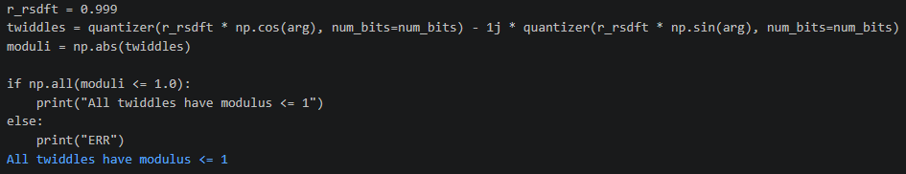
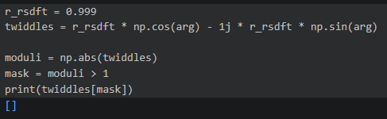
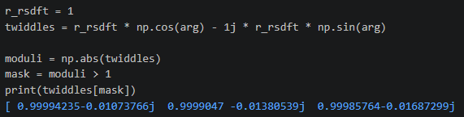
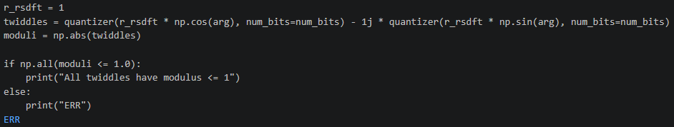

Msdft ideal and msdft_dc ideal respect the unitary circumference, but not the quantized versions. In the picture: 1 referes to quantized, 2 to ideal. The lists under test are made appending twiddles at every cycle
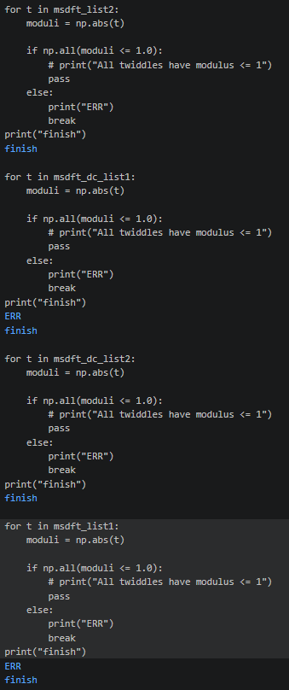

Choosing r = 0.999 for msdft and msdft_dc the absoulute values respects the unitary circle:
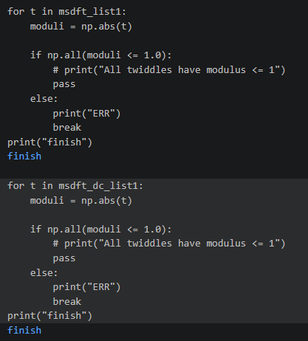

24/10/2026
23:17 r = 0.99 for rsdft and rsdft_dc and r = 0.999 for msdft and msdft_dc. In the picture below are shown resonance frequencies due (i think) to the quantizer at 8 bit only.
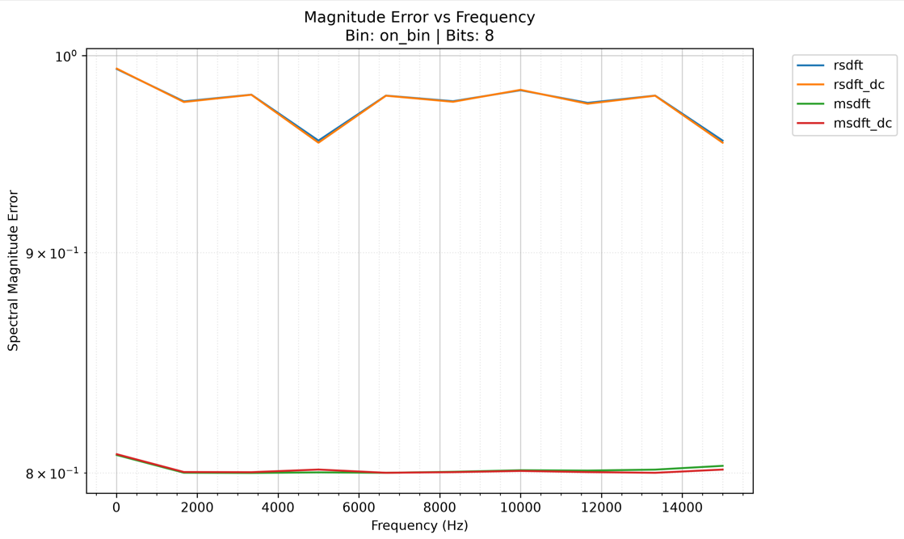
21:36 possible solution choose r = 0.999 for msdft and msdft_dc
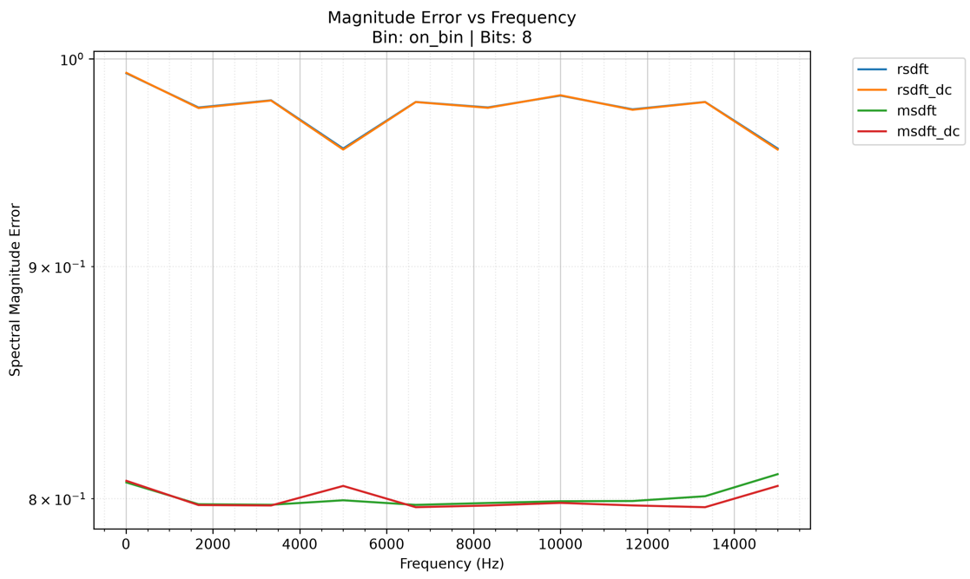
It seems there is a resonance around 5kHz and 15kHz in both algorithms
21:23 New problem with msdft_dc:
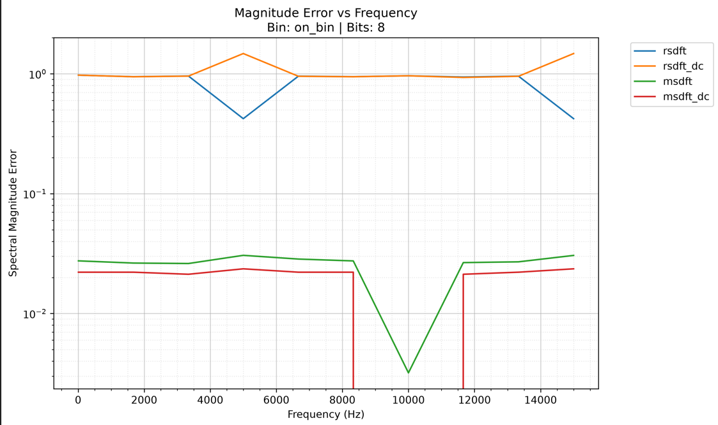
It seems a resonation point, maybe is given by r = 1 for both msdft and msdft_dc

19:30 finished to modify summary plots and fixed some errors in the code (abs(spectr_fft) before the complex error calculation).
2 types of results:
- images_rsdft_r1: here results are calculated considering r = 1 w.r.t. Rsdft and rsdft_dc
- images_rsdft_r995: r = 0.995 for both rsdft and rsdft_dc

18/10/2026
17:00 Added msdft_dc
12:15 Removing r = 0.999 from msdft the precision is even higher
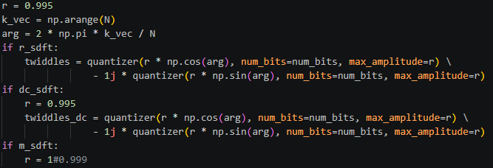
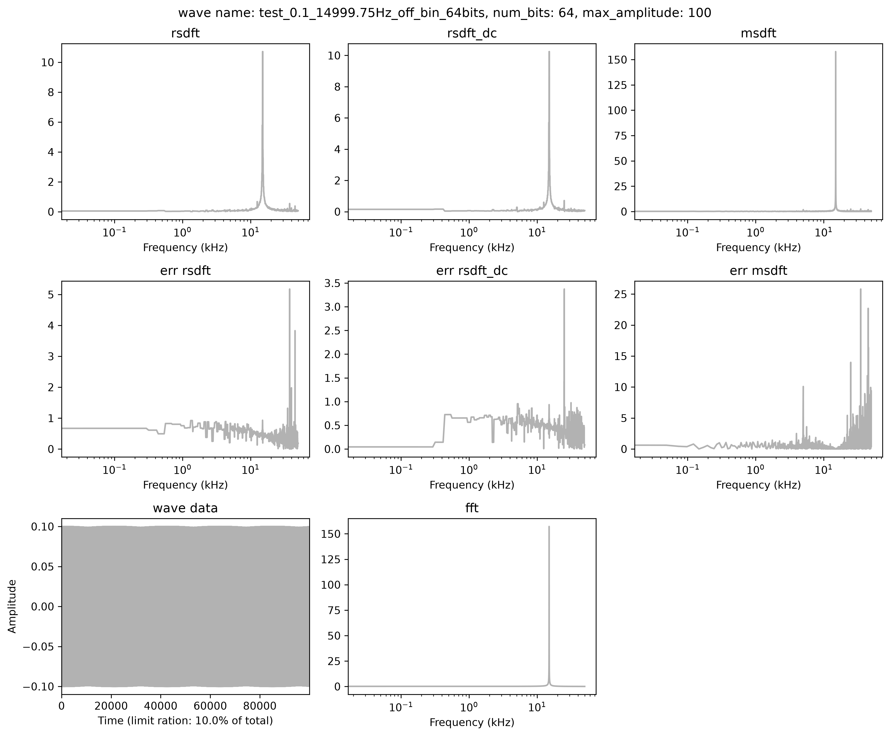
12:00 Possible solution to convergence problem
Set r = 0.995 (look only rsdft). In the picture below remains those 2 resonants peaks at N/4 and N*3/4
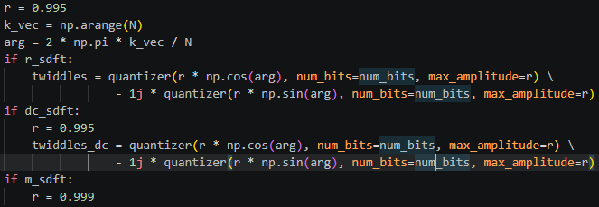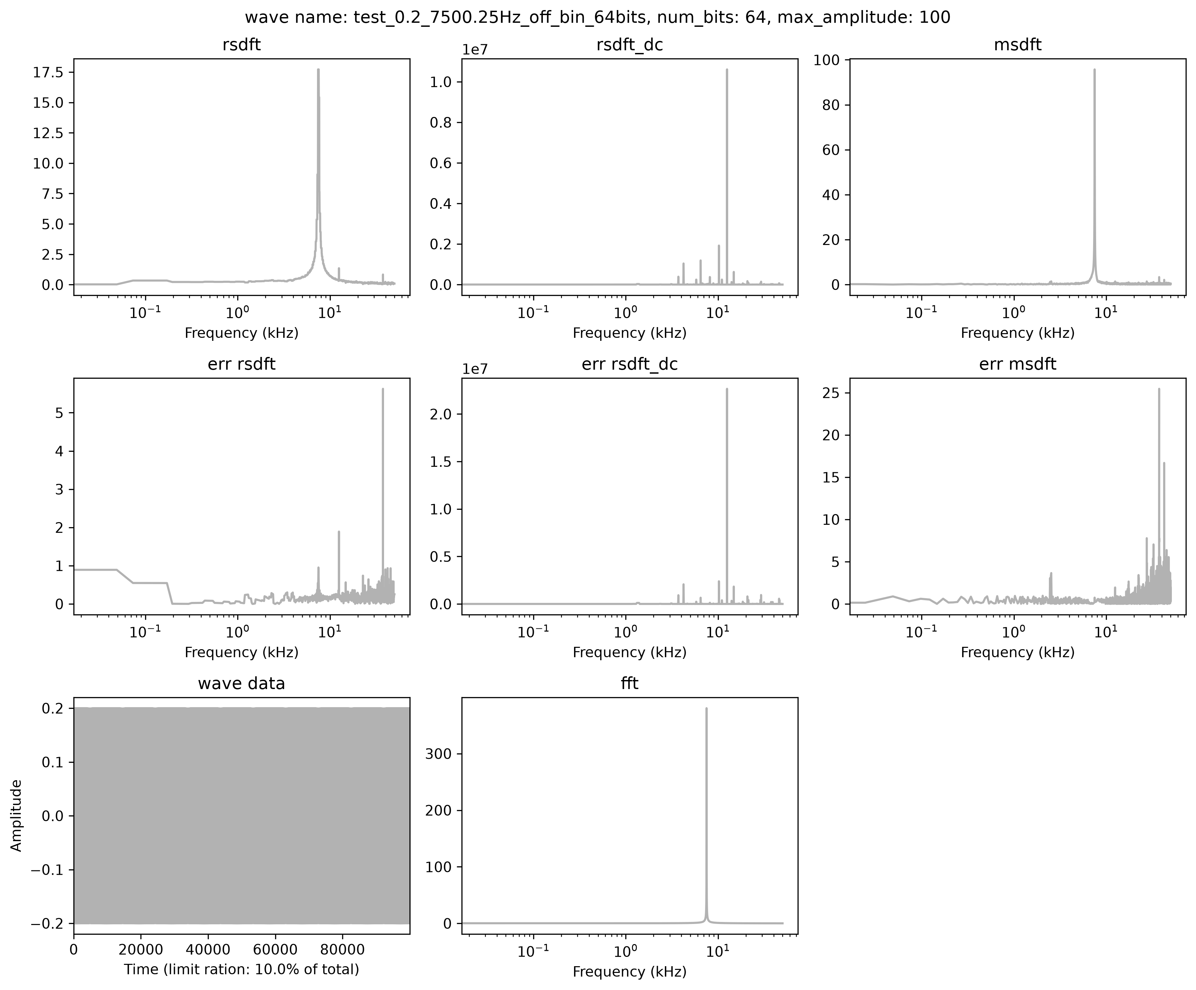

16/10/2026
22:30 Problem: the algorithm rsdft doesn’t converges after the quantization is applied and the spectrum is made with 2 frequencies: N/4 and N*3/4
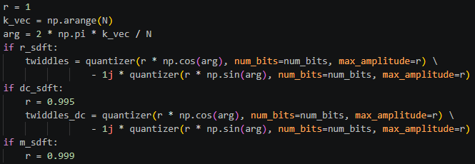
Instead the mrsdft works good
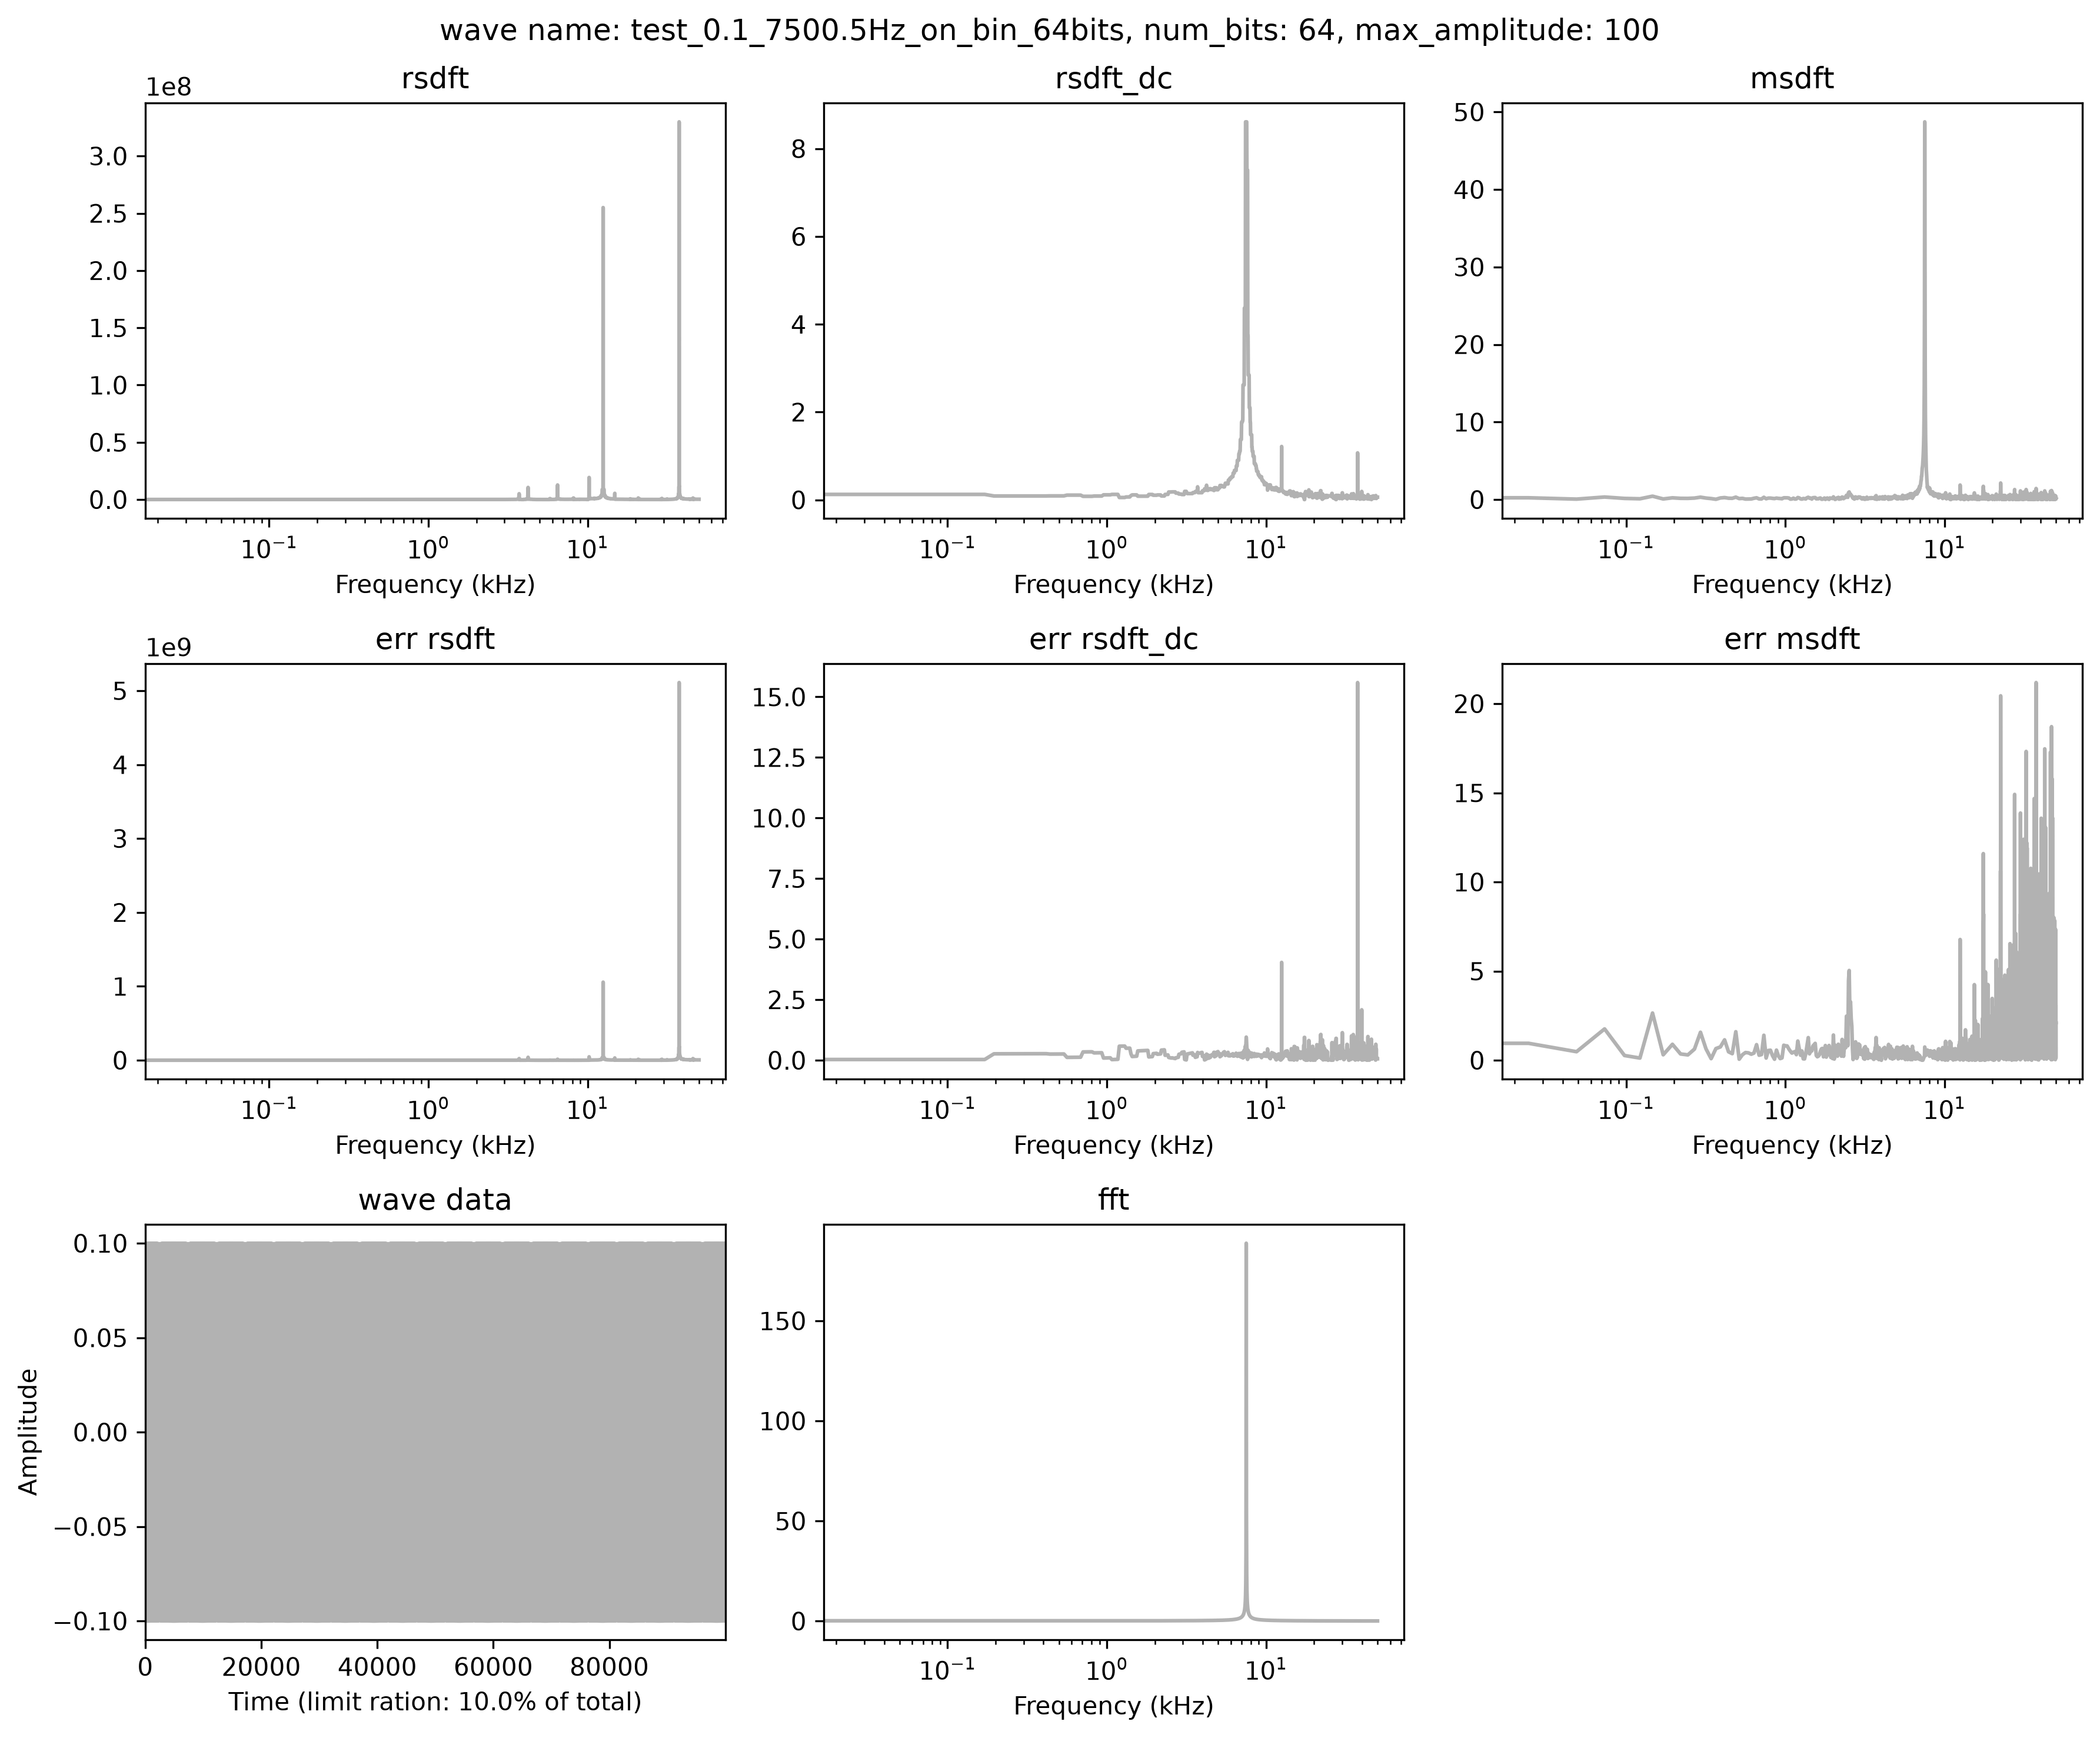

22:00 Added quantization function
