

POLYTECHNIC UNIVERSITY OF TURIN
Master of Science in Computer Engineering

Projects and Laboratory on Communication Systems

LMS Security System
A security system gadgeteer based

Lentini Alfonso – s220389
Mannella Luca – s222325
Sacco Stefano – s214119

Introduction
Our project is a security system based on Microsoft .NET Gadgeteer, developed mainly in C# using the .NET framework v4.3 (for server side) and the .NET Micro Framework v4.3 (for the client side). To perform image processing in the server side of our project we chose to use the AForge.NET library (that is available under the terms of GNU General Public License).

Microsoft .NET Gadgeteer is an open-source toolkit for building small electronic devices using the .NET Micro Framework. It combines the advantages of object-oriented programming, solderless assembly of electronics, and support for customizable physical design.

The .NET Framework is a software framework developed by Microsoft that runs primarily on Microsoft Windows composed mainly by two modules: The Framework Class Library (FCL) and the Common Language Runtime (CLR).
The Framework Class Library is a large class library that provides language interoperability (each language can use code written in other languages) across several programming languages. Programs written for .NET Framework are executed in a software environment known as Common Language Runtime, an application virtual machine that provides services such as security, memory management, and exception handling. For that reason, the code written using .NET Framework is called "managed code".

The .NET Micro Framework (also called NETMF) is an open-source .NET platform for resource-constrained devices with at least 256 KB of flash and 64 KB of RAM. It includes a small version of the .NET CLR and supports development in C#, Visual Basic .NET, and debugging (in an emulator or on hardware) using Microsoft Visual Studio. NETMF features a subset of the .NET base class libraries, an implementation of Windows Communication Foundation (WCF), a GUI framework loosely based on Windows Presentation Foundation (WPF), and a Web Services stack based on SOAP and WSDL. NETMF also features additional libraries specific to embedded applications. The .NET Micro Framework aims to make embedded development easier, faster, and less expensive by giving embedded developers access to the modern technologies and tools used by desktop application developers. Additionally, it allows desktop .NET developers to use their skills in the embedded world, enlarging the pool of qualified embedded developers.

AForge.NET is an open source C# framework with several image processing functionalities designed for developers and researchers in the fields of Computer Vision and Artificial Intelligence originally developed by Andrew Kirillov for the .NET Framework.

Chapter 1 – What the Project does
Our security system, after a setup phase, uses the camera to control a room.
In the setup phase the system snaps a picture that will be used as reference to find an intruder. Periodically the system controls if there are significant differences between the “setup picture” and the picture that was just taken using a heuristic algorithm developed by us to compensate the low computational power of the CPU. If the image is judged suspicious the client sends the picture to the server for having a more sophisticated analysis.

The server analyses the image snapped by the client and reacts in two different ways:
- If the image is judged “safe” the server responds to the client that everything is ok and nothing happens
- If the image is judged “critical” the server sends an email to the user with the suspicious picture and it responds to the client that the alarm must be raised

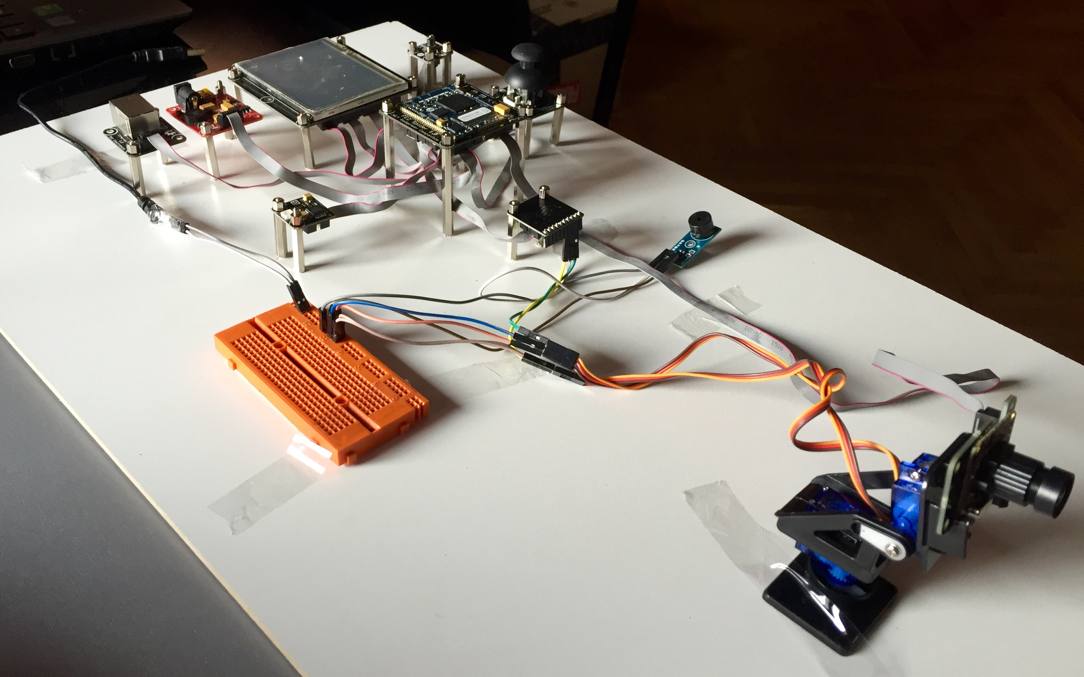
Figure 1.1 – Our project mounted on the board

Chapter 2 – Used Modules
For develop our system we use some modules made by GHI Electronics provided by the professor and other modules retrieved by us.

GHI Electronics modules:
- FEZ Spider I Mainboard
- Display T35 (3.5’’ with touchscreen)
- USB Client DP Module (used as power supply)
- Camera
- Multicolor LED (Daisylink)
- Button
- Ethernet J11D
- Joystick
- Extender

Our Modules:
- Buzzer
- Camera motion support (with 2 servomotors)
- Board for device connection (orange module)

We use the display to let the user to interact with our system, it allows the user to enter the pin to enable and disable the alarm and it allows to the user to see what the camera is filming.
The multicolor LED is used to give information to the user, in particular it becomes red when the network goes down and green when the network goes up.
The joystick is used to pilot the camera motion support to set the camera angle in the desired position, when the user wants to confirm the camera setup he has to click on the button.
The extender module is used to connect the board on which are connected the camera motion support and the buzzer (necessary to raise the alarm).

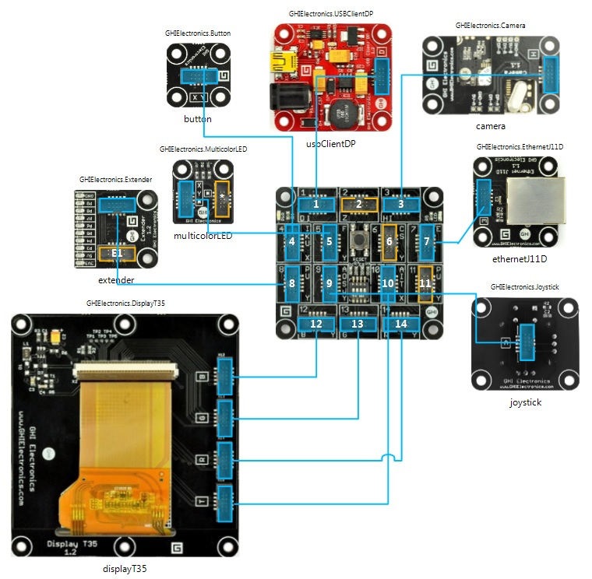
This picture shows the modules of our project interconnected:
Figure 2.1
Logical structure of the modules of the project

Chapter 3 – Software Modules
The main modules of our application are:
- The gadgeteer based client
- The C# Server
- The C# Web Service
- A MySQL Database
- A WAMP based web application (written in PHP)
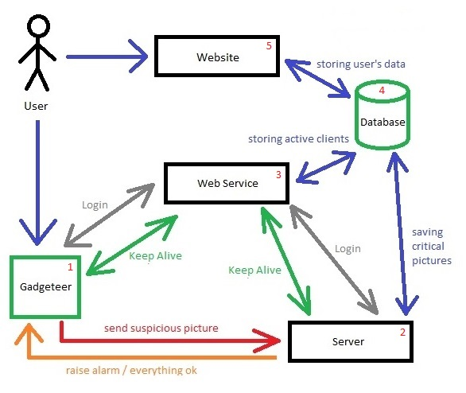

3.1 Application Workflow

To start using our system the user must register an account on our website. During the registration process the user must give us an email address (on which he will receive communication about possible intrusions), the MAC address of its gadgeteer-based system and a PIN that will give him access to the security system and to the reserved area of the website.

When the system is turned on, a PIN is required to proceed. After entering the PIN, the gadgeteer application contacts the Web Service for knowing if the user has the right to use our application. After a query to the database, the Web Service replies to the client if the login must have success or not. If the connection is allowed the Web Service returns to client the IP address of the server and the port on which all the communications with the server must be established from that moment.

When the client is successfully logged in it enters in the setup phase, in this phase the user has the possibility to set the camera angle. When the camera is set up a starting picture is taken and send to the server.
From that moment the client will send a keep alive message to the Web Service (on the same port that it has previously received) every 35 seconds; this communication is necessary to know if all the blocks of our system are always connected (to avoid the possibility that the system can be hacked by cutting a cable). The Web Service will forward the keep alive message to the server that will checks if the connection is still alive, then an answer is send to the Web Service that will reply to the client.

From that moment the system takes pictures periodically. Each captured picture will be compared with the picture taken in the setup phase, if the two images are quite different the suspicious picture is send to the server that will decide if the picture is critical or not.
If the picture is judged critical by the server, the client raise the alarm.

The server receives the suspicious pictures from the client and, using the AForge.NET library, decides if the image is effectively critical or not. If the image is judged critical an email is sent to the address registered in the website and the picture is stored on the server.

Chapter 4 – Particularities & Weakness
In our opinion, the main particularity of our system are the algorithms for the intrusion detection.
In the client side, the computational power of the FEZ spider is very low so performing a complete difference between two pictures of size 320x240 was quite impossible.
To solve this problem, we thought to use a heuristic approach. Our algorithm takes only 9 squares of dimension 8x8 pixels. In this way we reduce the complexity of two orders of magnitude calculating the difference only between 576 pixels (the entire image processing would require to compare 76800 pixels) maintaining a good level of accuracy.
In the server side, thanks to the Aforge.NET library, we implement an algorithm that is able to find the differences in the pictures and it is able also to highlight them directly on the suspicious image.
Another particularity of our system is the presence of the web application that allows to the users not only to register their account, but also to see the suspicious pictures taken from the camera from every PC connected to the internet.

Unfortunately, due to the computational power of the CPU, the final result is not good as we desired.
We want to add to our system also a Passive Infrared sensor, but the CPU is not able to execute in an appropriate way another thread for the management of the PIR.
We want to send the keep alive message with a higher frequency but if we do that, the CPU is not able to compute the difference between the two pictures and send the suspicious picture to the server with an acceptable speed.
We want also to have a more fluid camera regulation but if we manage the joystick movement in a more precise way the system is not able to perform a fluid streaming on the display.

Our application is still a prototype and should not considered an application ready to be sell on the market. For that reason, there are some security aspects that are not treated in an appropriate way. For example, our client device sends the PIN to the server without any authentication mechanism or encryption algorithm. We know that in a commercial application that is an aspect that cannot be ignored.

