**Low-tech graphite-based strain sensor**

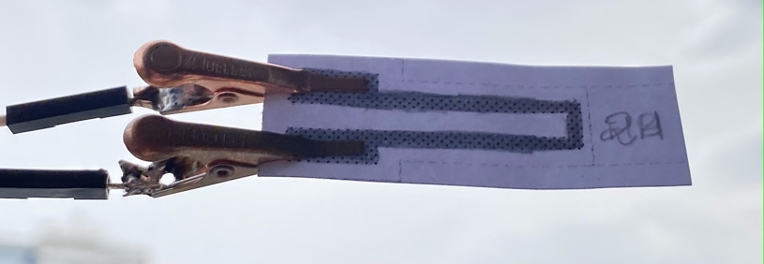**General features**

* Low power consumption
* Easy-to-use
* Small size and ultra-light
* Environment-friendly
* Low cost

**General description**

This strain sensor based on graphite nanoparticles was developed in the Physics Department of INSA Toulouse.

Writing with a pencil on a piece of paper allows to deposit a layer of graphite. The system being granular, there is a dependence between the electrical conductivity and the average space between the particles. Thus, a deformation of the paper sheet will modify the global conductivity of the graphite layer. This induces a measurable resistance variation which allows us to create a strain sensor.

We used different types of pencils (2H, HB, B, 2B) and measured the variation of resistance for each of them as a function of the radius of curvature to characterize each type of pencil.

The measurements have been possible thanks to a PCB including a transimpedance amplifier on an Arduino Uno board. Several modules have been installed to display the resistance variations such as an OLED panel, a rotatory encoder, and a Bluetooth module to receive the values on an external Android APK application.

**Pin description**

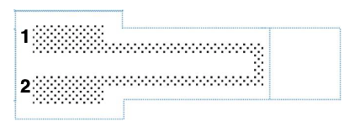

Figure 1 : Top view – Connection pins

|  |  |
| --- | --- |
| Pin number | Usage |
| 1 | Connection to Vin |
| 2 | Connection to +VCC |

**Specifications**

|  |  |
| --- | --- |
| Type | Strain Sensor |
| Materials | * Graphite (H, 2H, HB, B, 4B, 6B, 9B pencils) * Paper * Metal clips |
| Sensor type | Passive – *Power supply required* |
| Power supply | +5V |
| Nature of output signals | Analog |
| Measurand | Voltage |
| Response time | <50ms |
| Typical application | Deformation evaluation (compression strain or tension deformation) |

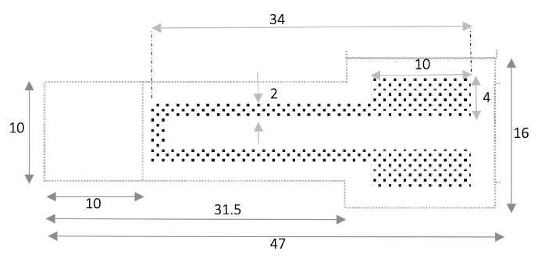**Dimensions**



Graphite layer

Thickness: 0.3mm

Figure 2 : Top view - Dimensions (mm)

**Standard use condition**

|  |  |  |
| --- | --- | --- |
|  | Unit | Typical value |
| Temperature | °C | 20±5 |
| Humidity | % | 60±5 |
| Air quality | %N2/O2 | 80/20 |

**Electrical characteristics**

|  |  |  |  |  |
| --- | --- | --- | --- | --- |
|  | Unit | Value | | |
|  | Min. | Typical | Max. |
| 2H pencil | MΩ | 150 | 300 | 430 |
| HB pencil | MΩ | 30 | 60 | 110 |
| B pencil | MΩ | 40 | 85 | 155 |
| 2B pencil | MΩ | 30 | 70 | 160 |

**Strain sensor characteristics**

The sensor is based on a deposit of ultra-fine graphite particles. Its characteristics have been determined by measuring its resistance to different deformations with varying radius of curvature.

The deformation is calculated with the following formula:

$$deformation=\frac{thickness}{2⋅R_{curvature}}$$

*Warning:* Having a repeatable experiment is difficult. The amount of graphite decreases over time because of:

* the metal clips friction with the paper
* the contact of the paper sheet with fingers
* the varying amount of graphite deposited on each sample

The following figures show the variation of resistance measured for different radii of curvature, knowing that R0 is the sensor’s resistance when it is not subjected to any external mechanical stress. The following measurements were performed for 2B, B, HB and 2H pencils.

Each line is the average of the measurement of 2 sensors for each pencil.

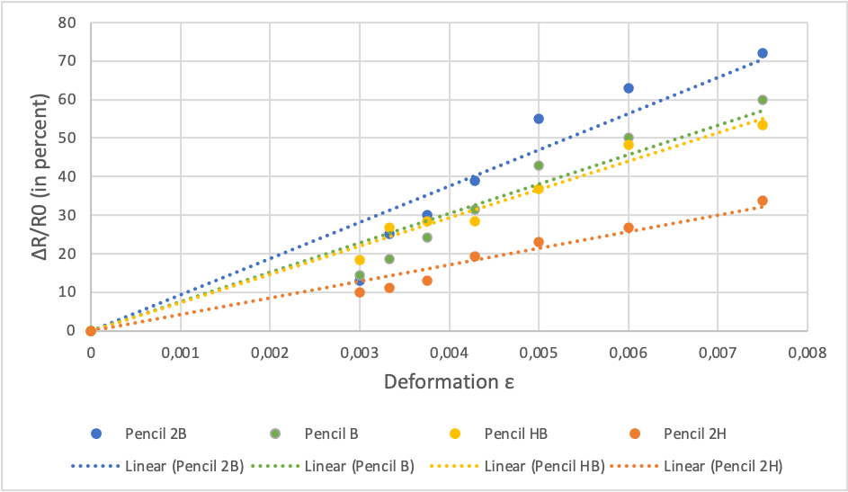

Table 1 : Average relative resistance in function of mechanical deflection of 4 graphite sensors (pencils 2B, B, HB, 2H)

The lettering of the pencils relates to their hardness. A darker pencil means more graphite has been deposited onto the surface.

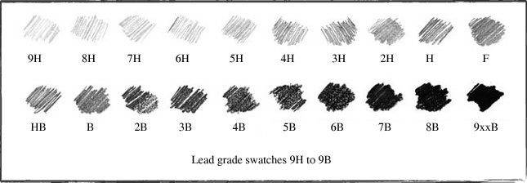

Figure 3 : Lead grade swatches 9H to 9B

As it can be seen on *Table 1,* the darker the pencil is, the more the relative resistance varies with deformation.

**Typical application**

Below is a typical application of this sensor.

The sensor is connected to a transimpedance amplifier and a low-pass filter.

R5 and C1 form a voltage noise filter to protect the operational amplifier from electrostatic discharge. C1 and R1 form a filter for current noise. The signal is then amplified by the operational amplifier LTC-1050 and passes through the active filter composed of C4 and R3 and the output filter composed of C2 and R6. C3 allows to filter the noise on the supply. R2 is interchangeable to adapt the caliber.

The resulting voltage can then be connected to a 5V ADC such as an Arduino board. The assembly presented above avoids an excess of noise at the input of the ADC, which could bring it to saturation. From the voltage value Vread on the Arduino board, it is possible to recover the resistance value of the sensor with the formula below:

At low frequencies, we have:

$$R_{sensor}=\left(1+\frac{R_{3}}{R_{2}}\right)⋅\frac{R_{1}⋅V_{CC}}{\frac{5}{1024}⋅V_{read}}-R_{1}-R_{5}$$