Luca Pontellini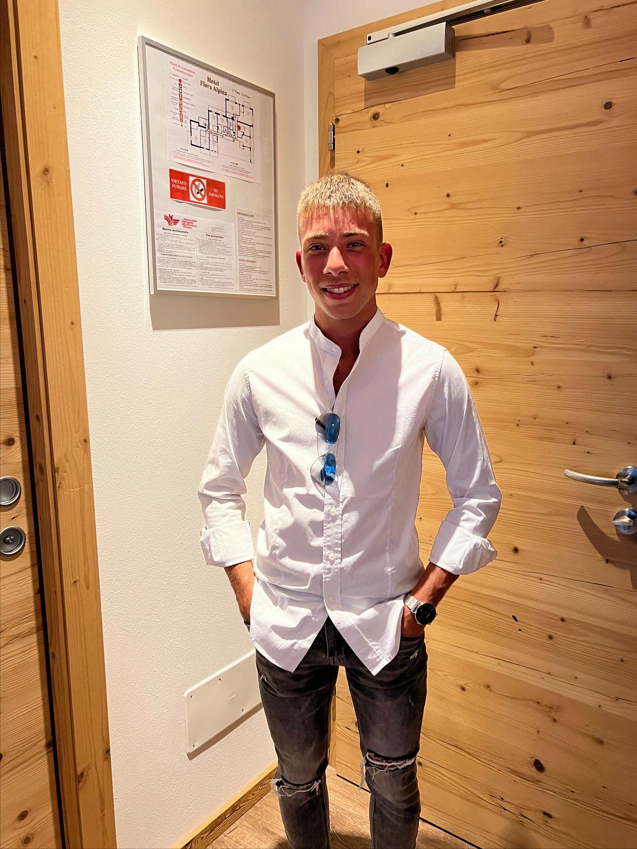

📍**Address:** Via Garibaldi 56 20121, Milano (MI)

📞**Telephone:** (+39) 02 1234 5678

✉️**Email:** [luca.pontellini@techsolutions.com](mailto:luca.pontellini@techsolutions.com)

🌍**Nationality:** Italian

🗓️**Date of Birth:** 01 January 1980

**👨Gender:** Male

👤**Status:** Single

# DESIRED EMPLOYMENT/OCCUPATIONAL FIELD

Software Developer

# WORK EXPERIENCE

## Tech Solutions, Milan

Date: January 2023 - Present

Occupation or Position Held: Software Developer

Main Activities and Responsibilities:

* Development and maintenance of web applications using Python and JavaScript.
* Collaboration with design and product management teams to ensure high-quality solutions.
* Implementation of new features and resolution of user-reported bugs.
* Optimization of website performance and improvement of code security.

Name and Address of Employer: Tech Solutions, Via Roma 123, 20121 Milan (MI)

Type of Business or Sector: Software Development, Information Technology

## ByteBridge Solutions, Turin

Date: March 2018 - May 2020

Occupation or Position Held: Software Engineer

Main Activities and Responsibilities:

* Design and implementation of features for web applications using Java and JavaScript.
* Coordination of a small team of developers to ensure timely project delivery.
* Execution of code reviews to maintain high quality standards.
* Collaboration with the Quality Assurance team to identify and resolve bugs before release.

Name and Address of Employer: ByteBridge Solutions, Corso Vittorio Emanuele II 45, 10121 Turin (TO)

Type of Business or Sector: Software Engineering, Web Development

### EDUCATION AND TRAINING

## State Institute of Higher Education P. Gobetti - A. De Gasperi (ITIS "Gobetti - De Gasperi"), Via Largo Centro Studi, 12/14, 47833 Morciano di Romagna (RN)

Date: September 2020 - June 2026

Title of qualification awarded: Diploma of Higher Technical Education in Computer Science

Principal subjects/occupational skills covered:

* **Information Technology**: Competence in programming, web development, and database management
* **Technical Sciences**: Fundamentals of telecommunications, computer systems, and networks
* **Mathematics and Sciences**: Knowledge of algebra, geometry, chemistry, physics, earth sciences, and biology
* **Humanities and Language**: Study of Italian and English grammar, literature, history, English, and religion
* **Practical Skills**: Laboratory experience with technical tools, network simulations, and computer applications
* **Physical Education**: Participation in various sports and promotion of a healthy lifestyle

Name/type of organization providing education and training: State Institute of Higher Education P. Gobetti - A. De Gasperi (ITIS "Gobetti - De Gasperi"), Morciano di Romagna

Level in national or international classification: Secondary School Diploma

### PERSONAL SKILLS AND COMPETENCES

**Mother Tongue(s):**

* Italian (Level C2)

**Other Language(s):**

* **English**: B1/B2 (Intermediate/Upper Intermediate proficiency in reading, writing, and speaking. Competence in grammar and communication skills.)
* **Spanish**: A1 (Basic proficiency, studied for 1 year in middle school.)

### DIGITAL SKILLS

* **Programming Languages**: Python, HTML, JavaScript, SQL
* **Web Development**: HTML, CSS, JavaScript
* **Database Management**: MySQL, PostgreSQL
* **Network Simulation**: Cisco Packet Tracer
* **Version Control**: Git, GitHub
* **Office Software**: Microsoft Office (Word, Excel, PowerPoint)
* **Operating Systems**: Windows, Linux
* **IDE and Editors**: Visual Studio Code, PyCharm
* **Basic Cybersecurity**: Understanding of cybersecurity principles and best practices

### HOBBIES AND INTERESTS

**Sports**: Football (Soccer), cycling, and running

**Model Railway**: A scaled-down representation of a real or imaginary railway system, including trains, tracks, stations, landscapes, buildings, and other scenic elements. Using materials such as plastic, wood, metal, and paper to create realistic or imaginative scenes, ranging from small dioramas to large layouts that occupy entire rooms.

**Video Games**: Minecraft (preferred), Rocket League, GTA V, etc.

### DRIVING LICENCE

* **Car**: Category B
* **Moped**: Category AM

### ADDITIONAL INFORMATION

### Certifications: ECDL (European Computer Driving Licence)

**References**

* **Informatics**:
  + **Casadei Claudio**: claudio.casadei@isissgobetti.it
  + **Livi Andrea**: andrea.livi@isissgobetti.it
  + **Angelo Galanti**: angelo.galanti@isissgobetti.it
* **Systems and Networks**:
  + **Casali Dario**: dario.casali@isissgobetti.it
  + **Armando Mancini**: armando.mancini@isissgobetti.it
  + **Pierluigi Buccino**: pierluigi.buccino@isissgobetti.it
* **TPSIT**:
  + **Di Matteo Pietro**: pietro.dimatteo@isissgobetti.it

I authorize the processing of personal data in the CV according to Legislative Decree 196/2003 and EU Regulation 2016/679" in which an individual gives explicit permission to the company for the collection and processing of personal data.