* Option 1: Write a target (or screening) proposal for a disease of your choice, using publicly available data and your analysis to support your arguments.
* Option 2: Write a Rmarkdown/Jupyter report analysing data from [the Drug Central](https://drugcentral.org/) database, raising your own scientific questions about drug-target associations and answering them with analysis.

Option 1

* infer efficacy, safety profiles, potency and selectivity (GI, Shannon Entropy, SPARK, mapping)
* for which patients will the drug work? (module 5)
* How does the drug work really? (module 4)
* A gene can be a target

Option 1 or 2

Drug target by

* DNA and RNA sequencing 🡪 Variation causes problems by LD
* Genes with biologically understandable genetic association are more likely to be good targets
* Drug target assessments by Module 1, slides 36 ff
* Protein, RNA or DNA as target? S 41

🡪 Genomics

If there are no good drug targets, you may try (module 2):

1. Phenotypic drug discovery

2. Natural products

3. Biologics

4. Interaction-based (multispecific) drug discovery

5. Drug repurposing or combination studies

A zoo of modalities (module 3):

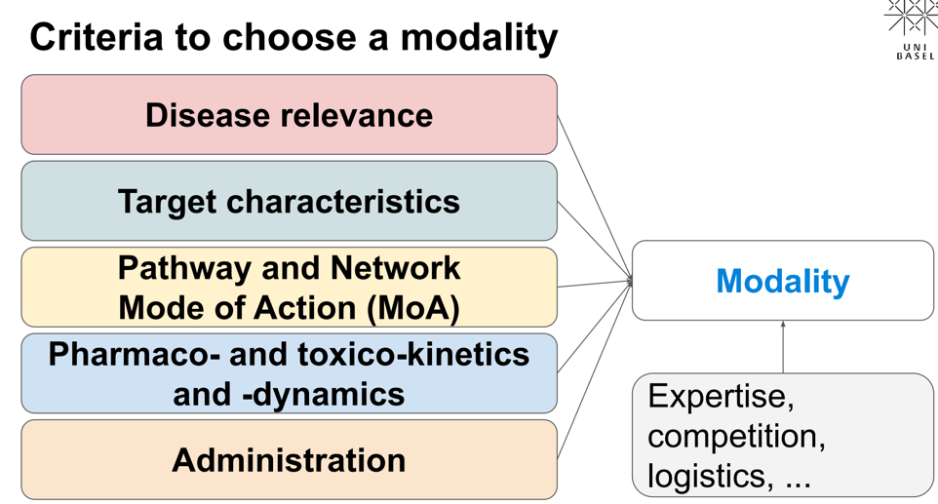Ein Bild, das Text enthält.
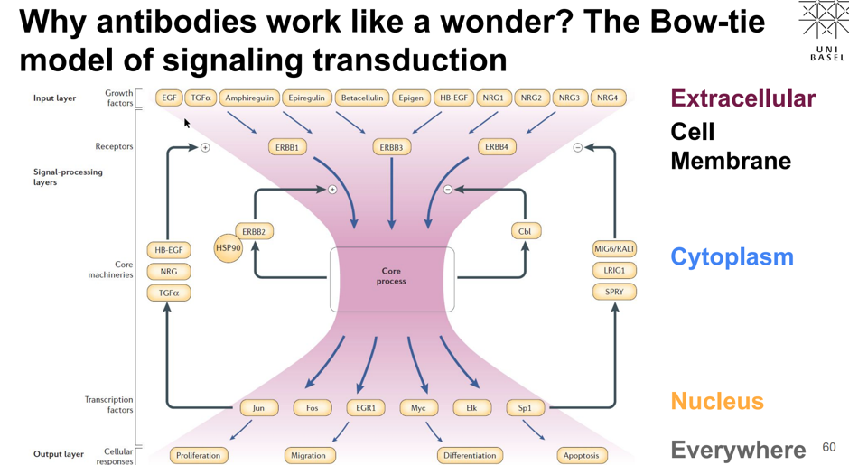

Expectation of efficacy and safety profiles (module 4):

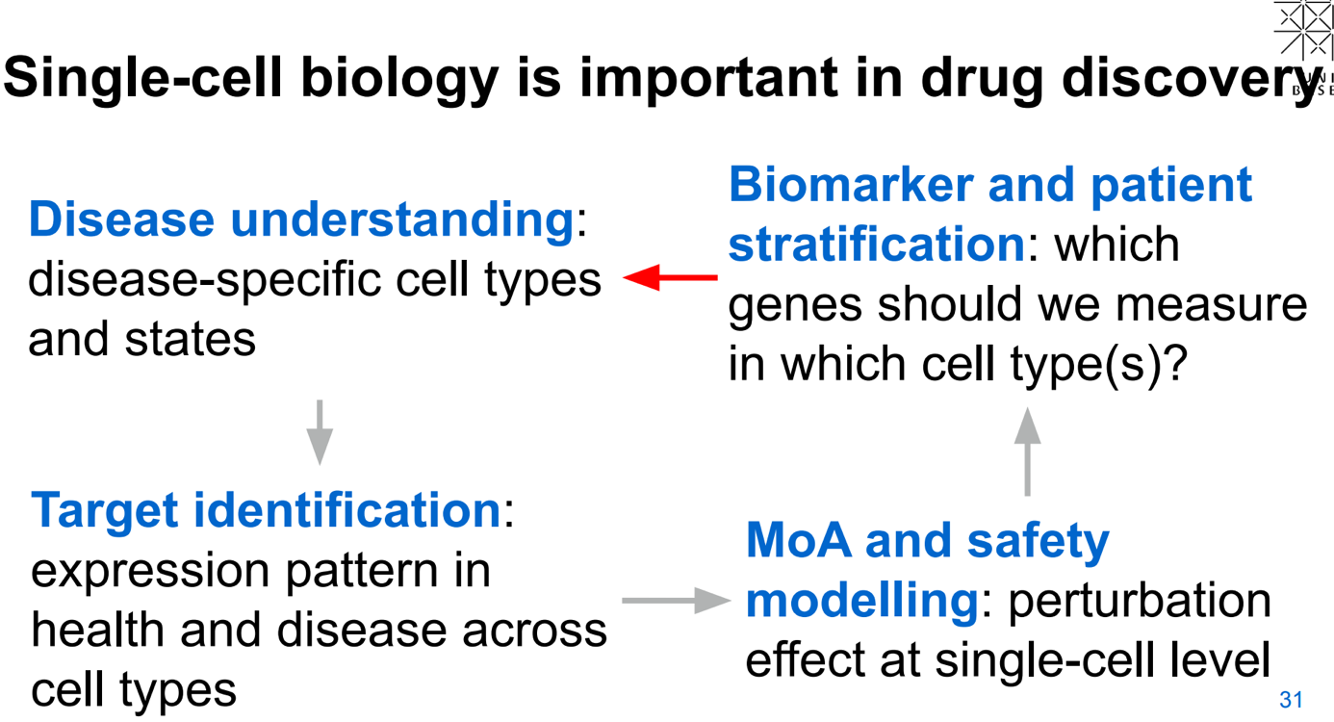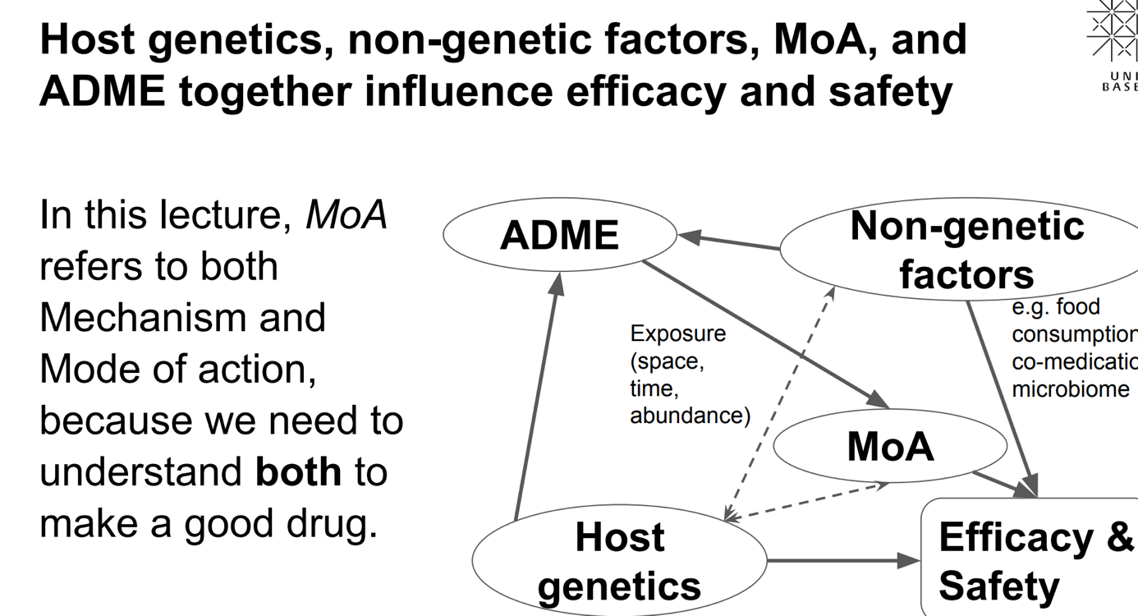

Challenges:

* Many causes, same effect
* Multiple MoAs are possible
* Genetics may affect MoAs

🡺 Understanding MoA of oligonucleotides, small molecules, antibodies with proteomics based on mass spectrometry