Define an algorithm in Matlab based on dynamic programming for the following scheduling problem.

Schedule the following *n* jobs, where *pj* is the processing time, *Cj* is the completion time, *Lj* is the lateness, and *dj* is the due date for the *j*-th job on 1 machine.

|  |  |  |  |  |  |  |  |  |  |  |
| --- | --- | --- | --- | --- | --- | --- | --- | --- | --- | --- |
| Job | J1 | J2 | J3 | J4 | J5 | J6 | J7 | J8 | J9 | J10 |
| *pj* | 5 | 3 | 6 | 8 | 4 | 12 | 12 | 5 | 3 | 2 |
| *dj* | 12 | 60 | 16 | 15 | 9 | 15 | 32 | 20 | 18 | 18 |
| *wj* | 1 | 1 | 1 | 1.5 | 1 | 1 | 2 | 1 | 1.2 | 3 |

The problem has job priorities defined by weights *wj* and constraints. The problem has the following objective (minimize the overall weighted tardiness)

$$1|\left|prec\right||\sum_{j}{w_{j}}T_{j}$$

with **at least one** of the following preceding constraints

The tardiness is defined as

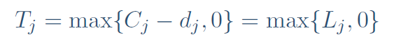

Verify that the solution that has been obtained is optimal comparing with the solution obtained in a mathematical programming problem defined in Excel (or other spreadsheet tool with optimization module) or Lingo or Cplex or Matlab