Final Design
Web Visualization
Prepared by Date _______________
Barbara Lara, WEB and CO2 lead
Checked by Date _______________
Matheus Bitaraes, Project Manager
Approved by Date _______________
Barbara Lara, Web and CO2 lead
Authorised for use by Date _______________
Dr. Felipe Gonzalez, Project Coordinator

Queensland University of Technology
QUT-ARCAA
Gardens Point Campus
Brisbane, Australia, 4001.

This document is Copyright 2015 by the QUT. The content of this document, except that information which is in the public domain, is the proprietary property of the QUT and shall not be disclosed or reproduced in part or in whole other than for the purpose for which it has been prepared without the express permission of the QUT

This document is Copyright 2012 by the QUT. The content of this document, except that information which is in the public domain, is the proprietary property of the QUT and shall not be disclosed or reproduced in part or in whole other than for the purpose for which it has been prepared without the express permission of the QUT

Revision Record
Document Issue/Revision Status | Description of Change | Date | Approved
1.0 | Initial Issue | 29 May 2015 | Barbara Lara
2.0 | Second Issue | 02 September 2015 | Barbara Lara
3.0 | Final Issue | 27 October 2015 | Barbara Lara

Table of Contents
Paragraph Page No.
1 Introduction 6
1.1 Scope 6
1.2 Background 6
2 Reference Documents 7
2.1 QUT Avionics Documents 7
2.2 Non-QUT Documents 7
3 Subsystem Introduction 8
4 Subsystem Architecture 9
4.1 Interfaces 10
5 Design 11
5.1 Software Design 11
5.1.1 Web Visualization Design 11
5.1.2 Software Flow Diagram 15
6 Conclusion 16

List of Figures
Figure Page No.
Figure 4-1: Airborne Elements - System Architecture (RD/2) 9
Figure 4-2: Ground Elements - System Architecture (RD/2) 9
Figure 5-1- Webpage preliminary coding 12
Figure 5-2:Webpage layout 13
Figure 5-3-3: PhpMyAdmin page from WampServer 14
Figure 5-4: Software Flow Diagram 15

Definitions
UAV | Unmanned Aerial Vehicle
UAVG5 | Unmanned Aerial Vehicle Group 5
GCS | Ground Control Station
CO2 | Carbone Dioxide
WEB | Web Visualization Subsystem
FTP | File Transfer Protocol
USB | Universal Serial Bus

Introduction
This document belongs to the WEB subsystem of the UAVG5 project. It is part of the systems engineering approach and follows the Trade Study and Background research. This finaldesign document contains an overview of the WEB subsystem.
This document states and describes the interfaces between the WEB and the other subsystems in the UAVG5 project. For this purpose, the UAVG5 System Architecture will be analysed so the interfaces can be mapped out throughout the design phase.

Scope
This Final Design introduces the Web Visualization solution and states its interfaces, inputs and outputs in the UAVG5 project context. The UAVG5 Subsystem Architecture is presented along with a description of the operation of the subsystem. Detailed designs of software, algorithms and other specifications are then presented.

Background
The Australian Research Centre of Aerospace Automation (ARCAA) conducts research into all aspects of aviation automation, with a particular research focus on autonomous Technologies which support the more efficient and safer utilisation of airspace, and the development of autonomous aircraft and on-board sensor systems for a wide range of commercial applications.

ARCAA commissioned students of ENB354 to design and build a UAV for indoor air quality. This aircraft is a multi-rotor based UAV concept. The UAV is required to conduct constant air sampling around a room, identify a maker on the ground (which can have two different layouts), then map its location inside the room.

Reference Documents

QUT Avionics Documents
RD/1 | UAV - Customer Needs | UAV for Indoor Air Quality
RD/2 | UAVG5-PM-PMP-01 | Project Management Plan
RD/3 | UAVG5-PM-SR-01 | System Requirements
RD/ 4 | UAVG5-WEB-TS-01 | Trade Study- Web Visualization
RD/ 5 | UAVG5-CO2-PD-01 | Final Design – Air Quality Sensor
RD/ 6 | UAVG5-TEL-PD-01 | Final Design - Telecommunications
RD/ 7 | UAVG5-PWP-PD-01 | Final Design – Power and Propulsion
RD/ 8 | UAVG5-PM-ICD-01 | The Interface Control Document
RD/ 9 | UAVG5-CO2-DWG-01 | Air Quality Sensor Wiring Diagram
RD/ 10 | UAVG5-TEL-DWG-01 | Telecommunications Wiring Diagram
RD/11 | UAVG5-PWP-DWG-01 | Power and Propulsion Wiring Diagram
RD/12 | UAVG5-TAIP-PD-01 | Final Design – Target Analysing & Image Processing
RD/13 | UAVG5-TEL&WEB-TR-01 | Raspberry Pi Wi-Fi data transmission and Webpage data acquisition
RD/14 | UAVG5-TAIP&WEB-TR-01 | Imagery Display in the Webpage
RD/15 | UAVG5-GCS&WEB-TR-01 | CO2 Graph Display in the Webpage

Non-QUT Documents
RD/16 | http://www.wampserver.com/ | WampServer web page

Subsystem Introduction
To fulfil the High Level Objectives (HLOs) defined in RD/1, and the System Requirements REQ-M-01, REQ-M-06, REQ-M-12, REQ-M-14, REQ-M-21, REQ-M-22, REQ-M-23, REQ-M-24, REQ-M-27, REQ-M-28, REQ-M-29 and REQ-M-30 defined in RD/3, the Web Visualization must be capable of displaying CO2 concentration data in real time in the Ground Control Station (GCS).
With the intention of completing the tasks, the UAVG5 needs to be equipped with a module able to transmit the CO2 concentration to the Ground Control Station. A Raspberry Pi, a Wi-Fi dongle and a Router were selected and are contemplated in the Telecommunications (TEL) subsystem documents RD/6 and RD/10. The GCS shall have a Web server computer to gather the air quality data from the router, store it in a database software and access it from a Web page.
Other UAV information such as Imagery and telemetry data shall also be displayed in the Web page. The imagery data will be also accessed from the router and more details about this subsystem devices are available in the Target Analysing & Image Processing (TAIP) documents RD/12. The telemetry link will be connected in the same computer as the Web server. More details about this device connections are available in the Telecommunications (TEL) subsystem documents RD/6 and RD/10.

Subsystem Architecture
An overview of the subsystem’s interfaces control diagram and subsystem architecture is displayed in Figure 1 and Figure 2.
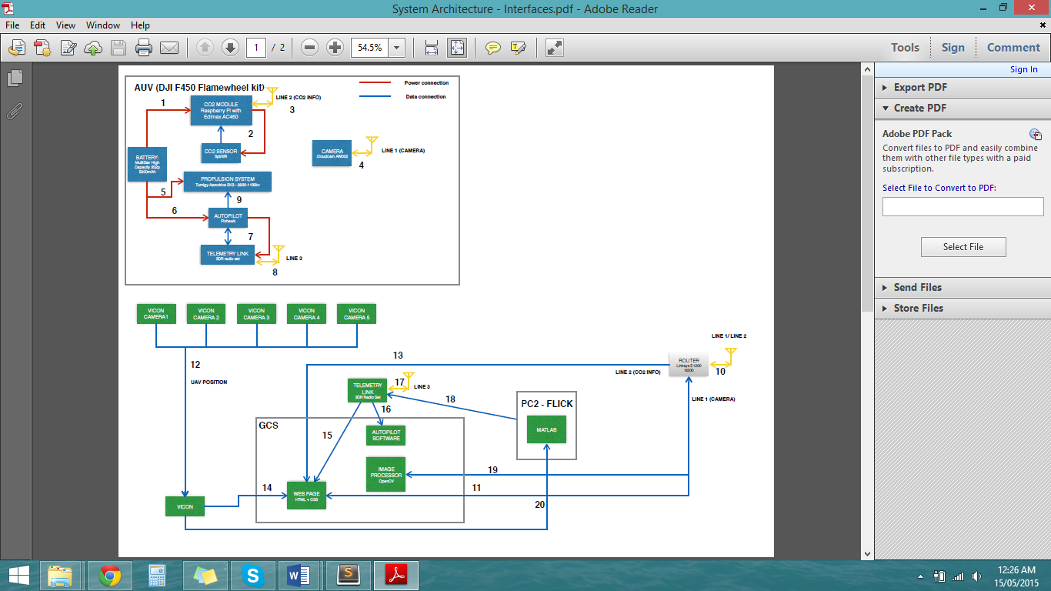
Figure 4-1: Airborne Elements - System Architecture (RD/2)

Figure 4-2: Ground Elements - System Architecture (RD/2)

Interfaces
Interface 11 The web server computer will access the image information from the router via Wi-Fi. The data will be available in the IP address 192.168.0.154 and will be displayed on the web page.
Interface 13 The router will transmit air quality data to the webserver via a Wi-Fi.
Interface 14 The Vicon cameras program will send the position of the UAV to the webserver PC which will be used with the purpose of building the 3D air quality data x UAV position graph to be displayed in the webpage.

More details on these interfaces can be seen in RD/8.

Design
After completing the system requirements (RD/3), background research, and a trade study (RD/4) it was decided that the database software and programming languages to be used in the UAVG5 Project would be MySQL and HTML script +CCS and PHP respectively. This present document for the Web Visualisation subsystem will be based on this decisions.

Software Design
In order to fulfil a majority of the Air Quality Sensor requirements the appliance of software is essential. The data from the CO2 sensor must be available in a web interface. Therefore a program is needed in the Raspberry Pi to gather the data from the CO2 sensor and send it via Wi-Fi connection to a router in the GCS (Server Python Coding). This program is detailed in document RD/5. Other programs are also needed in the local computer located in the GCS to receive the air quality data from the router and display it on the web page and they are described hereafter.
    - Client Python Coding
The python coding used for connecting to the server, which runs in the Raspberry Pi, and writing the data in the database is showed in Figure 5-1.
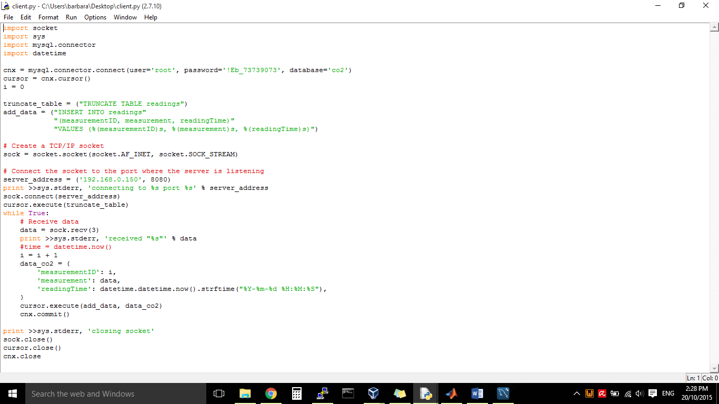
TCP/IP socket receiving the data and writing in the database
INSERT INTO command to write the data in the database
Connection with the database co2
Figure 5-1:Client Python Coding
    - Database Design
The MySQL database created to store CO2 measurements and UAV location data is showed in Figure 5-2. The database co2 has the reading table which contains measurementID, measurement, readingTime, location_x, location_y and location_z attributes.
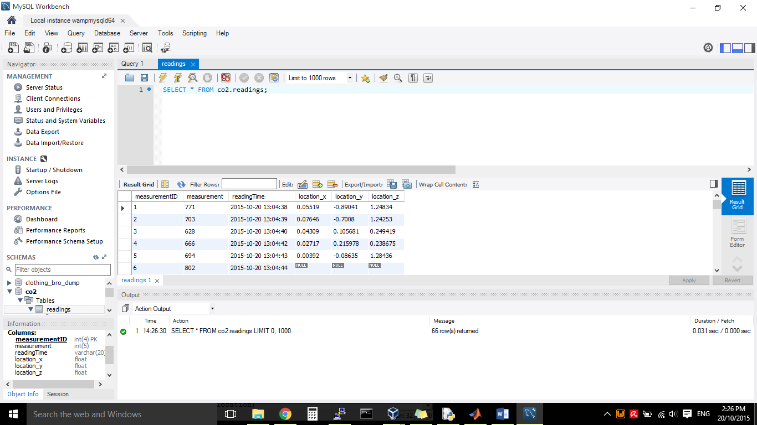
Database table and stored data
Figure 5-2: Database design

The software used for the database development is WampServer RD/16. WampServer is a web development software for Windows. It allows the creation of web applications with PHP and a MySQL database. Its PhpMyAdmin feature allows the database management. Figure 5-3 shows the PhpMyAdmin page and the database feature.
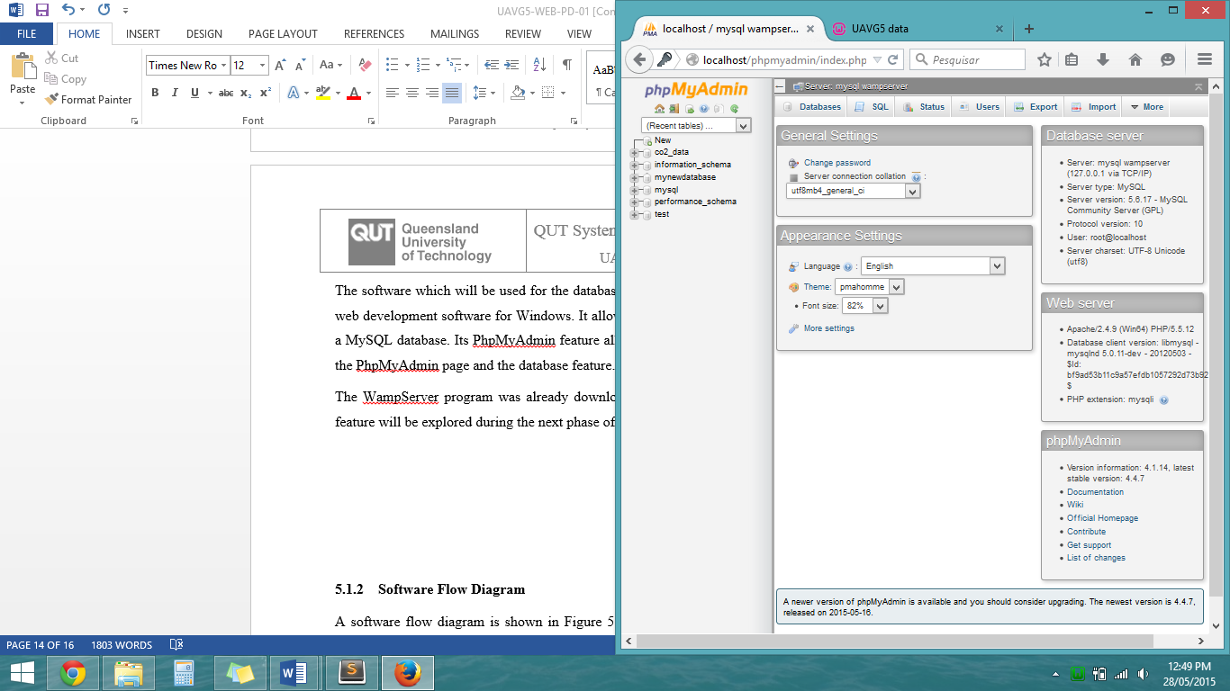
Figure 5-3: PhpMyAdmin page from WampServer

    - Subscriber/Server Python Coding
In a Linux machine (VirtualBox used) a subscriber needs to be run in order to get the positioning data from the UAV which is published by the Vicon program. The data also needs to be sent to the computer which hosts the database server by TCP/IP sockets. Figure 5-4 shows the coding used for this solution.
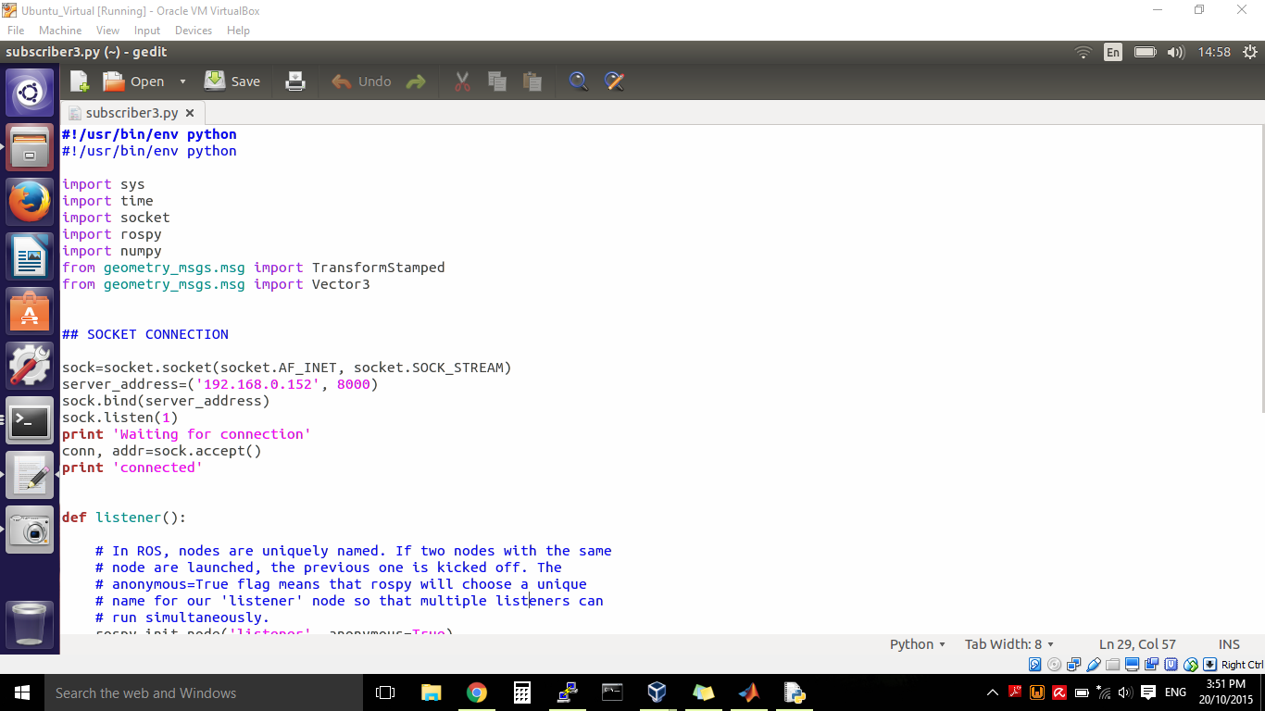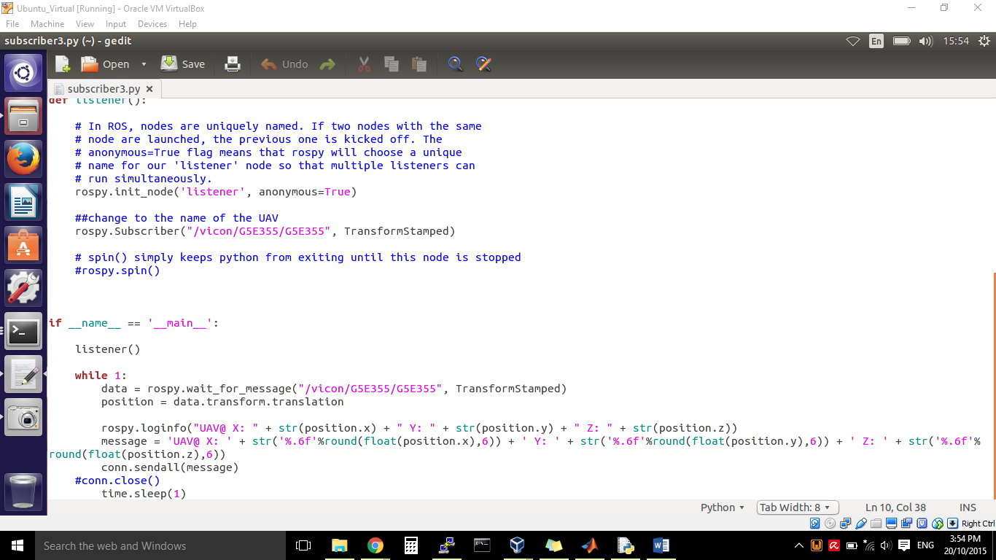
TPC/IP socket message sending with ROS connection data
Old ROS connection (not used)
TCP/IP socket connection
Figure 5-4: Subscriber/Server Python Coding

Subscriber/Client Python Coding
In order to receive the data from the subscriber via TCP/IP socket and write it in the database, another python coding is needed. Figure 5-5 shows the code used. Beyond the socket connection, the code also connects to the database created and described in section 5.1.2. It updates all the location data with the information received from the Subscriber/Server program.
A delay of one second was needed in order to enable the position data writing in the database.
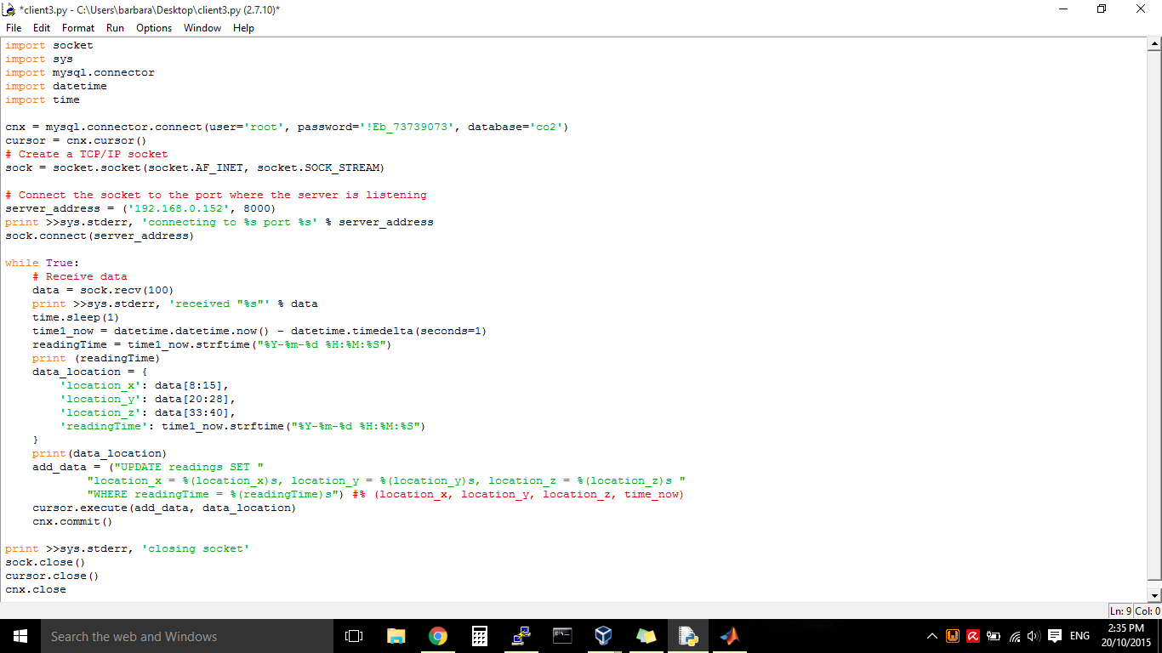
Database update with the received data from the Subscriber/Server Python program
TCP/IP socket connection
Database connection
Figure 5-5: Subscriber/Client Python coding

    - MATLAB Coding
The MATLAB coding connects to the database and retrieves the CO2 measurement, X and Y position data in order to draw a graph. This graph is saved in an external .jpg file which is constantly updated in the webpage. Figure 5-6 shows the code used in this solution.

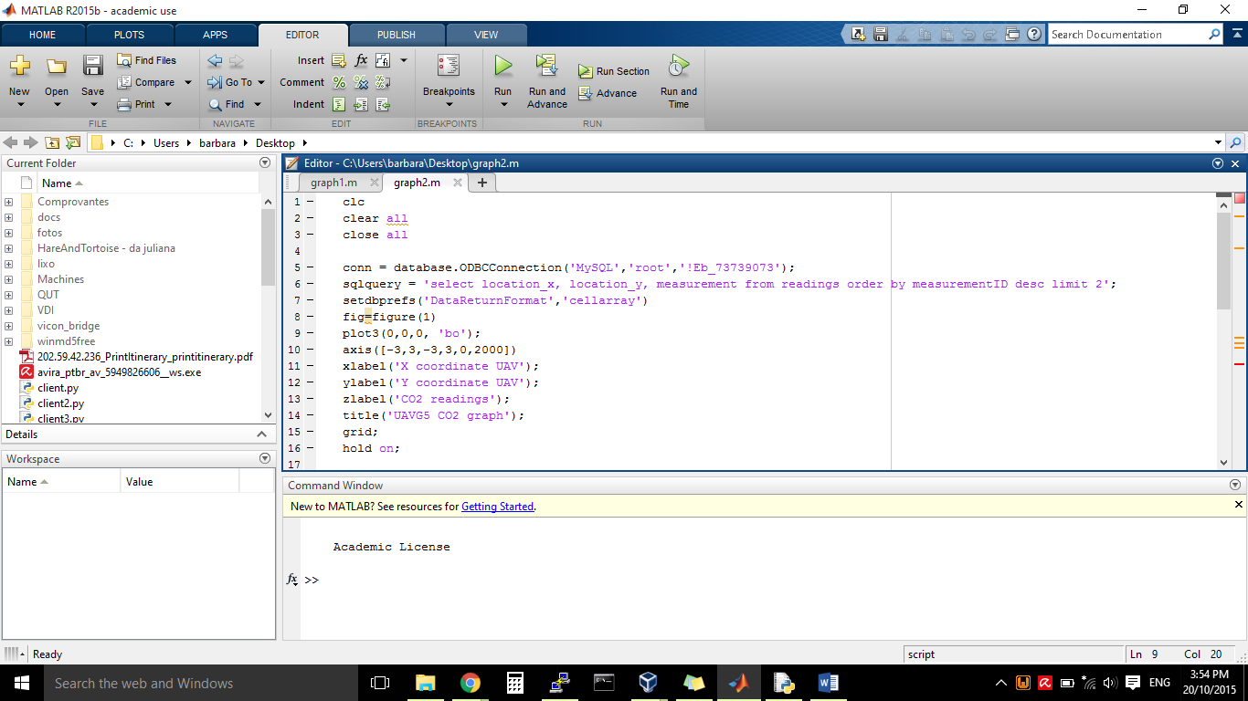
Database connection
Graph creation
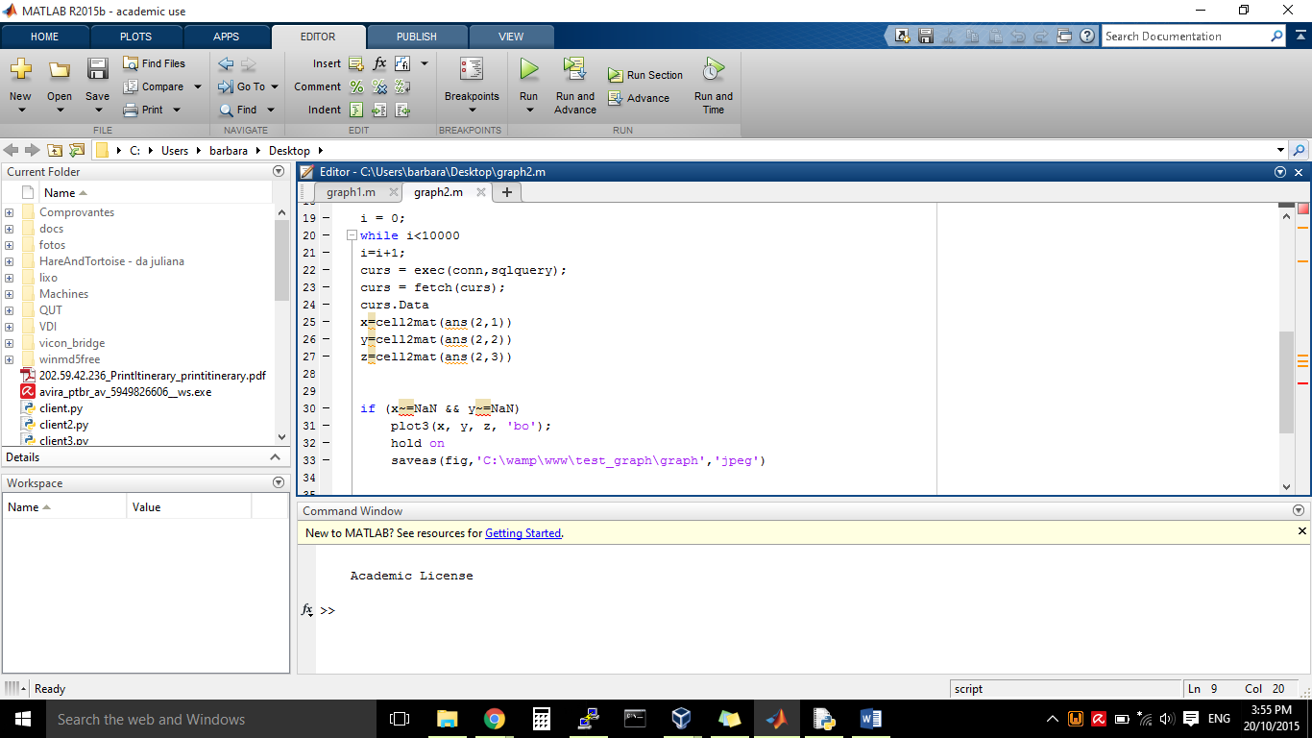
Graph drawing
Data update
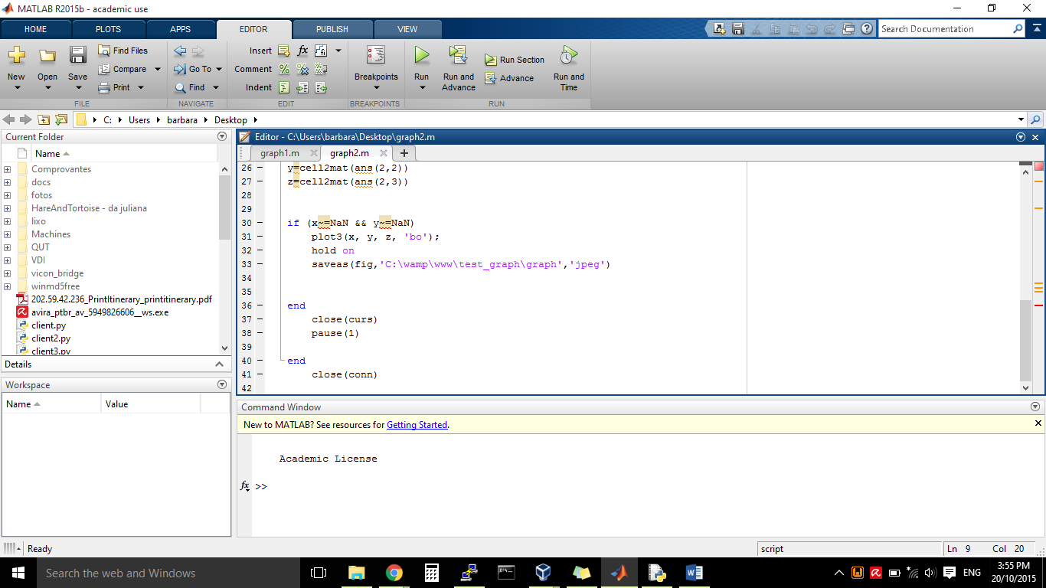
Figure 5-6: MATLAB coding

Web Visualization Design
The Web Visualization subsystem relies on three components for operation. This document shows the coding final design.
The webpage is located in the webserver computer that is located in the Ground Control Station. The webpage is then accessed from the same computer or another computer using the router specified in document RD/6.
The final design for the webpage coding is shown in pictures 5-1-1, 5-1-2, 5-1-3 and 5-1-4 below. The first part of the HTML coding displays the UAV Imagery accessed from the router. The IP camera page was successfully added to the web page and as well as the image displayed inline in the web page.
The second part of the HTML coding shows the CO2 measurement. This part of the coding represents the interaction with the database as it will contain the CO2 data sent by the Raspberry Pi.
The third part of the HTML coding shows the CO2 concentration vs. UAV location graph image. The image is generated by Matlab and uploaded in the webpage.
The HTML+CSS coding is shown e Figure 5-1-1. The PHP coding used to retrieve data from the database is showed in Figure 5-1-3. And the AJAX code used to automatically update the HTML page information every one second. Figure 5-7 shows the coding used.

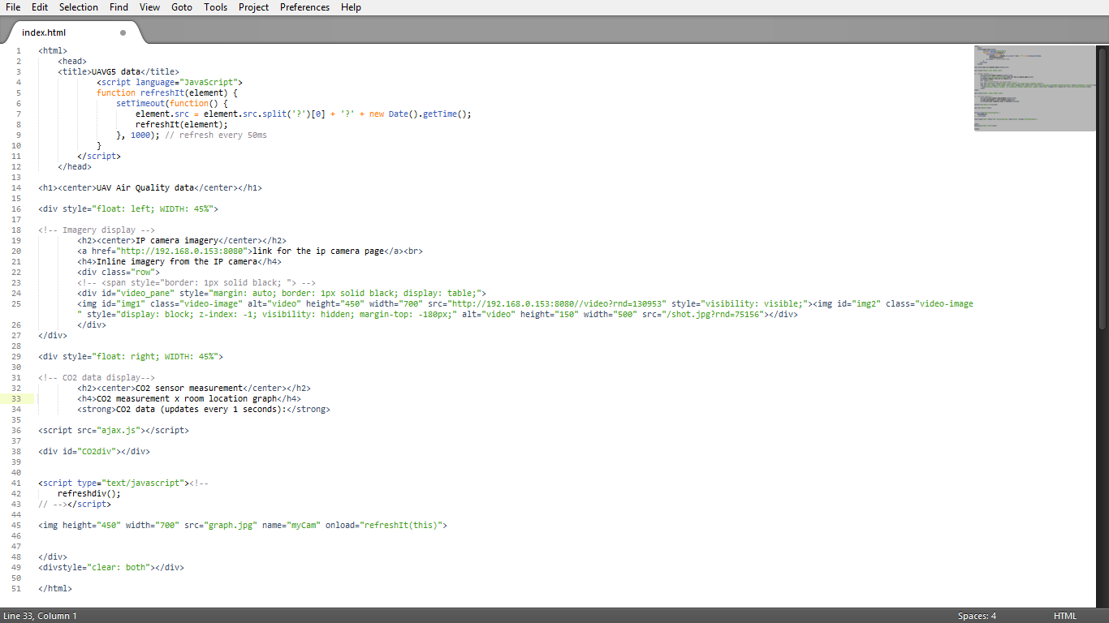
Matlab 3D graph image – CO2 meas. Vs. UAV position
UAV Imagery webpage access.
CO2 data: interaction with the database via PHP coding.
Figure 5-7- Webpage preliminary coding

The results of each part of the coding can be checked in the test report documents RD/13, RD/14 and RD/15. Figure 5-8 shows the final result of the webpage.
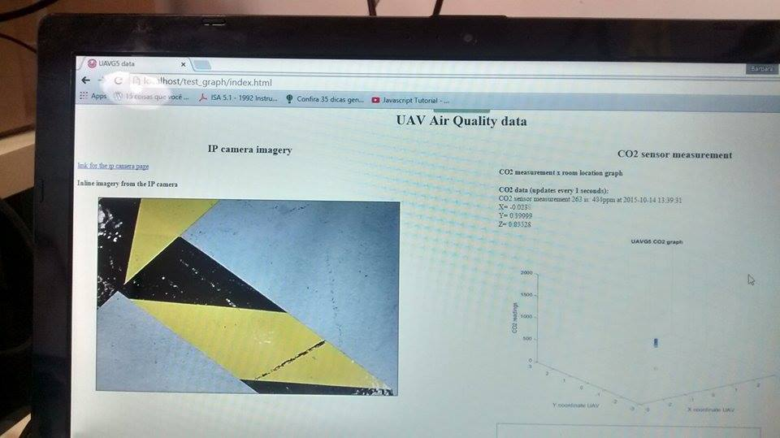
Figure 5-8: Webpage layout

Software Flow Diagram
A software flow diagram is shown in Figure 5-4 below. It outlines the data flow related to the Web Visualization subsystem. The web server computer downloads the CO2 and imagery data from the router and the air quality data will be upload it in the database. A PHP script gets the data from the database and makes it available to HTML+CCS coding to reference and display it in the web page. The imagery data from the IP camera is also gathered from the router and also displayed in the webpage. This can be seen in the flow diagram below:

Figure 5-9: Software Flow Diagram

Conclusion
After completing the UAVG5 system requirements and trade study, it is clear that the WEB subsystem consists of one hardware component (webserver computer) combined with other telecommunication, imagery and air quality hardware devices (Raspberry Pi, USB Wi-Fi dongle, router and CO2 sensor, Vicon cameras software) and some software to create a platform of user’s data visualization.
The project fulfils or contributes to the fulfilment of the customer needs and System requirements. REQ-M-12, REQ-M-14, REQ-M-21 and REQ-M-22 are satisfied as the solution provided allow the visualisation of imagery, telemetry and air quality data visualization from the UAV in the Ground Control Station through a web interface. This design also contributes to the fulfilment of the REQ-M-24, REQ-M-27, REQ-M-28, REQ-M-29 and REQ-M-30 which are related to the UAVG5 performance requirements in the final project presentation.
This final design document specifies the Web Visualization subsystem. It was adapted during all the project in order to contemplate all changes during design and implementation phases.

