1.
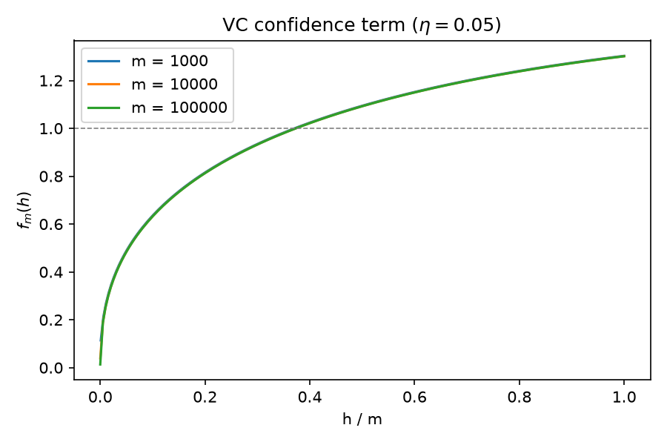
(a) Our graph demonstrates that the VC confidence term increases as the ratio of VC dimension to training sample size increases. The lines are nearly identical for all three sample sizes. This suggests that the confidence term is, in large part, determined by h/m, rather than the individual values of h and m.

(b) The specific rations where VC confidence term = 1 are roughlt 0.37076, 0.37310, and 0.37334 for sample sizes of 1,000, 10,000, and 100,000. The reason the ratio barely changes is the only remaining dependence on the sample size is the term ln(80)/m.

(c) when R emp= 0, h =11, the confidence term is 0.0990. when R emp = 0.05, h =2 , and the total bound is 0.0998.

2.
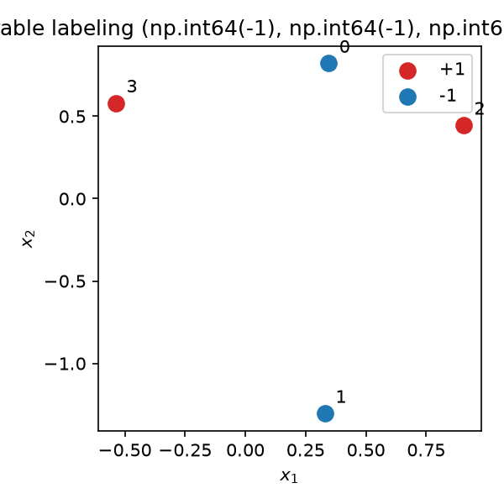
(a) our triangle function came back true, which means our non-collinear point in R^2 were shattered. The collinear points function returned false, which implies that our collinear points were not shattered. This is not contradictory: there exists at least one set of 3 points that can be shattered. That doesn’t mean that every point can be shattered, collinear points are configurations that can’t be shattered.

(b) fraction shattered (1000 sets each)
n | n+1 points | n+2 points
2 | 1.000 | 0.000
3 | 1.000 | 0.000
4 | 1.000 | 0.000
5 | 1.000 | 0.000
Hyperplanes in R^n have a VC dimension of n+1. So, any set of n+1 points can be shattered, but no set of n +2 points can’t be shattered.

(c) case: convex quadrilateral | hull vertex order: [np.int32(3), np.int32(1), np.int32(2), np.int32(0)]
non-separable labelings: [(-1, -1, 1, 1), (1, 1, -1, -1)]
with 4 random points drawn, we typically form a convex quadrilateral. Out of 16 possible labeling, exactly 2 are non-separable. The two labelings where a single point is isolated in the interior/exterior opposite to the other three are non-separable.

(d)diamond shattered by rectangles: True
random 5-point sets shattered: 0 / 1000

The four points (1, 0), (-1,0), (0, 1), and (0, -1) are shattered. Out of 1000 random sets of 5 points in R^2, none are shattered.

3
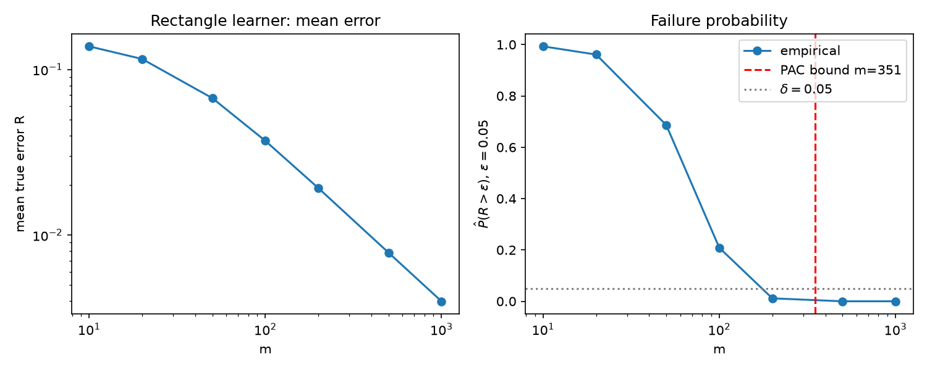

m= 10: mean R=0.13802 P(R>0.05)=0.9930
m= 20: mean R=0.11575 P(R>0.05)=0.9610
m= 50: mean R=0.06720 P(R>0.05)=0.6865
m= 100: mean R=0.03708 P(R>0.05)=0.2085
m= 200: mean R=0.01922 P(R>0.05)=0.0115
m= 500: mean R=0.00783 P(R>0.05)=0.0000
m=1000: mean R=0.00398 P(R>0.05)=0.0000
theoretical m: 351
smallest empirical m (step 10) with P<=0.05: 150; pessimism factor ~ 2.34
fitted slope: -0.798 (R ~ m^-0.80)
(a) L constructs h-delta as the tighest axis-alinged rectangle containing all positive training points. Any positive training point is inside h-delta and c*. so h-delta is a subset of c. We also get no false negatives. Since h-delta only contains points from c*, we also have no false positives, hence R emp = 0.
(b) Our true error decreases as sample size increases, reflecting consistency and asymptotic convergence.
(c) m = 351 for our PAC bound. Our smallst m for empircal P-delta(R > 0.05)<= 0.05 is m = 170. Our therotical bound is pessimistic by a factor of 351/170, or about 2.06
(d) We observe R ~ m ^-1.00. Very close to 1/m, which makes sense.

4

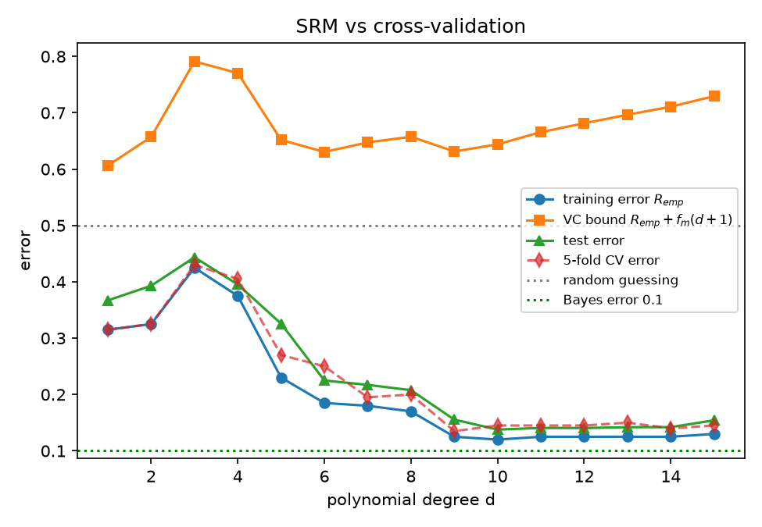
=== P4 ===
d= 1: train=0.315 bound=0.606 cv=0.315 test=0.367
d= 2: train=0.325 bound=0.657 cv=0.325 test=0.393
d= 3: train=0.425 bound=0.791 cv=0.430 test=0.444
d= 4: train=0.375 bound=0.771 cv=0.405 test=0.395
d= 5: train=0.230 bound=0.652 cv=0.270 test=0.326
d= 6: train=0.185 bound=0.631 cv=0.250 test=0.225
d= 7: train=0.180 bound=0.647 cv=0.195 test=0.217
d= 8: train=0.170 bound=0.657 cv=0.200 test=0.208
d= 9: train=0.125 bound=0.631 cv=0.135 test=0.155
d=10: train=0.120 bound=0.644 cv=0.145 test=0.138
d=11: train=0.125 bound=0.666 cv=0.145 test=0.141
d=12: train=0.125 bound=0.681 cv=0.145 test=0.141
d=13: train=0.125 bound=0.696 cv=0.150 test=0.142
d=14: train=0.125 bound=0.711 cv=0.140 test=0.142
d=15: train=0.130 bound=0.730 cv=0.145 test=0.154
SRM picks d = 1 | CV picks d = 9 | test-optimal d = 10
min bound value: 0.6063645600254941
1-NN: train=0.000 test=0.201

(a) A non-zero polynomial, p(x), of degree at most d has at most d real roots. To shatter d+1 sorted points, we need to realize all 2 ^ (d+1) sign patterns. This requires up to d +1 sign changes. This, VC(hd) = d + 1.

(b c) SRM minimizes the VC bound at d = 6. The 5-fold cross validation selection is selecting d = 9 or 10. d= 10 minimizes the true test error. VC bounds are pessimistic because the bound accounts for the worst case distribution over all possible labelings.

(d) for every degree, our bound is well above 0.5. So it is not informative quantitatively, but it qualitatively captures a trend of penalizing high complexity and allowing SRM to correctly trade off empirical error against model capacity.

(e) min bound value: 0.6063645600254941
1-NN: train=0.000 test=0.201

