EFREI · AGH University of Krakow · OOAD with UML · Spring 2026
Team 10 : HomeAppShop
Home Appliances Shop — UML Requirements Model
Project Documentation Report
TEAM | Team 10
PROJECT | HomeAppShop — Home Appliances Shop
COURSE | Software Development (Life) Cycle — UML Modeling
SCOPE | Requirements Description via Use Case Diagrams (Cockburn Pattern)
MEMBER 1 | All group members — SS-1: Sales Management
MEMBER 2 | Lyne Ngouowa— SS-2: Order Fulfillment & Delivery
MEMBER 3 | Orlane Ndjibou — SS-3: Procurement & Stock Management
MEMBER 4 | Luc Lajie — SS-4: Reporting & Financial Management
DEADLINE | 21.03.2026

Subsystem Overview
SS-1 Sales Management  Covers the complete in-store and Internet sales process conducted by the Employee on behalf of Clients.  Actor: Employee | SS-2 Order Fulfillment & Delivery  Covers the Client-facing ordering experience including packing and dispatch requests to a delivery address.  Actor: Client
SS-3 Procurement & Stock Management  Handles shortage notifications, procurement decisions, and restocking from cooperating warehouse or producer.  Actor: Manager | SS-4 Reporting & Financial Management  Generation and storage of monthly sales/purchase reports; transfer of financial documents to external Book Keeper.  Actor: Manager

SS-1: Sales Management · SS-2: Order Fulfillment & Delivery · SS-3: Procurement & Stock Management · SS-4: Reporting & Financial Management

TABLE OF CONTENTS
0. Team & Work Distribution
1. System Overview
1.1 System Description
1.2 Actors
1.3 Subsystem Overview
2. Subsystem 1 — Sales Management (SS-1)
2.1 Use Case Diagram — SS-1
2.2 User Stories — SS-1
2.3 Use Case Scenarios — SS-1
2.4 Activity Diagram — SS-1
2.5 Sequence Diagrams — SS-1
3. Subsystem 2 — Order Fulfillment & Delivery (SS-2)
3.1 Use Case Diagram — SS-2
3.2 User Stories — SS-2
3.3 Use Case Scenarios — SS-2
3.4 Activity Diagram — SS-2
3.5 Sequence Diagrams — SS-2
4. Subsystem 3 — Procurement & Stock Management (SS-3)
4.1 Use Case Diagram — SS-3
4.2 User Stories — SS-3
4.3 Use Case Scenarios — SS-3
4.4 Activity Diagram — SS-3
4.5 Sequence Diagrams — SS-3
5. Subsystem 4 — Reporting & Financial Management (SS-4)
5.1 Use Case Diagram — SS-4
5.2 User Stories — SS-4
5.3 Use Case Scenarios — SS-4
5.4 Activity Diagram — SS-4
5.5 Sequence Diagrams — SS-4
6. Class Diagram
6.1 Class Diagram Figure
6.2 Class Descriptions
6.3 Main Relationships
6.4 Enumeration Types
7. Summary

0. Team & Work Distribution
As required by the project instruction, this section documents each Team Member's contribution in percentage and the artefacts they authored. Author names appear under every figure caption throughout this report.

Team Member | Subsystem(s) | % Work | Artefacts Authored
Member 1 (All group members) | SS-1: Sales Management | ~25 % | US1-1…US1-8; UC1-1…UC1-5; UCD-1; AD-1; SeqD-1, SeqD-2, SeqD-3,Class Diagram
Lyne Ngouowa | SS-2: Order Fulfillment & Delivery | ~25 % | US2-1…US2-8; UC2-1…UC2-5; UCD-2; AD-2; SeqD-4, SeqD-5, SeqD-6
Orlane Ndjibou | SS-3: Procurement & Stock Management | ~25 % | US3-1…US3-8; UC3-1…UC3-5; UCD-3; AD-3; SeqD-7, SeqD-8, SeqD-9
Luc Lajie | SS-4: Reporting & Financial Management | ~25 % | US4-1…US4-8; UC4-1…UC4-4; UCD-4; AD-4; SeqD-10, SeqD-11;

1. System Overview

1.1 System Description
HomeAppShop is a retail management information system for a home appliances shop. It supports the complete business cycle: in-store and Internet sales, stock verification, packing and home delivery, procurement of out-of-stock items from cooperating suppliers, and monthly financial reporting to an external Book Keeper.

An Employee sells appliances directly to the Client on their direct order or via the Internet portal. Clients may pay extra for packing and home delivery. When an item is unavailable, the Employee notifies the Manager, who decides to order from a cooperating warehouse or producer. The Manager also generates monthly reports and transfers all financial documents to the external Book Keeper.

1.2 Actors
Actor | Type | Role in System | Interacts With
Employee | Primary | Processes in-store and Internet sales; checks stock; records payments; organises packing & dispatch; notifies Manager of shortages. | Client, System, Manager, Delivery Service
Client | Primary | Places orders (in-store or online); requests home delivery; makes payment for appliance and optional shipping. | Employee, System, Delivery Service
Manager | Primary | Receives shortage notifications; decides on procurement; generates monthly reports; transfers financial documents to Book Keeper. | Employee, Warehouse/Producer, Book Keeper, System
Warehouse/Producer | Secondary (external) | Supplies appliances upon Manager's purchase order. | Manager
Book Keeper | Secondary (external) | Receives financial documents from Manager for external legal accounting. | Manager
Delivery Service | Secondary (external) | Collects packed parcels; delivers to Client addresses; provides tracking numbers. | Employee, Client

1.3 Subsystem Overview
SS# | Subsystem | Description | Primary Actor(s) | Member
SS-1 | Sales Management | In-store and Internet sales; stock check; payment recording; receipt; order status update. | Employee, Client | All group memebrs
SS-2 | Order Fulfillment & Delivery | Client ordering experience; packing; dispatch; delivery tracking. | Client, Employee, Delivery Service | Lyne Ngouowa
SS-3 | Procurement & Stock Management | Shortage alerts; Manager procurement decision; purchase orders; stock receipt. | Manager, Employee, Warehouse/Producer | Njibou Orlane
SS-4 | Reporting & Financial Management | Monthly sales/purchase reports; document storage; transfer to Book Keeper. | Manager, Book Keeper | Luc Lajie

2. Subsystem 1 — Sales Management (SS-1)
Author: Member 1 — [All group members] | SS-1: Sales Management

This subsystem covers all activities performed by the Employee in processing both direct in-store sales and Internet orders — from product search through stock verification, payment recording, receipt issuance, dispatch arrangement, and shortage notification.

2.1 Use Case Diagram — SS-1
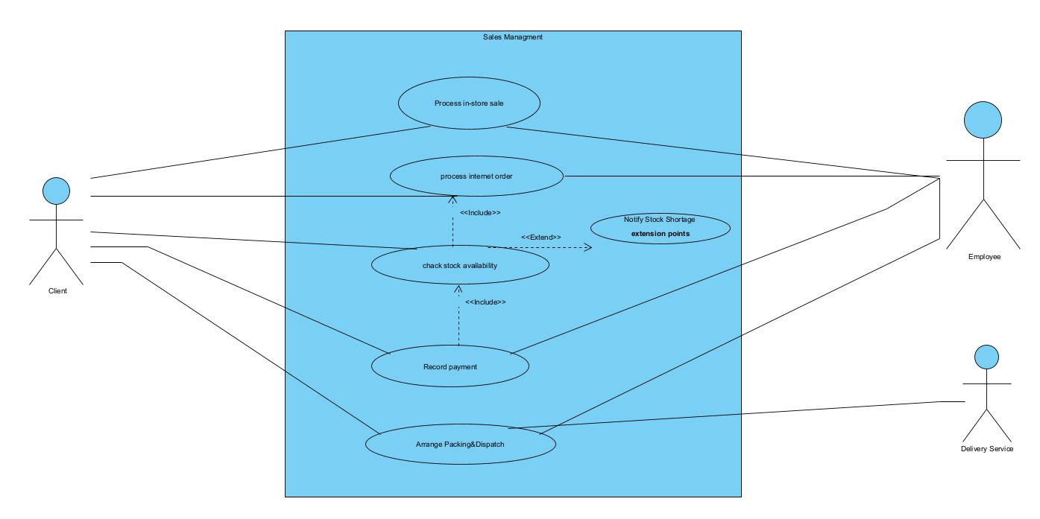
Figure 1 — Use Case Diagram: SS-1 Sales Management | [ Primary actors: Employee (left), Client (right) ] | [ UC IDs: UC1-1 Process In-Store Sale; UC1-2 Process Internet Order; UC1-3 Check Stock Availability; UC1-4 Record Payment & Issue Receipt; UC1-5 Update Order Status ] | [ Author: Member 1 — [All group members] ]

2.2 User Stories — SS-1
ID | As a ... | I want to ... | So that ...
US1-1 | Employee | register a direct in-store sale | the transaction is recorded and inventory is updated immediately
US1-2 | Employee | process a pending Internet order from the queue | online Clients receive the same quality of service as walk-in Clients
US1-3 | Employee | check stock availability before confirming any order | I never confirm an order for an item that is not in the store
US1-4 | Employee | record the Client's payment and issue a numbered receipt | financial records remain accurate and the Client has proof of purchase
US1-5 | Employee | arrange packing and dispatch of goods | Clients who request home delivery have their orders sent out promptly
US1-6 | Employee | notify the Manager when a requested item is out of stock | procurement can be initiated without delay
US1-7 | Client | place a direct in-store order | I can purchase an appliance immediately during my visit
US1-8 | Client | place an order through the Internet portal | I do not need to visit the shop in person

2.3 Use Case Scenarios — SS-1

UC1-1 Process In-Store Sale
Use Case ID | UC1-1
Actor(s) | Employee (primary), Client (secondary)
Goal | Register a successful in-store sale, decrement stock, and issue a receipt.
Precondition | Employee is logged in. Client is present with a chosen appliance or product code.
Trigger | Client presents the appliance or states the product code to the Employee.
Main Flow — Success Scenario | 1. Employee enters the product name or code into the system.  2. System retrieves and displays: product name, price, and current stock level.  3. Employee verifies stock is available (includes UC1-3: Check Stock Availability).  4. Employee adds the product and quantity to the sale transaction.  5. System calculates the total price including applicable tax.  6. Client chooses a payment method (cash, card, or bank transfer).  7. Employee records the payment (includes UC1-4: Record Payment & Issue Receipt).  8. System decrements the stock by the sold quantity.  9. System records the transaction and generates a numbered receipt.  10. Employee hands the receipt to the Client.
Alternate / Extension Flows | • A1 — Out of stock at step 3: System shows stock = 0. Employee triggers UC1-6 (Notify Manager). Employee informs Client of delay.  • A2 — Client requests home delivery after step 7: Employee initiates UC2-4 (Request Packing & Delivery).  • A3 — Client adds more items: Return to step 1 for each additional item.
Postcondition | Sale recorded; inventory updated; receipt issued to Client.
Exception / Error Flows | Payment declined → transaction cancelled; stock NOT decremented; system logs the failed attempt.

UC1-2 Process Internet Order
Use Case ID | UC1-2
Actor(s) | Employee (primary), Client (initiator via Internet portal)
Goal | Fulfil an online order placed by a Client through the shop's Internet channel.
Precondition | Client has placed an order via the Internet portal. Order appears in Employee's queue.
Trigger | New Internet order appears in the Employee's order-management queue.
Main Flow — Success Scenario | 1. Employee opens the pending Internet order from the queue.  2. System displays full order details: items, quantities, Client address, and payment status.  3. Employee checks stock availability for all items (includes UC1-3).  4. Employee confirms the order and verifies payment (includes UC1-4).  5. If Client requested delivery: Employee initiates UC2-4 (Request Packing & Delivery).  6. System updates the order status to 'Dispatched' or 'Ready for Collection'.  7. System sends order confirmation and tracking information to the Client by e-mail.
Alternate / Extension Flows | • A1 — Partial stock: Employee contacts Client to confirm partial shipment or waiting.  • A2 — Item unavailable: System triggers shortage notification (UC1-6). Employee informs Client of delay.  • A3 — Payment not confirmed: Order placed on hold; Employee contacts Client to resolve.
Postcondition | Order status updated; goods dispatched or Client notified of delay.
Exception / Error Flows | System failure → order flagged 'Pending — System Error'; Employee retries on reconnection.

UC1-3 Check Stock Availability
Use Case ID | UC1-3
Actor(s) | Employee (primary), System (secondary)
Goal | Verify in real time that the requested appliance is available in the required quantity.
Precondition | A sale or order process is in progress. Product code or name is known.
Trigger | Employee initiates a product search during UC1-1 or UC1-2.
Main Flow — Success Scenario | 1. System queries the stock database for the specified product code.  2. System retrieves the current stock quantity.  3. System compares available quantity against the requested quantity.  4. If stock ≥ requested: System returns 'Available' status with current stock level.  5. Employee proceeds with the sale transaction.
Alternate / Extension Flows | • A1 — Stock insufficient: System returns 'Insufficient Stock'. Employee informs Client; UC1-6 triggered.  • A2 — Stock = 0: System returns 'Out of Stock'. UC1-6 triggered automatically.
Postcondition | Stock availability status returned to the calling use case (UC1-1 or UC1-2).
Exception / Error Flows | Database timeout → Employee manually checks the store; availability entered manually.

UC1-4 Record Payment & Issue Receipt
Use Case ID | UC1-4
Actor(s) | Employee (primary), Client (secondary)
Goal | Record the Client's payment and produce a valid numbered receipt linked to the transaction.
Precondition | Sale items confirmed and total calculated. Client is ready to pay.
Trigger | Employee selects 'Record Payment' after confirming sale items.
Main Flow — Success Scenario | 1. System displays the total amount payable.  2. Employee selects the payment method: cash, card, or bank transfer.  3. Client provides payment.  4. System records the payment: method, amount, date, and time.  5. System generates a numbered receipt linked to the transaction ID.  6. Employee hands or e-mails the receipt to the Client.
Alternate / Extension Flows | • A1 — Card declined: Employee requests alternative payment method.  • A2 — Online payment pending: Order marked 'Awaiting Payment Confirmation'; receipt issued once confirmed.
Postcondition | Payment recorded; receipt issued and archived in the system.
Exception / Error Flows | System failure during receipt generation → manual receipt produced; transaction flagged for reconciliation.

UC1-5 Update Order Status
Use Case ID | UC1-5
Actor(s) | Employee (primary), System (secondary)
Goal | Keep order status current so that Client, Employee and Manager have accurate visibility.
Precondition | An order exists in the system. Employee is logged in.
Trigger | An order progresses to a new stage.
Main Flow — Success Scenario | 1. Employee opens the relevant order in the system.  2. Employee selects the new status: Completed / Dispatched / Ready for Collection / On Hold / Cancelled.  3. Employee optionally adds a note (e.g. reason for hold, tracking reference).  4. System saves the new status with a timestamp.  5. System sends an automatic status-update notification to the Client by e-mail or SMS.
Alternate / Extension Flows | • A1 — Employee selects 'Dispatched': System prompts for tracking number before saving.  • A2 — Employee selects 'On Hold': System prompts for reason and estimated resolution date.
Postcondition | Order status updated in system; Client automatically notified.
Exception / Error Flows | Notification delivery failure → status saved; notification re-queued for next retry cycle.

2.4 Activity Diagram — SS-1

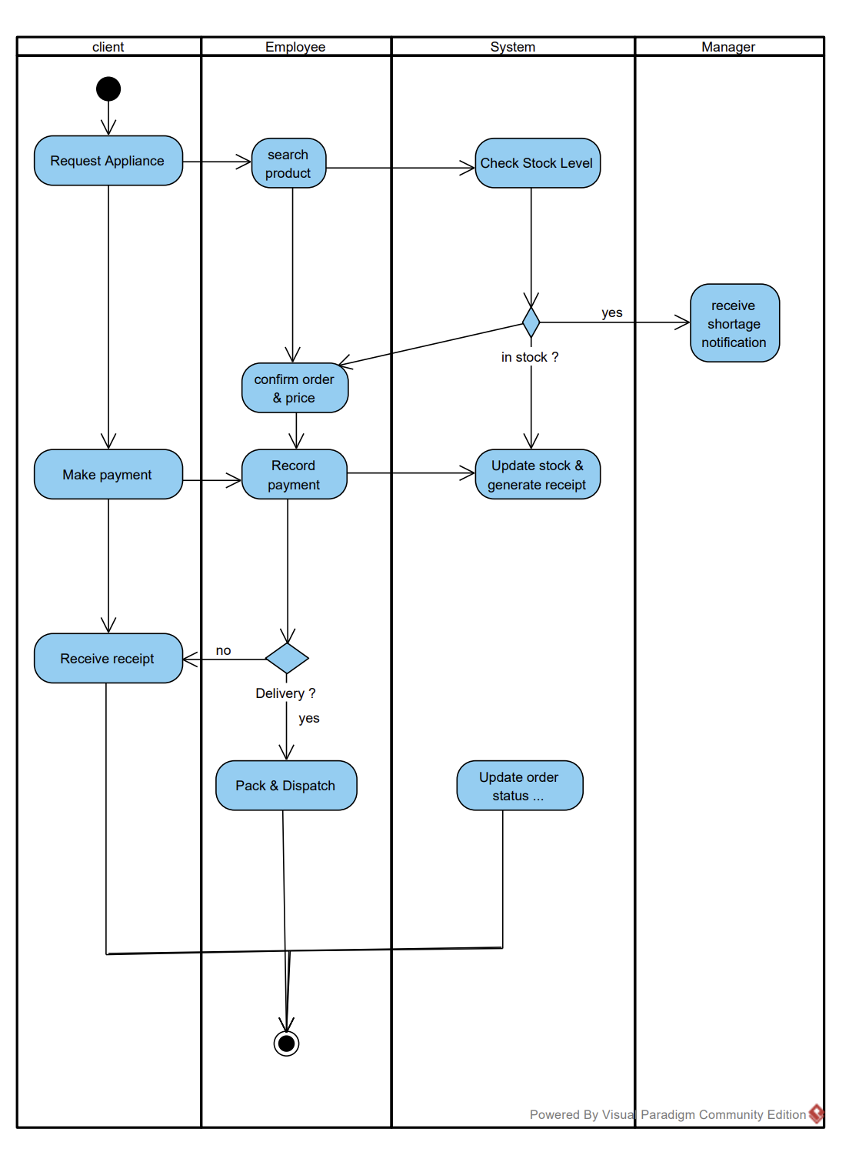
Figure 2 — Activity Diagram AD-1: SS-1 Sales Management | [ Swimlanes: Client | Employee | System | Manager ] | [ Start: Client requests appliance / Internet order arrives. End: Receipt issued, status updated. ] | [ Decision: Channel? (In-store/Internet); Stock available? (Yes/No); Delivery requested? (Yes/No) ] | [ Author: All group members]

2.5 Sequence Diagrams — SS-1
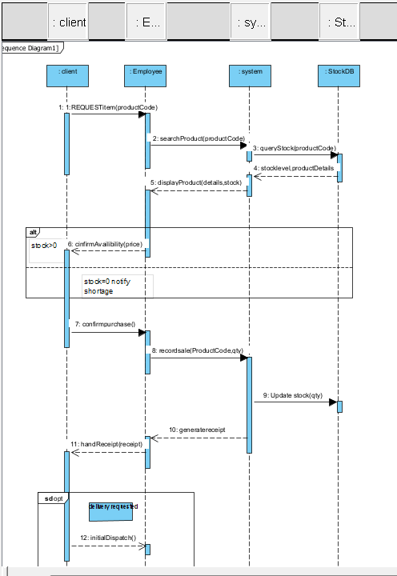
Figure 3 — SeqD-1: UC1-1 Process In-Store Sale | [ Lifelines: :Client | :Employee | :System | :StockDB | :TransactionDB ] | [ alt: [stock > 0] → continue / [stock = 0] → notifyManager() ] | [ Author: All group members ]

3. Subsystem 2 — Order Fulfillment & Delivery (SS-2)
Author: Lyne Ngouowa | SS-2: Order Fulfillment & Delivery

This subsystem covers the Client-facing ordering experience: browsing and selecting appliances, placing direct or Internet orders, requesting packing and home delivery, making payment (including optional shipping fee), and tracking the shipment.

3.1 Use Case Diagram — SS-2
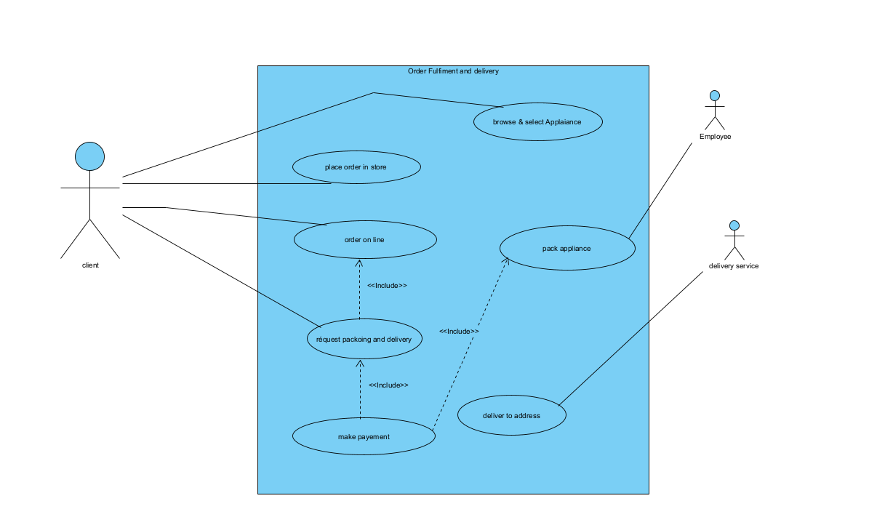
Figure 6 — Use Case Diagram: SS-2 Order Fulfillment & Delivery | [ Primary actor: Client (left). Supporting actors: Employee (right), Delivery Service (right) ] | [ UC IDs: UC2-1 Browse & Select Appliance; UC2-2 Place Direct Order; UC2-3 Place Internet Order; UC2-4 Request Packing & Home Delivery; UC2-5 Track Delivery ] | [ Author: Lyne Ngouowa ]

3.2 User Stories — SS-2
ID | As a ... | I want to ... | So that ...
US2-1 | Client | browse and select appliances with their prices and specs | I can make an informed purchase decision before ordering
US2-2 | Client | place a direct in-store order at the counter | I can buy an appliance immediately on my visit
US2-3 | Client | place an order via the Internet portal | I do not need to visit the shop in person
US2-4 | Client | request packing and home delivery of my purchased appliance | I do not need to transport a large or heavy item myself
US2-5 | Client | view the shipping fee before confirming the delivery request | I know the full cost before committing to pay
US2-6 | Client | make payment for the appliance and optional shipping fee | my order is confirmed and the shop can process it
US2-7 | Client | receive a tracking number once my order is dispatched | I can monitor the shipment and plan for its arrival
US2-8 | Client | be notified when a previously unavailable item comes back in stock | I can complete my order without repeatedly contacting the shop

3.3 Use Case Scenarios — SS-2

UC2-1 Browse & Select Appliance
Use Case ID | UC2-1
Actor(s) | Client (primary), System (secondary)
Goal | Allow the Client to browse the catalogue, find an appliance and view its details before ordering.
Precondition | System is online. Catalogue contains at least one active product.
Trigger | Client opens the catalogue or enters a search term.
Main Flow — Success Scenario | 1. Client browses categories or enters a search keyword.  2. System retrieves and displays matching appliances with name, photo, price, and stock status.  3. Client applies optional filters (category, price range, availability).  4. System updates the list in real time.  5. Client selects an appliance to view full details (price, specs, photos, stock level).  6. If stock > 0: Client can proceed to place an order (UC2-2 or UC2-3).  7. If stock = 0: System displays 'Currently unavailable' and offers a stock alert subscription.
Alternate / Extension Flows | • A1 — No results found: System suggests related categories.  • A2 — Client subscribes to stock alert: System records the subscription and notifies Client when item is restocked (UC3-5).
Postcondition | Client has viewed appliance details and can proceed to order.
Exception / Error Flows | Catalogue database unavailable → System displays error and invites Client to retry.

UC2-2 Place Direct Order (In-Store)
Use Case ID | UC2-2
Actor(s) | Client (primary), Employee (secondary)
Goal | Register a direct in-store purchase, update stock, and issue a receipt.
Precondition | Employee is logged in. Client is present at the counter.
Trigger | Client requests to purchase an appliance at the counter.
Main Flow — Success Scenario | 1. Employee searches for the appliance in the system (includes UC1-3).  2. System displays product details, price, and stock level.  3. Employee adds the appliance and quantity to the transaction.  4. System calculates the total including tax.  5. Client makes payment (includes UC2-6: Make Payment).  6. System decrements stock, records the transaction, and generates a receipt.  7. Employee hands the receipt to the Client.
Alternate / Extension Flows | • A1 — Out of stock: UC3-1 (Shortage Notification) triggered. Employee informs Client of delay.  • A2 — Client requests delivery: Employee initiates UC2-4 (Request Packing & Delivery) after payment.
Postcondition | Sale recorded; stock updated; receipt issued.
Exception / Error Flows | Payment declined → transaction cancelled; stock NOT decremented.

UC2-3 Place Internet Order
Use Case ID | UC2-3
Actor(s) | Client (primary), System (secondary)
Goal | Client successfully submits an online order through the Internet portal.
Precondition | Client is registered on the portal or using guest checkout.
Trigger | Client clicks 'Place Order' on the checkout page.
Main Flow — Success Scenario | 1. System displays the cart summary: items, quantities, prices, and subtotal.  2. Client reviews and confirms the delivery address.  3. System checks stock availability for all items in the cart (includes UC1-3).  4. System calculates optional shipping fee if delivery is requested.  5. Client selects payment method and confirms payment (includes UC2-6).  6. System records the order with status 'Received' and generates an order reference.  7. System sends order confirmation e-mail to Client.  8. Order appears in the Employee's Internet order queue.
Alternate / Extension Flows | • A1 — Item out of stock: System flags the item; Client can remove it or wait.  • A2 — Payment failed: System retains the cart; Client prompted to retry or change method.
Postcondition | Order recorded; Client notified by e-mail; order in Employee queue.
Exception / Error Flows | Internet connection lost during checkout → cart saved; Client re-enters checkout on reconnection.

UC2-4 Request Packing & Home Delivery
Use Case ID | UC2-4
Actor(s) | Client (primary), Employee (secondary), Delivery Service (secondary)
Goal | Client's purchased appliance is professionally packed and delivered to their home address.
Precondition | Payment for the appliance confirmed. Client requests delivery and provides a valid address.
Trigger | Client selects 'Request Home Delivery' during or after checkout.
Main Flow — Success Scenario | 1. Client provides delivery address.  2. System calculates the shipping fee based on address and appliance weight/dimensions.  3. Client is informed of the shipping fee and accepts.  4. Client pays the shipping fee (includes UC2-6).  5. Employee is notified to prepare the item for dispatch.  6. Employee packs the appliance and prints the dispatch label.  7. Delivery Service collects the packed parcel and issues a tracking number.  8. System records the tracking number and updates order status to 'Dispatched'.  9. System sends the tracking number to Client by e-mail/SMS.
Alternate / Extension Flows | • A1 — Client refuses shipping fee: Client opts for in-store collection; order marked 'Ready for Collection'.  • A2 — Address not serviceable: System flags address; Employee advises Client to collect from shop.
Postcondition | Parcel handed to Delivery Service; tracking number sent to Client; order status = 'Dispatched'.
Exception / Error Flows | Delivery Service unavailable → parcel stored; order marked 'Awaiting Delivery Collection'.

UC2-5 Track Delivery
Use Case ID | UC2-5
Actor(s) | Client (primary), System (secondary), Delivery Service (secondary)
Goal | Allow the Client to monitor the real-time status and estimated delivery date of their shipment.
Precondition | Order has status 'Dispatched'. A tracking number is recorded in the system.
Trigger | Client clicks the tracking link in the dispatch confirmation e-mail or in their account.
Main Flow — Success Scenario | 1. Client accesses the tracking page for their order.  2. System retrieves the current tracking information from the Delivery Service API.  3. System displays: current status, location, and estimated delivery date.  4. At delivery: System updates order status to 'Delivered' and notifies Client.
Alternate / Extension Flows | • A1 — Delivery failed (no one home): Delivery Service updates status; System notifies Client; redelivery scheduled.  • A2 — Tracking data unavailable: System shows last known status with a note to contact Delivery Service.
Postcondition | Client has viewed shipment status.
Exception / Error Flows | Delivery Service API unavailable → System shows last known status with timestamp.

3.4 Activity Diagram — SS-2
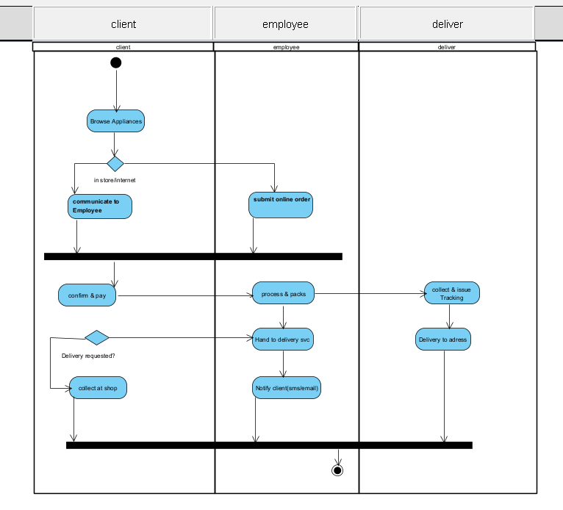
Figure 7 — Activity Diagram AD-2: SS-2 Order Fulfillment & Delivery | [ Swimlanes: Client | Employee / System | Delivery Service ] | [ Start: Client browses appliances. End: Appliance delivered or collected. ] | [ Decision: Channel? (In-store / Internet); Delivery requested? (Yes/No); Fee accepted? ] | [ Author: Lyne Ngouoawa ]

3.5 Sequence Diagrams — SS-2
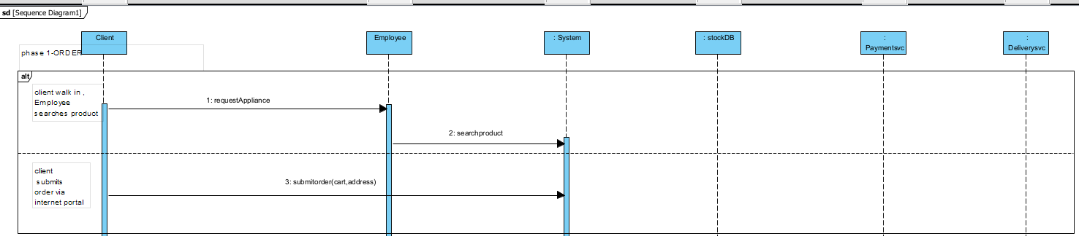
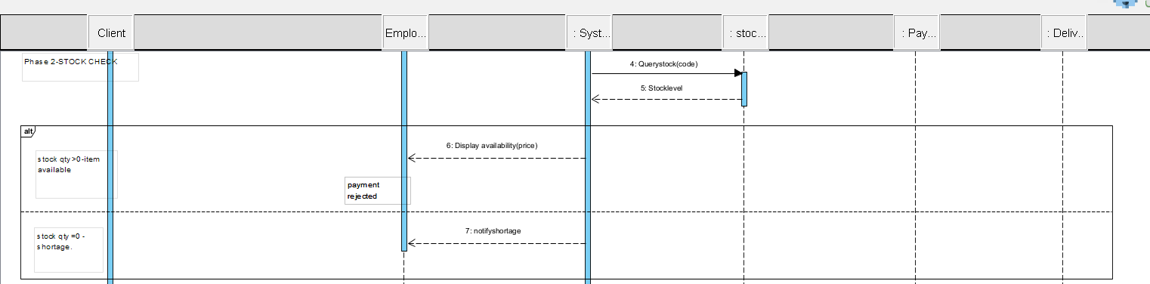
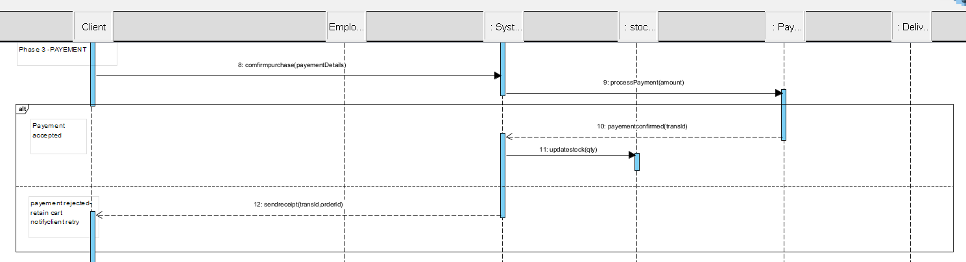
Figure 8 — SeqD-4: UC2-3 Place Internet Order | [ Lifelines: :Client | :System | :Employee | : ] | [ Author: Lyne Ngouowa ]

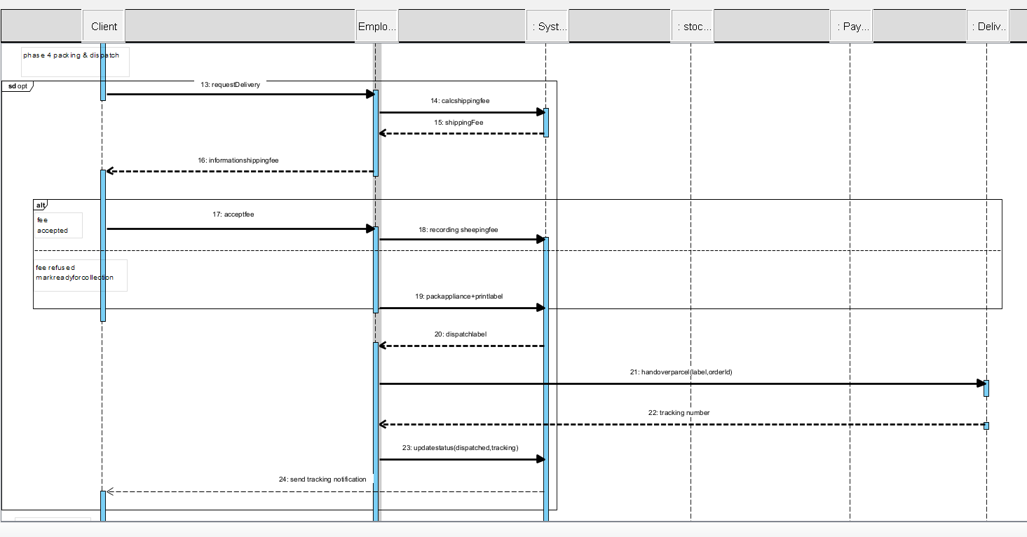
Figure 9 — SeqD-5: UC2-4 Request Packing & Home Delivery | [ Lifelines: :Client | :Employee | :System | :DeliveryService ] | [ Author: Lyne Ngouowa ]

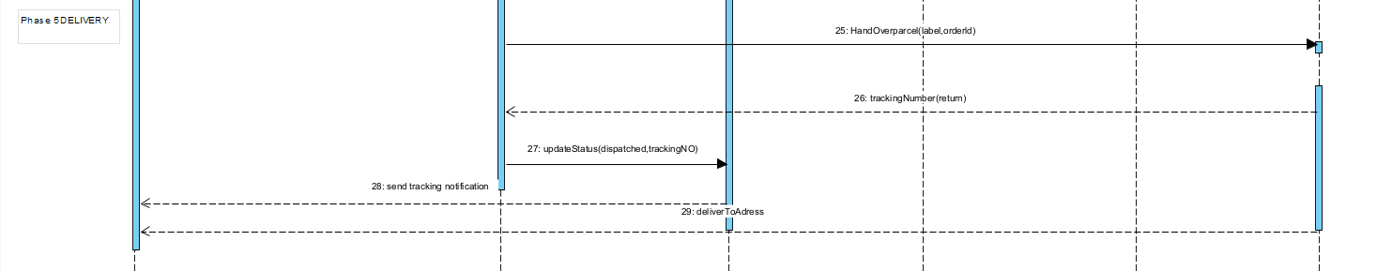
Figure 10 — SeqD-5: UC2-4 Home Delivery | [ Lifelines: :Client | :Employee | :System | :DeliveryService ] | [ Author: Lyne Ngouowa ]

4. Subsystem 3 — Procurement & Stock Management (SS-3)
Author: Member 3 — Orlane Njibou | SS-3: Procurement & Stock Management

This subsystem handles stock shortage notifications, the Manager's procurement decisions, formal purchase orders to suppliers, stock receipt confirmation, and automatic Employee notifications when restocked items become available.

4.1 Use Case Diagram — SS-3
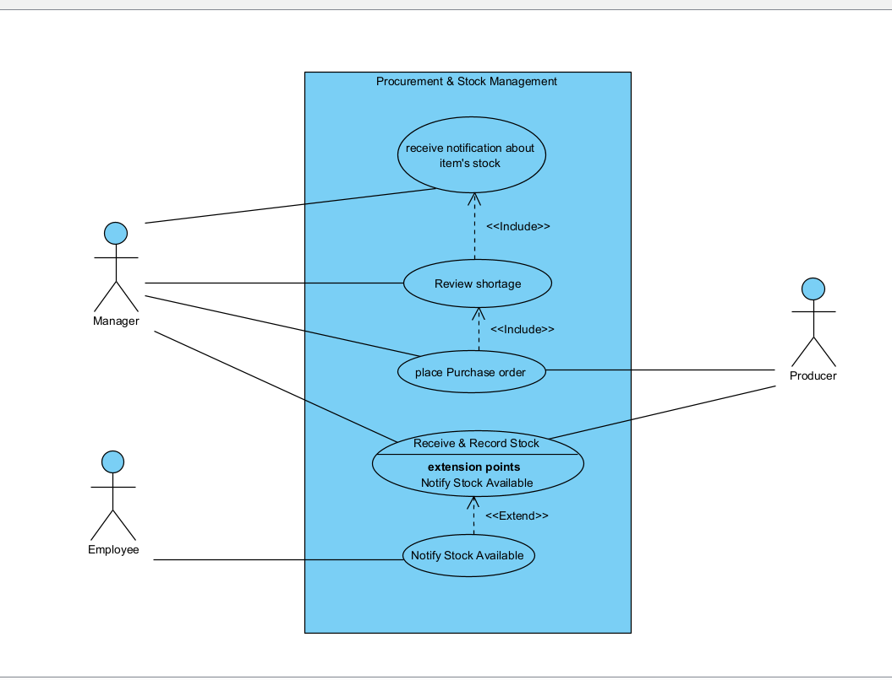
Figure 11 — Use Case Diagram: SS-3 Procurement & Stock Management | [ Primary actor: Manager (left). Supporting: Employee (left), Warehouse/Producer (right) ] | [ UC IDs: UC3-1 Receive Shortage Notification; UC3-2 Review Shortage & Decide; UC3-3 Place Purchase Order; UC3-4 Confirm Receipt of Restocked Appliances; UC3-5 Notify Employee — Stock Available ] | [ Author: Orlane Njibou ]

4.2 User Stories — SS-3
ID | As a ... | I want to ... | So that ...
US3-1 | Manager | receive an automatic notification when an item's stock reaches zero | I am immediately aware of shortages without waiting for an Employee report
US3-2 | Manager | view full shortage details including pending Client orders | I can assess urgency and quantity before deciding on procurement
US3-3 | Manager | compare available suppliers on price and lead time | I can make a cost-effective and timely procurement decision
US3-4 | Manager | place a formal purchase order to the selected supplier | the procurement is officially recorded and traceable
US3-5 | Manager | confirm receipt of delivered stock and update inventory | the system immediately reflects accurate stock levels for Employees and Clients
US3-6 | Employee | be notified when a previously out-of-stock item becomes available | I can immediately fulfil the pending Client order
US3-7 | Manager | view a dashboard of current stock levels for all appliances | I can proactively identify low-stock items before a shortage occurs
US3-8 | Manager | mark a restocked item as 'Back in Stock' in the system | pending Client orders can be automatically fulfilled

4.3 Use Case Scenarios — SS-3

UC3-1 Receive Stock Shortage Notification
Use Case ID | UC3-1
Actor(s) | System (primary, automatic), Manager (recipient), Employee (alternative trigger)
Goal | Ensure the Manager is immediately and fully informed when an appliance reaches zero stock.
Precondition | Stock of an appliance has just reached 0 following a sale or manual check.
Trigger | System detects stockQty = 0 after a stock decrement. OR Employee manually reports a shortage.
Main Flow — Success Scenario | 1. System detects that an appliance's stock quantity has reached 0.  2. System creates a StockAlert record: appliance name, code, quantity needed, pending Client orders.  3. System sends a notification to the Manager (dashboard alert + e-mail).  4. Appliance is automatically marked as 'Out of Stock' in the catalogue.  5. Manager receives the notification and reviews shortage details (triggers UC3-2).
Alternate / Extension Flows | • A1 — Employee manually reports shortage: Employee selects 'Report Shortage'; system creates alert and notifies Manager.
Postcondition | StockAlert recorded; Manager notified; appliance marked 'Out of Stock' in catalogue.
Exception / Error Flows | Notification delivery failure → alert remains in Manager dashboard; system retries sending.

UC3-2 Review Shortage & Decide on Procurement
Use Case ID | UC3-2
Actor(s) | Manager (primary)
Goal | Assess the stock shortage and decide on the most appropriate procurement action.
Precondition | UC3-1 (Shortage Notification) has been received. Manager is logged in.
Trigger | Manager opens the stock shortage notification in the system.
Main Flow — Success Scenario | 1. System displays shortage details: appliance name, code, stock = 0, quantity needed, pending Client orders.  2. Manager reviews cooperating warehouse stock availability and pricing.  3. Manager reviews producer pricing and estimated lead time.  4. Manager selects the preferred supplier and specifies the required quantity.  5. Manager confirms the procurement decision.  6. System proceeds to UC3-3 (Place Purchase Order).
Alternate / Extension Flows | • A1 — Neither supplier has stock: Manager defers; system marks item 'Backordered — No Supplier'; reviewed weekly.  • A2 — Manager decides not to reorder (discontinued): Item flagged 'Discontinued'; affected Clients notified.
Postcondition | Procurement decision recorded; UC3-3 initiated or item flagged as deferred/discontinued.
Exception / Error Flows | System cannot retrieve supplier data → Manager records decision manually; system updated when connectivity restored.

UC3-3 Place Purchase Order to Supplier
Use Case ID | UC3-3
Actor(s) | Manager (primary), Warehouse / Producer (secondary)
Goal | Submit a formal purchase order to the selected supplier to restock the shortage appliance.
Precondition | UC3-2 completed; supplier and quantity confirmed by Manager.
Trigger | Manager confirms procurement decision in UC3-2.
Main Flow — Success Scenario | 1. System pre-fills the purchase order: supplier name, appliance code, quantity, and date.  2. Manager reviews and edits the purchase order if needed.  3. Manager submits the purchase order.  4. System records the purchase order with status 'Submitted'.  5. System transmits the purchase order to the supplier's system.  6. Supplier acknowledges receipt; System updates purchase order status to 'Confirmed'.
Alternate / Extension Flows | • A1 — Supplier does not acknowledge within 24h: System sends automated reminder; Manager notified after 48h.
Postcondition | Purchase order recorded and acknowledged by supplier; restocking in progress.
Exception / Error Flows | Transmission to supplier fails → purchase order flagged 'Transmission Error'; Manager contacts supplier directly.

UC3-4 Confirm Receipt of Restocked Appliances
Use Case ID | UC3-4
Actor(s) | Manager (primary), System (secondary)
Goal | Update inventory to reflect newly delivered stock and enable fulfilment of pending Client orders.
Precondition | Purchase order (UC3-3) has been confirmed. Supplier delivers appliances to the shop.
Trigger | Manager selects 'Confirm Stock Receipt' on the open purchase order.
Main Flow — Success Scenario | 1. Manager opens the purchase order in the system.  2. Manager verifies the delivered quantity against the order.  3. Manager confirms receipt and enters the actual received quantity.  4. System updates the appliance's stock quantity.  5. System marks the StockAlert as 'Resolved'.  6. System notifies Employee(s) that the item is now back in stock (UC3-5).  7. Employee(s) can now fulfil any pending Client orders.
Alternate / Extension Flows | • A1 — Partial delivery: Manager records actual quantity; purchase order remains open for remainder.  • A2 — Damaged goods: Manager refuses the lot; purchase order marked 'Disputed'; supplier contacted.
Postcondition | Stock updated; StockAlert resolved; Employee notified; pending orders can be fulfilled.
Exception / Error Flows | System unavailable during confirmation → Manager records on paper; system updated when restored.

UC3-5 Notify Employee — Stock Available
Use Case ID | UC3-5
Actor(s) | System (primary, automatic), Employee (recipient)
Goal | Automatically inform the Employee when a previously out-of-stock appliance is restocked so pending orders can be fulfilled.
Precondition | UC3-4 (stock receipt confirmed) has been completed. Pending Client orders exist for the appliance.
Trigger | System detects that stock of a previously zero-quantity appliance has been updated to > 0.
Main Flow — Success Scenario | 1. System identifies all pending Client orders for the newly restocked appliance.  2. System sends a notification to the responsible Employee(s): appliance name, quantity available, list of pending orders.  3. Employee reviews the notification and fulfils the pending orders (UC1-1 or UC1-2).  4. System updates each pending order status from 'On Hold' to 'Processing'.
Alternate / Extension Flows | • A1 — No pending orders: System simply updates the stock status; no Employee notification required.
Postcondition | Employee notified; pending orders can be immediately processed.
Exception / Error Flows | Employee notification delivery failure → alert remains in Employee dashboard; system retries.

4.4 Activity Diagram — SS-3
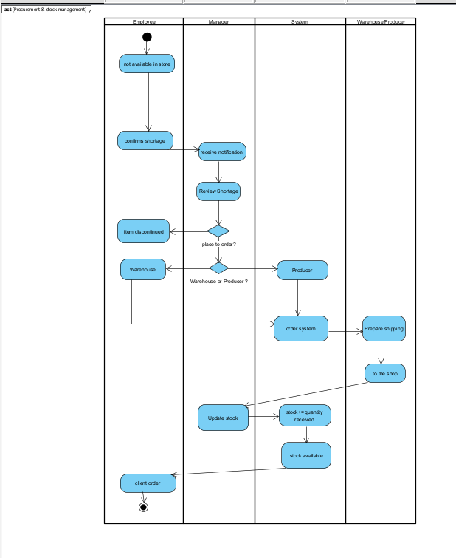
Figure 12 — Activity Diagram AD-3: SS-3 Procurement & Stock Management | [ Swimlanes: Employee | Manager | System | Warehouse/Producer ] | [ Start: Stock reaches zero. End: Inventory updated, pending orders fulfilled. ] | [ Author: Member 3 ]

4.5 Sequence Diagrams — SS-3
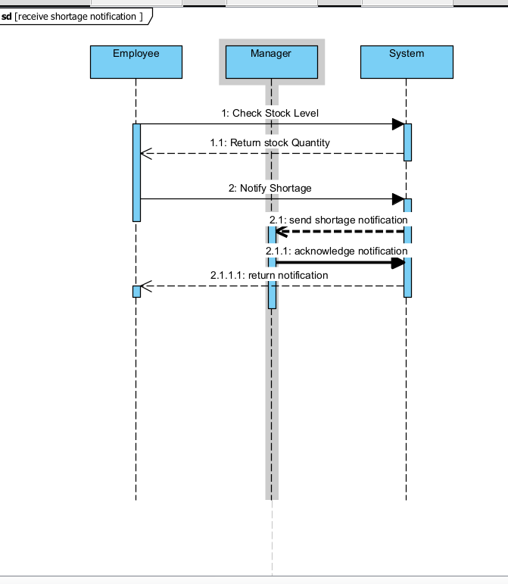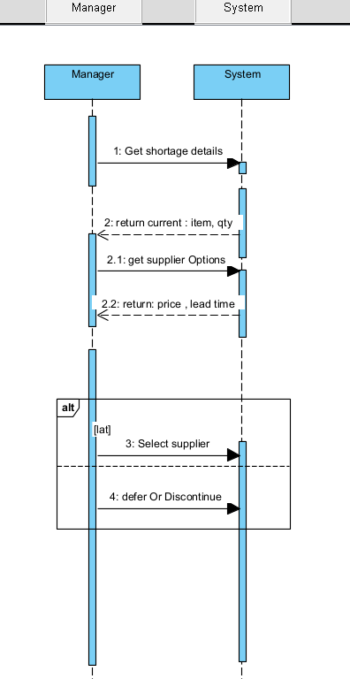
Figure 13 — SeqD-7: UC3-1 + UC3-2 Shortage & Procurement Decision | [ Lifelines: :Employee | :System | :Manager | :SupplierDB ] | [ Author: Orlane Njibou ]

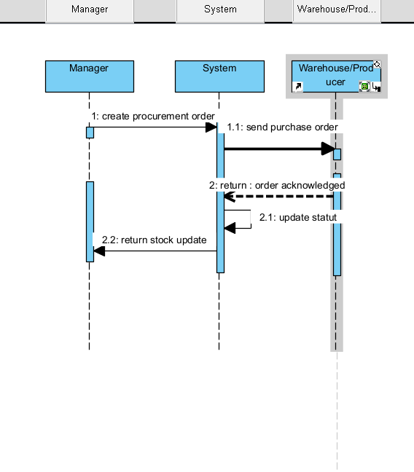 [ *** INSERT DIAGRAM FROM VISUAL PARADIGM HERE *** ]
Figure 14 — SeqD-8: UC3-3 Place Purchase Order | [ Lifelines: :Manager | :System | :Warehouse | :Producer ] | [ Author: Member 3 ]

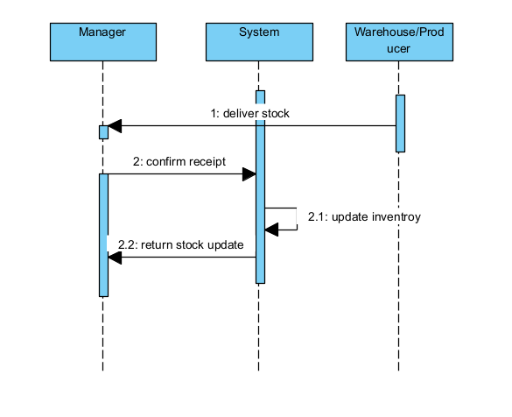 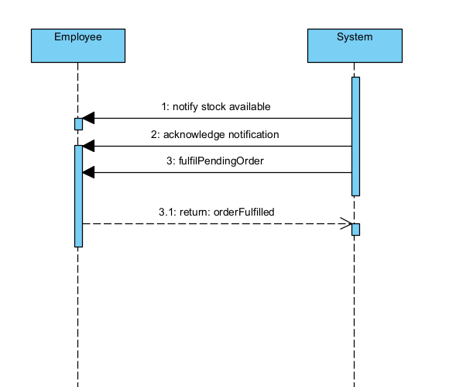 [ *** INSERT DIAGRAM FROM VISUAL PARADIGM HERE *** ]
Figure 15 — SeqD-9: UC3-4 + UC3-5 Stock Receipt & Employee Notification | [ Lifelines: :Manager | :System | :StockDB | :Employee ] | [ Author: Member 3 ]

Figures 13–15 — Sequence Diagrams SeqD-7, SeqD-8, SeqD-9: SS-3 Procurement & Stock Management

5. Subsystem 4 — Reporting & Financial Management (SS-4)
Author: Lajie Luc Junior — SS-4: Reporting & Financial Management

This subsystem models the Manager's financial oversight workflow: generating and storing monthly sales and purchase reports, previewing and exporting them, and securely transferring all financial documents to the external Book Keeper.

5.1 Use Case Diagram — SS-4
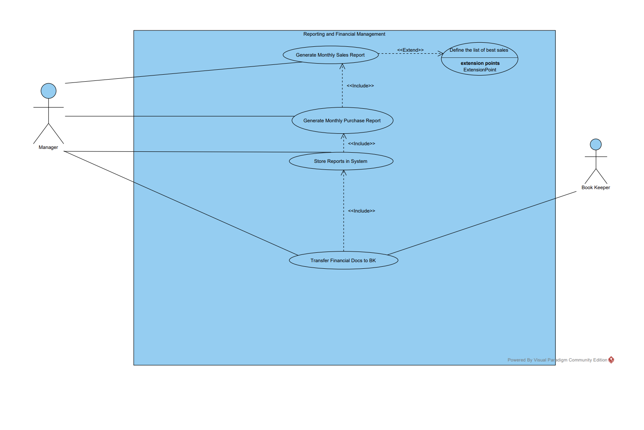
Figure 16 — Use Case Diagram: SS-4 Reporting & Financial Management | [ Primary actor: Manager (left). Secondary actor: Book Keeper (right, external) ] | [ UC IDs: UC4-1 Generate Monthly Sales Report; UC4-2 Generate Monthly Purchase Report; UC4-3 Store Report in System; UC4-4 Transfer Financial Documents to Book Keeper ] | [ Author: Luc Lajie ]

5.2 User Stories — SS-4
ID | As a ... | I want to ... | So that ...
US4-1 | Manager | generate a monthly sales report for a selected calendar period | I can review shop revenue and identify best-selling appliances
US4-2 | Manager | generate a monthly purchase report for a selected period | I can monitor procurement costs and evaluate supplier performance
US4-3 | Manager | store all generated monthly reports in the system with a timestamp | historical financial records are preserved and accessible for auditing
US4-4 | Manager | transfer all financial documents to the external Book Keeper | legal accounting obligations are fulfilled
US4-5 | Manager | preview a report before saving it | I can verify the data is correct before archiving
US4-6 | Manager | export a report in PDF or Excel format | I can share it with the Book Keeper in the required format
US4-7 | Manager | receive confirmation when the Book Keeper acknowledges receipt of documents | I have proof that the transfer was successful
US4-8 | Manager | retry a failed document transfer | accounting obligations are met even if the first attempt fails

5.3 Use Case Scenarios — SS-4

UC4-1 Generate Monthly Sales Report
Use Case ID | UC4-1
Actor(s) | Manager (primary), System (secondary)
Goal | Produce a complete, accurate monthly sales report for the selected calendar period.
Precondition | Manager is logged in with report-generation privileges. Sales transactions exist for the target period.
Trigger | Manager selects 'Generate Report → Monthly Sales' and specifies month and year.
Main Flow — Success Scenario | 1. Manager selects the reporting period (month and year).  2. System queries all sales transactions for the period.  3. System aggregates: total revenue, number of transactions, top-selling appliances by quantity and value, revenue by category.  4. System formats data into the standard monthly sales report template.  5. System displays a preview of the report.  6. Manager reviews and confirms the report is correct.  7. Manager saves the report (includes UC4-3: Store Report in System).  8. System stores the report with date/time stamp and unique report ID.
Alternate / Extension Flows | • A1 — No transactions in period: System generates a 'Zero Sales' report; stores as per UC4-3.  • A2 — Manager requests export: System offers PDF or Excel download.
Postcondition | Monthly sales report stored in system; available for transfer via UC4-4.
Exception / Error Flows | Database query timeout → Manager notified; system retries after 5 minutes.

UC4-2 Generate Monthly Purchase Report
Use Case ID | UC4-2
Actor(s) | Manager (primary), System (secondary)
Goal | Produce a complete monthly procurement/purchase report for the selected period.
Precondition | Manager is logged in. Purchase orders exist for the target period.
Trigger | Manager selects 'Generate Report → Monthly Purchases' and specifies month and year.
Main Flow — Success Scenario | 1. Manager selects the reporting period.  2. System queries all purchase orders and supplier invoices for the period.  3. System aggregates: total procurement costs, orders by supplier, quantities restocked by appliance.  4. System formats data into the standard monthly purchase report template.  5. System displays a preview.  6. Manager reviews and confirms.  7. Manager saves the report (includes UC4-3).  8. System stores the report with timestamp and unique ID.
Alternate / Extension Flows | • A1 — No purchases in period: System generates a 'Zero Purchases' report.  • A2 — Manager requests export: System offers PDF or Excel download.
Postcondition | Monthly purchase report stored in system; available for transfer via UC4-4.
Exception / Error Flows | Database query timeout → Manager notified; system retries.

UC4-3 Store Report in System
Use Case ID | UC4-3
Actor(s) | System (primary, automated), Manager (secondary)
Goal | Persist a generated report with a unique identifier, timestamp, and transfer status.
Precondition | A report has been generated (UC4-1 or UC4-2) and confirmed by the Manager.
Trigger | Manager confirms the report in UC4-1 or UC4-2.
Main Flow — Success Scenario | 1. System assigns a unique report ID (e.g. RPT-SALES-2026-02).  2. System saves the report with: ID, type, period, generation date/time, status = 'Stored'.  3. System confirms storage: 'Report saved successfully'.  4. Report becomes available in the Manager's report archive.
Alternate / Extension Flows | • A1 — Storage failure: System notifies Manager; report saved to local file with manual upload instruction.
Postcondition | Report persisted in system archive with status 'Stored'.
Exception / Error Flows | Database full / storage error → Manager notified; report exported locally.

UC4-4 Transfer Financial Documents to Book Keeper
Use Case ID | UC4-4
Actor(s) | Manager (primary), Book Keeper (secondary, external)
Goal | Securely transfer all relevant financial documents for the period to the external Book Keeper.
Precondition | Monthly reports generated and stored (UC4-1, UC4-2, UC4-3 complete). All invoices and receipts archived.
Trigger | End of accounting period; Manager selects 'Transfer Financial Documents'.
Main Flow — Success Scenario | 1. System lists all pending financial documents: sales reports, purchase reports, purchase invoices, sales receipts.  2. Manager reviews the document list and confirms the selection.  3. Manager initiates the secure transfer to the Book Keeper.  4. System packages all documents and sends via the secure transfer channel.  5. Book Keeper acknowledges receipt.  6. System records the transfer event: timestamp, document list, recipient confirmation.  7. System marks all transferred documents as 'Transferred — [Date]'.
Alternate / Extension Flows | • A1 — Transfer fails (network error): System logs failure; Manager retries or exports documents for manual delivery.  • A2 — Book Keeper requests additional documents: Manager locates items and initiates supplementary transfer.
Postcondition | All documents delivered and acknowledged by Book Keeper; transfer event logged.
Exception / Error Flows | Secure channel permanently unavailable → Manager prints and sends physically; system updated to 'Transferred — Manual'.

5.4 Activity Diagram — SS-4
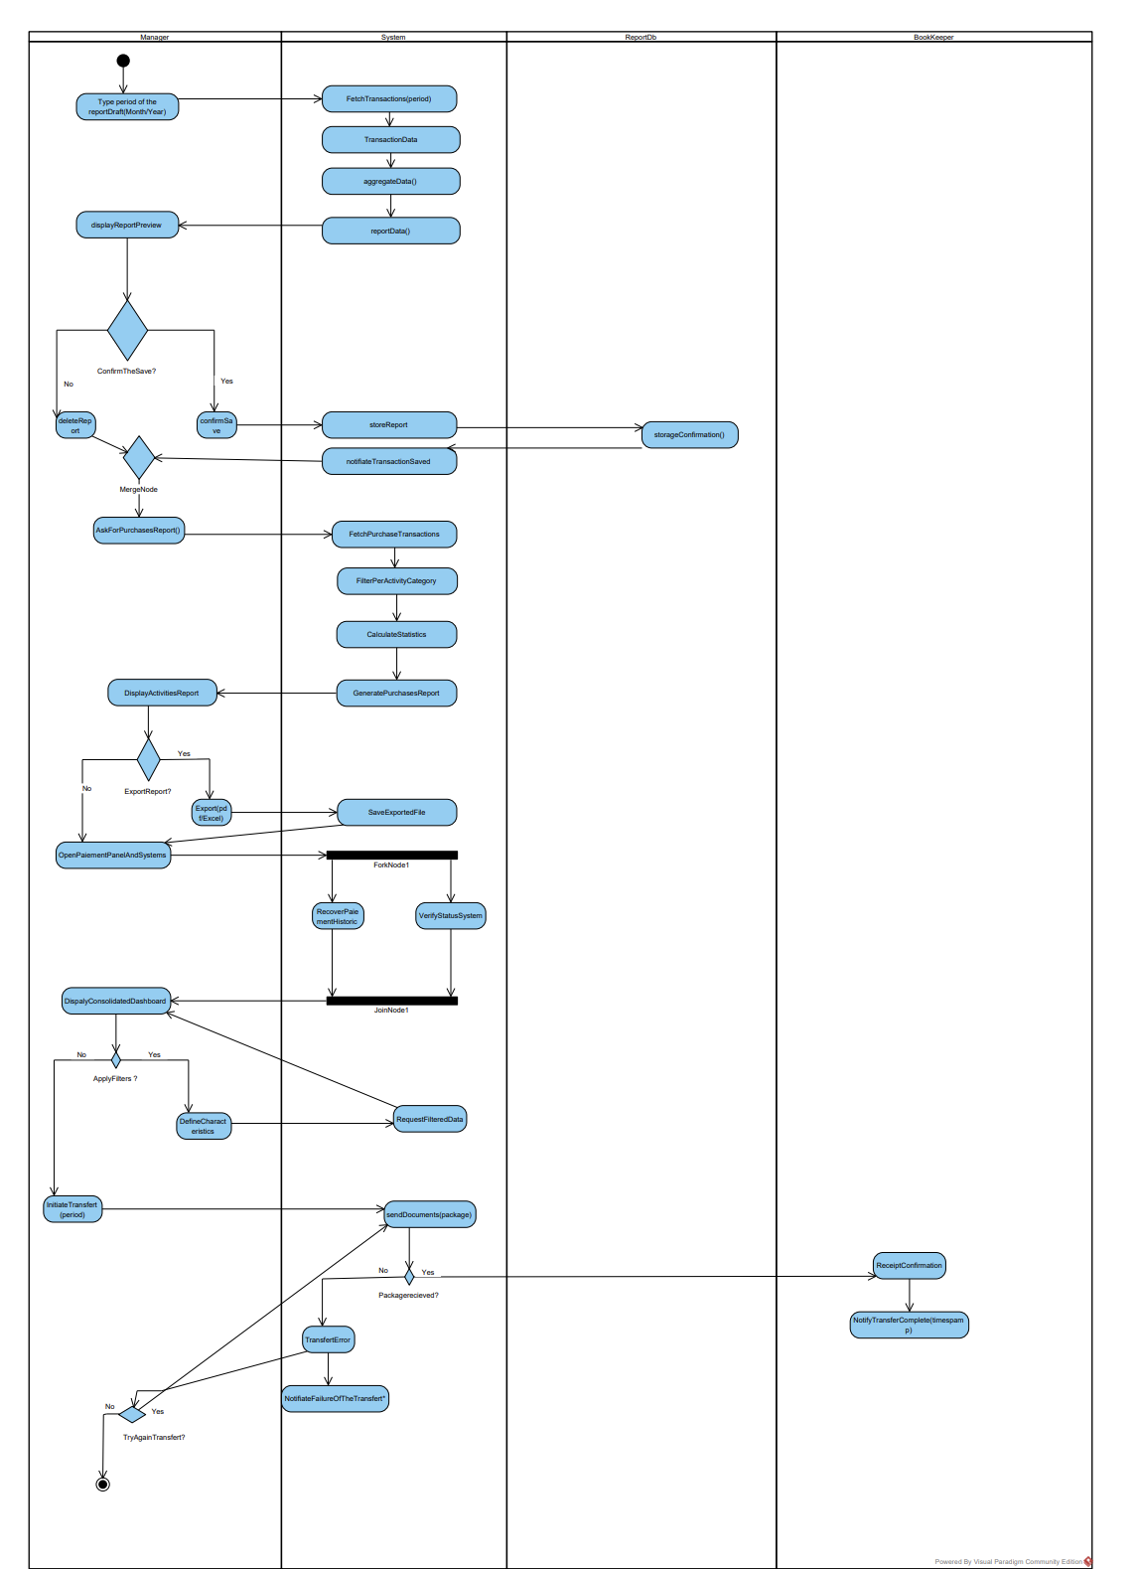
Figure 17 — Activity Diagram AD-4: SS-4 Reporting & Financial Management | [ Swimlanes: Manager | System | Book Keeper ] | [ Start: End of accounting period. End: Transfer confirmed & logged. ] | [ Fork/Join: Generate sales AND purchase reports in parallel before transfer ] | [ Author: Luc Lajie]

5.5 Sequence Diagrams — SS-4
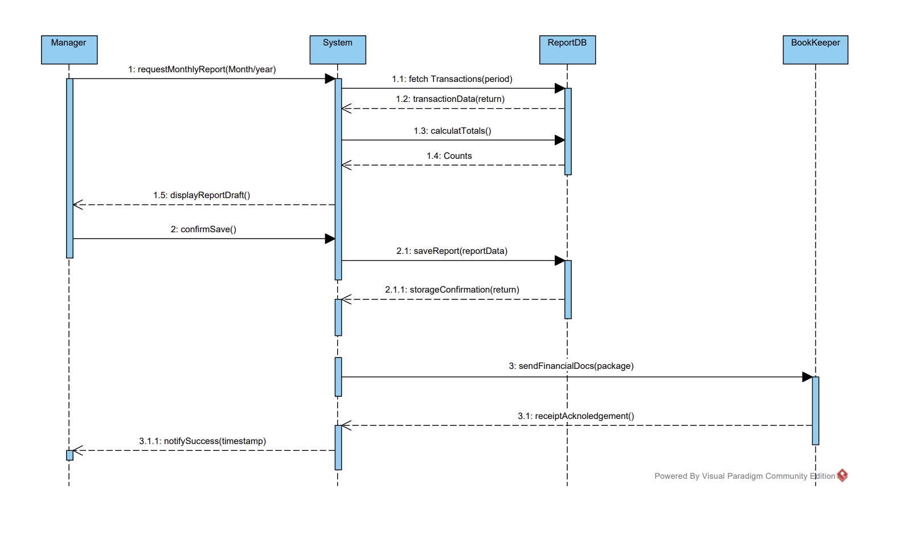
Figure 18 — SeqD-10: UC4-1 Generate Monthly Sales Report | [ Lifelines: :Manager | :System | :TransactionDB | :ReportDB ] | [ Author: Luc Lajie ]

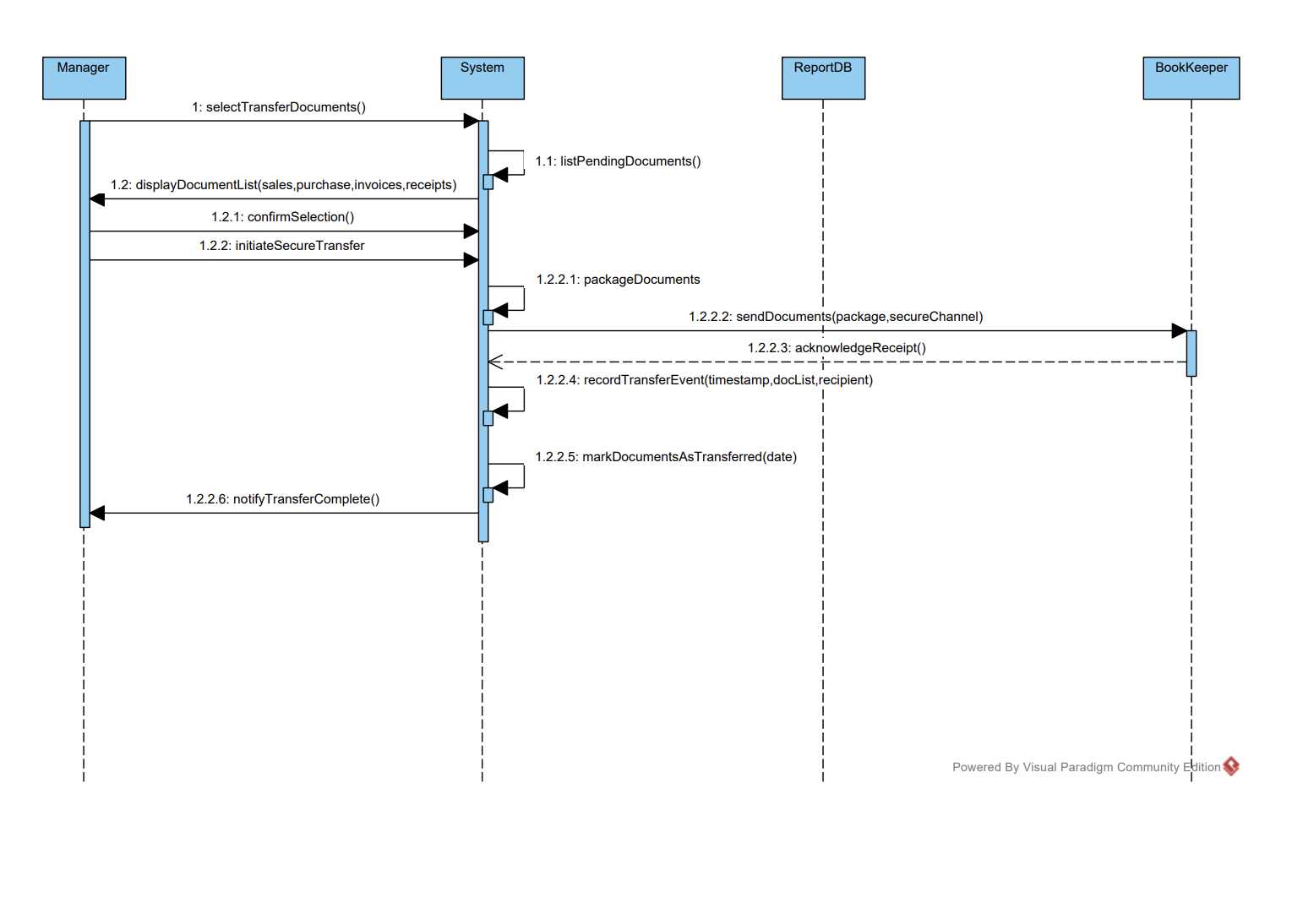
Figure19-seqD-12:UC4-2 Generate Monthly purchase Report –[Author: Luc Lajie] /[Lifelines:Manager/:System/:reportDB/:BookKeeper

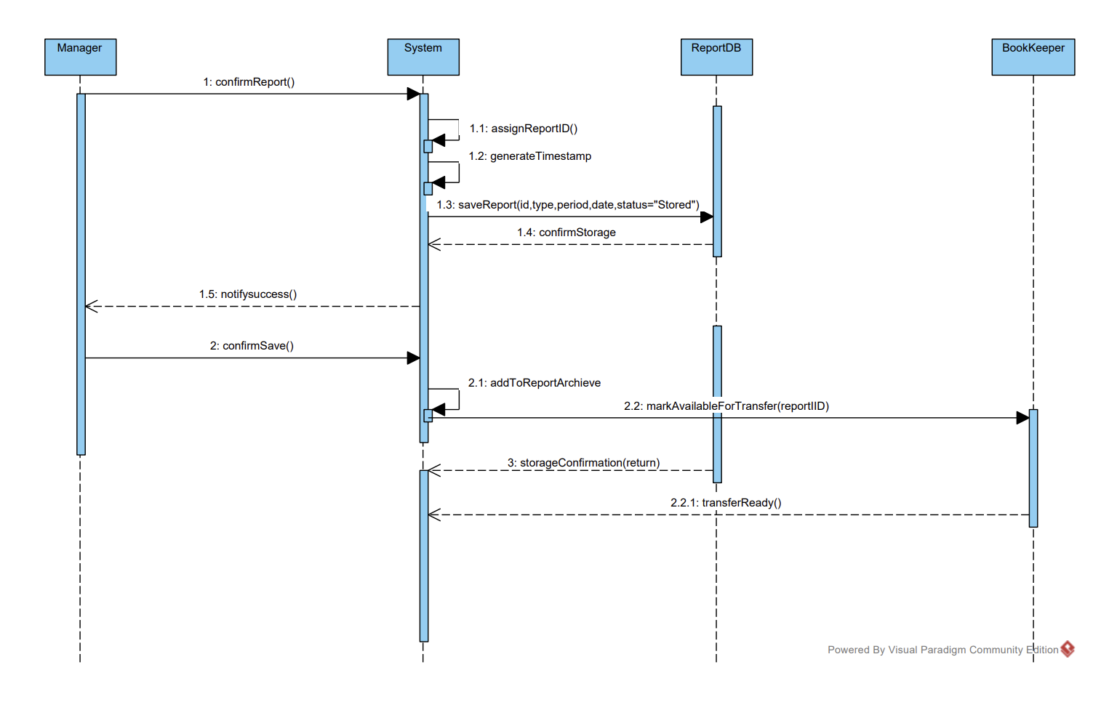
Figure 20-seqD-13:UC4-3 Store Report in System/[Lifelines:Manager/System/reportDB/BookKeeper]
Author: Luc Lajie

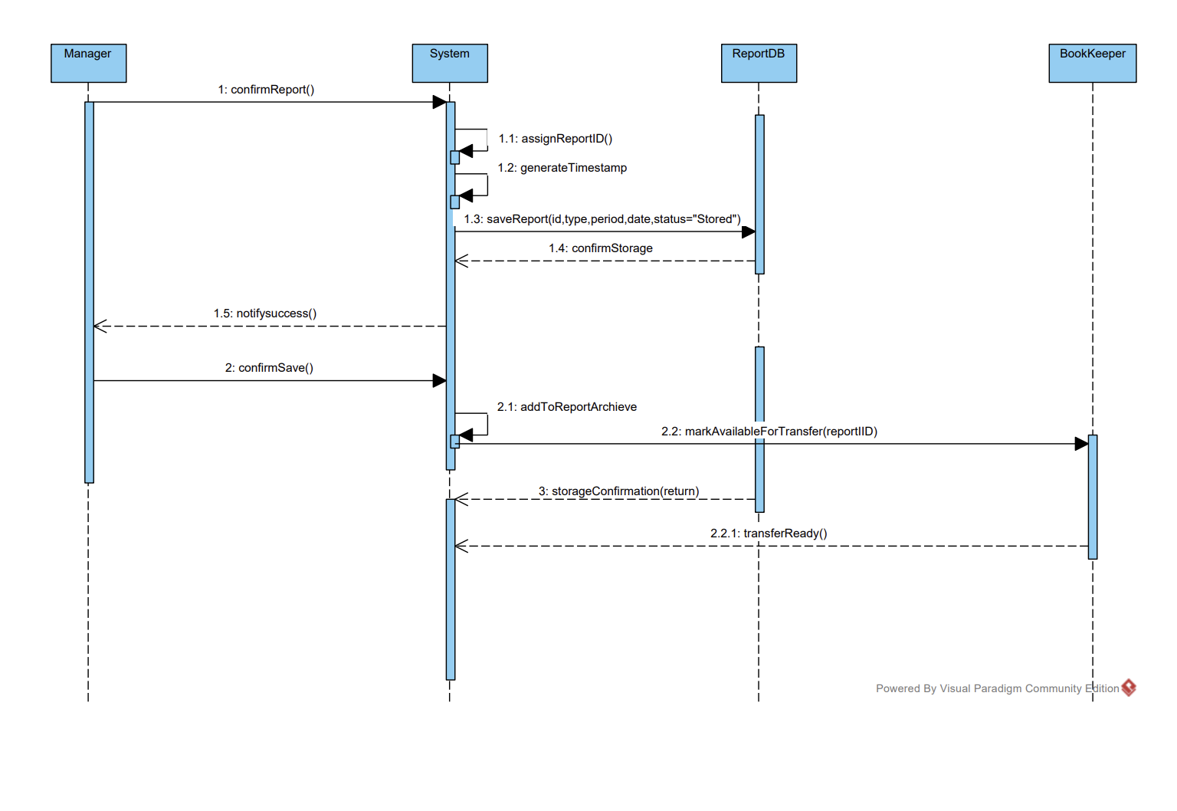
Figure 21 — SeqD-11: UC4-4 Transfer Financial Documents to Book Keeper | [ Lifelines: :Manager | :System | :ReportDB | :BookKeeper ] | [ alt: [transfer success] / [failure → retry] ] | [ Author: Luc Lajie ]

6. Class Diagram
Author: Team work — coordination: All group members — Class Diagram — HomeAppShop Domain Model

The Class Diagram is an independent structural model of the HomeAppShop domain. It captures all key business entities, their attributes and methods, and the relationships (generalisations, associations, compositions, dependencies) between them. It provides a unified structural foundation across all four subsystems.

6.1 Class Diagram Figure
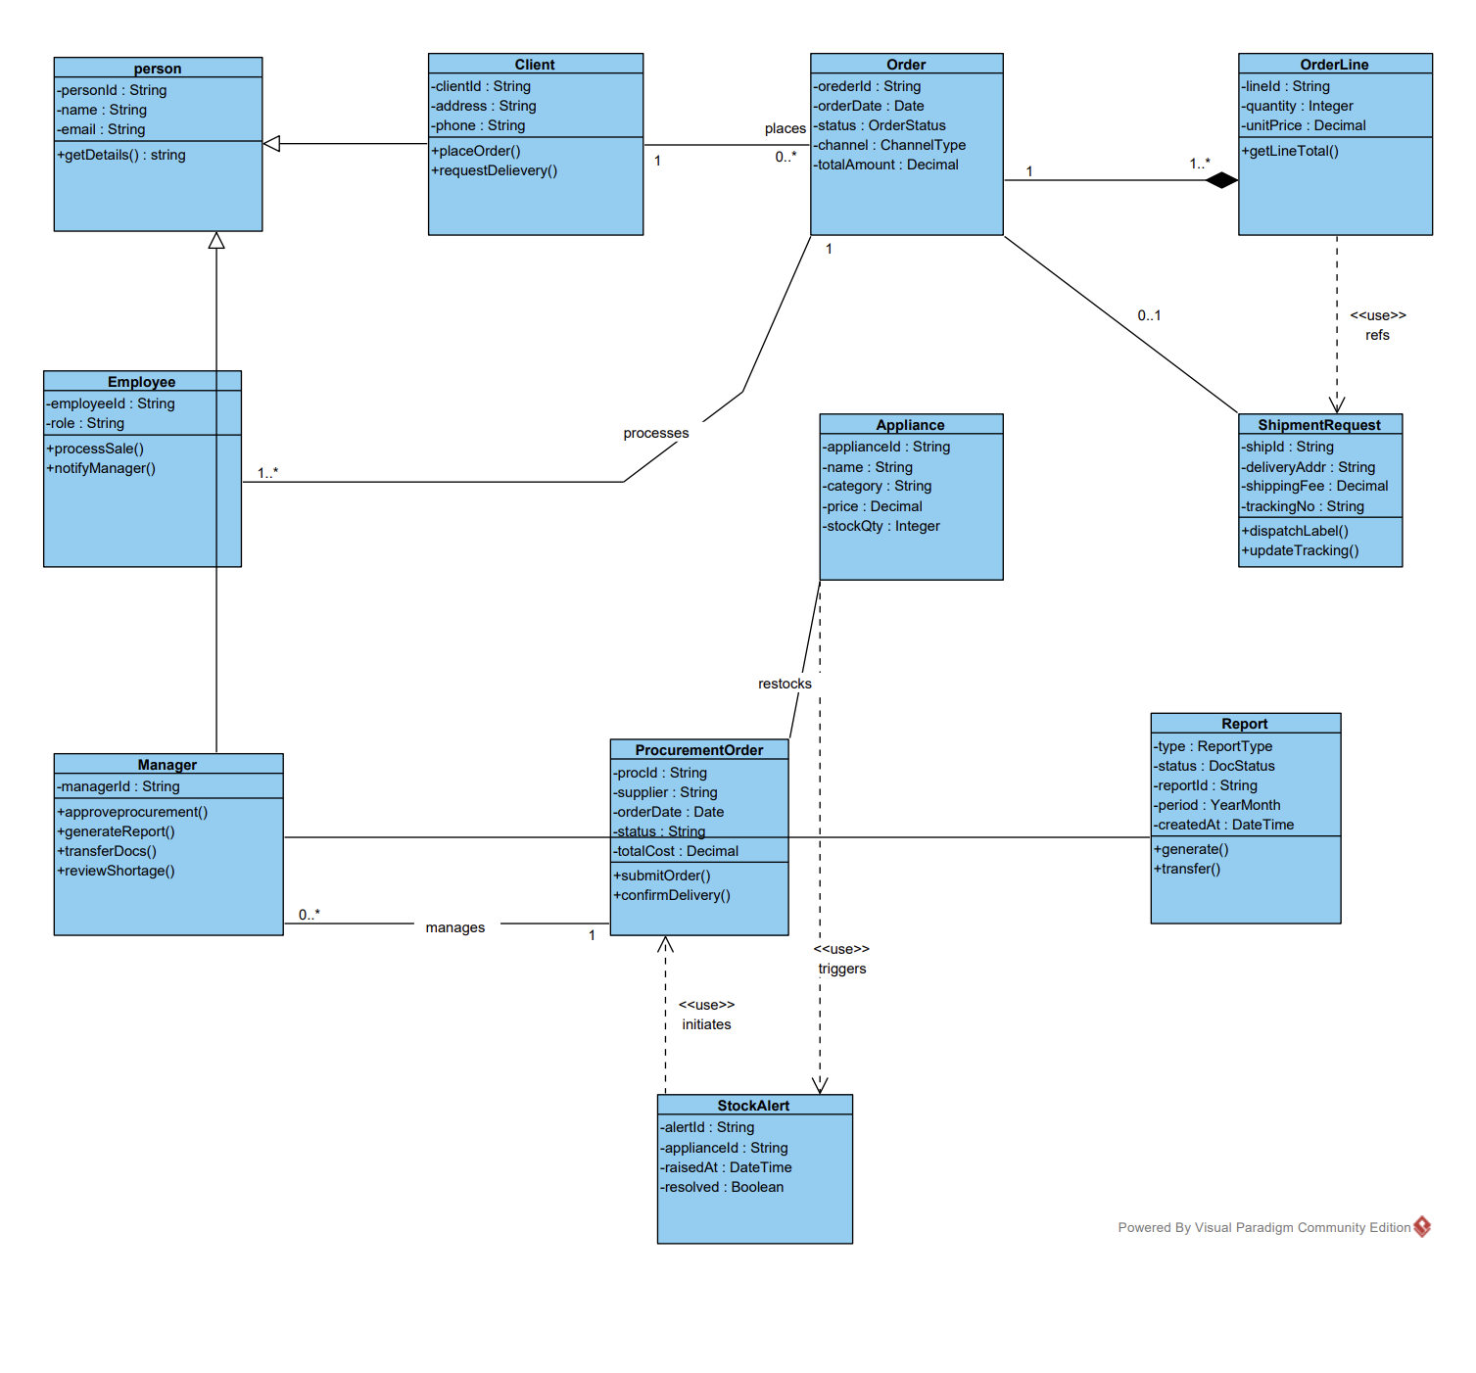
Figure 20 — Class Diagram: HomeAppShop Domain Model (all subsystems) | [ Classes: Person (abstract), Employee, Manager, Client, Appliance, Order, OrderLine, Payment, ShipmentRequest, ProcurementOrder, Report, StockAlert ] | [ Author: Team — coordination Member 4 ]

6.2 Class Descriptions
Class | Type | Responsibility | Key Attributes | Key Methods
Person | Abstract | Abstract base for all human actors. Holds common identity attributes. | personId, name, email, phone | getDetails()
Employee | Concrete (extends Person) | Processes sales, handles dispatch, notifies Manager of shortages. | employeeId, role, hireDate | processSale(); notifyManager(); arrangeDispatch()
Manager | Concrete (extends Person) | Approves procurement, generates reports, transfers financial docs. | managerId, department | decideProcurement(); generateReport(); transferDocuments()
Client | Concrete (extends Person) | Places orders, requests delivery, makes payment. | clientId, address, phone | placeOrder(); requestDelivery(); makePayment()
Appliance | Concrete | Product in catalogue. Tracks stock. Triggers StockAlert at zero. | applianceId, name, brand, category, price, stockQty | checkStock(); updateStock(qty); isAvailable()
Order | Concrete | Sales transaction. Contains order lines, payment, optional shipment. | orderId, orderDate, status, channel, totalAmount | calculateTotal(); updateStatus(); generateReceipt()
OrderLine | Concrete | One line in an Order: Appliance + quantity + unit price. | lineId, quantity, unitPrice | getLineTotal()
Payment | Concrete | Records payment for an Order or shipping fee. | paymentId, amount, method, status, dateTime | record(); generateReceipt()
ShipmentRequest | Concrete | Delivery details for Orders requiring home delivery. | shipId, deliveryAddress, shippingFee, trackingNumber, status | generateLabel(); updateTracking()
ProcurementOrder | Concrete | Formal purchase order to restock an Appliance from a supplier. | procId, supplier, orderDate, status, totalCost, expectedDelivery | submit(); confirmDelivery(); cancel()
Report | Concrete | Monthly sales or purchase report. Can be transferred to Book Keeper. | reportId, period, type, createdAt, status | generate(); store(); transfer(); export(format)
StockAlert | Concrete | Auto-raised when Appliance stockQty = 0. Links to ProcurementOrder. | alertId, applianceId, raisedAt, resolved | notifyManager(); markResolved()

6.3 Main Relationships
Relationship | Type | Multiplicity
Person → Employee / Manager / Client | Generalisation | —
Client → Order | Association | 1 — 0..*
Order → OrderLine | Composition | 1 — 1..*
OrderLine → Appliance | Association | * — 1
Order → Payment | Composition | 1 — 1
Order → ShipmentRequest | Composition | 1 — 0..1
Manager → ProcurementOrder | Association | 1 — 0..*
ProcurementOrder → Appliance | Association | * — 1
Appliance → StockAlert | Dependency | 1 — 0..*
StockAlert → ProcurementOrder | Association | 1 — 0..1
Manager → Report | Association | 1 — 0..*

6.4 Enumeration Types
- OrderStatus: {Received, Processing, Dispatched, Delivered, Ready_for_Collection, On_Hold, Cancelled}
- ChannelType: {InStore, Internet}
- ShipStatus: {Pending, With_Delivery_Service, In_Transit, Delivered, Failed}
- ReportType: {MonthlySales, MonthlyPurchase}
- DocStatus: {Generated, Stored, Transferred_Digital, Transferred_Manual}

7. Summary
This report presents the complete UML requirements model for the HomeAppShop system, developed by Team 10 as part of the OOAD with UML course (EFREI — Spring 2026, AGH University of Krakow). The model covers four subsystems — one per Team Member — each documented with Use Case Diagrams, Cockburn-pattern UC scenarios, Activity Diagrams with swimlanes, and Sequence Diagrams. A shared Class Diagram provides the unified structural foundation.

The four subsystems are defined by functional domain rather than by actor, ensuring a clean separation of concerns:
- SS-1 Sales Management covers the complete selling cycle performed by the Employee.
- SS-2 Order Fulfillment & Delivery covers the Client-facing ordering and delivery experience.
- SS-3 Procurement & Stock Management covers shortage detection, supplier selection, and restocking.
- SS-4 Reporting & Financial Management covers monthly report generation and transfer to the Book Keeper.

Subsystem | User Stories | UCD | UC Scenarios | AD | Sequence Diagrams
SS-1 Sales Management | 8 (US1-1...8) | UCD-1 | 5 (UC1-1...5) | AD-1 | SeqD-1, SeqD-2, SeqD-3
SS-2 Order Fulfillment & Delivery | 8 (US2-1...8) | UCD-2 | 5 (UC2-1...5) | AD-2 | SeqD-4, SeqD-5, SeqD-6
SS-3 Procurement & Stock Mgmt | 8 (US3-1...8) | UCD-3 | 5 (UC3-1...5) | AD-3 | SeqD-7, SeqD-8, SeqD-9
SS-4 Reporting & Financial Mgmt | 8 (US4-1...8) | UCD-4 | 4 (UC4-1...4) | AD-4 | SeqD-10, SeqD-11
Class Diagram | — | — | — | — | CD-1 (12 classes, 11 relationships)

Report submitted as: Team10_HomeAppShop_v1.docx
Presentation submitted as: Team10_HomeAppShop_v1.pptx

— End of Report —

