Student: Lucas Cardoza

Class: CSC 540 Introduction to Artificial Intelligence

Instructor: Dr. Siming Liu

Assignment: 4

For my 540 Assignment 4, Handwritten Digit Recognition using Neural Networks (NN), I made 10 runs through my program. I have listed the number of epochs and hidden layers used for each run, and a screen shot of the results for the test data of each run. I have only graphed the first fifteen results of each run to use as a comparison between runs. After reviewing the results from these runs, I think the best set of parameters would be the those of Run #10. In that run the epoch was 5 and the number of hidden layers was 40 and received an accuracy score of just over 83%. I must note that there seems to be some inconsistencies with the data. For instance, it would seem to me that the parameters for Run #5 (epoch of 5 and hidden layers of 50) would have been the best of the test runs, but the accuracy score shows otherwise. I suppose this is a good example of an overfitted model. Based on the results I have here, I would say that the epoch number seems to play a more important role in increasing accuracy than the number of hidden layers.

**Legend for the graphs:**

Blue = NN predicted the correct number in the image.

Red = NN did not predict the correct number in the image.

The format under the image, i.e., 1 15% (1), lists first the number predicted by the NN, the percentage of confidence in the accuracy of the prediction, then the actual number in the image.

**Run #1:**

Epochs: 1

Hidden layers: 5

**Results:**

Test accuracy: 0.25312933325767517

Graphs:

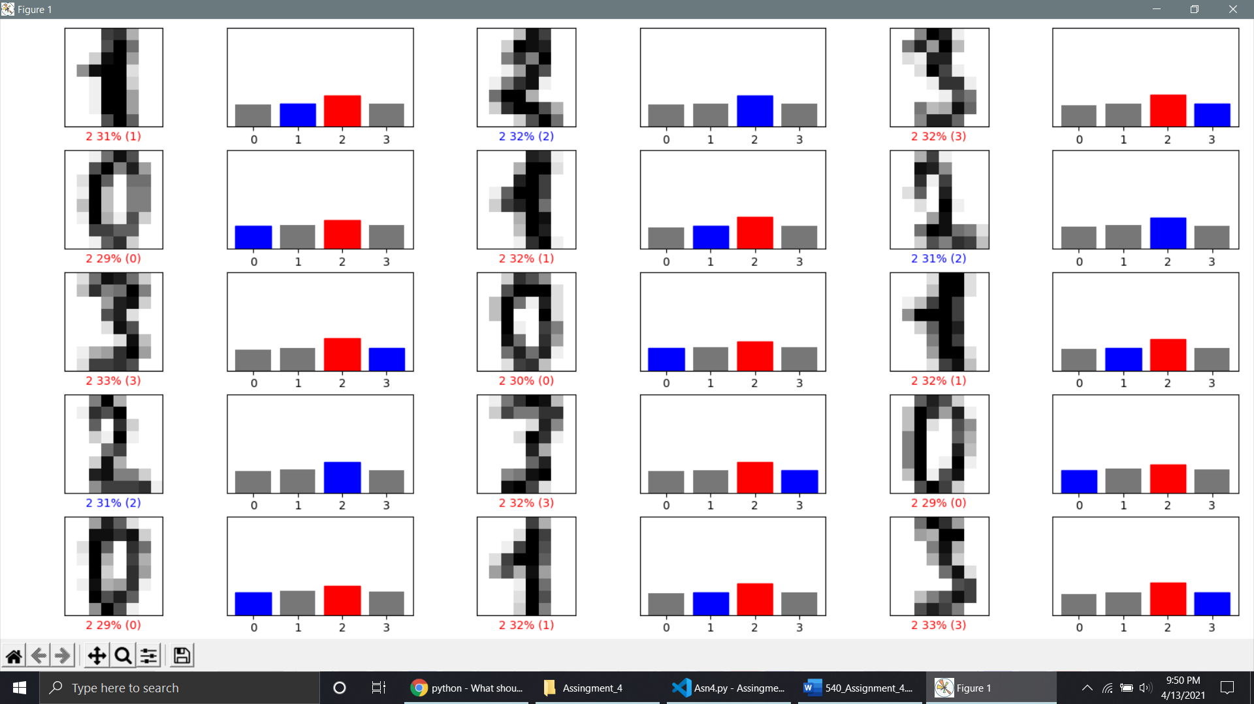

**Run #2:**

Epochs: 2

Hidden layers: 10

**Results:**

Test accuracy: 0.1515994369983673

Graphs:

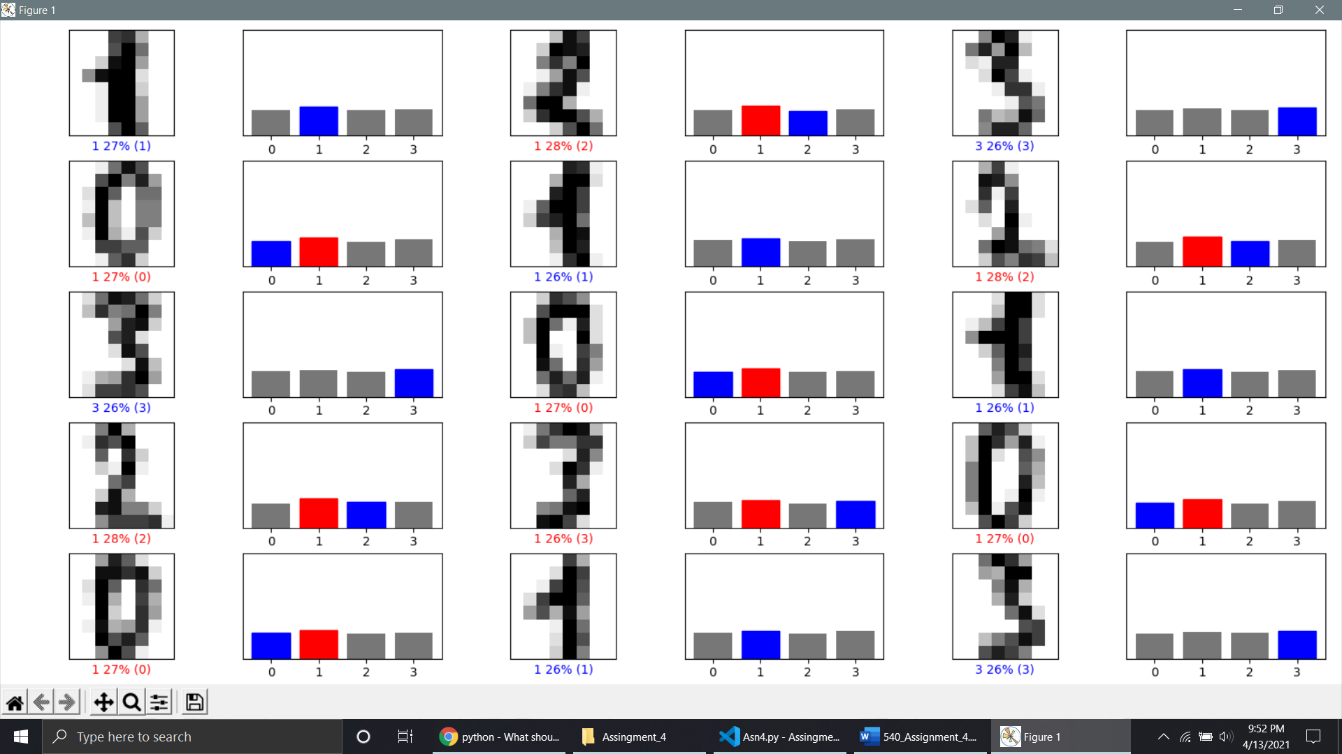

**Run #3:**

Epochs: 3

Hidden layers: 20

**Results:**

Test accuracy: 0.5883170962333679

Graphs:

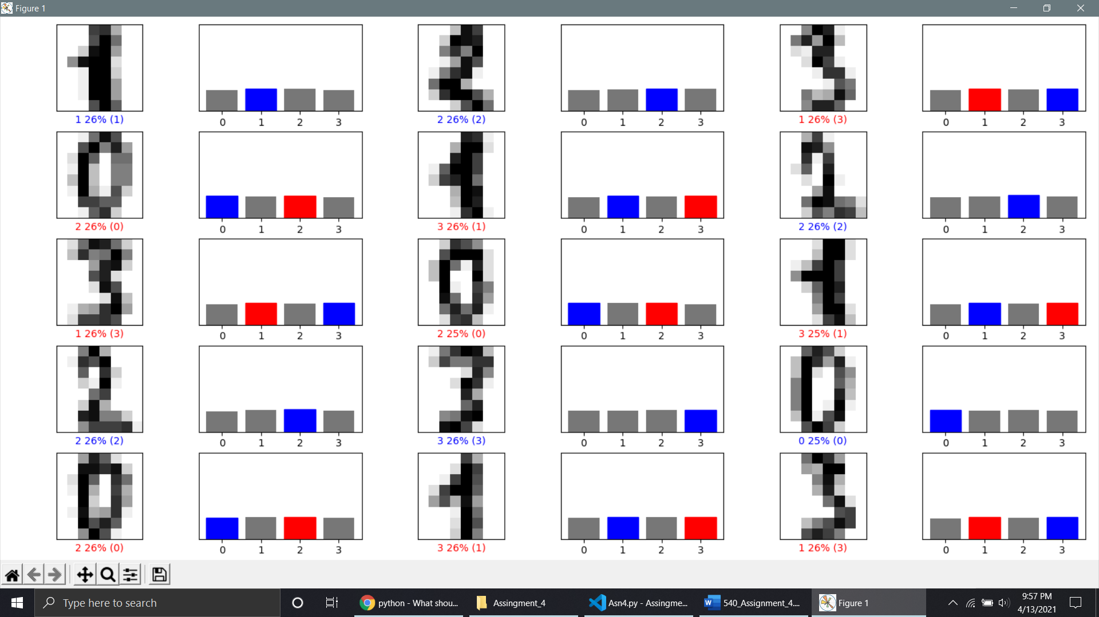

**Run #4:**

Epochs: 4

Hidden layers: 40

**Results:**

Test accuracy: 0.660639762878418

Graphs:

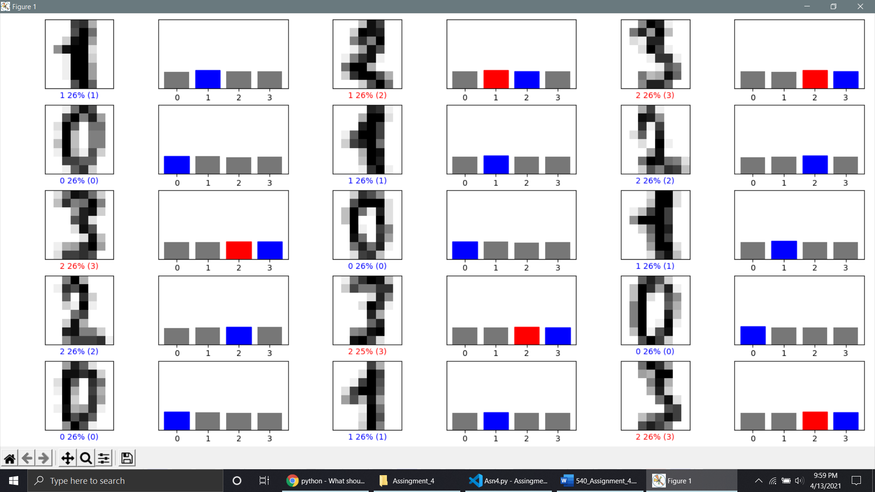

**Run #5:**

Epochs: 5

Hidden layers: 50

**Results:**

Test accuracy: 0.7426981925964355

Graphs: 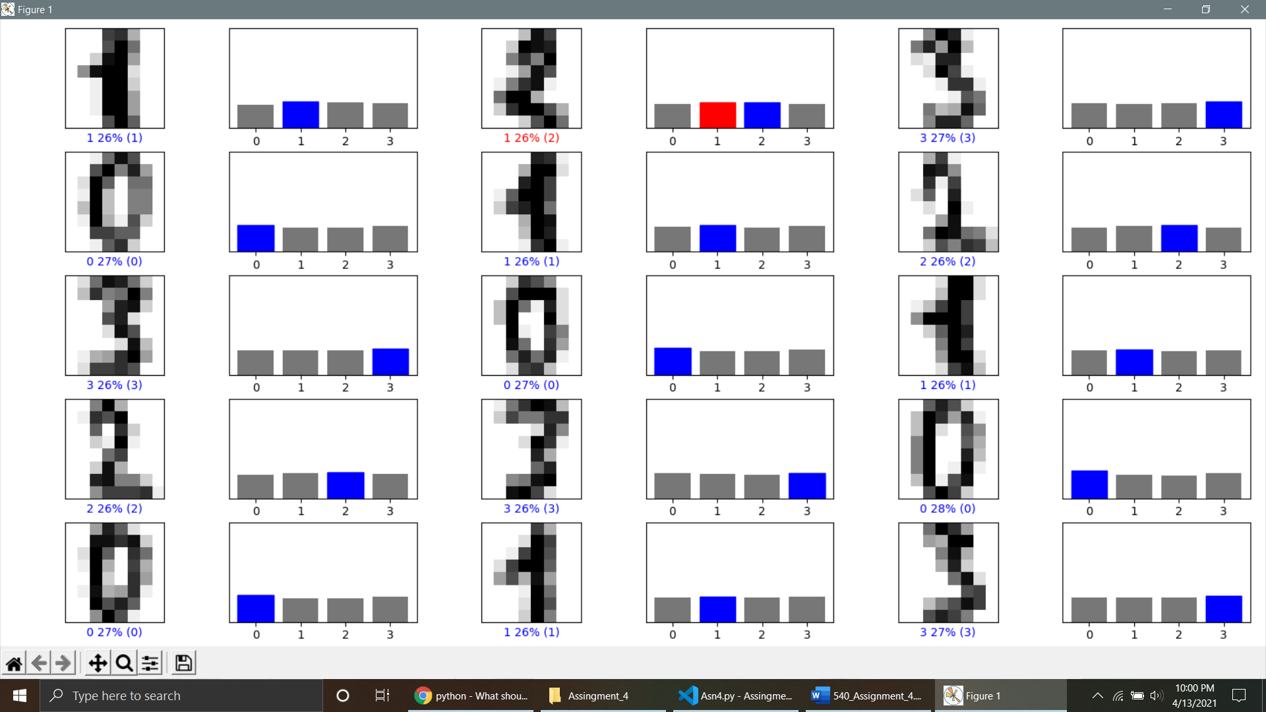

**Run #6:**

Epochs: 5

Hidden layers: 5

**Results:**

Test accuracy: 0.2447844296693802

Graphs:

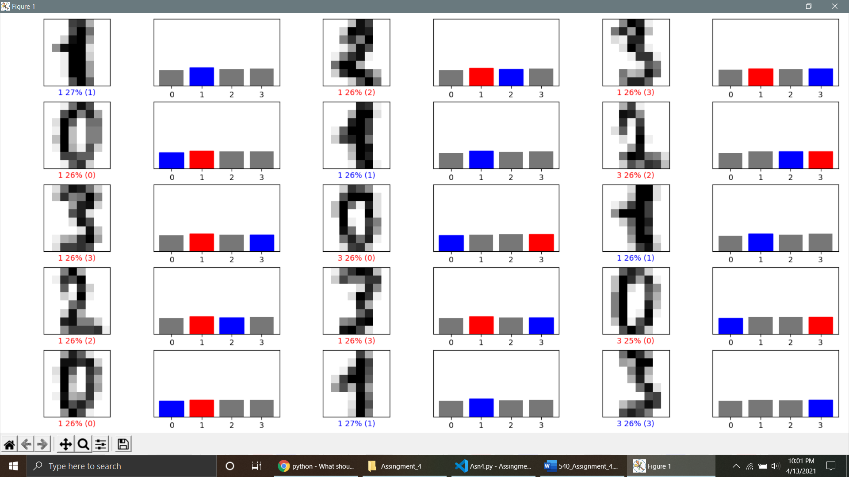

**Run #7:**

Epochs: 1

Hidden layers: 50

**Results:**

Test accuracy: 0.25312933325767517

Graphs:

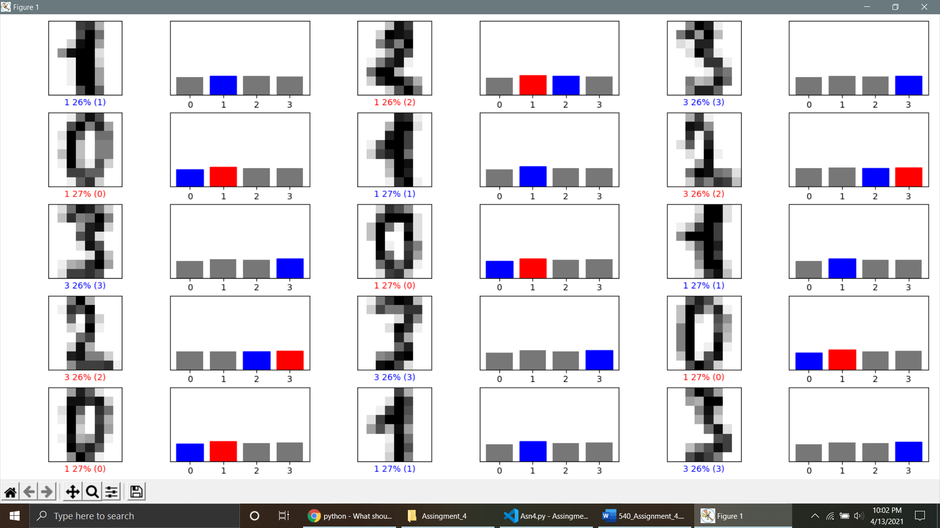

**Run #8:**

Epochs: 1

Hidden layers: 30

**Results:**

Test accuracy: 0.35326841473579407

Graphs:

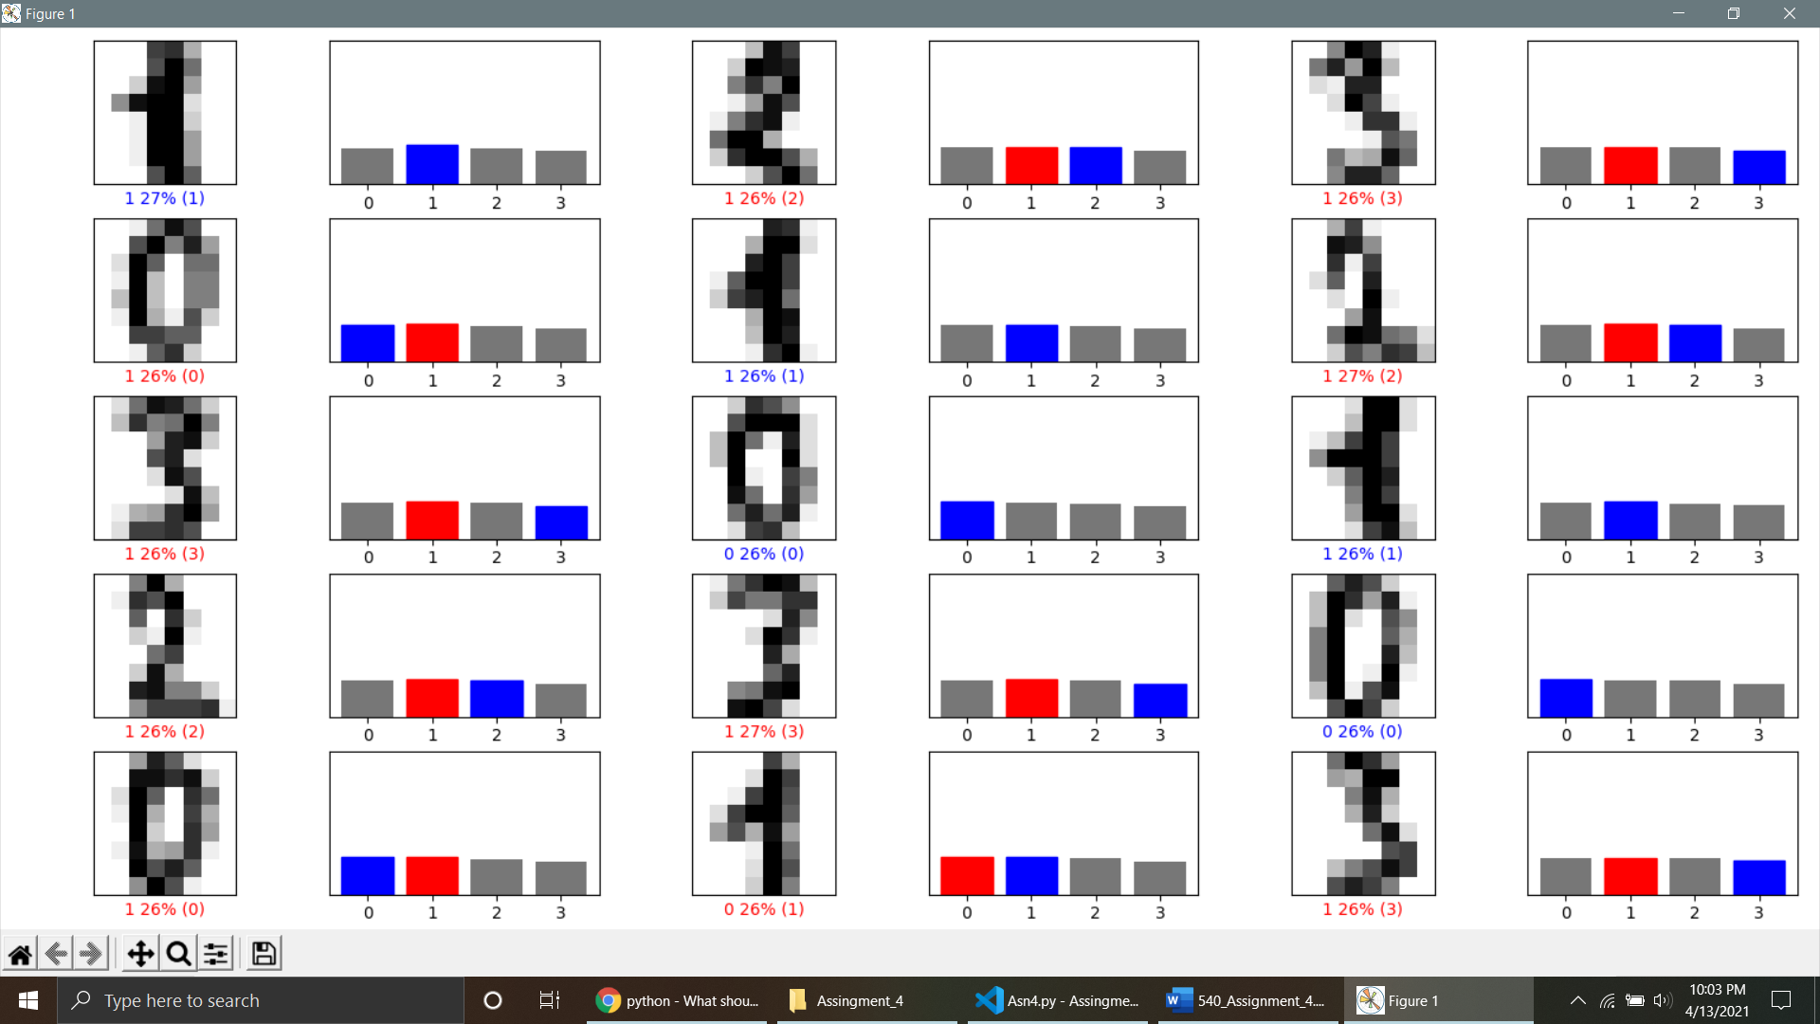

**Run #9:**

Epochs: 5

Hidden layers: 30

**Results:**

Test accuracy: 0.7579972147941589

Graphs:

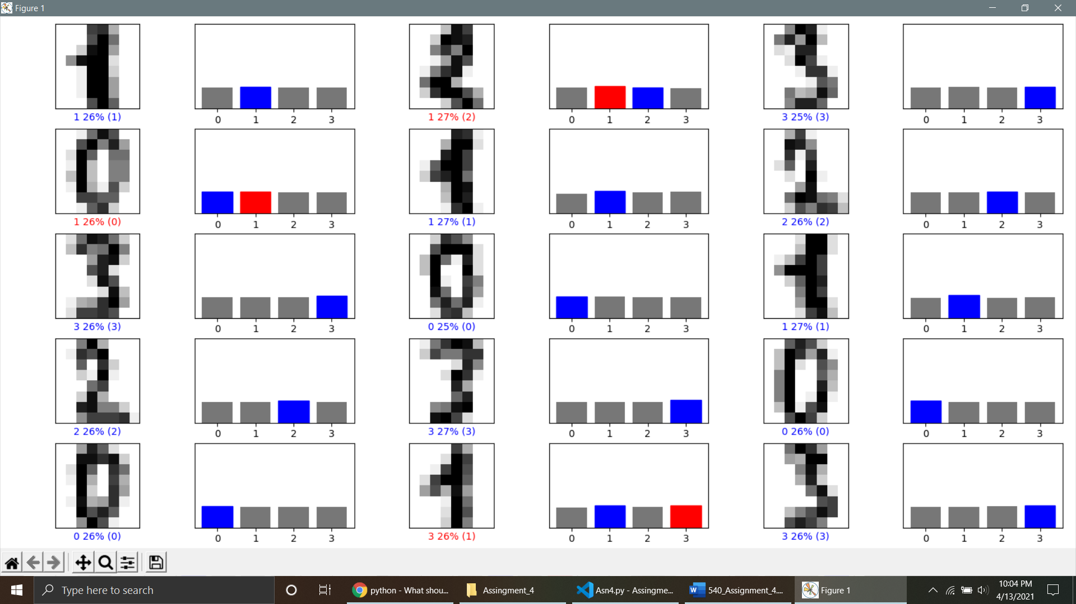

**Run #10:**

Epochs: 5

Hidden layers: 40

**Results:**

Test accuracy: 0.8344923257827759

Graphs:

