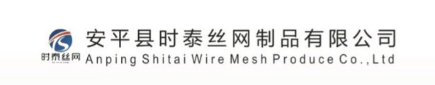
MANUFACTURER’S CONTACT DETAIL FORM
To:
Rural Electrification and Renewable Energy Corporation
Ground Floor: Kawi House, South C
P.O. 34585 – 00100
NAIROBI,
KENYA

Manufacturer Details:
Company Legal Name
ANPING SHITAI WIRE MESH PRODUCE CO., LTD
Company Trading
ANPING SHITAI WIRE MESH INTERNATIONAL TRADE CO.,LTD
(Write the names in full)
Manufacturer Contacts:
Telephone No. +86-19031387172 Postal Adress No.
Xinangtun Industrial Zone, , China.
Email sales03@shitaiwiremesh.com Website www.shitaimesh.com/
Physical Adress Xinangtun Industrial Zone, Anping County, Hebei Province, China.
Main Contact:
Full Name Kiki Email sales03@shitaiwiremesh Position Manager
Cellular: +8619031387172
Describe your field of specialization: HESCO BASTION BAGS, RAZOR WIREFENCE, SOUND BATTERIES, PROTECTIVE BARRIERS AND OTHER PRODUCTS

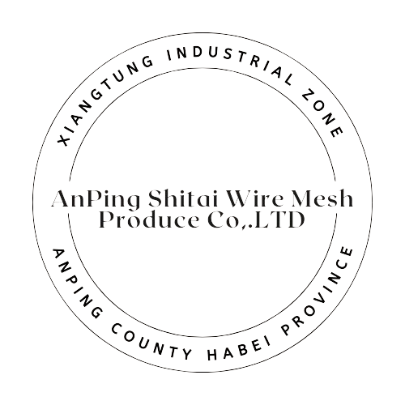
Signed (Authorized Signatory)
Name: Kiki

