Validation-Budget Sensitivity in Lightweight Link Prediction: An Empirical Study
PILOT MANUSCRIPT — NOT YET A SUBMISSION-READY SCI FINAL VERSION

Abstract
Selecting a link-prediction method by validation performance is standard practice, but the amount of validation evidence available for that decision is often treated as a secondary implementation detail. This pilot study measures how a limited validation budget affects downstream algorithm selection among six lightweight link-prediction heuristics. For each repeated network split, methods are compared on a budgeted validation sample and the selected method is evaluated on an independent test set. Selection loss is defined as the test-performance gap between the selected method and the test-optimal method. The bundled pilot produced 1,584 selection experiments across twelve graphs and two negative-sampling regimes. Mean pooled selection loss declined as the requested validation budget increased, although high-budget estimates were partly constrained by small validation pools. The package establishes a reproducible protocol for a larger benchmark study; the current pilot results should not be used as final journal claims without expanding the benchmark corpus and completing the pre-specified uncertainty analysis.

1. Research Question
How much can a finite validation budget change the algorithm ultimately selected for link prediction, and what independent-test performance is lost when the validation-selected method is not the test-optimal method?

2. Protocol
- Six classical local predictors are compared: Common Neighbors, Jaccard, Adamic-Adar, Resource Allocation, Preferential Attachment, and Degree Sum.
- For each repetition, graph edges are divided into training, validation, and independent test pools.
- Balanced positive/negative candidate sets are formed under random-negative and two-hop hard-negative regimes.
- At each budget, the validation winner is selected by ROC AUC and then evaluated on the independent test set.
- Selection loss is defined as oracle test AUC minus the test AUC of the validation-selected method.

3. Pilot Results
Negative regime | Budget | Mean selection loss | Misselection rate
random | 20 | 0.0446 | 0.659
random | 50 | 0.0344 | 0.606
random | 100 | 0.0314 | 0.598
random | 200 | 0.0311 | 0.591
random | 500 | 0.0313 | 0.606
random | 1000 | 0.0313 | 0.606
two_hop | 20 | 0.0346 | 0.394
two_hop | 50 | 0.0262 | 0.318
two_hop | 100 | 0.0227 | 0.280
two_hop | 200 | 0.0226 | 0.258
two_hop | 500 | 0.0227 | 0.265
two_hop | 1000 | 0.0227 | 0.265
The pooled pilot pattern shows lower mean selection loss as the requested validation budget increases. The largest changes occur at the lowest budgets. Requested budgets of 500 and 1000 often exceed the available balanced validation pool for smaller networks, so those points should be interpreted together with effective-budget diagnostics.
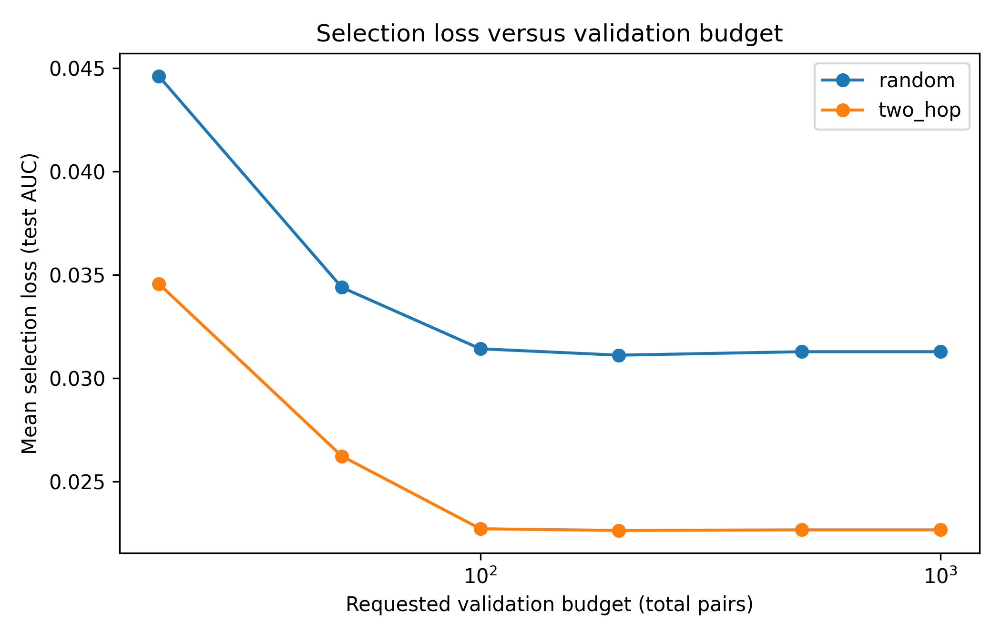
Figure 1. Mean selection loss versus requested validation budget.
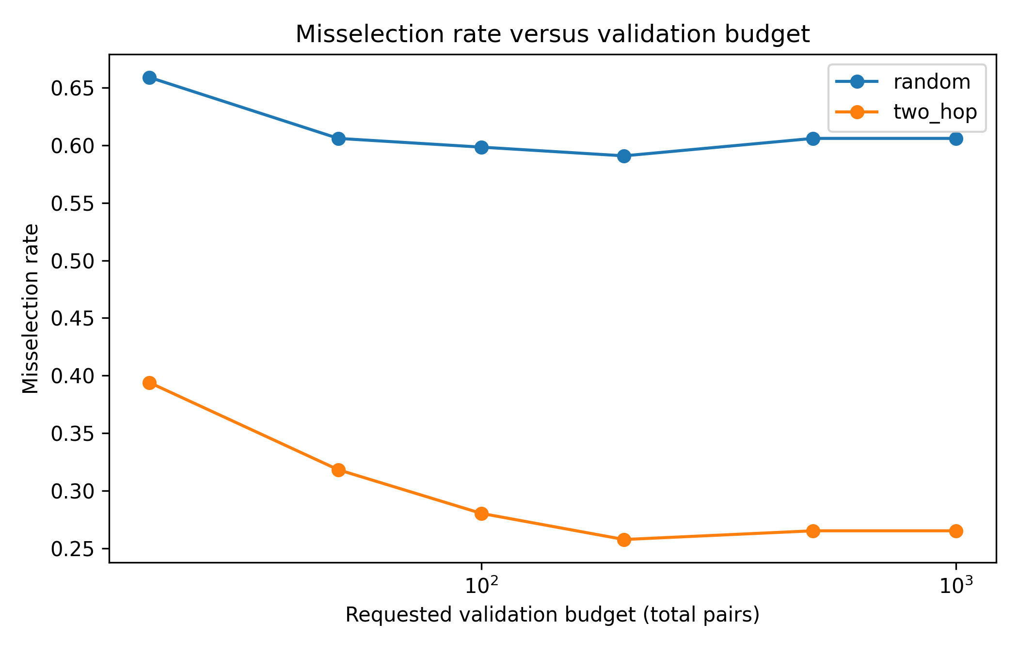
Figure 2. Misselection rate versus requested validation budget.

4. Interpretation and Limits
The pilot supports the practical premise that validation size can influence downstream method choice. However, the present benchmark mixes four small empirical NetworkX examples with eight synthetic stress networks. A submission version should use a broader documented benchmark suite, freeze the final protocol before the full run, report network-level uncertainty intervals, and perform a current literature-based novelty check.

5. Reproducibility
The complete pilot code, configuration, raw results, summaries, and plotting scripts are included in this package. Run `python scripts/run_experiment.py` followed by `python scripts/analyze_results.py` after installing the requirements.

Submission Status
This document is a pilot manuscript generated from actual bundled experiment outputs. It is not a representation that the study is ready for SCI submission.

