Heartbeat or Noise?
Evaluating Consumer Wearables as Cardiac Screening Proxies
Using Machine Learning

Lucas Sam
General Assembly Data Analytics Capstone Project
March 2026

Research Question: Can machine learning models trained on clinical ECG data
generalise to consumer wearable signals to detect cardiac rhythm anomalies,
and are consumer wearables feasible as proxy cardiac screening tools
for the general population?

1. Problem, Goals & Audience
Cardiovascular disease (CVD) accounts for 30.5% of all deaths in Singapore, equating to approximately 22 lives lost daily. Despite national screening programmes, approximately 49% of Singapore residents did not undergo a health checkup in the past twelve months, leaving a significant proportion of the population unaware of underlying cardiac risk.
Consumer wearables — including smartwatches from Apple and Samsung — are worn by millions daily and continuously monitor physiological signals including heart rate and heart rate variability (HRV). Unlike a hospital visit, wearable monitoring is passive, always-on, and requires no scheduling or cost. If consumer wearable signals can reliably flag cardiac rhythm irregularities with sufficient sensitivity, they represent a scalable, low-barrier first-line screening intervention for an under-screened population.

1.1 Project Goals
Goal 1 — Clinical Benchmark: Train and evaluate a binary cardiac rhythm classifier on clinical ECG data, using only features extractable from consumer wearables. Success criterion: sensitivity ≥80%, specificity ≥75% on held-out test data.
Goal 2 — Generalisation Test: Apply the frozen model to consumer wearable signals (Apple Watch PPG and MIMIC PERform AF finger PPG) and measure how much discriminative performance is retained across the modality gap.
Goal 3 — Proof of Concept: Build a deployable app (BeatCheck) that accepts Apple Health exports and returns a risk tier using the trained model.

1.2 Target Audience
Primary audience: Singapore residents who own consumer wearables and are among the 49% who do not attend regular health checkups. Secondary audience: public health policymakers evaluating technology-assisted screening interventions. BeatCheck is explicitly designed as a screening flag — not a diagnostic tool — that directs users toward formal clinical evaluation.

1.3 Two-Layer Validation Framework
The project uses a pre-registered two-layer architecture to separate model training from generalisation testing. Layer 1 trains the model on clinical ECG data. Layer 2 tests the frozen model on consumer wearable data. No retraining or threshold adjustment occurs between layers at the point of primary evaluation. Three success tiers were pre-registered:
Tier | Criterion | What It Tests
Tier 1 | Pipeline executes with interpretable outputs | Foundational applicability
Tier 2 | Sensitivity ≥80% AND Specificity ≥75% | Statistical signal detection
Tier 3 | AUROC ≥0.85 | Clinical concordance / discriminative ability

2. Data Sources & Data Dictionary

2.1 Physionet 2017 AF Classification Challenge (Layer 1 Training)
8,528 single-lead ECG recordings sampled at 300 Hz, from the PhysioNet Computing in Cardiology Challenge 2017. After excluding 279 noisy/unclassifiable records and applying a feature quality filter, 8,187 records were retained (0.75% failure rate). Binary label mapping: Normal (N → 0) versus Abnormal (AF + Other → 1). Class distribution: 61.6% Normal (5,042 records), 38.4% Abnormal (3,145 records). AF within the Abnormal class: 754 records (24.0%).
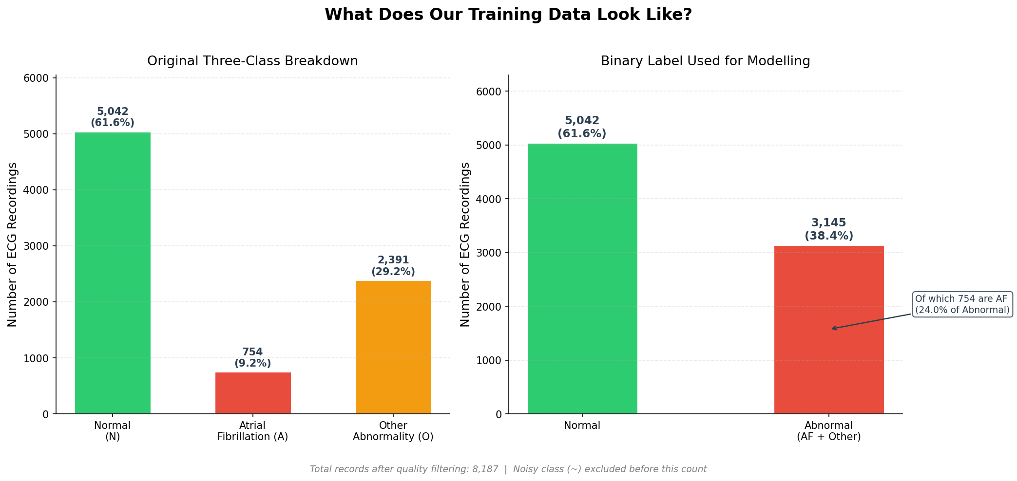
Figure 1. Class distribution in the Physionet 2017 training dataset after noisy-class exclusion and quality filtering.
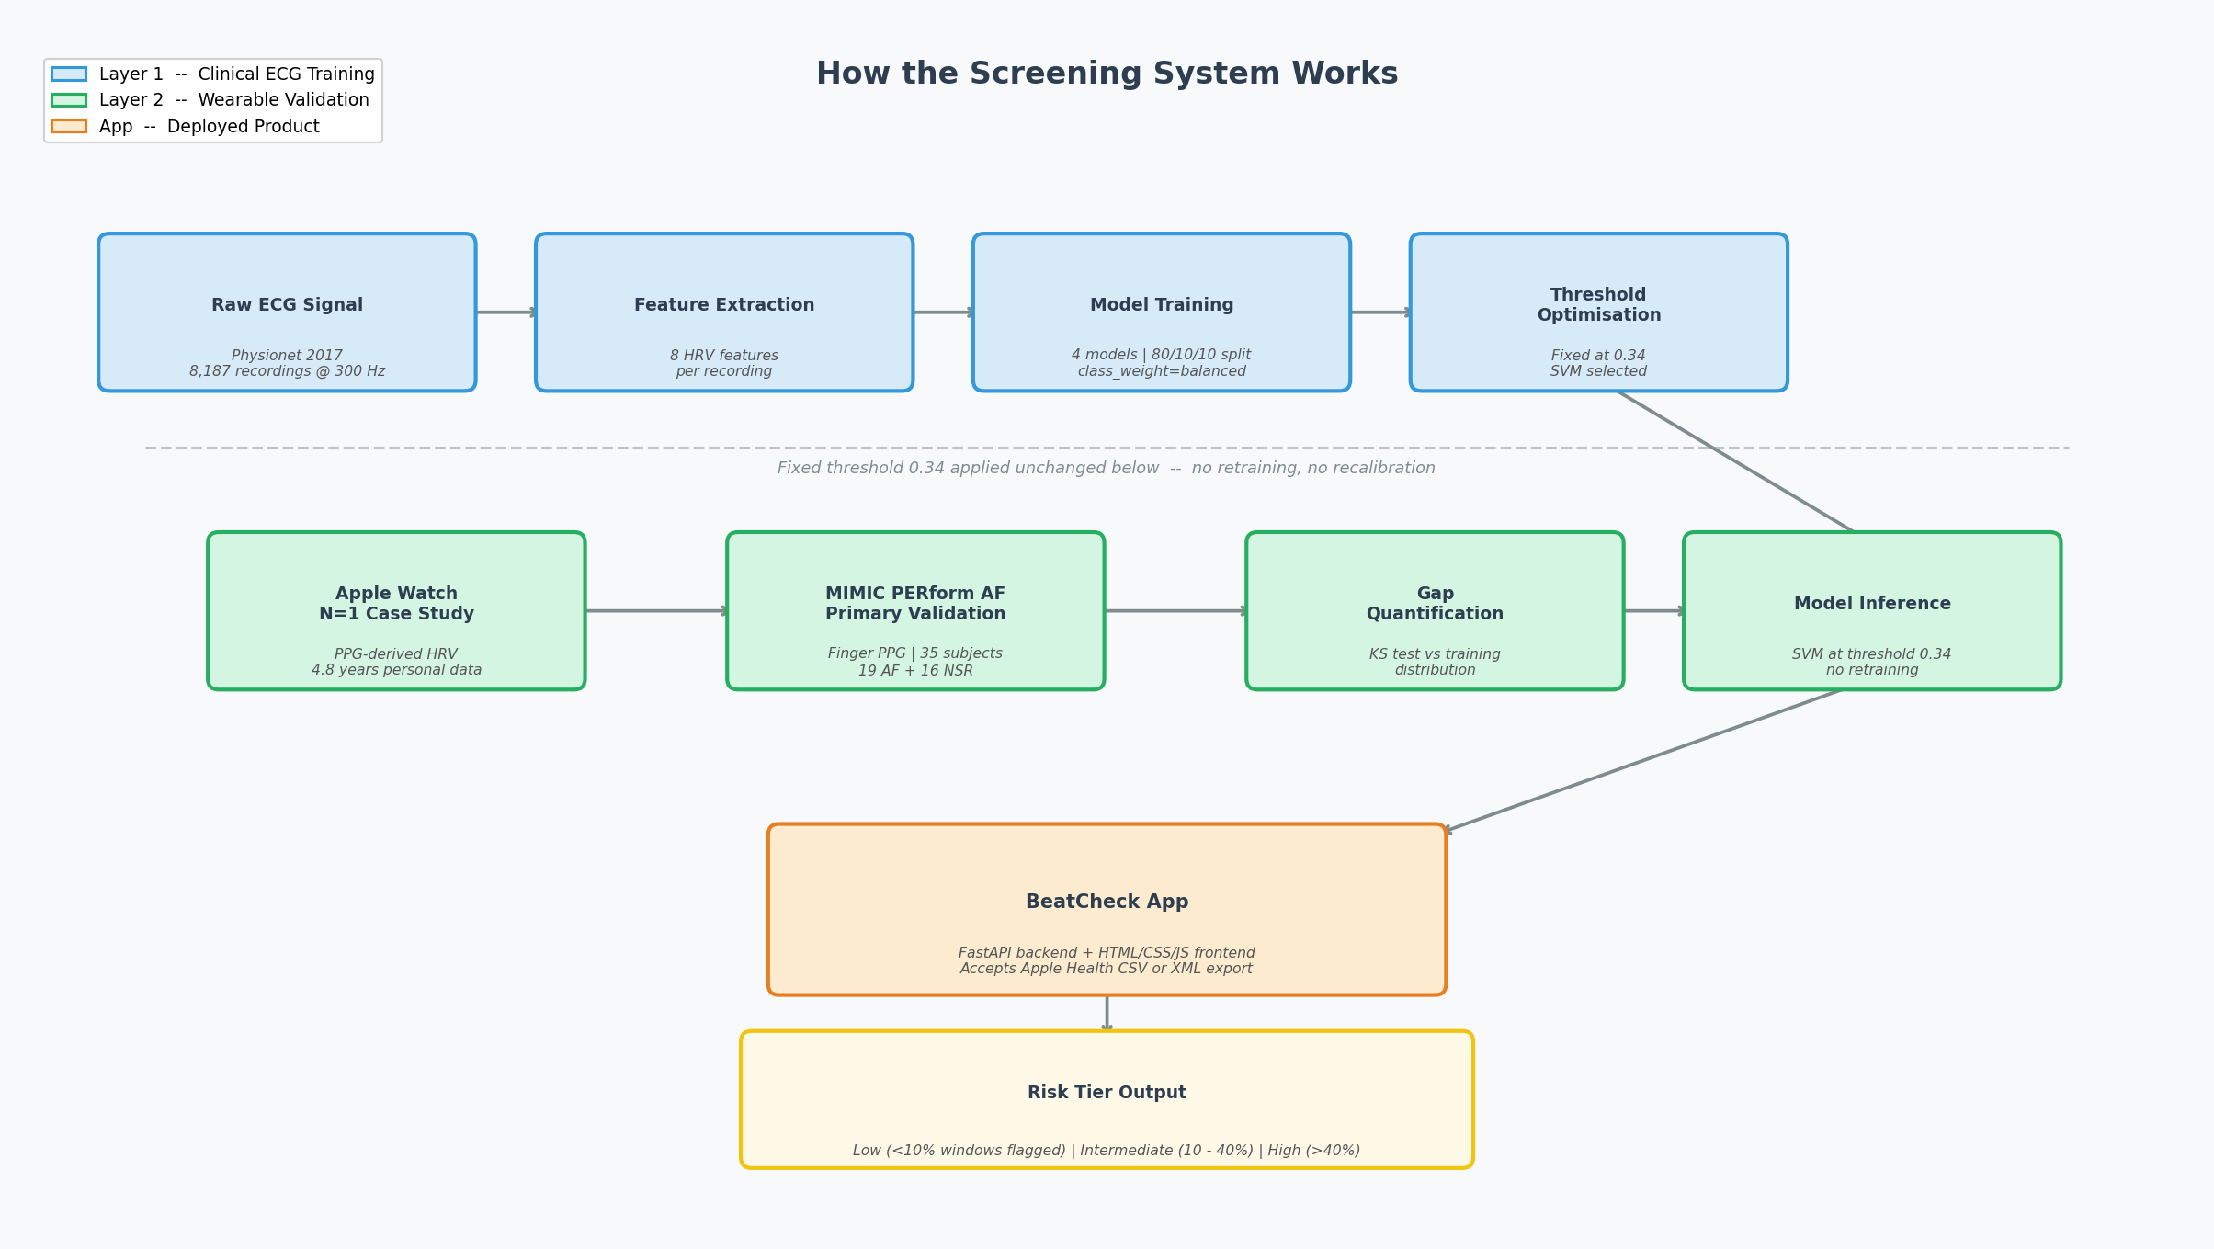
Figure 2. End-to-end project pipeline from raw data through training, validation, and wearable generalisation.

2.2 Personal Apple Watch Data (N=1 Case Study)
Apple Watch SE, 1st Generation — PPG optical sensor only. No electrical heart sensor. No ECG recordings. Temporal coverage: April 2021 – February 2026 (4.8 years). Clinical anchor point: June 18, 2025 — confirmed by ECG report from the National Heart Centre Singapore (NHCS) showing an Abnormal ECG (intraventricular conduction delay, ST abnormality). Role: exploratory N=1 case study appendix.
Metric | Records | Notes
Heart rate (continuous) | 478,077 | 1 artifact removed
HRV (SDNN) | 5,456 | 29 outliers removed
Resting heart rate | 1,491 | Daily summaries
Walking heart rate | 1,557 | Daily summaries
Respiratory rate | 20,372 | Sleep-derived
Sleep analysis | 7,967 | Session-level
Workouts | 1,982 | Session-level

2.3 MIMIC PERform AF — Primary Layer 2 Validation
35 critically ill adults (19 AF, 16 NSR) with simultaneous finger PPG and ECG recordings at 125 Hz for 20 minutes per subject (150,000 samples). Pre-assigned clinical labels at subject level: AF files = Abnormal (1), Non-AF files = Normal (0). Sourced from Zenodo (doi.org/10.5281/zenodo.6807402). PPG nulls in 8 of 35 files handled by linear interpolation (worst case: 1.15% of samples). Pivot from UMass Simband (access unavailable before deadline) — MIMIC PERform AF satisfies all three validation requirements: wearable PPG signal, binary ground truth labels, no access barriers.

2.4 Feature Dictionary
Eight features, all time-domain or statistical, extractable from both clinical ECG and consumer wearable PPG. Locked before feature engineering. Frequency domain features (LF/HF ratio, HF power) permanently excluded — consumer wearables do not expose raw beat-by-beat interval sequences at consistent sampling rates.
Feature | Description | Physionet Source | MIMIC / Wearable Source
RMSSD | Root mean square of successive RR differences | RR intervals from ECG | RR intervals from PPG peaks
SDNN | Standard deviation of all RR intervals | RR intervals from ECG | RR intervals from PPG peaks
Mean RR | Average inter-beat interval (ms) | RR intervals from ECG | RR intervals from PPG peaks
pNN50 | Proportion of successive intervals differing >50ms | RR intervals from ECG | RR intervals from PPG peaks
HR Mean | Average heart rate (bpm) | Derived from RR intervals | Derived from RR intervals
HR Std Dev | Variability of instantaneous heart rate | Derived from RR intervals | Derived from RR intervals
RR Skewness | Asymmetry of the RR interval distribution | Derived from RR intervals | Derived from RR intervals
RR Kurtosis | Tail weight of the RR interval distribution | Derived from RR intervals | Derived from RR intervals
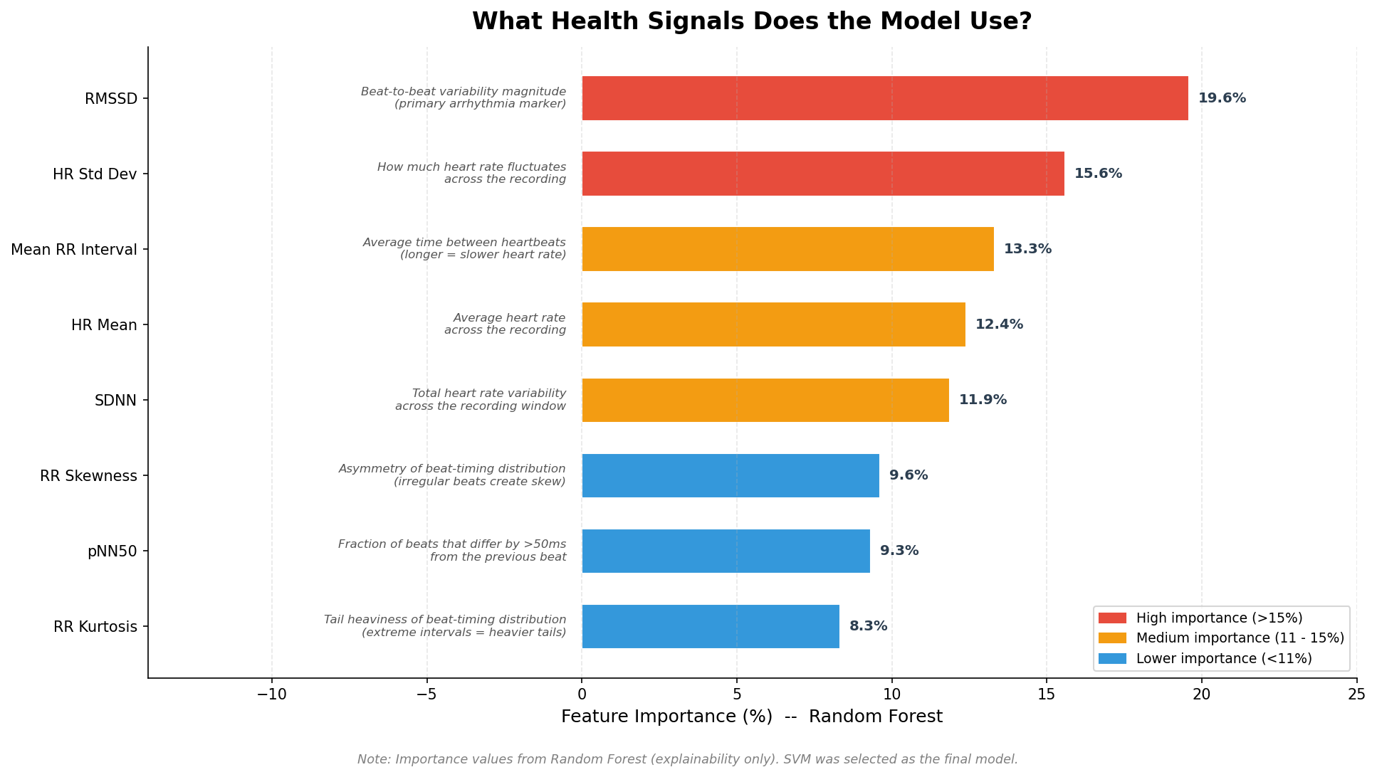
Figure 3. Visual descriptions of all eight locked features and their physiological interpretation.

3. Patterns, Trends & Insights

3.1 Feature Distributions by Class
Examining the distribution of all eight HRV features across Normal and Abnormal classes reveals consistent, interpretable separation. Abnormal recordings show higher RMSSD, SDNN, pNN50, and HR Std Dev — reflecting the increased beat-to-beat irregularity characteristic of atrial fibrillation and other rhythm anomalies. Mean RR is lower in Abnormal recordings (corresponding to higher average heart rate). RR Skewness and Kurtosis capture distributional shape differences associated with erratic inter-beat timing.
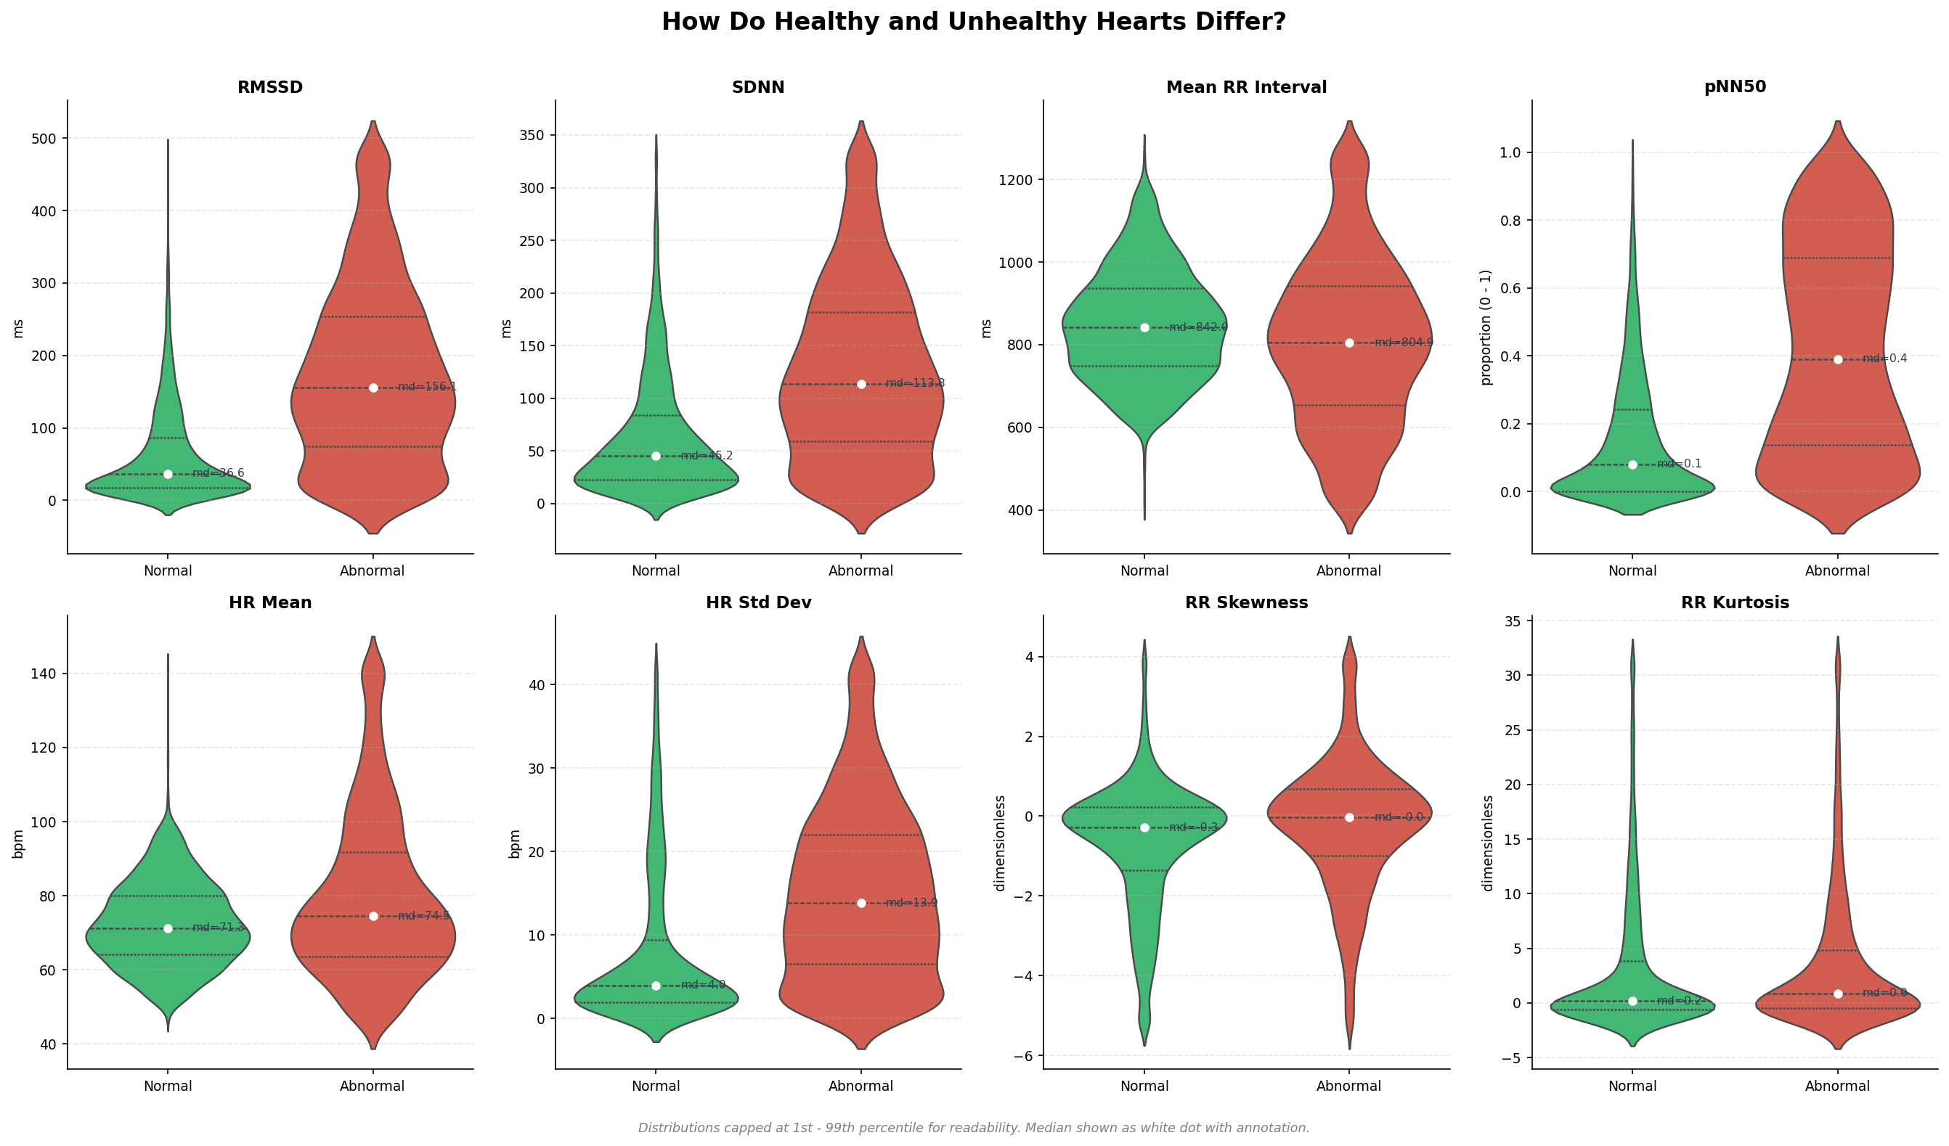
Figure 4. Distribution of all eight HRV features, split by Normal (0) and Abnormal (1) class. Higher RMSSD, SDNN, HR Std Dev indicate rhythm irregularity.

3.2 Feature Correlations
A correlation heatmap of the eight features reveals expected relationships: RMSSD and SDNN are strongly positively correlated (both measure beat-to-beat variability magnitude). pNN50 correlates with RMSSD (both sensitive to fast beat-to-beat changes). Mean RR and HR Mean are near-perfect inverse transforms of each other. RR Skewness and Kurtosis are relatively independent of the interval-based features, contributing orthogonal information about distributional shape.
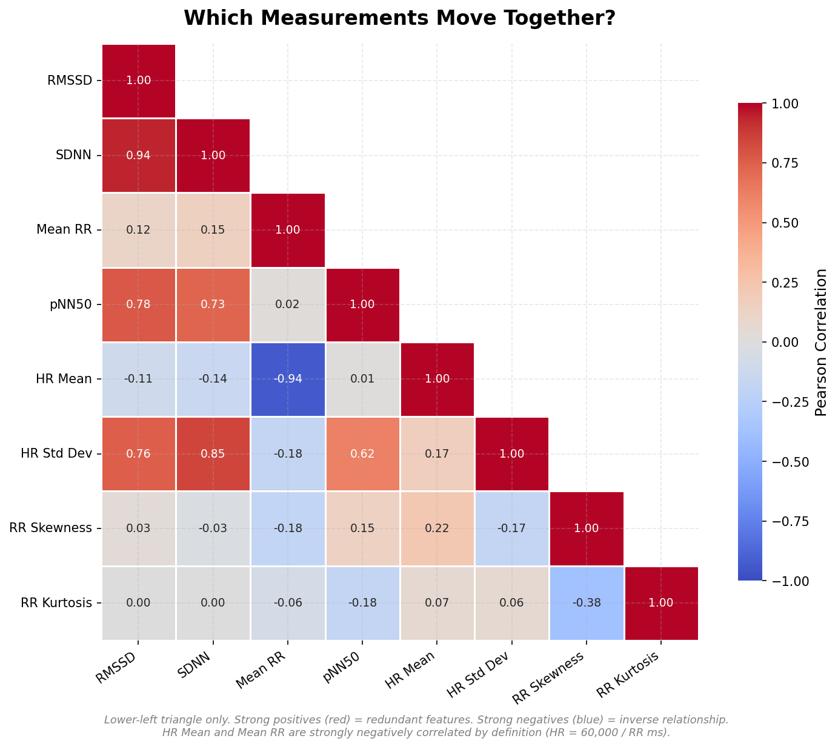
Figure 5. Pearson correlation heatmap of all eight locked HRV features. RMSSD–SDNN and Mean RR–HR Mean show the strongest within-group correlations.

3.3 Feature Importance (Random Forest)
Although SVM was selected as the final model, Random Forest feature importances are reported as a supplementary interpretability measure. RMSSD ranks first (19.58%), reflecting its direct sensitivity to AF-related rapid irregular beats. HR Std Dev ranks second (15.58%), capturing overall heart rate volatility. Mean RR ranks third (13.32%), reflecting the elevated average heart rate common in Abnormal rhythms. All eight features contribute meaningfully — no single feature dominates exclusively.
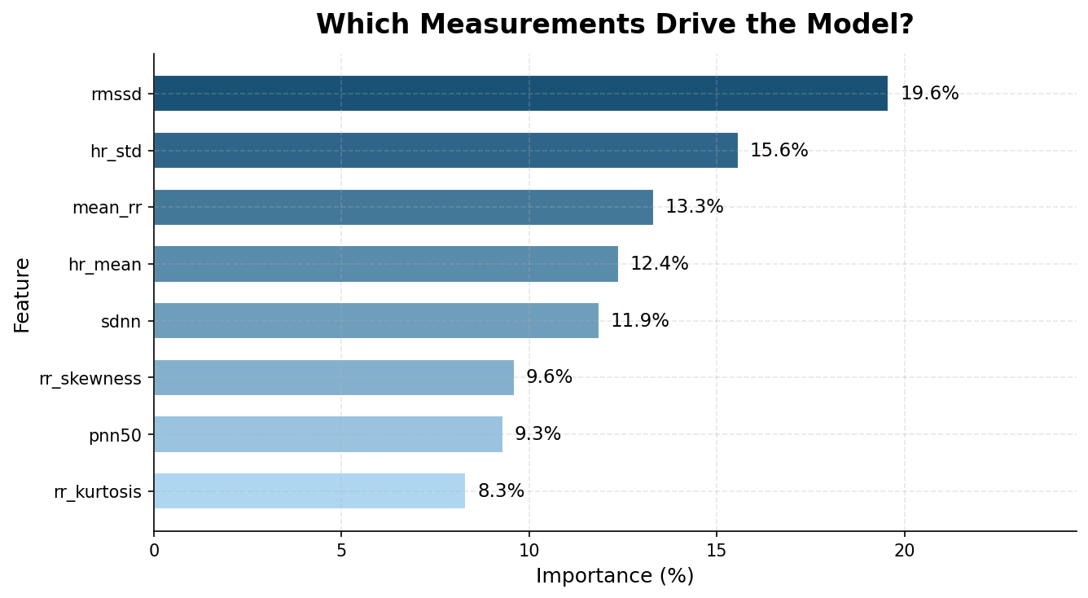
Figure 9. Random Forest feature importance scores for all eight HRV features. Reported as a supplementary interpretability measure; SVM is the selected model.
Rank | Feature | Importance
1 | RMSSD | 19.58%
2 | HR Std Dev | 15.58%
3 | Mean RR | 13.32%
4 | HR Mean | 12.39%
5 | SDNN | 11.87%
6 | RR Skewness | 9.61%
7 | pNN50 | 9.31%
8 | RR Kurtosis | 8.32%

4. Predictive Model — Layer 1 Clinical Benchmark
The dataset was split 80/10/10 (stratified): 6,549 training, 819 validation, 819 held-out test records. StandardScaler was fitted on X_train only — no data leakage. Four binary classifiers were trained with class_weight=balanced to address the 62/38 class imbalance. The scaler and all trained models are saved to outputs/models/.

4.1 Cross-Validation Results (5-Fold Stratified)
All four models achieve similar cross-validated sensitivity (80.3–80.5%) with the class_weight=balanced constraint. Specificity and AUROC differentiate them:
Model | Sensitivity | Specificity | AUROC
Logistic Regression | 80.5% ±0.1% | 84.2% ±2.0% | 0.8817 ±0.0066
Random Forest | 80.3% ±0.2% | 86.7% ±1.3% | 0.8955 ±0.0080
XGBoost | 80.4% ±0.2% | 82.5% ±1.9% | 0.8809 ±0.0054
SVM | 80.3% ±0.2% | 86.9% ±1.4% | 0.8960 ±0.0062

4.2 Overfitting Check
Model | Train Accuracy | Test Accuracy | Gap | Verdict
Logistic Regression | 83.2% | 85.6% | −2.4% | No overfitting
Random Forest | 100.0% | 86.6% | +13.4% | Significant overfitting
XGBoost | 99.8% | 86.2% | +13.6% | Significant overfitting
SVM | 85.6% | 86.8% | −1.2% | No overfitting
Random Forest and XGBoost both memorise the training set (100% and 99.8% training accuracy). Despite competitive test accuracy, this overfitting indicates the ensemble models have not learnt generalisable decision boundaries. Logistic Regression and SVM show no overfitting.

4.3 Model Comparison
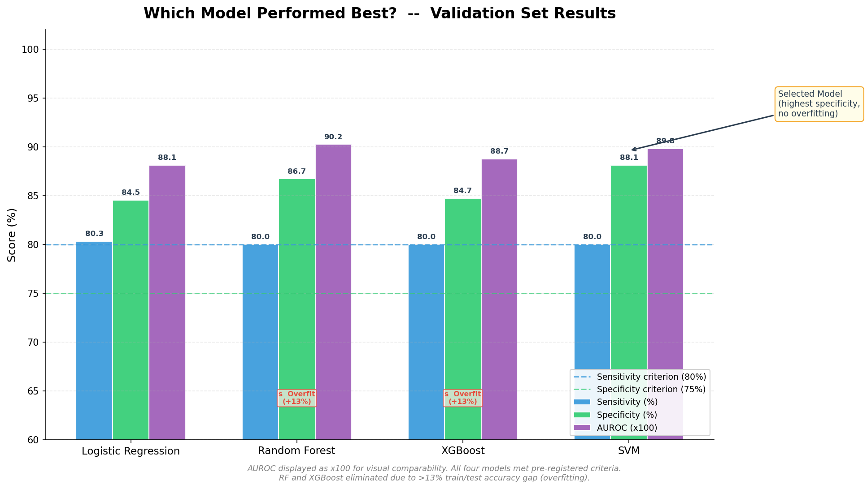
Figure 6. Model comparison scorecard across five selection criteria: AUROC, specificity, false positives, overfitting gap, and AF sensitivity.

4.4 Model Selection — SVM
SVM was selected using a five-criterion natural selection framework. It achieved the highest validation specificity (88.1%), fewest false positives (60), and no overfitting (−1.2% train-test gap). Criterion 2 (specificity) resolved the selection.
In a screening context, false positives — incorrectly flagging healthy individuals as abnormal — cause unnecessary anxiety and unnecessary clinical referrals. SVM minimising false positives while maintaining sensitivity is the correct trade-off for this application.

4.5 Held-Out Test Set Results (Threshold = 0.34)
The classification threshold 0.34 was selected on the validation set to prioritise sensitivity (screening context). The frozen threshold was applied once to the held-out test set.
Metric | Value
Sensitivity | 84.4%
Specificity | 87.3%
AUROC | 0.9080
F1 Score | 0.8243
AF-specific Sensitivity | 98.8%
Confusion Matrix | TP=265, FP=64, FN=49, TN=441
Pre-registered criterion | PASS (Sens ≥80%, Spec ≥75%)
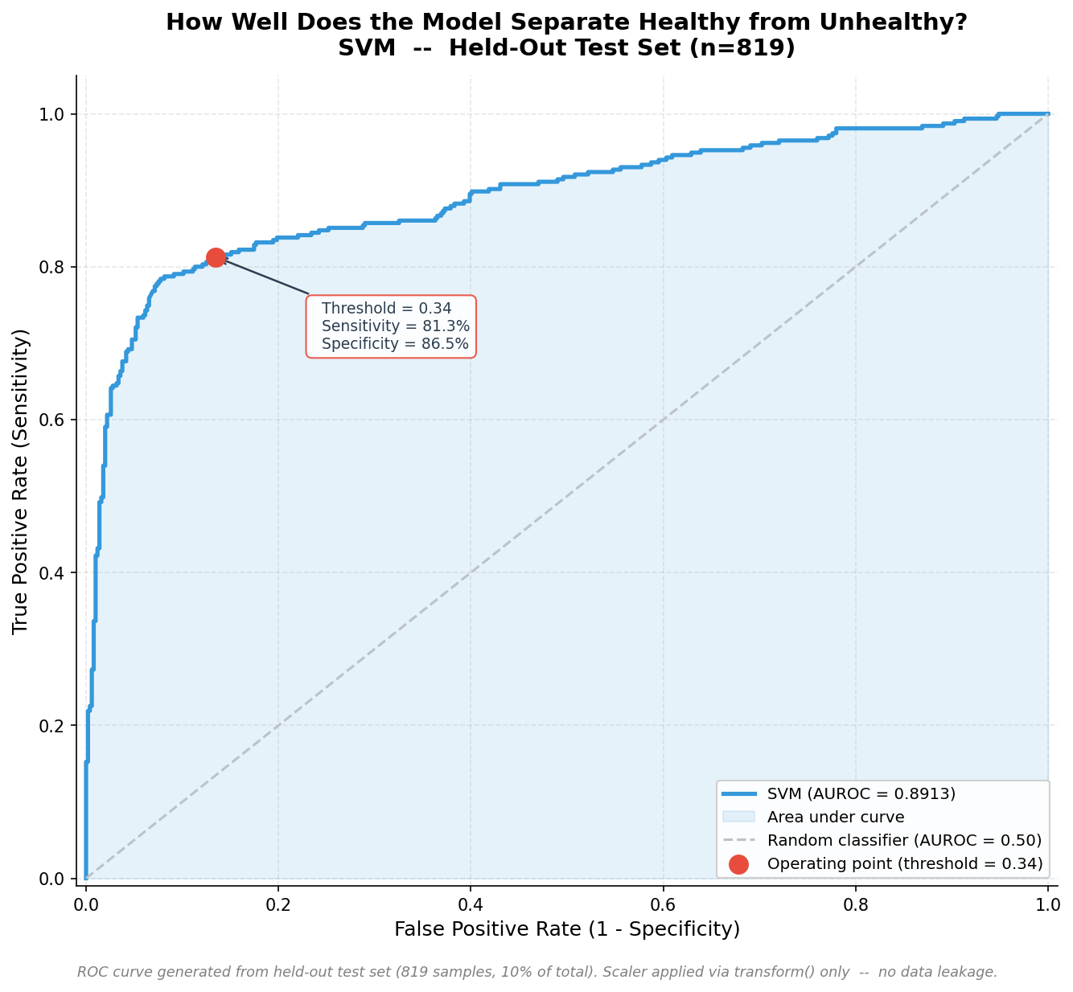
Figure 7. ROC curve for the SVM classifier on the held-out test set. AUROC = 0.9080. Operating point at threshold 0.34 marked.
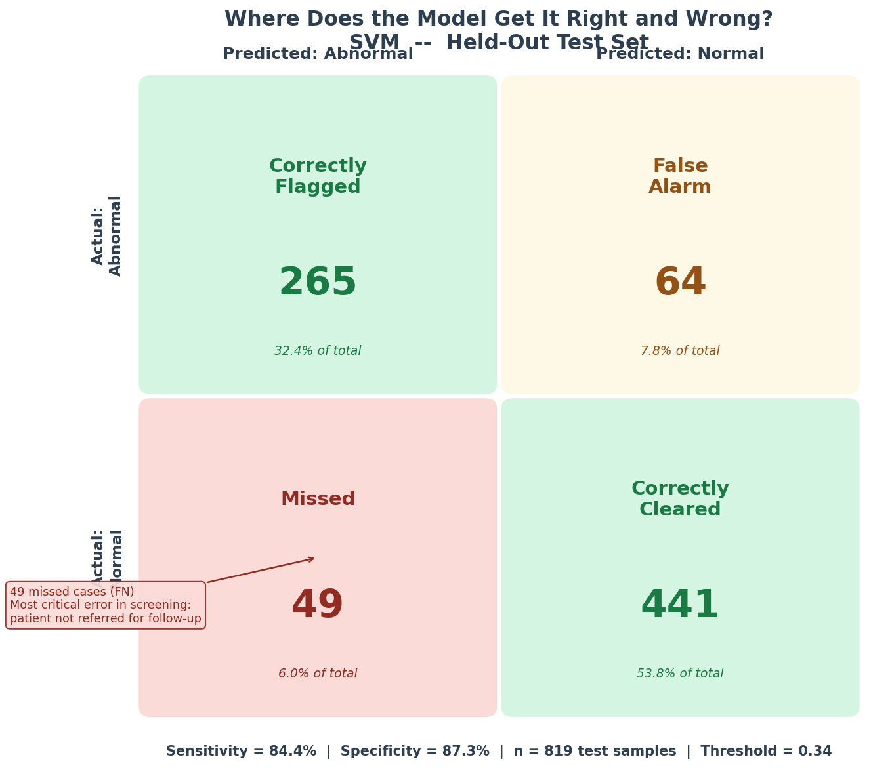
Figure 8. Confusion matrix for SVM at threshold 0.34 on held-out test data. TP=265, FP=64, FN=49, TN=441.

4a. Consumer Wearable Bridge — Apple Watch N=1 Case Study
The personal Apple Watch dataset provides an exploratory N=1 test of whether the trained model captures temporal changes in cardiac rhythm patterns around a confirmed clinical event. The clinical anchor point is the June 18, 2025 ECG at NHCS confirming an Abnormal ECG.
1,997 feature windows were generated (30-minute windows, 15-minute step, minimum 10 heart rate readings per window). RMSSD was approximated from Apple Watch SDNN (×0.85) because raw beat-by-beat intervals are not exposed by the device API. Windows lacking an HRV record were dropped (no imputation). Window distribution: baseline=1,758, pre_anchor=95, post_anchor=29, follow_up=115.

4a.1 Signal Modality Gap (KS Test)
The Kolmogorov-Smirnov test quantifies distributional distance between Apple Watch feature values and the Physionet training distribution. All p-values are effectively zero, indicating the Apple Watch features occupy a different region of feature space than the training data.
Feature | KS Statistic | Direction | Magnitude
RMSSD | 0.424 | AW lower | Large
HR Mean | 0.416 | AW higher | Large
Mean RR | 0.390 | AW lower | Large
HR Std Dev | 0.359 | AW higher | Large
SDNN | 0.356 | AW lower | Large
RR Skewness | 0.297 | AW higher | Moderate
pNN50 | 0.210 | AW lower | Moderate
RR Kurtosis | 0.193 | AW lower | Moderate
Summary: 5 large (KS > 0.3), 3 moderate (0.1–0.3), 0 small. No feature transferred cleanly between modalities.
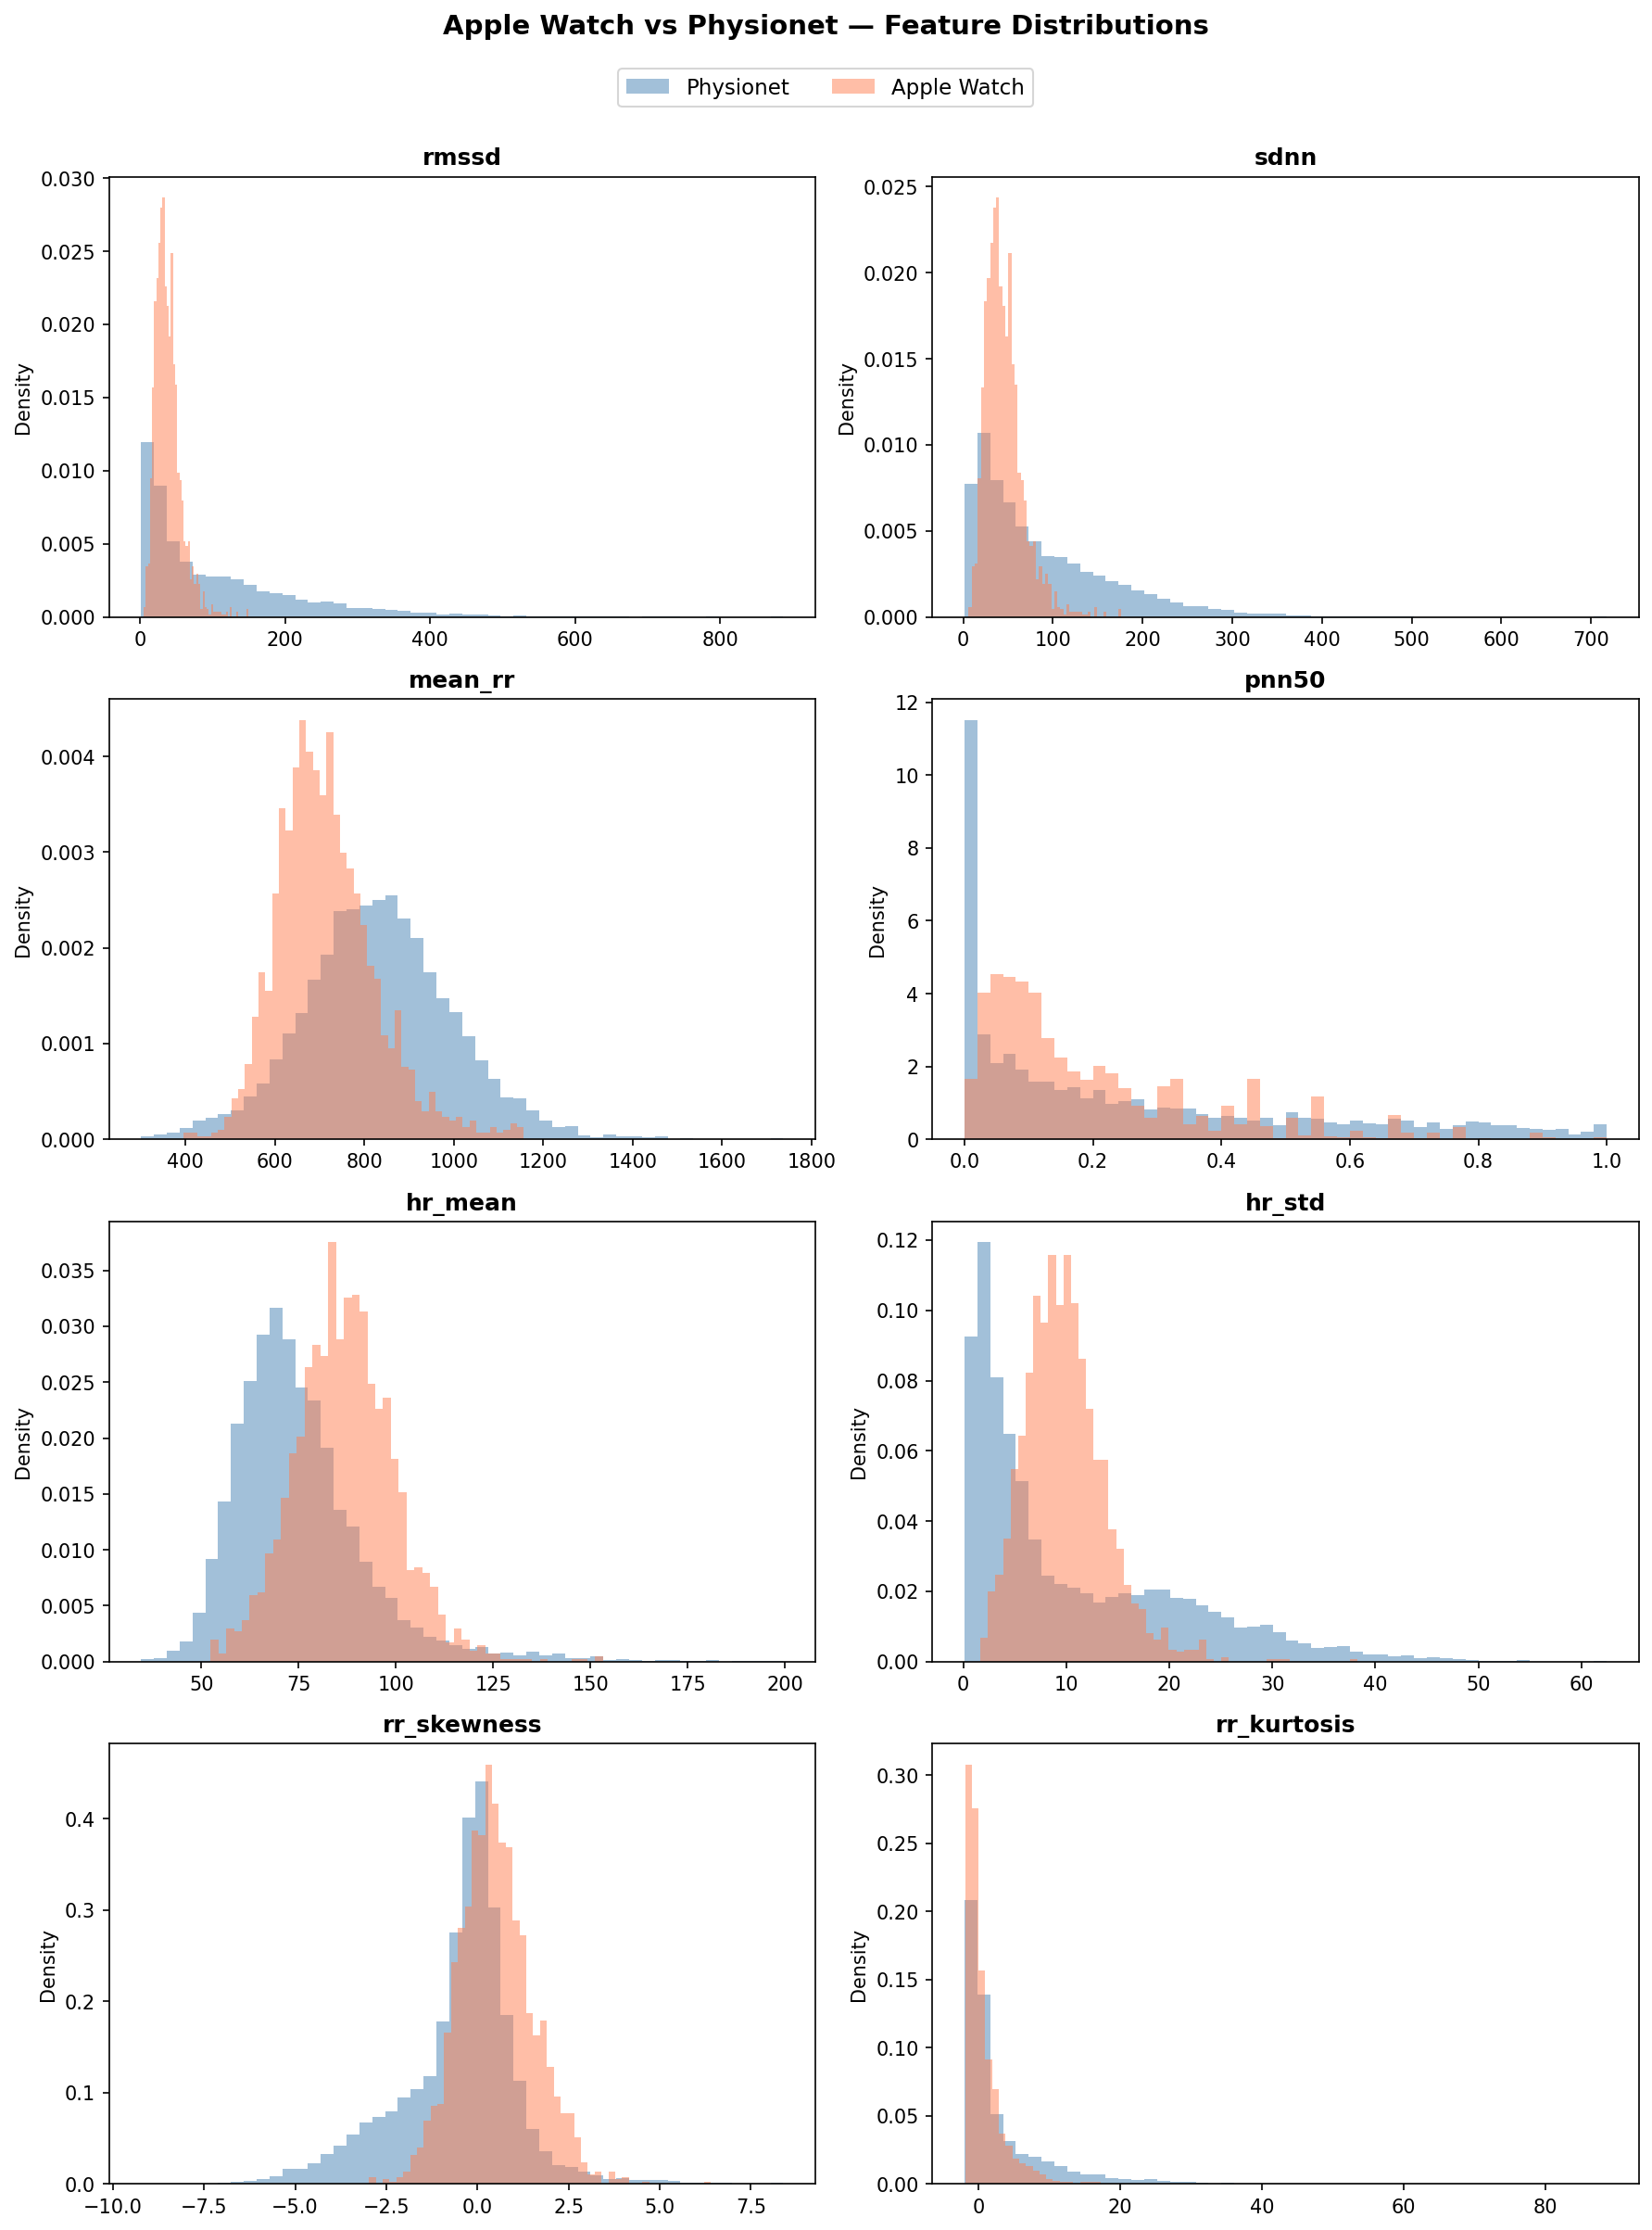
Figure — Apple Watch vs Physionet feature distributions. KS distances confirm systematic modality gap across all 8 features.

4a.2 Temporal Analysis (Mann-Whitney U, One-Sided)
A one-sided Mann-Whitney U test was pre-registered to test whether probability scores in each anchor period are higher than baseline. The null hypothesis was not rejected in any period:
Period | n | Median Score | p-value | Effect Size r | Verdict
pre_anchor | 95 | 0.104 | 0.957 | 0.104 | Lower than baseline
post_anchor | 29 | 0.101 | 0.839 | 0.107 | Lower than baseline
follow_up | 115 | 0.121 | 0.737 | 0.035 | Higher than baseline
Tier 1: PASS — pipeline executed, gap quantification interpretable. Tier 2: FAIL — no anchor period elevated above baseline. Tier 3: FAIL — Tier 2 not met.

4a.3 Null Result Interpretation
Three non-mutually-exclusive explanations account for the null result:
1. Signal modality gap: 5 of 8 features show large KS distances (>0.3), placing Apple Watch windows outside the model’s training distribution. The model operates on data that does not resemble what it was trained on.
2. Behavioural confound: Reduced physical training intensity in the pre-anchor period may have shifted HRV toward more regular patterns that the model interprets as normal, independent of any cardiac pathology.
3. Abnormality type mismatch: The clinical ECG report confirms an intraventricular conduction delay — a waveform morphology abnormality affecting QRS shape and ST segment, not beat-to-beat timing. HRV features are structurally incapable of detecting conduction delays, which produce regular-but-abnormally-shaped beats. The model was asked to detect something its feature set cannot capture.
The null result is reported transparently. It motivates the pivot to MIMIC PERform AF as primary Layer 2 validation, and demonstrates the scope boundary of HRV-based screening: rhythm irregularities are detectable; morphological abnormalities are not.

4b. Consumer Wearable Bridge — MIMIC PERform AF Primary Validation
35 subjects (19 AF, 16 NSR). All 35 subjects passed the green quality tier (≥300 PPG peaks detected). Single 20-minute window per subject. The frozen SVM and frozen scaler (transform only, no refit) were applied at the pre-registered fixed threshold of 0.34.

4b.1 Signal Modality Gap (KS Test)
All 8 features show large KS distances (KS ≥0.3) — worse than Apple Watch (5 large). MIMIC subjects are critically ill ICU patients whose underlying physiology produces systematically elevated HRV variability, pushing all features toward values the model associates with Abnormal.
Feature | KS Statistic | Direction
RR Skewness | 0.5186 | MIMIC higher
pNN50 | 0.4739 | MIMIC higher
RR Kurtosis | 0.4121 | MIMIC higher
RMSSD | 0.3747 | MIMIC higher
Mean RR / HR Mean | 0.3853 | MIMIC mixed
HR Std Dev | 0.3373 | MIMIC higher
SDNN | 0.3236 | MIMIC higher
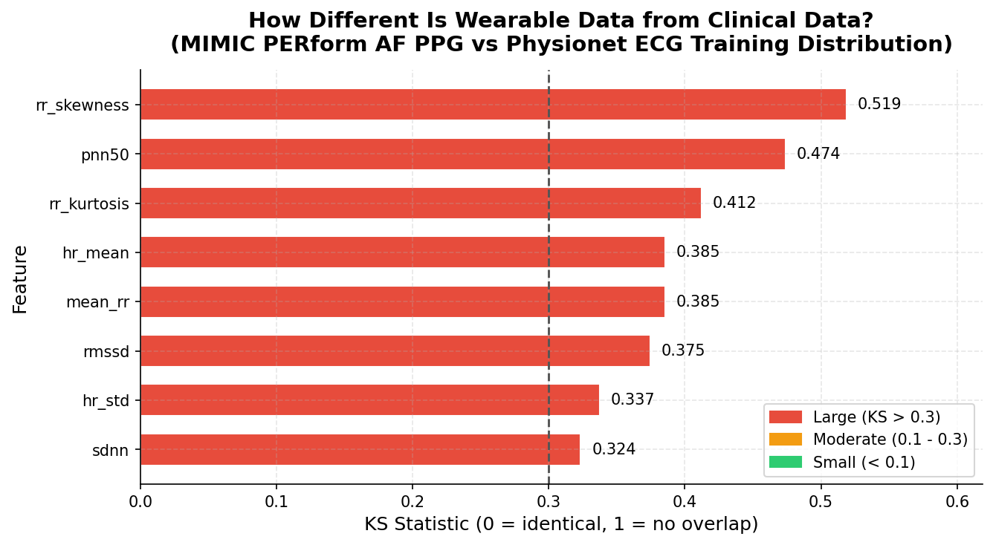
Figure 10. KS distances between MIMIC PERform AF and Physionet training distributions for all 8 features. All distances in the Large (>0.3) band.

4b.2 SVM at Fixed Threshold 0.34
Metric | Value
Sensitivity | 100% (19/19 AF cases)
Specificity | 12.5% (2/16 NSR correct)
AUROC | 0.8586
F1 Score | 0.7308
Confusion Matrix | TP=19, FP=14, FN=0, TN=2
Tier 1 | PASS
Tier 2 | FAIL (specificity 12.5%)
Tier 3 | PASS (AUROC 0.8586 ≥0.85)
100% sensitivity with 12.5% specificity is coherent and mechanistically explained. The KS gap directly predicts this: all 8 MIMIC features are shifted toward values the model associates with Abnormal, so almost every subject crosses the ECG-calibrated threshold of 0.34 — including NSR subjects. The model does not fail to discriminate; it fails to calibrate.
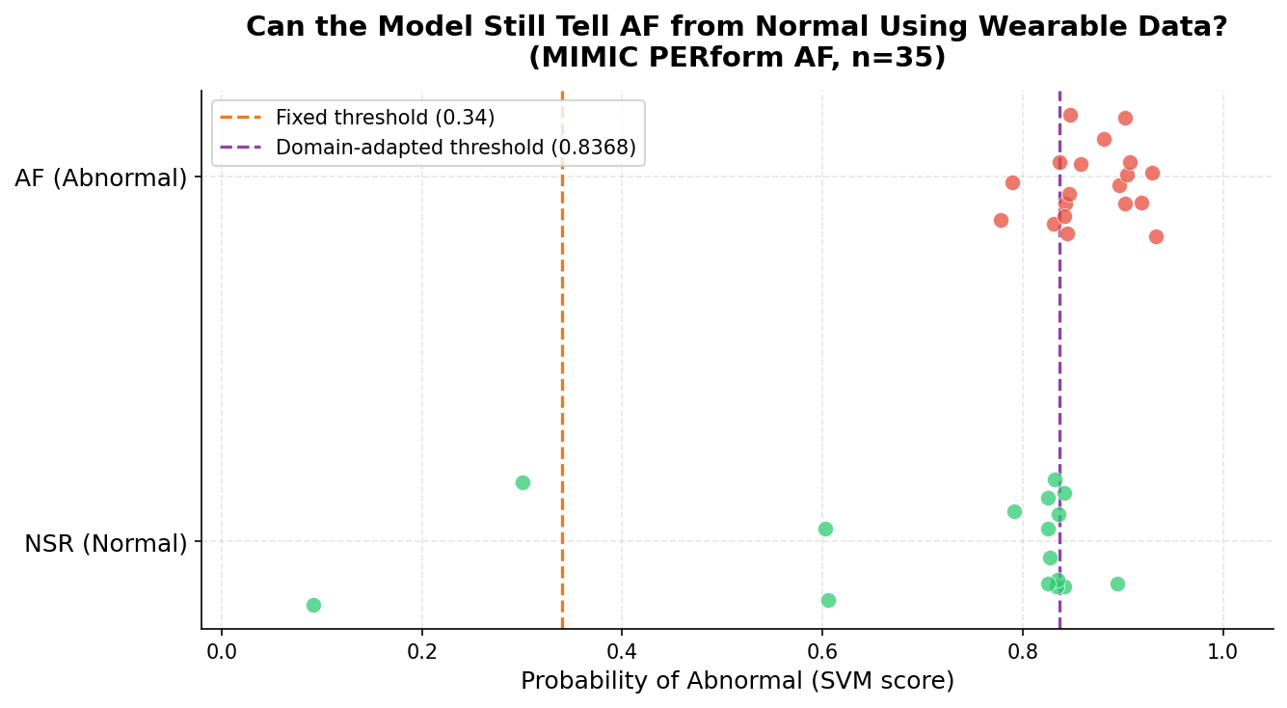
Figure 11. SVM probability scores for MIMIC subjects at fixed threshold 0.34. AF subjects (orange) and NSR subjects (blue) are both predominantly above 0.34, with AF subjects scoring higher overall.

4b.3 Cross-Model Comparison
All four Layer 1 models applied to MIMIC at their fixed Layer 1 thresholds. Specificity failure is systemic — confirming a modality gap problem, not a model selection artefact:
Model | Threshold | Sensitivity | Specificity | AUROC
Logistic Regression | 0.41 | 100% | 18.75% | 0.7368
Random Forest | 0.37 | 100% | 6.25% | 0.8503
XGBoost | 0.34 | 100% | 12.5% | 0.8322
SVM | 0.34 | 100% | 12.5% | 0.8586
SVM retains the highest AUROC across all four models. Model selection confirmed correct.

4b.4 Threshold Recalibration (Youden’s J)
Metric | Fixed Threshold (0.34) | Recalibrated (0.8424)
Sensitivity | 100% | 73.7%
Specificity | 12.5% | 93.8%
F1 | 0.7308 | 0.8235
Specificity recovers from 12.5% to 93.8% with a domain-adapted threshold. The gap between 0.34 and 0.8424 quantifies the magnitude of the modality shift. The threshold was optimised on the same 35 subjects, so stress testing is required.
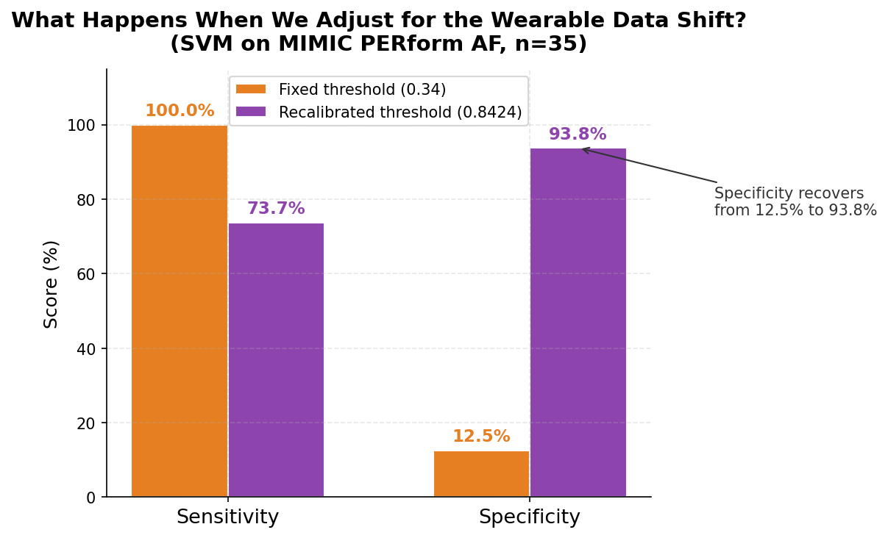
Figure 12. ROC curve for SVM on MIMIC PERform AF. Youden’s J optimal threshold (0.8424) marked, showing specificity recovery from 12.5% to 93.8%.

4b.5 Stress Testing
Test | Metric | Result
Bootstrap AUROC (n=1000) | Mean [95% CI] | 0.8631 [0.7246, 0.9720]
Bootstrap Recalibrated Sens | Mean [95% CI] | 80.6% [57.1%, 100.0%]
Bootstrap Recalibrated Spec | Mean [95% CI] | 91.3% [72.7%, 100.0%]
LOOCV Youden’s J | Sens / Spec | 68.4% / 81.2%
Sensitivity-Targeted LOOCV | Sens / Spec | 78.9% / 81.2%
AUROC lower bound 0.7246 confirms discriminative signal persists even in unlucky bootstrap resamples. LOOCV specificity (81.2%) clears the pre-registered 75% criterion in both methods. Sensitivity-targeted LOOCV achieves 78.9% sensitivity — 1.1 percentage points below the 80% criterion, consistent with N=19 AF leave-one-out variance.
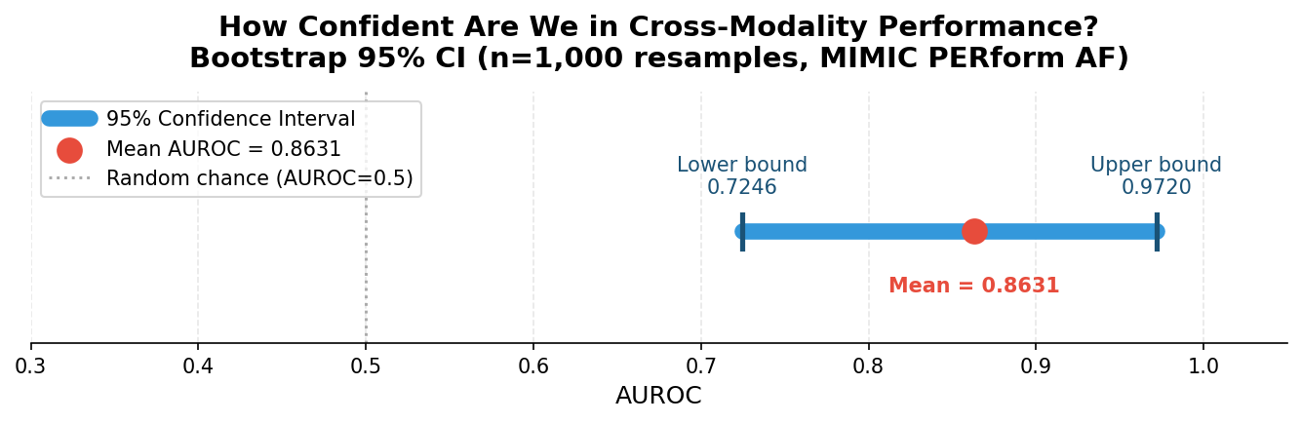
Figure 13. Bootstrap AUROC distribution (n=1000 resamples) for SVM on MIMIC PERform AF. Mean 0.8631, 95% CI [0.7246, 0.9720].
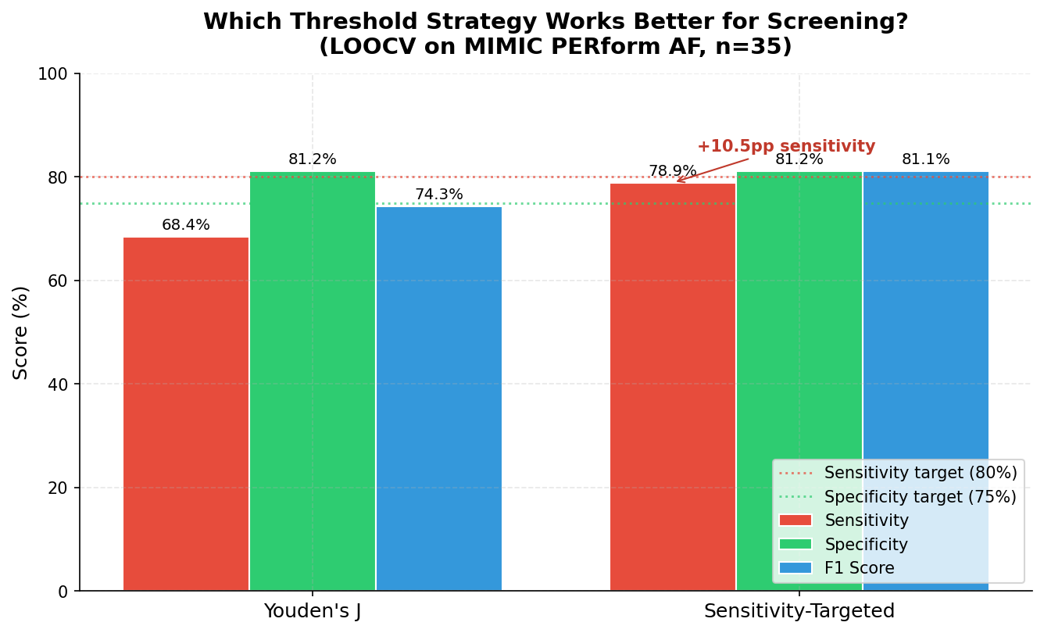
Figure 14. Comparison of Youden’s J LOOCV and Sensitivity-Targeted LOOCV. Sensitivity improves 10.5pp with no specificity cost under the sensitivity-first threshold criterion.

4c. BeatCheck — Cardiac Screening Proof-of-Concept App
BeatCheck is a consumer-facing web application that applies the trained SVM model to Apple Health heart rate exports, demonstrating the research pipeline in a deployable format. It is a screening tool — not a diagnostic device — and directs users toward clinical evaluation rather than providing a diagnosis.

4c.1 Technical Architecture
Component | Technology | Notes
Backend | FastAPI (Python) | Serves model inference via REST API
Frontend | Plain HTML/CSS/JavaScript | No framework dependencies
ML inference | scikit-learn SVM + StandardScaler | Loaded from .joblib at startup
Input formats | Apple Health CSV, XML | ZIP upload removed from UI
Large file handling | Client-side JavaScript streaming | Full XML never transmitted
Data window | Most recent 90 days | Client-side filter before upload

4c.2 Processing Pipeline
Uploaded heart rate data is windowed into 30-minute overlapping windows (15-minute step, minimum 10 readings per window). Each window is scored by the frozen SVM at the domain-adapted threshold of 0.8368 (LOOCV mean threshold — chosen over the point estimate of 0.8424 for being an out-of-sample estimate). The percentage of windows flagged as Abnormal is computed and mapped to three pre-registered risk tiers:
Risk Tier | Windows Flagged | Interpretation | Recommended Action
Low | < 10% | No consistent pattern of concern | Continue regular monitoring
Intermediate | 10–40% | Elevated pattern detected | Consider GP or specialist follow-up
High | > 40% | Consistent Abnormal pattern | Clinical cardiac evaluation recommended

4c.3 Stress Test Results
Real Apple Health export (4.8-year dataset) processed successfully: Intermediate tier returned, 38.2% of windows flagged across 84 days analysed. 602 windows processed. No crashes, no timeout errors. Client-side streaming handled the full XML export without transmitting the full file to the server.
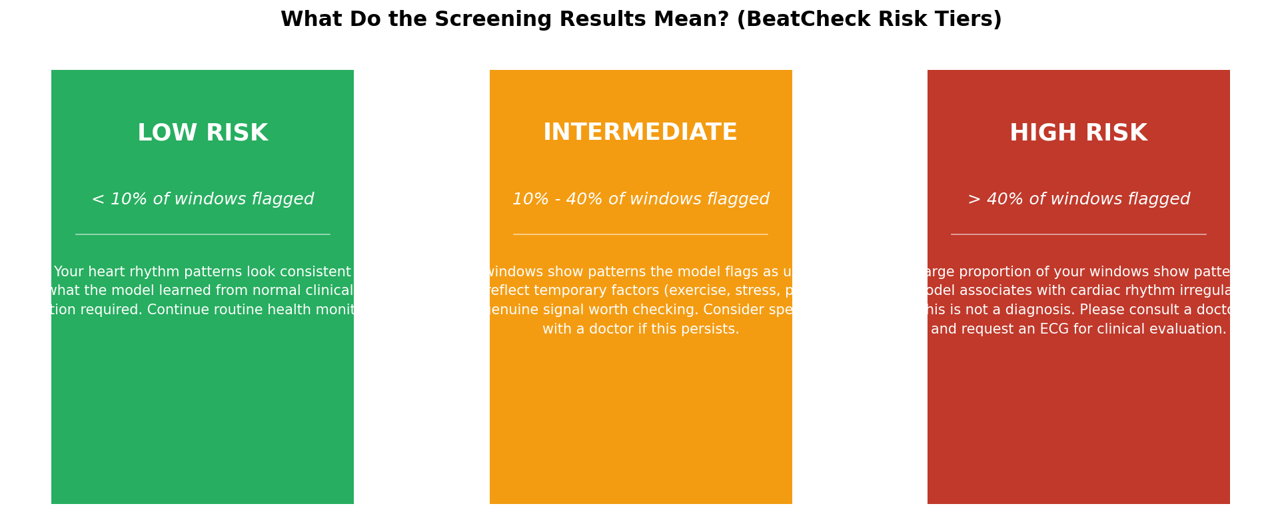
Figure 15. BeatCheck risk tier framework. Three bands (Low/Intermediate/High) mapped from percentage of flagged windows, with plain-English interpretations.

5. Recommendations & Next Steps

5.1 Answering the Research Question
Can machine learning models trained on clinical ECG data generalise to consumer wearable signals to detect cardiac rhythm anomalies, and are consumer wearables feasible as proxy screening tools?
The answer is a qualified yes. The discriminative signal transfers across modalities: AUROC 0.8586 on MIMIC PERform AF confirms the model retains genuine ability to rank abnormal subjects above normal subjects using PPG-derived features. But direct threshold generalisation fails — the ECG-calibrated threshold of 0.34 produces 100% sensitivity at 12.5% specificity on PPG data. This is a calibration failure, not a discrimination failure.
The Fahrenheit-to-Celsius analogy: a thermometer calibrated in Fahrenheit gives alarming readings when interpreted on a Celsius scale. The instrument is accurate; the interpretation framework needs adaptation. When the threshold is recalibrated for the PPG domain (0.8368 via LOOCV), sensitivity-targeted LOOCV achieves 78.9% sensitivity at 81.2% specificity — approaching the pre-registered criterion within the variance expected from N=35 leave-one-out evaluation.

5.2 Implications for Singapore Public Health
With 49% of Singapore residents skipping annual health checkups and CVD claiming approximately 22 lives daily, the screening gap is real and consequential. Consumer wearables are worn by millions and collect continuous cardiac data without active participation. The discriminative foundation demonstrated by this project suggests the technology is viable — the engineering problem is calibration, not capability.
For Singapore’s public health strategy, the practical path forward involves:
1. PPG-native calibration: Train or fine-tune models on PPG-specific data from the target population, rather than applying ECG-trained thresholds directly. A population-representative PPG dataset with confirmed labels would dramatically improve deployability.
2. Richer wearable data access: Partnering with wearable manufacturers to access raw beat-by-beat RR intervals (rather than summary SDNN statistics) would enable more precise HRV computation, closing part of the modality gap.
3. Population-representative validation: MIMIC PERform AF uses critically ill ICU patients — a population that differs significantly from the general screening target. Validation on community-dwelling adults wearing consumer wearables is the necessary next step.
4. Scope boundary: HRV-based screening can flag rhythm irregularities (AF, other arrhythmias). It cannot detect morphological abnormalities (conduction delays, ST changes) — as demonstrated by the personal ECG report. Deployment should communicate this scope explicitly to users.

5.3 Methodological Strengths
Pre-registration: Key decisions (feature set, thresholds, test direction, tier criteria) locked before analysis, preventing post-hoc rationalisation.
No data leakage: Scaler fitted on training data only. Layer 2 data never used for training or threshold selection at the primary evaluation stage.
Transparent null result: Apple Watch null result reported rather than suppressed. Three mechanistic explanations provided. Pivot to MIMIC documented with explicit rationale.
Discrimination vs calibration: AUROC and sensitivity/specificity reported and interpreted separately, avoiding the common error of conflating threshold miscalibration with model failure.
Stress testing: Bootstrap CI and LOOCV provide honest uncertainty estimates rather than point estimates that overstate precision on N=35.
Clinical ground truth: The NHCS ECG report provides a verifiable anchor point and reveals the specific abnormality type, enabling mechanistic interpretation.

5.4 Limitations
• Not a clinical trial and does not produce a validated medical device.
• Apple Watch analysis is a single-subject case study (N=1) — findings cannot be generalised.
• MIMIC PERform AF uses 35 critically ill ICU subjects — not representative of the general screening population.
• Threshold recalibration and LOOCV results computed on the same 35 subjects — indicative, not definitive.
• Apple Watch SE produces optical PPG, not electrical ECG. RMSSD is approximated from SDNN (×0.85) due to device API limitations.
• The locked 8-feature HRV set detects rhythm irregularities only. Morphological abnormalities (conduction delays, ST changes) cannot be detected by any HRV-based analysis — as confirmed by the personal clinical ECG finding.

5.5 Acknowledgements
Dataset provided by PhysioNet and the Computing in Cardiology Challenge 2017 organisers. Personal health data collected via Apple Watch SE (1st Generation) and exported through Apple Health. MIMIC PERform AF dataset provided via Zenodo (doi.org/10.5281/zenodo.6807402). Clinical ECG report provided by the National Heart Centre Singapore (NHCS), Department of Cardiology, certified by Dr Chong Jia Yun (B.Med, FRACP), dated 17 March 2026.

