- Trained chunked Word2Vec models for each subreddit split into three time periods (before 2016, 2017–2020, 2021–2024).
- Aligned model spaces using orthogonal Procrustes and computed per-word cosine similarity to compare subreddits.
Use all the intersecting words
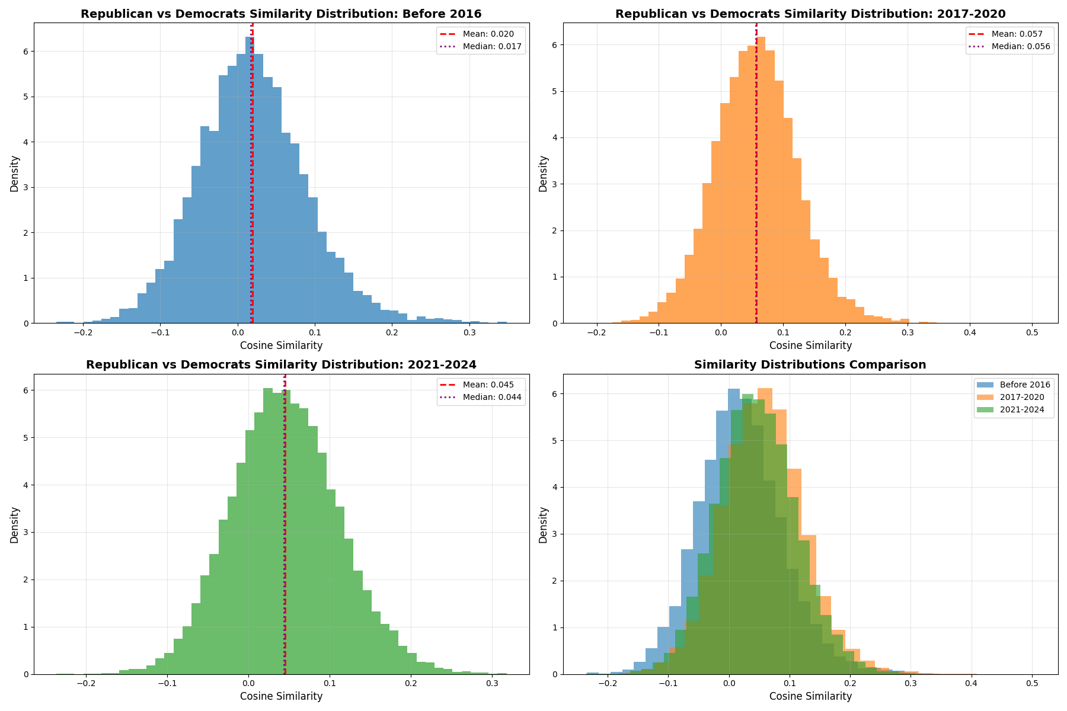

Use 1000 common anchor words to align without stopwords
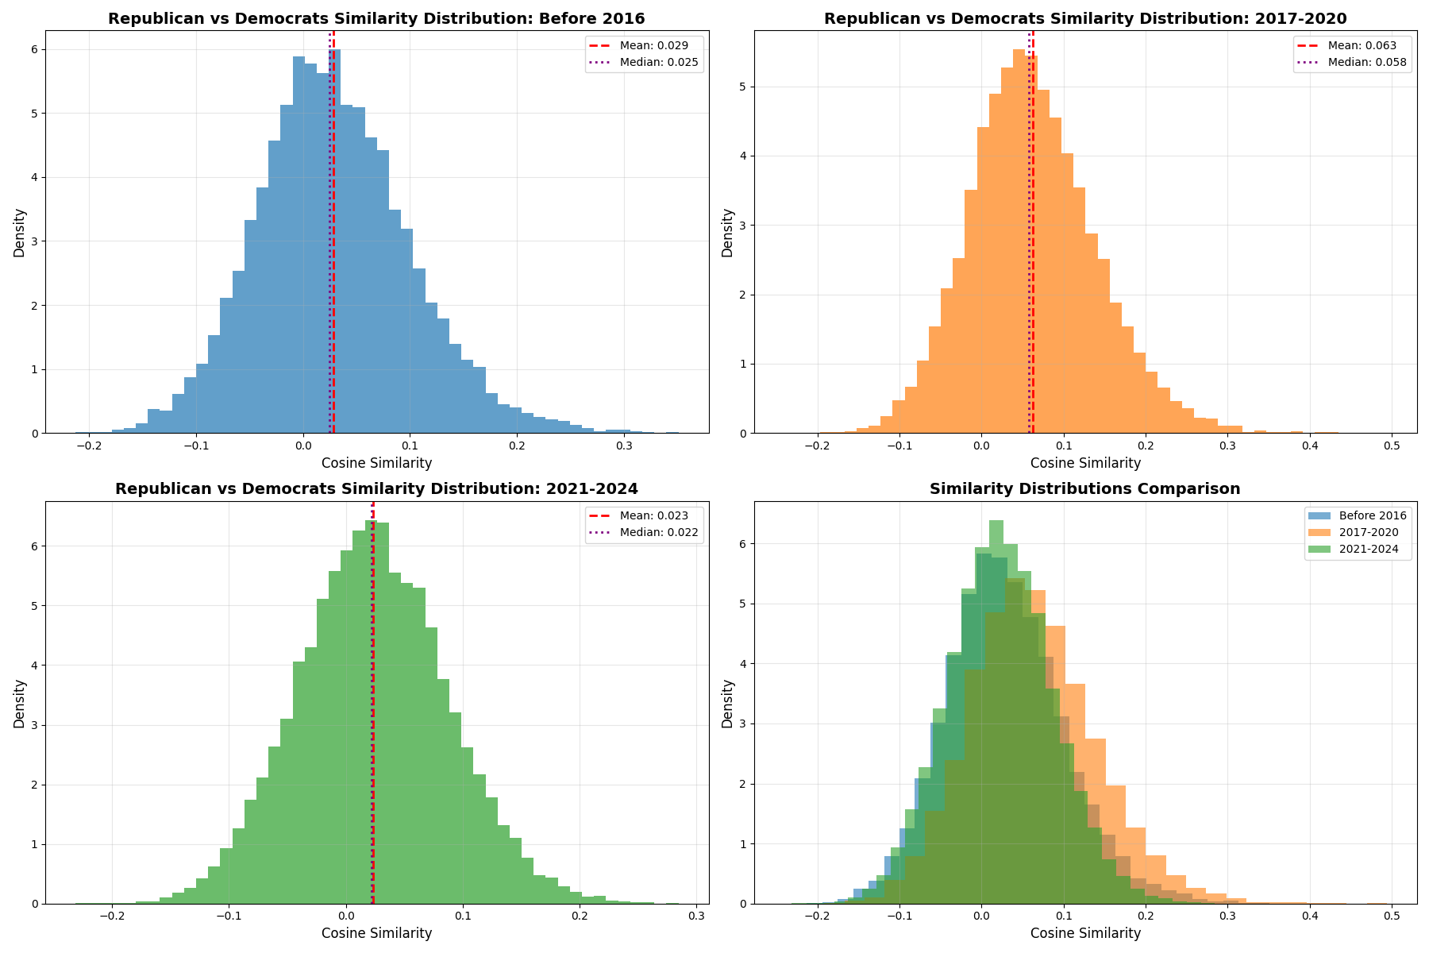
Use 1000 common anchor words with stopwords
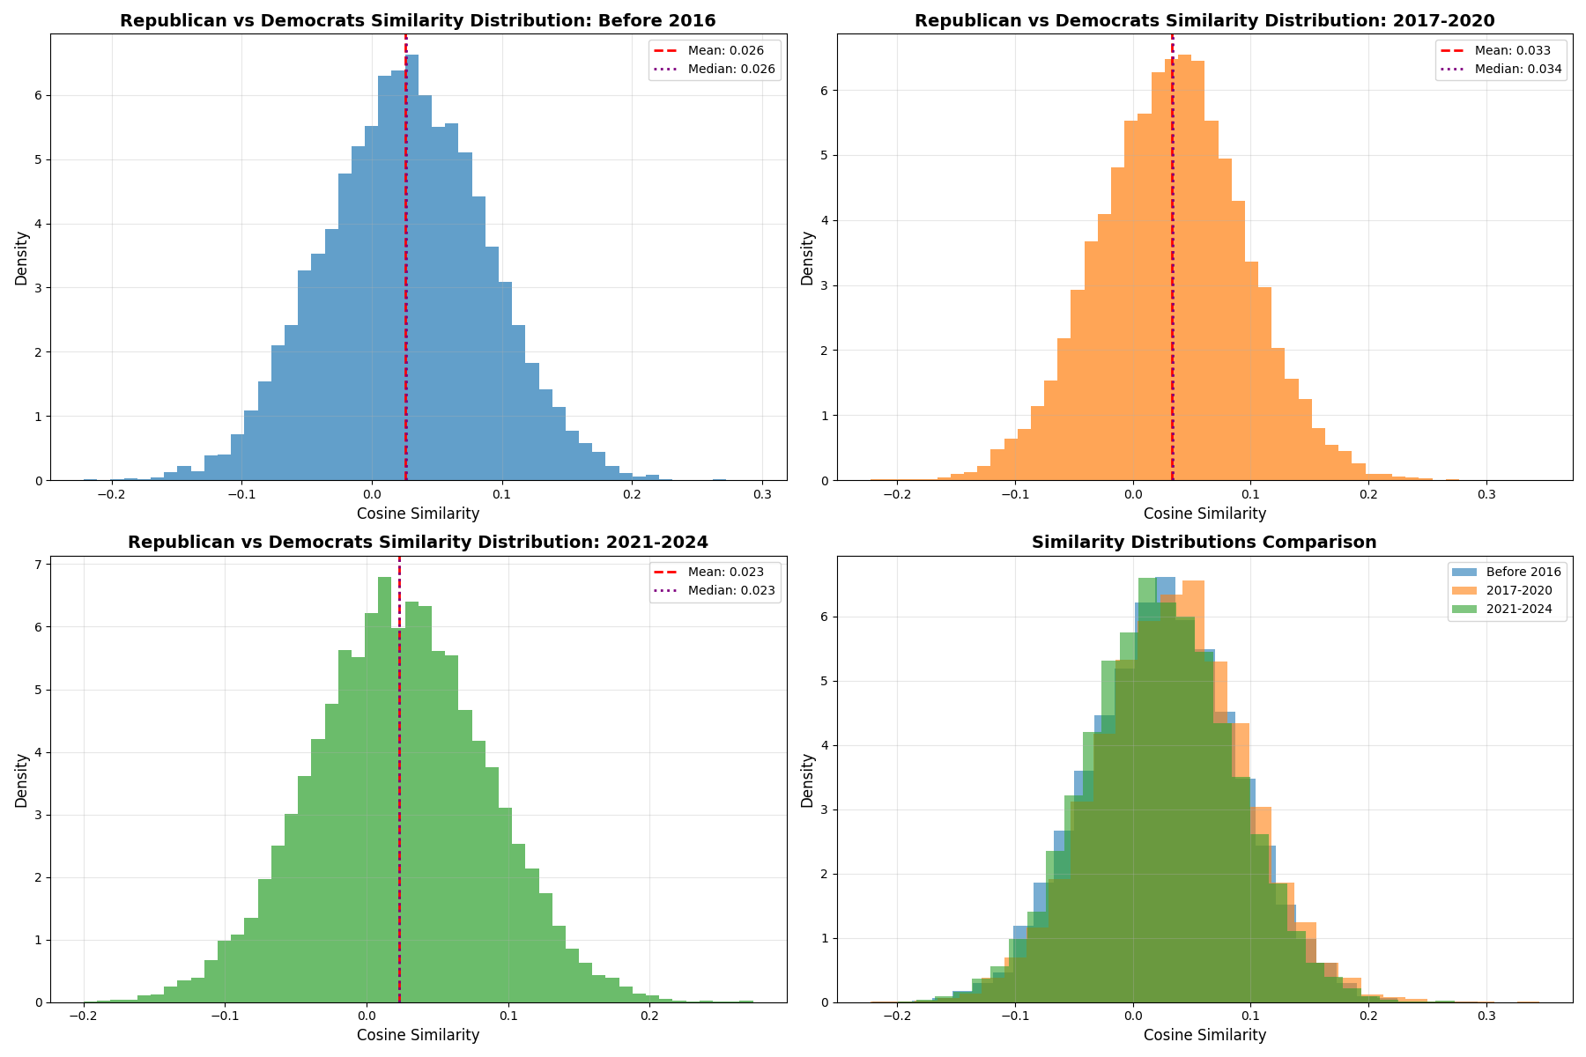
Raw model (Not aligned)
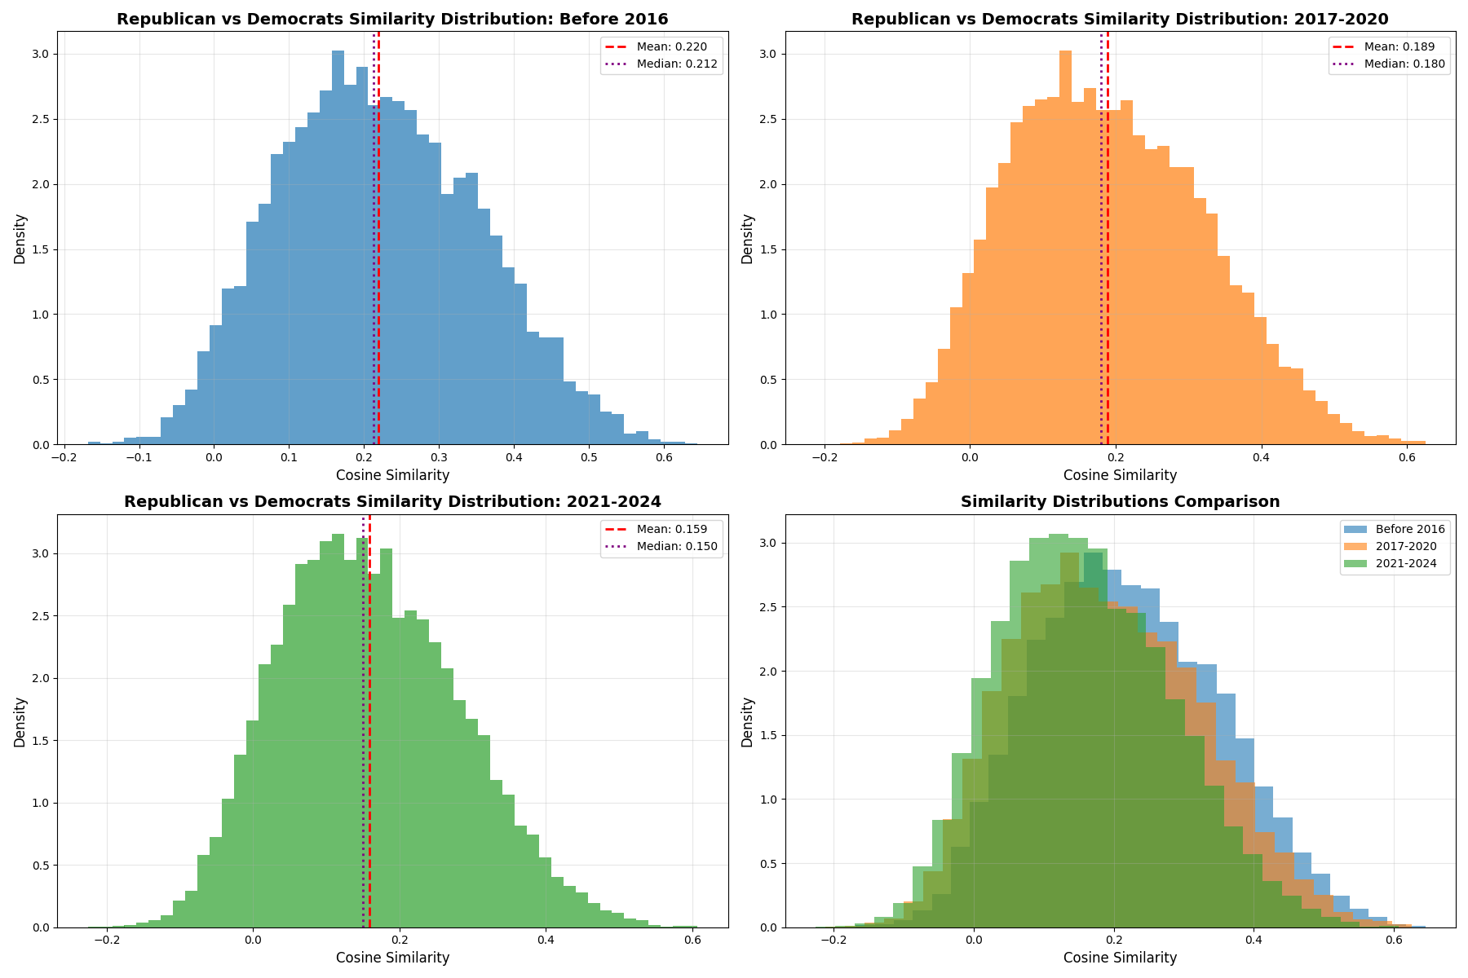
- Selected politically salient words via TF-IDF and constructed an anchor set from high-overlap frequent words across subreddits.
Use anchor words for alignment, plot top 500 most frequently occurring political words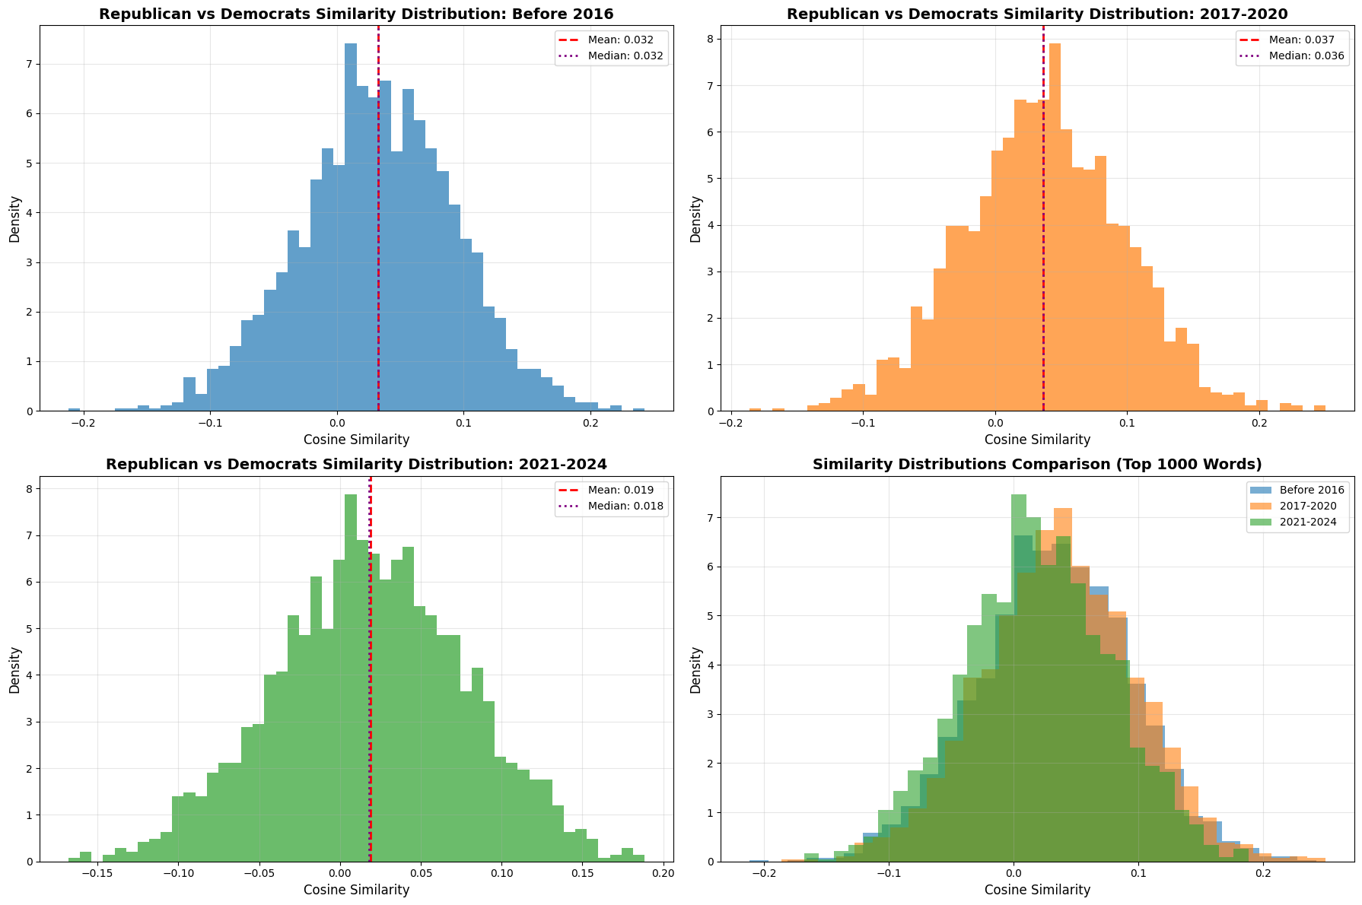
The problems encountered:
corresponding word vectors in the two models may be roughly uncorrelated?
- Extracted ±5-token context windows around target words for contextual analysis. The mean of context word vectors produced a context centroid per occurrence and derived polarization metrics based on cosine distance.
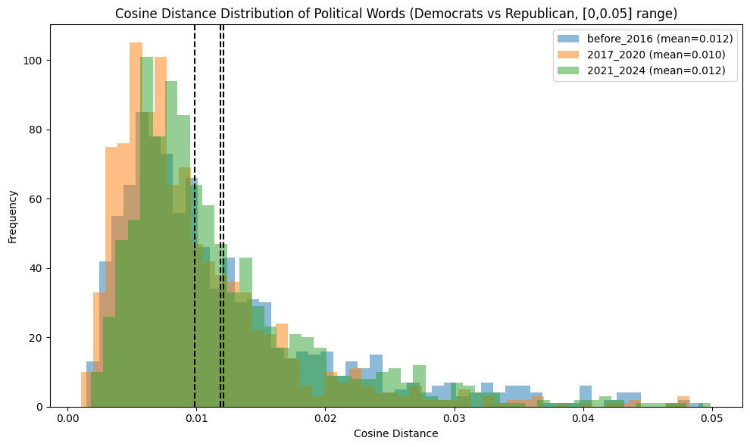
The problems encountered:
After checking the top 50 words and the bottom 50 words, the cosine similarity of the words with high occurrence frequencies will tend to approach 0, while the cosine similarity of those with low occurrence frequencies will be very large.
Expectation:
Look at words that frequently appear near "Trump" in each subreddit. Polarization shows in differing associates. Example: In Democrats, "Trump" co-occurs with "corruption" or "impeachment"; in Republicans, with "leadership" or "economy."

TRING HDBSCAN:
- Align the two models (finished)
- For the target word, get top K neighbors from each model (finished)
- Take the Democrat vector and the aligned Republican vector (finished)
- Run HDBSCAN on those vectors (min_cluster_size 50?)
How do I quantify the difference?

Thoughts:
Use BERT-based models to get context-aware embeddings, then apply sentiment classifiers (positive/negative). Compute average sentiment scores for "Trump" in posts from each subreddit. Example: In r/Democrats, "Trump" might average a sentiment score of -0.7 (negative), while in r/Republicans it's +0.6 (positive), showing polarization.

