Amazon Leadership Principles

We use our Leadership Principles every day, whether we're discussing ideas for new projects or deciding on the best approach to solving a problem. It is just one of the things that makes Amazon peculiar.

Luca Cirillo

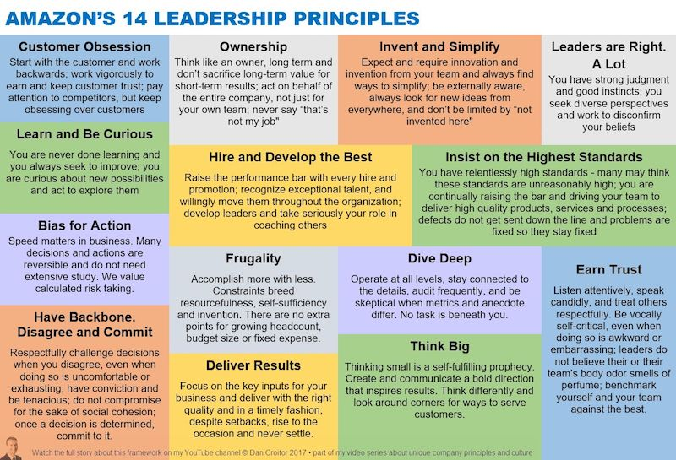

Table of Contents
Customer Obsession 3
Ownership 4
Invent and Simplify 5
Are Right, A Lot 6
Learn and Be Curious 7
Hire and Develop the Best 8
Insist on the Highest Standards 9
Think Big 10
Bias for Action 11
Frugality 12
Earn Trust 13
Dive Deep 14
Have Backbone; Disagree and Commit 15
Deliver Results 16
Strive to be Earth's Best Employer 17
Success and Scale Bring Broad Responsibility 18

Customer Obsession
Leaders start with the customer and work backwards. They work vigorously to earn and keep customer trust. Although leaders pay attention to competitors, they obsess over customers.
Not focusing only on tasks assigned by your boss. It is important working considering the point of view of who use our software

Situation | One time when I was working on a banking project, an application developed from scratch by me and used by banking promoter
Task | I was focused on the development of the front end and I noticed that would be usefull for a banking promoters know the activity done by their own subordinate (since the application presented a workflow in which a banking promoter would have done is work only when his subordinates would have terminates theirs tasks)
Action | I have proposed to my project manager this idea. The project manager accepted it and realized a push notification system based on alert indicators that showed details of the task done by banking promoter’s subordinates
Result | It was useful and I have helped the banking promoters to monitoring the activity of this subordinates and prevents long waiting
Reflection

Ownership
Leaders are owners. They think long term and don’t sacrifice long-term value for short-term results. They act on behalf of the entire company, beyond just their own team. They never say “that’s not my job."
They never say “that’s not my job”

Situation | I was working for Italian Public administration project
Task | I was involved on realization of the electronic invoice web services meanwhile other colleagues were working on a document system that exposed a service that my application needed to interact but they experienced some compatibility problem with some libraries
Action | I asked to their and mine project manager if I could help them into troubleshooting. They confirm me that I can do this task, so I have done problem solving on compatibility and I found the best tool and version to use.
Result | The colleagues were free to continues to develop the remaining business logic on their web service
Reflection

Situation | Banking application, the application went down for two days
Task | My task was to solve the problem
Action | I’ve helped the system engineers. I’ve identified that a node in a cluster was down. I noticed from the server log that was some installation trouble after the update done by system engineers some days before. I’ve asked them to momentarily exclude that node from cluster since I supposed that the load balancing strategy was resource based and that the broken node results always as the less loaded one despite it didn’t could fulfill the incoming requests
Result | The application went up again and the systems group starting to solve problem on the problematic node in order to bring it up in the cluster again
Reflection

Invent and Simplify
Leaders expect and require innovation and invention from their teams and always find ways to simplify. They are externally aware, look for new ideas from everywhere, and are not limited by “not invented here." As we do new things, we accept that we may be misunderstood for long periods of time.
There is always another solution/idea

Situation | I was working on integration of Java based application with oracle DB
Task | One of our non functional requirements was the performance improvement compared to the previous application version
Action | I have refactored code from and develop a JPA integration. Then I have rewrite the code deleting JPA and introduce JDBC query. Initially I have written static query, after I have evaluated that it would be better for the manutability to construct query dinamically basing on passed parameter. So I construct an object model that allows to construct query dinamically using statement objects like select, from, where, and, or etc. Finally I have noticed that exist a JDBC version of a tool named QueryDSL that I’ve used in the past so I’ve studied the integration and than developed the last version
Result | Each step solution got a performance improvement and the final one also simplify the sql query construction improving maintenability instead of sql query string concatenations and reduce the number of code’s line.
Reflection

Are Right, A Lot
Leaders are right a lot. They have strong judgment and good instincts. They seek diverse perspectives and work to disconfirm their beliefs.
Work to disconfirm their belief

Situation | There was a working choice to make
Task | I construct my idea in my mind
Action | I evaluated my idea with others colleagues (also junior) in order to verify if it presents lacks
Result | I was available to change my idea modifying it
Reflection | The team work bring always to the best solution

Learn and Be Curious
Leaders are never done learning and always seek to improve themselves. They are curious about new possibilities and act to explore them.
Availability to learn something new, since that worked yesterday is not going to work today

Situation | I was developing a new front end and back end application for a banking customer
Task | I have to develop both back end and front end with the best technologies
Action | I hadn’t experience with JS front end framework but only with Java based technologies like, struts, JSP, ICE Faces and so on. So I decided to study Angular 8 and then I have developed front end with this technology
Result | The performance and usability was batter than old java based technologies and I was happy to have learned something new
Reflection | Accepting the challenge make me more confident on front end developing

Hire and Develop the Best
Leaders raise the performance bar with every hire and promotion. They recognize exceptional talent, and willingly move them throughout the organization. Leaders develop leaders and take seriously their role in coaching others. We work on behalf of our people to invent mechanisms for development like Career Choice.
Our exceptional talent need to receive the attention they need.
If you are comfortable, you are not growing, because doing things which challenge and scare you is the best way to learn
It’s responsibility of every single person to help others grow

Situation | I was working alone in a banking sector
Task | I needed of help of a new junior colleague
Action | I help the colleague to grow, improving his coding skills
Result | It was able to do every tasks and helped other colleagues in turn
Reflection

Insist on the Highest Standards
Leaders have relentlessly high standards — many people may think these standards are unreasonably high. Leaders are continually raising the bar and drive their teams to deliver high quality products, services, and processes. Leaders ensure that defects do not get sent down the line and that problems are fixed so they stay fixed.
Tied heavily on the ownership principle.
You innovate when you know you’re not done, and we insist that everyone has such high standards that we’re never done.
Never to deliver to requirements (to only meet our goals) at all times (once you look past our officials project goals) our goal is to improvement.
Not fix only the bug but the root causes of problems.

Situation | I was working on an application
Task | I have to solving a huge amount of bug on login functionality
Action | I have deeply analyzed the root cause of the problem that was due to a bad and not unit tested code. I have re wrote it from scratch
Result | There was no more bug
Reflection

Situation | I was working on Italian lottery game
Task | We need to improve performance
Action | I have limited the number of object convertions and when was needed I’ve optimized it choosing the best in performance that was Jackson Stream. I have introduced Redis cache in order to save time to calculate the hash of request data, very usefull because, since we received request in a asyncronous manner via ActiveMQ, the producer often makes retry operation with the same request to check the status of the previous request. I have transformed all the service involved in the operation idempotent in order to return always the same result by same requests (and so retry requests). I have rewrite the DB integration from JPA to JDBC using QueryDSL library as query string builder in order makes a code also maintainable and less error prone.
Result | Performance improvement
Reflection

Think Big
Thinking small is a self-fulfilling prophecy. Leaders create and communicate a bold direction that inspires results. They think differently and look around corners for ways to serve customers.
Prefers impossible idea, because explaining constraints to a co-worker is easier than explaining how to invent and think

Bias for Action
Speed matters in business. Many decisions and actions are reversible and do not need extensive study. We value calculated risk taking.
Option A or Option B? Pick and move on

Situation | I was working on developing new mortgage application for BNP Paribas bank
Task | The project followed SCRUM methodology ad I was part of developer team as back end developer. There should has been an architect in the firsts sprint in order to define the overall architecture and the model but for some reason he wasn’t has decided
Action | I have started to coordinate the dev team defining the solution, using in the early sprint a lot of assumption in order to compensate the lack of information in the stories. I have defined using a board the UI that we have presented to the product owner. In the first day of every sprint I defined the interface agreement of the microservices that I should have developed to which the front end developers should has integrate.  I have communicated so much with the DBA of the project in order to define the model that best would have fit the scenarios and the stored procedures. I proposed the business domain model to the product owner.
Result | Those actions helps to clarify to the dev team and to the product owner the main functional scenarios and the business models
Reflection

Frugality
Accomplish more with less. Constraints breed resourcefulness, self-sufficiency, and invention. There are no extra points for growing headcount, budget size, or fixed expense.
Having too much to do, and to little time is perfectly ok. Not doing everythings you want on the projects is healthy because doing everythings you ever wanted to do is inefficient. The last thing on your stack pack will never be done, and we should all be happy with that.

Situation | I was working on Liferay based application
Task | I have to re write UI and some functionalities of the main page of banking promoter application but I have lack of knowledge on Liferay and the others teammates were almost all days occupied with maintenace activities. The activity should have done with 4 months if all of us were 100% of working day available.
Action | Since another team was working on developing the new banking promoter application in Angular 8 framework (that was yet in production) and since that the developing and testing activities were very slow on Liferay, I decided to realize some of the required functionalities directly on the new Angular 8 application that I have included in the Liferay main page as IFrames.
Result | Developing and testing on Angular 8 help me to save very much times speeding up my job (about 10 time faster) since it was no more necessary struggle to configuring new portlets in liferay and waiting to build heavy war (portlet) and deploy it on local Tomcat webserver to see the changes.
Reflection

Earn Trust
Leaders listen attentively, speak candidly, and treat others respectfully. They are vocally self-critical, even when doing so is awkward or embarrassing. Leaders do not believe their or their team’s body odor smells of perfume. They benchmark themselves and their teams against the best.
It’s very important for a leader to be able to recognize when they’ve made a mistake, so that they can correct it quickly. This “earn trust” with co-workers, as well as ensure that future mistakes can be corrected quickly.
We you are explaining a mistake, first recognize your own, before explaining other misses.

Situation | I was working on Fideuram banking application
Task | I was a huge amount of tasks to do as like as others my teammates. We had done several mistakes likes non very well testing activities that causes several bugs, developing without clarify and agree the goals
Action | I have asked to all teammates to talking about their problems during that period. I started talking about my mistake caused by that so stressfull period since I’ve accidentally deleted some important data on test environment. We have decided to re define a priority of goals, identifying whose that are needed in the set of the goals that we wanted to do
Result | The mistakes ceased and we have improved the product quality and also reduced the stress
Reflection

Dive Deep
Leaders operate at all levels, stay connected to the details, audit frequently, and are skeptical when metrics and anecdote differ. No task is beneath them.
“Trust yet verify”

Situation | I was working on application maintenance
Task | I have to solving a huge amount of bug on login functionality
Action | I have deeply analized the root cause of the problem that was due to a bad and not unit tested code. I have rewrited it from scratch
Result | There was no more bug
Reflection

Have Backbone; Disagree and Commit
Leaders are obligated to respectfully challenge decisions when they disagree, even when doing so is uncomfortable or exhausting. Leaders have conviction and are tenacious. They do not compromise for the sake of social cohesion. Once a decision is determined, they commit wholly.
We do things (not because the boss said so) because it’s the decision we’ve made, and with the data we’ve gathered.
Data based disagreements are great.
Cheering at others failures suggest that you are playing a zero sum game.
Leaders has to recognize when disagree are needed and when not and when it’s time to move and start delivering.

Situation | I was working for a lottery game application
Task | I have to develop the new sale operation improving performance than has done before
Action | I have demonstrate that calling all microservices involved in the sale in a sequentially manner and using queues between each microservices for handle request/response was worst in term of performance than developing a synchronous communication, deleting queues and scaling vertically the orchestrator to handle the increase of the memory of 20% usage due to queues deletions
Result | I have convinced the team about this approach and now we are writing all the sell operations of Italian lottery games with this approach
Reflection

Deliver Results
Leaders focus on the key inputs for their business and deliver them with the right quality and in a timely fashion. Despite setbacks, they rise to the occasion and never settle.
“right quality” often is not “perfect quality”- Right quality is often less quality than we’d prefer (see Frugality). We never have time re resources to accomplish things the way we want, so we accomplish things the way we need. We deliver the right result.
Situation | I was working for a banking promoter application
Task | I noticed that we would have been in late for the delivery
Action | I proposed to my project manager to excludes from release some minus important features and we would have consolidated and tested those remains
Result | We have delivered the main features before and released the others features 3 weeks later
Reflection

Strive to be Earth's Best Employer
Leaders work every day to create a safer, more productive, higher performing, more diverse, and more just work environment. They lead with empathy, have fun at work, and make it easy for others to have fun. Leaders ask themselves: Are my fellow employees growing? Are they empowered? Are they ready for what's next? Leaders have a vision for and commitment to their employees' personal success, whether that be at Amazon or elsewhere.

Success and Scale Bring Broad Responsibility
We started in a garage, but we're not there anymore. We are big, we impact the world, and we are far from perfect. We must be humble and thoughtful about even the secondary effects of our actions. Our local communities, planet, and future generations need us to be better every day. We must begin each day with a determination to make better, do better, and be better for our customers, our employees, our partners, and the world at large. And we must end every day knowing we can do even more tomorrow. Leaders create more than they consume and always leave things better than how they found them.

