Report

Occupancy is an important factor in the performance equation of a GPU. Occupancy is the ratio of active warps to max number of warps that can run on a GPU in parallel. If the number of active warps is fewer than the max, the GPU performance is not maximized. Occupancy depends on a few GPU features:
- Warps per SM
- Blocks per SM
- Registers per SM
- Shared Memory per SM

Occupancy can be determined interactively using a few commands on the terminal. Running deviceQuery gives us the warps and blocks. Compiling a cuda file using -Xptxas -v flag generates a .cubin file that contains tge registers and shared memory.

The following shows empirical data in determining occupancy. The input size was doubled. The flat part of the graph indicates that there are not enough threads running on the GPU. As a result, increasing the input size does not change the execution time. Once occupancy is reached, execution time begins to increase.

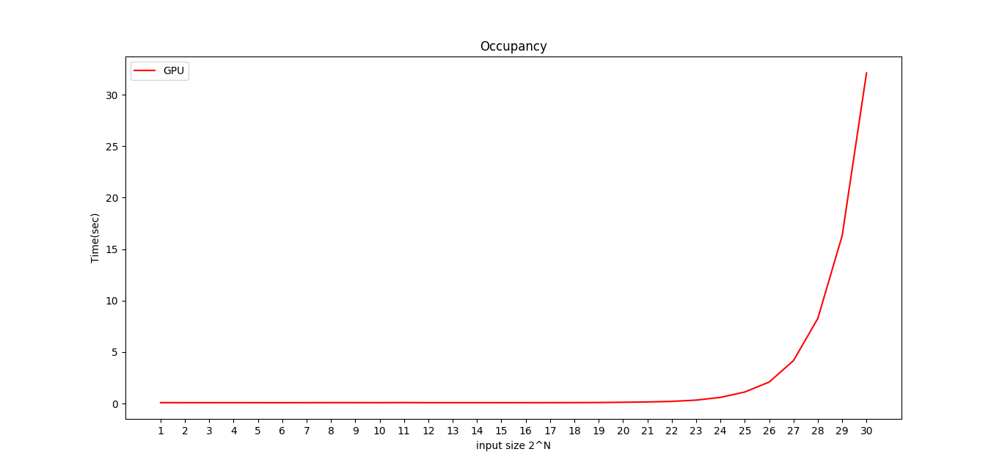

This is another graph on occupancy. This graph shows the relationship of performance to occupancy. Low poerformance is obtained when there are still available warps on the GPU. As the active warps approach the max number, performance flattens out, approaching peak performance.

