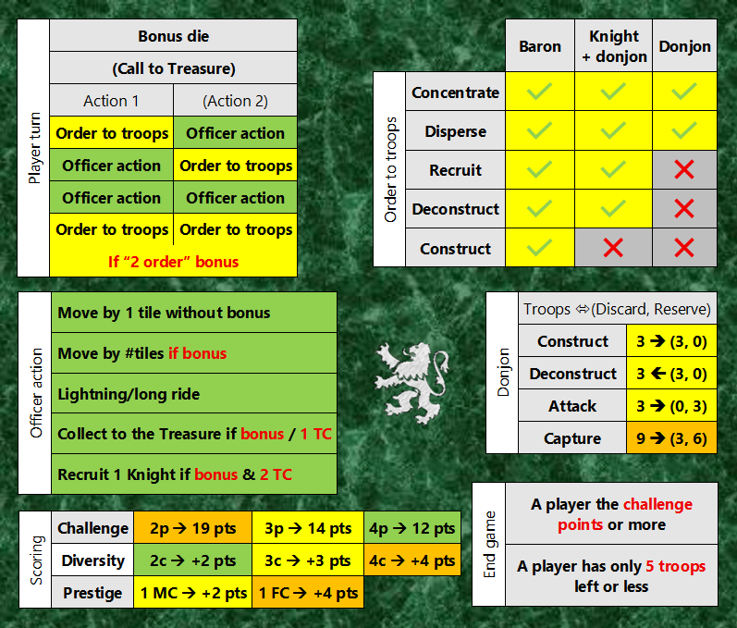
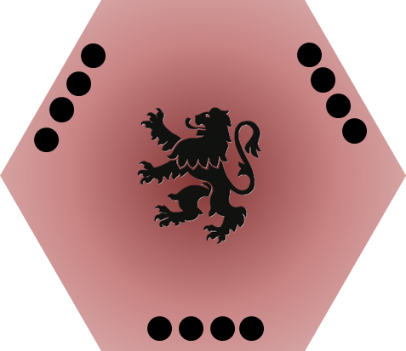

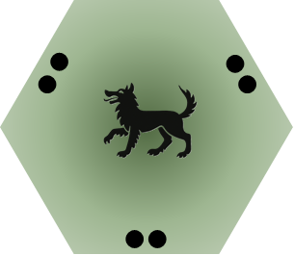
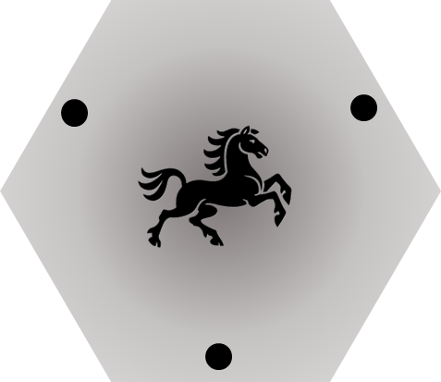

 | 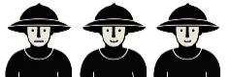 |  |  | 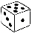
 |  |  |  | 1 | 2 | 3 | 4 | 5 | 6
 | Recruit # troops |  | 1 | 1 | 1 | 2 | 2 | 3 | 3 | +1 Tile 1
 | … if donjon |  | 1 | 2 | 2 | 2 | 3 | 3 | 3
 | 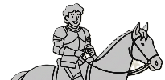
 |  |  |  | 1 | 2 | 3 | 4 | 5 | 6
 | Move Officer by # tiles |  | 1 | 3 | 3 | 2 | 2 | 1 | 1 | +1 Tile 2
 |   2 orders to troops? |  |  |  |  |  |  |  |  |  | Bonus
 |  |  |  | 1 | 2 | 3 | 4 | 5 | 6
 |  |  |  |  |  |  | 
 | 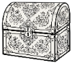  Collect for the Treasure? |  |  |  |  |  | OR 1 TC
 |  |  |  | 1 | 2 | 3 | 4 | 5 | 6
 | 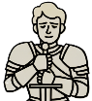  Recruit 1 Knight? |  |  |  |  |  | AND 2 TC
 |  |  |  | 1 | 2 | 3 | 4 | 5 | 6

 |  | Baron | Knight  + donjon | Donjon
Order to troops | Concentrate
Order to troops | Disperse
Order to troops | Recruit
Order to troops | Deconstruct
Order to troops | Construct

Player turn | Bonus die
Player turn | (Call to Treasure)
Player turn | Action 1 | (Action 2)
Player turn | Order to troops | Officer action
Player turn | Officer action | Order to troops
Player turn | Officer action | Officer action
Player turn | Order to troops | Order to troops
Player turn | If “2 order” bonus

Officer action | Move by 1 tile without bonus
Officer action | Move by #tiles if bonus
Officer action | Lightning/long ride
Officer action | Collect to the Treasure if bonus / 1 TC
Officer action | Recruit 1 Knight if bonus & 2 TC

Scoring | Challenge | 2p 19 pts | 3p 14 pts | 4p 12 pts
Scoring | Diversity | 2c +2 pts | 3c +3 pts | 4c +4 pts
Scoring | Prestige | 1 MC +2 pts | 1 FC +4 pts

End game | A player the challenge points or more
End game | A player has only 5 troops left or less

Donjon | Troops (Discard, Reserve)
Donjon | Construct | 3 (3, 0)
Donjon | Deconstruct | 3 (3, 0)
Donjon | Attack | 3 (0, 3)
Donjon | Capture | 9 (3, 6)

Examples of diversity points
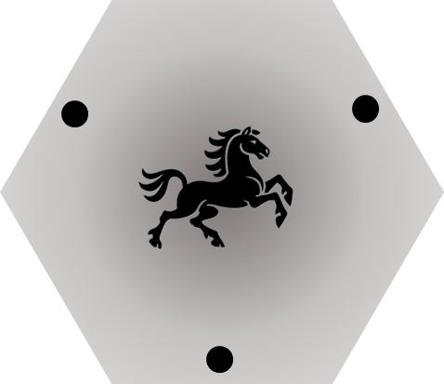 | +2 points
 | +3 points
 | +4 points

